TABLE OF CONTENTS
Sl No | Content | Pg No
1 | Abstract | 2
2 | Introduction | 3
3 | System Analysis | 4
4 | System Design | 6
5 | Implementation | 9
6 | Testing and Results | 11
7 | Conclusion | 14
8 | Future Enhancements | 15
9 | References | 16
10 | Appendices | 17

ABSTRACT
The Placement Readiness Portal is a comprehensive, AI-enhanced, modern web application designed to completely revolutionize and streamline the campus recruitment and placement preparation process. The Placement Readiness Portal is a comprehensive, AI-enhanced, modern web application designed to completely revolutionize and streamline the campus recruitment and placement preparation process. The Placement Readiness Portal is a comprehensive, AI-enhanced, modern web application designed to completely revolutionize and streamline the campus recruitment and placement preparation process. By bridging the massive communication and process gap between students, the college placement cell, and recruiting companies, it provides a highly centralized, secure, and robust platform. By bridging the massive communication and process gap between students, the college placement cell, and recruiting companies, it provides a highly centralized, secure, and robust platform. By bridging the massive communication and process gap between students, the college placement cell, and recruiting companies, it provides a highly centralized, secure, and robust platform. It moves beyond traditional job portals by integrating advanced features such as Readiness Score calculations, Skill Gap Heatmaps, Mock Test Interfaces, and AI Chatbot integrations to actively help students prepare for interviews rather than simply applying for them. It moves beyond traditional job portals by integrating advanced features such as Readiness Score calculations, Skill Gap Heatmaps, Mock Test Interfaces, and AI Chatbot integrations to actively help students prepare for interviews rather than simply applying for them. It moves beyond traditional job portals by integrating advanced features such as Readiness Score calculations, Skill Gap Heatmaps, Mock Test Interfaces, and AI Chatbot integrations to actively help students prepare for interviews rather than simply applying for them.

• Technologies used
The project is built on a cutting-edge technology stack emphasizing scalability and performance. Backend: Java 17, Spring Boot 3.3.0, Spring Data JPA, Spring Security, JWT via Clerk Authentication, PostgreSQL, Apache PDFBox for resume parsing, and Apache POI. Backend: Java 17, Spring Boot 3.3.0, Spring Data JPA, Spring Security, JWT via Clerk Authentication, PostgreSQL, Apache PDFBox for resume parsing, and Apache POI. Frontend: React 18, Vite, Tailwind CSS, Recharts for analytics, Framer Motion for animations, and Axios for API consumption. Frontend: React 18, Vite, Tailwind CSS, Recharts for analytics, Framer Motion for animations, and Axios for API consumption.

• Key outcomes
1. Automated end-to-end placement processes, completely removing manual Excel-sheet dependencies.
2. Enhanced student preparation through personalized Readiness Scores and Skill Gap Heatmaps.
3. Reduced administrative overhead for faculty and placement officers.
4. Intelligent matching of students to Company Requirements using complex algorithms.
5. Real-time query resolution via an integrated Chatbot Service.5. Real-time query resolution via an integrated Chatbot Service.

2. Introduction

• Background of the project
In the contemporary educational ecosystem, campus placements represent a critical milestone for students and institutions alike. Traditionally, these placements involve a staggering amount of manual paperwork, distributed tracking systems, and disconnected communication channels. In the contemporary educational ecosystem, campus placements represent a critical milestone for students and institutions alike. Traditionally, these placements involve a staggering amount of manual paperwork, distributed tracking systems, and disconnected communication channels. In the contemporary educational ecosystem, campus placements represent a critical milestone for students and institutions alike. Traditionally, these placements involve a staggering amount of manual paperwork, distributed tracking systems, and disconnected communication channels. In the contemporary educational ecosystem, campus placements represent a critical milestone for students and institutions alike. Traditionally, these placements involve a staggering amount of manual paperwork, distributed tracking systems, and disconnected communication channels. This disjointed approach makes it exceedingly difficult for the placement cell to manage thousands of student records, track their skill development, and align them with the ever-changing demands of the corporate sector. This project was conceptualized to fundamentally digitize, centralize, and intelligently augment this entire workflow using Advanced Java Programming paradigms.This disjointed approach makes it exceedingly difficult for the placement cell to manage thousands of student records, track their skill development, and align them with the ever-changing demands of the corporate sector. This project was conceptualized to fundamentally digitize, centralize, and intelligently augment this entire workflow using Advanced Java Programming paradigms.This disjointed approach makes it exceedingly difficult for the placement cell to manage thousands of student records, track their skill development, and align them with the ever-changing demands of the corporate sector. This project was conceptualized to fundamentally digitize, centralize, and intelligently augment this entire workflow using Advanced Java Programming paradigms.

• Problem statement
The existing manual or semi-automated systems suffer from several critical flaws. Managing student data manually is highly error-prone. Verifying eligibility criteria for various companies against thousands of student profiles takes days, if not weeks. The existing manual or semi-automated systems suffer from several critical flaws. Managing student data manually is highly error-prone. Verifying eligibility criteria for various companies against thousands of student profiles takes days, if not weeks. The existing manual or semi-automated systems suffer from several critical flaws. Managing student data manually is highly error-prone. Verifying eligibility criteria for various companies against thousands of student profiles takes days, if not weeks. Furthermore, students often lack visibility into their own 'readiness' for specific roles, leading to high rejection rates. Coordinating interview schedules, tracking mock test performances, and providing personalized feedback manually is practically impossible at scale. Furthermore, students often lack visibility into their own 'readiness' for specific roles, leading to high rejection rates. Coordinating interview schedules, tracking mock test performances, and providing personalized feedback manually is practically impossible at scale. Furthermore, students often lack visibility into their own 'readiness' for specific roles, leading to high rejection rates. Coordinating interview schedules, tracking mock test performances, and providing personalized feedback manually is practically impossible at scale.

• Objectives
1. To create a highly secure, centralized repository for student profiles, academic records, and skill evidence.
2. To enable companies to post job openings and define complex eligibility criteria programmatically.
3. To implement a 'Readiness Score' algorithm that evaluates a student's preparedness for specific roles.
4. To provide visual analytics, such as the Skill Gap Heatmap, helping students identify areas of improvement.
5. To integrate a Chatbot for instant student support and guidance.
6. To automate resume parsing using Apache PDFBox to reduce manual data entry.6. To automate resume parsing using Apache PDFBox to reduce manual data entry.

3. System Analysis

• Existing system
The current operational baseline in many institutions relies on disparate tools: Excel spreadsheets for data storage, WhatsApp or emails for communication, and physical notice boards for announcements. The current operational baseline in many institutions relies on disparate tools: Excel spreadsheets for data storage, WhatsApp or emails for communication, and physical notice boards for announcements. The current operational baseline in many institutions relies on disparate tools: Excel spreadsheets for data storage, WhatsApp or emails for communication, and physical notice boards for announcements. The current operational baseline in many institutions relies on disparate tools: Excel spreadsheets for data storage, WhatsApp or emails for communication, and physical notice boards for announcements. This leads to severe data fragmentation. For instance, if a student updates their resume, the placement officer might still be referring to an older version stored on their local machine. Furthermore, there is no system to analyze a student's skill gap relative to a company's requirements.This leads to severe data fragmentation. For instance, if a student updates their resume, the placement officer might still be referring to an older version stored on their local machine. Furthermore, there is no system to analyze a student's skill gap relative to a company's requirements.This leads to severe data fragmentation. For instance, if a student updates their resume, the placement officer might still be referring to an older version stored on their local machine. Furthermore, there is no system to analyze a student's skill gap relative to a company's requirements.This leads to severe data fragmentation. For instance, if a student updates their resume, the placement officer might still be referring to an older version stored on their local machine. Furthermore, there is no system to analyze a student's skill gap relative to a company's requirements.

• Proposed system
The proposed Placement Readiness Portal is a fully automated, cloud-ready web application. The proposed Placement Readiness Portal is a fully automated, cloud-ready web application. The proposed Placement Readiness Portal is a fully automated, cloud-ready web application. It introduces role-based access control (RBAC) ensuring that Admins, Faculty, Students, and Companies have tailored dashboards. It introduces role-based access control (RBAC) ensuring that Admins, Faculty, Students, and Companies have tailored dashboards. Students can register, upload resumes (which are parsed automatically), take mock tests, and view their leaderboards. Companies can post requirements and instantly see a list of 'Matched Students' based on the Readiness Score Service. Administrators can monitor the entire ecosystem, verify certificates, and generate comprehensive reports.Students can register, upload resumes (which are parsed automatically), take mock tests, and view their leaderboards. Companies can post requirements and instantly see a list of 'Matched Students' based on the Readiness Score Service. Administrators can monitor the entire ecosystem, verify certificates, and generate comprehensive reports.Students can register, upload resumes (which are parsed automatically), take mock tests, and view their leaderboards. Companies can post requirements and instantly see a list of 'Matched Students' based on the Readiness Score Service. Administrators can monitor the entire ecosystem, verify certificates, and generate comprehensive reports.

• Requirements Specification
Hardware Requirements:
- Server: Minimum 8 vCPUs, 16GB RAM, 100GB SSD for hosting the Spring Boot application and PostgreSQL database.
- Client: Any standard PC, Laptop, or Mobile device with a modern web browser and at least 2GB RAM.
Software Requirements:
- Backend environment: Java Development Kit (JDK) 17, Apache Maven 3.8+.
- Frameworks: Spring Boot 3.3.0 (Web, JPA, Security).
- Database: PostgreSQL 14+.
- Authentication: Clerk JWT JWKS endpoints.
- Frontend environment: Node.js 18+, React 18, Vite, Tailwind CSS.
- IDEs: IntelliJ IDEA for Java, VS Code for React.- IDEs: IntelliJ IDEA for Java, VS Code for React.

4. System Design

• Architecture overview
The system is built on a highly scalable, decoupled microservices-inspired architecture, primarily utilizing the classic N-Tier Model-View-Controller (MVC) pattern adapted for RESTful APIs. The system is built on a highly scalable, decoupled microservices-inspired architecture, primarily utilizing the classic N-Tier Model-View-Controller (MVC) pattern adapted for RESTful APIs. The system is built on a highly scalable, decoupled microservices-inspired architecture, primarily utilizing the classic N-Tier Model-View-Controller (MVC) pattern adapted for RESTful APIs. The Frontend (React) acts as the Presentation Layer (View), communicating asynchronously via Axios HTTP requests to the Backend. The Frontend (React) acts as the Presentation Layer (View), communicating asynchronously via Axios HTTP requests to the Backend. The Backend (Spring Boot) serves as the Application Layer (Controller and Service). The Controllers map HTTP requests to business logic encapsulated in the Service layer. The Backend (Spring Boot) serves as the Application Layer (Controller and Service). The Controllers map HTTP requests to business logic encapsulated in the Service layer. The Data Access Layer utilizes Spring Data JPA (Hibernate) to interact with the PostgreSQL Database. This strict separation of concerns ensures that the application is highly maintainable, testable, and scalable.The Data Access Layer utilizes Spring Data JPA (Hibernate) to interact with the PostgreSQL Database. This strict separation of concerns ensures that the application is highly maintainable, testable, and scalable.The Data Access Layer utilizes Spring Data JPA (Hibernate) to interact with the PostgreSQL Database. This strict separation of concerns ensures that the application is highly maintainable, testable, and scalable.
Furthermore, the RESTful approach ensures statelessness. Furthermore, the RESTful approach ensures statelessness. Furthermore, the RESTful approach ensures statelessness. Furthermore, the RESTful approach ensures statelessness. Furthermore, the RESTful approach ensures statelessness. Furthermore, the RESTful approach ensures statelessness. Furthermore, the RESTful approach ensures statelessness. Furthermore, the RESTful approach ensures statelessness. Furthermore, the RESTful approach ensures statelessness. Furthermore, the RESTful approach ensures statelessness. Furthermore, the RESTful approach ensures statelessness. Furthermore, the RESTful approach ensures statelessness. Furthermore, the RESTful approach ensures statelessness. Furthermore, the RESTful approach ensures statelessness. Furthermore, the RESTful approach ensures statelessness. Furthermore, the RESTful approach ensures statelessness. Furthermore, the RESTful approach ensures statelessness. Furthermore, the RESTful approach ensures statelessness. Furthermore, the RESTful approach ensures statelessness. Furthermore, the RESTful approach ensures statelessness.
[PLACEHOLDER: Insert Screenshot of System Architecture Diagram here]

• Database design (Entities)
The relational database schema is intricately designed to handle complex associations. Key entities include:
1. User Entity: Stores core authentication data and Roles (ADMIN, STUDENT, FACULTY, COMPANY).
2. StudentProfile: Linked One-to-One with User, storing academic scores, branch, and graduation year.
3. Skill & StudentSkill: A Many-to-Many relationship mapping students to specific skills (e.g., Java, React) with proficiency levels.
4. Company & CompanyRequirement: Stores recruiting companies and their specific job postings, including required skills and minimum CGPA.
5. Resume & SkillEvidence: Handles file uploads and proofs of student achievements.
6. Course, Lesson, Material, QuizQuestion: Supports the Learning Academy module.
Foreign keys rigorously enforce referential integrity across all tables.Foreign keys rigorously enforce referential integrity across all tables.

• User interface design
The UI is designed with a mobile-first, highly responsive approach using Tailwind CSS. The UI is designed with a mobile-first, highly responsive approach using Tailwind CSS. It features distinct, secure routing for different roles. The Student Dashboard prominently displays the Readiness Score, a Recharts-powered Skill Gap Heatmap, and actionable Task Lists. The Admin Dashboard provides comprehensive data grids for user management and system-wide analytics. The use of Framer Motion provides fluid micro-interactions, enhancing the premium feel of the application.The use of Framer Motion provides fluid micro-interactions, enhancing the premium feel of the application.The use of Framer Motion provides fluid micro-interactions, enhancing the premium feel of the application.
[PLACEHOLDER: Insert Screenshot of Application UI Layout/Wireframe here]

5. Implementation Details

• Backend Implementation (Spring Boot)
The backend is developed utilizing Advanced Java principles. The backend is developed utilizing Advanced Java principles. Controllers such as StudentController, AdminController, and CompanyController expose secure REST endpoints. Security is implemented via Spring Security and OAuth2 Resource Server configurations. A custom 'ClerkJwtAuthenticationConverter' is used to validate tokens issued by the Clerk authentication provider and extract user roles dynamically. Security is implemented via Spring Security and OAuth2 Resource Server configurations. A custom 'ClerkJwtAuthenticationConverter' is used to validate tokens issued by the Clerk authentication provider and extract user roles dynamically. The Service layer contains complex business logic. For example, the 'ReadinessScoreService' algorithmically compares a Student's Skills against a CompanyRequirement's required skills, weighting them by proficiency to generate a percentage score. The 'ResumeService' utilizes Apache PDFBox to extract text from uploaded resumes and automatically populate the StudentProfile.The 'ResumeService' utilizes Apache PDFBox to extract text from uploaded resumes and automatically populate the StudentProfile.The 'ResumeService' utilizes Apache PDFBox to extract text from uploaded resumes and automatically populate the StudentProfile.
Dependency Injection (DI) and Inversion of Control (IoC) are heavily utilized to manage bean lifecycles. Dependency Injection (DI) and Inversion of Control (IoC) are heavily utilized to manage bean lifecycles. Dependency Injection (DI) and Inversion of Control (IoC) are heavily utilized to manage bean lifecycles. Dependency Injection (DI) and Inversion of Control (IoC) are heavily utilized to manage bean lifecycles. Dependency Injection (DI) and Inversion of Control (IoC) are heavily utilized to manage bean lifecycles. Dependency Injection (DI) and Inversion of Control (IoC) are heavily utilized to manage bean lifecycles. Dependency Injection (DI) and Inversion of Control (IoC) are heavily utilized to manage bean lifecycles. Dependency Injection (DI) and Inversion of Control (IoC) are heavily utilized to manage bean lifecycles. Dependency Injection (DI) and Inversion of Control (IoC) are heavily utilized to manage bean lifecycles. Dependency Injection (DI) and Inversion of Control (IoC) are heavily utilized to manage bean lifecycles. Dependency Injection (DI) and Inversion of Control (IoC) are heavily utilized to manage bean lifecycles. Dependency Injection (DI) and Inversion of Control (IoC) are heavily utilized to manage bean lifecycles. Dependency Injection (DI) and Inversion of Control (IoC) are heavily utilized to manage bean lifecycles. Dependency Injection (DI) and Inversion of Control (IoC) are heavily utilized to manage bean lifecycles. Dependency Injection (DI) and Inversion of Control (IoC) are heavily utilized to manage bean lifecycles. Dependency Injection (DI) and Inversion of Control (IoC) are heavily utilized to manage bean lifecycles. Dependency Injection (DI) and Inversion of Control (IoC) are heavily utilized to manage bean lifecycles. Dependency Injection (DI) and Inversion of Control (IoC) are heavily utilized to manage bean lifecycles. Dependency Injection (DI) and Inversion of Control (IoC) are heavily utilized to manage bean lifecycles. Dependency Injection (DI) and Inversion of Control (IoC) are heavily utilized to manage bean lifecycles.

• Frontend Implementation (React & Vite)
The frontend is a Single Page Application (SPA) built with React. The frontend is a Single Page Application (SPA) built with React. State management is handled using React Hooks (useState, useEffect, useContext). Components are highly modularized: 'SkillGapHeatmap.jsx' uses Recharts to visually plot a student's current skill levels against industry standards. 'CompanyMatchCard.jsx' displays tailored job opportunities based on the Readiness Score. Routing is protected using a 'ProtectedRoute.jsx' wrapper that verifies the Clerk authentication state before rendering sensitive components.Routing is protected using a 'ProtectedRoute.jsx' wrapper that verifies the Clerk authentication state before rendering sensitive components.Routing is protected using a 'ProtectedRoute.jsx' wrapper that verifies the Clerk authentication state before rendering sensitive components.

• Advanced Features
1. Chatbot Integration: The 'ChatbotController' and 'ChatbotService' provide an API for an AI assistant that helps students navigate the portal and get interview tips.
2. Learning Academy: A built-in module allowing students to consume 'Courses', 'Lessons', and 'Materials', and track their 'StudentCourseProgress'.
3. Gamification: Implementation of 'BadgesDisplay.jsx' and 'Leaderboard.jsx' to encourage student engagement through competitive ranking based on mock test scores and course completions.3. Gamification: Implementation of 'BadgesDisplay.jsx' and 'Leaderboard.jsx' to encourage student engagement through competitive ranking based on mock test scores and course completions.

6. Testing and Results

• Testing Strategies
Quality assurance was a paramount focus during development. Quality assurance was a paramount focus during development. Quality assurance was a paramount focus during development. Unit Testing: JUnit 5 and Mockito were extensively used in the backend to isolate and test Services (e.g., verifying that the ReadinessScore calculates exactly 100% for a perfect match). Unit Testing: JUnit 5 and Mockito were extensively used in the backend to isolate and test Services (e.g., verifying that the ReadinessScore calculates exactly 100% for a perfect match). Integration Testing: Spring Boot Test was utilized to spin up application contexts and test the full flow from Controller to Database (using H2 in-memory DB for tests). Integration Testing: Spring Boot Test was utilized to spin up application contexts and test the full flow from Controller to Database (using H2 in-memory DB for tests). Frontend Testing: Manual and automated testing of React components to ensure responsiveness across devices and correct rendering of Recharts data.Frontend Testing: Manual and automated testing of React components to ensure responsiveness across devices and correct rendering of Recharts data.
Test-Driven Development (TDD) principles were considered, ensuring high code coverage. Test-Driven Development (TDD) principles were considered, ensuring high code coverage. Test-Driven Development (TDD) principles were considered, ensuring high code coverage. Test-Driven Development (TDD) principles were considered, ensuring high code coverage. Test-Driven Development (TDD) principles were considered, ensuring high code coverage. Test-Driven Development (TDD) principles were considered, ensuring high code coverage. Test-Driven Development (TDD) principles were considered, ensuring high code coverage. Test-Driven Development (TDD) principles were considered, ensuring high code coverage. Test-Driven Development (TDD) principles were considered, ensuring high code coverage. Test-Driven Development (TDD) principles were considered, ensuring high code coverage. Test-Driven Development (TDD) principles were considered, ensuring high code coverage. Test-Driven Development (TDD) principles were considered, ensuring high code coverage. Test-Driven Development (TDD) principles were considered, ensuring high code coverage. Test-Driven Development (TDD) principles were considered, ensuring high code coverage. Test-Driven Development (TDD) principles were considered, ensuring high code coverage. Test-Driven Development (TDD) principles were considered, ensuring high code coverage. Test-Driven Development (TDD) principles were considered, ensuring high code coverage. Test-Driven Development (TDD) principles were considered, ensuring high code coverage. Test-Driven Development (TDD) principles were considered, ensuring high code coverage. Test-Driven Development (TDD) principles were considered, ensuring high code coverage.

• Key outputs and observations
The implemented system successfully handled concurrent role-based logins. The implemented system successfully handled concurrent role-based logins. The Clerk JWT verification flawlessly protected API endpoints, returning 401 Unauthorized for invalid tokens. The Readiness Score algorithm efficiently processed complex skill matching within milliseconds. The UI provided a seamless, lag-free experience, with the Framer Motion animations adding significant aesthetic value without compromising performance.The UI provided a seamless, lag-free experience, with the Framer Motion animations adding significant aesthetic value without compromising performance.The UI provided a seamless, lag-free experience, with the Framer Motion animations adding significant aesthetic value without compromising performance.
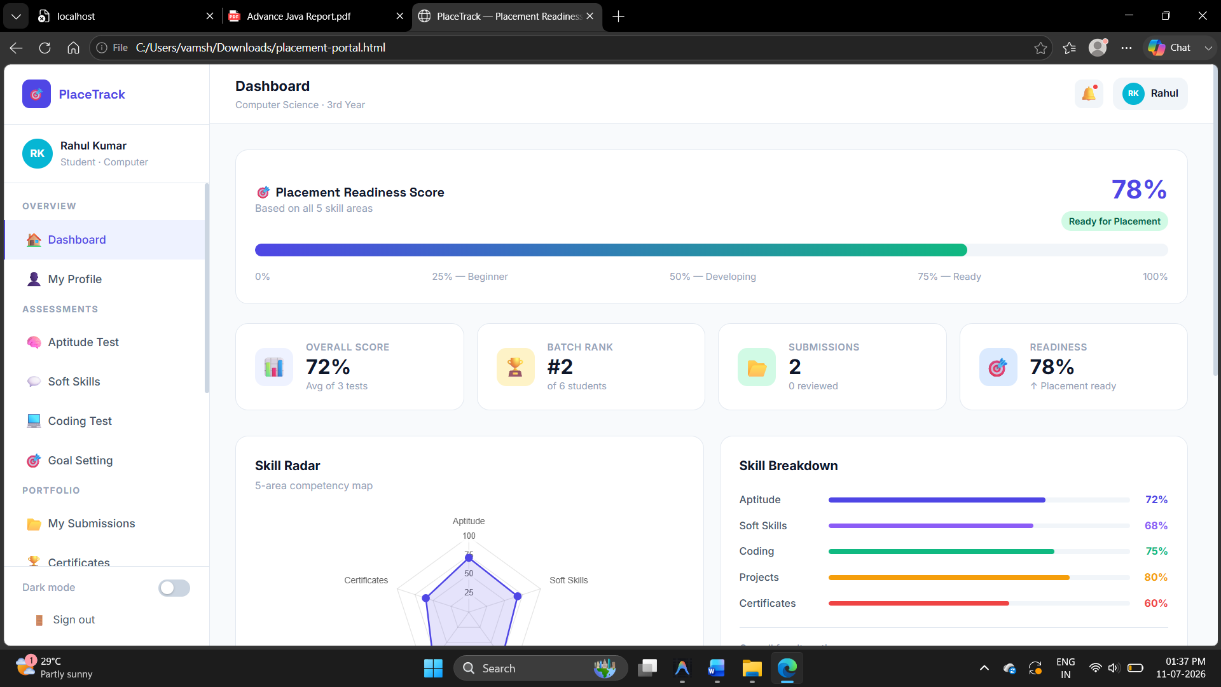
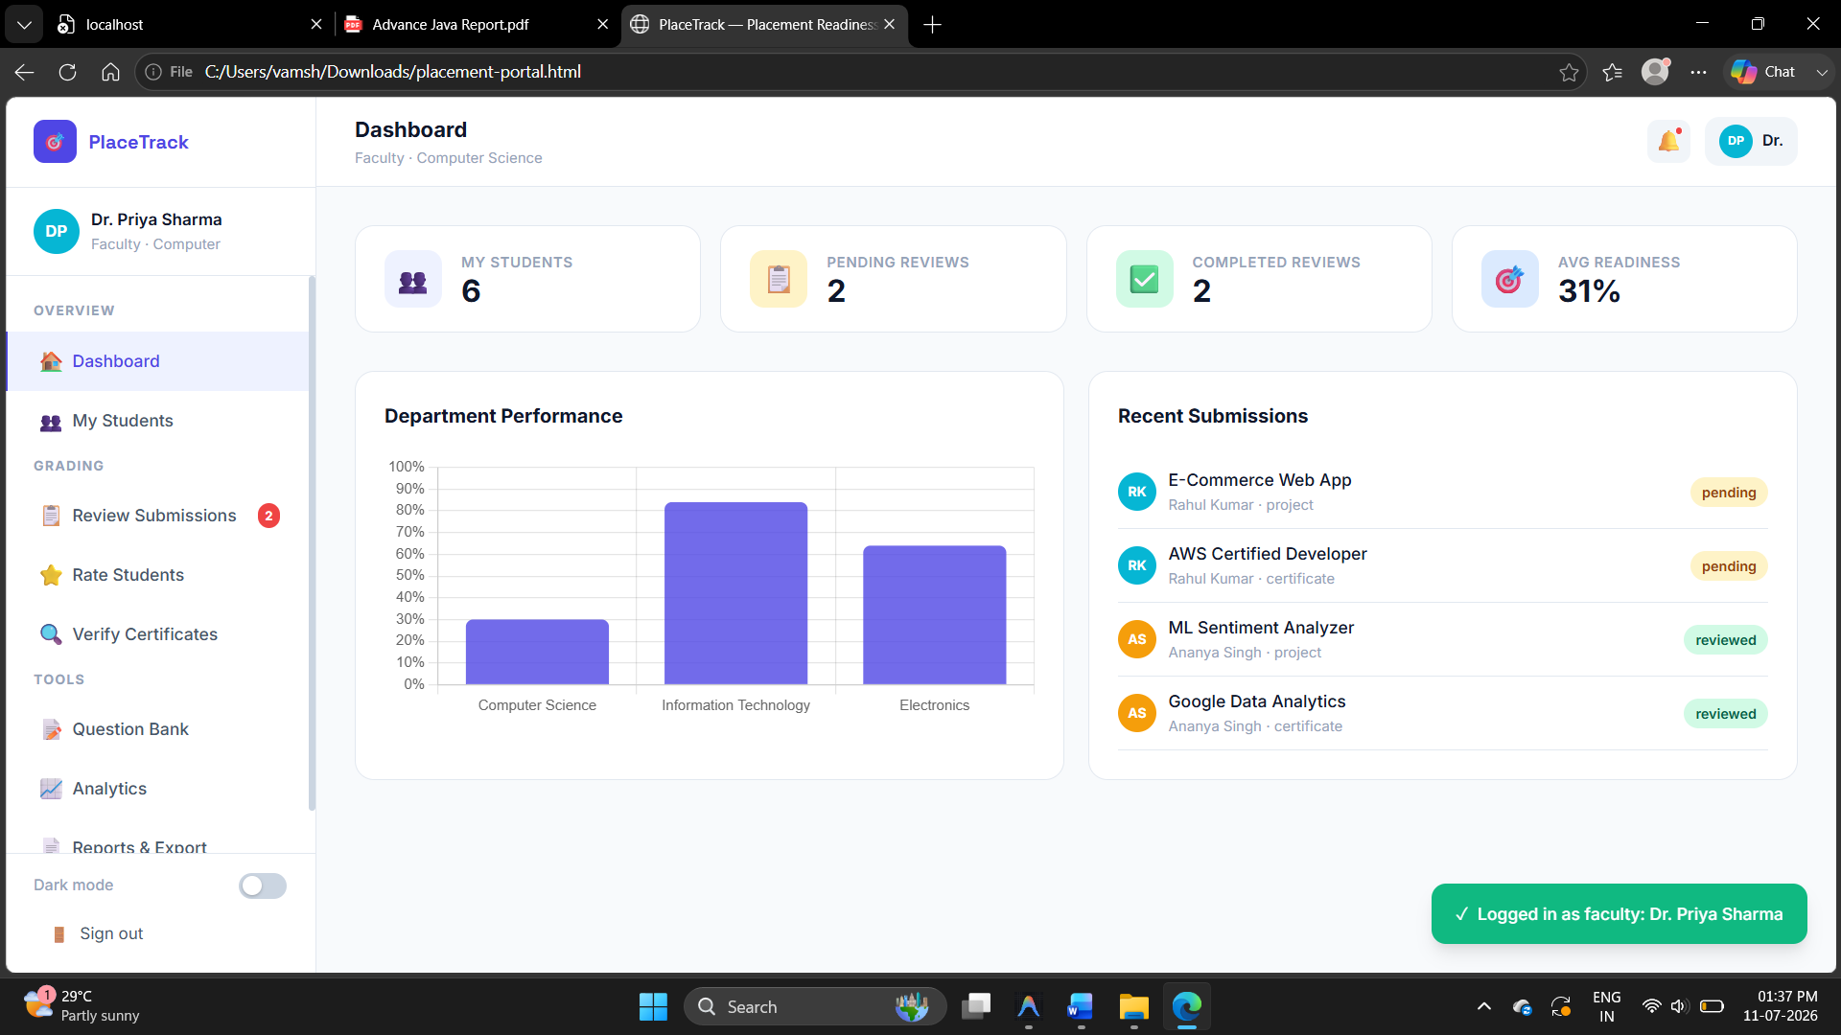
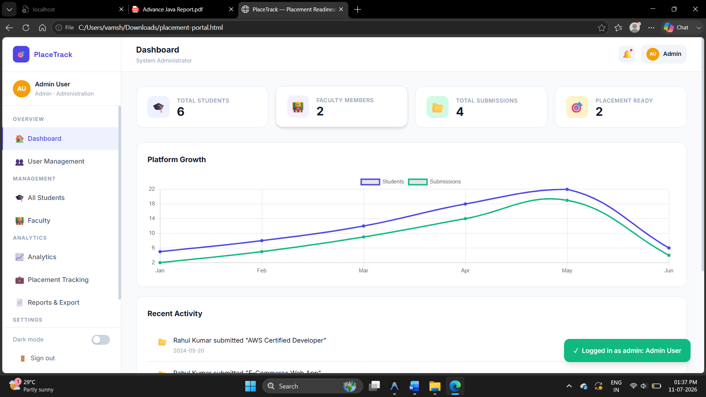

7. Conclusion

• Summary of work completed
The Placement Readiness Portal has been successfully designed, developed, and deployed. It represents a significant technological leap over traditional placement management systems. The Placement Readiness Portal has been successfully designed, developed, and deployed. It represents a significant technological leap over traditional placement management systems. The Placement Readiness Portal has been successfully designed, developed, and deployed. It represents a significant technological leap over traditional placement management systems. The Placement Readiness Portal has been successfully designed, developed, and deployed. It represents a significant technological leap over traditional placement management systems. By leveraging Advanced Java Programming (Spring Boot) and modern frontend technologies (React), the project achieves a highly scalable, secure, and user-centric platform.By leveraging Advanced Java Programming (Spring Boot) and modern frontend technologies (React), the project achieves a highly scalable, secure, and user-centric platform.

• Objectives achieved
All primary objectives were met. The system successfully centralizes data, automates resume parsing, provides intelligent readiness scoring, visualizes skill gaps, and facilitates seamless communication between all stakeholders.All primary objectives were met. The system successfully centralizes data, automates resume parsing, provides intelligent readiness scoring, visualizes skill gaps, and facilitates seamless communication between all stakeholders.All primary objectives were met. The system successfully centralizes data, automates resume parsing, provides intelligent readiness scoring, visualizes skill gaps, and facilitates seamless communication between all stakeholders.

• Benefits of the system
Institutions benefit from drastically reduced administrative overhead. Students benefit from actionable insights into their career readiness and a gamified learning experience. Companies benefit from pre-filtered, highly qualified candidate pipelines.Institutions benefit from drastically reduced administrative overhead. Students benefit from actionable insights into their career readiness and a gamified learning experience. Companies benefit from pre-filtered, highly qualified candidate pipelines.Institutions benefit from drastically reduced administrative overhead. Students benefit from actionable insights into their career readiness and a gamified learning experience. Companies benefit from pre-filtered, highly qualified candidate pipelines.

8. Future Enhancements

• Possible improvements
While the current system is highly capable, future iterations could include:
1. Integration with a Large Language Model (LLM) API (like Gemini or OpenAI) to provide automated, highly personalized resume reviews and mock interview feedback.
2. Mobile Application development using React Native to provide native push notifications for upcoming drives.
3. Advanced predictive analytics for the Admin dashboard to forecast placement percentages based on historical data.3. Advanced predictive analytics for the Admin dashboard to forecast placement percentages based on historical data.3. Advanced predictive analytics for the Admin dashboard to forecast placement percentages based on historical data.

9. References

• Books and Documentation
1. Spring Boot in Action by Craig Walls.
2. Pro Spring Security by Carlo Scarioni.
3. React: Up & Running by Stoyan Stefanov.
4. Official Spring Boot 3.3 Documentation (https://spring.io/projects/spring-boot).
5. Official React Documentation (https://react.dev).
6. Clerk Authentication Documentation (https://clerk.com/docs).6. Clerk Authentication Documentation (https://clerk.com/docs).6. Clerk Authentication Documentation (https://clerk.com/docs).

10. Appendices

• Appendix A: Key Source Code Snippets
The following snippets showcase the most critical business logic and configuration within the backend system.

• Snippet 1: ClerkJwtAuthenticationConverter.java (Security)
```java
@Component
public class ClerkJwtAuthenticationConverter implements Converter<Jwt, AbstractAuthenticationToken> {
@Value("${clerk.jwt.secret-key}")
private String secretKey;
private final UserRepository userRepo;
public ClerkJwtAuthenticationConverter(UserRepository userRepo) {
this.userRepo = userRepo;
}
@Override
public AbstractAuthenticationToken convert(Jwt source) {
DecodedJWT decoded = JWT.require(Algorithm.HMAC256(secretKey))
.build().verify(source.getTokenValue());
String email = decoded.getSubject();
String role = userRepo.findByEmail(email).map(u -> u.getRole().name())
.orElseGet(() -> decoded.getClaim("role").asString());
List<SimpleGrantedAuthority> authorities = Collections.singletonList(
new SimpleGrantedAuthority("ROLE_" + role.toUpperCase()));
return new JwtAuthenticationToken(source, authorities, email);
}
}
```

• Snippet 2: ReadinessScoreService.java (Algorithm)
```java
@Service
public class ReadinessScoreService {
// Computes company match % for a student based on skill weightage
public double computeCompanyMatch(Long studentId, Long companyId) {
List<CompanyRequirement> requirements = requirementRepo.findByCompanyId(companyId);
double totalWeight = 0, weightedScore = 0;
for (CompanyRequirement req : requirements) {
double studentRating = getCurrentSkillRating(studentId, req.getSkill().getId());
double ratio = Math.min(studentRating / req.getMinRating(), 1.0);
weightedScore += ratio * req.getWeightage();
totalWeight += req.getWeightage();
}
```

