SQL:
Employees earning more than their colleagues
Lets see employees table:
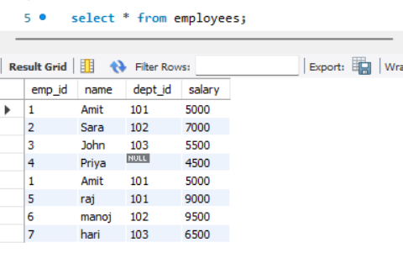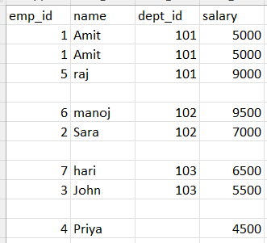
So we need to calculate the avg salary of each department and then use that in select query.
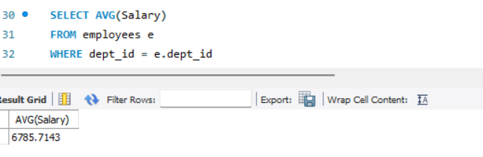
now the main query is
SELECT * FROM employees e
WHERE e.Salary > (SELECT AVG(Salary)
FROM employees WHERE dept_id = e.dept_id );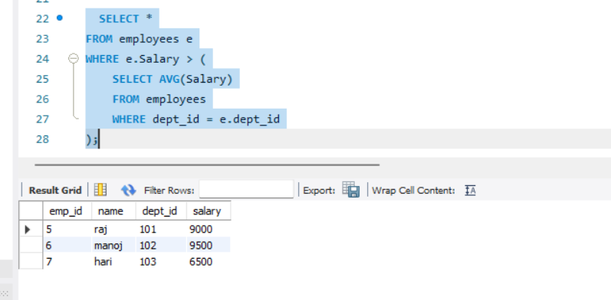
1.Inner Join:
We are selecting value column in both a and b tables and the from a table we are joining with b table. So if the row has matches in both tables it will keep the value if not it will discard the value.
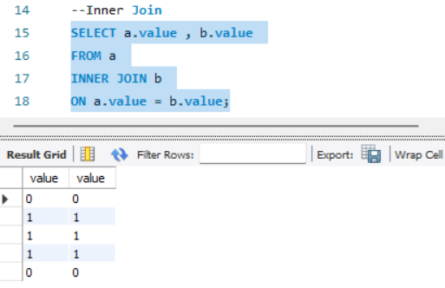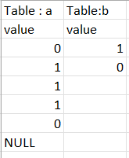
Here we have like 6 rows in a and 2 rows in b so we have 12 combinations
If we check the condition on a.value = b.value
0 = 1 false discard the value
0 = 0 true so it will keep
1 = 1 true
1= 0 false discard the value
…..
…..
Null = 1 false
Null = 0 false
So in a table we have 2 ‘0’s and 3 ‘1’s and in b we 1 ‘1’ and 1 ‘0’.
So total we have 3(1) * 1(1) and 2(0) * 1(0) = 2 ‘0’s and 3 ‘1’s total 5 rows.

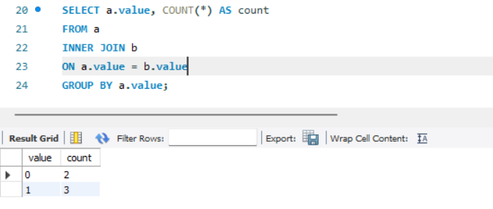
FROM → JOIN → ON → GROUP BY → SELECT
1.From table ‘a’ we have 6 rows and
2.then we are combining table ‘a’ and ‘b’ using inner join so the combinations would be 6 * 2 12 rows.
3.Then it will check the condition(on a.value =b.value) If the value matches it keep and if no matches it will discard. So here we have 3(1) * 1(1) and 2(0) * 1(0) = 2 ‘0’s and 3 ‘1’s total 5 rows.
4. SQL groups rows based on a.value
5. Counts number of rows in each group and give the result
2.Left Join:
We are selecting value column in both a and b tables and the from a table we are joining with b table. So if the row has matches in both tables it will keep the value if not it will add the value null value in b table and keep the value.

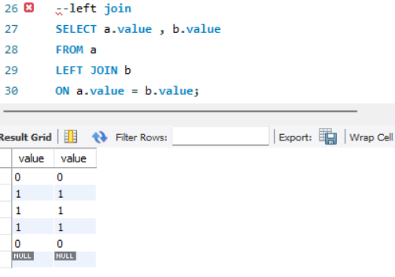
Here we have like 6 rows in a and 2 rows in b so we have 12 combinations
If we check the condition on a.value = b.value
0 = 1 false discard the value
0 = 0 true so it will keep
1 = 1 true
1= 0 false discard the value
…..
…..
Null = 1 false
Null = 0 false here if no match found we will fill with NULL value in B table.
So in a table we have 2 ‘0’s and 3 ‘1’s and in b we 1 ‘1’ and 1 ‘0’.
So total we have 3(1) * 1(1) and 2(0) * 1(0) = 2 ‘0’s and 3 ‘1’s total 5 rows.
So here we have 1 NULL row, so total count it 6.
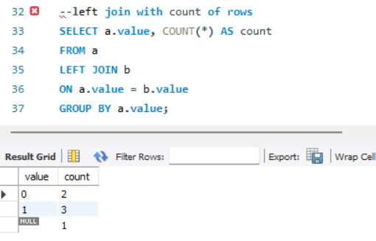
FROM → JOIN → ON → GROUP BY → SELECT
1.From table ‘a’ we have 6 rows and
2.then we are combining table ‘a’ and ‘b’ using left join so the combinations would be 6 * 2 12 rows.
3.Then it will check the condition(on a.value =b.value) If the value matches it keep and if no matches it will fill with NULL. So here we have 3(1) * 1(1) and 2(0) * 1(0) = 2 ‘0’s and 3 ‘1’s total 5 rows and 1 row with NULLvalue so total we have 6 rows.
4. SQL groups rows based on a.value
5. Counts number of rows in each group and give the result
3.Right Join
For each row in B, it searches for matching rows in A using the condition a.value=b.value
If matches are found it will keep, If no match is found the row from B is still included.
Columns from A are filled with NULL.
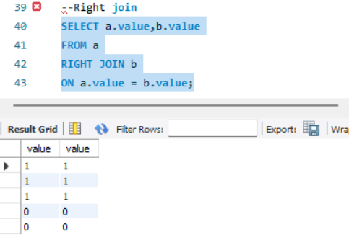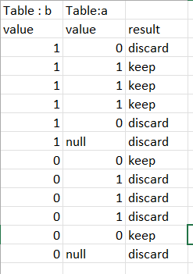
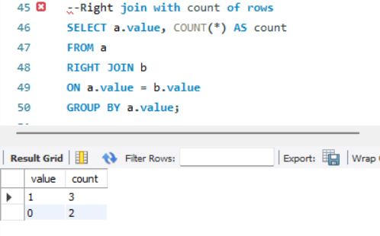
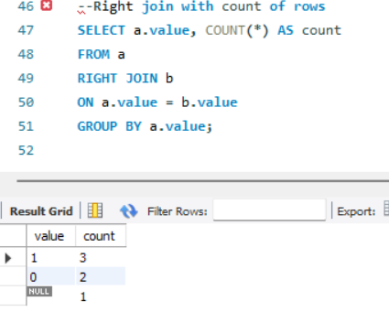
NOTE:If b column has null value then RIGHT JOIN keeps all B rows, so A columns filled with NULL
4.FULL OUTER JOIN
It will give all matching rows in both a & b and unmatched rows in a (i.e NULL)& for b we don’t have any unmatched value because b values(1,0) matched with table ‘a’ values. So the total rows will be 6
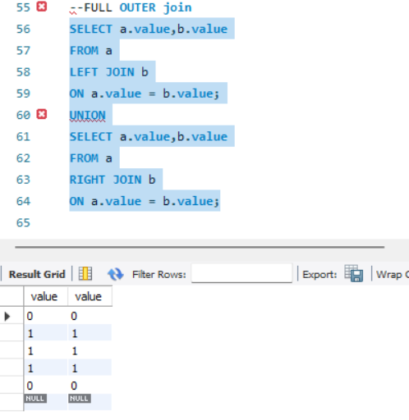
SQL Queries:
- Select only the Names of all the Bands
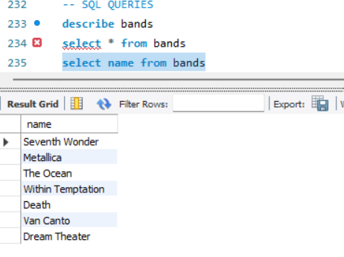

- Select the Oldest Album
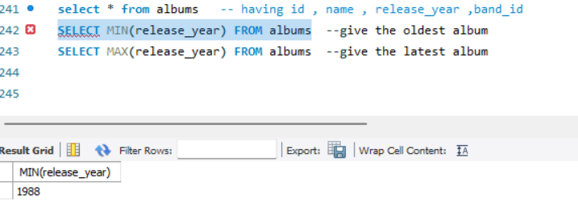
- Get all Bands that have Albums
Here the tables shows id 1 has 3 id 2 has 3 …id 6 has 3. So we can use inner join to write the query.
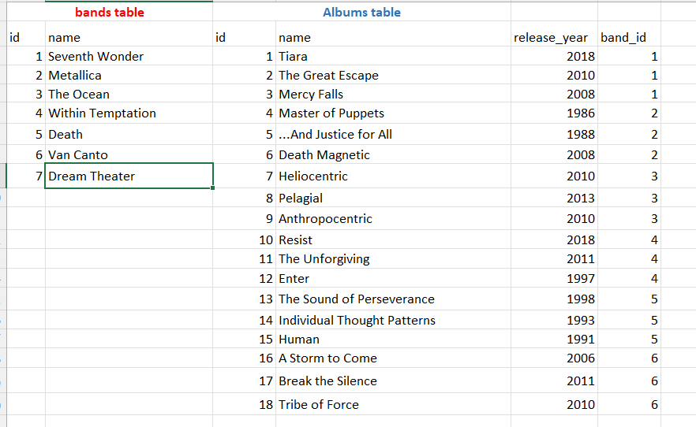
- Get all Bands that have No Albums
List the bands and albums table. If you check here Dream theater id 7 doesn’t have any albums.

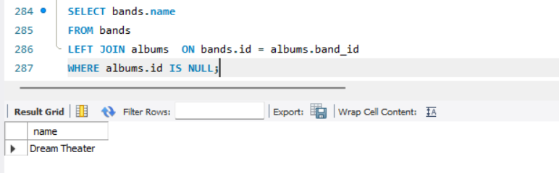
- Get the Longest Album NA
- Update the Release Year of the Album with no Release Year
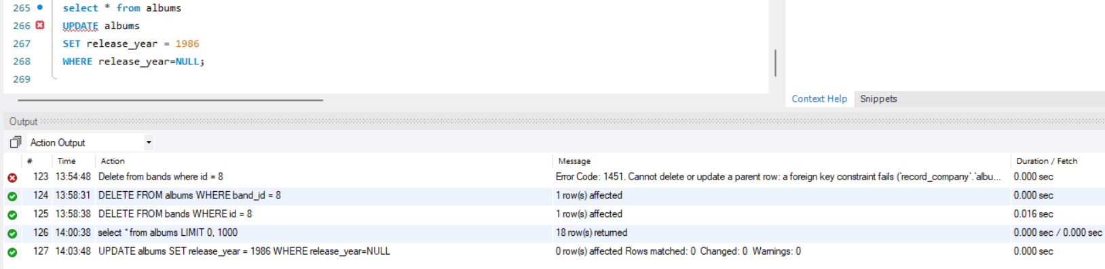
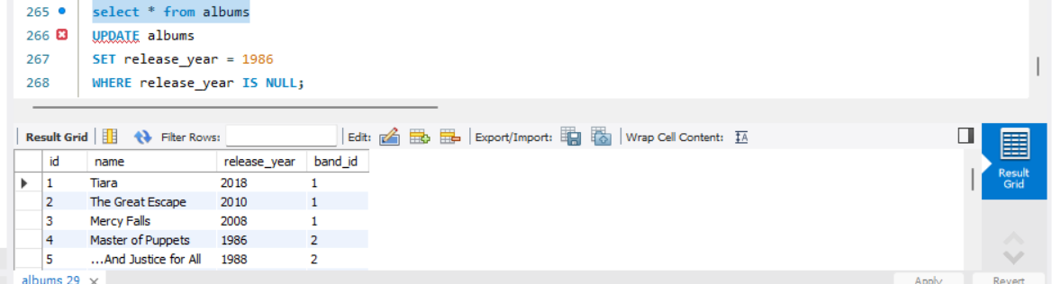
- Insert a record for your favorite Band and one of their Albums

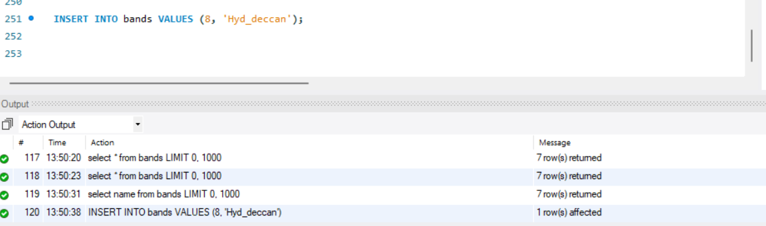
Now we are adding this band id to albums


- Delete the Band and Album you added
1st we need to delete the albums associated to that bandid
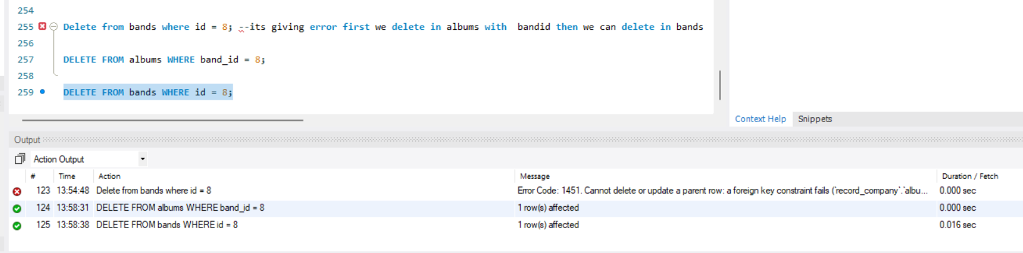
- Get the Average Length of all Songs
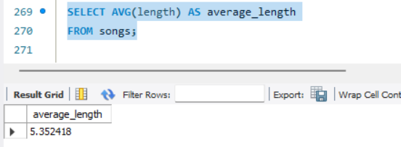
- Select the longest Song off each Album SolutionNA
- Get the number of Songs for each BandNA

