Program 1 :
class Employee {
int id = 101;
String name = "Rahul";

void accept() {
System.out.println("Employee details accepted");
}

void display() {
System.out.println("Employee ID: " + id);
System.out.println("Employee Name: " + name);
}
}

class Manager extends Employee {
String department = "CSE";
int teamSize = 10;

void accept() {
super.accept();
System.out.println("Manager details accepted");
}

void display() {
super.display();
System.out.println("Department: " + department);
System.out.println("Team Size: " + teamSize);
}
}

public class Main {
public static void main(String[] args) {
Manager m = new Manager();

m.accept();
m.display();
}
}

Output :
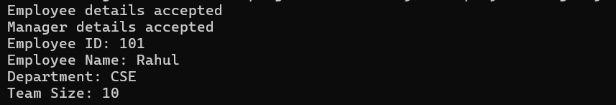

Program 2 :
class Employee {
final String company = "ABC Company";

final void policy() {
System.out.println("Follow company rules");
}

void display() {
System.out.println("Company Name: " + company);
policy();
}
}

public class Main {
public static void main(String[] args) {
Employee e = new Employee();
e.display();
}
}
Output :
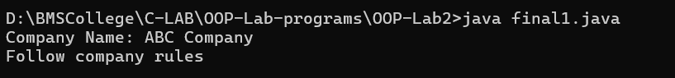

Program 3 :
class Book {
int bookId;
String title;
String author;
double price;

static int count = 0;

Book(int id, String t, String a, double p) {
bookId = id;
title = t;
author = a;
price = p;
count++;
}

void display() {
System.out.println("Book ID: " + bookId);
System.out.println("Title: " + title);
System.out.println("Author: " + author);
System.out.println("Price: " + price);
}

void search(int id) {
if (bookId == id)
display();
}

void search(String t) {
if (title.equalsIgnoreCase(t))
display();
}

Book compare(Book b) {
if (price > b.price)
return this;
else
return b;
}
}

public class library {
public static void main(String[] args) {
Book b1 = new Book(101, "Java", "James", 450);
Book b2 = new Book(102, "Python", "Guido", 600);
Book b3 = new Book(103, "C Programming", "Dennis", 300);

System.out.println("All Books:");
b1.display();
b2.display();
b3.display();

System.out.println("\nSearch by Book ID:");
b1.search(101);

System.out.println("\nSearch by Title:");
b2.search("Python");

System.out.println("\nCostlier Book:");
Book costly = b1.compare(b2);
costly.display();

System.out.println("\nTotal Books Created: " + Book.count);
}
}
