AC0000183249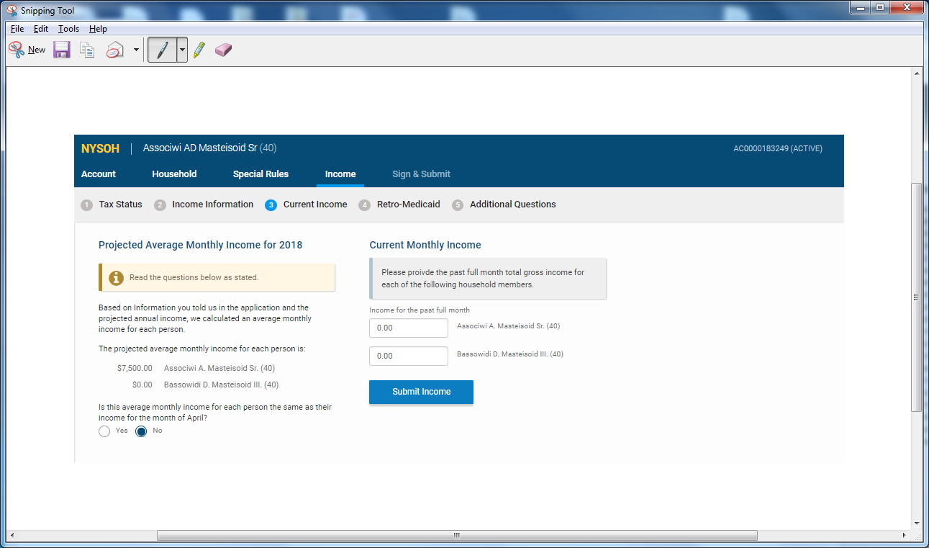

WHEN USER SELECTS ‘SUBMIT INCOME’ THE ‘INCOME USED FOR MEDICAID QUALIFICATION’ IS DISPLAYED. NO ERROR MESSAGE IS DISPLAYED WHEN ‘INCOME FOR THE PAST FULL MONTH’ IS ZERO AND SKIPPED. 