**Process analytics of human-AI collaboration**

**Project Description:**

This project will apply various process mining techniques on an anonymized dataset of human-AI collaboration, to reveal and compare interaction patterns. The reason for taking up this project is due to the lack of empirical research on human-AI interaction in an educational setting which can help provide actionable decisions that an organization building AI tools for the educational setting can take.

**Introduction:**

Our Project is an exploratory research project that aims to reveal and compare interaction patterns in human-AI collaboration using advanced process mining techniques. By transforming complex interaction data into easy-to-read graphs and visualizations, we seek to enhance understanding of collaboration dynamics while ensuring user anonymity. This analysis will not only facilitate insights into optimizing workflows and improving decision-making processes but also contribute to the development of effective AI systems for organizations to maximize benefits.

**Literature Review:**

The Project focuses on applying process mining techniques to analyze human-AI collaboration, addressing the complexities and inefficiencies that often arise in these interactions. As noted by Sun et al. (2023), while AI integration has transformed workflows, many organizations struggle to leverage these technologies due to a lack of understanding of interaction dynamics. Current methods often rely on surface-level metrics, obscuring deeper insights into user behavior and decision-making. Jiang et al. (2024) emphasize the need for a user-centered perspective to improve collaboration outcomes. By uncovering hidden interaction patterns, this project aims to provide a comprehensive view of collaboration dynamics, facilitating internal learning and optimizing workflows. Additionally, as Kaufmann et al. (2023) highlight, understanding task-specific algorithm advice acceptance can inform AI design, ensuring systems align with user expectations. Ultimately, this project is critical for organizations seeking to maximize the benefits of AI integrations in their operations.

**Objective:**

We want to study the human-AI interactions and find interesting insights. Due to the lack of empirical research in this field of human-AI interactions we are hoping this project can provide that empirical research. This project focuses on educational setting of students using AI’s assistance while writing essays with the hope of providing some insights that can be considered while decision making by an organization that’s developing AI tools for education.

**Methodology:**

This empirical research was conducted using an anonymized dataset comprising trace data from 47 students' essays written with the assistance of AI. We aimed to identify the types of AI assistance utilized by students during their essay writing process. This identification was achieved by analyzing the prompts submitted by students to ChatGPT (AI). The dataset originates from a foreign educational institution that employs ChatGPT with specific restrictions, such as not providing complete essays when requested.

**FINDINGS**

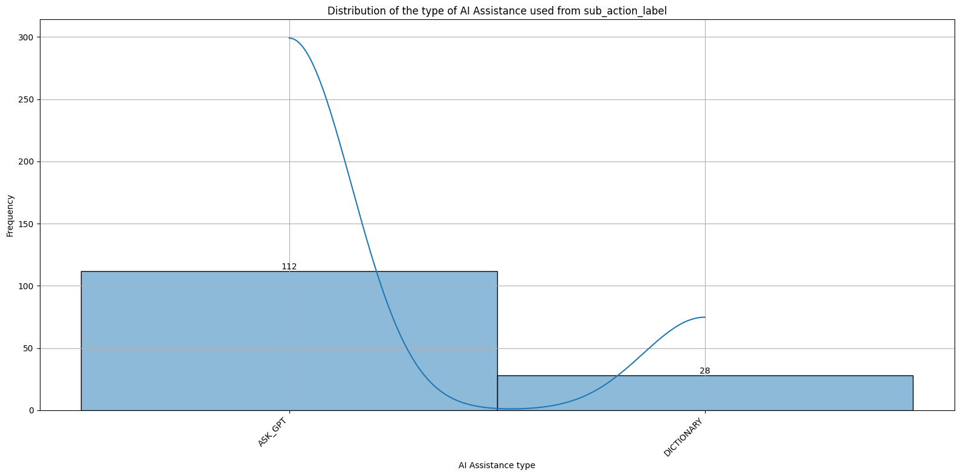

From the above bar plot, you can see that we have found two main types of AI Assistances – Ask_GPT and DICTONARY along with the number times that type was used. You can see that 80% of the time AI assistance was used was the Ask_GPT and only 20% of the time Dictionary was used. Ask_GPT was found to be like a regular ChatGPT where a question was asked and ChatGPT will answer it appropriately. The dictionary, however was when the AI performed like a Dictionary in the sense it gave other words for the student’s given words as opposed to coherent sentences.

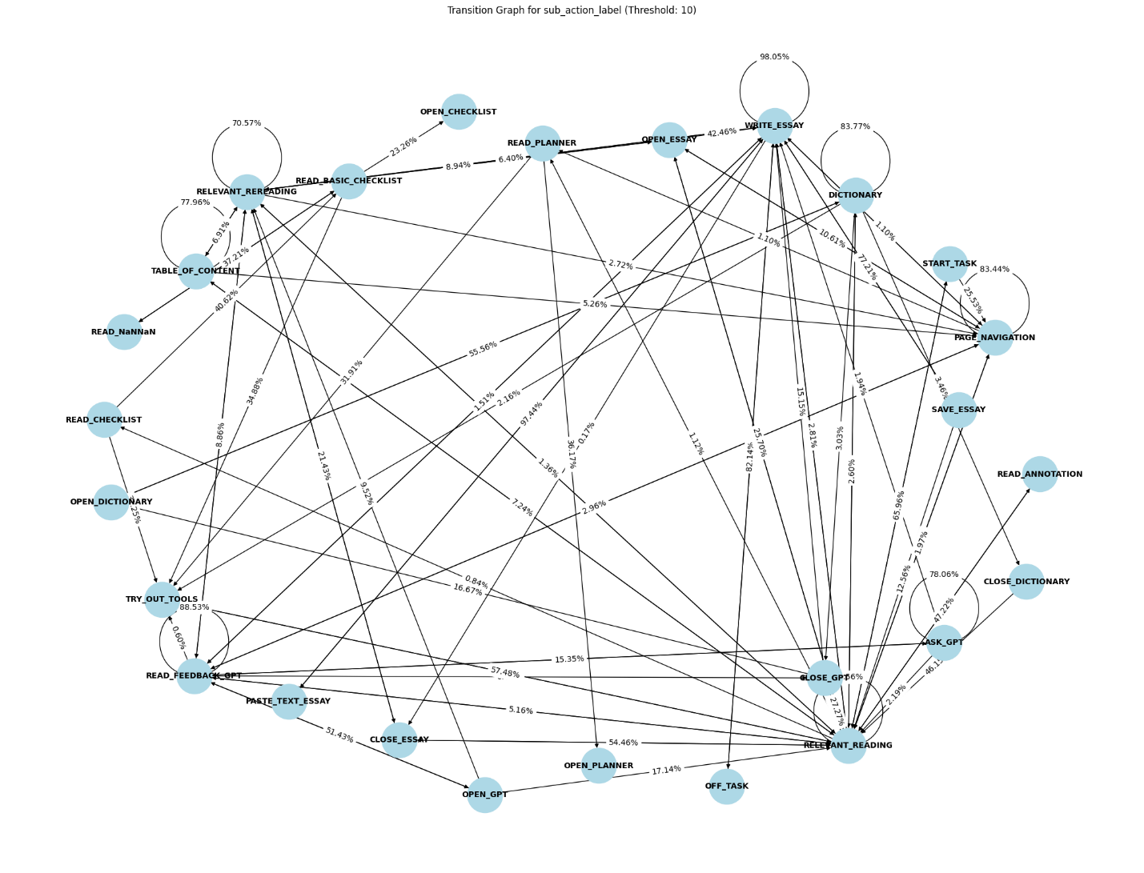

The actions most frequently performed by students included ‘RELEVANT READING,’ ‘WRITE_ESSAY,’ and ‘READ_FEEDBACK_GPT,’ which aligns with the nature of the essay writing trace dataset. The transition graph illustrates the step-by-step actions taken by students while composing their essays using AI tools, revealing a common process. For instance, one significant sequence of actions is as follows:

START_TASK → RELEVANT READING → OPEN_ESSAY → RELEVANT READING → OPEN_GPT → READ_FEEDBACK_GPT → WRITE_ESSAY → SAVE_ESSAY.

While directed network graphs can sometimes be challenging to interpret, the transition matrix provides the same information in a more accessible tabular format, with the X-axis representing 'To' and the Y-axis representing 'From.'

In addition to the primary findings, several intriguing observations emerged from the dataset. Notably, out of 47 students, only one expressed gratitude to ChatGPT after receiving a response to their prompt. This highlights an interesting aspect of user interaction with AI, suggesting that expressions of gratitude may not be a common practice among students. Furthermore, even amidst the serious task of essay writing, students found moments of levity, as evidenced by one student humorously asking ChatGPT, "Am I handsome?" This lighthearted inquiry reflects the unique relationship students have with AI, blending academic pursuits with a touch of personal engagement.

**DISCUSSION**

In this section, we explore the various types of individual AI assistance in detail. One prominent type is the DICTIONARY function, primarily utilized by foreign students seeking English translations of words from their native languages. This feature not only aids in finding direct translations but also assists students in discovering synonyms for their English vocabulary. For instance, within our dataset, examples include the words "screaming" and "fear," where students sought alternative expressions. Additionally, this function enables users to explore different English phrases, such as "rising action" and "Monday morning," thereby broadening their linguistic repertoire.

Another significant tool is Ask_GPT, where ChatGPT serves as a translation resource for foreign students, allowing them to translate entire sentences rather than just single words. Beyond translation, this tool is also employed for inspiration and brainstorming; for example, one entry in our dataset illustrates a student asking, "How can I write a good title?" Furthermore, ChatGPT is used to gain insights into specific situations, which can enhance essay writing. An instance from our dataset shows a student inquiring, "Why no internet?" This question prompted ChatGPT to provide reasons for the lack of internet, which the student could then incorporate into an essay discussing the implications of internet outages on a school day. Lastly, ChatGPT serves as a valuable resource for grammar-related inquiries, whether for grammar checking, understanding syntax, or learning proper usage. Examples from our dataset include questions like, "How to use past tense?" and "One day I didn’t use the internet—grammar."

**Results**

The findings indicate that ChatGPT is highly beneficial in an educational setting, particularly when certain restrictions are in place, such as not providing complete essays upon request but rather serving as an assistant. This project offers valuable insights for organizations developing AI tools for educational purposes, highlighting areas of focus that include, but are not limited to, grammar checking, brainstorming tools, and dictionaries for finding synonyms or alternative phrases. These applications of AI in educational settings have the potential to significantly enhance students' academic performance.

In conclusion, this project underscores the transformative potential of AI in education, suggesting that with thoughtful implementation, AI can greatly improve the learning experience for students.