**PowerBI - RetailAB Project**

**Meaningful**

**Reports**

**In Minutes**



**Transform Your**

**Data into…**

Prepared By : Venkateshwarlu Kummari

1.Source Data (Source Data for Project. SQL Server)

The Source has Nine Tables

Returns

Sales

Date Table

Segment

Regions

Ship Mode

Products

Customers

Address

Prepared By : Venkateshwarlu Kummari

Task-1

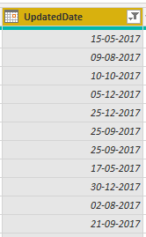

* Connect to the Data Source(SQL SERVER) Bring The Data/Tables From the Database.
* Go to Sales Table Change the Updated Date Column Data-Type to Date Data-Type.
* Create a Parameters Called StartDate.
* Assign This Parameters to Update date Column.
* As Shown in the Below Figures.

Prepared By : Venkateshwarlu Kummari

Task-1 (Continuation)

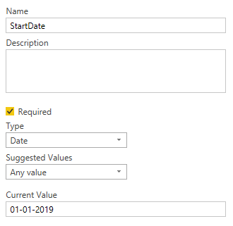 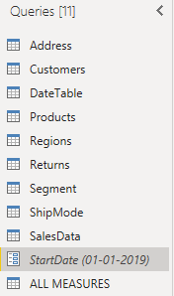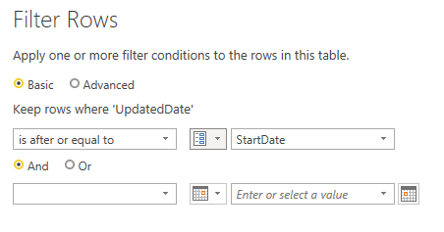

Prepared By : Venkateshwarlu Kummari

Task-2

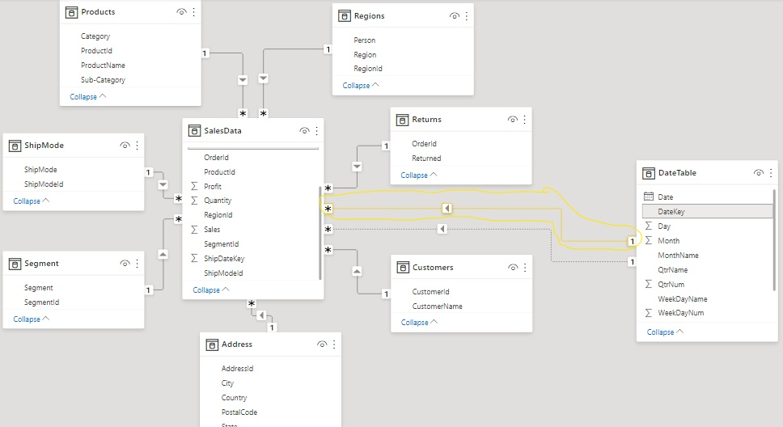

* Load all the Nine Tables Into Power Pivot.
* Ensure that all the tables are properly related to each other through common columns.
* Create the Relationship Between Data Table and Sales Table Using Common Column (Date Key Column) in Date Table, (OrderDatekey & ShipDateKey) in Sales Table.
* Active Relationship Should Be (OrderDateKey & DateKey) as shown in the figure.
* Give The Relationship Between Returns Table and sales Table.
* Finally Prepare the Model as Shown in the Figure
* In Sales Table we have Only the Data from 01/01/2019.

Prepared By : Venkateshwarlu Kummari

Task-3

* Create Three Hierarchies.

1) Create a Hierarchy to show Year, Quarter, Month, WeekName, Weekday Wise Data in a Single Visual.

2) Create a Hierarchy to Show Category, Sub-Category, Product Wise Data in a Single Visual.

3) Create a Hierarchy to show Country, State, City Wise data in a single Visual.

* Stop the Default Date Hierarchies.
* Short The Month Name Column Based on the Month Number

Column.

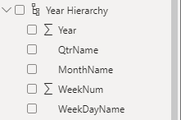 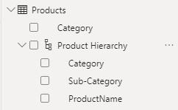

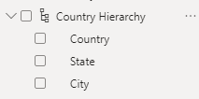

Prepared By : Venkateshwarlu Kummari

Task-4

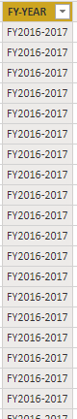 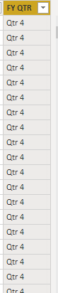

* In Date Table Derive the FY-Year Column (Month Need to Start With “April” and ends with “March”) Using DAX Functions.
* In the same Way Derive The FY-Qtr Column (Qtr1=April-June, Qtr2=July-sept, Qtr3=Oct-Dec, Qtr4 Jan-March) Using DAX Functions.
* You Need to short the Month Name Column by MonthNum Column
* You Need Declare This as date Table
* Finally Relate this DATE Table with Transactions Table.

Prepared By : Venkateshwarlu Kummari

Task-5

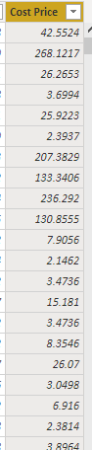

* Derive the Cost Price Column Using Sales, Quantity, Profits Columns as shown in the Figure

Prepared By : Venkateshwarlu Kummari

Task-6

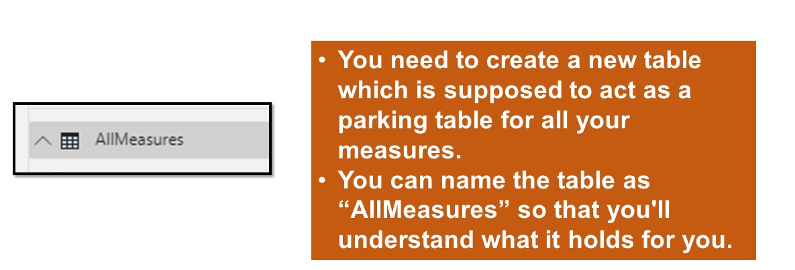

Prepared By : Venkateshwarlu Kummari

Task-7

* Create The Measures Using Existing Fact Columns In The Sales Table
* Ex:- Sum Of Sales, Total Quantity, Total Discount, Total Profits.

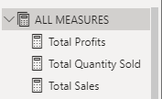

Prepared By : Venkateshwarlu Kummari

Task-8

* Create a Workspace in Power BI Service Called RetailAB.
* Publish This Dataset to the RetailAB Workspace.
* Now Download the DATA GATEWAY and Install it in The Server Machine from Where You are Getting the Data.
* Add the Data Source Connections to the Gateway
* Configure This connection to the RetailAB Dataset.
* Now go to Dataset--> Click on 3 Dots --> Settings --> go to Parameters Here Change the Startdate Parameter to Startdate=1/1/2017
* Now Click on Refresh to Get the Entire Data to the Workspace.

Stop the Default Date Hierarchy

Prepared By : Venkateshwarlu Kummari

Task-9

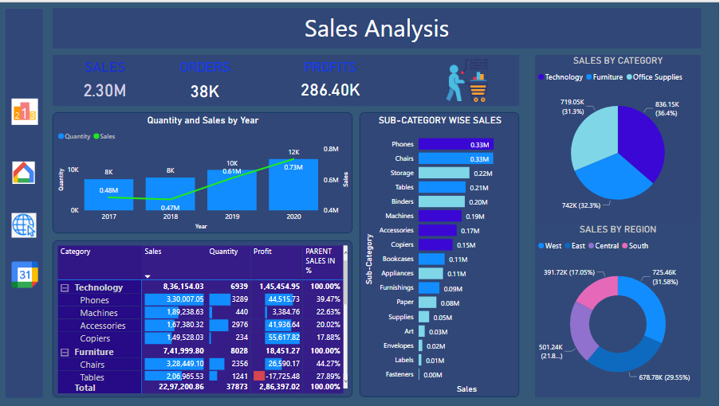

* You Need to Create a Page as per sample. Colors, Fonts, Position Of the Visuals are as for Your Choice.
* Visual You Need to Present: 3 Cards, One Combo Chart (Line and Clustered Column Chart)
* One Stacked Bar Chart to Show Sub-Category wise sales
* One Pie-Chart to Show Category Wise Sales
* One Donut-Chart to Show Region Wise Sales.
* Create a Matrix Visual as shown in the Image Use ALLEXCEPT Dax Function to Get the Parent sales in Percentages.
* Create Drill Through on a Region Column to Regio Wise Analysis Page.

Prepared By : Venkateshwarlu Kummari

Task-10

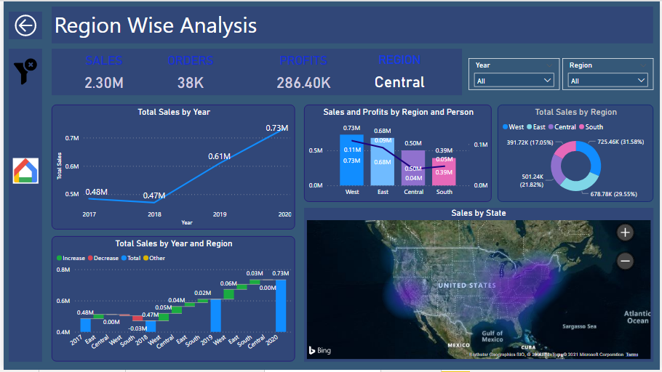

* Create a Report Page called **Region Wise Analysis**.
* Visuals Need to keep in This Report Page are:
* Four Card Visuals (sales, Orders, Profits, Regions).
* Two Slicers (Year and Region).
* One Line Chart to show Year Wise sales.
* One Combo Chart to Show sales and Profits by Region and Person
* One Donut Chart to Show Region Wise Sales.
* Create a Waterfall Chart to Show Year and Region Wise Sum of Sales.
* Create Map Visual to show State Wise sales. (Map Should be Heat map)
* Create Drill Through on Region Column.
* Create a Bookmark to Clear all the Filters at a Time.
* Create a Page Navigation to Go to Main Page by Clicking on the Home Image.

Prepared By : Venkateshwarlu Kummari

* Create a Report Page called **Calendar Date Wise sales.**
* One Slicer to show the Years
* One Line Chart to Show Month Wise Sales.
* Another One More Line Chart to Show FY-Year Wise Sales.
* One Stacked Column Chart to show QTR Wise sales.
* One Table Visual to Show Year wise Order Date and Ship date sales.
* Show the same Data in Stacked Column Chart.
* Create a Bookmark to Clear all the Filters at a Time.
* Create a Page Navigation to Go to Main Page by Clicking on the Home Image

Task-11

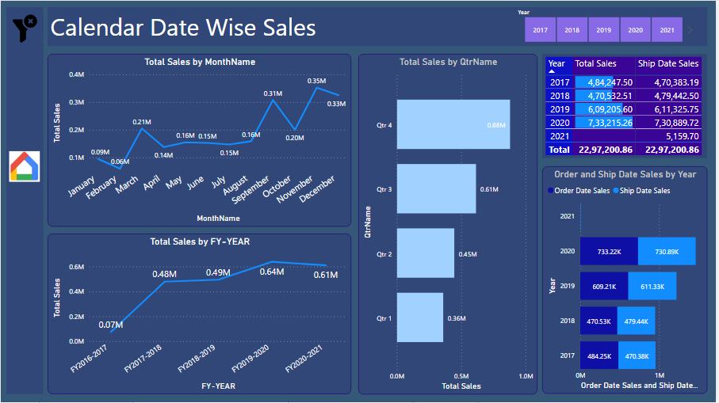

Facilitator: SUNIL KUMAR | Microsoft Certified Data Analysts | Power BI |Microsoft Certified DA100

Prepared By : Venkateshwarlu Kummari

Task-12

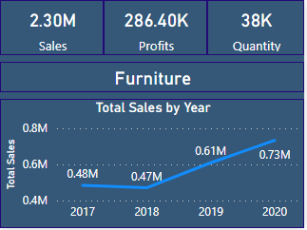

* Create a Custom ToolTip and Show it on the Visual Category Wise Sales.
* As Shown in the Visualization.
* Assign this Tooltip to the Pie Chart visual in the Main page.
* Create the Page Navigations to all the Four Pages.

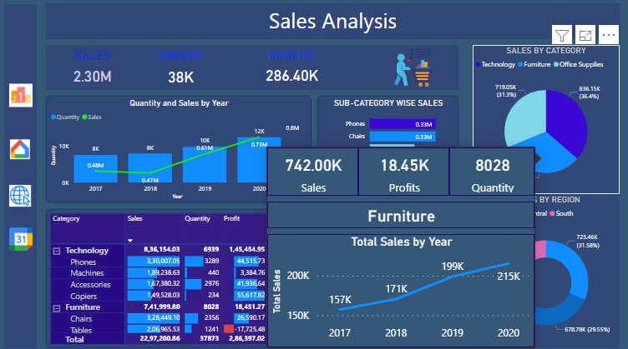

Prepared By : Venkateshwarlu Kummari

Conclusion

* Treated The Above Three Pages as One Report and Name This Report as Retail AB Report 1.
* Make Sure That all The Requirements Should be Correct.
* After Developing all the Pages Publish This Report to Retail AB Workspace.

Prepared By : Venkateshwarlu Kummari

RetailAB Report 2

Task-1

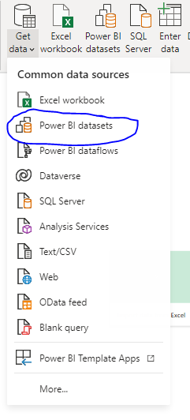

Prepared By : Venkateshwarlu Kummari

* Open New Power BI File Click on Get data and Connect to the RetailAB Dataset Which is already there in the Power BI Service.
* After Connecting to the Dataset Create the Report according to the Requirements

Task-2

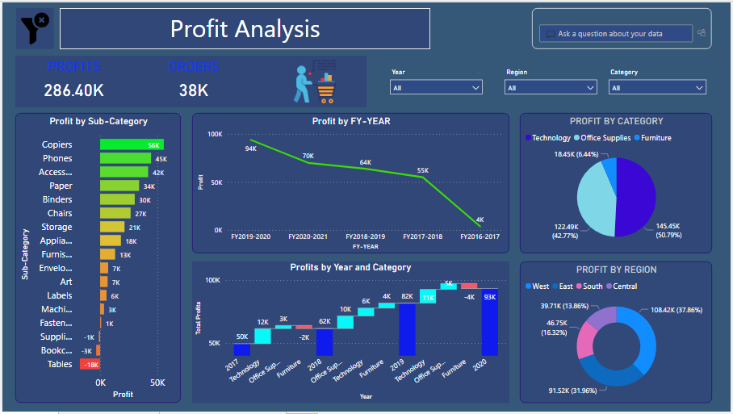

Prepared By : Venkateshwarlu Kummari

Task-2 (Requirements)

* Create a Report Page called **Profit Analysis.**
* Two Card Visuals to Show Profits and Orders.
* Three Slicers Visuals for Year, Region, Category.
* One Stacked Column Chart to Show Sub-Category Wise Profits.
* Line Chart to Show FY-Year Wise Profits.
* One Waterfall Chart to Show Year Wise Category Wise Profits.
* One Pie-Chart to show Category Wise Sales.
* One Donut Chart to show Region Wise Sales.
* Place One Q&A Visual in This Report Page.
* Create a Bookmark to Clear all Slicer Filters
* Assign this Bookmark to the Clear filter Image Which is their on the Top.

Prepared By : Venkateshwarlu Kummari

Task-3

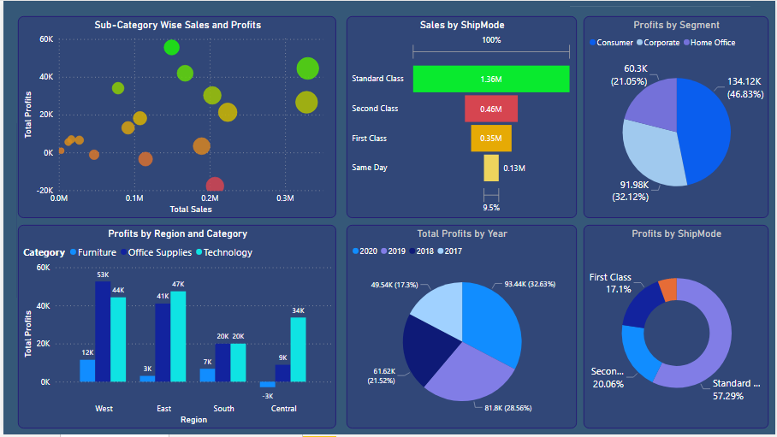

Prepared By : Venkateshwarlu Kummari

Task-3 (Requirements)

* Create a Visual to Show Sub-Category Wise Sales and Profits. (To Identify Which Sub-category Is Getting More Sales and More Profits)
* The Purpose Of This Visual is to Compare two Fact Values Based On The Single Dimensional Column.
* One Funnel Chart to Identify Which Mode of Shipments Is Preferred by the Customers.
* Create a Clustered Chart to show Region and Category wise Profits.
* Create a Visual to Show to Show Segment Wise Profits.
* Create a Visual to show Year Wise Profit.
* Create a Visual to show Ship Mode wise Profits in Percentages.

Prepared By : Venkateshwarlu Kummari

Task-4

SS

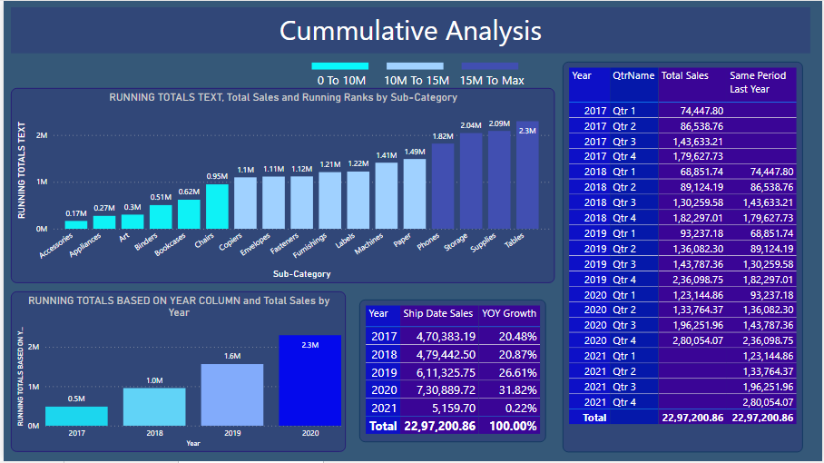

Prepared By : Venkateshwarlu Kummari

Task-4 (Requirements)

* Create a visual to Show Running Totals (or) Cumulative Totals

Base on the Sub-Category Column. i.e Text Column and also Give Ranking Based on the Running Totals.

* Create a visual to Show Running Totals (or) Cumulative Totals

Based on the Date Column. i.e Year Column.

* Create a table visual to Show Ship Date wise Sales and their Growth in Percentages.
* Create a Table Visual to Show Qtr Wise Cumulative Totals Use Total QTD Dax Function.

Prepared By : Venkateshwarlu Kummari

Task-5

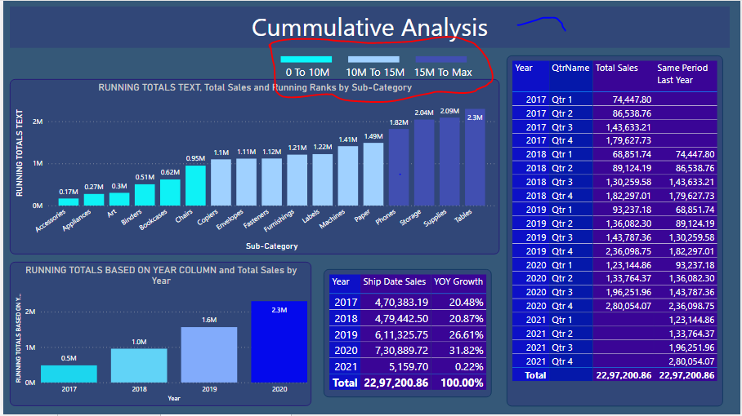

* Create a Custom Legend to Show the Conditional Color Formatting of the Visual.

Prepared By : Venkateshwarlu Kummari