Cricket Score Dashboard - UX Design Specification
Portfolio-grade UX document for a React application demonstrating Hooks, Routing, Context API, Lazy Loading, Custom Hooks, and API integration.

Home Dashboard
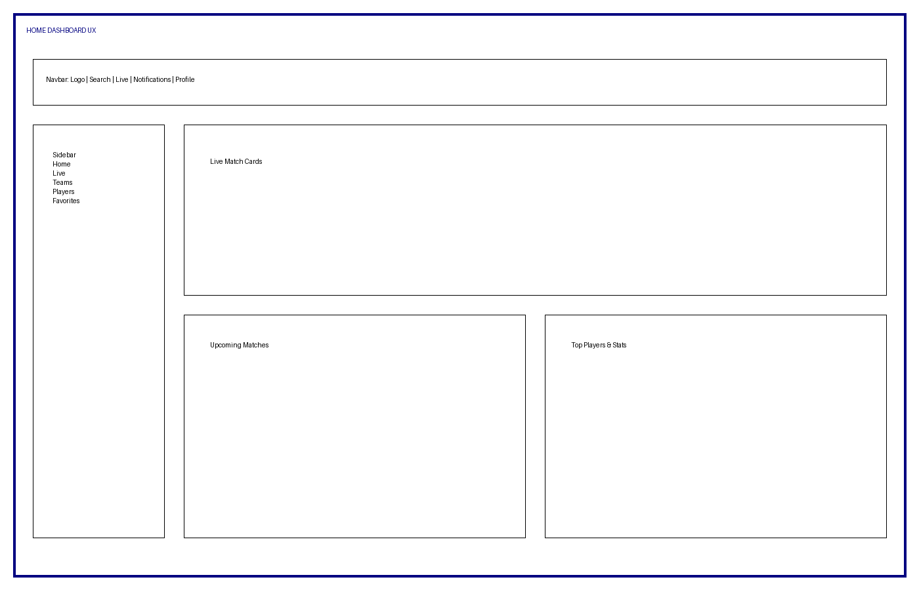

Live Match Details
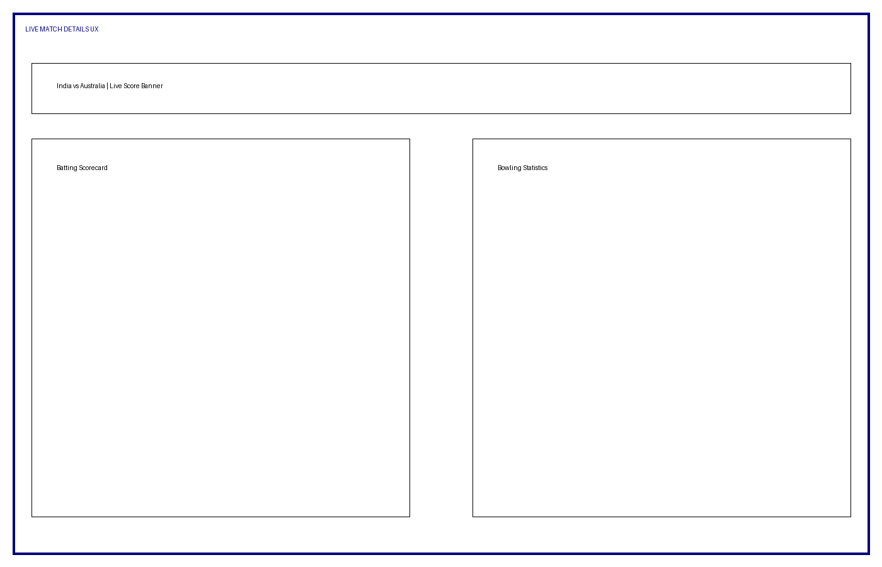

Player Profile
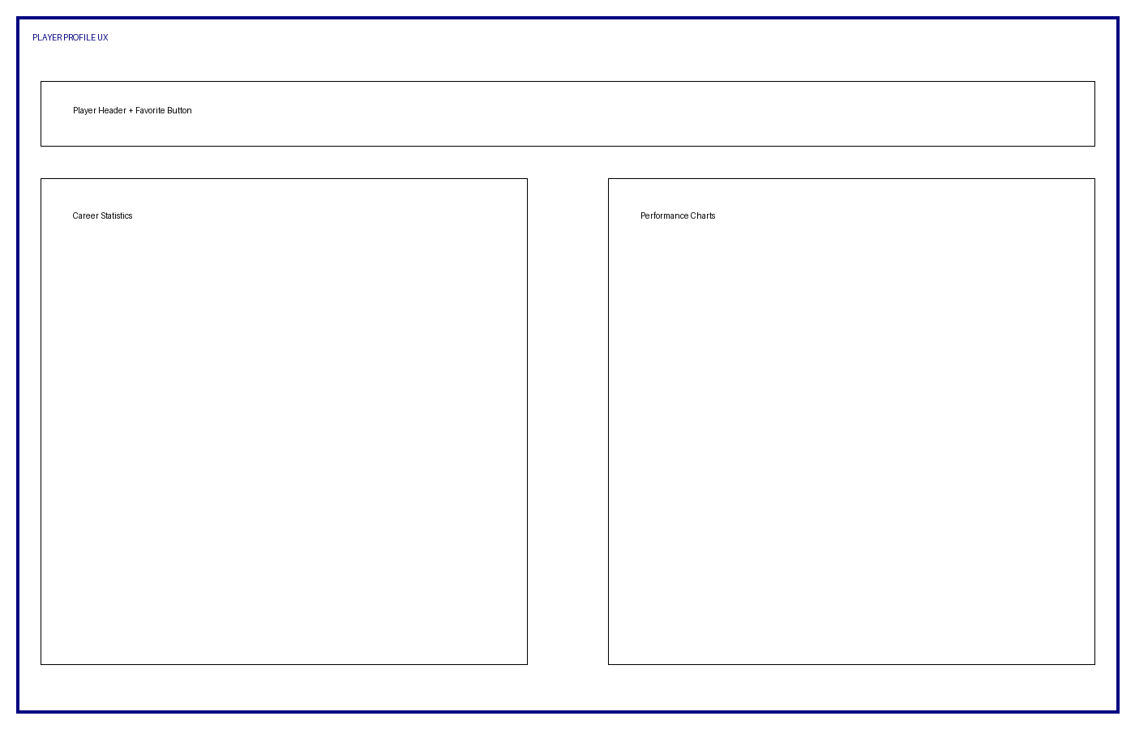

User Flow & Navigation
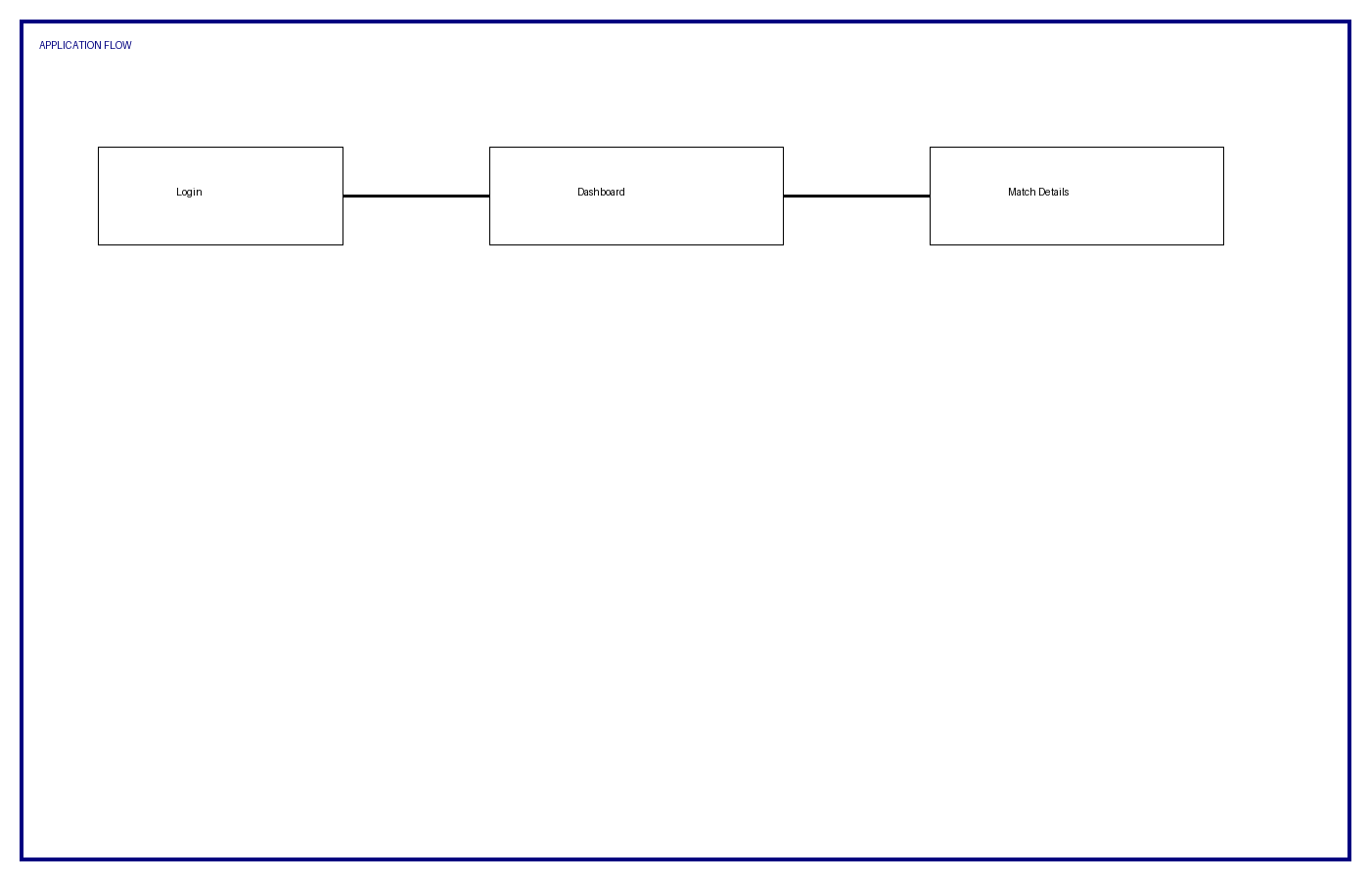

Component Tree
App → Layout → Navbar, Sidebar, Routes → Pages → Reusable Components

Routing Design
/, /live, /match/:id, /teams, /team/:id, /players, /favorites

Context State
ThemeContext, FavoritesContext, AuthContext

Hooks Usage
useState, useEffect, useContext, useMemo, useCallback, useFetch, useDebounce

