Cricket Score Dashboard - Visual Design Document
Detailed React project with wireframes, architecture and screen designs.

Dashboard
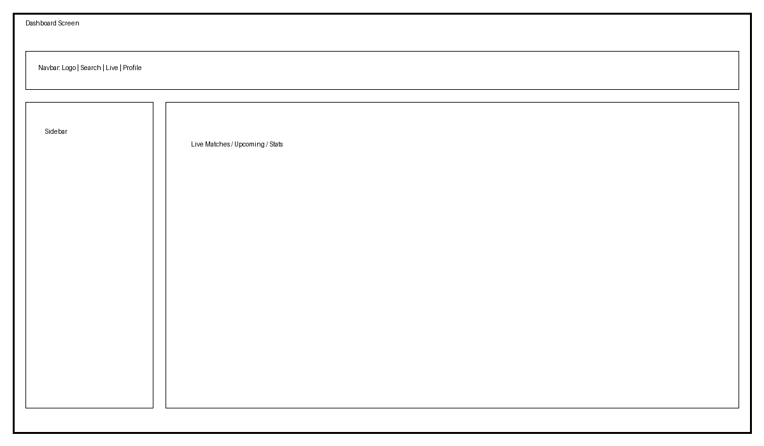

Match Details
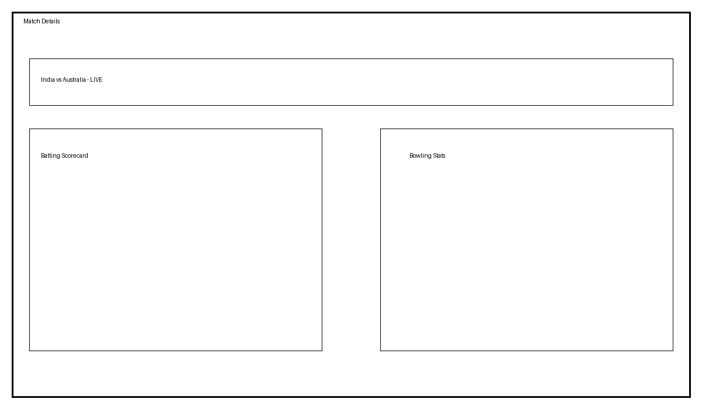

Player Profile
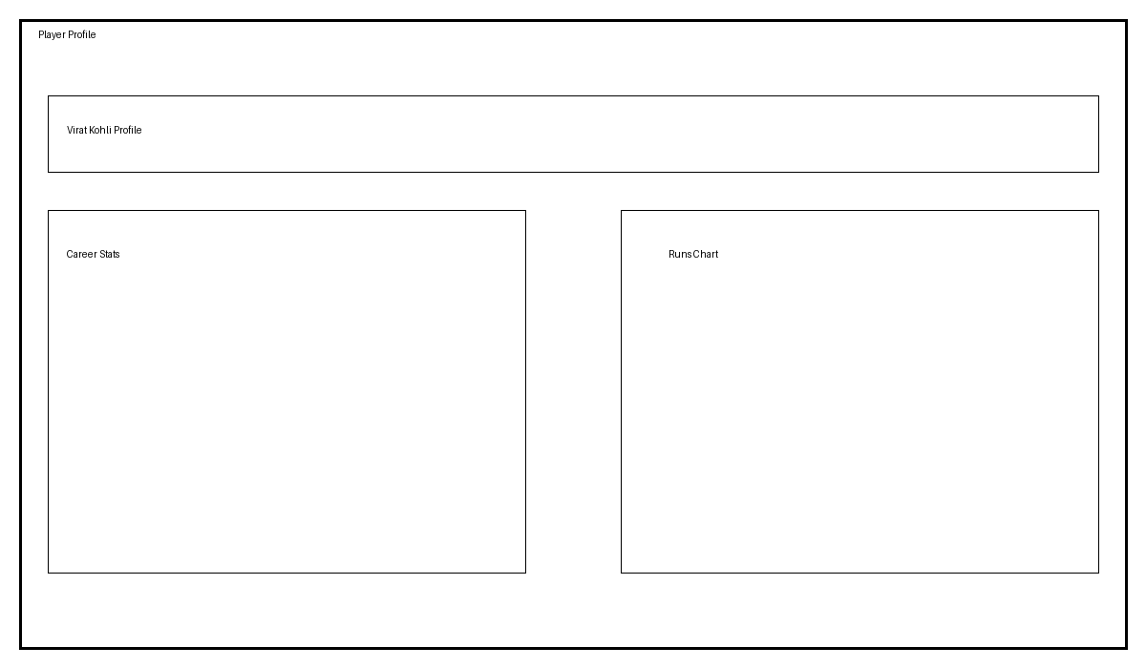

Architecture


React Features Covered
Hooks, Routing, Props, Context API, Lazy Loading, Suspense, Custom Hooks, API Integration, State Lifting, Performance Optimization.

