USER WALKTHROUGH

Enterprise Knowledge
Assembly Studio
  - From governed enterprise assets to reusable Customer 360 knowledge products

A practical guide for creating, assembling, governing, validating, publishing, and measuring enterprise knowledge products.
Prototype guide | Customer 360 implementation example | Version 1.0
Updated July 29, 2026
Audience: Enterprise architects, data and AI platform leaders, governance teams, knowledge-product owners, and conference-demo facilitators.

How to use this guide
Follow the screens in sequence for a complete Customer 360 demonstration, or jump directly to a section when you need a specific task.
Start locally: From the repository root, run ./start.sh and open http://127.0.0.1:4173. The prototype uses deterministic mock data and does not require API keys or an external backend.

The connected story
- Discover governed assets produced by existing data, metadata, MDM, lineage, document, semantic, and graph platforms.
- Create a knowledge project with explicit business scope, quality targets, policies, access, and stewardship.
- Assemble entities, semantics, relationships, provenance, and policy bindings through governed agent services.
- Validate quality and retrieval readiness against measurable acceptance criteria.
- Publish approved knowledge products through endpoints for RAG, copilots, analytics, applications, and agents.
- Measure consumption and use activity evidence to improve the next governed version.

Navigation model
- Top-level navigation: Home, Knowledge Projects, Enterprise Assets, Knowledge Products, and Administration.
- Project tabs: Overview, Assets & Sources, Graph & Model, Build & Govern, Quality & Monitoring, Publish & Serve, Usage & Insights, Activity, and Settings.
- Contextual inspectors: Open on the right when a selected asset, product, graph node, edge, recommendation, or run needs detail.
Demo tip: At 1600 x 1000 resolution, the full navigation, KPI rows, enterprise tables, and contextual inspectors remain visible without browser zoom.

1. Orient yourself on Home
Use Home as the launch point for projects, recent work, platform activity, and enterprise-wide status.
Route /
- Use the compact left navigation to move between Home, Knowledge Projects, Enterprise Assets, and Knowledge Products.
- Review the KPI cards for project, asset, product, quality, and agent-run health.
- Select New Knowledge Project to start an assembly workflow, or continue into the existing Customer 360 example.
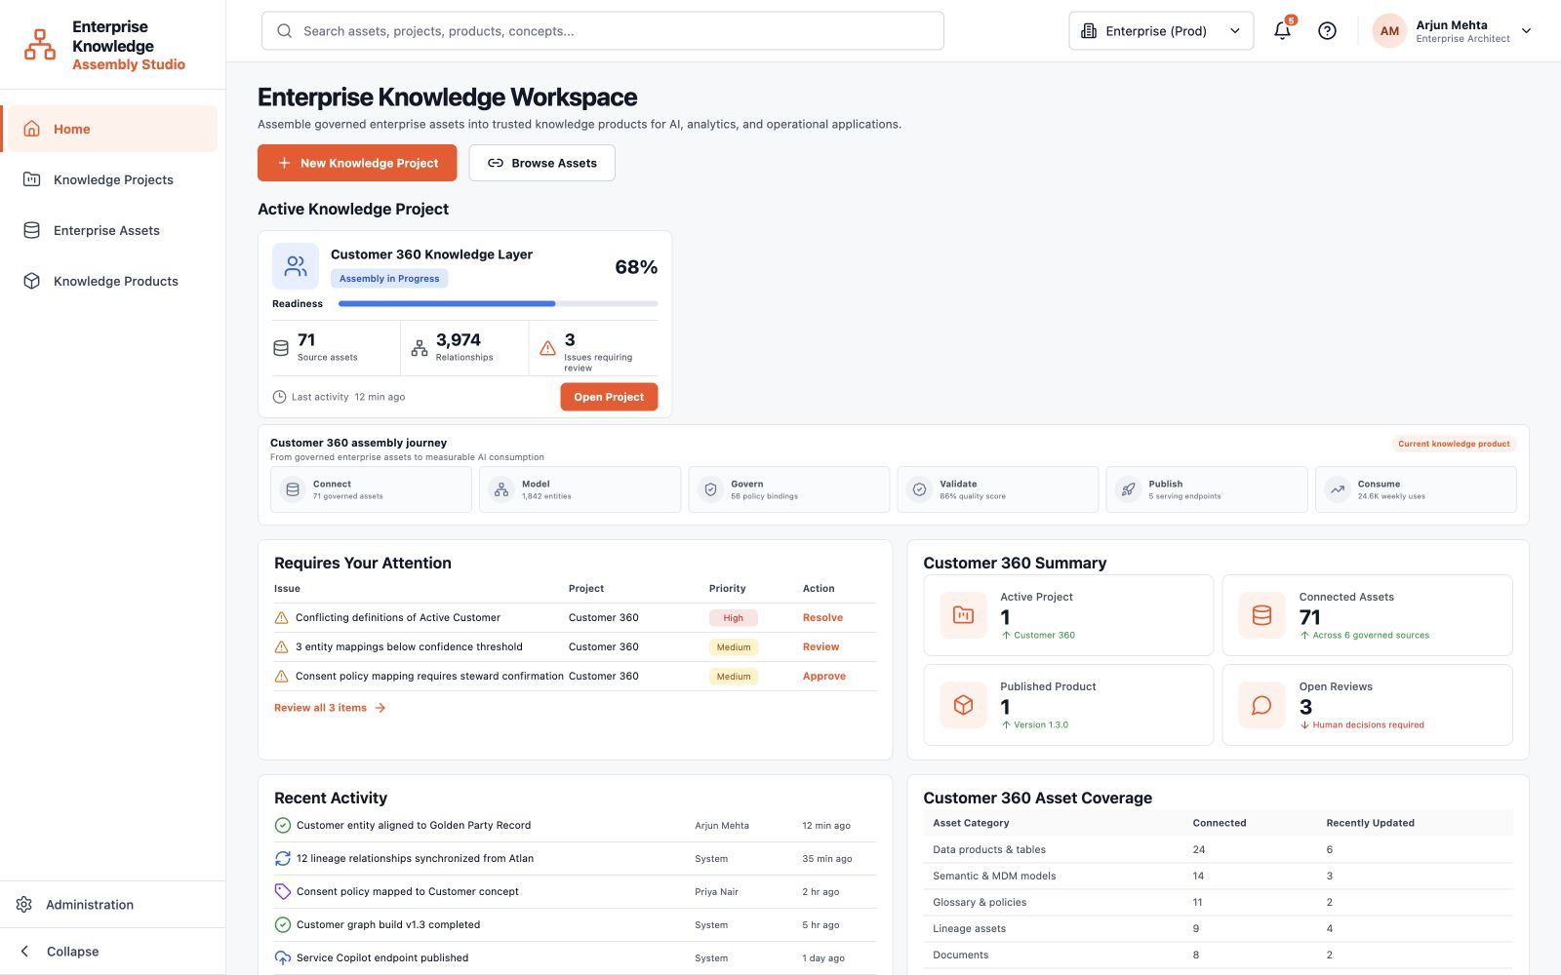
Figure 1. Orient yourself on Home at 1600 x 1000 demo resolution.
What to notice: The top navigation stays generic. Customer 360 is the single implementation example, not the identity of the platform.

2. Review the Knowledge Projects portfolio
Understand project status and enter either a new workflow or the existing Customer 360 workspace.
Route /projects
- Review portfolio KPIs, lifecycle status, ownership, progress, and quality indicators.
- Open Customer 360 Knowledge Layer to follow the complete connected story.
- Select New Knowledge Project when you want to recreate the Customer 360 example through the guided wizard.
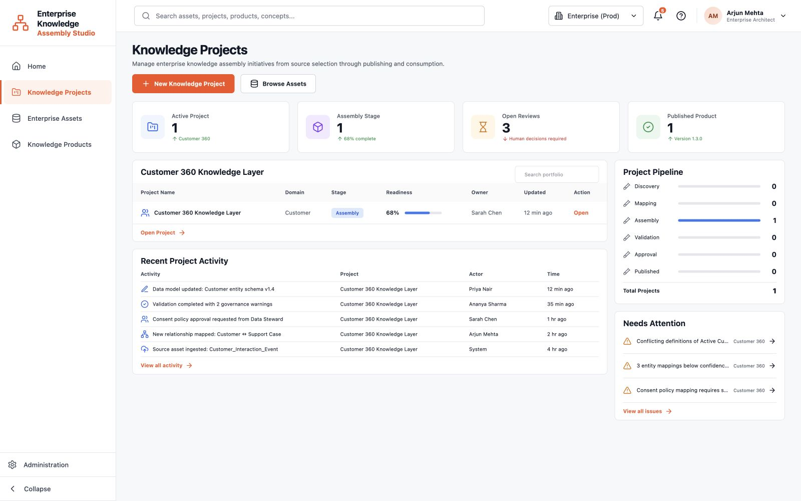
Figure 2. Review the Knowledge Projects portfolio at 1600 x 1000 demo resolution.
What to notice: A knowledge project is the governed assembly workspace. A knowledge product is the publishable result produced by that project.

3. Explore governed Enterprise Assets
Browse the governed assets that are available to be assembled into knowledge projects.
Route /assets
- Filter by asset type, source system, domain, knowledge role, status, or quality.
- Select a source-system logo to narrow the inventory to Databricks, MDM, SharePoint, Atlan, dbt, or Neo4j.
- Review quality, owner, freshness, and readiness before including an asset in a project.
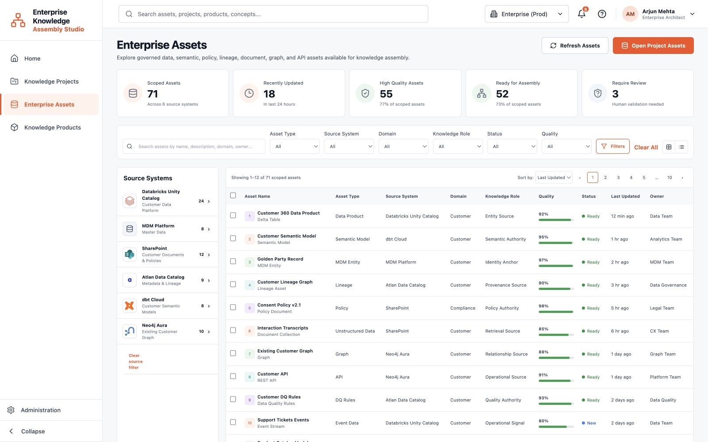
Figure 3. Explore governed Enterprise Assets at 1600 x 1000 demo resolution.
What to notice: This catalog represents outputs from existing enterprise platforms. The studio orchestrates them; it does not replace those systems.

4. Inspect available Knowledge Products
See which reusable knowledge products are published or in progress and who consumes them.
Route /products
- Select Customer 360 Knowledge Product from the table.
- Use the contextual inspector to review its version, owner, quality, endpoints, consumers, and governance state.
- Open the associated project when you need to change the assembly or prepare a new version.
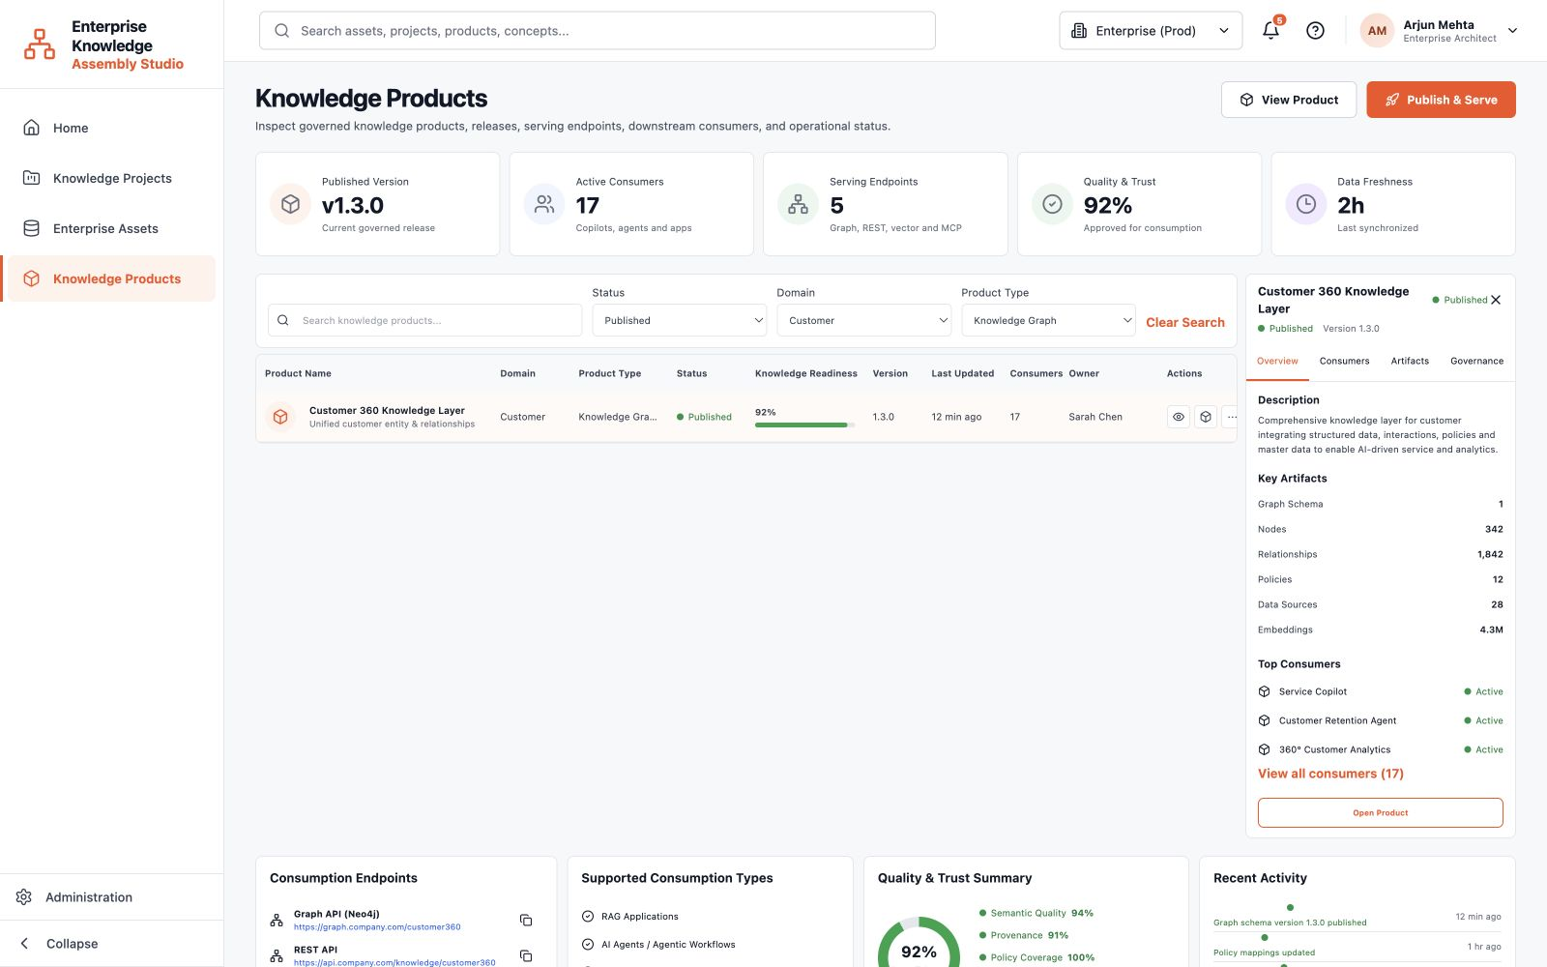
Figure 4. Inspect available Knowledge Products at 1600 x 1000 demo resolution.
What to notice: The prototype intentionally contains one knowledge product so the demonstration remains focused and internally consistent.

5. Create a project: Scope & Domains
Define the business outcome, domain boundaries, target consumers, and expected knowledge product.
Route /projects/new
- Confirm the project name and business objective, then choose the primary domain and sub-domains.
- Select target consumers such as RAG applications, copilots, AI agents, and analytics.
- Review the seeded business questions, sensitivity, residency, and approval controls before continuing.
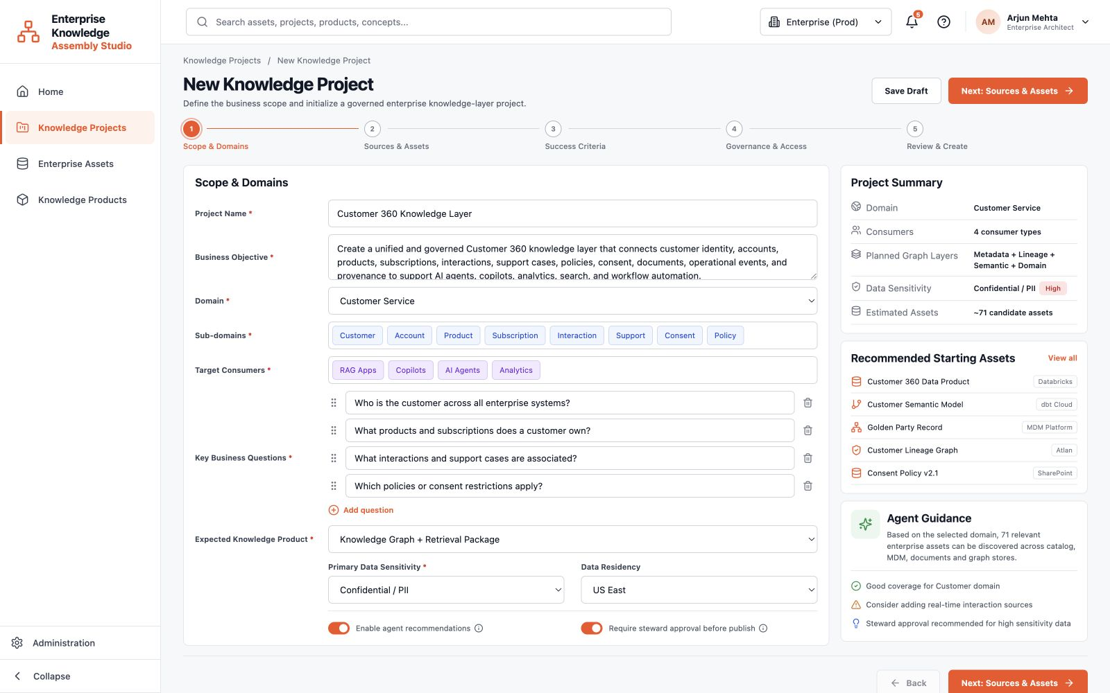
Figure 5. Create a project: Scope & Domains at 1600 x 1000 demo resolution.
What to notice: The wizard is pre-seeded with Customer 360 data so a conference demonstration can be completed quickly and deterministically.

6. Create a project: Sources & Assets
Connect enterprise systems and select the governed assets that will contribute to the knowledge layer.
Route /projects/new
- Verify that the required source systems are connected and healthy.
- Search and filter the discovered assets by type, domain, source, and knowledge role.
- Include or exclude assets and apply governed recommendations when they improve coverage.
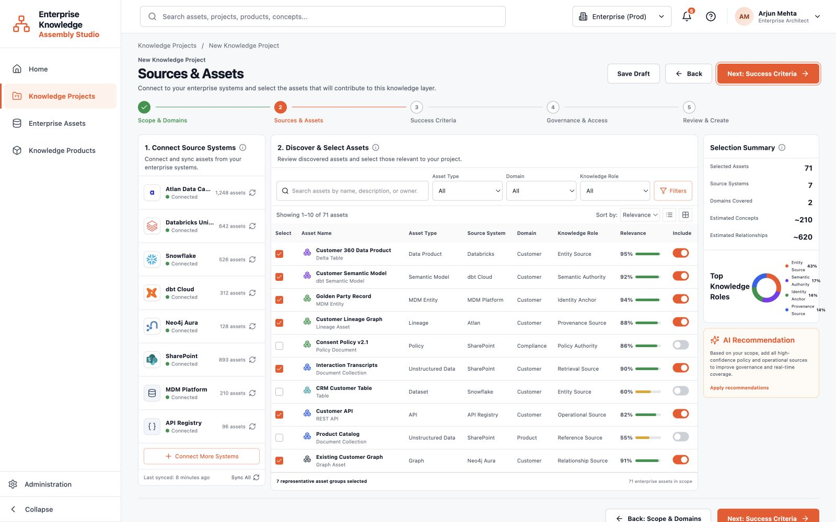
Figure 6. Create a project: Sources & Assets at 1600 x 1000 demo resolution.
What to notice: Asset selection is reversible. Recommendations are auditable suggestions and remain subject to human review.

7. Create a project: Success Criteria
Translate the business objective into measurable quality, retrieval, coverage, and governance targets.
Route /projects/new
- Review each success metric, its target, measurement method, and criticality.
- Adjust targets when the project has stricter domain or regulatory requirements.
- Confirm the acceptance criteria that must pass before the product can be published.
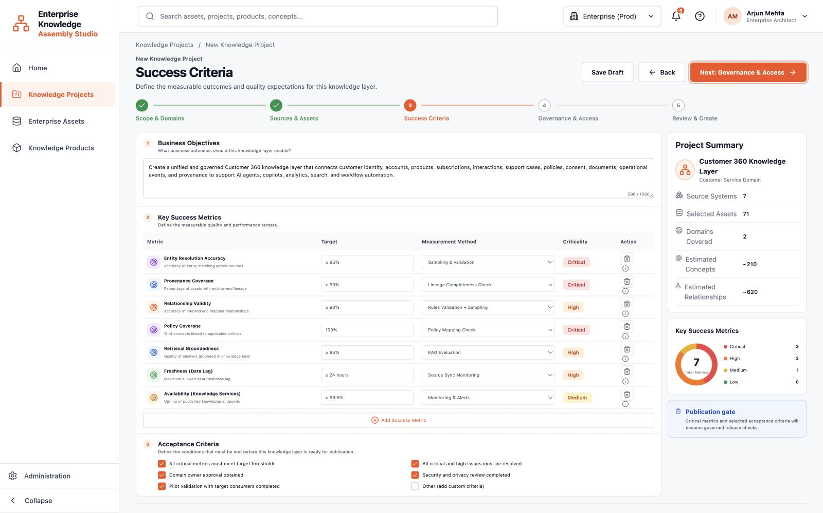
Figure 7. Create a project: Success Criteria at 1600 x 1000 demo resolution.
What to notice: Success criteria are used later by quality checks and publishing gates, keeping the project outcome measurable.

8. Governance & Access
Attach classifications, policies, access groups, stewardship, and approval requirements before assembly begins.
Route /projects/new
- Confirm information classifications and policy tags for customer and consent data.
- Review the selected governance policies and the access level granted to each enterprise group.
- Keep steward approval enabled for sensitive or PII-bearing knowledge products.
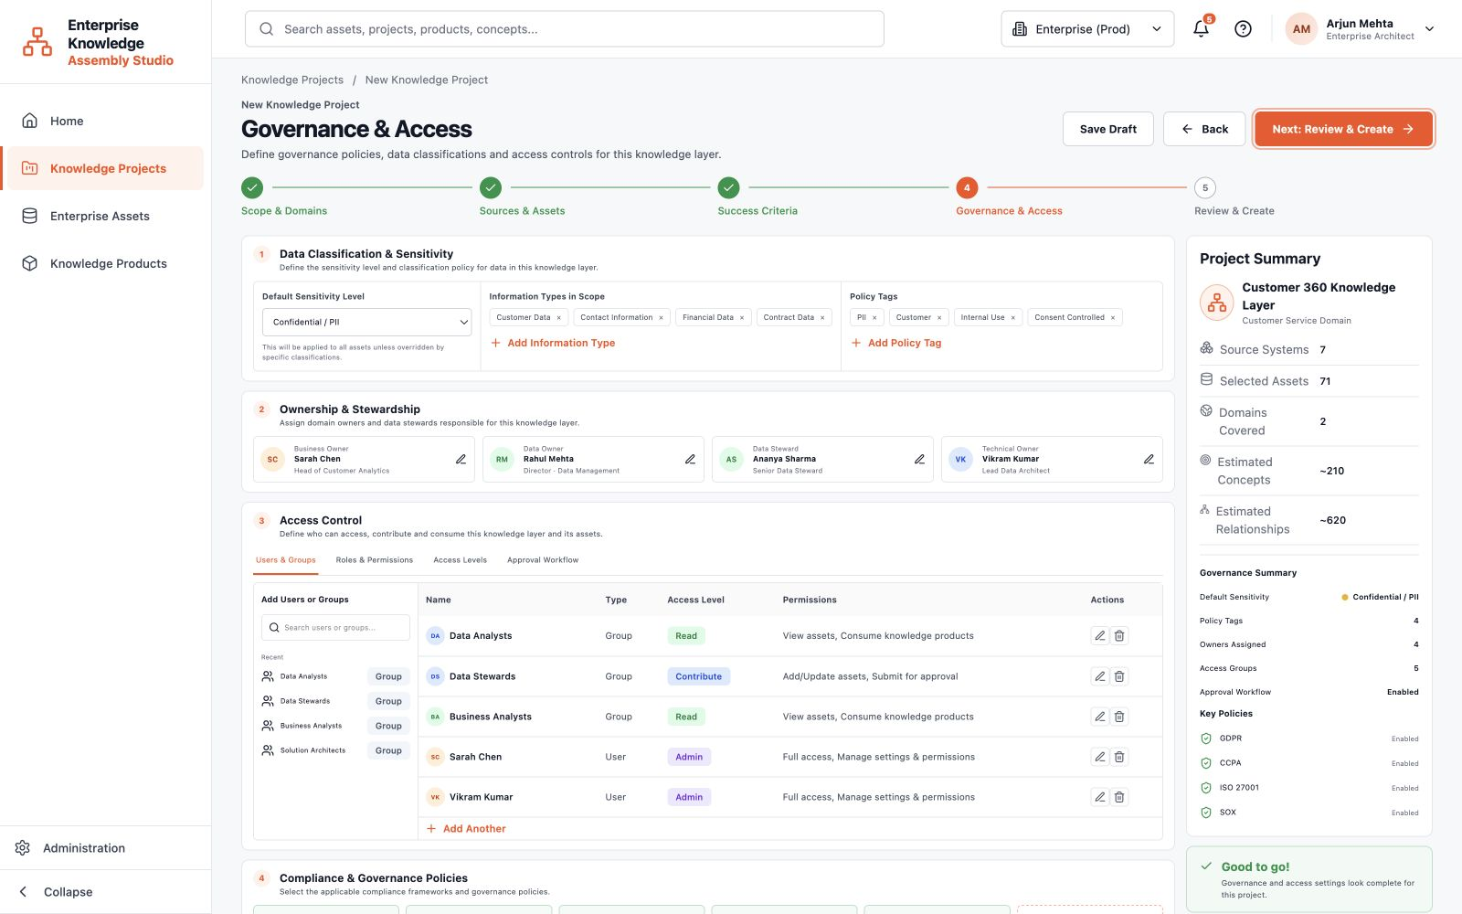
Figure 8. Governance & Access at 1600 x 1000 demo resolution.
What to notice: Governance is configured before publication and remains visible throughout assembly, validation, and serving.

9. Create a project: Review & Create
Review the complete configuration and correct any issue before initializing the governed project.
Route /projects/new
- Check project scope, selected sources, asset counts, success criteria, and governance controls.
- Use the Edit actions to return to a specific step without losing the rest of the configuration.
- Select Create Project when the review summary is complete.
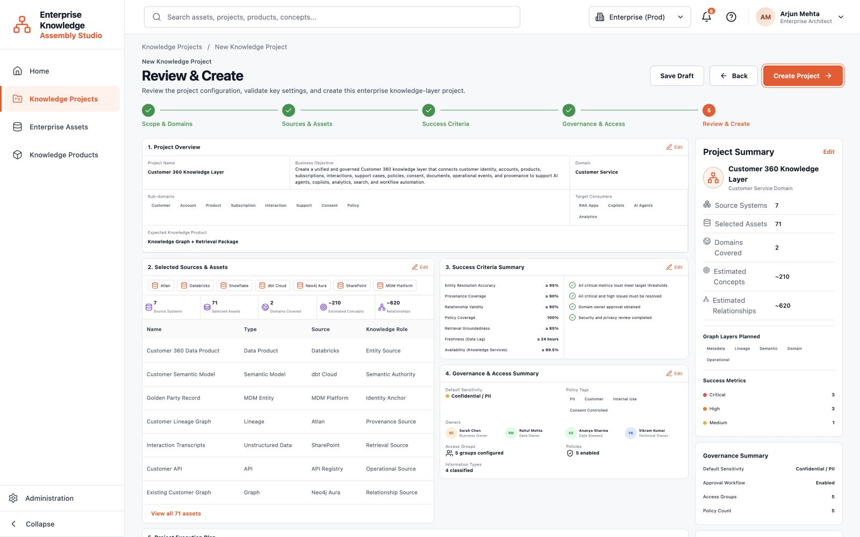
Figure 9. Create a project: Review & Create at 1600 x 1000 demo resolution.
What to notice: Creation starts deterministic agent services. The UI shows auditable objectives, evidence, confidence, and status rather than hidden model reasoning.

10. Monitor project initialization
Verify that the project was created and that governed discovery and assembly services have started.
Route /projects/new
- Follow the initialization stages from project creation through asset discovery, semantic mapping, graph construction, validation, and draft publication.
- Review activated agents and the event log for current status and evidence.
- Open the project workspace once initialization is underway.
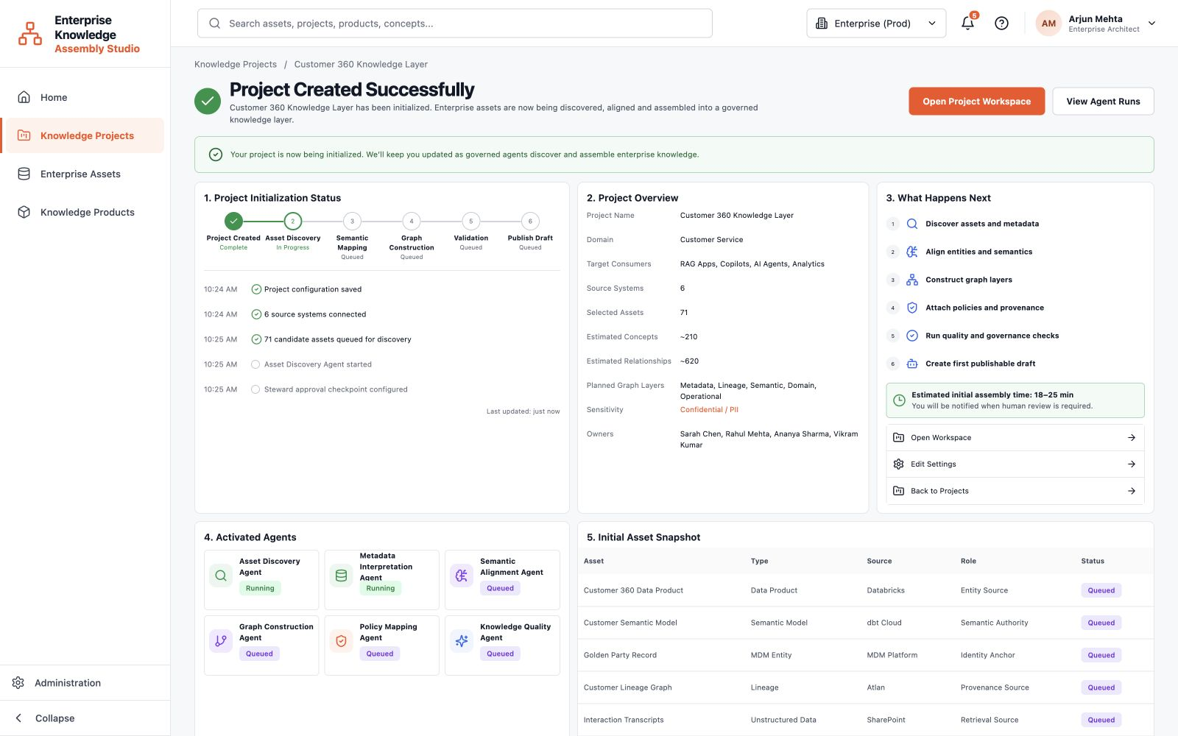
Figure 10. Monitor project initialization at 1600 x 1000 demo resolution.
What to notice: The simulated services are deterministic for demo reliability, but the execution trace mirrors a governed enterprise-agent operating model.

11. Read the Customer 360 project overview
Use the overview as the shared status page for progress, health, activity, timeline, sources, and next governed actions.
Route /projects/customer-360
- Read the KPI row from Current Assembly through Data Freshness.
- Review project description, health, recent activity, timeline, and top source systems.
- Use Next Governed Actions or Quick Links to continue to the right workspace tab.
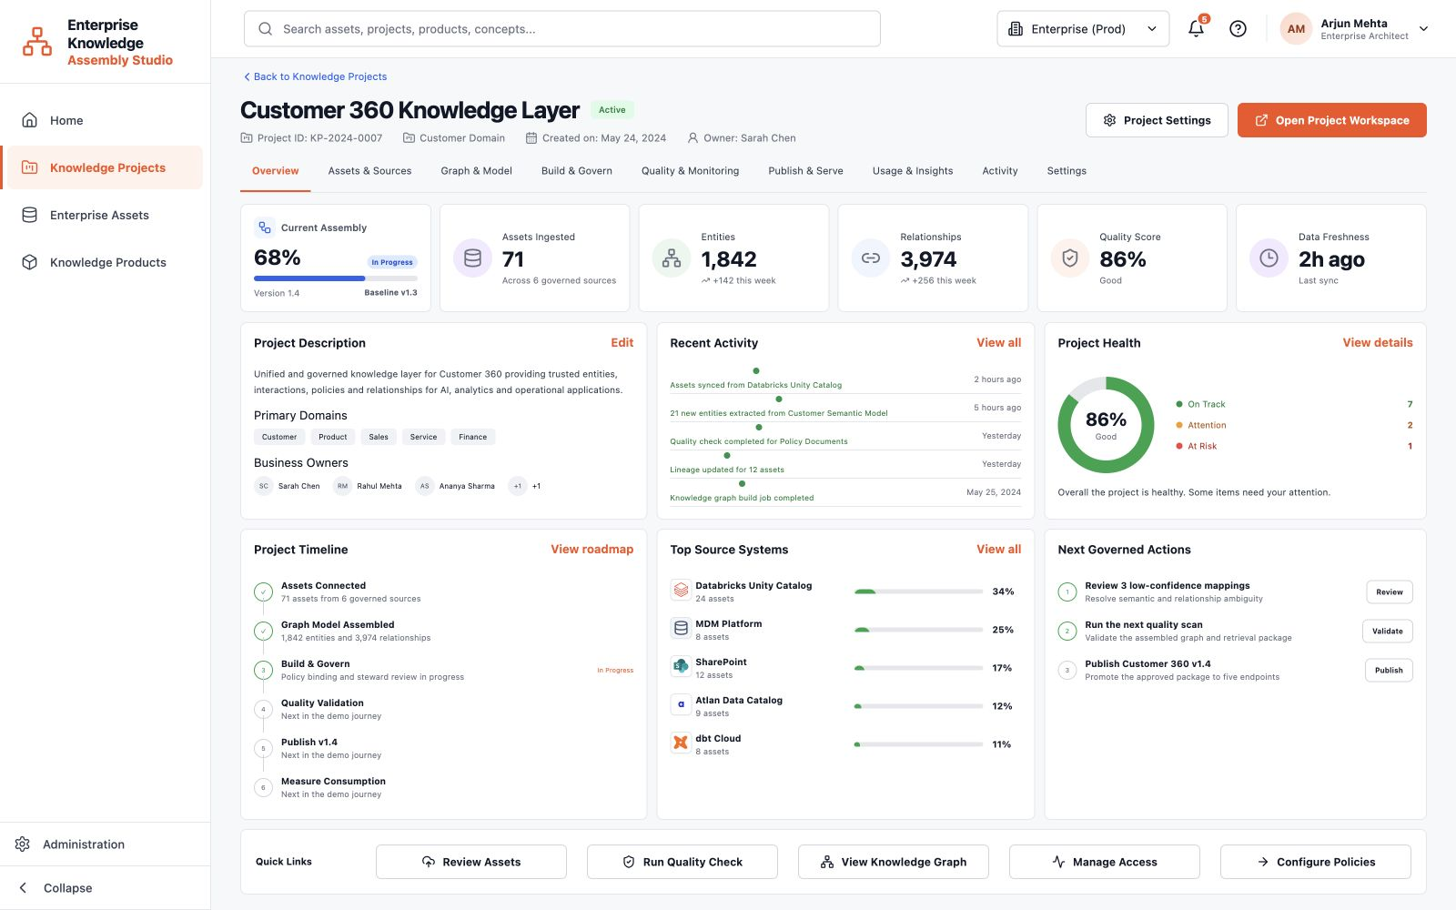
Figure 11. Read the Customer 360 project overview at 1600 x 1000 demo resolution.
What to notice: The horizontal project tabs tell a connected story: connect, model, govern, validate, publish, and measure.

12. Manage project Assets & Sources
Confirm source health, review project-scoped assets, and improve coverage before graph assembly.
Route /projects/customer-360/assets
- Review connected source systems, sync freshness, and asset counts.
- Search and filter the project inventory by source, domain, role, and status.
- Open recommendations when the coverage panel identifies high-impact missing assets.
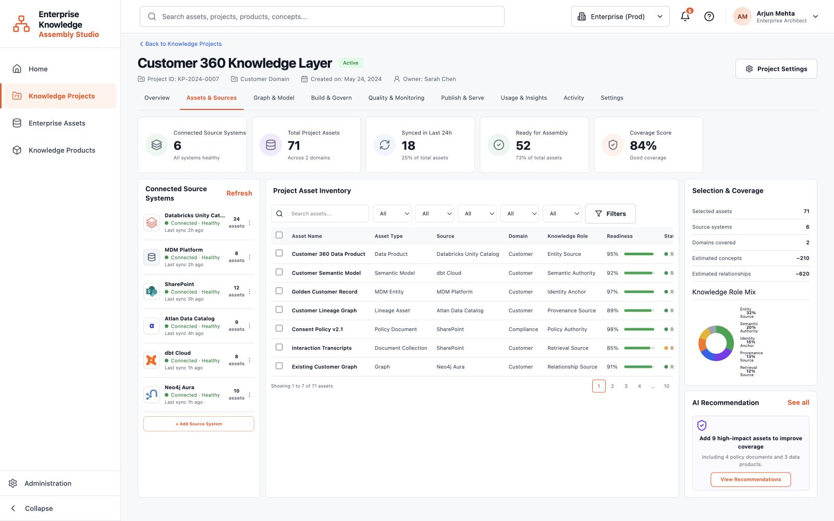
Figure 12. Manage project Assets & Sources at 1600 x 1000 demo resolution.
What to notice: This view is project-scoped. The global Enterprise Assets page remains the broader inventory across the organization.

13. Explore the Graph & Model
Inspect the assembled knowledge graph, relationships, model layers, provenance, and downstream impact.
Route /projects/customer-360/graph
- Use search, zoom, pan, fit-to-screen, layout, and layer controls to navigate the graph.
- Select a node or relationship to open its inspector and review provenance, confidence, policies, lineage, and connected assets.
- Use neighborhood expansion or shortest-path exploration to investigate how enterprise concepts are connected.
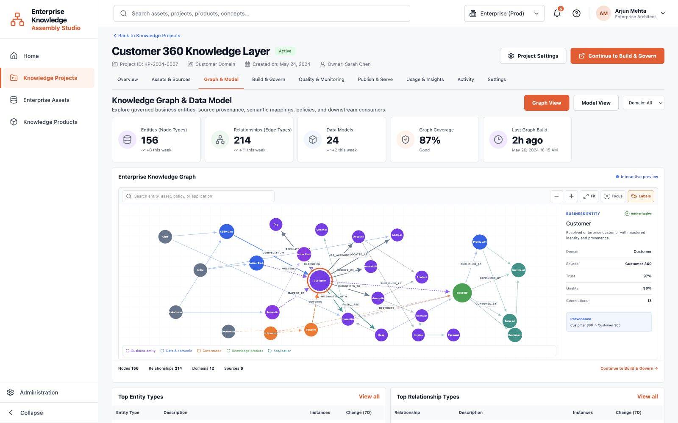
Figure 13. Explore the Graph & Model at 1600 x 1000 demo resolution.
What to notice: The graph is a multi-layer enterprise knowledge representation, not only a diagram of tables or a database topology.

14. Run Build & Govern
Assemble semantic assets, attach governance controls, and review agent-generated recommendations.
Route /projects/customer-360/build
- Select Run Assembly to simulate the governed assembly pipeline.
- Follow concept extraction, entity alignment, semantic mapping, relationship inference, policy attachment, and provenance assembly.
- Review or reject recommendations and inspect agent runs when human judgment is required.
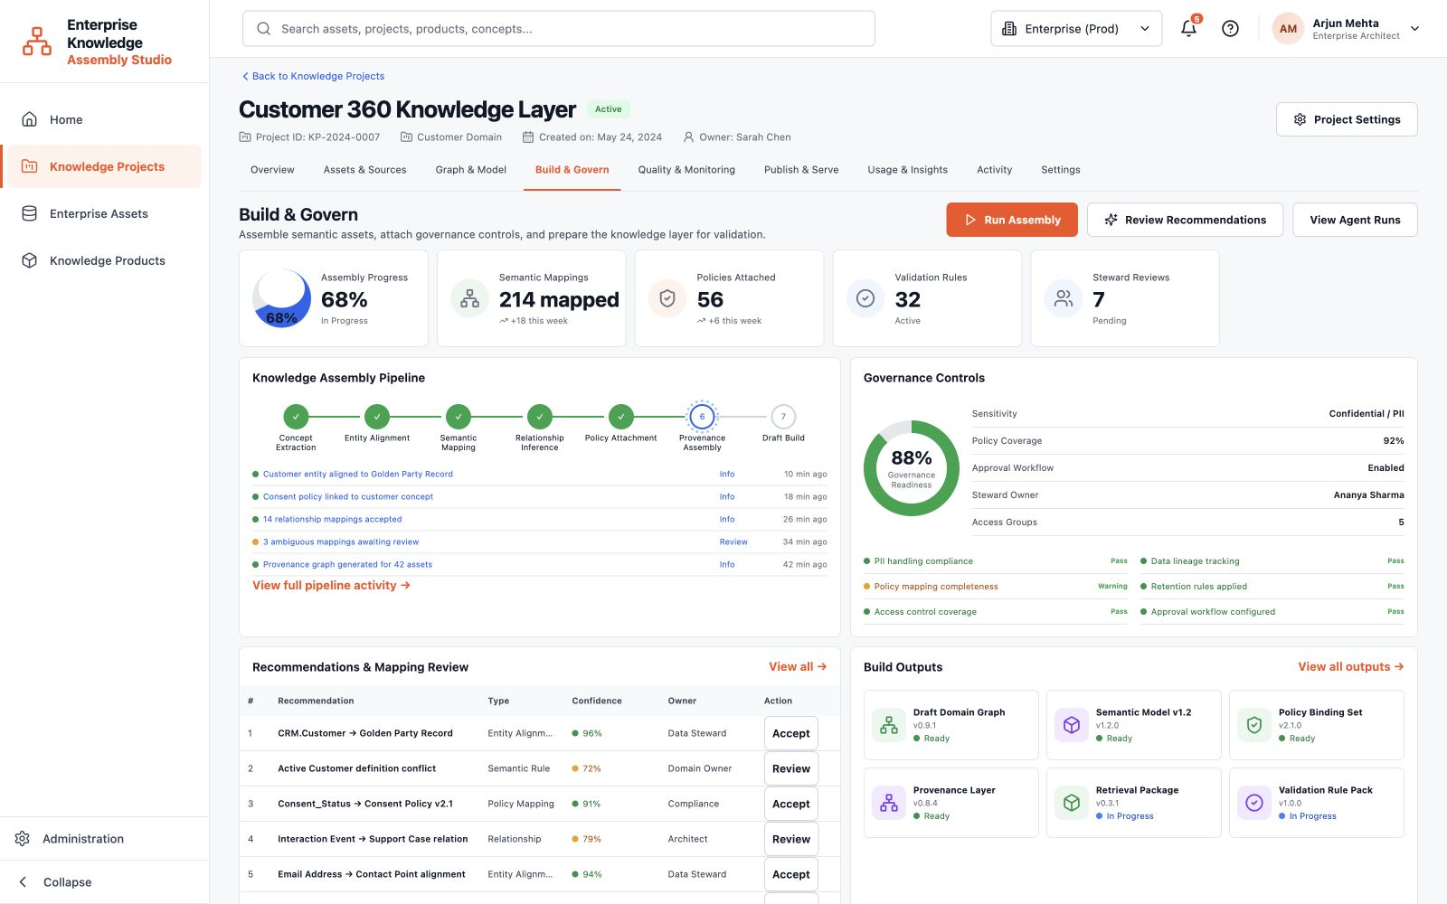
Figure 14. Run Build & Govern at 1600 x 1000 demo resolution.
What to notice: Every agent action is presented as an auditable service execution with inputs, tools, output, evidence, confidence, duration, and review status.

15. Validate Quality & Monitoring
Measure whether the assembled knowledge layer satisfies quality, governance, freshness, and retrieval expectations.
Route /projects/customer-360/quality
- Run a quality check and review the overall score and quality dimensions.
- Inspect warnings, failed checks, drift indicators, and the affected assets or relationships.
- Resolve critical findings before moving the draft into publication.
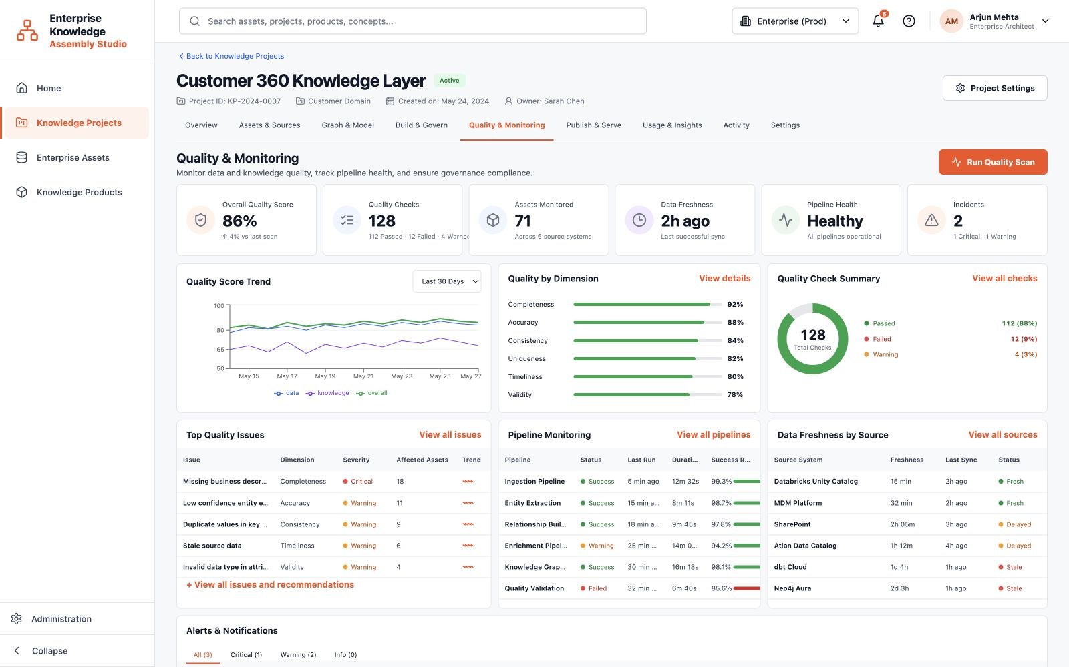
Figure 15. Validate Quality & Monitoring at 1600 x 1000 demo resolution.
What to notice: Quality is evaluated against the success criteria configured during project creation, closing the loop between intent and evidence.

16. Publish & Serve the knowledge product
Promote an approved assembly version into governed endpoints for applications, analytics, copilots, and agents.
Route /projects/customer-360/publish
- Review version readiness, governance approvals, and the release pipeline.
- Inspect serving endpoints, access requirements, consumers, and deployment history.
- Publish the approved version or copy endpoint details for downstream integration.
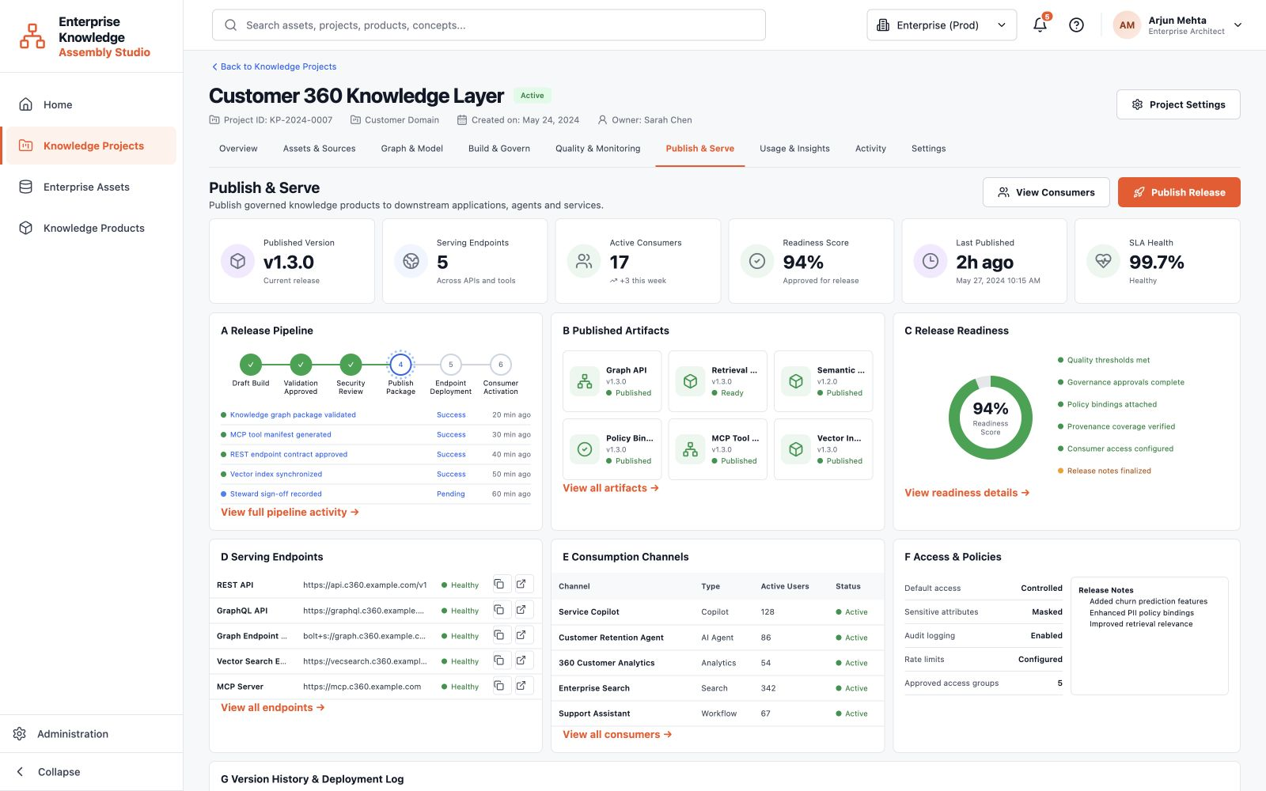
Figure 16. Publish & Serve the knowledge product at 1600 x 1000 demo resolution.
What to notice: Publishing is governed promotion, not a data export. Lineage, policy bindings, ownership, and quality evidence remain attached.

17. Measure Usage & Insights
Understand adoption, endpoint usage, application demand, geography, search behavior, and improvement opportunities.
Route /projects/customer-360/usage
- Review total consumption, active consumers, applications, API calls, response time, and satisfaction.
- Compare applications, knowledge assets, consumer types, and geographic distribution.
- Use search insights and recommendations to improve the next knowledge-product version.
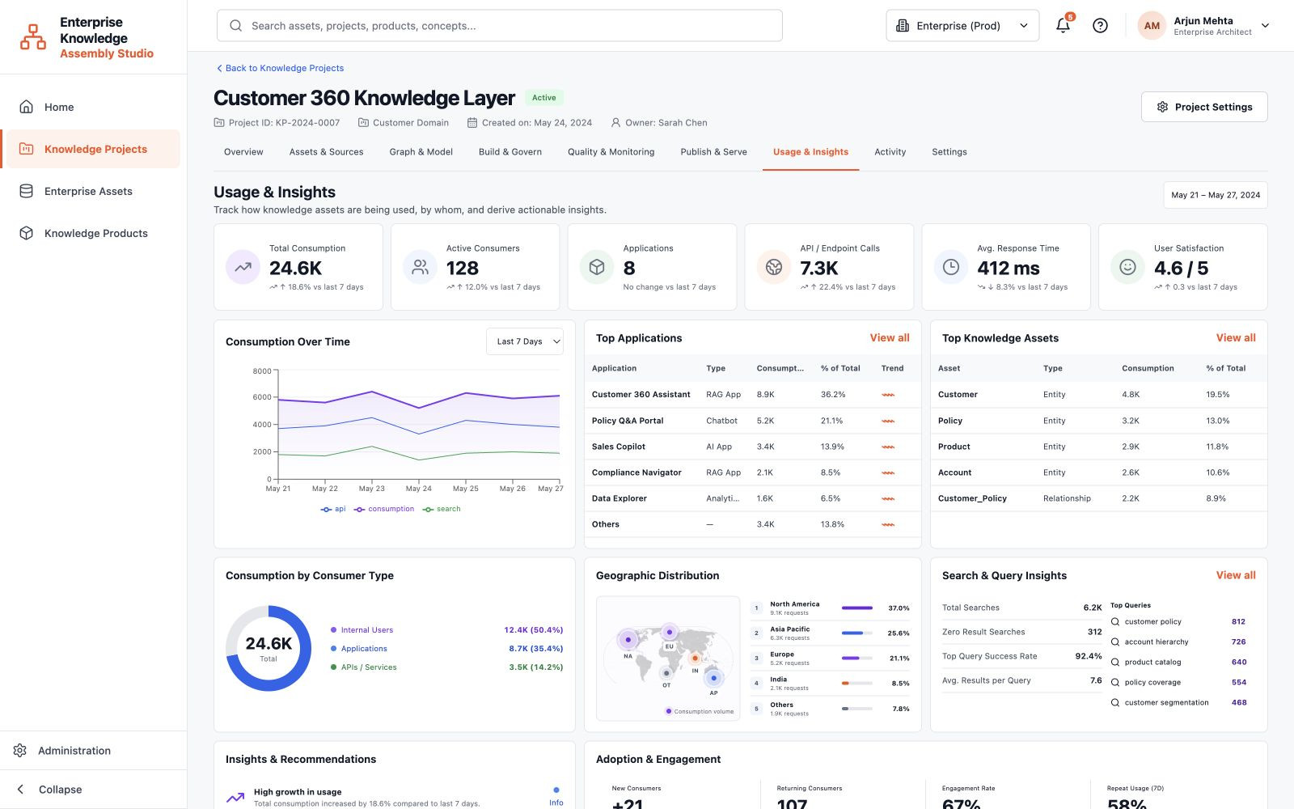
Figure 17. Measure Usage & Insights at 1600 x 1000 demo resolution.
What to notice: Usage completes the feedback loop: measured consumption and unmet queries become inputs to the next governed assembly cycle.

18. Audit Activity and agent runs
Review what happened, which service performed it, what evidence was produced, and whether review is required.
Route /projects/customer-360/activity
- Filter activity by type, status, agent, or time range.
- Open an agent run to inspect its objective, inputs, tools, output, evidence, confidence, duration, and human-review requirement.
- Use alerts and recent events to identify operational or governance follow-up.
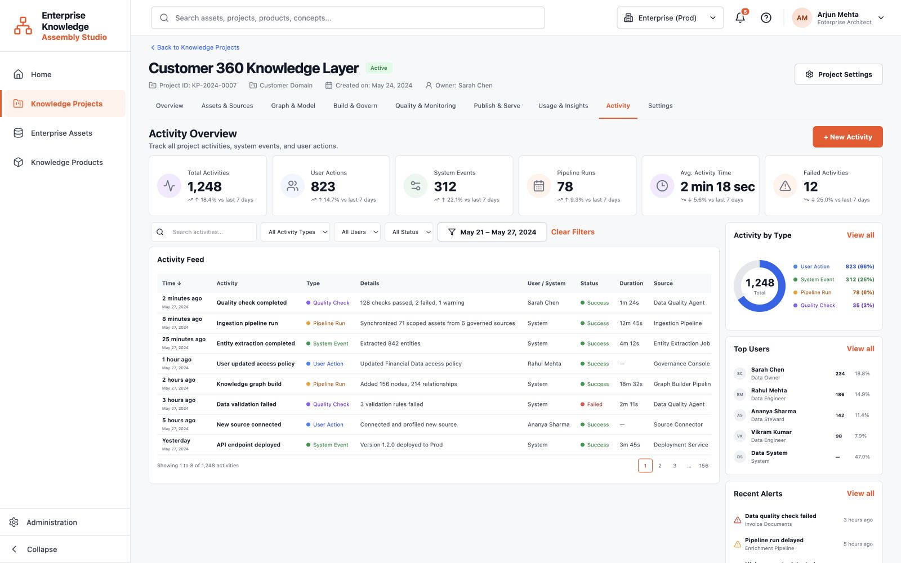
Figure 18. Audit Activity and agent runs at 1600 x 1000 demo resolution.
What to notice: The activity model intentionally avoids conversational personas and hidden chain-of-thought. It exposes only governed execution evidence.

19. Configure project Settings
Maintain project metadata, integrations, assembly behavior, access, notifications, and lifecycle controls.
Route /projects/customer-360/settings
- Edit project identity, ownership, domain, and descriptive metadata.
- Review integrations, build settings, governance behavior, access rules, and notification preferences.
- Use lifecycle and danger-zone controls carefully because they change project operation or availability.
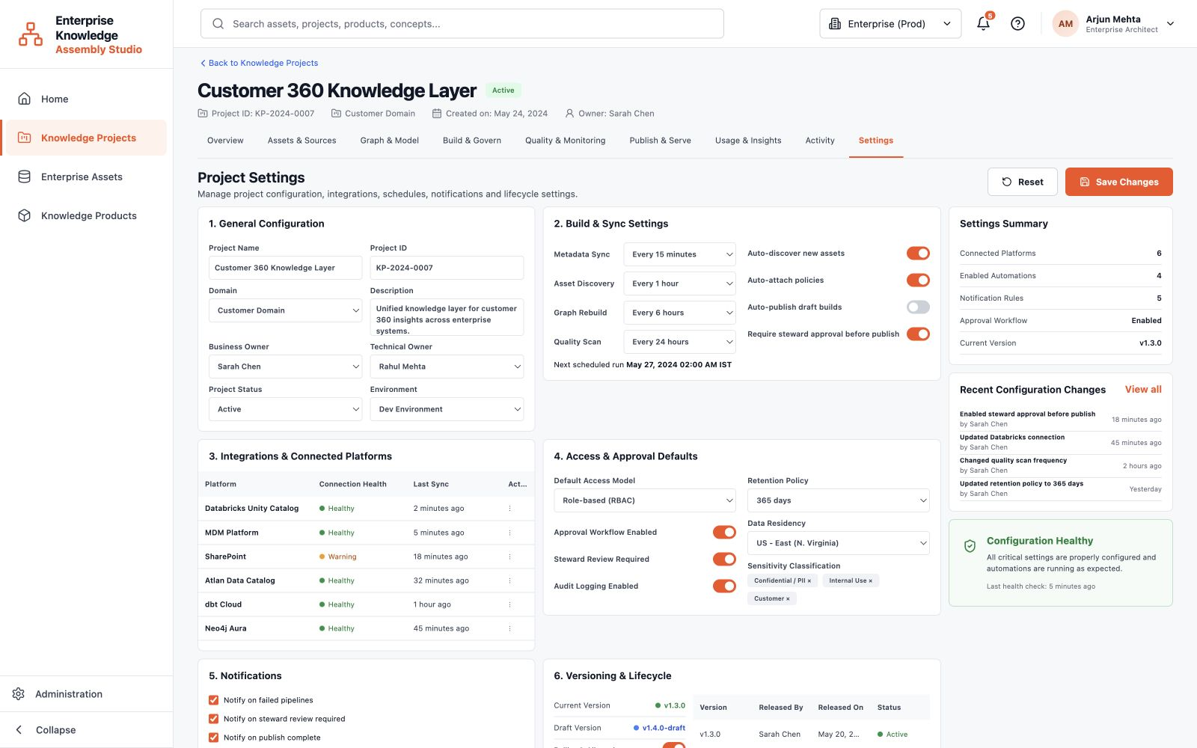
Figure 19. Configure project Settings at 1600 x 1000 demo resolution.
What to notice: Settings belong inside the project workspace, while top-level Administration remains reserved for platform-wide concerns.

Suggested 12-minute demonstration
Use this sequence when presenting the product to an audience that needs the enterprise story before the implementation details.
- Home (1 minute): establish the platform as a generic enterprise knowledge-assembly studio.
- Enterprise Assets (1 minute): show that governed platform outputs already exist and remain authoritative.
- New Project wizard (2 minutes): demonstrate scope, sources, metrics, governance, and review.
- Initialization (1 minute): explain governed agents and auditable execution evidence.
- Project Overview and Assets (1 minute): show connected project health and coverage.
- Graph & Model (2 minutes): search, select a node, inspect provenance, and explain graph layers.
- Build & Govern and Quality (2 minutes): run assembly, review recommendations, and validate readiness.
- Publish & Serve and Usage (2 minutes): show endpoints, consumers, adoption, query insights, and the feedback loop.

Messages to reinforce
- The studio orchestrates existing enterprise capabilities; it does not replace the data platform, catalog, MDM, lineage, or document systems.
- Governance and evidence are attached throughout the workflow, not added after publication.
- Agents are governed enterprise services with observable objectives, tools, outputs, evidence, confidence, duration, and human-review requirements.
- Customer 360 is the implementation example. The platform and project-creation experience remain generic.
End state: The audience should understand how distributed governed assets become a reusable, measurable, and publishable enterprise knowledge product.

