E-COMMERCE SALES
ANALYTICS
Power BI Project Documentation Report
Data Cleaning & Validation in Power Query | Interactive Analysis in Power BI

Prepared by | Venkatesh
Project Title | E-Commerce Sales Analytics
Tools Used | Microsoft Excel, Power Query and Power BI
Data Source | ECommerce_Raw_Dataset1.xlsx
A business intelligence project to analyze order performance,
product categories, customer ratings and regional trends.

1. Executive Summary
This project analyzes e-commerce order data using Microsoft Power BI. The raw dataset was cleaned and validated in Power Query before being used to create an interactive, multi-page dashboard. The report provides an overview of order volume, quantity, customer ratings, delivery time, discounts, payment methods, product categories and regional performance.
- Performed data cleaning and validation in Power Query.
- Prepared the data model using fact and dimension tables.
- Created KPI cards, slicers, charts, a map and summary tables in Power BI.
- Reviewed sales and order trends to identify high-performing regions and product categories.

2. Project Overview & Business Objectives
The main objective is to convert raw e-commerce data into useful business insights. The dashboard helps users monitor order performance, understand customer preferences, compare regional demand and identify areas that may need operational or promotional attention.

Business Questions
- How many orders and units are recorded?
- What is the order-status distribution?
- Which regions and states have the highest order counts?
- Which product categories receive the most orders?
- Which payment methods are used by customers?
- What are the average customer rating, delivery time and discount?
- How do order trends change by year, quarter and month?

3. Dataset & Data Model
The project uses the supplied ECommerce_Raw_Dataset1.xlsx workbook as its source. The Power BI Fields pane in the dashboard shows a fact table supported by dimension tables.
Model Table | Purpose
Fact_Table | Stores transactional/order-level data used for measures and analysis.
Dim_Customer | Supports customer-related analysis.
Dim_Date | Supports year, quarter, month and date-based analysis.
Dim_Location | Supports region, state and city analysis.
Dim_Order_Status | Supports order-status analysis.
Dim_Product | Supports product category and sub-category analysis.
The model follows a fact-and-dimension structure to organize the data for reporting. Relationships should be checked in Model view to confirm the intended one-to-many relationships and filter directions.

4. Data Processing & Methodology

4.1 Power Query – Data Cleaning and Validation
Power Query was used to prepare the raw data before loading it into the Power BI model. The cleaning and validation process included reviewing column structure, checking data quality and ensuring fields were suitable for analysis.
- Reviewed column names and the structure of the raw dataset.
- Checked blank and missing values in important columns.
- Reviewed duplicate records and repeated order identifiers.
- Standardized inconsistent text values where required.
- Assigned appropriate data types to date, numeric and text columns.
- Checked date, quantity, discount and amount fields for valid values.
- Loaded the prepared data into the Power BI model.

4.2 Power BI – Data Analysis & Visualization
Power BI was used to create measures, KPI cards, interactive visuals and slicers. The dashboard is arranged into three report pages: Sales & Orders Overview Dashboard, Regional & Category Sales Analysis, and Key Insights.

5. Dashboard Analysis

5.1 Page 1 – Sales & Orders Overview Dashboard
This page provides a high-level summary of order activity and allows users to filter the report by region, state, city and product category.
Visual / KPI | What it Shows
Total Orders – 976 | Total order count displayed in the KPI card.
Total Quantity – 5K | Total quantity ordered, displayed in rounded form.
Average Rating – 3.08 | Average customer rating.
Average Delivery Days – 5.99 | Average delivery duration in days.
Average Discount – 14.39 | Average discount value shown by the report.
Orders by Year, Quarter, Month and Order Status | Trend of order counts over time, split by order status.
Total Orders by State | State-wise order count; Maharashtra is highest in the displayed ranking.
Orders by Product Category | Treemap comparison of order counts across product categories.
Slicers | Region, State, City and Product Category filters.
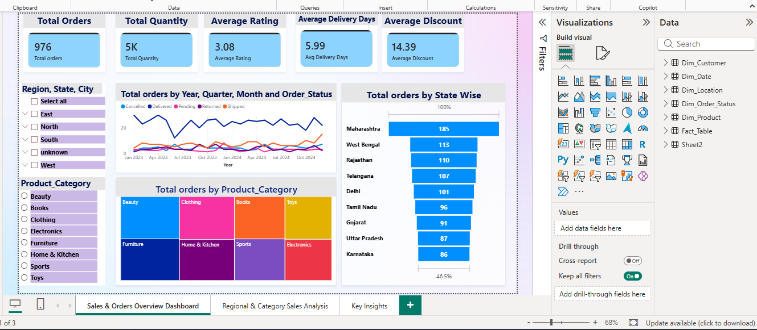
Figure 1. Sales & Orders Overview Dashboard

5.2 Page 2 – Regional & Category Sales Analysis
This page provides a more detailed view of order status, payment methods, delivery performance, product categories, quarterly trends and geographic distribution.
Visual | What it Shows
Orders by Order Status | Distribution of orders across delivered, shipped, cancelled, returned and pending statuses.
Orders by Payment Method | Order distribution across payment methods such as UPI, Net Banking, Debit/Credit Card, Cash on Delivery and EMI.
Average Delivery Days | Gauge visual showing an average delivery value of 5.95 days on this page.
Region-wise Product Category | Matrix comparing product-category order counts by region.
Orders by Product Category | Bar chart comparing category-level order counts.
Orders by Year, Quarter and Region | Quarterly order trend split by region.
Total Quantity by Discount | Scatter plot showing the relationship between total quantity and discount percentage.
Orders by Sub-Category | Bar chart comparing order counts across product sub-categories.
Orders by State | Map visual showing geographic order distribution.
Region and Product Category Slicers | Filters for interactive exploration.
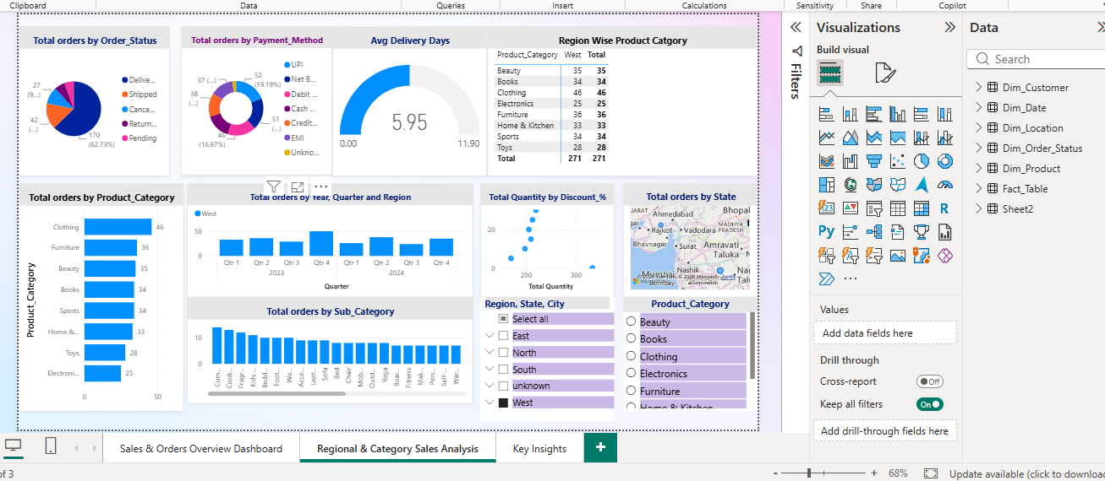
Figure 2. Regional & Category Sales Analysis

5.3 Page 3 – Key Insights
The third report page is named Key Insights. It is intended to communicate the main findings and business conclusions from the dashboard.
The following key insights and conclusion points are based on the project insight summary provided with the dashboard:
- Most orders are delivered successfully.
- North and South regions have the highest number of orders.
- Maharashtra, West Bengal and Rajasthan have the most orders.
- Beauty, Furniture and Clothing are the leading categories in the insight summary.
- The average customer rating is 3.08, indicating room for improvement.
- The average delivery time is approximately 6 days.
- Discounts may influence sales performance and should be reviewed by category.
- Electronics and Toys have fewer orders and may need focused promotional activity.

6. Business Recommendations
- Review customer feedback and identify ways to improve the average rating.
- Monitor delivery performance and investigate delays in the order fulfillment process.
- Use state- and region-level order trends to plan targeted marketing campaigns.
- Evaluate promotional activity for lower-order categories such as Electronics and Toys.
- Compare payment-method usage to improve the checkout experience.
- Review discount levels alongside sales and profitability before changing pricing strategies.

7. Conclusion
The E-Commerce Sales Analytics project demonstrates the use of Power Query for data cleaning and validation and Power BI for interactive analysis and reporting. The three-page dashboard presents key metrics and trends related to orders, products, customers, payments, delivery performance and geography. These insights can help business users monitor current performance and identify areas for improvement.

8. Tools & Technologies
- Microsoft Excel – Raw dataset source.
- Power Query – Data cleaning, transformation and validation.
- Microsoft Power BI – Data modeling, DAX measures, interactive visuals and dashboard reporting.
— End of Report —

