1.Click on Install
Input:

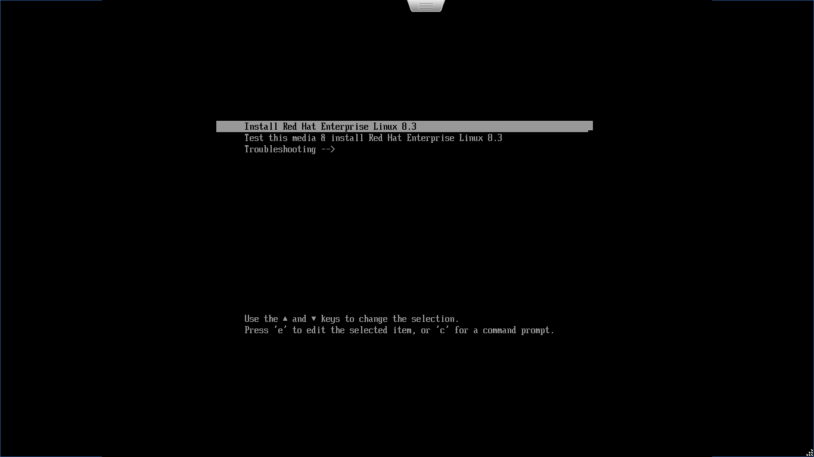

Output: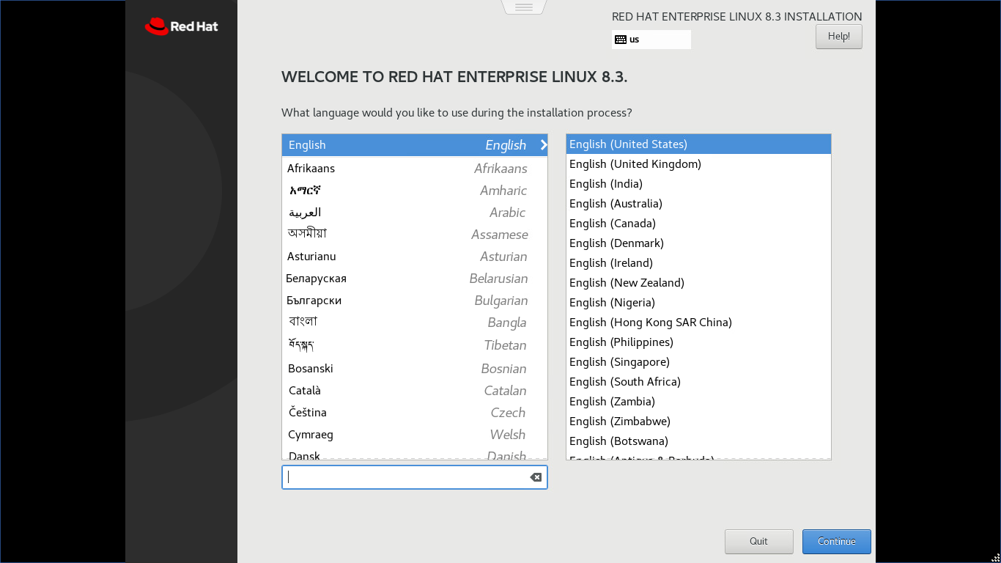

- Click on continue Button placed on bottom right:

Output:
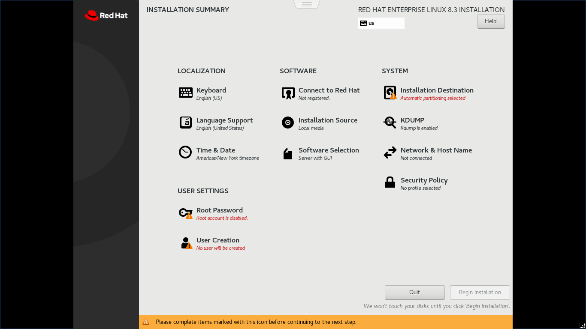

- select installation destination

Input:

Output:
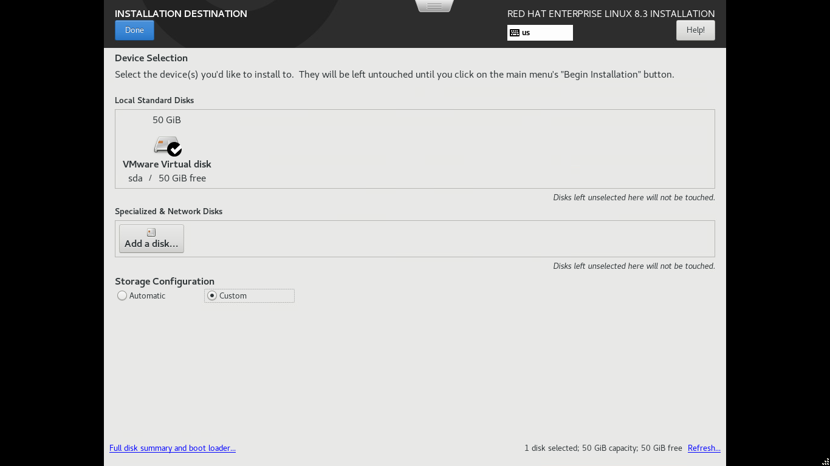

- select custom and click on done button over top

Input:

Output:

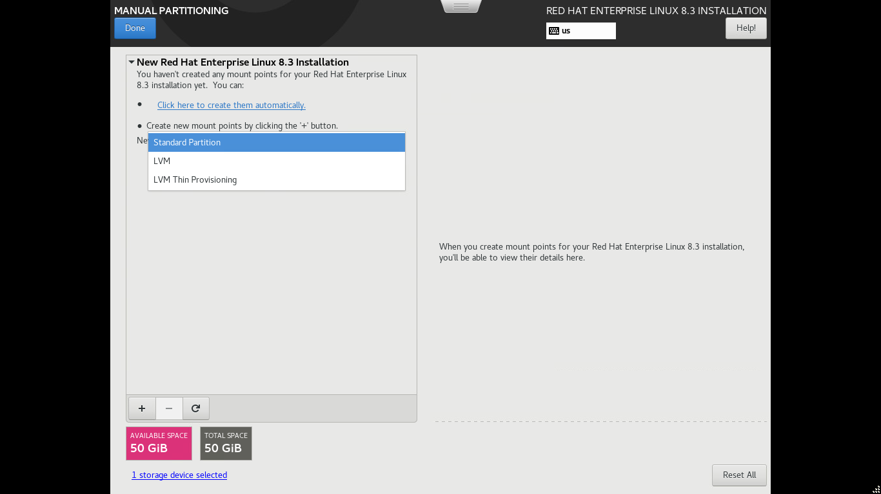

- select standard partition

Input:

Output:

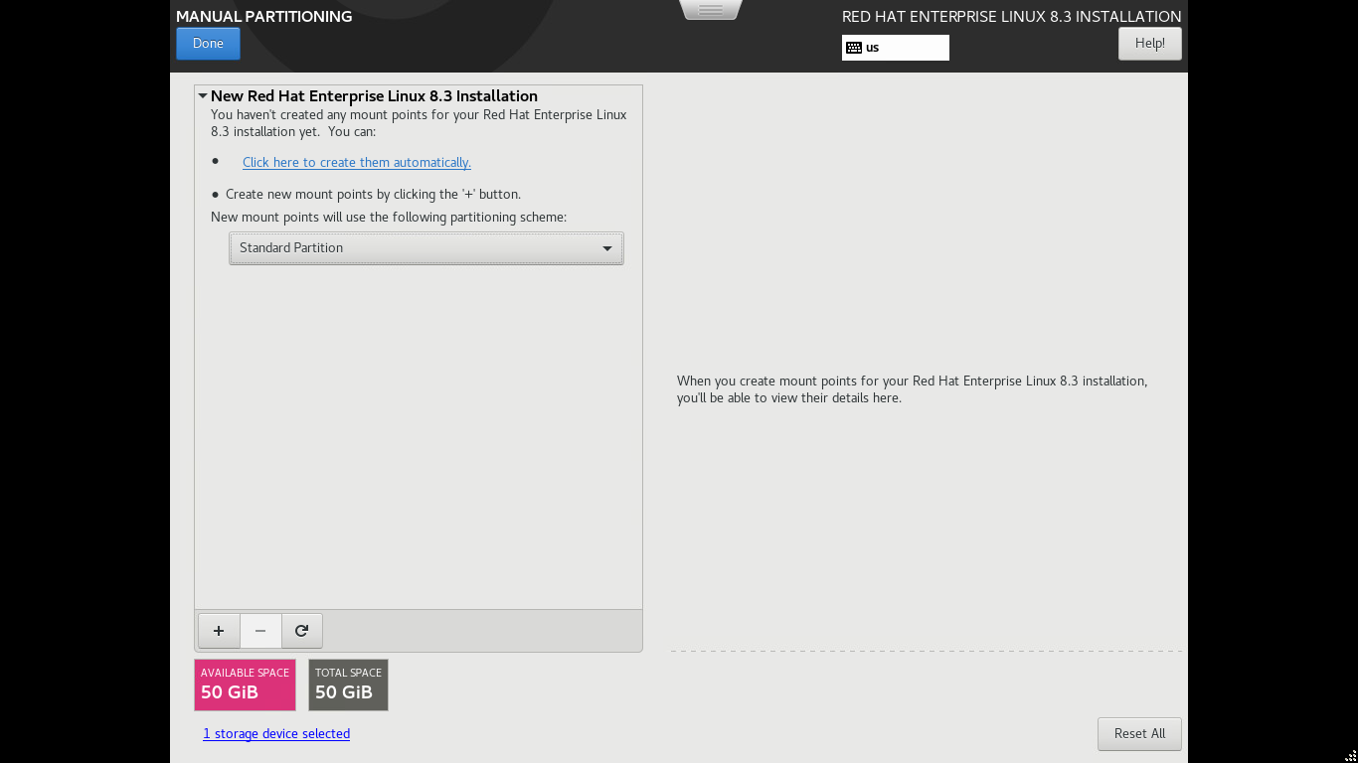

- click on “+” button

Input:

Output:

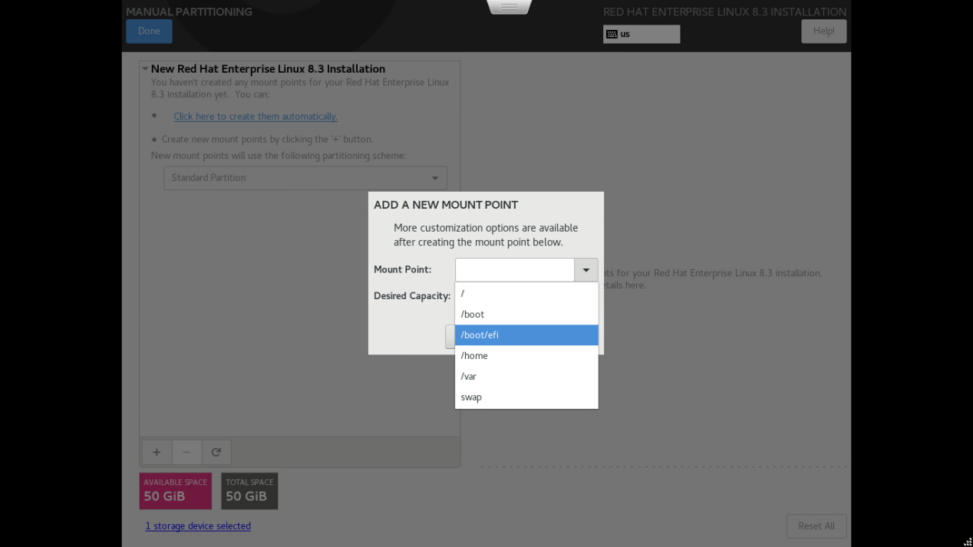

- (a) Select /boot/efi from dropdown mountpoint

7 (b) Enter desired capacity 500mb and click on add mount point

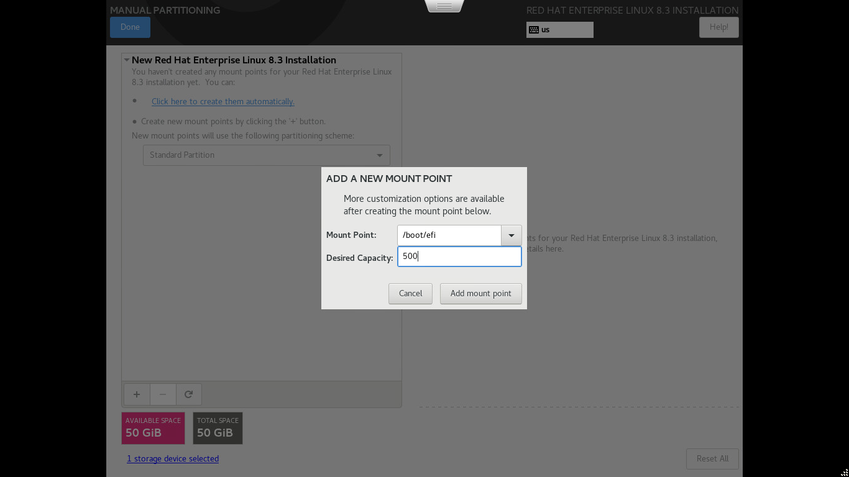

Output:

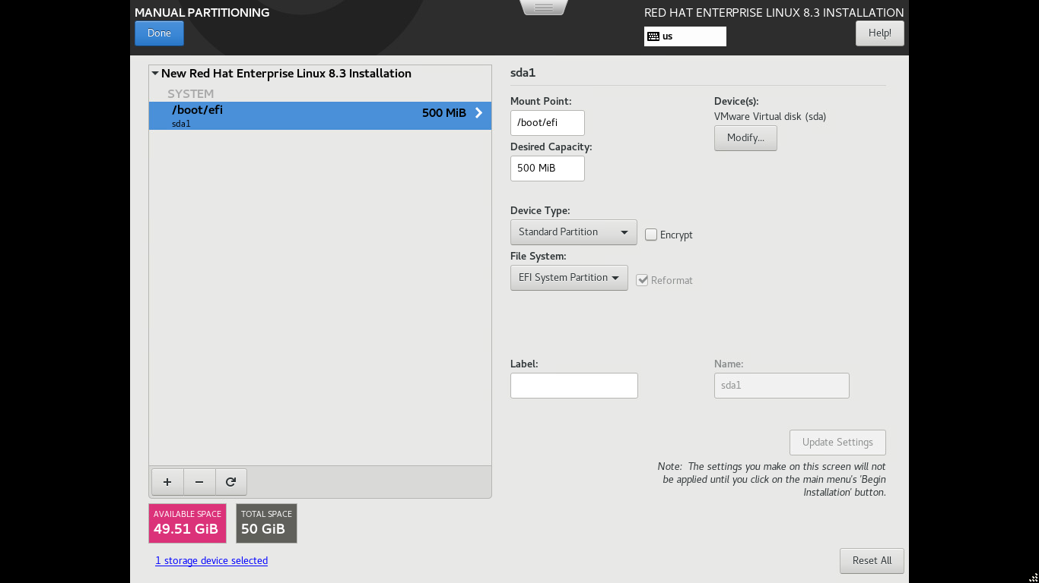

- (a) Click on “+” and add select mount point as “swap”

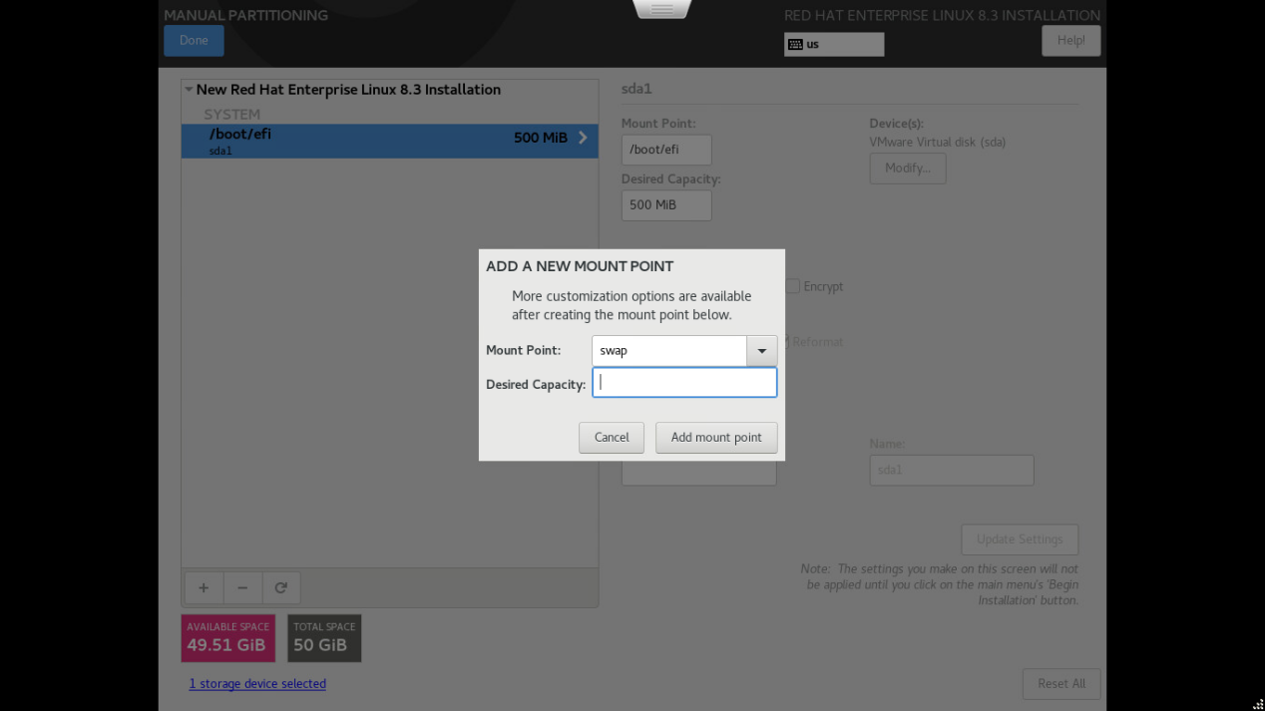

8 (b) Enter Desired Capacity “4096” or “8192” and click on Add Mount Point

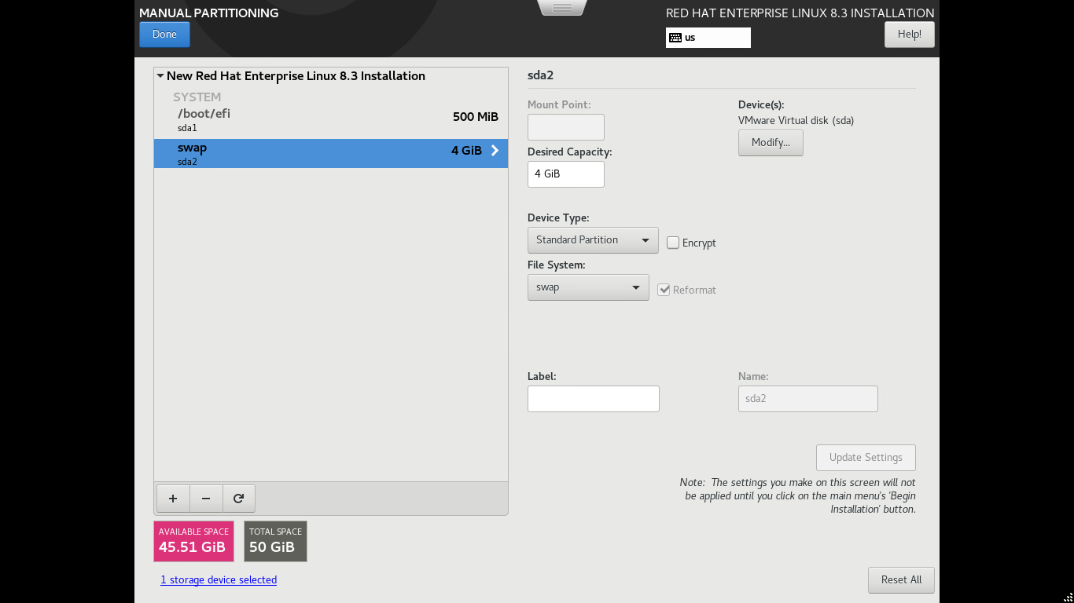

- (a) Click on “+” and select mount point as “/”

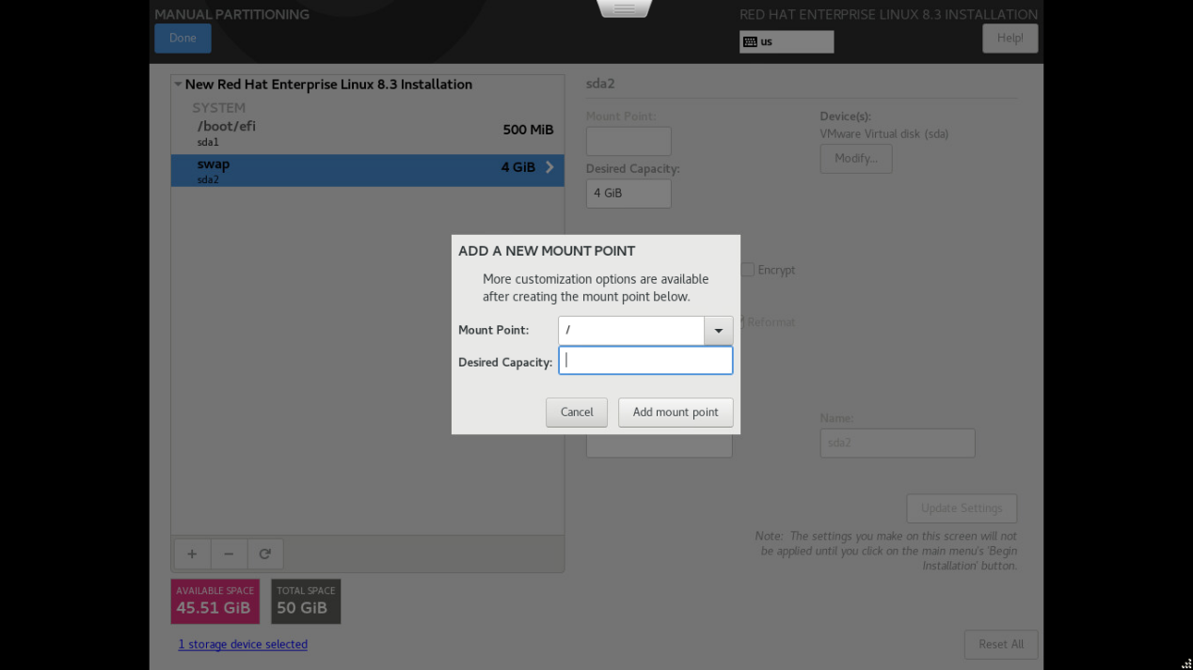

9 (b) Keep Desired Capacity as blank and Select Add Mount Point

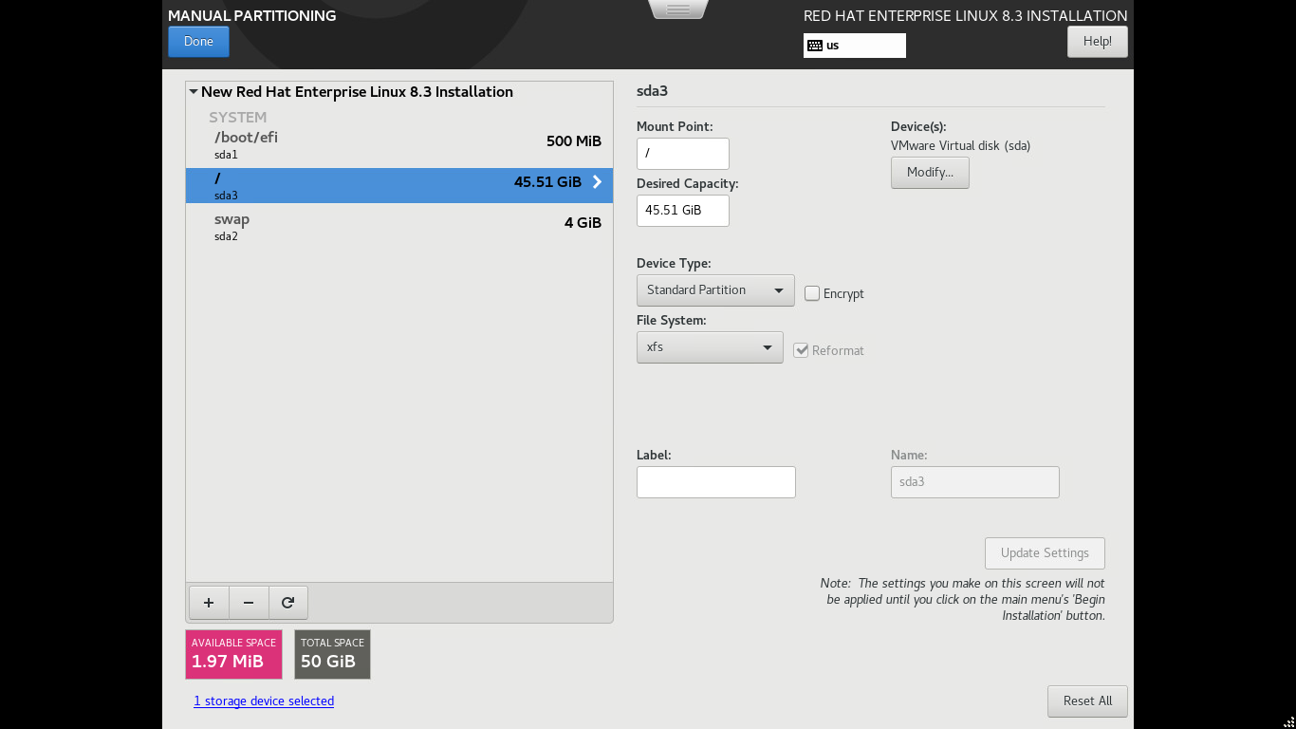

- (a) Click on Done Button over top

Input:

Output:

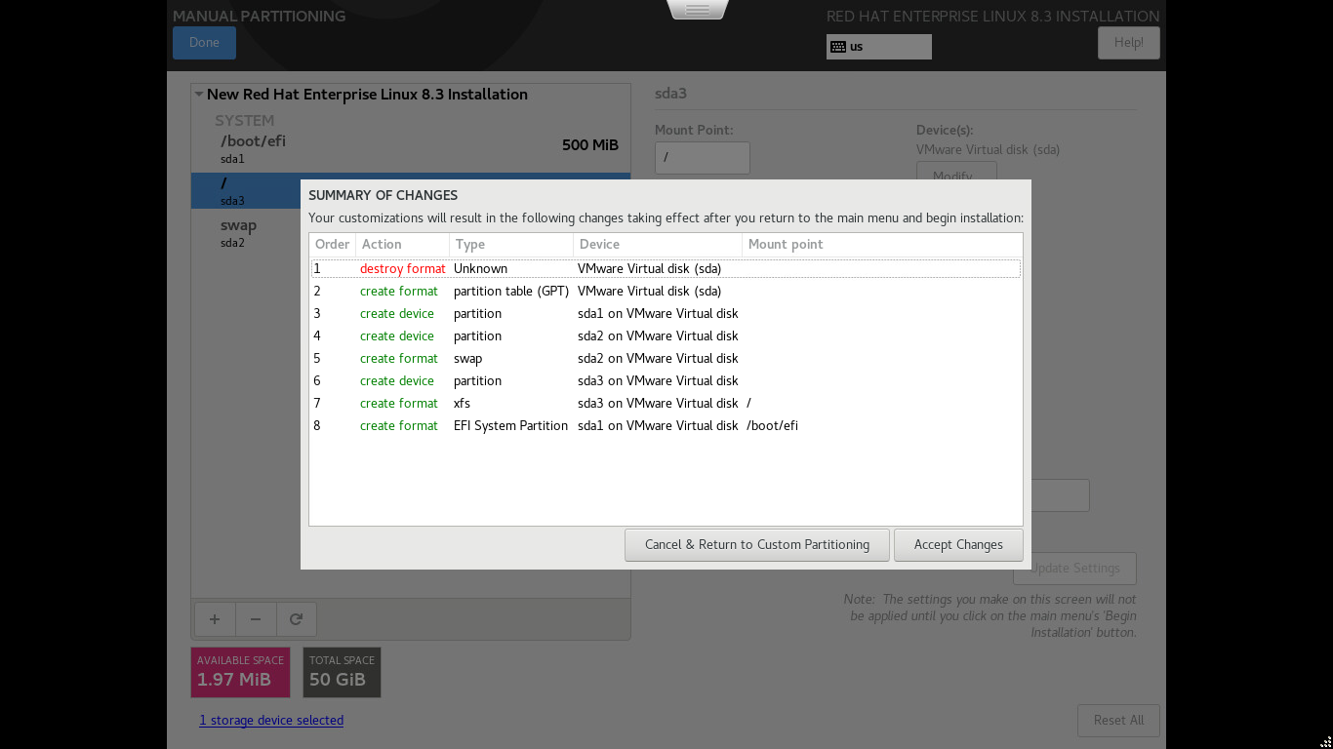

10 (b) Click on Accept Changes

Output:

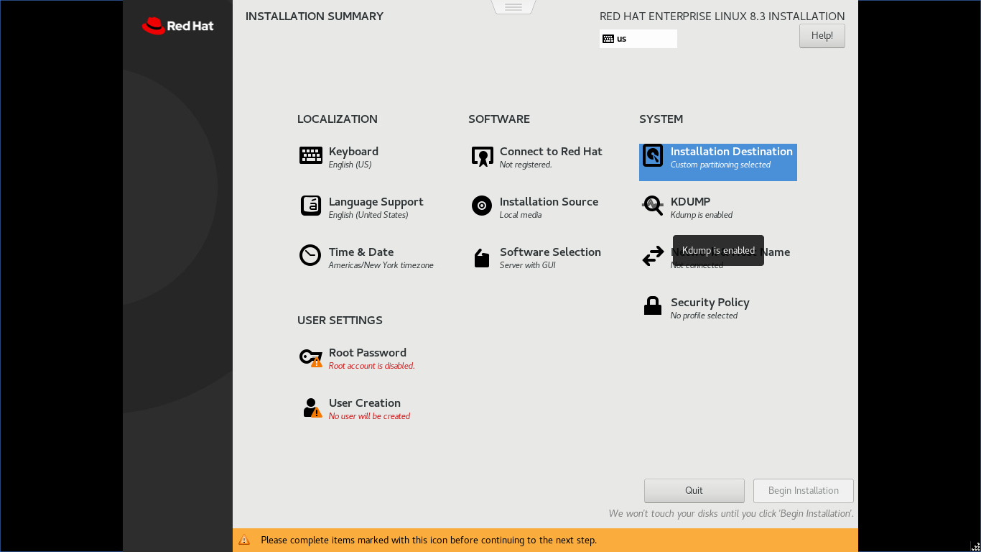

- click on time and date:

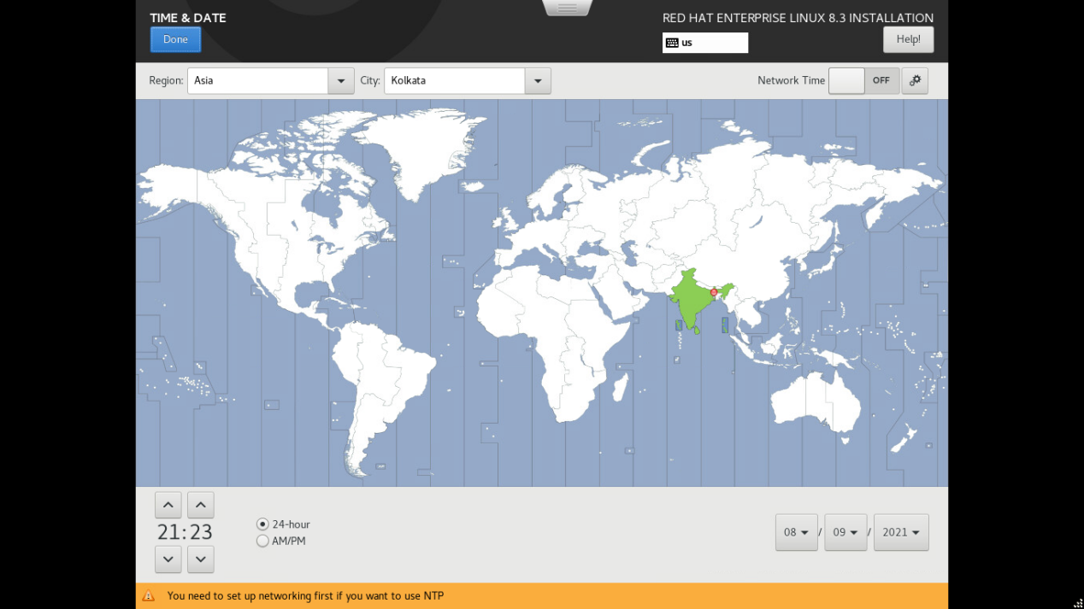

Select Time zone and click on Done

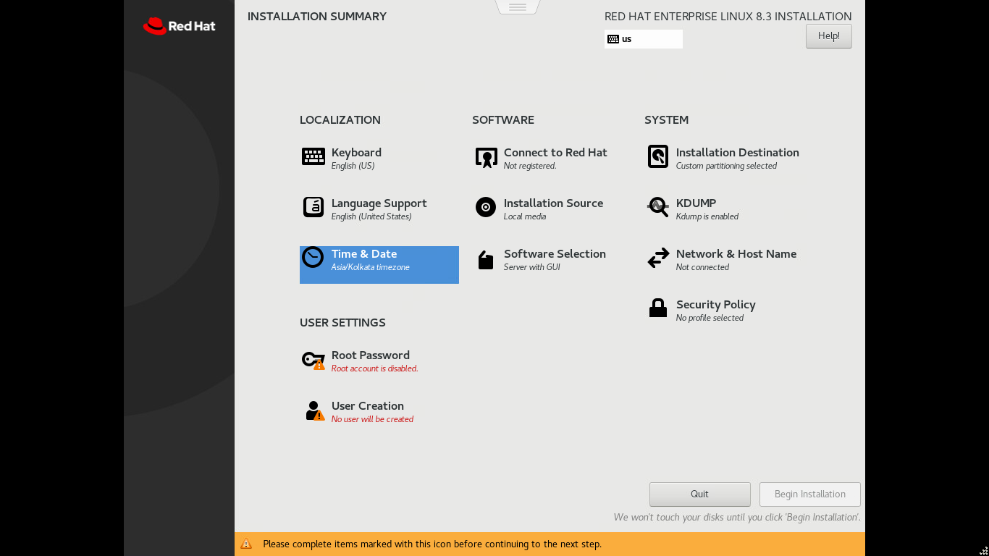

- Click on Software Selection:

Output:

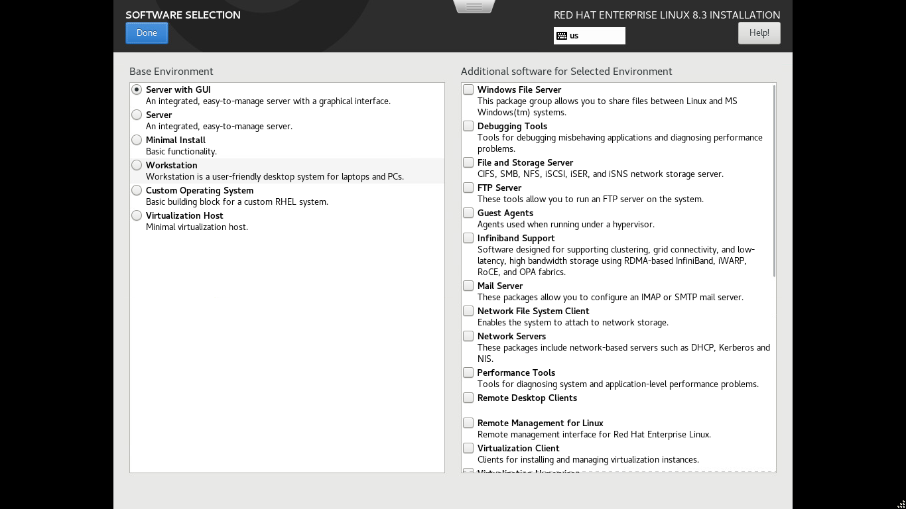

13 .Select Minimal Install from left side menu and select all check points from right side menu items.

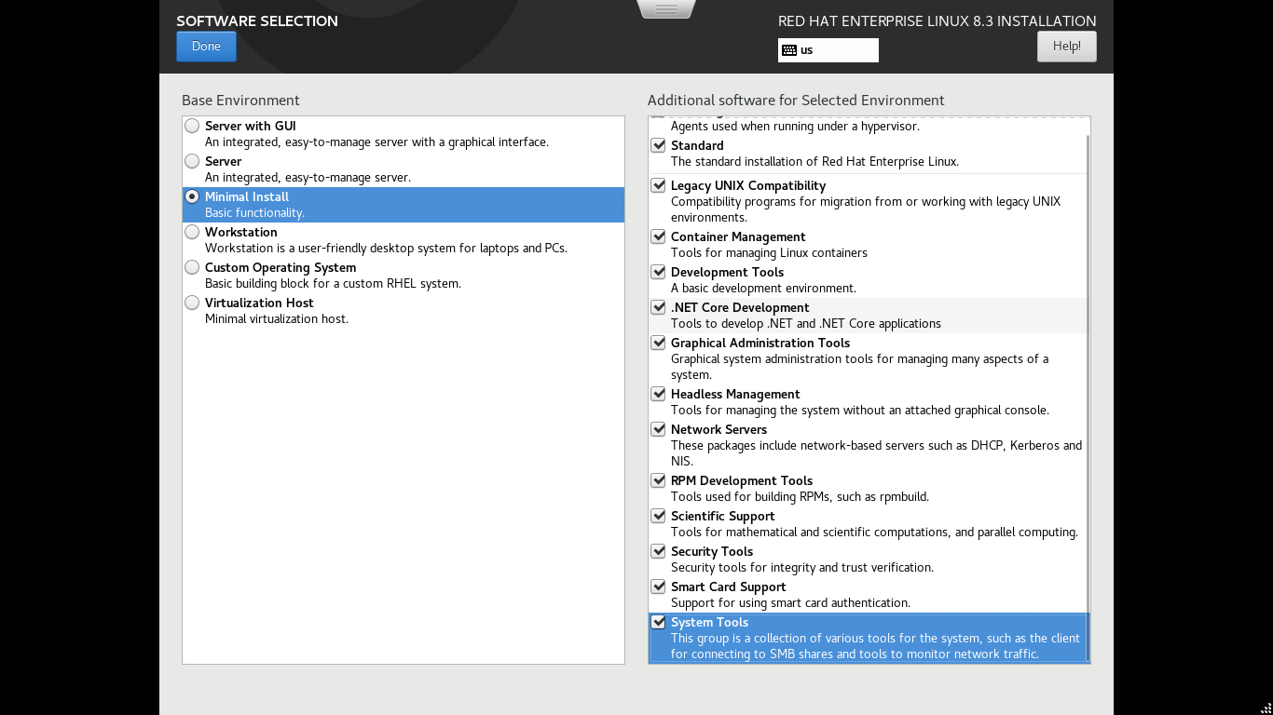

14. Click on Network & Host Name

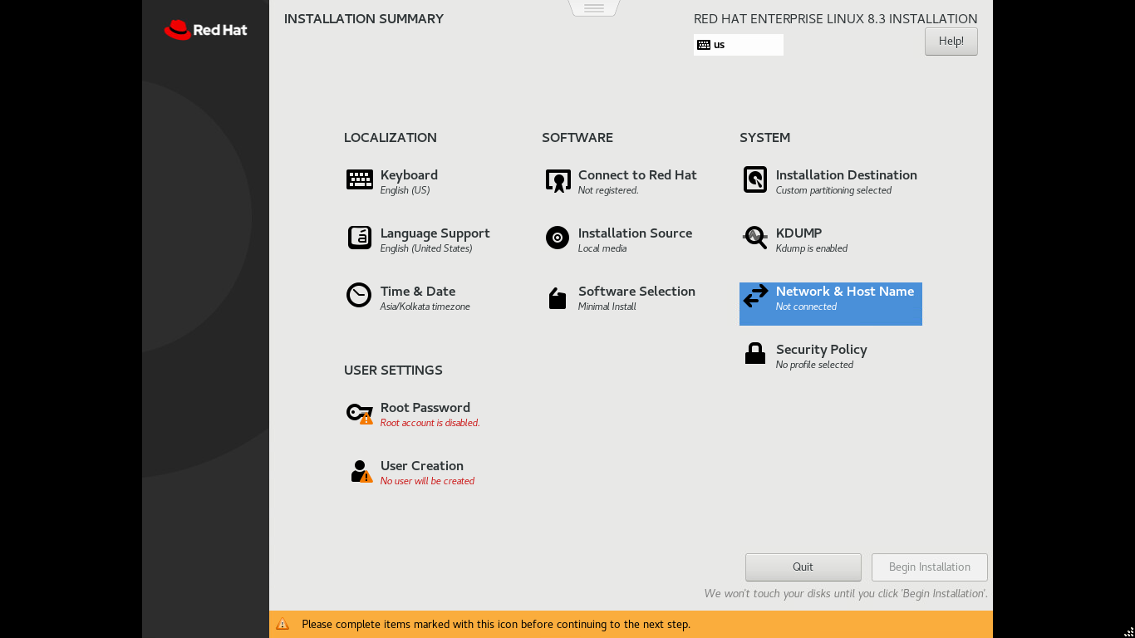

Output:

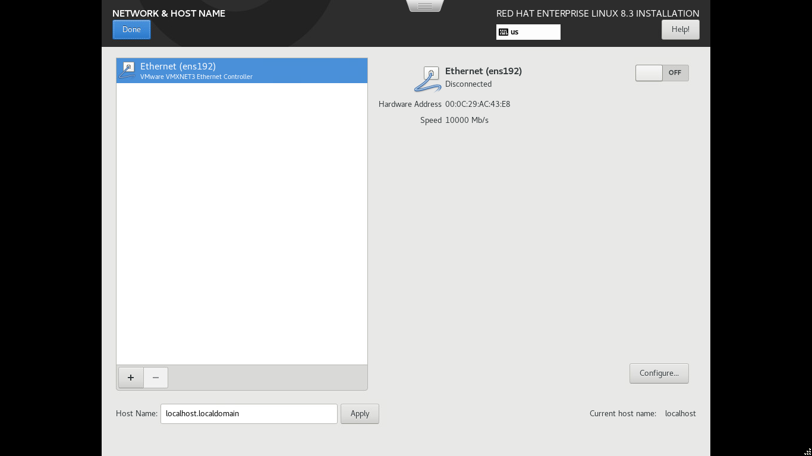

- Enable Ethernet from off to ON and click on Done

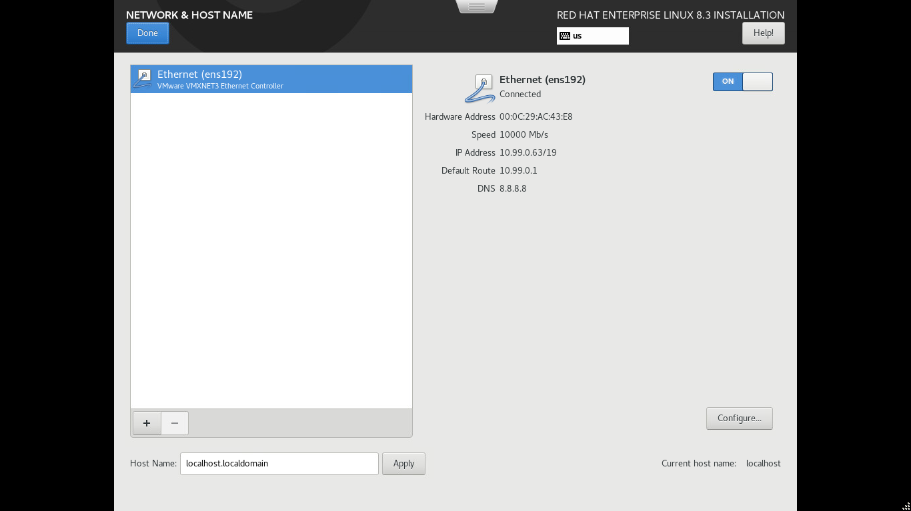

Output:

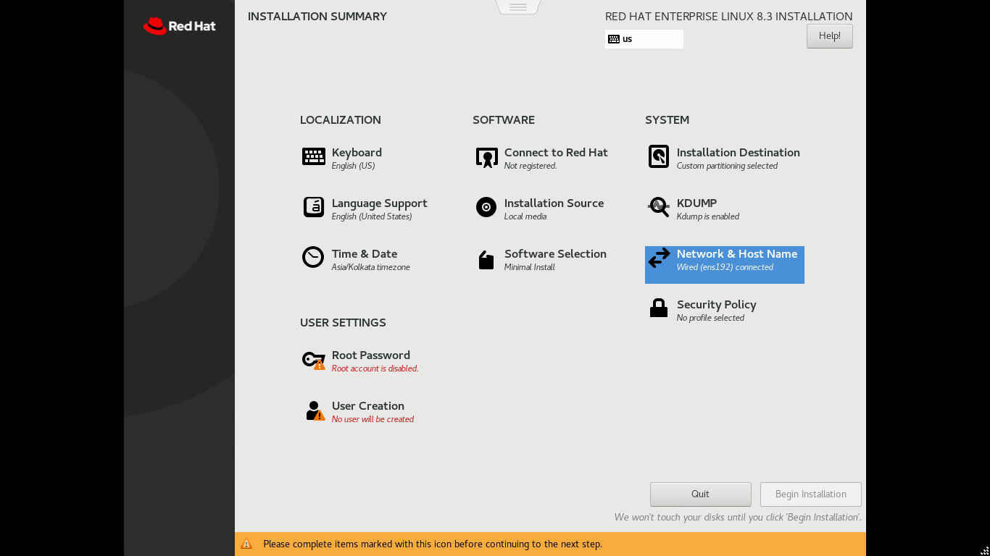

- Click on Root password:

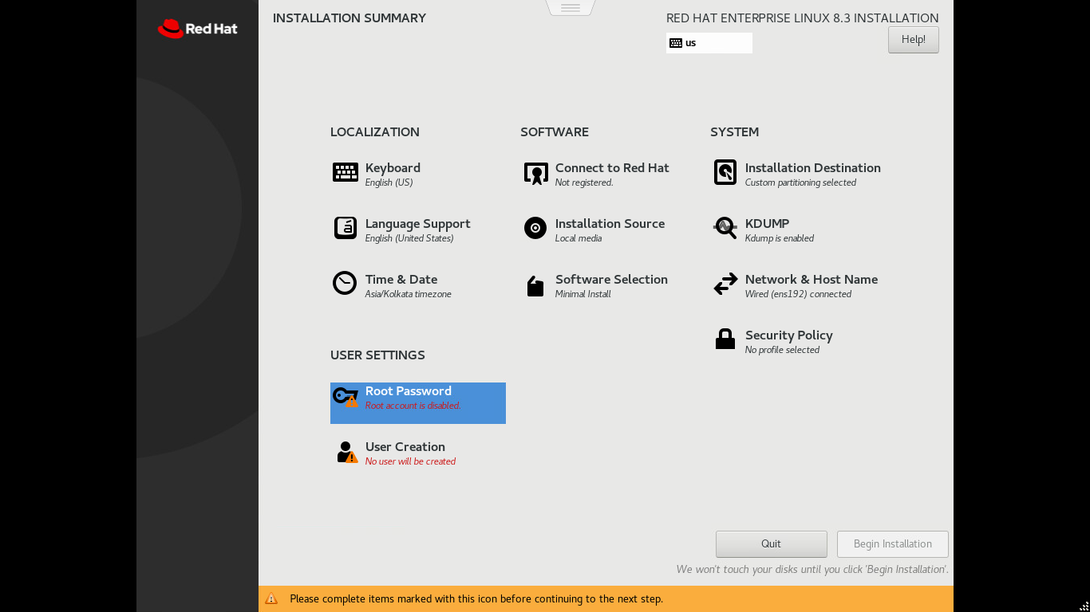

Output:

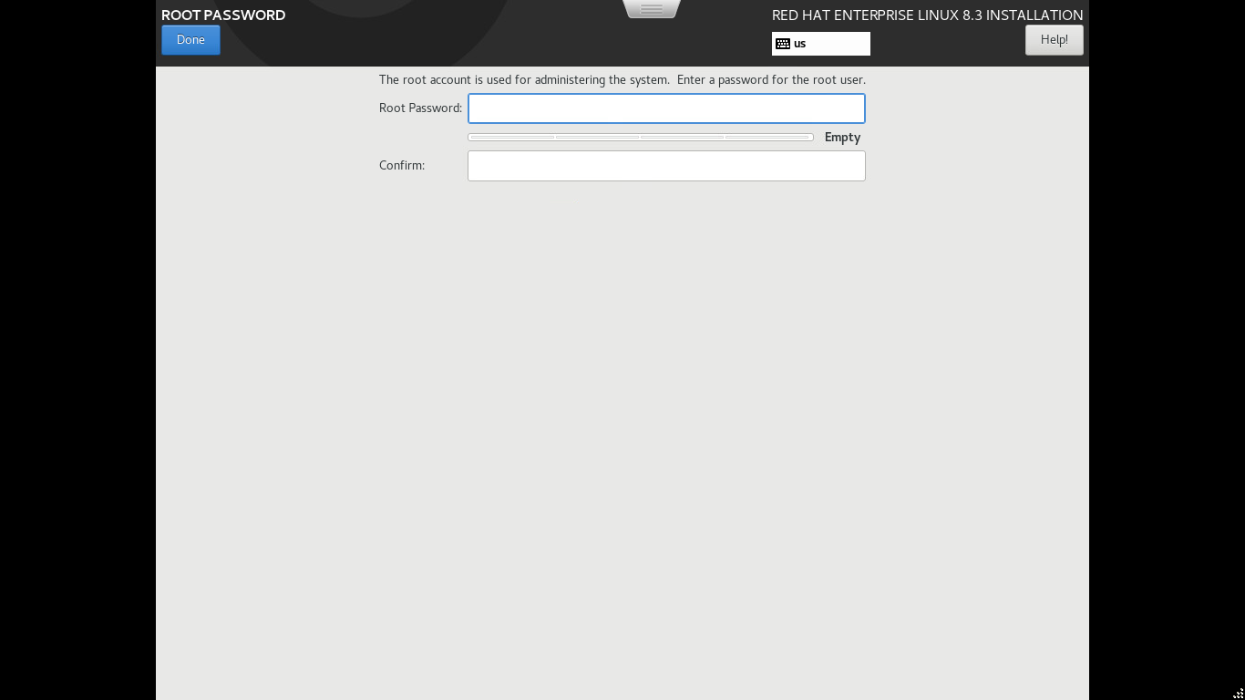

- Enter Root password, confirm password and click on Done

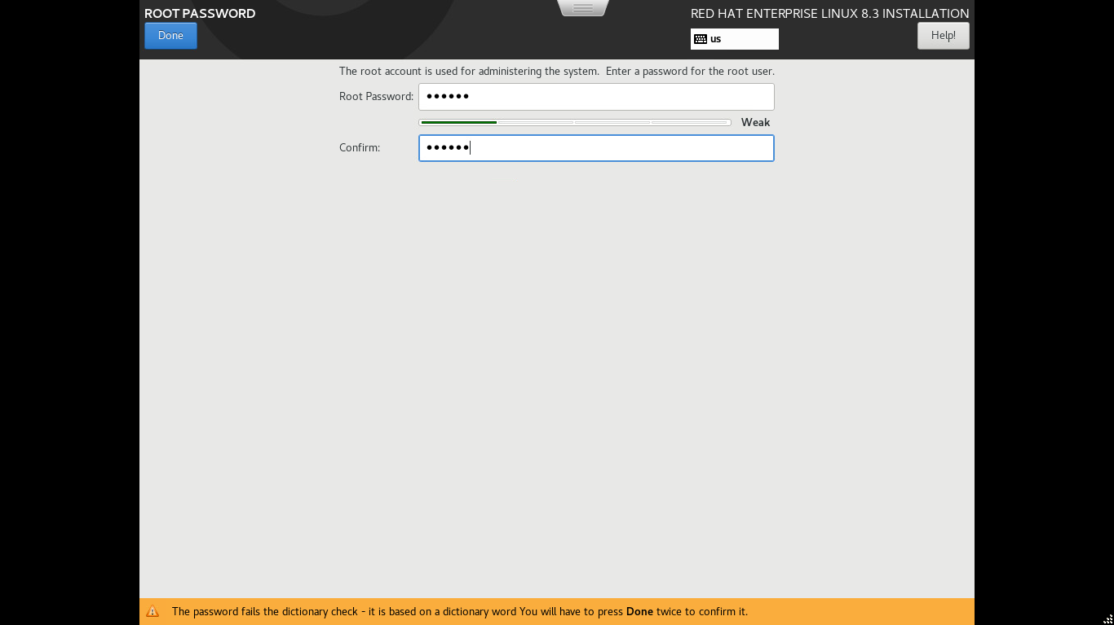

Output:

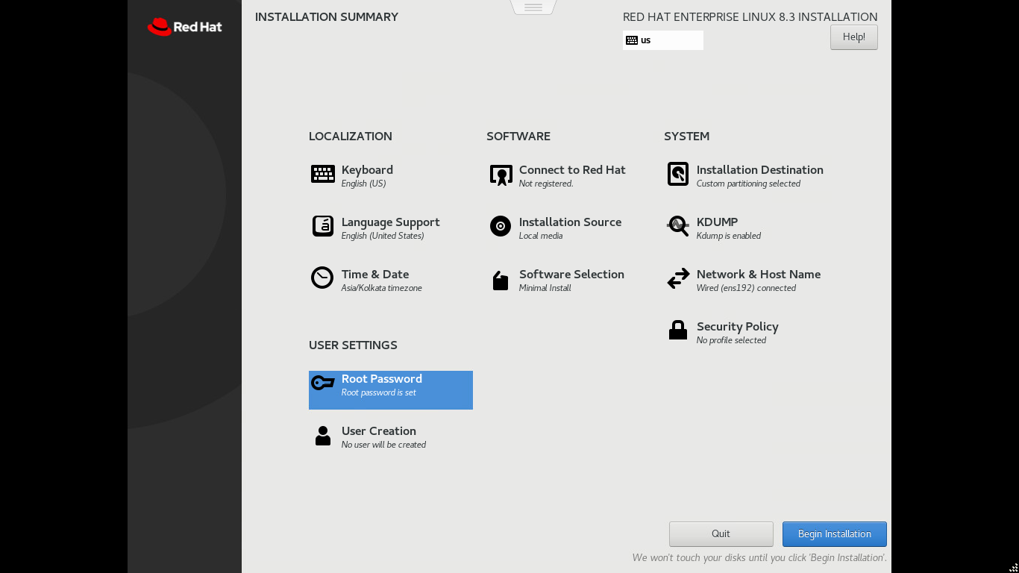

- Click on User Creation:

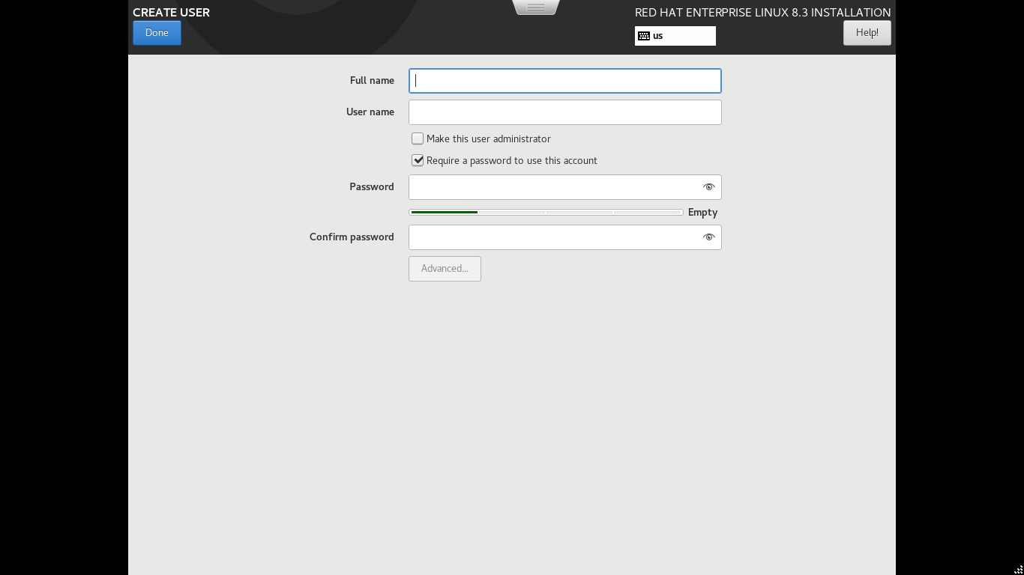

- Enter the valid detail and click on done button twice

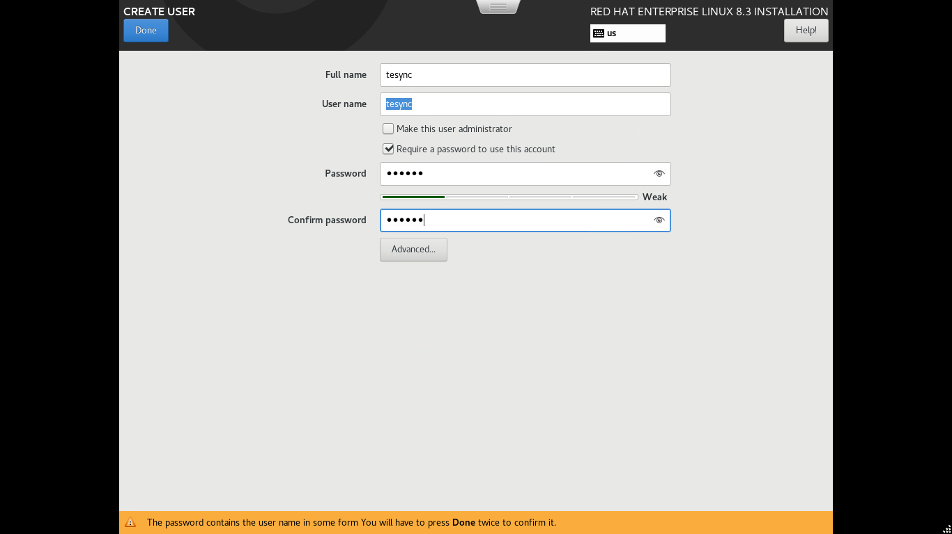

Output:

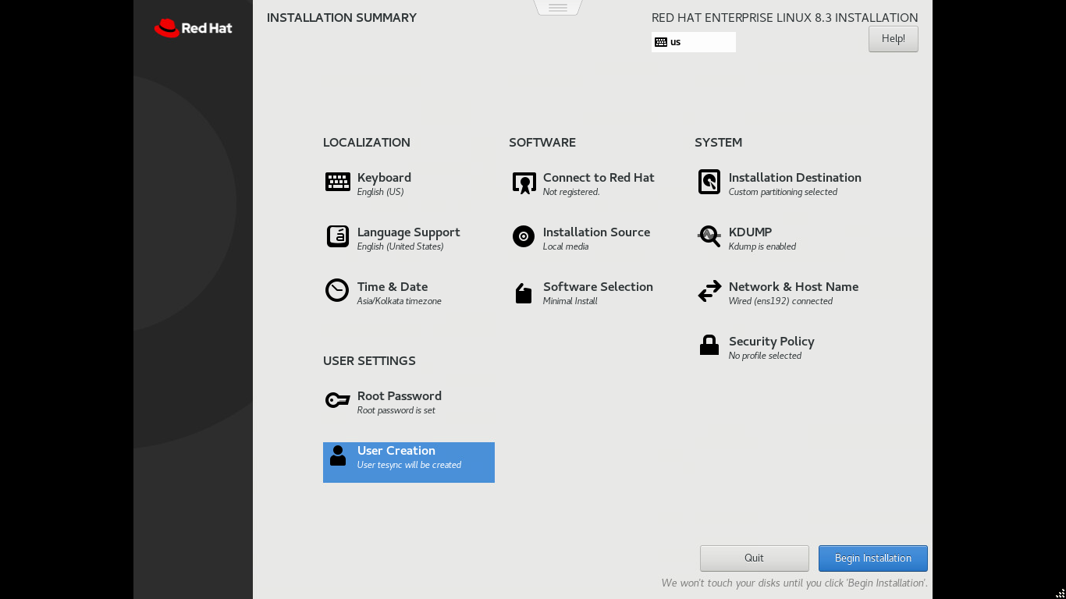

- Click on Begin installation

Output:

