Technologies

Java, Spring Boot

Steps:

Please follow the below steps to execute the project

1) Check out the project

2) Do maven clean install

3) Run com.github.ApiApplication file to start the server

4) Check server is started or not

5) If started, type "http://localhost:8080/getFollowerDetails?gitId=1555350" in browser

6) Response is in JSON object

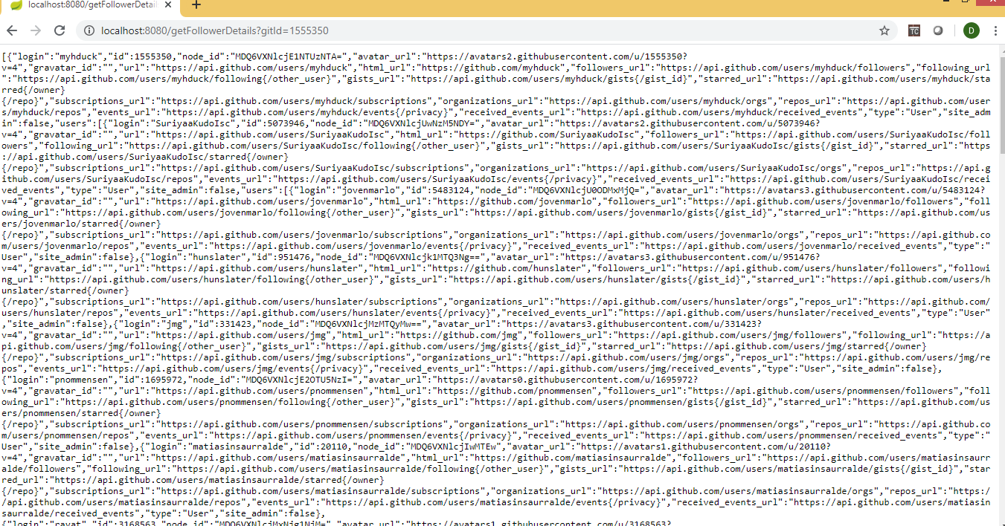

7) I have added response in response.json file in git to verify the output