FROME A GENOME DATABASE TO A SEMANTIC knowledge BASE
by
BOBBY E. MCKNIGHT
(Under the Direction of Ismailcem Budak Arpinar)
ABSTRACT
The association of experimental data with domain knowledge expressed in ontologies facilitates information aggregation, meaningful querying and knowledge discovery to aid in the process of analyzing the extensive amount of interconnected data available for genome projects. TcruziKB is an ontology based problem solving system to describe and provide access to the data available for a traditional genome database for the parasite Trypanosoma Cruzi. The problem solving environment enables many advanced search and information presentation features that enable complex queries that would be difficult, if not impossible, to execute without semantic enhancements. However the problem solving features do not only improve the quality of the information retrieved but also reduces the strain on the user by improving usability over the standard system.

INDEX WORDS: Semantic Web, SPARQL, Query, Ontologies, Bioinformatics, Genomics

from a genome database to a semantic knowledge base

by

Bobby e. mcknight
B.S., The University of Georgia, 2006

A Thesis Submitted to the Graduate Faculty of The University of Georgia in Partial Fulfillment of the Requirements for the Degree

master OF computer science

ATHENS, GEORGIA
2008

© 2008
Bobby E. McKnight
All Rights Reserved

Frome a genome database to a semantic knowledge base

by

bobby e. Mcknight

Major Professor: Ismailcem Budak Arpinar

Committee: John A. Miller
Liming Cai

Electronic Version Approved:

Maureen Grasso
Dean of the Graduate School
The University of Georgia
August 2008

ACKNOWLEDGEMENTS
Thanks to Maciej Janik and Matthew Eavenson (Cuadro project), Sena Arpinar and Ying Xu (collaborators at IOB), members of the J.C.K. Laboratory and the TcruziDB team (for facilitating access to data and evaluation subjects and providing valuable advice).

TABLE OF CONTENTS
Page
ACKNOWLEDGEMENTS iv
LIST OF TABLES vii
LIST OF FIGURES viii
CHAPTER
1 INTRODUCTION 1
2 DATA INVENTORY AND KNOWLEDGE ENGINEERING 6
3 VISUAL QUERY BUILDER 10
3.1 Query Structure 11
3.2 Enhancing Queries and Search Results 12
3.3 Natural Language Query Building 14
4 MULTI-PERSPECTIVE DATA EXPLORATION 19
4.1 Tabular Explorer 19
4.2 Statistical Explorer 20
4.3 Graph Explorer 22
4.4 Literature Explorer 24
5 EVALUATION 26
6 RELATED WORK 30
6.1 Keyword Search 31
6.2 Formal Language 33
6.3 Query Building 34
6.4 Natural Language Query 39
6.5 Hybrid Methods 41
7 CONCLUSION 44
REFERENCES 45
APPENDICES 45
A SCHEMAS AND DATASETS 50
B TCRUZIKB – WEB APPLICATION 55
C SUS EVALUATION RESULTS 71
D EMPERICAL EVALUATION RESULTS 72

LIST OF TABLES
Page
Table 1: SUS scores broken down by area of expertise 27
Table 2: A Breakdown of the Features Provided by Semantic Search Engines. 33
Table 3: A Breakdown of the Features Offered by Query Building Systems. 39
Table 4: A Comparison of Natural Language Query Systems. 43

LIST OF FIGURES
Page
Figure 1: Diagrammatic description of the ontology schema 7
Figure 2: SPARQL query created by the Visual Query Builder 13
Figure 3: Sample of the Interactive Natural Language Query Interface. 16
Figure 4: Sample of the Interactive Natural Language Query Interface. 16
Figure 5: Figure 5: Our interpretation of the parse tree from Figure 1.. 17
Figure 6: The Statistical Explorer showing the percentage of expression results for the property “Life Cycle Stage” 21
Figure 7: The results in graphical format. 22
Figure 8: Expanded Graphical Explorer 23
Figure 9: Formula for Gain and Entropy 24
Figure 10: Formula for document scores 25
Figure 11: Sample statement from SUS 26
Figure 12: The iSPARQL Interface 36
Figure 13: The GINSENG Interface in Action 42

CHAPTER 1
INTRODUCTION
The contemporary Bioinformatics researcher, when formulating a hypothesis or looking for evidence to validate one, commonly performs intensive querying to genome databases, i.e. using a Web interface to pose questions about a collection of information on one or a set of organisms. However, current techniques invariably require high human involvement to manually browse through an extensive mass of data, observe evidences, analyze their interconnections and draw conclusions. The size, diversity and complexity of data and tools make this a time consuming and difficult task.
The scientific analysis of the parasite Trypanosoma cruzi (T.cruzi), the principal causative agent of human Chagas disease, is our driving biological application. Approximately 18 million people, predominantly in Latin America, are infected with the T.cruzi parasite[1]. Research on T.cruzi is thus an important human disease related effort, which has reached a critical juncture with the quantities of experimental data being generated by labs around the world, in large part because of the publication of the T.cruzi genome in 2005 . Although this research has the potential to improve human health significantly, the data being generated exist in independent heterogeneous databases with poor integration and accessibility. Our goal is to integrate these data and create an infrastructure to facilitate their analysis and mining.
In contrast with the use of downloaded raw data and custom processing scripts for information integration, the association of experimental data with domain knowledge expressed in ontologies facilitates richer integration, meaningful querying and knowledge discovery to aid in the process of analyzing the extensive amount of interconnected data available for genome projects. The use of ontologies in this work, unlike the common understanding of ontologies in the Bioinformatics field , goes beyond the reference to a standardized vocabulary and explores the representation of conceptual relationships between entities to guide the researcher on “connecting the dots” from hypotheses to evidences, in a Relationship Web .
As part of this project, we engineered an ontology to describe domain knowledge and the data available for the project TcruziDB[2], a genome database for the parasitic agent Trypanosoma cruzi. In comparison with traditional genome databases the use of semantic web technologies in this context offers advantages such as:
- Unlimited flexibility on the query perspective: TcruziDB.org offers 5 standpoints, where the user can search for Genes, ESTs, Contigs, Scaffolds and ORFs. Those queries reflect the possible uses of the system as predicted by the development team and/or the community of users involved in the development stages. In such system, the user is limited to the available queries and in the advent of a request for new queries, human involvement is required for the implementation of the necessary SQL statements and visualization interfaces. Through the use of the ontologies’ schemas - i.e. the definition of the possible types of data and interconnections available in the knowledge base - we offer a high-level querying system, where the user is guided by the system throughout the process of posing a question in an intuitive way, e.g. looking for: “Gene -> codes for -> Protein -> expressed in -> Epimastigote (Life Cycle Stage)”.
- Complex query handling: a key component of ontologies as envisioned by our project is the concept of a relationship. Through the use of ontologies a user will be able to ask questions not only about entities (Genes, ESTs, ORFs), but also about how those entities are related. For instance, someone might be interested in giving 2 accession numbers for genes from different organisms and retrieving all the known relationships between those genes. Such query might return, for the sake of the argument, that they both have expression results in a life cycle stage where the organism is resident in water. This type of query is viable through the use of ontologies to reveal semantic associations, and is very difficult otherwise (e.g. Gene -> has expression -> Protein Expression -> in life cycle -> Life Cycle Stage -> environment -> Water).
-TcruziKB not only supports guided form based query formulation but a query mechanism all human beings are familiar with, natural language querying. Using this feature a user can ask questions in unrestricted English such as “Find genes that code for proteins that are in life cycle stages present in the human body”. While using the natural language query interface the user receives help from the system in the form of keyword suggestions from the knowledge base to help them properly construct a query.
- Loosely-coupled web integration of distributed data sources: most genome databases integrate data from different sources in some level, usually by downloading, parsing and storing external data in a relational database. In our system we are able to integrate our data with external sources in the server side, but also provide loosely-coupled dynamic integration at the client side. Through the use of Ajax, Linked Data and SPARQL endpoints, our system is able to dynamically query multiple sources and “mash up” the results in one page for visualization.
In addition to the provision of data integration and query capabilities, TcruziKB aims at helping the user on the difficult task of making sense of the information in hands. We implemented multiple interfaces for results exploration to allow for the user to analyze query results through different perspectives:
- The tabular explorer lists the results in a spreadsheet format, with a row per item and a column per attribute, while cells contain values. This perspective provides prompt access to all attributes of a group of items, allowing for sorting and filtering of data in a well known and widely used interface style for biomedical researchers.
- The graph explorer, by the other hand, focuses on relationships, drawing each item and value as nodes, and the attributes as edges. This perspective brings connectivity to the first level, allowing the researcher to unveil hidden relationships between data.
- The statistical explorer offers a higher level summarization of data in a first glance. It is often very important for the researcher to understand first the general characteristics of the dataset, before more specific questions can be posed.
- The enhanced literature search suggests papers that might be interesting to help the researcher to understand the result set being displayed. We calculate keyword weight based on the ontology and submit a query to the NCBI e-Utils[3] web services, before ranking and displaying the abstracts to the user.
We expect the above mentioned contributions to compose a valuable toolkit for data sharing and analysis on the Web that can be reused and extended for virtually any genome project, and even any domain of knowledge. In the following sections we describe the knowledge engineering and data acquisition for TcruziDB, followed by the query interface and the visualization perspectives. Both subjective and objective evaluation strategies are used to rate the usability of the system compared to the usability of the non-semantical enhanced TcruziDB. Final considerations and future work are presented in final chapters.

CHAPTER 2
DATA INVENTORY AND KNOWLEDGE ENGINEERING
In the field of Genomics, data comes from different sources and in heterogeneous representation formats. From simple char-delimited files (flat files) to complex relational database schemas, gigabytes of annotations are available for use[4]. We engineer an ontology to represent the knowledge in this domain and to serve as an umbrella for integration of the multiple sources.
The ontology engineering process comprised both a top-down (deductive) and a bottom-up (inductive) stage. Since the TcruziDB database was already available with valuable information, we started the modeling process by observing examples of data and building the definitional component of the ontology (a.k.a. ontology schema) in an inductive process. Following, we consulted the literature for precise definitions of the identified classes, and further deductive exploration of possible dimensions in the light of the identified use cases. In every class definition throughout the modeling process we searched for existing ontologies in order to reuse or extend its contents. Ontology reuse is highly desirable, since it promotes both the efficiency of the modeling process itself and the interoperability level of the resulting system.
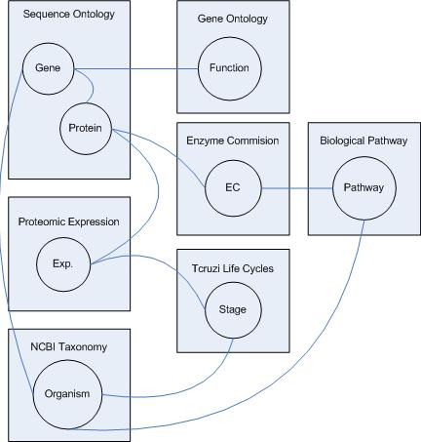
Figure 1: Diagrammatic description of the ontology schema

Through the ontology engineering process we identified a manageable subset from the domain to test the system and its underlying concepts. As depicted in figure 1, our ontology schema is able to represent genes, as well as the organisms they belong to and the proteins that they encode. Proteins may present enzymatic function, which in turn may be part of a process represented in a biological pathway. Proteomic expression is also captured, including the information about the life cycle stage in which the protein was expressed, as well as quantitative measures of that expression. GO, SO, Taxonomy and EnzyO are reused in this project.
While the ontology schema encompasses the description of classes and properties, as well as mappings and extensions to pre-existing ontologies, the assertional component of the ontology (also called knowledge base) associates data with definition from the domain model. We obtain data from several sources, including Pfam flat files, Interpro XML and relational data stored in the Genome Unified Schema (GUS) for TcruziDB. We automatically mapped the GUS Schema to an ontology using the D2RQ mapping framework . Some of the ~400 tables mapped were manually verified for enhancement and reuse of existing ontologies. The subset of the TcruziDB dataset used in this project includes: 19,613 automated gene predictions (protein coding); 139,147 protein expression results from metacyclic trypomastigotes (CL strain) and amastigotes, trypomastigotes and epimastigotes (Brazil strain) of T. cruzi. The dataset also features links to the sequence ontology, gene ontology and enzyme commission numbers. Some external data was also downloaded and imported from flat files to the ontology, containing information such as: 31,630 protein domain (Pfam) annotations; 8,065 ortholog groups predicted by the OrthoMCL algorithm.
As part of the knowledge base creation process, every biological sequence (nucleotides or amino acids), as well as annotations associated with those sequences are identified in our system by a URI. We choose to use the original URL that gives access to the item in its original web interface as their identifier. We also added this URL to the rdfs:seeAlso annotation property, so that we are able to take the user to the original web interface by a click within our interface. If the original URL changes through time, the URI will still be a valid identifier, and we can update the rdfs:seeAlso property to reflect the most up to date URL for the item. However, if we desire to import more data into the knowledge base, the URL change could possibly cause inconsistencies if not treated appropriately. This problem can be overcome by contacting the data provider and having them to commit to a naming scheme (e.g. a basic namespace) independent of the resource location (URL). We are in the process of establishing those contacts.
The ontology schema produced as a result of this work is domain focused, instead of application specific. This means that it can be reused by other applications in the same domain or in related domains of knowledge. Additionally, any project that commits to the use of these ontologies enables seamless inter operation with our system, enabling our reuse of their data, or their utilization of ours.

CHAPTER 3
VISUAL QUERY BUILDER
The key enabler of TcruziKB visual query builder is the ontology schema, which represents all possible types of data residing in the knowledge base and how they can be interconnected. Through the use of RDFS domain and range meta-properties, we are able to describe a property in terms of the class that it applies to, and the range of possible values that it can assume – as in the property “translated_to” applies to a “Gene” and its value has to be a “Protein”. It is through these property descriptions that our system is able to guide the user in building a query.
The system starts the query with a standard information retrieval (IR) task, in which the user performs a simple keyword query for a term (class or instance) to start building a more complex query. This initial search is performed on top of the whole set of ontologies loaded by the system. Its performance is enhanced by “indexing” the data in advance (as it arrives) — an appropriate vector is built for each item, and stored in a vector-space database (the Lucene text search engine is used for this purpose). The user can directly select an instance of interest to root the query onto, or select a class and accept “any” instance of this class as a result. Then, by reading the ontology schema, the system retrieves all possible properties that apply to the selected “root” term, and present them in a list for the user to choose. When a property is chosen, another background query to the schema retrieves the possible classes in the range of that property, and the process continues iteratively, until the intended query is achieved. After the user has built the query through the visual interface, the system encodes and submits a SPARQL query to the server in the background (via Ajax calls).
Item 3.1 explains in details the structure of the queries built, and the automatic extensions implemented by the visual query builder. Item 3.2 explains the support for queries to multiple servers. The results for the queries are obtained in XML and can be displayed through several user-friendly perspectives. Item 3.3 details the basic characteristics of the result set and how the system implements a protocol for the result set’s content enhancement. The multi-perspective exploration of the results is presented in details in the next chapter.

3.1 Query Structure
The queries composed by the visual query builder are directed graph patterns to be searched in a knowledge base. The graphs can be decomposed in paths, the paths decomposed in triples and the triples decomposed in basic elements.
The basic elements of a query are: class, instance, property and variable. The triples compose the basic elements in the structure: “subject (S), predicate (P), object (O)”, where subject and object can be a class, instance or a variable, and the predicate can be either a property or a variable. For example, observe the triple “GeneX, codes_for, ?protein”, where the question mark preceding an element denotes a variable. A query using this triple indicates that this pattern is to be searched in the knowledge base, allowing the variables in the triple to be substituted by any actual value that matches the remaining of the triple. In the example showed, the query will return any proteins that GeneX codes for, as long as this is explicitly stated in the knowledge base through the property “codes_for”. Triples can be connected to one another to form a path, such as “(genes, codes_for, ?protein) AND (?protein, ?related_to, Amastigote)”. In this example, we composed a path by using the logical connector “AND” to connect two triples. Logical connectors supported are “AND” and “OR”. The expected result for this query would be any proteins that have any relationship with the Amastigote life cycle stage of Tcruzi, along with the relationships found as part of the result. The addition of filters to constrain the matched results is also possible. In the visual query builder we support filters in order to search for elements that match a certain regular expression, such as “all proteins whose names starting with 'Muc'.” Other advanced elements are envisioned, such as searching for any paths connecting two instances, with the possibility of expressing constraints on the searched paths, as described in previous work by our research group . Such advanced issues are under development and are not supported by the system as of this moment.

3.2 Enhancing Queries and Result Sets
An important feature of the query builder is its ability to guide the user through a directed graph pattern from any standpoint, in any direction desired. For example, a user should be able to start in a “Protein” and find any “(?protein, has_expression, ?proteinExpression)”, as well as start in “ProteinExpression” and find any “?proteinExpression, is_expression_of, ?protein).” We anticipate that not all data sources will explicitly state the inverse of every property, so the query builder is able to create a virtual “inverseOf” relationship for the user interface. The virtual relationship is realized by its concrete inverse by flipping the subject and object. As a matter of fact, we anticipate that some data sources will not present an ontology schema of any kind. In that case, the visual query builder navigability would be seriously compromised, since it would not know which property applies to which class. However, for cases where the schema is not present, but the metadata is – i.e. there are no domain and range descriptions, but the type of the instances is known – we can build a virtual schema by inspecting all properties and the types of their subjects and objects. This feature is supported, but not executed automatically due to its computational cost.
After the user has built the desired graph pattern to be searched, the visual query builder pro actively enhances the query by adding triples to retrieve extra information about the results (in case they are available). So, in addition to what was explicitly stated by the user to be present in the results, the system retrieves the label, type and original web page for each resource. These additions are valuable in analytical interfaces since they facilitate the understanding of the information presented. Please refer to Figure 2 to see an example of a SPARQL query created by the visual query builder.
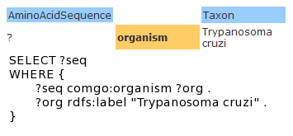

Figure 2: SPARQL query created by the Visual Query Builder

The interaction between the client (TcruziKB Query Builder) and the server is defined by the SPARQL Protocol for RDF . Servers implementing that protocol are often called SPARQL endpoints. We support queries to multiple SPARQL endpoints by storing a list of servers and performing calls to all of them each time a query is executed. The results are asynchronously received from the SPARQL endpoints and aggregated in a result set for further presentation to the user. The aggregation of results is nicely handled by the use of RDF and ontologies. The addition and configuration of new SPARQL endpoints is supported through our user interface. As a consequence, researchers using our system can automatically integrate and use new data sources without any development intervention.
We extended the SPARQL Protocol for RDF to support the automatic configuration of a SPARQL endpoint in our system. The extension is backwards compatible, so if a specific endpoint does not respond to the implemented extensions, it will still be added to the system. The extension basically consists of the implementation and retrieval of an ontology-based description of the namespaces cited in a SPARQL endpoint.

3.3 Natural Language Query Processing
A typical problem in bioinformatics is that the user of a particular program may not have a great deal of background in computer science. Therefore, requiring that queries to the system be asked in a formal query language is an unreasonable assumption. It is partially to overcome this limitation that research in natural language querying exists. Ontology assisted natural language processing has received much attention recently but still has many shortcomings when applied to real datasets. TcruziKB encompasses much of the existing research by providing an interface to allow biological researches to ask questions in natural English language but also utilizes algorithms to compensate for their shortcomings.
When a user opts to enter a query in natural English they are presented with a simple text box that they can enter text into. Because the initial phase of forming a query in this manner can be overwhelming suggestions are provided in a similar manner to the visual query builder that allow the user to select a starting point for their query except suggestions do not solely come from they ontology, they also come from a set of predefined English rules such as “Who”, “What”, “Find”, and so forth. After the user enters in some initial starting words they are presented with other suggestions relating to what they have previously entered. For example, if the user has entered “Gene” in their query they would be presented with suggestions corresponding to the properties of the Gene class from the ontology as well as English rule words. In figure 3 below, the user has entered a partial sentence and is now presented with suggestions most relevant to the word they are currently typing as well as words relating to other ontology words they have previously typed. In this case the user has entered the word “gene” previously and is not being presented with suggestions corresponding to properties of the Gene class in the ontology.
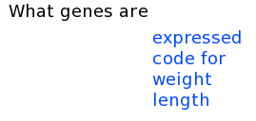

Figure 3: Sample of the Interactive Natural Language Query Interface.

Given an English sentence the Stanford parser builds a parse tree where each node denotes a part of the sentence. For example, “What is the life cycle stage of GeneX”gives the parse tree in Figure 4 and the interpretation can be seen in Figure 5.
(ROOT
(SBARQ
(WHNP (WP What))
(SQ (VBZ is)
(NP
(NP (DT the) (NN life cycle stage))
(PP (IN of)
(NP (CD GeneX)))))
(. ?)))
Figure 4: The parse tree generated from the Stanford Parser for the sentence “What is the life cycle stage of GeneX?”

Root (What is the life cycle stage of GeneX?)

What
is

the life cycle stage

of

GeneX

zzzzzzzz

Figure 5: Our interpretation of the parse tree from Figure 1.

The parse tree is now traversed in a pre-order fashion. While performing the mapping, stop words are ignored. The mapping of the nodes of the parse tree to the concepts in the ontology is done in two phases. In the first phase we try to map nodes in the parse tree to the properties in the ontology. If we find a match then a triple is created and is populated with the property. We pass this triple to the second phase. If a match is not found then we find the synonyms to the node from WordNet. For each synonym for WordNet[5] step 2 is repeated until we find a match. If no matches are found at the end of step 3 then we proceed to the second phase.
In the second phase we try to map nodes in the parse tree to the classes and instances in the ontology. If we find a match and if the second phase has been passed a triple containing a property then the class or instance is placed in the triple based on the domain and range of the property. This could still leave ambiguities such as “Protein -> interacts_with -> Protein” where the domain and range is the same. In this event the grammatical structure is used to determine if the instance is the subject or object. In the event that an entity can not be resolved to a triple then a new triple is created and populated with just the class or instance. If a match is not found then we find synonyms to the node from WordNet. For each Synonym for WordNet step 2 and 3 are repeated until a match is found. If no matches are found at the end of step 4 then the algorithm terminates. At the end of the second phase our triple/s is/are generated. We then build a SPARQL query using the triple/s.

CHAPTER 4
MULTI-PERSPECTIVE DATA EXPLORATION
Traditional databases in Genomics offer interfaces for data visualization that are limited to tabular formats [5], [6]. Some more sophisticated tools are available to render tabular data in the form of genome maps [7], but very little support is provided for analytical tasks that prioritize summarization and finding relationships between entities. In addition, the ability to “drill down” or keep exploring a result set with new requirements is very often not supported. Some genome databases such as the ones based on the GUS WDK support a query history and set operations on the results for the queries stored in the history. That means, for instance, that a user could make two distinct queries and choose to download the intersection of the result sets.
In the TcruziKB query interface, we lead the user directly to the formulation of complex questions in a flexible query builder, without requiring multiple queries and set operations on them. Additionally, we recognize that very often users do not know exactly what to expect in a result set, and thus we offer different perspectives of visualization so that the user can have an overview and better direct his search from the initial point on.

4.1 Tabular Explorer
The tabular explorer displays a result set in the form of a table of rows and columns, with each row representing a solution to the query. The columns represent variables that can assume as values a set of instances, properties or classes. This is a major difference to standard genome databases, where no query can be asked about “relationships” or “classes”, since those are not explicitly represented in the database. Those systems allow for queries such as “other entities related to a given entity”, but no support for “what relationships exist between two given entities” is provided. The interface allows the user to further filter or reorder the results in the table, providing extra exploration functionality.

4.2 Statistical Explorer
To allow for an overview of a result set, we created the statistical explorer. It aims at showing a statistical summary for each solution to a query. For each variable in the query, the system offers a chart per property. For each class-property pair, the chart shows the proportion of instances that assume each possible value. For instance, for a query for all protein expression results, the system would present one pie chart for each property of the class Protein (e.g. life_cycle_stage, ortholog_group, etc.), reflecting the distribution of values for those properties (e.g. 23% have value “Amastigote” for the property “life_cycle_stage”). This can be used to see how the set of instances in the result set compares to the knowledge as a whole.
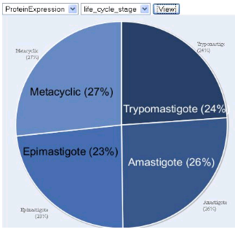

Figure 6: The Statistical Explorer showing the percentage of expression results for the property “Life Cycle Stage”

4.3 Graph Explorer
Ontologies define relationships between data which lends itself naturally to a directed graph representation. The query results can be displayed on a graph with classes/instances corresponding to nodes and properties corresponding to edges in the graph. This graph could give a biologist additional insight on the data by looking for clusters or paths between classes. By right clicking on a node, the results can be extended by adding additional classes and properties. This could reveal more relationships between the results. For a visual example refer to Figures 7 and 8. Figure 7 shows the query results in graphical format while Figure 8 shows the same graph appearing in Figure 7 but after the user has selected to add additional features. In this case the user has selected to show the organism that the amino acid sequences belong to. This demonstrates the power of the visualization format where a connection between two sequences becomes now apparent.
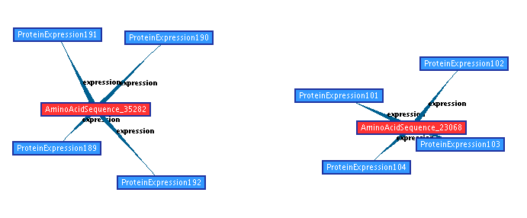
Figure 7: The results in graphical format. In this example the user has chosen to show amino acid sequences and the expression results for those proteins.
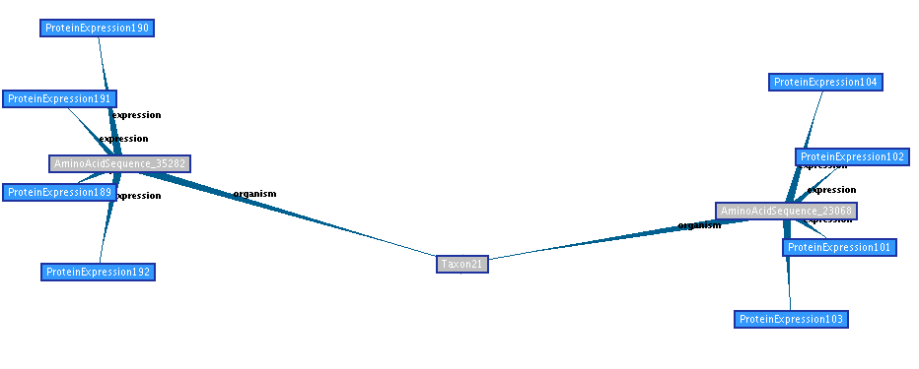
Figure 8: Expanded Graphical Explorer.

We recognize that graphs can get easily encumbered with too much information. The Graph Explorer offers the option to arbitrarily contract edges of a node or to select the most important edges, by coloring them in shades of red - from lighter red, less important, to stronger red, more important. We calculate the importance of relationships based on co-occurrence of data. For example, if a group of ortholog genes all contain a given annotation (e.g. protein domain), that will show that this is probably an important feature for that class of proteins. To calculate the importance of an edge, we pre-compute the information gain for each pair of classes that are interconnected in the ontology, i.e. classes that are in either side (domain or range) of a property. The following figure gives formula for entropy and gain. S represents the set of all instances, and A the set of all values for a given attribute (ontology property). V is a value of A, and Sv is the subset of instances of S where A takes the value V. The norms denote the size of the sets S and Sv respectively.

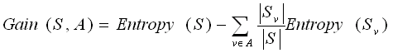
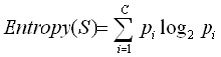
Figure 9: Formula for Gain and Entropy

4.4 Literature Explorer
In the field of Genomics, a researcher would commonly execute queries, visualize results and then look for publications that would confirm or complete her knowledge about the results she obtained for a given query. To again try to reduce the time invested by the researcher in browsing through massive information, we provide a loosely coupled integration with Pubmed, providing a dynamically generated list of abstracts that might be interesting in the context of the data being visualized.
We use the results from feature selection and ontology-based keyword augmentation to improve document retrieval in a Pubmed search. The top features selected with higher information gain are augmented with keywords from the ontology. Keyword augmentation is done by gathering other words that occur in the neighborhood of an instance, such as the label (rdfs:label property), class/superclass (rdfs:subclassOf, and rdf:type properties) and two hop connections (an instance connected to a neighbor, where a neighbor is any instance connected to a given “root” instance).
Document score is computed by multiplying the frequency of the term in the paper by the weight calculated by feature selection and ontology distance.

S = F * W
S = F * Gain / log2(D+1)
S = Score
F = Frequency
W = Weight
Gain = Information Gain defined in formula 1
D = Distance (in ontology)
Figure 10: Formula for document scores

CHAPTER 5
EVALUATION
We evaluated TcruziKB both subjectively and objectively with regard to its parent system, TcruziDB. A panel of 30 university members including professors, graduate students, and undergraduates were asked to perform searches using TcruziKB and TcruziDB and record their experience. For the subjective evaluation, the System Usability Scale (SUS)[8] was used as the benchmark. SUS is a 10 question form that rates the usability of the system from 0, very user unfriendly, to 100, highly user friendly. The average SUS scores for each system can then be used to compare the usability of the systems.

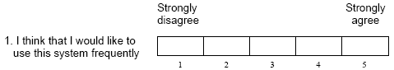
Figure 11: Sample statement from SUS

After using the system for several minutes to answer sample queries, the panel members scored their results on the SUS forms. The SUS averages show that the usability of TcruziKB is very similar to TcruziDB. TcruziKB received an average SUS score of 90.54 while TcruziDB scored 88.11. This implies that even though TcruziKB incorporates many advanced features it does not sacrifice usability, in fact it became slightly more usable than its parent system. The scores are broken down by area expertise in the table below.

Background Area | #users | TcruziKB Score | TcruziDB Score
Overall | 30 | 90.54 | 88.11
Computer Science | 20 | 95 | 84.77
Biology | 10 | 91.43 | 90.03
CS and Biology | 5 | 100 | 97.61

Table 1: SUS scores broken down by area of expertise

For the objective evaluation, five members of the panel were asked to record the time taken and the number of computer interactions (the number of mouse clicks and keystrokes) needed to perform a query on each system. For benchmarking, the following queries, of variable complexity, were given to the panel:
“Which genes have a protein expression where the parasite resides in the human body?”
This query can be executed as a single path query on TcruziKB of the form: “Gene → codes for → Protein → expressed in → Life Cycle Stage → resident in → Human Body.” On TcruziDB, the query is much less straightforward to execute because it requires the user have knowledge of the parasite, specifically which life cycle stages are relevant to the search.
“What are the relationships between gene Tc00.1047053409117.20 and any gene that has protein family PF03645?”
This query will require the user to search for the gene in question and browse through the links on its gene description page until the relevant protein family is found with TcruziDB. This requires a great deal of human involvement to accomplish because the user must manually follow links to determine if they contain the data they are looking for. In TcruziKB most of the work is done by the system, the user need only construct a query using the query builder.
“Which genes are in proteins expressed in the Epimastigote stage and in the Trypomastigote stage?”
With TcruziDB the user will need to view all genes that are in proteins expressed in the Epimastigote stage using the query forms then start a new search for all genes in proteins expressed in the Trypomastigote stage. After both searches have been conducted the user can get the genes that are expressed in both stages uses the “Combine Results” feature. This three step process on TcruziDB can be done from a single query in our system. “Gene → codes for → Protein → expressed in → Epimastigote AND Gene → codes for → Protein → expressed in → Trypomastigote.”
While both TcruziKB and TcruziDB were similar in terms of usability TcruziKB had a significant edge in time taken and the number interactions needed to obtain the query results. The average time taken to execute the above system was much less on TcruziKB than TcruziDB, which had times of 117.33 seconds and 211.33 seconds, respectively. This is because a great deal of backtracking is needed to construct complex queries on TcruziDB. The user actually conducts several queries to the system then must combine the results of each. In TcruziKB complex queries can be constructed all at once, eliminating the backtracking and thus reducing the time needed because only one query is executed. This avoids the time needed to obtain and display the results of each query and the time needed to integrate the results. The need for backtracking in TcruziDB is also reflected in the number of interactions needed requiring an average of 53.33 interactions as opposed to an average of 21.33 interactions in TcruziKB. This implies that time needed to do the backtracking is not only unnecessary computer processing time but is also time spent by the user doing unnecessary work.
We also rate the performance of the system's natural language query feature in it's ability to correctly answer various questions in plain English. We use a sampling of the English language equivalent of the simple gene finding queries appearing on the main web page of TcruziDB. These queries include “Find information on gene id Tc00.1047053508461.30”, “Which genes relate to kinase” and “Which proteins are expressed in the Epimastigote stage and have 3 percent sequence coverage?”. To get a diverse list of questions and to accommodate for different grammatical habits the 30 survey participants were asked to write questions or commands using the terminology on the gene search section of the TcruziDB homepage. A total of 50 questions were executed on the system and recall and precision was calculated. The system scored a recall of 90% and a precision of 83% showing it to be very effective at processing natural English language and generating the correct SPARQL needed to formally answer the query.

CHAPTER 6
RELATED WORK
The Semantic Web allows user's to ask far more complex queries than are possible with the current web and get far more precise results. This is because while the World Wide Web is human readable; the Semantic Web is computer readable meaning that computers can do far more meaningful computations on the data than with the previous web. The Semantic Web also is free of the ambiguities plaguing the web because everything is annotated in the owl language with concepts from ontologies that give document elements a formal definition. This allows Semantic Web agents to know the difference between “apple” the company and the fruit. Identifiers called URIs also remove additional ambiguities by assigning an identification key to a concept a computer can know if two entities are the same or different without regard to how they are labeled in the document.
In addition to these improvements, the Semantic Web also allows graph pattern type queries instead of the simple keyword queries that are common on the web today. This means a user can ask highly specific questions to a Semantic Web agent such as “Find gas stations in Atlanta where the gas price is less than $4.00”. The Semantic Web will not only know what each of the entities in the query mean (due to identifiers and ontologies) but will also know how they relate to each other (via properties in the ontology).
While these enchantments promise much for the Semantic Web to be successful it has to be able to be used easily by technical and non-technical users alike. Current World Wide Web search agents offer great simplicity in design in order to avoid alienating the average user, the Semantic Web much have ways to compete will this level of usability without sacrificing the enhancements that set it apart from the traditional web. In this section I explore research that hopes to accomplish just that. I cover query methods based on keywords that are similar in appearance to current web searches. I also look into formal language based methods of querying the Semantic Web similar to those in relational databases. Then, a promising method that assists user's in building formal queries so that complex queries can still be asked without direct knowledge of formal query languages is explored. Next, I examine the use of semantics in natural language querying, specifically mapping natural language queries to ontologies. Finally, I look into hybrid methods that combine query building and natural language processing.

6.1 Keyword Based
In keeping with the current methods of web search there has been considerable work done is searching the Semantic Web with keywords. Using interfaces that appear to be normal search engines with simple input boxes and search buttons powerful semantic searches can be conducted. These searches dig into the rich RDF and owl files that make up the semantic web and retrieve results free of ambiguity for the user.
One such keyword based search engine, SWSE (Semantic Web Search Engine)[22], accepts user input in a very similar fashion to current web search. However, once the search is executed it through an index of semantic documents to find relevant classes, properties, and ontologies pertaining to the user's keyword. For example, a search for the keyword “university” retrieves several hits relating to classes in ontologies. Furthermore, the results can be organized according to several fields such as properties and classes. SWSE provides a simple method to access current semantic documents and could prove to be particularly useful when searching for an ontology to use for a particular set of data.
Another keyword based search engine, Swoogle[23], allows the user to select which type of semantic documents they which to search through such as ontologies, documents, or terms. Keywords are then used to search through the set of document to find meaningful semantic results such as URIs, classes, properties, or entire ontologies on the subject. Again, this system eases the burden of finding relevant ontologies which would otherwise be a time consuming task all while using an interface very similar to Google.
Other semantic search engines offer similar functionality [24][25][26] and these same ideas even extend into highly domain specific areas such as biology [27][28]. Refer to Table 1 for a break down of the features provided by these systems. However, a common flaw remains in each, they are limited in their expressibility because they use such a simple query mechanism. Although they provide interfaces that are very familiar from the user standpoint, keyword based searches alone can't take full advantage of the rich relationships provided in ontologies.
System Name | Categorized Search | Categorized Results | Ontology Finding
SWSE | No | Yes | Yes
Swoogle | Yes | No | Yes
SinDice | Yes | Yes | Yes
Semantic Search | Yes | Yes | No
Yahoo Microsearch | Yes | Yes | Yes
Curbside.MD | Yes | No | No
Semantic Health Search | Yes | No | No
Table 2: A Breakdown of the Features Provided by Semantic Search Engines

6.2 Formal Language
The negative side of simple keyword based semantic search engines is that they fail to provide a mechanism for asking complex queries that can be asked with formal query languages. The Semantic Web offers an even richer possibility for discovering interesting relationships than even relational databases currently offer because of the RDF graph presented by the related semantic data. This opens the door for graph-based queries such as searching for specific graph patterns.
The SPARQL query language for RDF [29] is a W3C standard specification for a formal language to query RDF data with. SPARQL allows a user to specify a regular expression or graph pattern in order to obtain meaningful results. The queries asked can involve many classes and put constraints on several properties forming complex graph patterns such as “Find amino acid sequences that are expressed in the Epimastigote stage that have a minimum percent coverage of 3”.
SPARQLER [30] adds even more complexity to the SPARQL specification by allowing for path based queries and adding. SPARQLER allows users to discover relationships between two classes such as “Gene X” and “Cancer”. Under SPARQLER constraints can also be placed on the path requiring a certain number of nodes on the path or requiring that a specific pattern appear on the path.
SPARQL and SPARQLER allow users to take full advantage of the rich relationships provided by Semantic Web data to overcome the shortcomings of simple keyword based search engines. However, with the added complexity of the queries comes an at the expense of usability. It is safe to assume that the average web user would be able to make the change to a semantic keyword based search due to the similarity of the interface but suddenly requiring that web users use a formal language to express they query is not a safe assumption. The following section covers a middle ground combining the simplicity of keyword based search engines while still allowing expressiveness in query formulation.

6.3 Query Building
Researches are working on methods of combining the simplicity of keyword based searches while still allowing for complex relationship based queries in hopes of allowing non-technical users to be able to express their query in terms so the system can understand it. Semantic based query building is one method of achieving just this. Query building involves assisting the user as they construct their query. This could mean providing the user with suggestions from back end ontologies relevant to their keywords, providing drop down boxes with constraints, or other forms that build formal queries behind the scenes. Table 2 at the end of this section shows the features offered by several query building systems.
SEWASIE[31], is an example of an existing query building semantic information system. SEWASIE presents a visualized ontology that the user can browse through for a starting point to their query. For example, if a user was interested in finding information on mp3 players they could select the class labeled “Mp3_Player” from the visualized ontology. From this point they are presented with the list of properties, in the form of drop down boxes, belonging to the “Mp3_Player” class (along with inherited properties from it's parents) that they can place constraints on. Suppose a user selects to place a constraint on the “price” property, then they can enter in their constraint. This could include constraining the price to be less than $100 for example. Executing the query at this point would return all instances of “Mp3_Player” from the ontology that have a value for the “price” property that is less than 100. The user could also place additional constraints on other properties forming a query that includes many relationships and many other classes.
The downside of the SEWASIE system is in the initial query building phase, selection of the class of interest. SEWASIE actually presents the entire ontology for the user to browse through. This has the potential to be overwhelming for the user as ontologies can contain data far beyond the scope of interest of the user resulting in the user navigating through many items that are of no interest. The size of ontologies could also potentially overwhelm the user as they must navigate through a gigantic and complex web of classes, a far cry from more traditional search methods.
Other query building systems actually allow the user to build a graph pattern visually that can be used to search through semantic knowledge to find matches. The tool iSPARQL[32] does just that. The side of the interface contains all classes from the underlying ontologies. The user selects a class from the list and a node appears on the graph interface. Other classes can be selected resulting in new nodes being added to the graph. The user can select properties to connect the nodes with forming a graph. When a search is conducted the graph pattern built by the user is translated into SPARQL and used to find matches from the semantic knowledge are presented in various formats to the user. The figure below shows a screen shot of the iSPARQL interface in the initial query building stages.
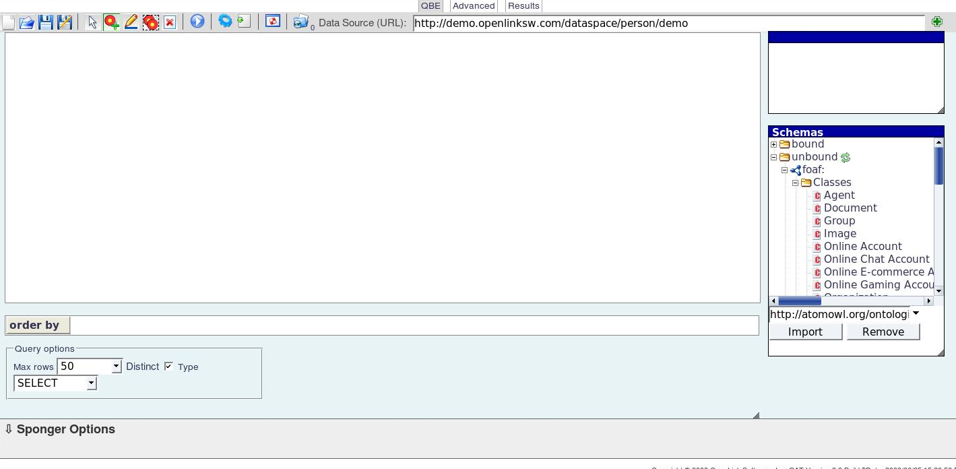
Figure 12: The iSPARQL Interface

While iSPARQL allows for any SPARQL query to be constructed its interface is vastly different than traditional web searches and could prove difficult to use for most. User's of the web a accustomed to typing their search and the switch to building an RDF graph might prove to be a ][difficult transition. Other systems [33,34], similar in design to iSPARQL and SEWASIE, fall victim to the same problems.
The GoGet[35] system, an interface specifically designed for the biological domain uses a semantic search technique common in many relational database backed information systems. It breaks down various fields from the ontology into forms that the user can search based upon. For example the user can enter text into a box labeled “Gene” to limit the search to instances of genes. Text can be entered in other forms as well, placing different constraints on different classes and properties, allowing for a more complex query. The system is highly limited, however, only working with one specific ontology. It also can not allow for some of the more sophisticated path based queries supported by the other query building systems.
TcruziKB, while being designed for the field of biology and comparative genomics, can support any RDF or OWL document making it useful to any field. It is similar in functionality to SEWASIE, allowing users to construct complex path based queries with help from the system. While SEWASIE uses a visualized ontology to find classes from the ontologies, TcruziKB opts for a more traditional approach, keyword based search. The use can enter in the name of a class to begin the query with and as they type suggestions from the ontology are fetched and shown to the user to assist them in their selection. For example, if a user types “Amino” they are presented with the suggestions “Amino Acid Sequence” and “Amino Group” from the ontology. This eliminates the problem of navigating through large ontologies because all of the information is entered in text box format.
Once a class is selected the system then provides a list of the properties belonging to the selected class via a drop down menu. A user can choose one of these properties to place additional constraints on. Suppose a user has selected “Amino Acid Sequence” as a starting point for their query, the system then presents them with a drop down box containing all the properties of “Amino Acid Sequence” including “protein expression”, “organism”, “go term”, and so forth. The user can select from amongst any of these and then place additional constraints on the range of the selected properties. For example if the user selected “organism” they are presented with a new text box which allows them to constrain the query based on the organism property. The user places constraints on this property in the same manner they began their query, typing keywords into the text box. This time, however, suggestions appear based on instances of the selected property.
The user is not just limited to forming a single triple. Each time the user selects a class or instance they can continue to enter in additional constraints building complex graph patterns. The user can also select “any instance”, “any property”, or “any class” at any stage during the query building process to allow for additional levels of complexity in the query. This results in the user being able to ask queries of the form “Amino Acid Sequence -> organism -> any organism -> resides in -> Human Body”.
System Name | Visual Querying | Suggestions | Multiple Data Sources | Path Based Querying
TcruziKB | Knowledge from the ontology presented to the user | Classes, properties, and instances | Any RDF/OWL ontology | Yes
SESASIE | Ontology drawn on the interface. Forms used to constrain fields. | No | Yes | Yes
ISPARQL | User constructs graph | No | Yes | Yes
GRQL | Ontology drawn on the interface. Forms used to constrain fields. | No | Yes | Yes
SDS | User constructs graph | No | Yes | Yes
GoGet | User completes forms | No | No | No
Table 3: A Breakdown of the Features Offered by Query Building Systems

6.4 Natural Language Querying
Since users of the web are able to verbally phrase the complex query they wish to execute natural language query processing seems is a research area that hopes to eradicate the difficulty associated with entering in complex queries. In natural language query systems the user enters in a query in their own native language, no special computer syntax is needed. With these systems as long as the user knows what they are looking for, they can ask it. It is the job of the system to understand what the user is thinking.
Advances in natural language parsing tools such as the Stanford Parser[37] and the Japanese Parser[38] have made it easier for a machine to understand the information contained in natural language text. These programs can identify the parts of speech contained in text such as nouns, verbs, and prepositions and construct a parse tree showing how the identified entities relate to each other. Dictionaries such as WordNet[39] and VerbNet[40] not only assist in part of speech tagging but also in allowing machines to match entities contained in text to concepts defined formally such as in ontologies.
ONLI[41], The Ontology Natural Language Interface, is a system that uses natural language parsing to tag and build a tree for a user's query given in natural language. The system uses the parse tree filled with tagged entities to match these entities to classes, properties, and instances in a background ontology. The structure of the parse tree allows triples to be constructed out the matches entities because it shows how the entities are connected to each other. The triples can then be transformed into a formal query language and executed on the knowledge to produce the results.
The limitation of ONLI is in the matching of tagged entities from natural language to formally defined ontology concepts. ONLI requires the user to be precises when entering in a natural language query by choosing words from the ontology to use in their query. This is not always a reasonable assumption to make. Ontologies can be very large and without suggestions of synonym support using the exact word found in the ontology is not always possible without a great deal of research.
Cypher[42], a similar semantic based natural language query system, advances the research by learning speech patterns as it is used. This AI based approach takes user input in natural language to form triples that are used to build a formal query, however, unlike ONLI, Cypher gets better each time it is used because of the underlying neural network that maps from natural language to ontology. Despite promising great improvement over ONLI, Cypher still does not take advantage of the popular open source dictionaries WordNet and VerbNet.
Overall natural language parsing remains a very difficult problem and achieving perfect accuracy in transforming a query in natural language into a formal query is still a long way off. Furthermore, there are many factors that affect the success of such systems including the size of the ontology, how rich the ontology is, and the parser used. The following section discusses research into combining query building with natural language processing to avoid having to solve the NLP problem.

6.5 Hybrid Methods
The more promising aspects of natural language querying and query building have been combined into one with the hopes of improving the accuracy and usability of semantic search interfaces. GINSENG[43], is a query building system with suggestions, similar to TcruziKB. However, instead of simply suggestion words from the ontology the system also suggests English words that can be used to enhance the query even though they don't appear in the ontology. These words can be simple stop words such as “the”, “of”, etc. or can be words that change the meaning of the query entirely such as “How many”, “at least”, “and”, “or”, etc. The system knows how to process these special words and uses rules to determine exactly how the formal language query resulting will be formed.
While GINSENG uses suggestions to enhance the interface it is not really doing in natural language parsing. It is simply building triples while looking at a set of predefined rules to order them. The end result if a query building system with suggestions from the ontology, rule words, and stop words and although it is not technically doing any natural language parsing the matching works better than pure natural language query processing systems because everything is selected by the user based on words the system understands. If a user follows the suggestions they can not enter in a query that the system won't understand.
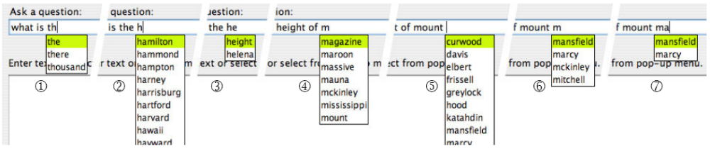
Figure 13: The GINSENG Interface in Action

TcruziKB also offers a natural language query processing interface combine with a query builder. Unlike, GINSENG, the words suggested are, just that, suggestions. The user does not have to select from them, they are free to enter in any natural language question. TcruziKB does part of speech tagging and parse tree construction for the user's question and then maps entities to concepts in the ontology much like ONLI does. However, whereas ONLI didn't take advantage of dictionaries or suggestions, TcruziKB uses both of these things in hopes of achieving greater accuracy.
Even in hybrid methods, designing a semantic system to be able to answer any question relating to it's underlying ontology is a long way off. A successful system in this area will need to take advantage of dictionaries, use keyword suggestions (but not rely solely on them), and use AI so it's better with time and adapts itself to it's user base. See the table below for a side-by-side comparison of the NLP and hybrid methods discussed.
System Name | Integrated Data  (from various sources) | Suggestions | Query Language | Synonyms | Parse  Tree Construction
TcruziKB | Yes | Yes | SPARQL | Yes | Yes
GINSENG | No | Yes | RDQL | No | No
ONLI | No | No | RDQL | No | Yes
Cypher | Yes | No | Several Supported | Yes | Yes
Table 4: A Comparison of Ontology Based Natural Language Query Systems

CHAPTER 7
CONCLUSION
We presented an application of ontology-based information aggregation, querying and exploration in the context of the Trypanosoma cruzi Genomics.
We constructed a query builder capable of composing complex queries through the navigation of ontology schemas. This approach enables complex queries that were only possible in traditional genome databases through multiple executions of simple queries and subsequent combination of results. User-provided addition and querying of new data sources is supported in a plug-and-play fashion.
Complex queries that require Web services executions to obtain parts of query results are supported through an extension to a SPARQL Endpoint implementation. As part of such queries, services are invoked and the results obtained are merged to the result set and returned to the user for presentation. The presentation and exploration of results in multiple interfaces is also investigated, helping to highlight for the researcher a manageable subset of interest from an extensive mass of information.
We expect the above mentioned contributions to compose a valuable toolkit for data sharing and analysis on the Web that can be reused and extended for any domain for which ontologies exist. As future work, we envision the expansion of the dataset, support for SPARQLER type path queries, and subgraph discovery queries.

REFERENCES
- WHO. Chagas. Accessed 24 March 2008.
- Luchtan, M., Warade, C., Weatherly, D., Degrave, W.M., Tarleton, R.L., Kissinger, J.C., TcruziDB: an integrated Trypanosoma cruzi genome resource. Nucleic Acids Research, 2004.
- D Maglott, J Ostell, KD Pruitt, T Tatusova. Entrez Gene: gene-centered information at NCBI. Nucleic Acids Research, 2005.
- NCBI Genbank Statistics http://www.ncbi.nlm.nih.gov/Genbank/genbankstats.html
- Dennis A. Benson, Ilene Karsch-Mizrachi, David J. Lipman, James Ostell, Barbara A. Rapp and David L. Wheeler. GenBank. Nucleic Acids Research, Vol. 28, No. 1 15-18, 2000.
- The InterPro database, an integrated documentation resource for protein families, domains and functional sites. R Apweiler, TK Attwood, A Bairoch, A Bateman, et al. Nucleic Acids Research, 2001.
- D Karolchik, R Baertsch, M Diekhans, TS Furey et al. The UCSC Genome Browser Database. Nucleic Acids Research, 2003.
- Brooke, J.: SUS - A "quick and dirty" Usability Scale. In: Jordan, P.W., et al. (eds.): Usability Evaluation in Industry. Taylor & Francis, London, 1996.
- S. Kullback. The Kullback-Leibler distance, The American Statistician 41:340-341, 2001
- Anyanwu, K. and A. Sheth. ρ-Queries: enabling querying for semantic associations on the semantic web. in Proceedings of the 12th intl. conf. on World Wide Web, 2003
- Ramakrishnan, C., et al., Discovering Informative Connection Subgraphs in Multi-relational Graphs. SIGKDD Explorations, 2005.
- Dan Klein and Christopher D. Manning. 2003. Fast Exact Inference with a Factored Model for Natural Language Parsing. In Advances in Neural Information Processing Systems 15, Cambridge, MA: MIT Press, pp. 3-10, 2002.
- Pablo N. Mendes, Bobby McKnight, Amit P. Sheth, Jessica C. Kissenger. "Enabling Complex Queries for Genomic Information Systems", Second IEEE International Conference on Semantic Computing, Santa Clara, CA, USA, 2008.
- Lassila, O. and R.R. Swick. Resource Description Framework (RDF) Model and Syntax Specification. [cited; Available from: http://www.w3.org/TR/1999/REC-rdf-syntax-19990222/, 1999
- Aleman-Meza, B., et al., Ranking Complex Relationships on the Semantic Web, in IEEE Internet Computing. p. pp. 37-44. 2005.
- Bizer, C. and A. Seaborne, D2RQ – Treating Non-RDF Databases as Virtual RDF Graphs, in 3rd International Semantic Web Conference (ISWC2004). Hiroshima, Japan, 2004.
- Eilbeck, K., et al., The Sequence Ontology: a tool for the unification of genome annotations. Genome Biol, 2005.
- Ashburner, M., et al., Gene ontology: tool for the unification of biology. The Gene Ontology Consortium. Nat Genet, 2000.
- Finn, R.D., et al., Pfam: clans, web tools and services. Nucleic Acids Res. 34(Database issue), 2006.
- G Antoniou, F van Harmelen. Web Ontology Language: OWL. Handbook on Ontologies, 2004.
- Lassila, O. and R.R. Swick. Resource Description Framework (RDF) Model and Syntax Specification. [cited; Available from: http://www.w3.org/TR/1999/REC-rdf-syntax-19990222], 1999.
- Andreas Harth, Hannes Gassert. On Searching and Displaying RDF Data from the Web. Demo at ESWC 2005, Heraklion, Greece, May 30, 2005.
- Li Ding, Tim Finin, Anupam Joshi, Rong Pan, R. Scott Cost, Yun Peng, Pavan Reddivari, Vishal Doshi, Joel Sachs, Swoogle: a search and metadata engine for the semantic web, Proceedings of the thirteenth ACM international conference on Information and knowledge management, November 08-13, Washington, D.C., USA, 2004.
- Giovanni Tummarello, Renaud Delbru, Eyal Oren. Sindice.com: Weaving the Open Linked Data.Proceedings of the International Semantic Web Conference, 2007.
- Smith, J.R. Naphade, M. Natsev, A. Multimedia semantic indexing using model vectors. International Conference on Multimedia and Expo, 2003. ICME '03. Proceedings. 2003.
- P. Mika. Semantic Search. informatik.rwth-aachen.de
- Curbside.MD http://www.curbside.md/
- Semantic Health Search http://www.curehunter.com
- BJ Smith, PJ Darzins, M Quinn, RF Heller. Modern methods of searching the medical literature. Med J Aust, 1992.
- E. Prud'hommeaux and A. Seaborne. SPARQL Query Language for RDF. http://www.w3.org/TR/2005/WD-rdf-sparql-query-20050217/, 2005.
- Kochut, K., Janik, M.: SPARQLeR: Extended Sparql for Semantic Association Discovery. In: 4th European Semantic Web Conf., Innsbruck, Austria. 2007.
- Bergamaschi, S., Fillottrani, P.R., Gelati, G. The sewasie multi-agent system. In: AP2PC, pp. 120–131, 2004.
- Semantic Discovery System http://www.insilicodiscovery.com/
- Athanasis, N., Christophides, V., and Kotzinos, D. Generating On the Fly Queries for the Semantic Web: The ICS-FORTH Graphical RQL Interface (GRQL). ISWC, 2004.
- Openlink iSPARQL http://demo.openlinksw.com/isparql/
- Shoop E, Casaes P, Onsongo G, Lesnett L, Petursdottir EO, Donkor EK, Tkach D, Cosimini M. GoGet Bioinformatics, 2004 Dec 12;20(18):3442-54, 2004.
- Dan Klein and Christopher D. Manning. 2003. Fast Exact Inference with a Factored Model for Natural Language Parsing. In Advances in Neural Information Processing Systems 15 (NIPS 2002), Cambridge, MA: MIT Press, pp. 3-10, 2002.
- Hiroshi Maruyama , Hideo Watanabe , Shiho Ogino, An interactive Japanese parser for machine translation, Proceedings of the 13th conference on Computational linguistics, p.257-262, August 20-25, 1990.
- Christiane Fellbaum. WordNet: An Electronic Lexical Database. MIT Press, 1998.
- Karin Kipper Schuler. VerbNet: A broad-coverage, comprehensive verb lexicon. PhD thesis, University of Pennsylvania, 2005.
- Leila Kosseim, Reda Siblini, Christopher Baker and Sabine Bergler. Using Selectional Restrictions to Query an OWL Ontology. International Conference on Formal Ontology in Information Systems (FOIS 2006. Baltimore, Maryland (USA), November 9-11, 2006.
- Cypher http://www.monrai.com/products/cypher
- Bernstein A., Kaufmann E.,Fuchs N. E., Talking to the Semantic Web - A Controlled English Query Interface for Ontologies. AIS SIGSEMIS Bulletin, Vol. 2, N. 1, p. 42-47, 2005.

APPENDIX A
SCHEMAS AND DATASETS
Example of TcruziDB sequence data annotated in the RDF format
sequences.rdf
...
<rdf:Description rdf:about="http://tcruzikb.bobbymcknight.com/comgo.owl#AminoAcidSequence_23412">
<comgo:organism rdf:resource="http://tcruzikb.bobbymcknight.com/comgo.owl#Taxon21"/>
<comgo:description>Golgi reassembly stacking protein (GRASP homologue), putative</comgo:description>
<comgo:length rdf:datatype="http://www.w3.org/2001/XMLSchema#decimal">513</comgo:length>
<comgo:mol_weight rdf:datatype="http://www.w3.org/2001/XMLSchema#decimal">55181</comgo:mol_weight>
<rdfs:label>Tc00.1047053504153.320</rdfs:label>
<rdf:type rdf:resource="http://tcruzikb.bobbymcknight.com/comgo.owl#AminoAcidSequence"/>
<comgo:pfam_domain rdf:resource="http://www.sanger.ac.uk/Software/Pfam#IPR007583"/>
<comgo:pfam_domain rdf:resource="http://www.sanger.ac.uk/Software/Pfam#PF04495"/>
<comgo:pfam_domain rdf:resource="http://www.sanger.ac.uk/Software/Pfam#PF04495"/>
</rdf:Description>
<rdf:Description rdf:about="http://tcruzikb.bobbymcknight.com/comgo.owl#AminoAcidSequence_23717">
<comgo:organism rdf:resource="http://tcruzikb.bobbymcknight.com/comgo.owl#Taxon21"/>
<comgo:description>surface protease GP63, putative</comgo:description>
<comgo:length rdf:datatype="http://www.w3.org/2001/XMLSchema#decimal">543</comgo:length>
<comgo:mol_weight rdf:datatype="http://www.w3.org/2001/XMLSchema#decimal">59193</comgo:mol_weight>
<rdfs:label>Tc00.1047053507993.350</rdfs:label>
<rdf:type rdf:resource="http://tcruzikb.bobbymcknight.com/comgo.owl#AminoAcidSequence"/>
<comgo:pfam_domain rdf:resource="http://www.sanger.ac.uk/Software/Pfam#IPR001577"/>
<comgo:pfam_domain rdf:resource="http://www.sanger.ac.uk/Software/Pfam#PF01457"/>
<comgo:pfam_domain rdf:resource="http://www.sanger.ac.uk/Software/Pfam#PF01457"/>
</rdf:Description>
...

COMGO system ontology Schema
comgo.owl
<?xml version="1.0"?>
<rdf:RDF
xmlns:rdf="http://www.w3.org/1999/02/22-rdf-syntax-ns#"
xmlns:xsd="http://www.w3.org/2001/XMLSchema#"
xmlns:rdfs="http://www.w3.org/2000/01/rdf-schema#"
xmlns:owl="http://www.w3.org/2002/07/owl#"
xmlns="http://tcruzikb.bobbymcknight.com/comgo.owl#"
xml:base="http://tcruzikb.bobbymcknight.com/comgo.owl">
<owl:Ontology rdf:about=""/>
<owl:Class rdf:ID="EnzymeClass">
<rdfs:label rdf:datatype="http://www.w3.org/2001/XMLSchema#string"
>Enzyme Class</rdfs:label>
</owl:Class>
<owl:Class rdf:ID="OrthologGroup">
<rdfs:label rdf:datatype="http://www.w3.org/2001/XMLSchema#string"
>Ortholog Group</rdfs:label>
</owl:Class>
<owl:Class rdf:ID="LifeCycleStage">
<rdfs:label rdf:datatype="http://www.w3.org/2001/XMLSchema#string"
>Life Cycle Stage</rdfs:label>
</owl:Class>
<owl:Class rdf:ID="AminoAcidSequence">
<rdfs:label rdf:datatype="http://www.w3.org/2001/XMLSchema#string"
>Amino Acid Sequence</rdfs:label>
</owl:Class>
<owl:Class rdf:ID="PfamDomain">
<rdfs:label rdf:datatype="http://www.w3.org/2001/XMLSchema#string"
>Pfam Domain</rdfs:label>
</owl:Class>
<owl:Class rdf:ID="Taxon">
<rdfs:label rdf:datatype="http://www.w3.org/2001/XMLSchema#string"
>Taxon</rdfs:label>
<rdfs:comment rdf:datatype="http://www.w3.org/2001/XMLSchema#string"
>Organism</rdfs:comment>
</owl:Class>
<owl:Class rdf:ID="ProteinExpression">
<rdfs:label rdf:datatype="http://www.w3.org/2001/XMLSchema#string"
>Protein Expression</rdfs:label>
</owl:Class>
<owl:ObjectProperty rdf:ID="gene_ontology_term">
<rdfs:comment rdf:datatype="http://www.w3.org/2001/XMLSchema#string"
>Generic association between a sequence and a gene ontology term. This should be broken in function, biological process and cellular component in the future.</rdfs:comment>
<rdfs:label rdf:datatype="http://www.w3.org/2001/XMLSchema#string"
>gene ontology term</rdfs:label>
</owl:ObjectProperty>
<owl:ObjectProperty rdf:ID="pfam_domain">
<rdfs:comment rdf:datatype="http://www.w3.org/2001/XMLSchema#string"
>Protein domain found in a sequence by running HMM Pfam</rdfs:comment>
<rdfs:range rdf:resource="#PfamDomain"/>
<rdfs:label rdf:datatype="http://www.w3.org/2001/XMLSchema#string"
>pfam domain</rdfs:label>
<rdfs:domain rdf:resource="#AminoAcidSequence"/>
</owl:ObjectProperty>
<owl:ObjectProperty rdf:ID="ortholog_group">
<rdfs:comment rdf:datatype="http://www.w3.org/2001/XMLSchema#string"
></rdfs:comment>
<rdfs:label rdf:datatype="http://www.w3.org/2001/XMLSchema#string"
>ortholog group</rdfs:label>
<rdfs:domain rdf:resource="#AminoAcidSequence"/>
<rdfs:range rdf:resource="#OrthologGroup"/>
</owl:ObjectProperty>
<owl:ObjectProperty rdf:ID="organism">
<rdfs:domain rdf:resource="#AminoAcidSequence"/>
<rdfs:comment rdf:datatype="http://www.w3.org/2001/XMLSchema#string"
>Organism from which this sequence was obtained</rdfs:comment>
<rdfs:label rdf:datatype="http://www.w3.org/2001/XMLSchema#string"
>organism</rdfs:label>
<rdfs:range rdf:resource="#Taxon"/>
</owl:ObjectProperty>
<owl:ObjectProperty rdf:ID="is_expression_of_sequence">
<rdfs:range rdf:resource="#AminoAcidSequence"/>
<rdfs:domain rdf:resource="#ProteinExpression"/>
<rdfs:label rdf:datatype="http://www.w3.org/2001/XMLSchema#string"
>is expression of sequence</rdfs:label>
<owl:inverseOf>
<owl:ObjectProperty rdf:ID="expression"/>
</owl:inverseOf>
</owl:ObjectProperty>
<owl:ObjectProperty rdf:ID="life_cycle_stage">
<rdfs:domain rdf:resource="#ProteinExpression"/>
<rdfs:label rdf:datatype="http://www.w3.org/2001/XMLSchema#string"
>life cycle stage</rdfs:label>
<rdfs:range rdf:resource="#LifeCycleStage"/>
</owl:ObjectProperty>
<owl:ObjectProperty rdf:about="#expression">
<rdfs:label rdf:datatype="http://www.w3.org/2001/XMLSchema#string"
>expression</rdfs:label>
<rdfs:comment rdf:datatype="http://www.w3.org/2001/XMLSchema#string"
>Mass spectrometry results of protein expresion for this sequence</rdfs:comment>
<rdfs:range rdf:resource="#ProteinExpression"/>
<rdfs:domain rdf:resource="#AminoAcidSequence"/>
<owl:inverseOf rdf:resource="#is_expression_of_sequence"/>
</owl:ObjectProperty>
<owl:ObjectProperty rdf:ID="enzyme_class">
<rdfs:comment rdf:datatype="http://www.w3.org/2001/XMLSchema#string"
></rdfs:comment>
<rdfs:domain rdf:resource="#AminoAcidSequence"/>
<rdfs:range rdf:resource="#PfamDomain"/>
<rdfs:label rdf:datatype="http://www.w3.org/2001/XMLSchema#string"
>enzyme class</rdfs:label>
</owl:ObjectProperty>
<owl:DatatypeProperty rdf:ID="is_expressed">
<rdfs:domain rdf:resource="#ProteinExpression"/>
</owl:DatatypeProperty>
<owl:DatatypeProperty rdf:ID="number_of_spans">
<rdfs:domain rdf:resource="#ProteinExpression"/>
</owl:DatatypeProperty>
<owl:DatatypeProperty rdf:ID="description">
<rdfs:comment rdf:datatype="http://www.w3.org/2001/XMLSchema#string"
>Description for amino acid sequence. May include function and other associations as legacy from original databases.</rdfs:comment>
<rdfs:domain rdf:resource="#AminoAcidSequence"/>
</owl:DatatypeProperty>
<owl:DatatypeProperty rdf:ID="sequence_count">
<rdfs:domain rdf:resource="#ProteinExpression"/>
</owl:DatatypeProperty>
<owl:DatatypeProperty rdf:ID="length">
<rdfs:domain>
<owl:Class>
<owl:unionOf rdf:parseType="Collection">
<owl:Class rdf:about="#AminoAcidSequence"/>
<owl:Class rdf:about="#ProteinExpression"/>
</owl:unionOf>
</owl:Class>
</rdfs:domain>
<rdfs:comment rdf:datatype="http://www.w3.org/2001/XMLSchema#string"
>Length of sequence</rdfs:comment>
</owl:DatatypeProperty>
<owl:DatatypeProperty rdf:ID="spectrum_count">
<rdfs:domain rdf:resource="#ProteinExpression"/>
</owl:DatatypeProperty>
<owl:DatatypeProperty rdf:ID="pi">
<rdfs:domain rdf:resource="#ProteinExpression"/>
</owl:DatatypeProperty>
<owl:DatatypeProperty rdf:ID="percent_covered">
<rdfs:domain rdf:resource="#ProteinExpression"/>
</owl:DatatypeProperty>
<owl:DatatypeProperty rdf:ID="mol_weight">
<rdfs:domain>
<owl:Class>
<owl:unionOf rdf:parseType="Collection">
<owl:Class rdf:about="#AminoAcidSequence"/>
<owl:Class rdf:about="#ProteinExpression"/>
</owl:unionOf>
</owl:Class>
</rdfs:domain>
<rdfs:comment rdf:datatype="http://www.w3.org/2001/XMLSchema#string"
>Molecular weight of sequence</rdfs:comment>
</owl:DatatypeProperty>
<LifeCycleStage rdf:ID="Epimastigote">
<rdfs:label rdf:datatype="http://www.w3.org/2001/XMLSchema#string"
>Epimastigote</rdfs:label>
</LifeCycleStage>
<Taxon rdf:ID="Taxon21">
<rdfs:comment rdf:datatype="http://www.w3.org/2001/XMLSchema#string"
>Trypanosoma cruzi</rdfs:comment>
<rdfs:label rdf:datatype="http://www.w3.org/2001/XMLSchema#string"
>Trypanosoma cruzi</rdfs:label>
</Taxon>
<Taxon rdf:ID="Taxon103">
<rdfs:comment rdf:datatype="http://www.w3.org/2001/XMLSchema#string"
>Leishmania major</rdfs:comment>
<rdfs:label rdf:datatype="http://www.w3.org/2001/XMLSchema#string"
>Leishmania major</rdfs:label>
</Taxon>
<Taxon rdf:ID="Taxon102">
<rdfs:comment rdf:datatype="http://www.w3.org/2001/XMLSchema#string"
>Trypanosoma brucei</rdfs:comment>
<rdfs:label rdf:datatype="http://www.w3.org/2001/XMLSchema#string"
>Trypanosoma brucei</rdfs:label>
</Taxon>
<LifeCycleStage rdf:ID="Amastigote">
<rdfs:label rdf:datatype="http://www.w3.org/2001/XMLSchema#string"
>Amastigote</rdfs:label>
</LifeCycleStage>
<LifeCycleStage rdf:ID="Metacyclic">
<rdfs:label rdf:datatype="http://www.w3.org/2001/XMLSchema#string"
>Metacyclic</rdfs:label>
</LifeCycleStage>
<LifeCycleStage rdf:ID="Trypomastigote">
<rdfs:label rdf:datatype="http://www.w3.org/2001/XMLSchema#string"
>Trypomastigote</rdfs:label>
</LifeCycleStage>
</rdf:RDF>

APPENDIX B
TCRUZIKB – WEB APPLICATION
We created a Web Application demo for the TcruziKB system to allow users to use the query formulation interfaces and obtain results in the results explorer interfaces. The application runs on an Apache Tomcat 6.0 Server using Java 6 Servlets to handle user requests. The following Application Programmer Interfaces (APIs) were used in creating the application.
- JDK 1.6.0
- Jena 2.4 API
- ARQ
- D2R
- Joseki
- XML DOM Parser
- Lucene
- MySQL 5.0
- TouchGraph

SCREEN SHOT - MAIN MENU OPTIONS
The TcruziKB homepage features menus for users to select query interfaces and result viewer interfaces. It also features various administration options like loading ontologies into the system.
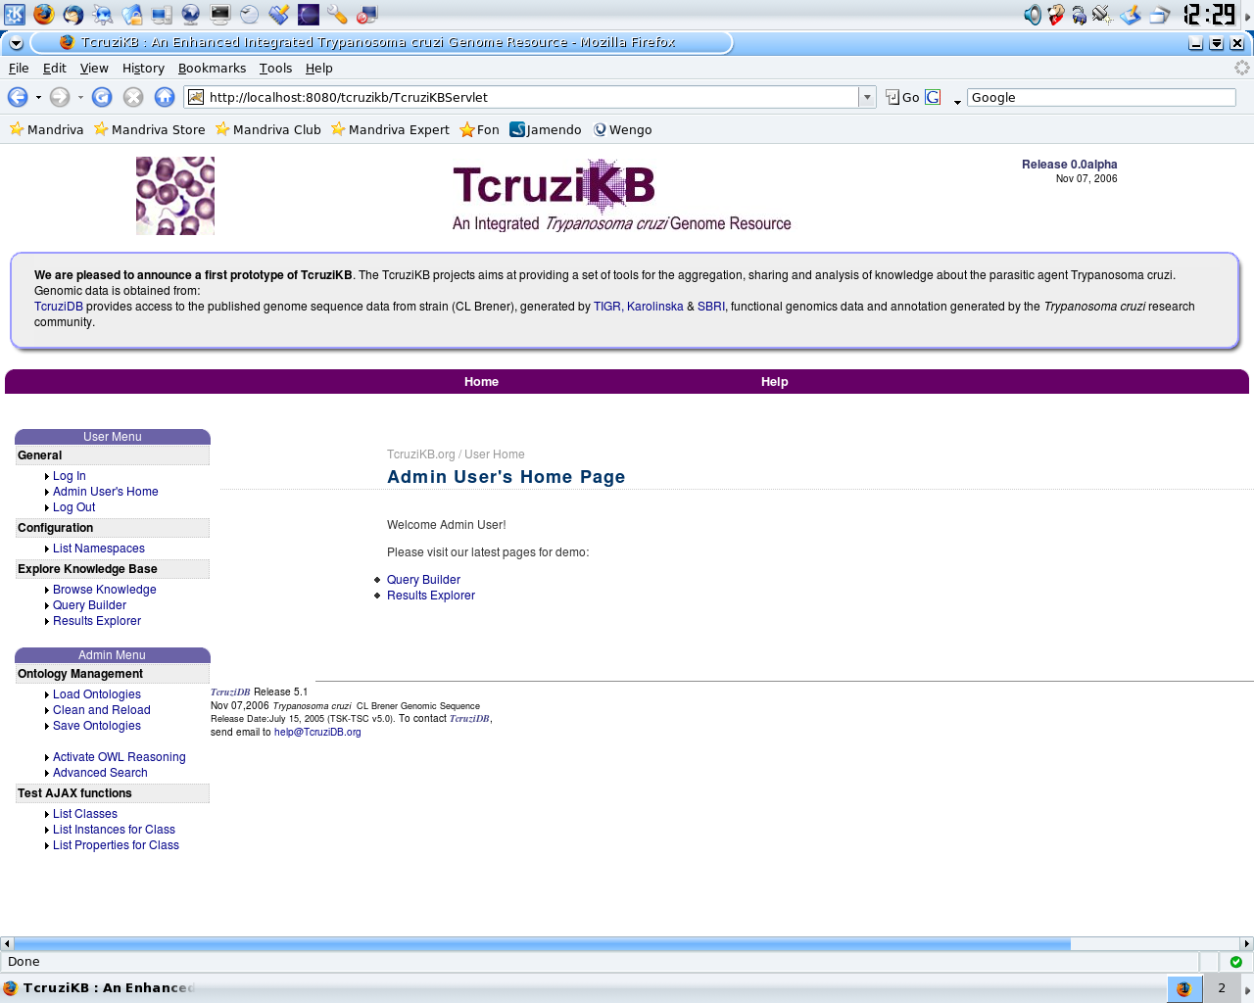

SCREEN SHOT – QUERY BUILDER STAGE 1
This screen shot shows the first stage in building a query to the system. The user selects a class from the ontology to begin the query with (AminoAcidSequence) and is presented with a list of it's properties to choose from.
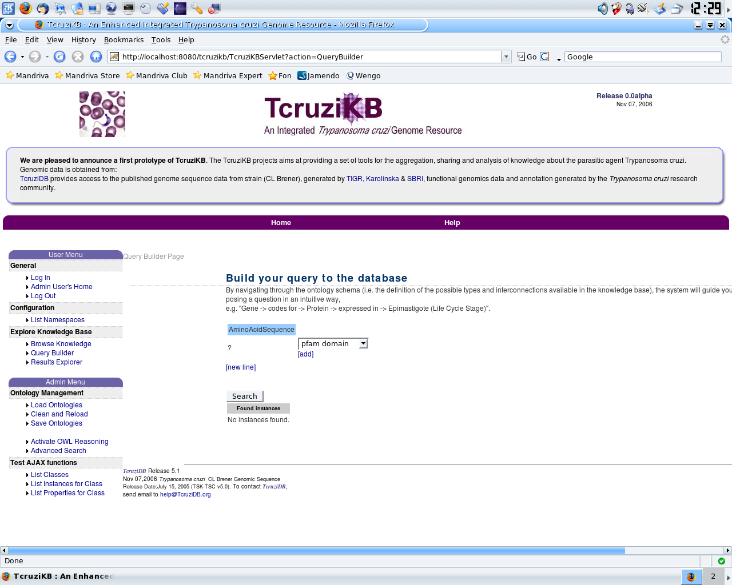
SCREEN SHOT – QUERY BUILDER STAGE 2
With the main class of interest selected the user selects from amongst a list of that classes properties. Here the user has selected the property “expression”.
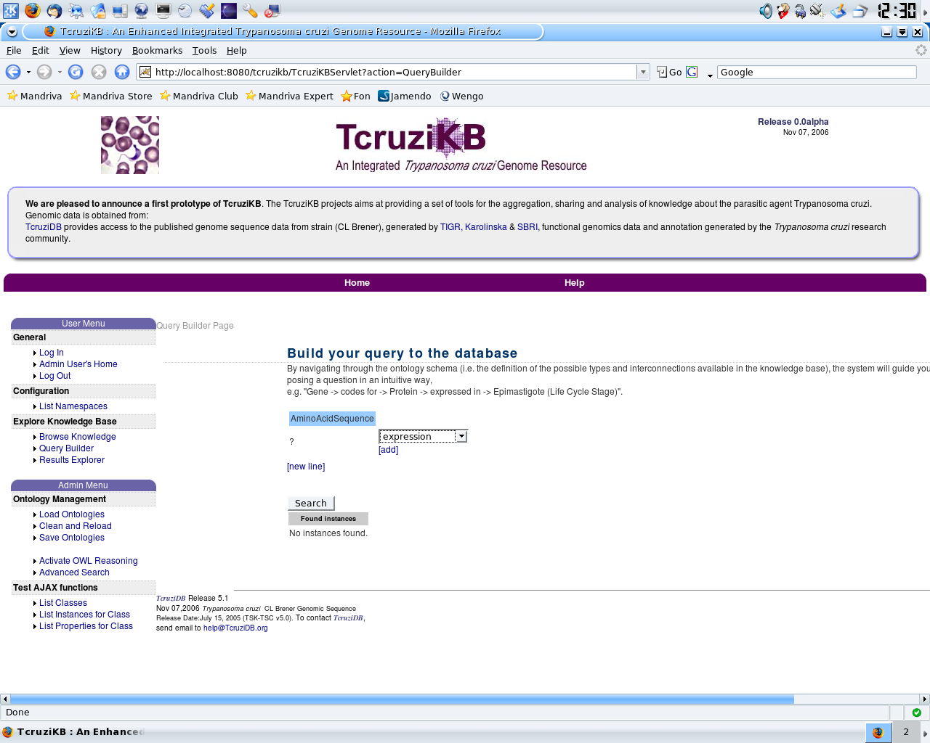
SCREEN SHOT – QUERY BUILDER STAGE 3
Now the user completes the a triple based upon the property they previously selected. Here they can type in the name of a particular instance or select any instance.
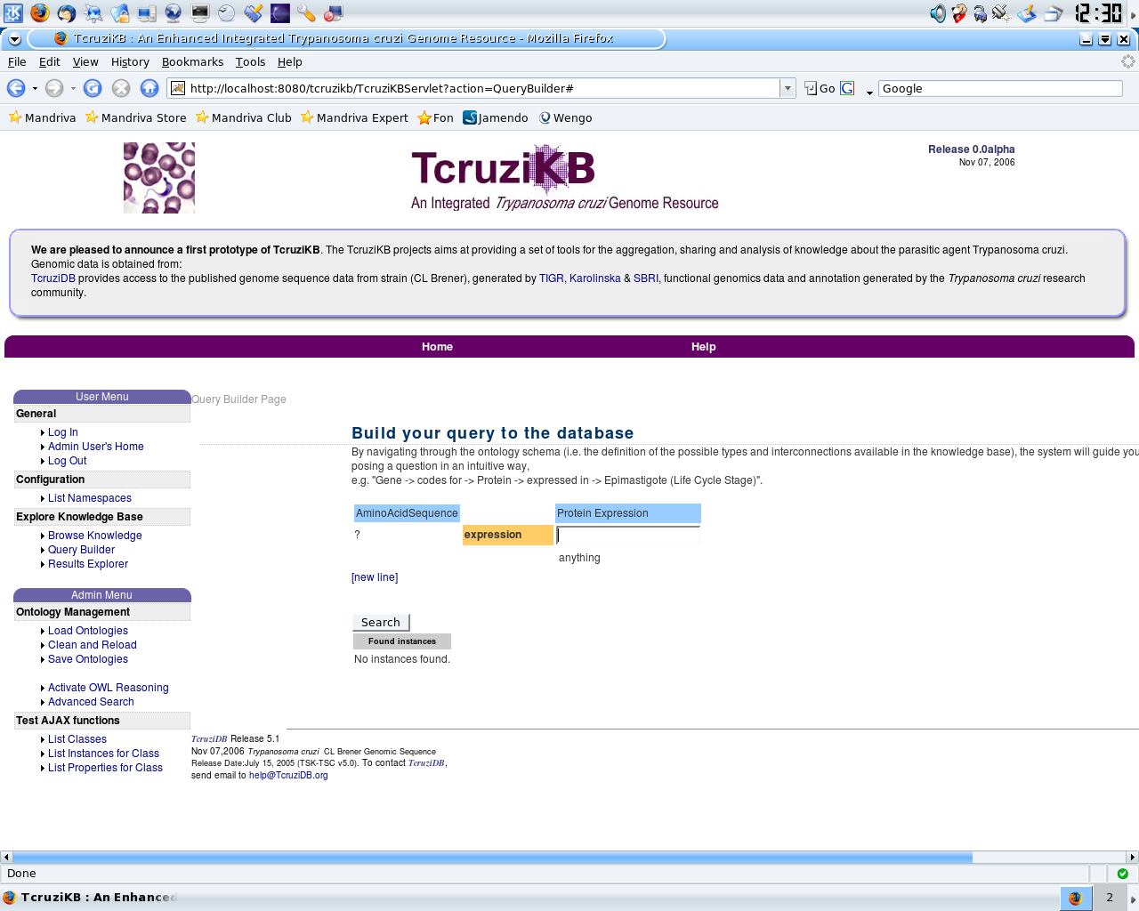
SCREEN SHOT – QUERY BUILDER STAGE 4
The user now is presented with a list of properties based on the type of the class they selected in the previous step. Now they have a complete triple so a query can be executed or additional restrictions can be applied. Here the user has selected to continue the query building process by adding a constraint on the “life cycle stage” property.
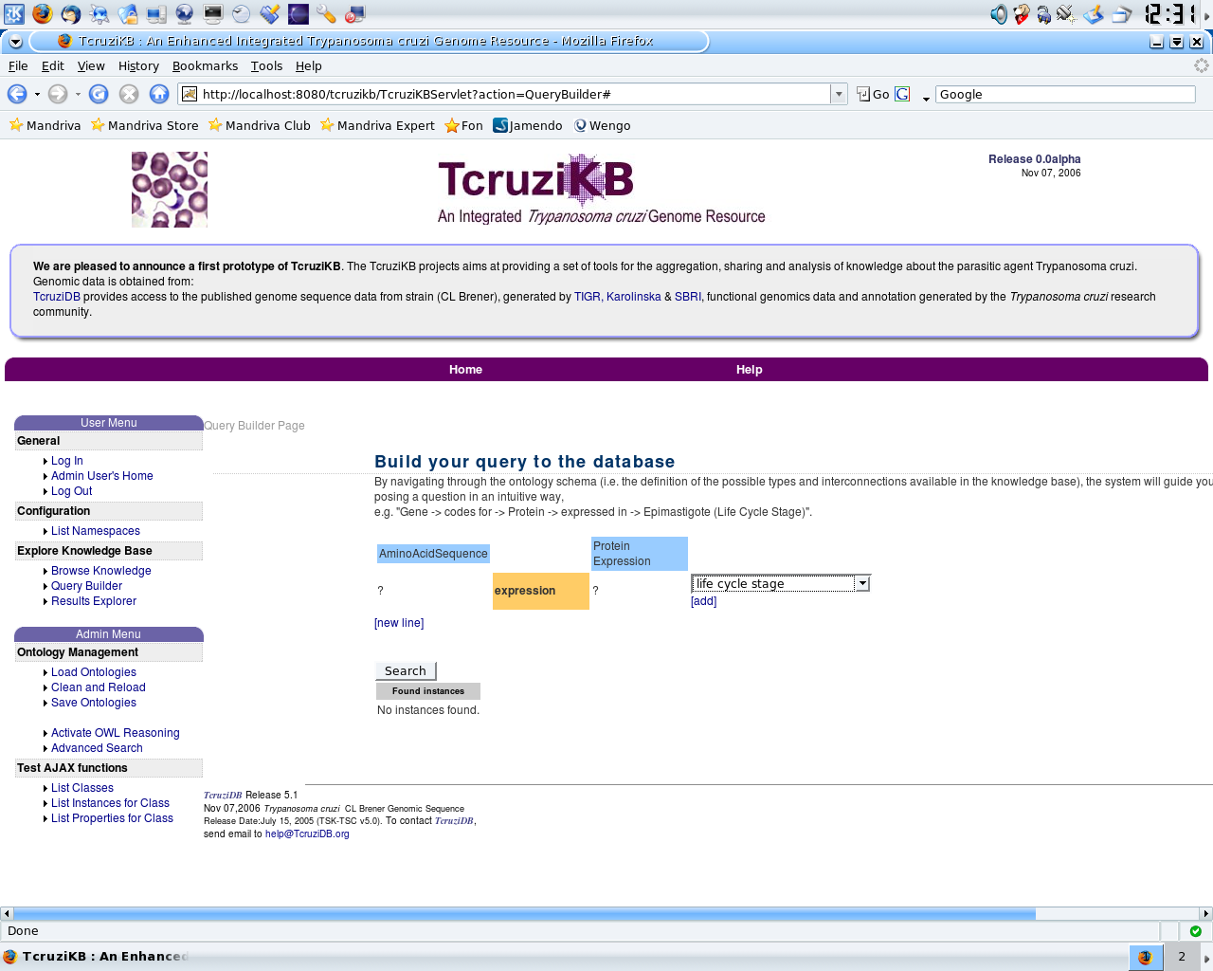
SCREEN SHOT – QUERY BUILDER STAGE 5
The user can now place constraints on the property the previously selected. Here they begin typing their constraint. As they type they are presented with suggestions, here when the user types “E” they get the suggestion “Epimastigote”, an instance of the life cycle stage class.
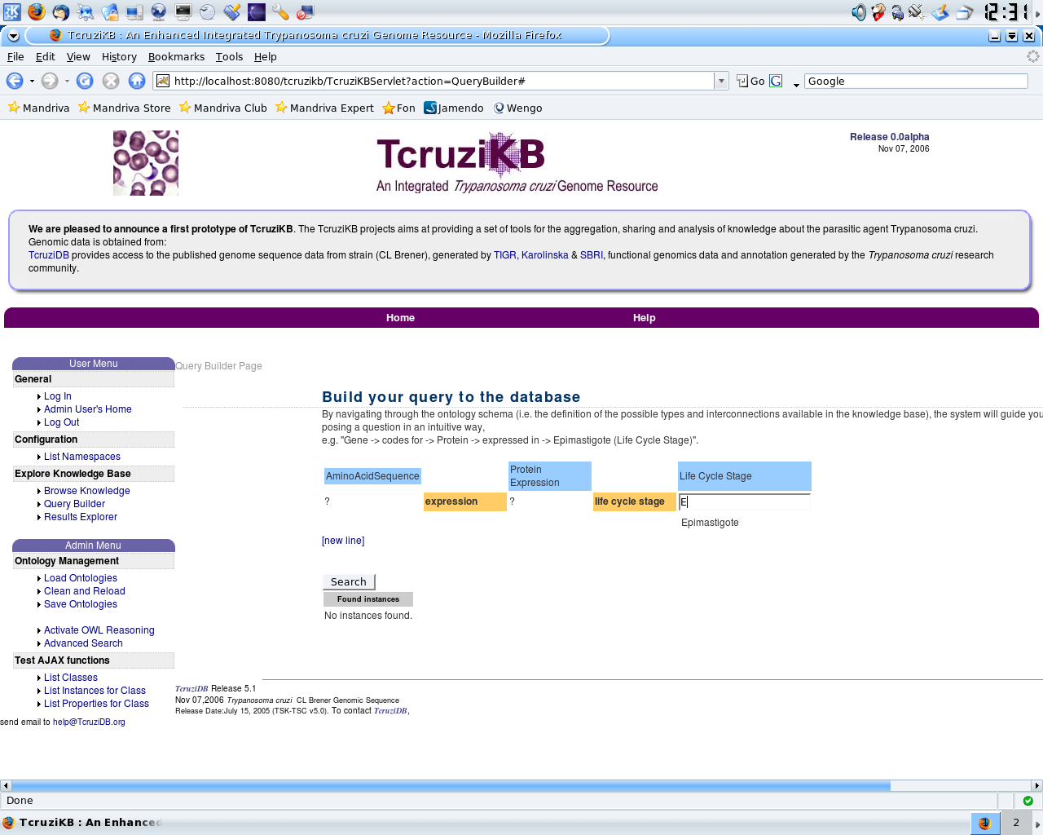
SCREEN SHOT – QUERY BUILDER STAGE 6
The user selected the “Epimastigote” constraint. Now they have the option of performing the search or continuing the query building process.
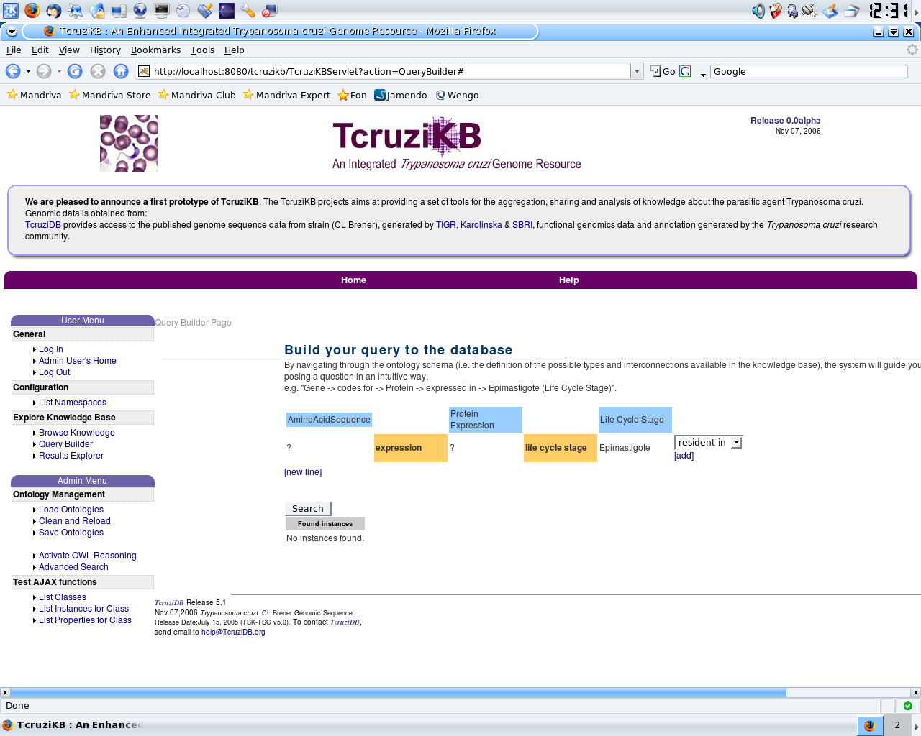
SCREEN SHOT – QUERY BUILDER STAGE 7
The user has selected the new line option to place addional restrictions on the class of interest, AminoAcidSequnce. This creates an AND relationship between the two query lines.
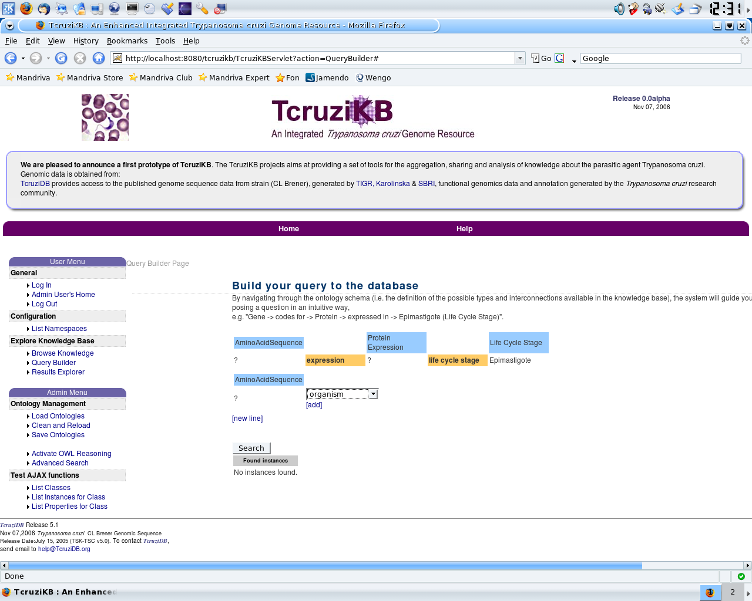
SCREEN SHOT – QUERY BUILDER STAGE 8
The user places additional restrictions on the organism property. As they type they are presented with suggestions which they can select from.
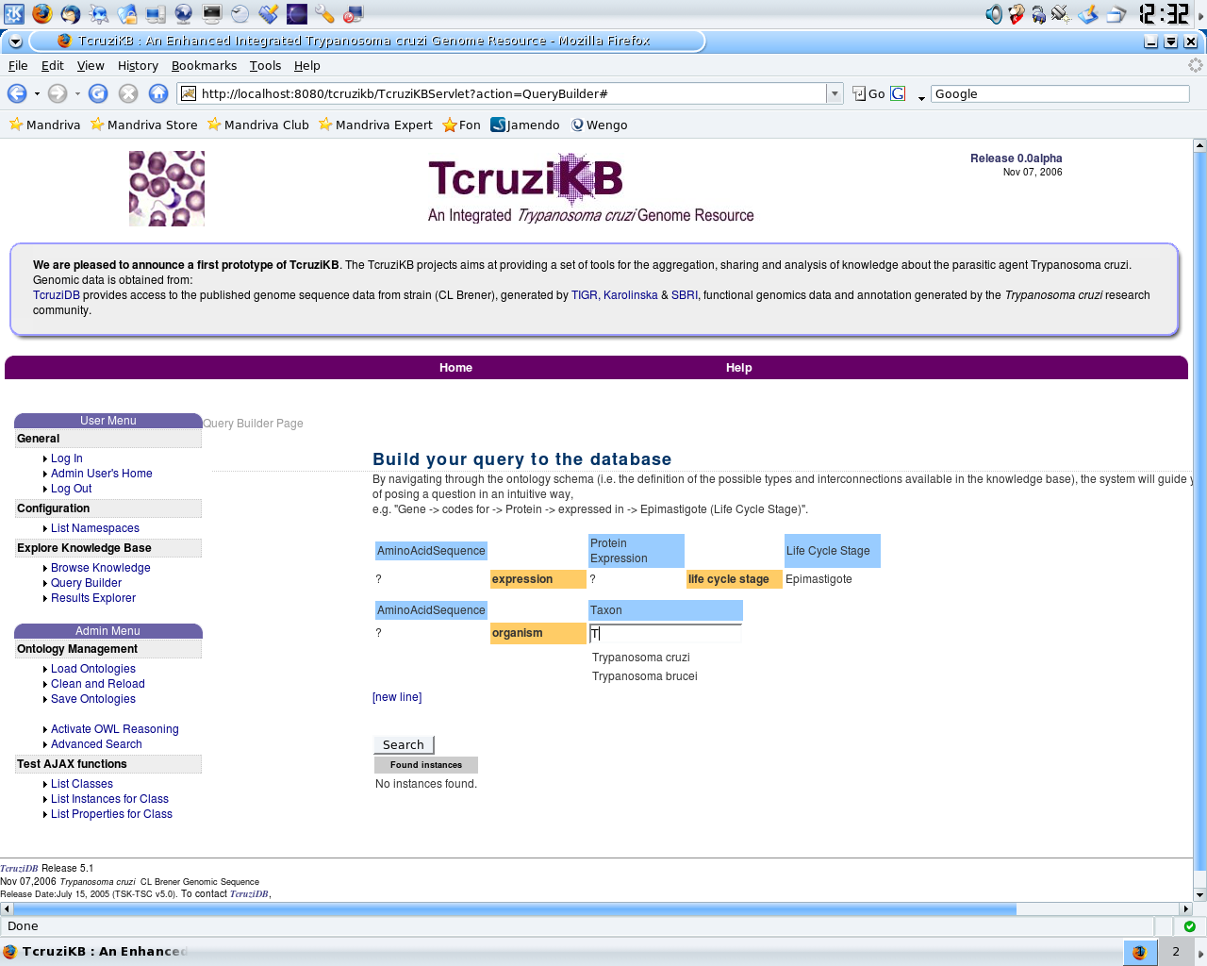
SCREEN SHOT – QUERY BUILDER STAGE 9
The user has opted to stop placing restrictions and now perform a search by clicking the “Search” button.
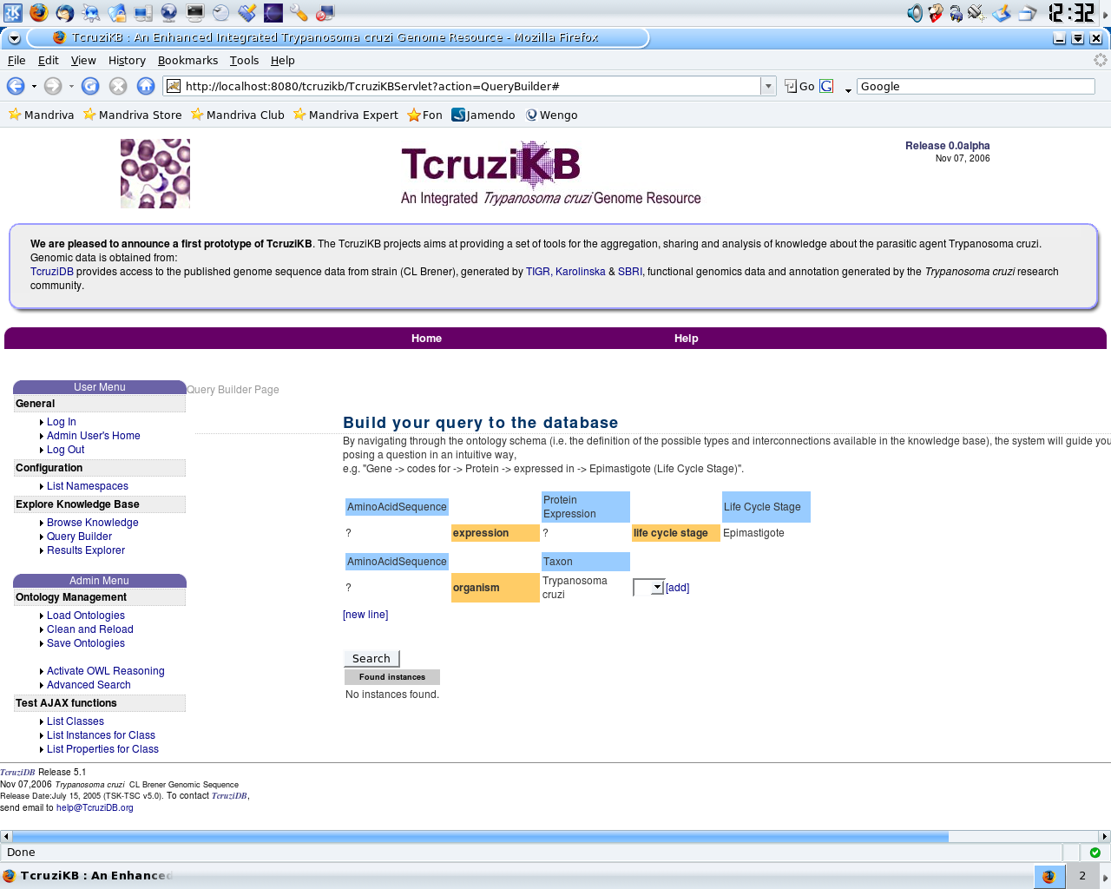
SCREEN SHOT – GRAPH EXPLORER STAGE 1
The user can perform a SPARQL query directly or use the query builder to generate SPARQL. When the query is ready they click the “Query” button to obtain the results in the Graph Explorer interface.
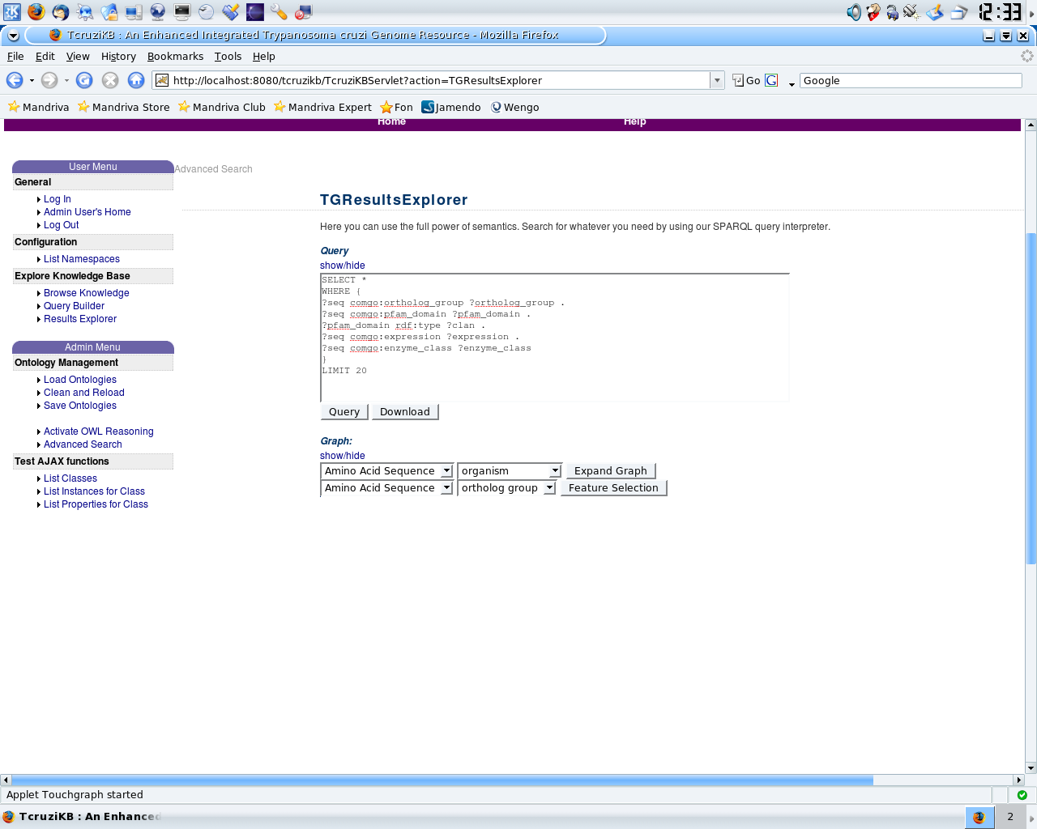
SCREEN SHOT – GRAPH EXPLORER STAGE 2
The user is presented with the results in an interactive graph format.
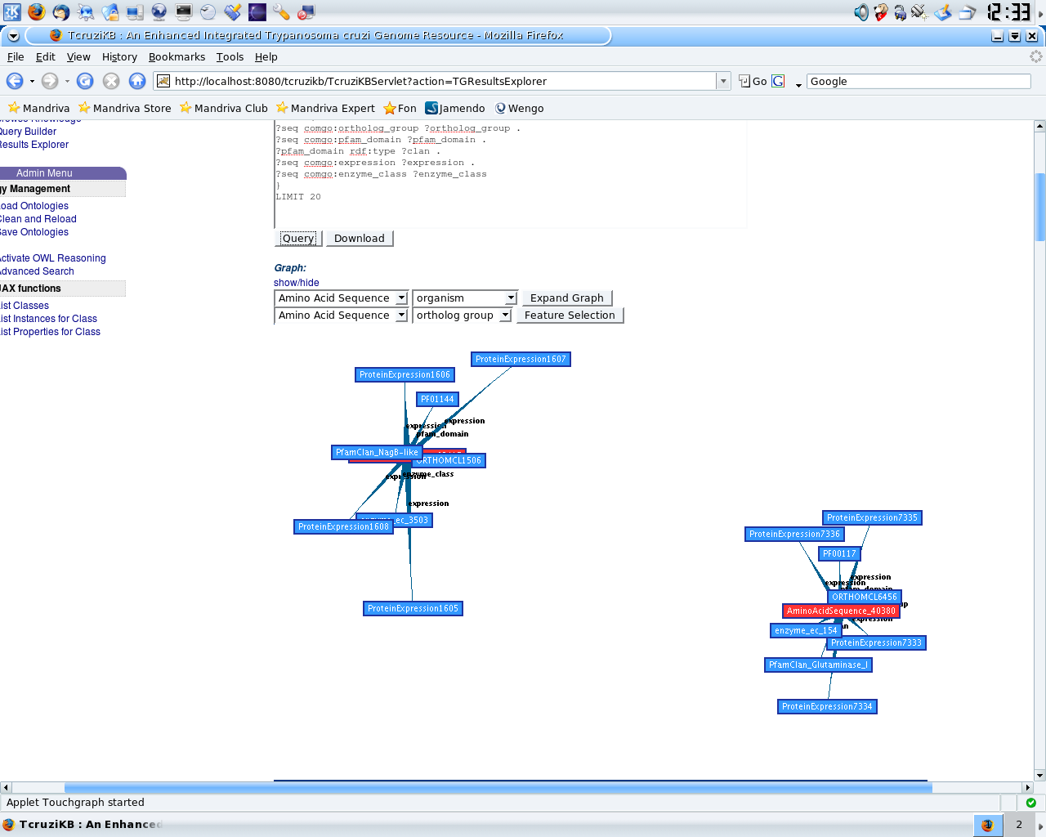
SCREEN SHOT – GRAPH EXPLORER STAGE 3
The user adds features to the graph by selecting what to add via the drop down menu and clicking “Expand Graph”. In this example the user has added “organims” to the graph. Additions are shown in gray.
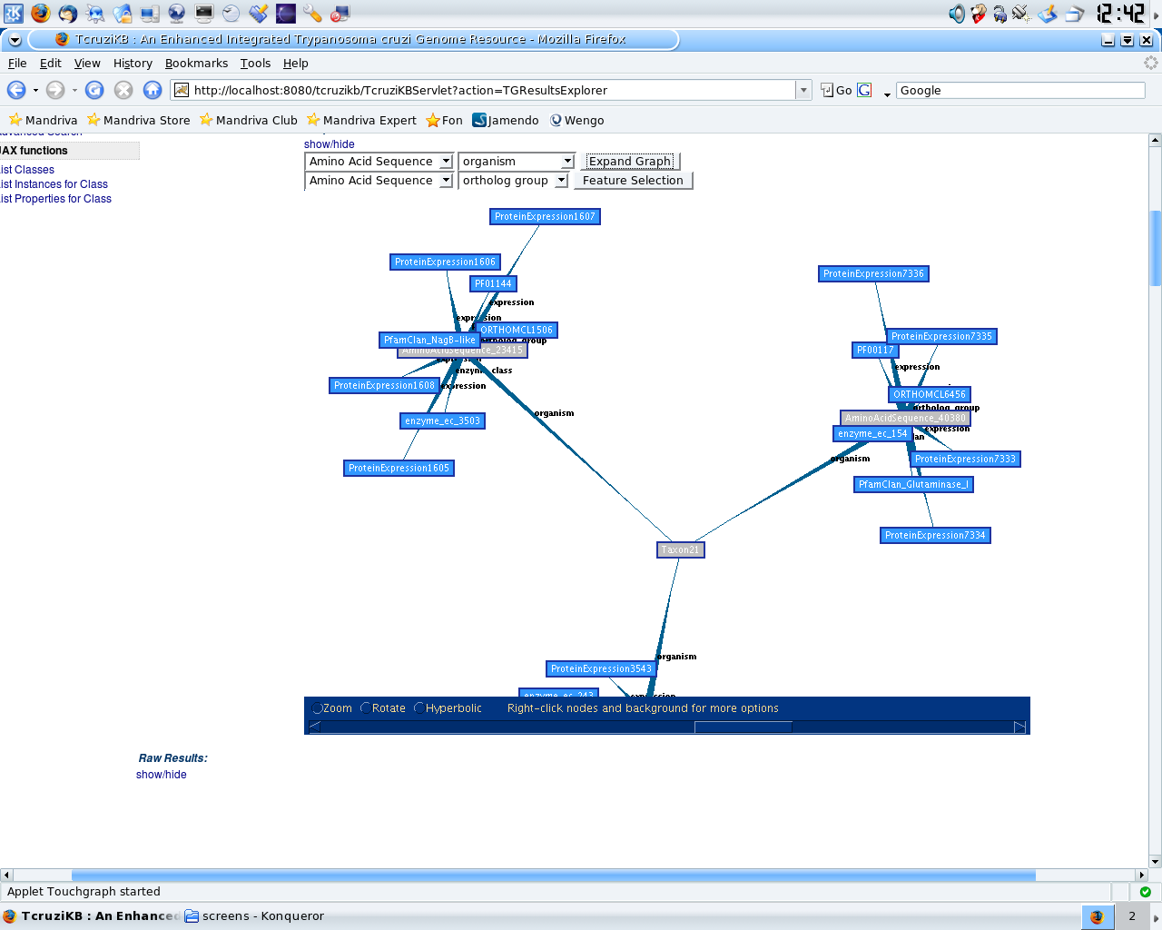
SCREEN SHOT – GRAPH EXPLORER STAGE 4
Because the graph can quickly become too complicated the user can click “Feature Selection” to highlight statistically significant features in the graph.
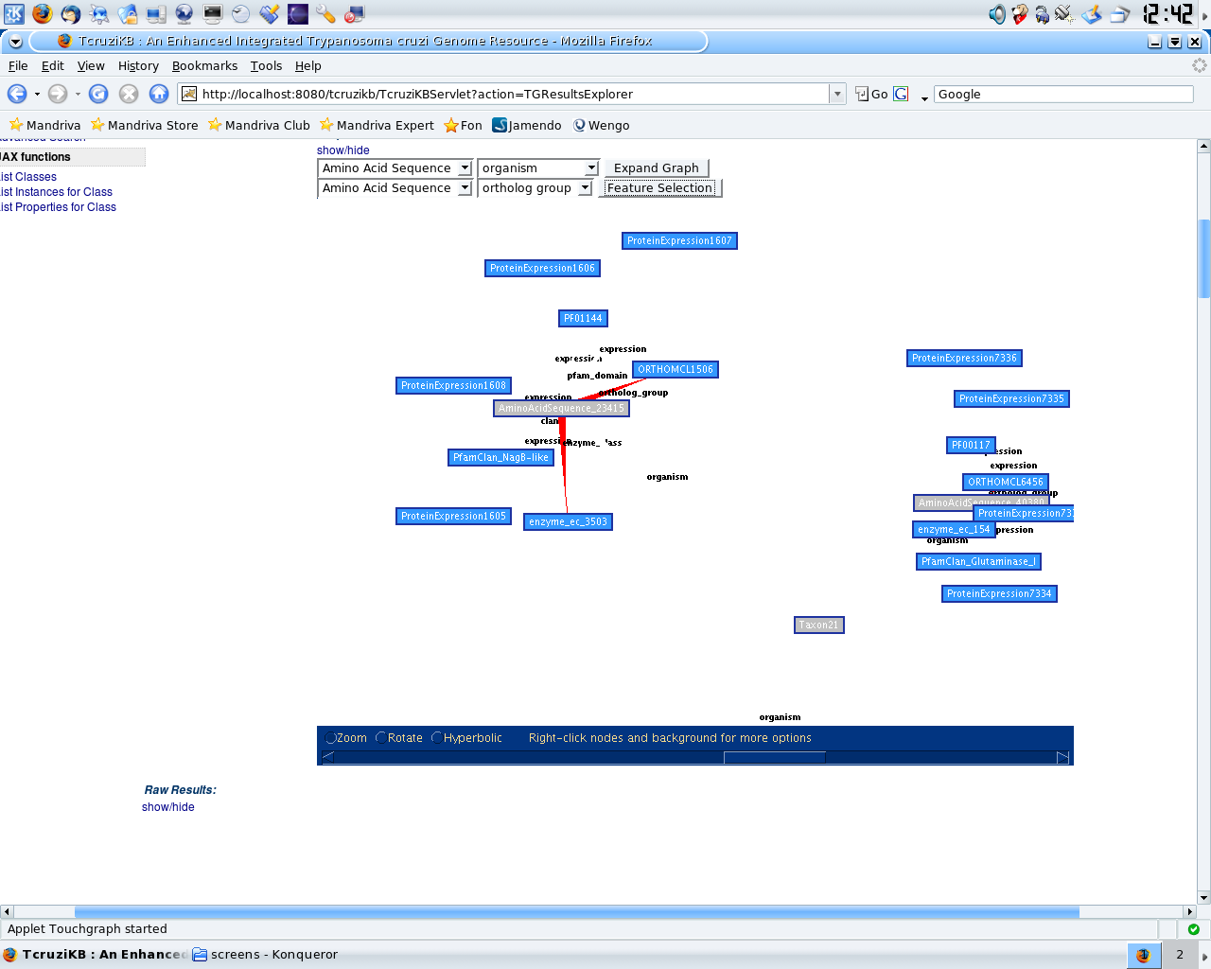
SCREEN SHOT – TABULAR RESULTS
Below is the screen shot of the Tabular Results Explorer view for a given query constructed using the query builder.
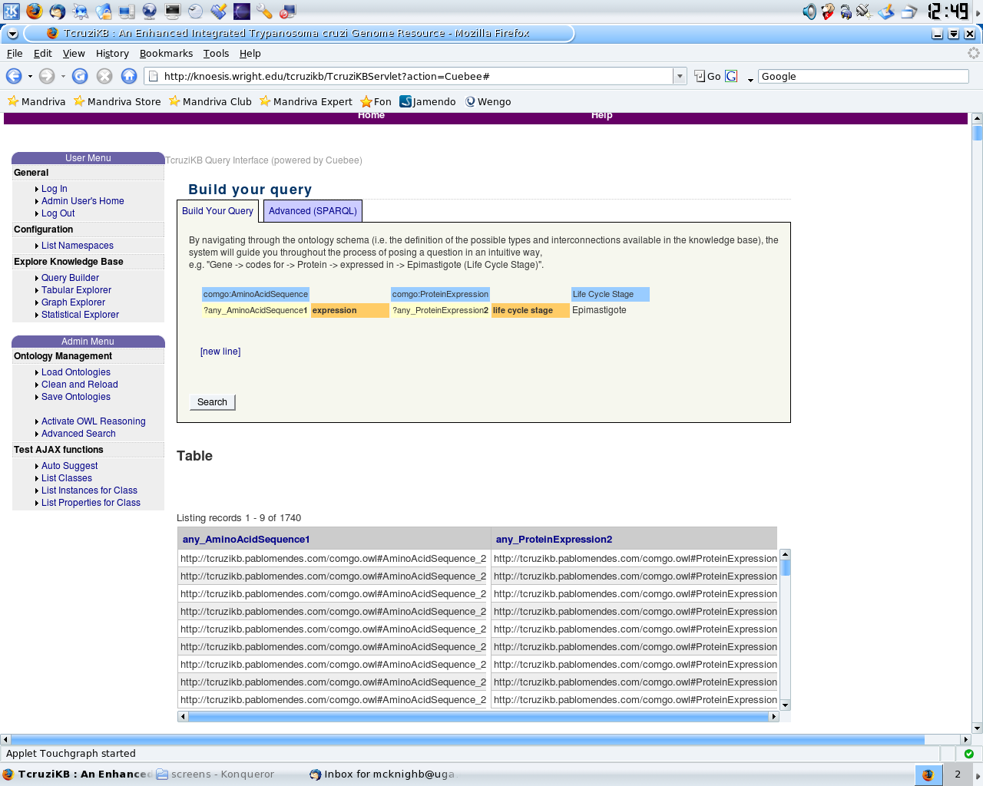

APPENDIX C
SUS EVALUATION RESULTS
SUS Evaluation results of TcruziKB and TcruziDB broken down by area of expertise.

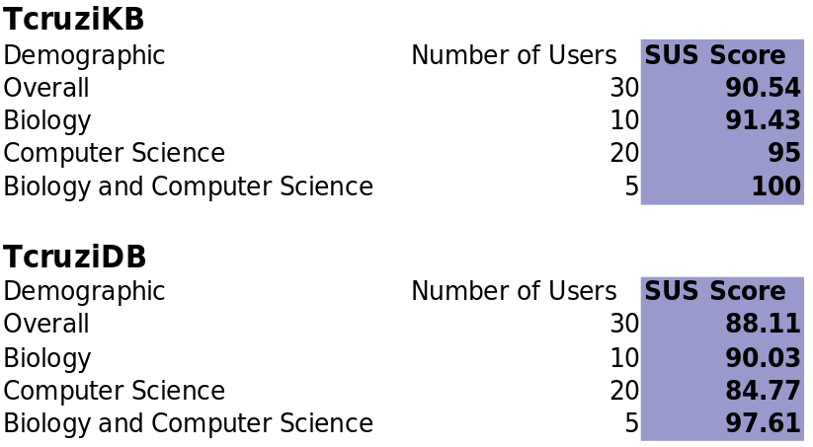

APPENDIX D
EMPERICAL EVALUATION RESULTS
Comparison of time taken and number of computer interactions needed to perform queries on TcruziKB and TcruziDB.

