SEMEF: A TAXONOMY-BASED DISCOVERY OF EXPERTS, EXPERTISE AND COLLABORATION NETWORKS
by
DELROY H. L. CAMERON
(Under the Direction of Ismailcem Budak Arpinar)
ABSTRACT
Finding relevant experts in research is often critical and essential for collaboration. Semantics can refine the level of granularity at which the expertise of various experts can be determined, by explicitly expressing relationships between topics and various subtopics using a taxonomy. Such topic-subtopics relationships allow extrapolation of expertise, based on the notion that expertise in subtopics is also indicative of expertise in a topic itself. Additionally, a taxonomy enables enrichment of researcher Expertise Profiles, based on explicit relationships between the topics of a publication and topic-subtopics relationships in the taxonomy. We describe an approach that uses semantics to find experts, expertise as well as collaboration networks, in a Peer-Review setting, using the implicit coauthorship network of the DBLP bibliography and a taxonomy of Computer Science topics. Various collaboration levels, based on degrees of separation, create the added dimension of presenting potentially unknown experts, also qualified for Program Committee (PC) membership, to the PC Chair(s).
INDEX WORDS: C-Net, Collaboration Level, Collaboration Strength, Collaboration Network, Geodesic, Expert Finder, Expertise Profile, Semantic Association, Semantic Web, Taxonomy

SEMEF: A TAXONOMY-BASED DISCOVERY OF EXPERTS, EXPERTISE AND COLLABORATION NETWORKS

by

DELROY H. L. CAMERON
B.S. in Computer Science Technology, Savannah State University, 2005

A Thesis Submitted to the Graduate Faculty of The University of Georgia in Partial Fulfillment of the Requirements for the Degree

MASTER OF SCIENCE

ATHENS, GA
2007

© 2007
Delroy H. L. Cameron
All Rights Reserved
SEMEF: A TAXONOMY-BASED DISCOVERY OF EXPERTS, EXPERTISE AND COLLABORATION NETWORKS

by

DELROY H. L. CAMERON

Major Advisor: | Ismailcem Budak Arpinar
Committee: | Prashant Doshi  Robert J. Woods

Electronic Version Approved:
Maureen Grasso
Dean of the Graduate School
The University of Georgia
December 2007
DEDICATION
To my mom Henrietta, for impressing upon me the importance of an education, demonstrated through her years of service in academia as an educator, and to my two beloved siblings, Sithendisi and Clayton for all their love, support and encouragement. I love you each, with all the love a brother and a son could ever have.

ACKNOWLEDGEMENTS
First, I would like to thank Dr. Ismailcem Budak Arpinar for his wisdom, guidance and direction throughout my academic and research career at the University of Georgia, providing me an opportunity to appreciate and contribute to the field of Semantic Web. Thanks also to Dr. Prashant Doshi for his intuitive suggestions and recommendations, which enhanced many aspects of this work. I would also like to thank my mentor, Dr. Boanerges Aleman-Meza, for his guidance, including time spent imparting ideas and technical skills, and more importantly indoctrinating me the general culture of research excellence. His vision and ideas continue to prove innovative on the global scale in the field of Semantic Web. I would also like to acknowledge my team member Sheron L. Decker, whose technical skills and ingenuity elevated the quality of many aspects of this work. His attitude and commitment were admirable and instrumental in keeping me motivated and focused throughout this research experience.
I am particularly grateful to Dr. Robert J. Woods and the Woods Research Group for their patience and understanding throughout my experience with the Complex Carbohydrate Research Center (CCRC). I am forever indebted to them for funding as well as the exposure to their spirit of dedication and professionalism, which serves as a model for producing high quality research. Equally, I am grateful to Shefail Dhar and the Office of the Vice President for Instruction (OVPI), for providing the initial opportunity for me to matriculate here at the University of Georgia, through funding during my first year. The technical skills acquired during my stint with OVPI have proven integral to my advancement since.
Finally, I would like to thank Ralph and Floretta Johnson for adopting me like family. I love you both and pray that God continues blessing you richly. Thanks also to my friends Jamal, Micah, Shayla and my roommate Brian for their friendship. And most of all, thanks to my best friend Khamisi, for his encouragement, support, inspiration and friendship. You will forever be considered to me, a true brother.
TABLE OF CONTENTS
Page
ACKNOWLEDGEMENTS v
LIST OF TABLES ix
LIST OF FIGURES x

CHAPTER
1 INTRODUCTION 1
2 BACKGROUND AND MOTIVATION 7
2.1 Semantic Web 7
2.2 Social Networks 13
2.3 Peer-Review Process 13
3 DATASET AND SCENARIO 15
3.1 Publication data 15
3.2 Papers-to-Topics Dataset 17
3.3 Taxonomy of Topics 18
3.4 Scenario 20
4 EXPERTISE PROFILES FOR RANKING EXPERTS 23
4.1 Publication Impact 24
4.2 Expertise Profiles 26
4.3 Ranking Experts 28
5 COLLABORATION NETWORKS EXPANSION 33
5.1 Social Networks 33
5.2 Geodesic 35
6 RESULTS AND EVALUATION 40
6.1 Validation 40
6.2 Collaboration Network Expansion 45
7 RELATED WORK 47
8 CONCLUSIONS AND FUTURE WORK 54
REFERENCES 56
APPENDIX A 62
SCHEMAS AND DATASETS 62
APPENDIX B 65
SEMANTIC EXPERT FINDER – WEB APPLICATION 65

LIST OF TABLES
Page
Table 1: SEMEF Dataset 21
Table 2: Citeseer Publication Impact Statistics for DBLP Listed Venues 25
Table 3: Expertise Profile 28
Table 4: Geodesic Collaboration Levels 35
Table 5: C-Net Unit 39
Table 6: WWW2006 Search Track Input Topics and Subtopics 41
Table 7: Past Program Committee List compared with SEMEF List 42
Table 8: PC Chair - PC Members Collaboration Relationships 45
Table 9: PC Chair - SEMEF List Collaboration Relationships 46

LIST OF FIGURES
Page
Figure 1: Metadata Representation in XML 9
Figure 2: Metadata Representation in RDF 9
Figure 3: Graphical RDF Data Model 10
Figure 4: Semantic Web Cake 12
Figure 5: SEMEF Taxonomy Schema 20
Figure 6: Taxonomy Instances Showing Topic and Subtopic Relationships 20
Figure 7: SEMEF Schema 22
Figure 8: Disparity in Expertise Profiles with Levels of Expertise 26
Figure 9: Algorithm for Computing Expertise Profile 27
Figure 10: Expertise Profile considering subtopics 30
Figure 11: Algorithm for Computing Rank value 31
Figure 12: STRONG Geodesic Collaboration 36
Figure 13: MEDUIM Geodesic Collaboration 36
Figure 14: WEAK Geodesic Collaboration 37
Figure 15: UNKNOWN Geodesic Collaboration 37
Figure 16: Average Number of PC in SEMEF List 43
Figure 17: Cumulative Number of PC in SEMEF List 43
Figure 18: Average Distribution PC in SEMEF List 44
Figure 19: Cumulative Distribution of PC in SEMEF List 44

CHAPTER 1

INTRODUCTION
Finding the relevant experts in industry as well as academia is an important practical problem. Crucial delays due to unproductive work can be reduced considerably and product quality and overall productivity can improve significantly, owing to the relevance and skill of acquired experts. Various settings including Software Engineering [32], Medicine [49], Enterprise [6] and Research [29] have used numerous techniques, which have been quite successful in their respective domains, for automatically discovering experts. However, many techniques lack Semantics, which bear significance in finding experts and expertise on a more widespread scale and at much finer levels of granularity.
In particular, in the Peer-Review Process, when reviewing scholarly manuscripts, relevant reviewers may be deduced by examining their ‘Expertise Profiles,’ based on the overall aggregation of their publications. The creation of such expertise profiles stands to benefit considerably from Semantics, particularly by linking an ontology of publications with a taxonomy of research topics [1] to explicitly express relationships between papers and numerous topics. Thus, by considering publications in subtopics of a given area, more accurate and complete expertise profiles can be derived semantically.
The publication data critical to realizing such an important task, unveils not only experts and expertise profiles across various domains, but also numerous Semantic Associations inherent in the underlying coauthorship network. Semantic Associations have applicability in a variety of areas, such as determining provenance and trust of data sources [16]. However, in this setting, Semantic Associations point to distinct Collaboration Network Communities within which Collaboration Levels among authors are relatively high, indicative of varying degrees of relationships among them. The examination of Semantic Associations and Collaboration Networks presents a scenario for identifying experts outside a PC Chair’s immediate neighborhood; a critical necessity when seeking experts (unknown to PC Chairs) for consideration on PC-Lists.
A method for identifying experts in a Peer-Review setting is therefore important, especially since conferences, workshops, symposiums etc, necessitate that qualified reviewers assess the quality of research submissions [41]. The Peer-Review philosophy itself, hinges on the very idea that a body of research submitted for publication must be innovative for sustained progress in any discipline [40]. Given the overwhelming likelihood that even the most experienced researcher may be unable to spot deficiencies in a complex body of work, peer review offers an opportunity for improvement by introducing independent experts to critically analyze and assess the integrity of research ideas [51].
While in theory this ideology is sound, the logistics of its implementation suffer several limitations. Many experts complain that the Peer-Review Process is unbearably slow, taking months and even years in many instances, before a submitted article appears in print. Others argue that the process itself is inherently flawed, because it offers an opportunity for bias during the decision making phase [41, 51]. Such concerns have led to innovative strategies, such as open reviewer identification and author anonymity, to prevent predisposed judgments from derailing the integrity of the Peer-Review Process. At the technical level, several methods for detecting conflict of interest relationships have been implemented, including email suffix matching and institution matching. Work in [4] proposes a variety of highly touted Semantic Web techniques for addressing this dilemma.
Few approaches to finding experts for Peer-Review, have been undertaken, and for a variety of reasons. First, finding experts requires defining areas for which appropriate expertise can be categorized. Second, researcher background must be matched accordingly, to enable quantification of expertise and the creation of expertise profiles. Both tasks require a suitable dataset from which expertise knowledge can be gleaned. While publication data appear a suitable source, expertise information also exists in many different forms, from many disparate data sources [2]. Particularly, expertise may be extracted from Curriculum Vitas (CVs) [7], Intranet Applications [29] and Concurrent Versioning Systems (CVS) [32], in addition to white papers, technical reports, scientific papers etc. The appeal of publication data is that it contains person-centric information about collaboration relationships between researchers. Chen in [10] purports that a thorough understanding of publication data enhances our understanding of the characteristics of the real world entities in the underlying coauthorship network encapsulated by such data.
Credible sources of publication data exist in the form of online digital libraries. Some of these include the Digital Bibliography Library Project (DBLP), Association for Computing Machinery Data Library (ACM DL), Institute of Electrical and Electronics Engineers (IEEE) and Science Direct (SD). Collectively, these libraries archive over three (3) million articles from various conferences, journals, books etc. However, although these data sources in principle offer a trusted foundation from which expertise profiles can be derived, in practice extracting such statistics is not a trivial task. Only few applications [29, 47] have used digital libraries for the purpose of determining expertise in the context of Peer-Review. In this thesis, we develop an application that uses Semantics for finding experts and expertise at fine levels of granularity, circumventing many of the common challenges involved with finding experts from publication data. Additionally, we show that consideration for ranking experts and analyzing collaboration relationships is imperative, if the study of experts is to be complete.
Categorizing experts according to their expertise also relies on the existence of a taxonomy of topics, for linking publications to various areas. In today’s world however, conference settings typically rely on conference organizers to find and compose qualified program committees. Contemporary Conference Management Systems including Confious [12], OpenConf [52] and Microsoft Conference Management Toolkit [13], offer little or no technical features facilitating this process. Therefore, accomplishing such an assignment hinges largely on organizers’ knowledge of experts in their field; an Arbitrary Knowledge approach, subject to many limitations.
The first limitation of the Arbitrary Knowledge approach arises due to various emerging communities and the diversification of research areas. It is possible that unknown experts may be overlooked [5, 8]. Newly emerging communities allude to continued expansion and inclusion of new actors in any research field, demanding that organizers keep abreast of such dynamic evolution. From a technical standpoint, most Social Networks adhere to the ‘small world phenomenon’ [35], and thus experts may be obtainable by modeling the network as a graph and analyzing network characteristics [28]. We exploit such graph models, by transforming the coauthorship network into an ontology. However, we remain wary of the reality that both the small world phenomenon and the notion of ‘six degrees of separation’ [20] characterize Social Networks in theory only. In the reality many Social Network characteristics such as Geodesic, Clustering Coefficient and Centrality are never explored. Nowhere is this more true than in a Peer-Review setting, since conference organizers are often apprehensive about soliciting unknown experts, due to a lack of familiarity, confidence and trust in their unknown counterparts.
The second limitation of the Arbitrary Knowledge approach is the human effort required to locate unknown experts. Conference organizers are typically overwhelmed with conference logistics, leaving minimal time for undertaking the laborious process of seeking unknown counterparts
In spite these disadvantages, the Arbitrary Knowledge approach has proven advantageous in the past. Quite often, conference organizers are themselves experts, who have collaborated with or share some affiliation or association with other top experts. Such frequent collaboration creates a level of synergy, important in ensuring effective completion of important tasks. Nonetheless, a system that automatically (or semi-automatically) discovers, quantifies, ranks and presents top experts for PC Chairs, eliminates the human effort needed for the Arbitrary Knowledge approach, presenting many unknown experts, otherwise difficult to locate manually. The contributions of this thesis are therefore as follows.
- We address the problem of finding experts by applying semantic technologies under the scenario of finding relevant reviewers for consideration for membership in a Program Committee for conferences (or workshops, etc). The main benefit of Semantics lies in achieving finer granularity in measuring expertise.
- We propose a solution to the problem of finding relevant experts potentially unknown to PC Chair(s), involving discovery of Collaboration Levels among experts groups and providing a second dimension in the selection process – a dimension indicating collaboration relationships among experts.
- We demonstrate the effectiveness of this approach by comparing existing experts listed in PCs of past conferences with recommended experts we discover from our techniques.

CHAPTER 2

BACKGROUND AND MOTIVATION
This chapter addresses many of the fundamental components used in engineering this application, particularly those related to the Semantic Web. The implementation of such ideas demonstrates the relevance and necessity for adoption of Semantics in addressing real world challenges [45]. The prospect of illustrating such a necessity through a well-structured application is the main motivation behind this work. We begin with an overview of the Semantic Web itself in the following section.
- Semantic Web
The Semantic Web is an extension of the current web in which web content is understood by Software Agents, enabling independent machine-to-machine interaction [21]. The overall goal is to enhance Information Sharing, Automatic Service Discovery and Interoperability among Web Applications, without human intervention. The necessity for the Semantic Web arises because of several limitations of the current web. For example, a user requesting “all Cities around the world currently below the poverty line, having a population exceeding 1 million and having been visited by former US President Bill Clinton,” challenges web developers to gather information from various sources and hard wire a tightly coupled application. Not only is this laborious, but also impractical for enumerating the set of all answerable queries on the web. Extensions to the existing web infrastructure allowing dynamic and independent application as well as Service interaction, when solving such complex queries are therefore warranted. In an interview [24] with Sir Tim Berners-Lee, Founder of the World Wide Web, he describes the Semantic Web as “….the Web [in which computers] becomes capable of analyzing all the data on the Web – the content, links, and transactions between people and computers”. In this context, a common understanding of all real world concepts by machines is needed. Web data must be described and published for Software Agents to understand their content. Currently however, the Hypertext Markup Language (HTML) convention for representing and linking documents on the web is devoid of Semantics, and was not intended for that purpose. HTML constructs instead focus on data presentation for human readability and understanding. The prospect of the Semantic Web therefore introduces a need for more expressive languages and technologies for capturing and conveying Data Semantics.
  - Languages and Technologies
The Resource Description Framework (RDF) is a family of specifications for modeling information on the Semantic Web [51]. It improves over HTML, and is based on the Extensible Markup Language (XML) syntax, which is a universal meta-language for defining markup [45]. XML allows users to define arbitrary tags for representing real world concepts, relationships and attributes. It is free-form and unstructured, and more suitable for representing Semantics. However, XML is not ideal. Its free-from nature often leads to multiple specifications of instances and relationships. Instead RDF provides well structured and standardized techniques, for decomposing statements into simple triples for processing. For example, an RDF triple of the form P(x, y), is such that x is the subject, y is the object and P is the predicate that binds the subject and object together. On the contrary, the simple sentence “David Billington is a lecturer of Mathematics,” may be represented and interpreted differently in XML. One interpretation exists in RDF, based entirely on the meaning of the sentence constructs, as demonstrated below. Figure 1 shows multiple XML representations, for the statement in which the Person David Billington, may be the subject or object of a triple or part of a relationship involving both concepts.
<course name=”Mathematics”>
<lecturer>David Billington</lecturer>
</course>

<lecturer name=”David Billington”>
<teaches>Mathematics</teaches>
</lecturer>

<teachingOffering>
<lecturer>David Billington</lecturer>
<course>Mathematics</course>
</teachingOffering >
Figure 1: Metadata Representation in XML
Figure 2 shows the RDF representation, in which “David Billington” belongs to the Class Professor, and Mathematics and instance of the Class Course.
<rdf:Description rdf:about=”Professor_2”>
<rdf:has_name>David Billington</rdf:has_name>
<rdf:teaches rdf:resource=”#Mathematics”/>
</rdf:Description>
Figure 2: Metadata Representation in RDF
The two resources are linked through the teaches relationship. This representation exploits the knowledge that a person who teaches a class belongs to a general class called Professor, or various other related Classes. RDF therefore models data, and is commonly considered more of a data model than a language.
Concepts in RDF require a unique identifier called a Uniform Resource Identifier (URI), comparable to a Uniform Resource Locator (URL) on the World Wide Web, for creating the universal identification needed by Software Agents. Figure 3 shows the RDF model of the previous example, in which an instance of the Professor Class (David Billington) is connected to an instance of the Course Class (Mathematics), through URIs for the two instances as well as their relationship.
mynamespace#David Billington
mynamespac#Mathematics
mynamespace#teaches
Figure 3: Graphical RDF Data Model
Another fundamental feature of RDF is domain independence, enabled through the use of RDF Schema (or RDFS) [45]. RDFS provides the framework for defining concepts, attributes and relationships, needed to develop an ontology. An ontology is a formal specification of such concepts, attributes and relationships in a specific domain of discourse [38], and contain Classes and Properties providing abstractions of concepts and relationships within a specific domain. According to Noy et al in [38], Classes represent collections of object instances with identical behavior, while Properties formalize the permissible relationships among instances of such Classes. Object Properties describe relationships between two Classes, while Data Type Properties describe relationships between one Class and a literal value (e.g. String, Integer etc). Properties also ensure consistency across ontologies by specifying possible domain and range relationships between Classes.
While RDF and RDFS together form the foundation of the Semantic Web, they are not a foolproof standard. The most notable shortcoming of RDF(S) is the inability to express constraints on relationships, such as the fact that a Person cannot be both male and female at the same time. The Web Ontology Language (OWL) derived from RDF, offers several constructs for representing such real world Semantic constraints, and thus has become a widely adopted successor to RDF(S).
A variety of additional components play an important role in the realization of the Semantic Web. Languages and ontologies are only the foundations. The distributed nature of the World Wide Web for example, presents an environment encouraging extensibility and free information exchange. Anyone can add and publish web document, and anyone can engineer and publish ontologies. Opportunities for nuances and inconsistencies in concept descriptions are therefore rampant. Similar concepts are invariably described differently by different individuals and groups. A means of reconciling such differences is a great necessity. Semantic Annotation and Reference Reconciliation are therefore integral aspects of the Semantic Web. Other important areas include Ontology Mapping and Ontology Alignment as well as Semantic Association Discovery.
  - Layered Architecture
The overall scope of the Semantic Web is best understood by examining its layered architecture. At the lowest level are URIs, which uniquely identify resources. Namespaces formally identify specific domains in which resource descriptions have been published, and thus form the basis for URIs to provide a means of qualifying the tags and attributes in an XML document, making them truly unique on the Web [44]. Several organizations define upper level ontologies have reusable namespaces. For example, the Dublin Core namespace belongs to the “Dublin Core Metadata Initiative (DCMI) [which] is an organization dedicated to promoting the widespread adoption of interoperable metadata standards […] for describing resources” [19]. The World Wide Web Consortium (W3C) [50] defines namespaces for RDF, RDFS and OWL.
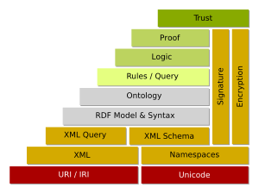
Figure 4: Semantic Web Cake

The primary purpose of an ontology being to express content semantically for intuitive query processing by Software Agents, necessitates machine interpretable rules for manipulating such content. Rules/Query and Logic are therefore important application layer components of the Semantic Web. Reasoning languages and APIs such as Jena, Sesame and SemDis and the RuleML rule language, serve the important task of manipulating Data Semantics and discovering various Semantic Associations. Such capabilities bring into focus the true role of the Semantic Web, which is to automate Information Discovery and facilitate seamless Information Exchange.
- Social Networks
Demonstrating the necessity for the Semantic Web is critical to its acceptance. An important aspect of this task involves applying Semantic Techniques in a wide spectrum of scenarios to solve real world challenges. Social Networks are no exception. Social Networks provide an environment from which meaningful information can be gleaned to discover important trends, facts and general characteristics about the physical structure of a network. Many research projects [17, 20, 36] have demonstrated the importance of Social Networks in realizing such goals. However, recently, much of the activity on Social Networks focuses on marketability, concentrating on automatically extracting information presenting it to the user. Popular Social Networking applications such as Facebook, Friendster and hi5 etc, have been hugely successful at this task. This application, aims to demonstrate the necessity for Semantics in addressing the real world challenges facing expert discovery, using a bibliographic dataset in a Peer-Review context.
- Peer-Review Process
An appropriate method for determining the quality of a body of scholarly material is to subject it to critical review from experts within the given research community [41]. Although many critics [25, 43] question the effectiveness of this philosophy, it has been widely adopted by funding agencies to award grants, as well as editors of books and conferences etc, to screen paper submissions. However, the extent of competitiveness among those courting Peer-Review, necessitates that at least two important considerations be addressed. First, the task of eliminating bias due to conflict of interest relationships, and second, the need for a mechanism for quantifying and locating suitable reviewers. The first necessity arises since authors are disinclined to object if submissions are reviewed by close friends, associates or affiliates, whose judgment will likely be affected by favoritism towards their material. Equally, knowledge of authors during Peer-Review may adversely affect others, if some reason for bias exists against them. Conflict of interest relationships must be detected and avoided to ensure fairness in a Peer-Review setting. We present our approaches for obtaining the dataset from which qualified reviewers can be obtained, in the next Chapter.
CHAPTER 3

DATASET AND SCENARIO
In scientific research, the publications of a researcher can be viewed as representative of his/her expertise [40]. Although many instances exists for which well recognized researchers have only few manuscripts, generally influential researchers publish many manuscripts in their field. A key component in finding experts from bibliographic data, is therefore obtaining a dataset replete with publications from which expertise can be derived. Furthermore, gleaning publications from numerous sources enables more complete representation of researcher background. Two important tasks are involved with determining expertise from publications. First, the task of linking publications to various topics to which such publications are deemed related, and second, the creation a taxonomy of topics for identifying topic-subtopics relationships, needed for extrapolating expertise and refining levels of granularity at which expertise can be captured. The latter task is based on the notion by Rodriquez et al in [40], that expertise in a subtopic is indicative of expertise in a topic itself. In the following sections, we discuss the activities involved with obtaining the dataset needed to achieve these tasks.
- Publication data
Many publicly available data sources replete with publications are available online. Prominent among these is DBLP, which archives close to 1 million articles related to Computer Science, originally published in books, journals, conferences, series etc. ACM also distributes, publishes and archives many research manuscripts from leading researchers, while IEEE “sponsors and cosponsors as many as 450 conferences worldwide each year [and] has more than 370,000 members, including more than 80,000 students, in over 160 countries”. Science Direct [42] contains a plethora of publication data, housing more than one quarter of the world's scientific, medical and technical information online. While Citeseer, Google Scholar, Libra and the Collection of Computer Science Bibliographies (CSB) are also additional sources from which publications can be obtained. DBLP however, is a good starting point for extracting the data needed for this application. We discuss our approach to using DBLP for such a task in the following sections.
  - DBLP
The Digital Bibliography and Library Project (DBLP) is the brainchild of Dr. Michael Ley, Professor of Computer Science at the University of Trier, Germany. Since its inception in the late 1980s, DBLP has evolved from a database and logic programming framework to a comprehensive online publications library in Computer Science. As of November 2007, its Server archives over 955,000 articles from more than 1200 conferences, journals, books etc, mirrored on four (4) sites, including ACM SIGMOD, VLDB and SunSITE. Each site provides several downloadable files containing all of DBLP’s records for free public access. Additionally, its presentation layer offers Consistency, Organization and Uniformity, facilitating crawling and information extraction. Articles are indexed consistently into various categories including books, journals, conferences, etc. Session names for the publication venue in which articles originally appeared have been preserved, making DBLP a useful starting point for categorizing papers according to various topics.
- Papers-to-Topics Dataset
While DBLP is a good starting point for obtaining publication data however, several challenges exists due to its limitations. First, its downloadable files fail to categorize all articles according to topics. Such relationships, though obtainable in some instances from its web interface, are critical in linking papers to topics. Another limitation (inherited from publication venues) is that many session names are much too vague to aptly characterize the context of articles. For example, session names such as Posters, Research Track, Session I, Session II etc, convey little about the content of articles under such headings. Moreover, the granularities at which sensible session names are specified in many cases are far too coarse.
The ACM Data Library however, is a digital library similar to DBLP but with important differences. It provides abstracts, references, index terms, and general terms for archived articles in addition to many metadata elements provided by DBLP. Index Terms (or keywords) are especially useful because they stem from an ACM taxonomy of topics, linking all ACM articles to various areas. Thus, we supplement the papers-to-topics relationships obtained initially by linking publications to session names in DBLP, with relationships based on index terms and abstracts. The Yahoo Keyword Extractor provides an API for extracting recognized keywords from paper abstracts. Details of the techniques involved in keyword extraction have been detailed by Decker et al in [14].
To obtain the paper abstracts and index terms for each DBLP listing, we follow DBLP’s Electronic Edition (‘ee’) attribute that links articles cross-listed in DBLP and other digital libraries including ACM, Science Direct and IEEE. We note however, that while index terms and abstracts are an effective means of augmenting papers-to-topics relationships, the tactic of using DBLP’s ee links to obtain such metadata was significantly undermined because many ee links were not always reliable. Numerous ee links redirect to unknown servers on page load, disrupting our focus crawling techniques, as well as those of popular Web Crawlers such as joBo.
In addition to paper abstracts and index terms, we obtained papers-to-topics relationships through linking papers to the general topic(s) of a publications venue. For example, all papers published in the International Semantic Web Conference (ISWC) are assumed related to the topic “Semantic Web” and so forth. Using session names, abstracts, index terms and conference names, the final papers-to-topics dataset related 476,299 articles in DBLP to 320 topics, through 676,569 relationships. We discuss the techniques involved with developing the taxonomy in the following section.
- Taxonomy of Topics
A taxonomy is a structure that allows general classification of concepts with respect to each other in a specific domain [51]. Taxonomies are distinct from ontologies, which provide more detailed description of concepts and their associations with possible constraints. Taxonomies are more general, expressing Class and subClass relationships between related concepts. Many attempts leading to the development of taxonomies across a wide variety of areas have been undertaken [22, 33]. The CoMMA project in [22] describes the use of Aristotelian principles to create a taxonomy of 420 concepts, with a maximal depth of 12 hops (using multi-inheritance), more than 50 relations and more than 630 labels. One such Aristotelian principle described by Gandon in [22], define a specie by giving its genus (genos) and its differentia (diaphora); the genus being a kind of species and the differentia characterizing the species within that genus. We follow traditional approaches for creating our taxonomy. The Bottom-Up approach which begins with low level concepts and uses abstraction to iteratively group higher level concepts reflecting coarser levels of generalization was of great importance. Additionally, the Top-Down approach, which defines top level concepts and uses specialization to identify particular instances of higher level concepts, was also useful. However, the Middle-Out approach, which is a composite of the two approaches, giving priority to the identification of core concepts followed by generalization and specialization techniques, was the primary approach taken.
The taxonomy was built in several stages. Initially, 216 topics obtained from the session names of Semantic Web related venues in DBLP, formed the core. A second set of topics was added after merging our session names with the CoMMA taxonomy described by Gandon in [22]. Further topics were added from conference names that mapped to sensible terms, as well as index terms and abstracts (128). After several refinements, the final taxonomy consisted of 320 topics.
This approach to building the taxonomy provided the advantage of validation at various stages, since overlapping topics corroborated their inclusion, while non existent topics aided expansion, by having them added to the taxonomy. Figure 5 shows the overall taxonomy schema, which contains DataType Properties for describing topic labels and alternative names (e.g. Artificial Intelligence, AI) for each topic, as well as Object Properties that relate topics to subtopics. Figure 6 shows instances from the taxonomy for the topic Semantic Web and some of its subtopics.

rdfs:literal
rdfs:label
rdfs:literal
dc:alternative

swtopics:Topic
swtopics:subtopic

Figure 5: SEMEF Taxonomy Schema
<swtopics:Topic rdf:about="#Semantic_Web">
<rdfs:label>Semantic Web</rdfs:label>

<swtopics:subtopic>
<swtopics:Topic rdf:about="#Semantic_Web_Services">
<rdfs:label>Semantic Web Services</rdfs:label>
<dc:alternative>Semantics in Web Services</dc:alternative>
</swtopics:Topic>
</swtopics:subtopic>
.
.
<swtopics:subtopic>
<swtopics:Topic rdf:about="#Semantic_search">
<rdfs:label>Semantic Search</rdfs:label>
</swtopics:Topic>
</swtopics:subtopic>
</swtopics:Topic>

Figure 6: Taxonomy Instances Showing Topic and Subtopic Relationships
- Scenario
Metadata Extraction is a key component when developing Semantic Web Applications. However it is one of many important aspects. As detailed by Aleman-Meza et al in [4], additional important tasks include Data Cleaning and Preparation, Entity Disambiguation, Ontology Representation, Querying and Inference, Visualization and most importantly Evaluation. Data Cleaning was applied on session names, to eliminate meaningless names, and also to remove conjunctions and prepositions from recognized topic phrases. Entity Disambiguation was necessary only to a limited extent when integrating CoMMA topics with the taxonomy. Ontology representation however, was central to our application.
The initial publications dataset contained 233,000 papers, linked to 216 session names. However, a subsequent focus crawl of DBLP, linking papers to session names as well as conference names, yielded a larger dataset, consisting of 473,276 papers, linked through 61,112 relationships. The papers-to-topics dataset derived from paper abstracts and index terms, linked 29,454 papers to 128 topics, through 38,736 relationships. Refinements to both datasets consolidated numerous topics as well as papers, leading to the final papers-to-topics dataset, which related 476,299 papers to 320 topics, through 676,569 relationships.
Data Source | #Article | #Authors | # Topics/Relationships
Papers-to-Topics (conference, session names) | 473,276 |  | 192/661,112
Papers-to-Topics (abstracts, index terms) | 29,454 |  | 128/38,736
Final Papers-to-Topics (final) | 476,299 |  | 320/676,569
SEMEF Taxonomy |  |  | 320 (topics)
SWETO-DBLP (August 2007) | 900000 | 560792
Table 1: SEMEF Dataset
Additionally, the SWETO-DBLP ontology, which is an expressive ontology representing DBLP in RDF [3] was also used. SWETO-DBLP contains the metadata for discovering Semantic Associations in the DBLP coauthorship network. Table 1 shows each dataset.

Query Processing, Inference, Visualization and Evaluation are covered in the remaining Chapters, while Figure 7 shows the overall relationship among the dataset schemas.
rdf:Description  PUBLICATIONS  rdfs:literal  swtopics:has_topic  swtopics:has_topic | rdf:Description  PAPERS-TO-TOPICS  sameURI
TAXONOMY  rdfs:literal  swtopics:Topic  swtopics:subtopic  dc:alternative  rdfs:label  rdfs:literal  rdfs:literal  opus:last_modified_date  rdfs:literal  rdfs:literal | opus:Article_In_Proceedings  opus:Proceedings  opus:author  opus:author  opus:year  SWETO-DBLP  opus:isIncludedIn  opus:pages  rdfs:label  rdfs:literal  opus:book  rdfs:literal  sameURI
Figure 7: SEMEF Schema
CHAPTER 4

EXPERTISE PROFILES FOR RANKING EXPERTS

Provided a trustworthy publication dataset from which expertise can be ascertained, two additional considerations must be addressed when finding experts. First, the task of obtaining expertise profiles for experts across all categories in which they have published, and second, the task of ranking those experts in various areas, through extraction and quantification of relevant expertise from their profiles.
Each task is not without conflict. The debate regarding appropriate benchmarks for quantification of expertise is ongoing. Furthermore, many argue that publication data alone is insufficient to truly capture expertise [25, 43]. Others counter that bibliographic data is plausible since empirical evidence support their effectiveness [9] have been demonstrated. As the debate rages on, our system yields results consistent with the latter assertion. But even among those who agree on the credibility of bibliographic data, quantifying expertise judiciously from publications is not without caveats. The notion that number of publications is proportional to expertise is not universally true. For example E.F. Codd, inventor of the relational database model, and recipient of the ACM Turing Award in 1981 and 1994, has only 49 articles in DBLP, while Hector Garcia-Molina, also an ACM Fellow awarded the ACM SIGMOD Innovations Award in 1999, had 248 publications in DBLP at the conclusion of 2003 (the year of Codd’s passing). This example highlights a scenario in which a researcher with many publications, by default may be considered more prolific than their counterpart with fewer published manuscripts, regardless of publication quality. Of course, this example is in no way an attempt to distinguish between the two researchers. In fact, these statistics alone would regard Garcia-Molina, as far more prolific in the field of databases. However, considering Codd’s transcendent contributions to the field, many may find it startling. Our example therefore establishes that number of publications alone, is insufficient for characterizing expertise. We therefore considered the ‘publication impact’ or ‘impact factor’ of the publications venue in which an article appears, to account for its quality.
- Publication Impact
The publication impact of a publication venue is a statistic that extrapolates the impact of its published research in the real world [48]. Impact is estimated using the average citation rate, where citations are normalized using the average citation rate for all articles in a given year, and transformed using ln (n+1) where n is the number of citations [11]. Citeseer has been a reliable source of publication impact statistics, for over 1220 Computer Science venues [26]. According to Citeseer, the Symposium on Operating Systems Design and Implementation (OSDI) and USENIX Symposium on Internet Technologies and Systems (USITS) are the two most influential publication venues in Computer Science. This comes as no surprise, since a critical element in the globalization of Computer Science Technology is the ability of software systems to efficiently manage low level functionalities such as Networking, Memory Management, Multiprocessing and Mobility. Table 2 shows a snippet of the publication impact for the top 20 publication venues, along with a few other selected venues, according to Citeseer.
The statistics show that venues focusing on Operating Systems, Computer Architecture, Programming Languages, Compilers, Networking and other System Design areas are highly ranked. Semantic Web and Database related venues are not as highly ranked, possibly because of the large turn around time between proposal and implementation of research ideas. We accept these statistics as an additional metric for quantifying expertise and creating expertise profiles, as debating their reliability is outside the scope of this thesis.

RANK | PUBLICATION VENUE | ACRONYM | IMPACT | top%
1 | Operating Systems Design and Implementation | OSDI | 3.31 | 0.08
2 | USENIX Symposium on Internet Technologies and Systems | USITS | 3.23 | 0.16
3 | Programming Language Design and Implementation | PLDI | 2.89 | 0.24
4 | Special Interest Group on Data Communications | SIGCOMM | 2.79 | 0.32
5 | Mobile Computing and Networking | MOBICOM | 2.76 | 0.40
6 | Architectural Support for Programming Languages and Operating Systems | ASPLOS | 2.70 | 0.49
7 | USENIX Annual Technical Conference Annual | USENIX | 2.64 | 0.57
8 | ACM Transactions on Computer Systems | TOCS | 2.56 | 0.65
9 | Special Interest Group on Graphics and Interactive Techniques | SIGGRAPH | 2.53 | 0.73
10 | Journal on Artificial Intelligence Research | JAIR | 2.45 | 0.81
11 | Symposium on Operating Systems Principles | SOSP | 2.41 | 0.90
12 | International Symposium on Micro architecture | MICRO | 2.31 | 0.98
13 | Symposium on Principle of Programming Languages | POPL | 2.26 | 1.06
14 | Principles and Practice of Parallel Programming | PPOPP | 2.22 | 1.14
15 | Machine Learning |  | 2.20 | 1.22
16 | International Symposium on Computer Architecture | ISCA | 2.19 | 1.31
17 | Computer Networks [and ISDN Systems] |  | 2.17 | 1.39
18 | Computational Linguistics |  | 2.16 | 1.47
19 | Workshop on Job Scheduling Strategies for Parallel Processing | JSSPP | 2.15 | 1.55
20 | Symposium on Volume Visualization | VVS | 2.14 | 1.63
102 | World Wide Web | WWW | 1.54 | 8.35
106 | Very Large Databases | VLDB | 1.52 | 8.68
232 | International Semantic Web Conference | ISWC | 1.10 | 19.00
438 | CIKM | CIKM | 0.73 | 35.87
Table 2: Citeseer Publication Impact Statistics for DBLP Listed Venues
- Expertise Profiles
We define the Expertise Profile of a researcher as the set of topic-value pairs for which he/she is knowledgeable. If a research paper can be linked to seven (7) topics, seven topic-value pairs appear in the expertise profile. These pairs update as additional publications are discovered, incrementing topic values by the amount of the publication impact. The aggregated values across all publications reflect an overall expertise profile.
  - Expertise of Coauthors
We assume that every coauthor is implicitly connected to the topics of each publication, regardless of the extent of their contribution. We make this claim because the aggregated effect of all publications alludes, not only to the overall area of expertise of a researcher but also the extent of their expertise as well.
Masters students tend to have few publications. Only one (1) relevant paper  :MS_Student | The PhD student may have additional publications with other collaborators, but not as many as the Professor  :PhD_Student
: Professor
Other
Relevant Paper
Professor has six (6) total publications in field, due to other collaborations
Figure 8: Disparity in Expertise Profiles with Levels of Expertise
For example a snapshot of the publication records for a Masters Student, PhD Student and a Professor clearly distinguishes the Professor as the true expert, since her aggregated publications under a given topic, likely exceeds that of the Masters and PhD students. This example, illustrated in Figure 8, suggests that while not foolproof, the original premise that ‘number of publications is proportional to expertise,’ is rather significant in revealing relative expertise.
  - Algorithm
Algorithm findExpertiseProfile(researcherURI, list of publications)
- create ‘empty expertise profile’
- foreach paper of researcher do
- get ‘topics’ list of paper (using papers-to-topics dataset)
- get ‘publication impact’
- if ‘publication impact’ is null do
- ‘publication impact’ ← default weight
- else
- ‘weight’ ← ‘publication impact’ + existing ‘weight’ from expertise profile
- if ‘expertise profile’ contains ‘topic’ do
- update ‘expertise profile’ with <’topic,’ ‘weight’>
- else
- add <’topic,’ ‘weight’> pair to ‘expertise profile’
- end
- return ‘expertise profile’
Figure 9: Algorithm for Computing Expertise Profile
The computation of expertise profiles is an algorithmic process, shown in Figure 9. The algorithm takes as input, a researcher URI and a list of her publications, from the papers-to-topics dataset. Step 1 creates an empty expertise profile to hold topic-value pairs, while steps 3-8 get all topics from the papers-to-topics dataset, for which each paper is related, complete with impact weights from the publication impact dataset. In steps 9-12, topic-value pairs are added to a topic-value map, updating existing topic-value pairs, and adding new discovered ones. The final result yields a topic-value map containing the expertise profile or the researcher.
Table 3 shows a simple expertise profile from our dataset in which a researcher has publications in WWW (impact of 1.54) and CIKM (impact of 0.73). Since the researcher has two publications on the topic Search Engines, in steps 9-10, the algorithm updates the value in the topic-value pair to 2.27; the sum of the publication impact of the two venues.
Publication | Topic | Publication Impact | Expertise Value
conf/www/FlakeGLG02 | Search Engines | 1.54 | 2.27
conf/cikm/GloverLBG99 | Search Engines | 0.73 | 2.27
conf/cikm/KrugerGCGFLO00 | Web Search | 0.73 | 0.73
conf/www/GloverTLPF02 | Classification | 1.54 | 1.54
conf/cikm/GloverPLK02 | Knowledge Discovery | 0.73 | 0.73
Table 3: Expertise Profile
- Ranking Experts
Ranking experts in various domains according to the measure of their expertise is the main activity in an expert finder system. Previous approaches for ranking experts using coauthorship networks include the Particle Swarm Propagation Algorithm [40] and Citation Linkage Analysis [47], covered the Chapter 7 (Related Work). Many of these approaches, while significant, are devoid of Semantics, which bears critical importance in discerning inexact but yet pertinent matches in expertise. The term expert however, is very broad and highly subjective. According to [15], an expert can be viewed as a person having special skill or knowledge in some particular field, but both ‘special skill’ and ‘knowledge,’ are quite difficult to define. In spite of such ambiguity, many so-called experts agree that the term expert is domain specific. For example, a researcher may be an expert in “Ontologies” but not necessarily in “Web Services.” Therefore, identifying experts at fine the level of granularity eliminates contention over misrepresentation of expertise. We present four perspectives from which experts can be ranked, based on levels of granularity using the taxonomy and an array of input topics.
- Single Topic without Taxonomy
Ranking experts based on a particular topic e.g. Search, without the use of the taxonomy requires iterating over all expertise profiles in the dataset extracting each topic-value pair for each author matching the given topic. The final list of authors, when sorted by value, reveals top experts.
- Single Topic with Taxonomy
The second scenario involving a single topic, using the taxonomy, requires iteratively traversing all expertise profiles in the dataset to obtain matching “topic-value” for researchers whose publications match the topic or any of its subtopics. When sorted by value top experts appear at the top. Note that an important aspect of this task requires relating papers, in the papers-to-topics dataset, only to the leaf nodes in the taxonomy. This prevents overestimating expertise, if a paper is expressed through relationships to both a topic as well as its subtopics. Figure 10 illustrates that for the researcher described in Table 3, the overall expertise when considering the topic Search, discovers only publications in its subtopics, (namely Search Engines and Web Search), for which the aggregated sum of expertise is (3.0). Note that this value excludes the values for Classification and Knowledge Discovery, since neither is considered a subtopic of Search. Thus, the notion that “expertise in subtopics is indicative of expertise in the topic itself” is corroborated by this example.
{Search Engines, 2.27}
{Web Search, 0.73}
opus:author
3.0
{Classification, 1.54}
{Knowledge Discovery, 0.73}
subtopic
other

Figure 10: Expertise Profile considering subtopics
- Array of Topics without Taxonomy
Ranking experts according to an array to topics without the taxonomy is identical to Case 2, except that the initial input topics, is given before hand. Iterating over each expertise profile and aggregating the sum of values for matching topics gives the expertise of each researcher.
- Array of Topics with Taxonomy
Ranking experts given an array input topics with the taxonomy requires filtering input topics to eliminate redundancy. The array of input topics must be examined to determine whether any topic-subtopic pairs exist. Such pairs must be eliminated, as they will be examined at lower levels of taxonomy, when traversing parent nodes. For an input topic array (T), in which Web Search is spotted as subtopic of Search, a subset topic array (T’) is created without Web Search, which free from the first level of redundancy.
T = {Link Analysis, Web Mining, Web Search, Ranking, Information Retrieval, Indexing, Search, Web Graph.}
T’ = {Link Analysis, Web Mining, Ranking, Information Retrieval, Indexing, Search, Web Graph}
Figure 11 shows the algorithm for obtaining the ‘rank value’ of a researcher given an array of input topics, using the taxonomy.
Algorithm rankValue(researcherURI, list of topics)
- set expertRank to zero
- create temp ‘expertise profile’
- filter topics
- foreach topic in filtered topics list do
- get ‘papers’ for this topic (using papers-to-topics dataset)
- foreach paper in papers list do
- if researcher is author do
- get ‘publication impact’ as ‘weight’
- expertRankValue = expertRankValue + ‘publication impact’
- add <’topic,’ ‘weight’> pair to temporary ‘expertise profile’
- end if
- end
- end
- return ‘rankValue’
Figure 11: Algorithm for Computing Rank value
In steps 1-2, rank value is set to zero and an empty expertise profile is created for holding topic-value pairs. Step 3 filters the array of input topics to remove redundancies. For each topic, each paper from the papers-to-topics dataset is checked determine whether the researcher is an author. In steps 6-12 the publication impact of the paper is obtained and the researcher rank value incremented by this impact factor, when there is a match. When sorted in ascending order by rank value, top experts appear first in the sorted list.
Equation (1) expresses the formula for computing this rank value R_{v}. The variable n represents the total number of filtered input topics and m represents the total number of papers under the topic for which the researcher is an author. T_{i} represents the actual topic. The variable PI _{(i, j)} refers to the publication impact of a paper under the given topic. The summation of the publication impact gives the total expertise rank value R_{v} for the researcher.
Σ Σ | (1)
m
n
T_{i}
j=0

PI _{(i, j)}
i=0

R_{v} =

The techniques described in this section for finding expertise and ranking experts, are by no means intended to discredit the service or question the credibility of any PC member on a past PC-List. In fact we benefit directly from the common practice of offer PhD students serving on PCs for workshops and conferences, as a means of preparation for careers in industry, research and academia. The primary goal of this application is to present PC Chairs with alternative options for selecting PC members, using a semi-automated application. Ultimately we realize that the decision resides solely with the conference organizers as to which researchers will be selected for PC membership, based on criteria agreed upon among them. In the next section we examine the second dimension of our work, concerned with discovering degrees of connectedness between PC Chairs and experts discovered using our application.
CHAPTER 5

COLLABORATION NETWORKS EXPANSION
In a Peer-Review setting, an expert finder application is important because it provides the important functionality of alleviating the job of the PC Chair(s). Since existing Contemporary Conference Management systems offer minimal support for finding experts, this is a significant undertaking. In this Chapter we address the approaches for discovering relationships between PC Chairs and experts discovered by our system, and recommended for PC membership. In Chapter 1, we made the important observation that conference organizers are themselves experts, closely associated with many other top experts. Therefore, by discovering relationships between PC Chairs and other experts outside their immediate neighborhood, we avoid possibly suggesting experts already known to PC Chairs i.e. “do not suggest to me experts whom I already know” [9]. In the next sections we examine the applicability of Semantics to Collaboration Networks, for discovering Collaboration Levels and Collaboration Relationships, with the ultimate goal of providing a means for expanding Collaboration Networks. We begin with Social Networks in the next section.
- Social Networks
A Social Network is a network consisting of people (or organizations or other social entities) connected by a set of social relationships, such as friendship, co-working or information exchange etc [23]. They often reveal information about some physical network within which network entities are somehow affiliated. For example, popular Social Networks such as Facebook, hi5 and FriendSter etc, identify various users belonging to groups such as institutions, organizations, geographic regions etc, in which they may be physically connected. Social Networks also provide ideas about user preferences and personalities [27]. Discovery of Semantic Associations among Social Network entities is important for understanding relationships within various groups and subgroups, in which key participant roles can be determined. To this end, Social networks have applicability in various scenarios including criminal and terrorist networks, sex offender activity monitoring and money laundering [4]. We also demonstrated in parallel work, the applicability of Social Networks to Global Positioning Systems (GPS) in which Semantic Associations based on Spatial and Temporal dimensions were gleaned to discover knowledge about real-world events [30]. Retracing target activity on the Spatial and Temporal planes, relative to events, potentially identify major players in criminal networks. Luper et al in [30], argue that the ultimate advantage of incorporating Semantics with GPS data enables authorities to concentrate their investigation on relevant targets only. Semantic Association Discovery is therefore important in the study of Social Networks.
Social Network analysis therefore, typically encompasses connectedness among network entities. Well connected graphs of Social Networks exhibit ‘small world’ behavior if its nodes have a much higher ‘Clustering Coefficient’ than a similarly sized random graph and also if on average, pairs of nodes have only a slightly larger ‘Characteristic Path’ than a comparable sized random graph [36]. According to Nascimento et al in [36], the Clustering Coefficient of a node in a Social Network measures the connectedness of direct neighbors to the given node. Characteristic Path length measures the average shortest path length between every pair of nodes in the graph. Centrality and Geodesic are also important Social Network attributes. Centrality, for example, is a measure of the average shortest path length between a given node and all others nodes in the network. If Centrality scores for a coauthorship graph are sorted in ascending order, authors most closely connected to all other authors in the network will appear first. The minimum path length that connects two nodes in a coauthorship graph is called the ‘Geodesic’ between them [20]. In this work, the Geodesic describes Collaboration Levels between PC Chairs and PC members, and is a key component for Collaboration Network Expansion. In the next section we present ideas for discovering the Geodesic between PC Chair(s) and potential PC members.
- Geodesic
We discovered Semantic Associations to obtain multiple ways in which a PC Chair may be related to an expert. Table 4 shows levels of collaboration we considered based on our dataset.
Geodesic | Description - w.r.t. PC Chair(s) | Degrees of Separation
STRONG | co-authors | One
MEDIUM | common co-authors | Two
WEAK | published in same proceedings | Multiple
WEAK | co-authors with common co-authors | Three
WEAK | co-author related to editor of proceedings | Multiple
EXTREMELY WEAK | co-author published in same proceedings | Three
UNKNOWN | no relationship based on dataset | Unknown
Table 4: Geodesic Collaboration Levels

The strongest and most obvious Geodesic relationship exists between coauthors of a publication. Figure 12 shows two authors connected through a STRONG relationship.
opus:Article_In_Proceedings_1

opus:author

opus:author
author_A

author_B

Figure 12: STRONG Geodesic Collaboration
Figure 13 shows the two authors, A and B, connected through a slightly weaker relationship; that of a common coauthor. In this example, a coauthor of author A (author_4) coauthors with another author (author_3) who coauthored with author B.
opus:Article_In_Proceedings_1
opus:Article_In_Proceedings_2

opus:author
opus:author
rdf:Seq
rdf:Seq
rdf:Seq
rdf:Seq
opus:author
opus:author

author_4

author_3

author_A

author_B

sameAs

Figure 13: MEDUIM Geodesic Collaboration

Figure 14 shows a WEAK relationship between two authors obtained through published at the same venue.
opus: Proceedings
opus:isIncludedIn
opus:isIncludedIn
opus:Article_In_Proceedings_341
opus:Article_In_Proceedings_52

rdf:Seq
rdf:Seq
opus:author
opus:author

author_A

author_B

Figure 14: WEAK Geodesic Collaboration
The least obvious relationship, shown in Figure 15, is classified as unknown. An Unknown relationship in our dataset does not categorically imply that no relationship exists between the two entities, but rather that no relationship exists in our dataset. Indeed relationships may be obtainable from other datasets or even personal and/or professional settings.
no known relationship based on dataset
author_1

author_2

Figure 15: UNKNOWN Geodesic Collaboration
  - C-Nets
Geodesic is an effective indicator of collaboration between two researchers. However, we define another important concept called a ‘C-Net,’ that further describes collaboration, especially within small research units, to distinguish prolific researchers in such settings. We define a C-Net as “an ordering of a cluster of experts selected from within a Collaboration Network according to the measure of the Collaboration Strength between each node and a given super node.” For example, in a scenario in which a Professor supervises a research lab with many students, the goal of a C-Net is to use the measure of ’Collaboration Strength’ (covered in depth by Newman et al in [37]), to distinguish who is the “boss,” i.e., the Professor. In essence C-Nets facilitate finding the “expert among experts.” The C-Net paradigm follows a similar intuition to that of “Relational ExpertiseNets” described by Song et al in [47]. The Relational ExpertiseNet of a person is the correlation of all their publications with respect to all cited publications in a given topic. For example, if 1028 citation linkages exists on the topic Semantic Web Middleware and a given author has 44 citations based on her publications in the field, the Relational ExpertiseNet is an expression of the ratio of her citation linkages to the total number of citations (44/1028). In our work, a C-Net is a two dimensional unit, containing both the Collaboration Strength between a prolific researcher and her coauthors, as well as their Geodesic relationships to the PC Chair(s).
We formally define a C-Net as a bidirectional Graph G_{k} consisting of a list of nodes, such that there exists a super node of maximum expertise value v_{m}, that is connected to every other node v_{i} in the bidirectional Graph G_{k} through an edge e_{j}.
G_{k} = {v₁, v₂, v₃………v_{n}} | G_{k} ∈ G  e_{j} = {v_{m}, v_{i}} or {v_{i}, v_{m}} | ∀ i, i ≠ m | (2)
In Equation (2), G represents the list of experts in the entire Collaboration Network, while G_{k} is an instance of a C-Net for a cluster of experts. The element v_{m} represents an expert whose expertise is greatest (called a super node) and for whom there is a direct coauthorship relationship to each of the other experts, with expertise value v_{i}. Table 5 shows a C-Net from our dataset, for an Expert A and four (4) of her coauthors. The super node (Expert A) has significantly greater expertise than the other nodes, as anticipated. Coauthor4 has the highest Collaboration Strength, most likely as a result of having coauthored more papers. The details of Collaboration Strength have been described by Decker in [14].
Node | Expertise | Collaboration Strength
Expert A | 14.80 | Collaboration Strength
Coauthor1 | 0.73 | 0.5
Coauthor2 | 0.73 | 0.5
Coauthor3 | 0.73 | 0.5
Coauthor4 | 1.81 | 1.0
Table 5: C-Net Unit

CHAPTER 6

RESULTS AND EVALUATION
We implemented a prototype application called SEMEF (SEMantic Expert Finder), which analyzes Program Committee lists of past conferences to evaluate our approach. From this perspective, we aimed to establish two things. First, we aimed to validate the efficacy of our system as a plausible Expert Finder and second, demonstrate that our system can be effectively used for discovering expert collaborations relationships and C-Nets, essential for expanding Collaboration Networks. Our evaluation therefore covers Validation and Collaboration Network Expansion.
- Validation
To validate SEMEF, we considered Search Tracks of the World Wide Web (WWW) Conference from the past three years. URIs for PC members from each track were obtained manually from DBLP through keyword based search on PC member names. Since SWETO-DBLP is derived from DBLP, URIs in SWETO-DBLP match their DBLP entry. Input topics for each track, was obtained from the Call for Papers (CFP) posting for each track. The set (T) shows the topics used for the WWW2006 Search Track based on the CFP.

T = {Search, Ranking, Indexing, Crawling, Information Retrieval, Query Processing, Link Analysis.}

We discussed in section 4.3.4 that the use of a taxonomy is a key component if the complete scope of researcher background can be obtained. Table 6, column 2, shows the first tier of the subtopics for the topics in (T), based on our taxonomy. Note that the list of subtopics is not exhaustive. Many subtopics themselves have further subtopics in the taxonomy. To avoid clutter we show only the first tier of subtopics. The full taxonomy is available online.
CFP Topics | SEMEF Subtopics
Search | Search Engines, Search Engineering, Semantic Search, Search Technologies, Similarity Search
Ranking | Page Rank, Link-Based Ranking
Indexing | None
Information Retrieval | None
Web Mining | None
Web Graph | None
Link Analysis | None
Table 6: WWW2006 Search Track Input Topics and Subtopics
Given the array of input topics and URIs for PC members, Algorithm 1 described in Figure 9 was used to create expertise profiles for determining expertise and expert rank. The keen observer may be unsettled by the observation that many well-known PC members have low expert rank. However, the criteria for finding suitable reviewers for this track, considers only relevant expertise based on the input topics. To obtain our SEMEF list of experts, the method outlined in Algorithm 2 in Figure 11, determines an individual reviewer’s expert value rank. When this algorithm is iteratively applied across all researchers in the dataset, the sorted results reveal experts with the highest rank based only on the input topics. Table 7 shows the relative distribution of PC members in each Search track from the past three years within our SEMEF list.

Percentage  SEMEF List | Search Track  (Number of PC Members in SEMEF List) |  |  |  | Cumulative Percentage  in SEMEF
Percentage  SEMEF List | Search2007 | Search2006 | Search2005 | Average | Cumulative Percentage  in SEMEF
(top) 0 -10% | 10 | 13 | 13 | 12 | 35%
10 – 20% | 5 | 8 | 6 | 6 | 52%
20 – 30% | 6 | 0 | 0 | 2 | 58%
30 – 40% | 4 | 1 | 1 | 2 | 65%
40 – 50% | 6 | 2 | 0 | 3 | 73%
50 – 60% | 3 | 1 | 1 | 2 | 79%
60 – 70% | 4 | 0 | 0 | 1 | 82%
70 – 80% | 1 | 1 | 0 | 1 | 85%
80 – 90% | 1 | 0 | 0 | 0 | 85%
90 – 100% | 0 | 0 | 0 | 0 | 85%
Total | 40/48 | 26/29 | 21/25 | 29/34
Total | 83% | 89% | 84% | 85%
Table 7: Past Program Committee List compared with SEMEF List
On average, SEMEF finds that 85% of the experts in the PC-List appear in our list, thus having some quantifiable expertise detectable by our system, based on the input topics. We also found that of the average number of PC members per year (29) in each track, 35% (or 12) are in the top 10% of our SEMEF list, while close to 60% (or 21) are in the top 30% of our SEMEF list. This establishes that the WWW Search Track has a good distribution of experts in its PC-Lists and that SEMEF is a plausible approach for finding them. Figure 16 shows a raw distribution of our results. The 2005 and 2006 tracks appear to have a greater percentage of top experts compared with 2007. Only two experts are not in top 20% of SEMEF, from 25 experts in 2005. Figure 17-19 show the average and cumulative distribution of our results.
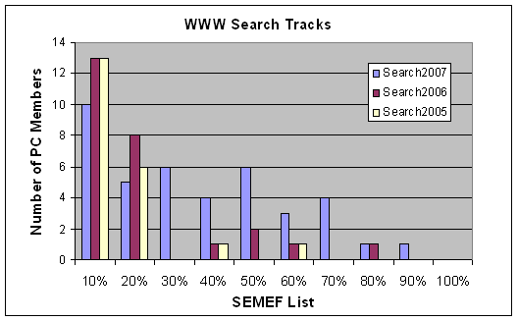
Figure 16: Average Number of PC in SEMEF List
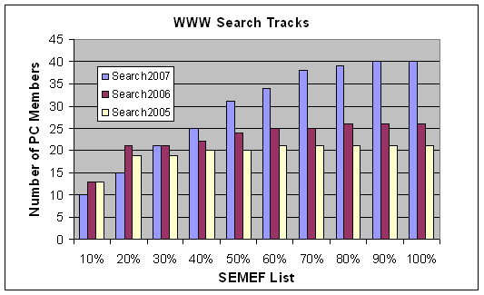
Figure 17: Cumulative Number of PC in SEMEF List
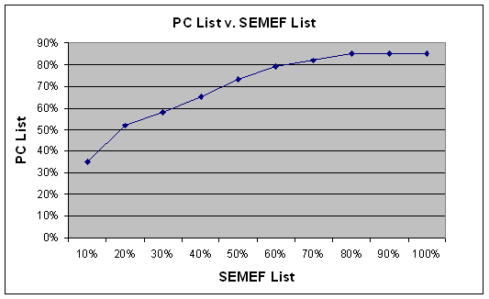
Figure 18: Average Distribution PC in SEMEF List
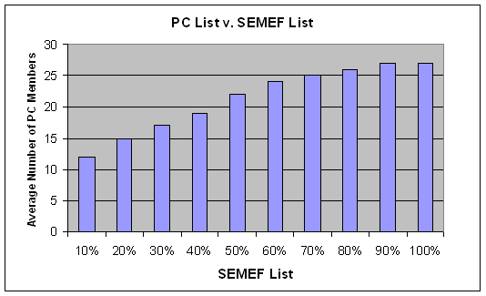
Figure 19: Cumulative Distribution of PC in SEMEF List

- Collaboration Network Expansion
Recommending experts for consideration on a program committee is not a straightforward task. To do this accurately, the closest relationships between PC Chairs and experts must be ascertained. Finding Semantic Associations between ‘PC Chair-PC member’ pairs for each track is therefore a necessary component of this application. Table 8 shows that the majority of experts in the PC-List have a weak relationship to each Chair based on our dataset, extending the argument that the WWW Search Track not only invites top experts in its PC-Lists, but more so experts with low Geodesic relative to PC Chairs.
Relationship | PC List  (Number of Expert Relationships) |  |  |  |  |  | Above  Average  Expertise  (in PC)
Relationship | Search2007 |  | Search2006 |  | Search2005 |  | Above  Average  Expertise  (in PC)
Relationship | Chair1 | Chair2 | Chair1 | Chair2 | Chair1 | Chair2 | Above  Average  Expertise  (in PC)
STRONG | 2 | 0 | 3 | 0 | 3 | 0 | 0
MEDIUM | 10 | 7 | 6 | 2 | 7 | 8 | 4
WEAK | 31 | 17 | 15 | 20 | 11 | 14 | 10
EXTREMELY WEAK | 1 | 2 | 1 | 2 | 0 | 0 | 0
Table 8: PC Chair - PC Members Collaboration Relationships
Table 9 shows however that a large number of experts, with expertise higher than the average expertise of experts in the PC-List, and with lesser or equal Geodesic exist. Thus, our system presents the PC Chairs with more choices about possible experts to invite. This is a task otherwise laborious when undertaken manually.

Relationship | SEMEF  (Number of Expert Relationships) |  |  |  |  |  | Above  Average Expertise  (not in PC)
Relationship | Search2007 |  | Search2006 |  | Search2005 |  | Above  Average Expertise  (not in PC)
Relationship | Chair1 | Chair2 | Chair1 | Chair2 | Chair1 | Chair2 | Above  Average Expertise  (not in PC)
STRONG | 6 | 2 | 10 | 3 | 10 | 2 | 3
MEDIUM | 106 | 53 | 88 | 55 | 88 | 76 | 16
WEAK | 649 | 293 | 608 | 582 | 605 | 576 | 58
EXTREMELY WEAK | 99 | 26 | 66 | 26 | 66 | 43 | 3
Table 9: PC Chair - SEMEF List Collaboration Relationships

CHAPTER 7

RELATED WORK
In industrial settings, academia and research alike, various approaches have been undertaken for finding experts. Many of these approaches, [6, 29, 31, 40, 53] although devoid of Semantics, have applicability in many domains, using heterogeneous datasets. We benefit from the ideas and techniques presented in many of these applications to aid the development a fairly robust system, demonstrating the advantages of incorporating Semantics in finding experts.
In [40] Rodriguez et al, describes an approach for determining relevant reviewers in the Peer-Review Process, using coauthorship graphs and the relative-rank particle-swarm propagation algorithm. The algorithm is founded on the premise that related experts in a given domain are obtainable from examining the coauthorship network of the coauthors of a given manuscript. Nodes and edges in the coauthorship graph are given weights based on the number of authors of a manuscript and the number of references to each author within the entire network. These node and edge weights propagate throughout the coauthorship network and stochastic analysis on outgoing edges express the probability of finding experts as the graph diffuses outwards. Weights represent states and energy levels of propagating nodes, which decay as the networks extends outwards. The most qualified reviewers are essentially nodes with the highest energy levels in the coauthorship graph.
Such an approach finds qualified reviewers for the bidding phase of the review process. We note that our approach is more multifaceted. First, we make recommendations for not only discovering experts using publication data, but also for analyzing collaboration relationships between them, for the purpose of understanding and suggesting unknown experts relative to the PC Chair(s) for expanding Collaboration Networks. We achieve this through characterizing collaboration levels based on the Geodesic between an author and a PC Member. Second, we provide the functionality of discovering close collaboration relationships or C-Nets within research sub groups. This provides an added dimension for PC Chairs to have greater insight to better form PC-Lists. Third, we extend our techniques to quantify expertise using publication impact statistics for the important task of developing expertise profiles for various experts.
Miki et al, present a similar citation link analysis approach [34] to that of Rodriguez et al in [34], for discovering social relationships between researchers in an academic setting. Publication data from Citeseer create a bibliographical author cocitation network from which collaboration and social relationships can be determined. In this work, bibliographical author cocitation measures the number of cocitations between two authors, A1 and A2, across a cadre of articles. The greater the ‘Citation Count’ (number of articles containing cocitations) between the two authors, the stronger is their expertise and relationship between them. Miki et al create an ontology based on the 200 most frequently cited researchers, annotated with relationships to all other authors, to capture mappings indicating identifiable author groups (or clusters) and their relative locations, as well as their degree of centrality and proximities across group boundaries. Degree of centrality is used identify other notable features, such as top experts called gatekeepers, who bridge research fields by linking entities of different clusters through coauthorship. The ideas presented by Miki et al bear some similarity to our work in terms of characterizing collaboration relationships among researchers. However, we define C-Net units, which rank relative positions of researchers within particular clusters based on expertise and Collaboration Strength. Furthermore, our approach for determining Collaboration Strength uses techniques presented by Newman in [37], dissimilar from the approach taken by Miki.
Work in [32] presents the concept of Experience Atoms (EAs), which are elementary units of experience extracted from Concurrent Versioning System (VCS) during the implementation and maintenance phases of the Software Engineering Life cycle. An Experience Atom represents code changes by a developer quantified to represent traceable work done on the system. The summation of experience atoms provides a reliable measure of expertise and aids discovery of experts from the perspective of software development. An evaluation of the Expertise Browser comparing the probability of software system failure with experience yielded expected results; systems developed by more experienced developers had a lower probability of failure.
The bottleneck in this approach is the extent of information sharing among the various software development companies from whom expertise can be gleaned. Privacy and security concerns in many cases serve as a deterrent to information exchange. The key difference between this and ours is that we exploit publicly available datasets from online digital libraries. This is a critical and very necessary requirement if public persuasion of the benefits of the Semantic Web is to be realized.
In [31], McDonald et al, present an Expertise Recommender (ER) system developed in the context on an organizational setting that uses Change History and a Tech support Heuristics for finding needed experts. The Tech support Heuristics described by McDonald, solves difficult problems by locating other individuals faced with a similar problem in the past, but who successfully found a solution. The system architecture (ER-Arch) uses a server with many high level extensible supervisor modules, to maintain user profiles (Profiling Supervisor), potentially matching users that can satisfy queries (Identification Supervisor) and a query engine for refining and filtering query requests and responses (Selection Supervisor). This system like the Expertise Browser is application specific and is limited by the extent of information sharing among the disparate data sources, as well as the semantic interpretation of such ideas as “suitable users,” “similar problems” and “solution.”
Zhang et al describe a similar application [53] that discovers experts in an online Web-based community (Java Forum) using PageRank and various other algorithms considering the nuances of such systems. Zhang et al exploits the plethora of data contained in thread based online forums for an application with over 330,000 messages, over 13,000 persons and nearly 56,000 relationships between posts. The first algorithm, (the Simple Statistical Measure), presumes that a user who answers many questions on a topic is an expert. ‘Number of posts’ corresponds directly to expertise. This adds another dimension of measurement, since a user with several posts may assist only a few others. On the contrary, a user with few posts may help many others. Zhang et al also consider in this statistical measure, that ‘number of posts’ may also reflect a lack of knowledge as well as expertise. The Z-score Measure thus considers the asking and reply pattern of a user, through their ‘Z_number’ and ‘Z_degree.’ The third dimension of ranking extends the PageRank algorithm proposed by Page et al [39], for ranking web pages, based on the number of links pointing to it, as well as recursively, the number of links pointing to each of incoming link and so forth. The adaptation of the PageRank algorithm, called the ExpertRank algorithm, considers not only the number of users a given user B helps, but also those users who themselves might have previously assisted user B. The expertise of any such users must be automatically boosted since B herself is an expert able to help others. This cascading ranking technique is quite popular in such settings. This work is significantly different from ours since it considers many algorithms for effectively capturing expertise in an online setting. The techniques we use are less complicated, relying primarily on the publication impact of articles to reflect their quality.
Balog et al describes a heterogeneous application in [6] developed in an organizational context for finding experts. Formal Probabilistic Models are used for determining expertise profiles, (containing expert documents), and also to determine top experts given a set of documents on a certain topic. These two aspects are quite similar to two dimensions of our work, in which we develop expertise profiles based on the aggregation of a researcher’s publications, and then rank experts based on a set of input topics and their expertise profiles. Balog however, estimates a language model for every document potentially belonging to an expert (Candidate Model) as well as a model for experts that might be related to a given topic based on a set of documents (Document Model). Various levels of candidate-document matches (exact, first name, last name, etc) are necessary since unlike publication data, associations with documents might not always be explicit. Technical reports may contain full names, while emails may contain only initials and last name. Balog et al use probabilistic candidate and document models, based on Bayes rule to link documents to candidates and vice versa. This approach highlights the benefit of using a heterogeneous data source for finding experts. Its also address the unmistakable challenge of reference reconciliation, which an inevitable component of such a process. Work in [18] however demonstrates the efficacy of Semantics for reconciling references, deemed a more effective alternative.
In [47] an ontological approach is used for classifying papers according to a pre-existing taxonomy of topics, for finding Relational and Evolutionary ExpertiseNets. The Cora dataset from which thousands of citation linkages were extracted was used to build Relational and Evolutionary ExpertiseNets for modeling expertise based on the number of citation linkages to a publication. This work bears some similarity to ours through the use of publication data and a taxonomy of topics to relate papers-to-topics yet their dataset is much more smaller. This aspect of similarity in the two approaches reinforces the importance of constructing a taxonomy for relating publications to different topics. However, a fundamental difference between this and our work is that we use the taxonomy to our advantage for finding expertise as very specific levels of granularity gleaning topic and subtopic relationships for inferring expertise when applicable. Furthermore the evaluation of this works makes it cumbersome to truly assess the contribution of the ideas presented.
In [29], Liu et al describe an RDF-based Matcher that aids PhD students in selecting appropriate advisors in a university setting, through integrating heterogeneous data sources using ontologies. The RDF-Matcher aims to express tacit knowledge contained in structured, unstructured and semi-structured forms, annotated and converted into RDF, using XML wrappers. A simple mediator module maintains a conceptual model of overall system schema, filtering and transforming queries from the user to the Expertise Manager which manages the domain knowledge. Though simplistic an application, the systems encompasses several steps necessary for developing a Semantic Web application outlined in [4] such as Metadata Extraction, Data Cleaning, and Ontology Representation. The obvious difference between theirs and this work is the level of depth we cover, including ranking of experts, and discovery of C-Nets for expanding Collaboration Networks.

CHAPTER 8

CONCLUSIONS AND FUTURE WORK
The SEMEF approach presented in this paper is a new method for finding expertise, experts and expanding collaboration networks in the context of the peer-review process. We examined collaboration networks by discovering Semantic Associations between experts and PC Chairs using publication data. We also introduced the concept of CollaborationNets (C-Nets) for grouping experts.
In accomplishing these important tasks, a number of datasets were used, including a taxonomy of Computer Science topics. The taxonomy proved extremely useful in two key aspects. First, it was a central connection point for linking topics to papers, and subsequently obtaining experts on such topics. Second, the taxonomy allows us to find exact and inexact matches of expertise, which is significant if an expert finder application is to be meaningful.
We evaluated our methods by comparing experts found using our system with PC members from past conferences. We found that in general, our system is fairly accurate in corroborating the expertise of PC members. For instance, more than 50% of the PC list was found in the top 20% of our expert finder list. Furthermore, we found a significantly greater number of experts with similar relationships to PC Chairs and comparable (if not higher) expertise that could be considered for invitation for joining future program committees.
We realize that there is room for improving our methods. In fact, by merely improving techniques and sources for data collection, we stand to obtain additional data (not limited to publications) that could provide further information for collaboration level detection. A more sophisticated keyword Extractor Algorithm for obtaining topics from the Call for Papers will at a very minimum, reduce the manual input required in our system, and likely increase the probability of topic matches in our taxonomy. Other expertise ranking techniques (e.g. [53]) could be adapted to improve the overall quality of our application. We investigate these in future work, with hopes of enhancing the SEMEF Semantic Web Expert Finder application.

REFERENCES
- Al-Sudani S., Alhulou R., Napoli A., Nauer E.: OntoBib: An Ontology-Based System for the Management of a bibliography. 17th European Conference on Artificial Intelligence, Riva del Garda, Italy (Aug 28-Sept 3, 2006).
- Aleman-Meza, B., Bojars, U., Boley, H., Breslin, J.G., Mochol, M., Nixon, L. J. B., Polleres, A., Zhdanova, A. V.: Combining RDF Vocabularies for Expert Finding. 4th European Semantic Web Conference, Innsbruck, Austria (June 3-7, 2007).
- Aleman-Meza, B., Hakimpour, F., Arpinar, I. B., Sheth, A. P.: SwetoDblp ontology of Computer Science publications. Journal of Web Semantics 5(3): 151-155 (2007)
- Aleman-Meza, B., Nagarajan, M., Ramakrishnan, C., Ding, L., Kolari, P., Sheth, A. P., Arpinar, I. B., Joshi, A., Finin, T.: Semantic Analytics on Social Networks: Experiences in Addressing the Problem of Conflict of Interest Detection. 15th International World Wide Web Conference. Edinburgh, Scotland, UK (May 22-26 2006)
- Anyanwu K., Maduko A., Sheth A.P.: SemRank: Ranking Complex Relationship Search Results on the Semantic Web. 14th International World Wide Web Conference. Chiba, Japan (May 10-14, 2005).
- Balog, K., Azzopardi, L., de Rijke, M.: Formal Models for Expert Finding in Enterprise Corpora. Special Interest Group on Information Retrieval, Seattle, Washington (August 6–11, 2006).
- Bojārs, U., Breslin J.G.: ResumeRDF: Expressing skill information on the Semantic Web. 1st International ExpertFinder Workshop. Berlin, Germany (January 16, 2007).
- Cameron, D., Aleman-Meza, B., Arpinar, I. B.: Collecting Expertise of Researchers for Finding Relevant Experts in a Peer-Review Setting. 1st International ExpertFinder Workshop. Berlin, Germany (January 16, 2007).
- Cameron, D., Aleman-Meza, B. Decker, S. L., Arpinar, I. B.: SEMEF: A Taxonomy based Discovery of Experts, Expertise and Collaboration Networks. University of Georgia, LSDIS Lab, Technical Report, July 2007.
- Chen, C.: Visualising semantic spaces and author co-citation networks in digital libraries. Journal on Information Process and Management, 35 (3): 401–420 (1999).
- citeseer.ist.psu.edu/impact.html. Estimated Impact of Publication Venues in Computer Science. 2007.
- confious.com. Confious The Conference Nous, 2007.
- cmt.research.microsoft.com. Microsoft Conference Management Toolkit, 2007.
- Decker, S.L., Aleman-Meza, B., Cameron, D., Arpinar, I. B.: Detection of Bursty and Emerging Trends for Identification of Researchers at the Early Stages of Research Areas, University of Georgia, LSDIS LAB, Technical Report, July 2007.
- dictionary.com. Dictionary.com, 2007
- Ding, L., Kolari, P., Finin, T., Joshi, A., Peng, Y., Yesha, Y.: On Homeland Security and the Semantic Web: A Provenance and Trust Aware Inference Framework. AAAI Spring Symposium on AI Technologies for Homeland Security, Stanford, California (March 21-23, 2005).
- Ding, L., Zhouy, L., Finin, T., Joshi, A.: How the Semantic Web is Being Used: An Analysis of FOAF Documents. 38th International Conference on System Sciences, Big Island, Hawaii (January 3-6, 2005).
- Dong, X., Halevy, A., Madhavan, J.: Reference Reconciliation in Complex Information Spaces. 24th ACM SIGMOD International Conference on Management of Data, Baltimore, Maryland (June 13-16, 2005).
- dublincore.org. Dublin Core Metadata Initiative, 2007
- Elmacioglu, E., Lee D.: On Six Degrees of Separation in DBLP-DB and More. SIGMOD Record, 34(2): 33-40 (2005).
- Fensel, D., Hendler, J. A., Lieberman, H., Wahlster, W.: Spinning the Semantic Web: Bringing the World Wide Web to its Full Potential, (2003).
- Gandon, F.: Engineering an Ontology for a Multi-Agent Corporate Memory System. 8th International Symposium on the Management of Industrial and Corporate Knowledge, Compiègne, France (October 22-24, 2001).
- Garton, L., Haythornthwaite, C., and Haythornthwaite, C.: Studying Online Social Networks, Journal of Computer-Mediated Communication, 3(1), 1997.
- Handschuh, S., Staab, S.: Annotation for the Semantic Web: Frontiers in Artificial Intelligence and Applications. (2003).
- Hecht, F., Hecht, B., Sandberg, A.: The Journal “impact factor”: a Misnamed, Misleading, Misused Measure, Cancer Genet Cytogenet, 104(2):77-81 (1998).
- Kaplan, N. R., Nelson, M. L.: Determining the Publication Impact of a Digital Library, Journal of the American Society of Information Science 51(4): 324-339, (2000).
- Katz, Y., Golbeck, J.: Social Network-based Trust in Prioritized Default Logic. 21st National Conference on Artificial Intelligence, Boston, Massachusetts (July 16–20, 2006).
- Kleinberg, J.: The Small-World Phenomenon: An Algorithmic Perspective. 32nd ACM Symposium on Theory of Computing, Portland, OR (May 21-23, 2000).
- Liu, P., Dew, P.: Using Semantic Web Technologies to Improve Expertise Matching within Academia. 2nd International Conference on Knowledge Management, Graz, Austria (June 2004).
- Luper, D., Cameron, D., Miller, J. A., Arabnia, H. R.: Spatial and Temporal Target Association through Semantic Analysis and GPS Data Mining. 5th International Conference on Information and Knowledge Engineering, Las Vegas Nevada, (June 25-28, 2007).
- McDonald, D. W., Ackerman, M. S.: Expertise Recommender: A Flexible Recommendation System and Architecture. 2000 Conference on Computer Supported Cooperative Work, Philadelphia, Pennsylvania (December 2-6, 2000).
- Mockus, A., Herbsleb J. A.: Expertise Browser: A Quantitative Approach to Identifying Expertise. International Conference on Software Engineering, Orlando, Florida (May 19-25, 2002).
- Mika, P.: Flink: Semantic Web Technology for the Extraction and Analysis of Social Networks, Journal of Web Semantics, 3(2-3): 211-223, (2005).
- Miki T., Nomura, S., Ishida T.: Semantic Web Link Analysis to Discover Social Relationships in Academic Communities. 2005 International Symposium on Applications and the Internet. Trento, Italy (January 31-February 4, 2005).
- Milgram, S.: The Small World Problem. Psychology Today, 60-67, May 1967.
- Nascimento, M. A., Sander, J. Pound, J.: Analysis of SIGMOD’s Co-Authorship Graph. ACM SIGMOD Record, 32(3): 8-10, (2003).
- Newman, M. E. J.: Coauthorship Networks and Patterns of Scientific Collaboration. National Academy of Sciences of the United States of America, 1(101): 5200-5205, (2004).
- Noy, N. F., McGuinness, D. L.: Ontology Development 101: A Guide to Creating Your First Ontology. Stanford Knowledge Systems Laboratory Technical Report, KSL-01-05, March 2001.
- Page L., Brin S., Motwani R., Winograd T.: The PageRank Citation Ranking: Bringing Order to the Web, Stanford Digital Library Technologies Project, 1998
- Rodriguez, M.A., Bollen, J.: An Algorithm to Determine Peer-Reviewers, Los Alamos National Laboratory Technical Report, LA-UR-06-2261, December 2005.
- Rowland, F.: The Peer Review Process. Joint Information Systems Committee, 15(12): 247-258, (2002).
- sciencedirect.com. Science Direct, 2007.
- Seglen P.: Why the Impact Factor of Journals Should Not be Used for Evaluating Research, British Medical Journal, 314(7079): 498-502, (1997).
- semanticfocus.com. Introduction to the Semantic Web Vision and Technologies, 2007.
- Shadbolt, N., Berners-Lee, T., Hall, W.: The Semantic Web Revisited. IEEE Intelligent Systems 21(3): 96-101, ( May/June 2006)
- Singh, M. P., Huhns, M. N.: Service Oriented Computing: Semantics Processes, Agents. (2005)
- Song, X., Tseng, B.L., Lin, C.-Y., Sun, M.-T.: ExpertiseNet: Relational and Evolutionary Expert Modeling. 10th International Conference on User Modeling, Edinburgh, Scotland (July 2005).
- Sun Y., Giles C. L.: Popularity Weighted Ranking for Academic Digital Libraries, 29th European Conference on Information Retrieval Research. Rome, Italy (April 5-7, 2007).
- Valle, E. D., Cerizza, D., Celino I.: Who Shall I Ask? A Discovery Engine for Booking a Meeting with the Right Specialist. 1st International ExpertFinder Workshop, Berlin, Germany (January 16, 2007).
- w3c.org. The World Wide Consortium (W3C). 2007.
- wikipedia.com. Wikipedia, 2007.
- zakongroup.com, OpenConf Peer-Review Software & System, 2007.
- Zhang, J., Ackerman, M. S., Adamic, L.: Expertise Networks in Online Communities: Structure and Algorithms. 16th International World Wide Web Conference, Banff, Canada (May 8-12, 2007).

APPENDIX A

SCHEMAS AND DATASETS

O’CoMMA Ontology Instances (4.4)
Classes
ArtificialIntelligence, CORBA, ComputerAlgebraMethods, ComputerAnalysis, ComputerGraphics, ComputerScience, ComputerVision, DiscreteEventSimulation, DistributedArtificialIntelligence, HCI, HTML, HTTP, ImageProcessing, Interactivity, Internet, JavaProgramming, KnowledgeEngineering, MedicalImagesProcessing, Network, ObjectProgramming, ParallelObjectProgramming, ParallelProgramming, Programming, RDF, RMI, Robotics, Simulation, SoftwareEngineering, SymbolicLearning, TCPIP, VirtualRealitySimulation, WML, Web, XML, ArtificialIntelligenceTopic, CORBATopic, ComputerAlgebraMethodsTopic, ComputerAnalysisTopic, ComputerGraphicsTopic, ComputerScienceTopic, ComputerVisionTopic, DiscreteEventSimulationTopic, DistributedArtificialIntelligenceTopic, HCITopic, HTMLTopic, HTTPTopic, ImageProcessingTopic, InteractivityTopic, InternetTopic, , JavaProgrammingTopic, KnowledgeEngineeringTopic, MedicalImagesProcessingTopic, NetworkTopic, ObjectProgrammingTopic, ParallelObjectProgrammingTopic, ParallelProgrammingTopic, ProgrammingTopic, RDFTopic, RMITopic, RoboticsTopic, SimulationTopic, SoftwareEngineeringTopic, SymbolicLearningTopic, TCPIPTopic, VirtualRealitySimulationTopic, WMLTopic, WebTopic, XMLTopic,

SWETO-DBLP Schema
Classes | Article, Article in Proceedings, Book, Book Chapter, Doctoral Dissertation, Edited Book, Edited Publication, Journal, Masters Thesis, Pages, Proceedings, Publication, Publishing Organization, School, Serial Publication, Series, Thesis, University, Webpage, rdf:Seq, owl:Ontology, Document, Organization, Person
Object Properties | Affiliation, at_university, Author, chapter_of, cites, editor, in_series, isIncludedIn,
Data Type Properties | Abstract, book_title, cdrom, Chapter, ee, isbn, journal_name, last_modified_date,  month, number, pages, volume, year

DATASET - Taxonomy of Topics (Instances)
Classes
Access Control, Access Control and Security,Adaptation, Adapting content to mobile devices, Adapting to content mobile devices, Adaptive e-learning systems, Adaptivity and mobility, Advanced Linking, Advertising and Security for E-Commerce, Agents and the Semantic Web, Aggregation, Applications and Architecture, Architecture, Architecture and implementation of Web sites, ArtificialIntelligence, Association Rules, BioInformatics, Browsers, Browsers and Tools, Browsers and UI web engineering hypermedia and multimedia security and accessibility, Browsing, CDNS and Caching, CORBA, Caching, Classification, Clustering, Collaborative Filtering, ComputerAlgebraMethods, ComputerAnalysis, ComputerGraphics, ComputerVision, Concurrency Control, Consistency, Constraints, Content, Content Transformation for Mobility, Content and Education, Context, Context Aware Systems, Correctness and security, Data Extraction, Data Integrity, Data Management, Data Mining, Data Mining classification, Data Model, Data Semantics, Data Streams, Database, Database Design, Database Systems, Developing Regions and peer-to-peer, DiscreteEventSimulation, DistributedArtificialIntelligence, Distributed Databases, Dynamic Content, Dynamic Services and analysis, E-Commerce, E-Commerce, Security, and Scalability, E-Commerce, Security and Scalability, E-Commerce and government, E-Communities, E Tools for Learning, Establishing the semantic web, Extraction and Visualization, Fighting search spam, File Organization, Formal Querying and Reasoning, Foundations of the semantic web, Functional Dependency, Graphics and Multimedia, HCI, HTML, HTTP, Hashing, High availability and performance, Hypermedia, Hypermedia in the Small, Hypermedia in the Large, ImageProcessing, Improved search ranking, Improving the browsing experience, Indexing, Indexing and querying, Inference, Information Filtering, Information Retrieval, Information Retrieval and Applications, Information Visualization, Information extraction, Integration, Integration and Interaction, Integration and Interoperability, Integrity Constraints, Interactivity, Internet, Interoperability, Interoperability, Integration and Composition, JavaProgramming, KnowledgeEngineering, Knowledge Acquisition, Knowledge Discovery, Knowledge Management, Languages and Authoring for the Semantic Web, Languages for the Semantic Web, Legal Ontologies and Methodologies, Link Analysis, Link based Ranking, Link based similarity, Linking, Load Management, MedicalImagesProcessing, Metadata, Mining the web, Mobile Computing, Mobile User Interface, Mobility, Mobility and Wireless Access, Multimedia, Natural Language Processing, Navigation, Network, New search paradigms, Normalization, OLAP, OWL, ObjectProgramming, Object Oriented Databases, Ontological Reasoning, Ontologies, Ontology and Ontology Maintenance, Ontology and services, Open hypermedia and the web, Open hypermedia on the web, P2P Systems, Page Rank, ParallelObjectProgramming, ParallelProgramming, Performance, Performance, reliability and scalability, Performance Analysis, Performance, Workload Characteristics and Adaptation, Personalization, Personalization in E-Commerce, Privacy, Programming, Protocols, Query, Query Expansion, Query Lanaguage for Semantic Web, Query Language for the Semantic Web, Query Languages, Query Optimization, Query Processing, Query result processing, Question Answering, Question Answering Over the Web, RDF, RDF Storage and Implementation Issues, RMI, Ranking, Ranking and classification, Recovery, Relational Algebra, Relational Database, Relational Model, Robotics, SQL, SVM, Sampling, Scalability, Scaling up the Semantic web, Schemas and semantics, Search, Search, Querying and Indexing, Search Technologies, Search and Querying, Search engine engineering, Search engineering, Searching, Querying and Indexing, Searching and Querying, Security, Security Trust and Privacy, Security privacy and ethics, Security and privacy, Security for Web Applications and P2P, Security through the eyes of users, Semantic Annotation, Semantic Web, Semantic Web Challenge, Semantic Web Middleware, Semantic Web Mining, Semantic Web Services, Semantic interfaces and OWL tools, Semantic search, Semantic web:ontology construction, Semantic web applications, Semantic web foundations, Semantics, Semantics and discovery, Semi-structured semantic data, Serializability, Server performance and scalability, Service, Service selection and metadata, Similarity Search, Simulation, Social Networks, SoftwareEngineering, SymbolicLearning, TCPIP, Temporal Databases, Text Categorization, Text Classification, Text Mining, Tools and Methodologies for Web Agents, Trust, Trustworthy Web Sites, UI and applications, Ubiquitous WWW, Usability and accessibility, Usage analysis, User Interfaces, User Interface for Emerging Applications, User Interfaces and Visualization, User Modeling, User focused search and crawling, User interfaces: semantic tagging,
Using the semantic web, VirtualRealitySimulation, Visualization, WML, Web, Web-Services and Applications, Web-based educational applications, Web Applications, Web Crawling, , Web Graph, Web Mining, Web Search, Web Services, Web Sites, Web application design, Web crawling and measurement, Web engineering, Web engineering: validation, Web engineering with semantic annotation, Web mining with search engines, Web site analysis and customization, Web site engineering, Wide-area architecture and protocols, Workload analysis, Writing the web, XML, XML Applications, XML Foundations, XML RDF, XML Tools, XML and web services, XML parsing and stylesheets, XML query and programming languages, XPath, XQuery, XSLT, e-learning, e-learning Environment, e-learning and scientific applications, search engines, ArtificialIntelligenceTopic, CORBATopic, omputerAlgebraMethodsTopic, ComputerAnalysisTopic, ComputerGraphicsTopic, ComputerVisionTopic, DiscreteEventSimulationTopic, DistributedArtificialIntelligenceTopic, HCITopic, HTMLTopic, HTTPTopic, ImageProcessingTopic, InteractivityTopic, InternetTopic, JavaProgrammingTopic, KnowledgeEngineeringTopic, MedicalImagesProcessingTopic, NetworkTopic, ObjectProgrammingTopic, ParallelObjectProgrammingTopic, ParallelProgrammingTopic, ProgrammingTopic, RDFTopic, RMITopic, RoboticsTopic, SimulationTopic, SoftwareEngineeringTopic, SymbolicLearningTopic, TCPIPTopic, VirtualRealitySimulationTopic, WMLTopic, WebTopic, XMLTopic,

APPENDIX B

SEMANTIC EXPERT FINDER – WEB APPLICATION

We created a Web Application demo for the SEMEF system to provide the user an interface to our system. The application runs on an Apache Tomcat 6.0 Server using Java Server Pages (JSP). The following Application Programmer Interfaces (APIs) were used in creating the application.
- JDK 1.6.0
- Jena 2.4 API
- Jericho 2.3 HTML Parser
- Semdis API
- Sesame 1.2.6
- BRAHMS API
- XML DOM Parser
The technologies knit together a system, beginning with the publication dataset for focus crawling DBLP, ACM etc, the papers-to-topics ontology, by linking literals to concepts in the taxonomy of topics, then using an array of input topics to find experts authors, and their collaboration levels based on metadata in SWETO-DBLP. The following screenshots demo the system.

SCREEN SHOT - MAIN MENU OPTIONS
The SEMEF homepage presents the options for viewing expert rank for from a previous Search Track. Tracks may be sorted by name, rank value (expertise) or collaboration relationship. The user can also specify the Verbose Mode explained later.
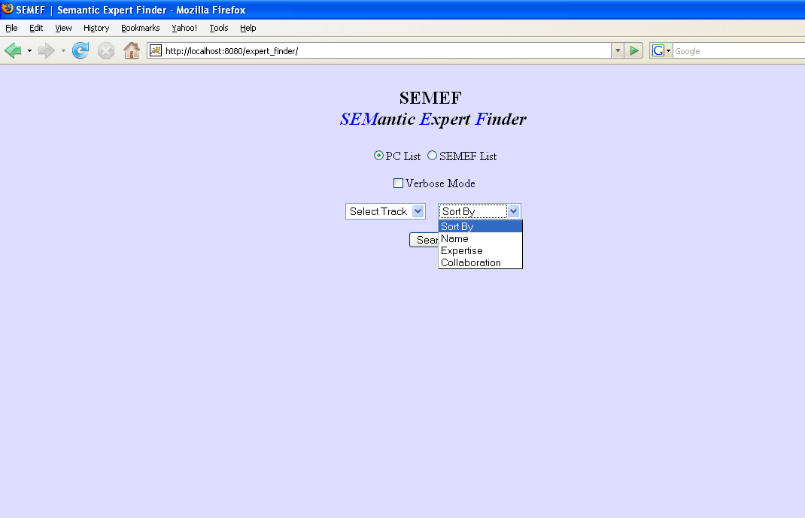

SCREEN SHOT – PAST PROGRAM COMMITTEE
The interface shows a link to the track (Search 2006) and the array of input topics, as well as Collaboration relationships between each PC member-PC Chair pair. Expert rank is shown in the leftmost column and corresponding rank value (or expertise) in the rightmost column.
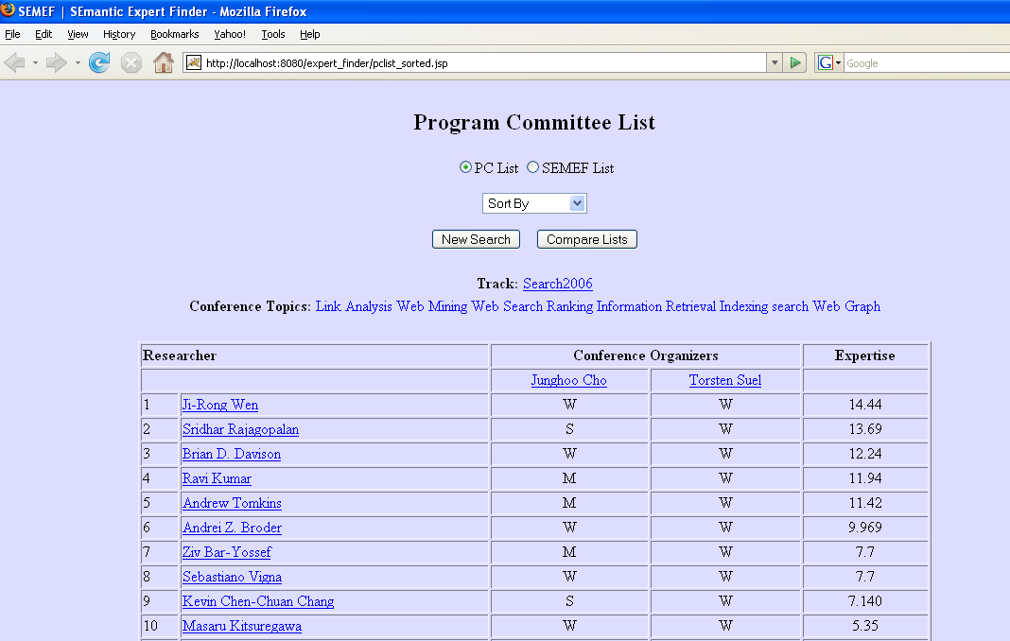

SCREEN SHOT – TRACK SITE (CFP)
The list of input topics is verifiable at the track website which contains the CFP for the given track.
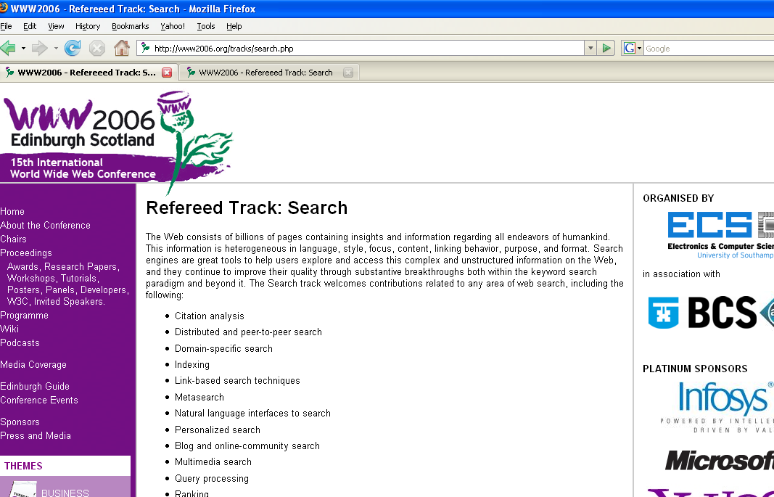

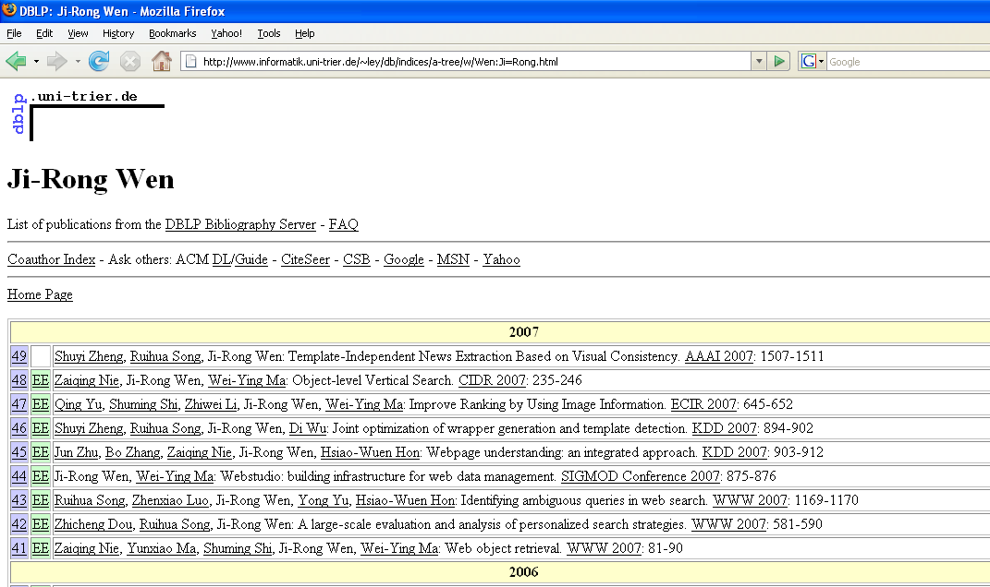
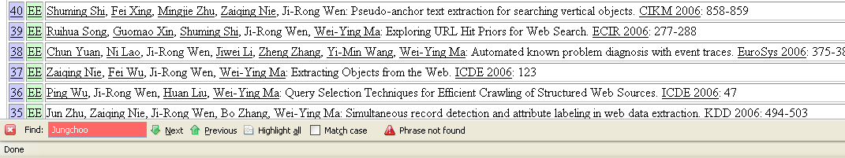
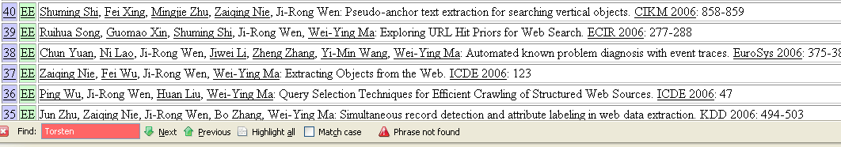

SCREEN SHOT – PAST PROGRAM COMMITTEE
Each concept is hyperlinked to its DBLP homepage. The Geodesic relationship can be verified as not being falsely negative or positive. The keyword based search should enable the user to verify that neither Junghoo Choo nor Torsten Seul has a direct relationship with Ji-Rong Wen as shown.

SCREEN SHOT – SEMEF LIST
The use is presented with a SEMEF list in which color indicates the positions of current PC members in the SEMEF list. Green shows PCM members in this case and Blue represents SEMEF experts. This screenshot clearly demonstrates a number of more qualified experts with equally weak relationships to the PC Chairs exist.
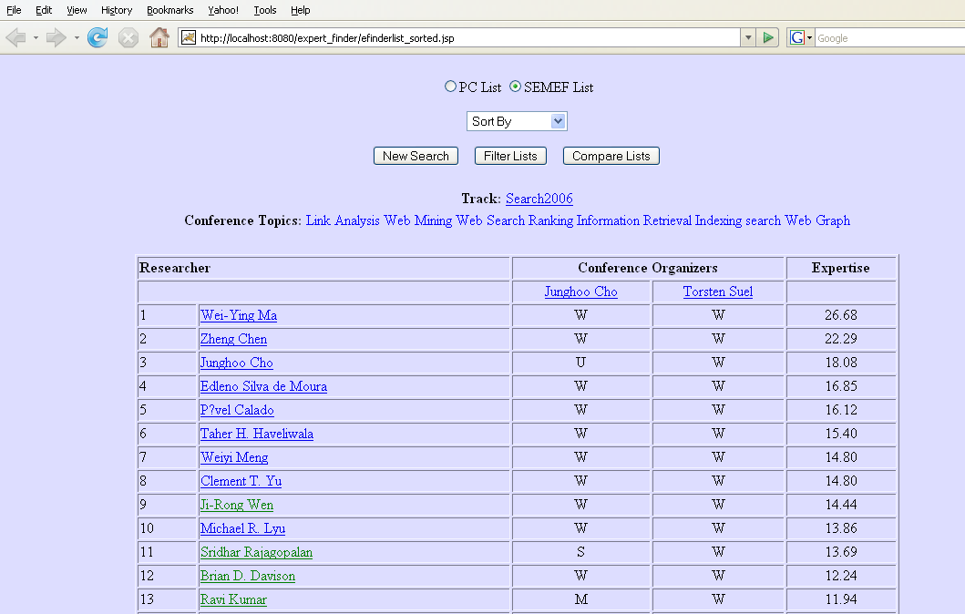

SCREEN SHOT – C-NET UNITS
This screen shot is the result of filtering the PC and SEMEF lists to obtain C-Net for the top experts. Ten (10) super nodes are shown in this screenshot, and the disparity of expertise between each and their coauthors within this C-Net.
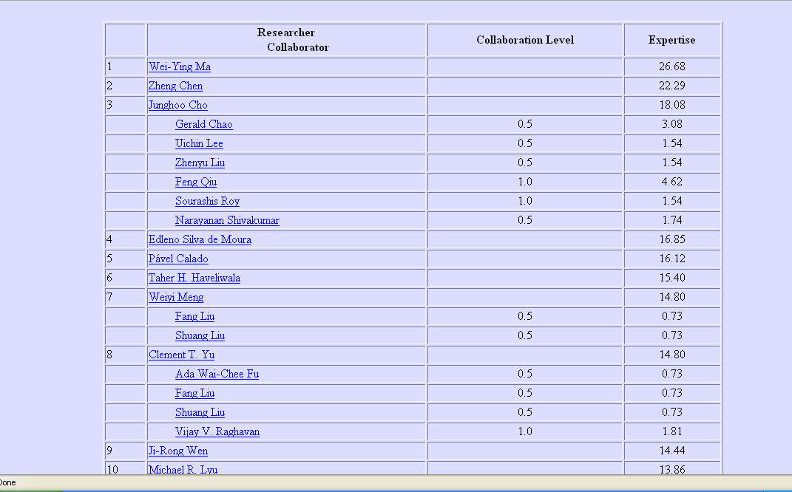

SCREEN SHOT – SEMEF EVALUATION
This screenshots shows the number of PC members in to top 10% of the SEMEF List. The user is presented with the option of viewing the number in different percentages of the SEMEF List by selecting from the drop down list.
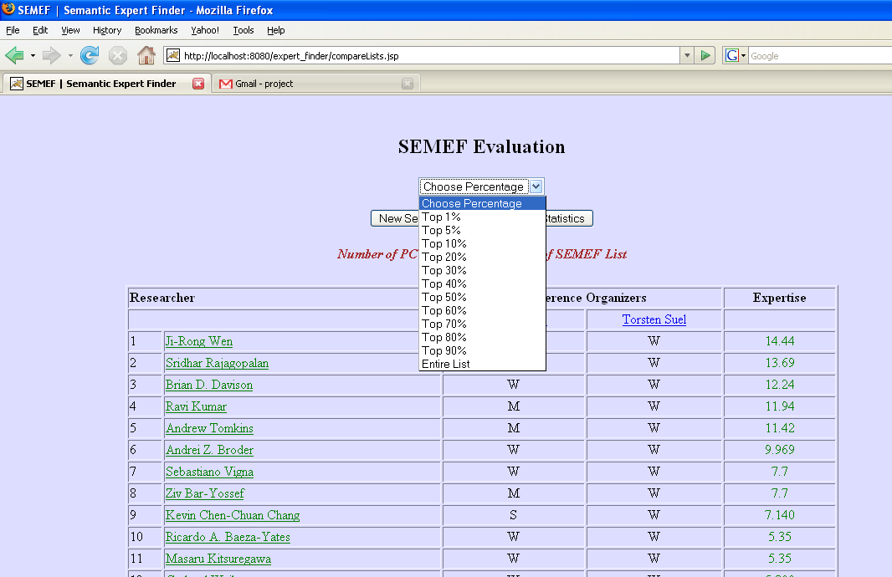

Dublin Core - http://purl.org/dc/elements/1.1/
RDF - http://www.w3.org/1999/02/22-rdf-syntax-ns#"
RDFS - http://www.w3.org/2000/01/rdf-schema#"
OWL - http://www.w3.org/2002/07/owl#
http://www.informatik.uni-trier.de/~ley/db/
http://www.informatik.uni-trier.de/~ley/addr.html
http://www.cs.uga.edu/~cameron/swtopics/swtopics#
http://cs.uga.edu/~cameron/swtopics/taxonomy

