B.M.S. College of Engineering

**(Autonomous Institution affiliated to VTU, Belagavi)**

Department of Computer Science and Engineering



**LAB REPORT**

**OBJECT ORIENTED JAVA PROGRAMMING 23CS3PCOOJ**

(December 2023-March 2024)

NAME: VENAKTESH VINAY CHANDLE

1BM22CS325

**B.M.S. College of Engineering Department of Computer Science and Engineering**



**Laboratory Certificate**

This is to certify that VENKATESH VINAY CHANDLE has satisfactorily completed the course of Experiments in Practical OBJECT ORIENTED JAVA PROGRAMMING prescribed by the Department during the odd semester 2023-24.

Name of the Candidate: VENKATESH VINAY CHANDLE

USN No.: 1BM22CS325 Semester: III Section: F

MAX MARKS OBTAINED 10

MARKS IN WORDS:

Signature of the staff in-charge Head of the Department Date:

LAB PROGRAM 1

1. Write a program to overload the method print that prints sum of n natural numbers when

one variable is passed, and prints the prime numbers in a given range when 2 parameters

are passed.INPUT

class Overload {

void print(int n) {

int sum = 0;

for(int i=1; i<=n;i++) {

sum = sum+i;

}

System.out.println("Sum of "+n+" natural numbers is "+sum);

}

void print(int m, int n) {

System.out.println("Prime numbers in the range are ");

for(int i=m;i<=n;i++) {

int flag=0;

for(int j=2;j<=i/2;j++) {

if(i%j == 0) {

flag = 1;

break;

}

}

if(flag==0)

System.out.println(i);

}

}

}

class OverloadDemo {

public static void main(String[] args) {

Overload o = new Overload();

o.print(5);

o.print(7,13);

}}

Output

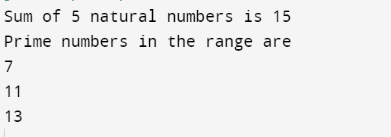

LAB PROGRAM 2

Write a Java program to create a class Grocery that has the variables c_name and c_phone.

Create a method to accept 3 parameters to specify quantity of dal, quantity of pulses and

quantity of sugar.The method to return the total price. Display the name, ph_no and total bill

of 3 customers

Input

class Grocery {

String c_name;

String c_ph;

double total;

Grocery(String c_name, String c_ph){

this.c_name= c_name;

this.c_ph = c_ph;

}

void calc(double q_dal,double q_pulses, double q_sugar) {

total = q_dal*100+q_pulses*80+q_sugar*50;

}

void display()

{

System.out.println("Name "+" "+"Phone number "+" "+"Total");

System.out.println(c_name+" "+c_ph+" "+total);

System.out.println();

}

}

class GDemo {

public static void main(String[] args) {

Grocery g1 = new Grocery("Rama","12345");

Grocery g2 = new Grocery("Shama","23456");

Grocery g3 = new Grocery("Bhima", "67891");

g1.calc(2, 2, 1);

g1.display();

g2.calc(3, 5, 2);

g2.display();

g3.calc(1, 1, 0.5);

g3.display();

}

}

Output

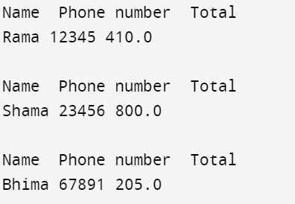

LAB PROGRAM 3

Write a Java program to calculate roots of a quadratic equation. Use appropriate methods to take

input, and calculate the roots.

Input

import java.util.Scanner;

class Quad {

int a, b, c;

double root1, root2, d;

Scanner s = new Scanner(System.in);

void input()

{

System.out.println("Quadratic equation is in the form : ax^2 + bx + c");

System.out.print("Enter a:");

a = s.nextInt();

System.out.print("Enter b:");

b = s.nextInt();

System.out.print("Enter c:");

c = s.nextInt();

}

void discriminant() {

d= (b*b)-(4*a*c);

}

void calculateRoots() {

if(d>0)

{

System.out.println("Roots are real and unequal");

root1 = ( - b + Math.sqrt(d))/(2*a);

root2 = (-b - Math.sqrt(d))/(2*a);

System.out.println("First root is:"+root1);

System.out.println("Second root is:"+root2);

}

else if(d == 0)

{

System.out.println("Roots are real and equal");

root1 = (-b+Math.sqrt(d))/(2*a);

System.out.println("Root:"+root1);

}

else

{

System.out.println("No real solutions. Roots are imaginary");

double real = -b / (2 * a);

double imaginary = Math.sqrt(-d) / (2 * a);

System.out.println("The equation has two complex roots: " + real + " + " + imaginary + "i and "

+ real + " - " + imaginary + "i");

}

}

}

class Main {

public static void main(String[] args) {

Quad q= new Quad();

q.input();

q.discriminant();

q.calculateRoots();

}

}

Output:

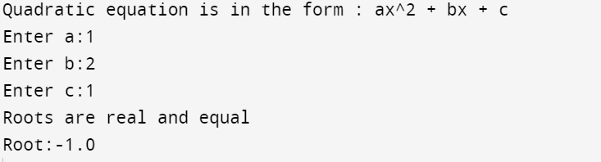

LAB PROGRAM 4

Create a class Book that contains four members: name, author, price, and num_pages. Include a

constructor to set the values for the members. Include methods to set and get the details of the

objects. Include a toString( ) method that could display the complete details of the book. Develop a

Java program to create n book objects.

Input:

import java.util.Scanner;

class Book{

String name, author;

int price, no_pages;

public Book(String name, String author, int price, int no_pages){

this.name = name;

this.author = author;

this.price = price;

this.no_pages = no_pages;

}

public String toString(){

System.out.println("Name: " + this.name);

System.out.println("Author: " + this.author);

System.out.println("Price: " + this.price);

System.out.println("Pages: " + this.no_pages);

return this.name + this.author + this.price + this.no_pages;

}

}

class BookMain{

public static void main(String args[]){

System.out.println("ram- abc1234");

Book books[] = new Book[10];

Scanner sc = new Scanner(System.in);

System.out.println("Enter no. of books: ");

int n = sc.nextInt();

sc.nextLine();

for(int i = 0; i < n; i++){

String name, author;

int price, no_pages;

System.out.println("Enter name: ");

name = sc.next();

System.out.println("Enter author: ");

author = sc.next();

System.out.println("Enter price: ");

price = sc.nextInt();

System.out.println("Enter no. of pages: ");

no_pages = sc.nextInt();

books[i] = new Book(name, author, price, no_pages);

}

System.out.println("\n");

for(int i = 0; i < n; i++){

System.out.println("Book " + (i+1) + " Details:\n");

books[i].toString();

System.out.println("\n");

}

}}

Output:

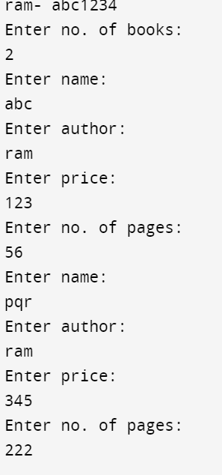

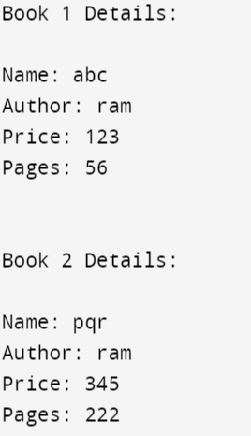

LAB PROGRAM 5

Write a Java program to create a class Student with members USN, name, marks(6 subjects).

Include methods to accept student details and marks, Also include a method to calculate the

percentage and display appropriate details. (Array of student object to be created)

Input:

import java.util.Scanner;

class Student {

String USN;

String name;

int[] marks = new int[6];

public void acceptDetails() {

Scanner scanner = new Scanner(System.in);

System.out.println("Enter USN:");

USN = scanner.nextLine();

System.out.println("Enter name:");

name = scanner.nextLine();

System.out.println("Enter marks for 6 subjects:");

for (int i = 0; i < 6; i++) {

System.out.print("Subject " + (i + 1) + ": ");

marks[i] = scanner.nextInt();

}

}

public double calculatePercentage() {

int totalMarks = 0;

for (int mark : marks) {

totalMarks += mark;

}

return (double) totalMarks / 6;

}

public void displayDetails() {

System.out.println("USN: " + USN);

System.out.println("Name: " + name);

System.out.println("Marks:");

for (int i = 0; i < 6; i++) {

System.out.println("Subject " + (i + 1) + ": " + marks[i]);

}

System.out.println("Percentage: " + calculatePercentage() + "%");

}

}

class Run {

public static void main(String[] args) {

Scanner scanner = new Scanner(System.in);

System.out.println("Enter the number of students:");

int numStudents = scanner.nextInt();

Student[] students = new Student[numStudents];

for (int i = 0; i < numStudents; i++) {

System.out.println("Enter details for student " + (i + 1) + ":");

students[i] = new Student();

students[i].acceptDetails();

}

System.out.println("\nDetails of students:");

for (int i = 0; i < numStudents; i++) {

System.out.println("\nStudent " + (i + 1) + ":");

students[i].displayDetails();

}

}

}

Output:

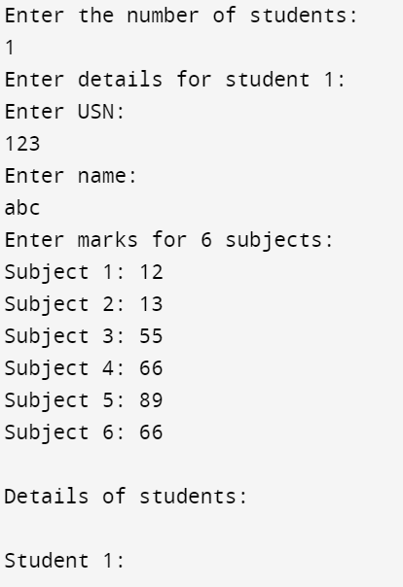

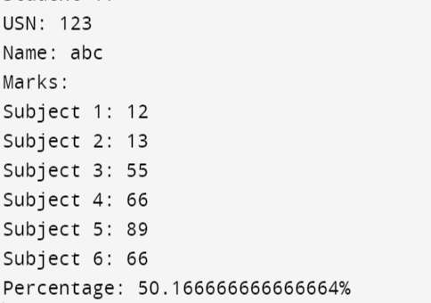

LAB PROGRAM 6

Develop a Java program to create an abstract class named Shape that contains two integers and

an empty method named printArea( ).Provide three classes named Rectangle, Triangle and Circle

such that each one of the classes extends the class Shape. Each one of the classes contain only

the method printArea( ) that prints the area of the given shape.

Input:

import java.util.Scanner;

class InputScanner{

int d1, d2;

Scanner sc = new Scanner(System.in);

InputScanner(){

if(this.getClass() == Circle.class){

System.out.println("Enter d1: ");

d1 = sc.nextInt();

}

else{

System.out.println("Enter d1 and d2: ");

d1 = sc.nextInt();

d2 = sc.nextInt();

}

}

}

abstract class Shape extends InputScanner{

abstract void printArea();

}

class Triangle extends Shape{

void printArea(){

System.out.println("Area of triangle is: " + (double)(d1*d2)/2);

}

}

class Rectangle extends Shape{

void printArea(){

System.out.println("Area of rectangle is: " + (double)(d1*d2));

}

}

class Circle extends Shape{

void printArea(){

System.out.println("Area of circle: " + (double)(3.14*d1*d1));

}

}

class AreaMain{

public static void main(String args[]){

Rectangle r = new Rectangle();

Triangle tr = new Triangle();

Circle c = new Circle();

r.printArea();

tr.printArea();

c.printArea();

}

}

Output:

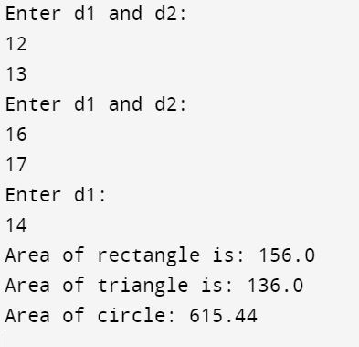

LAB PROGRAM 7

Write a program which creates two threads, one thread displaying “BMS College of Engineering” once every ten seconds and another displaying “CSE” once every two seconds.

Input:

import java.io.*;

class B extends Thread{

public void run(){

try{

for(int i = 0; i < 3; i++){

System.out.println("BMS College of Engineering");

Thread.sleep(10000);

}

} catch (InterruptedException e){

System.out.println(e);

}

}

}

class C extends Thread{

public void run(){

try{

for(int i = 0; i < 3; i++){

System.out.println("CSE ");

Thread.sleep(2000);

}

} catch (InterruptedException e){

System.out.println(e);

}

}

}

class ThreadMain{

public static void main(String args[]){

B b = new B();

C c = new C();

b.start();

c.start();

}

}

Output:

