FCM_SCN_008_TC_003

To verify whether user is able to extract the CIF file from transact

OFAC

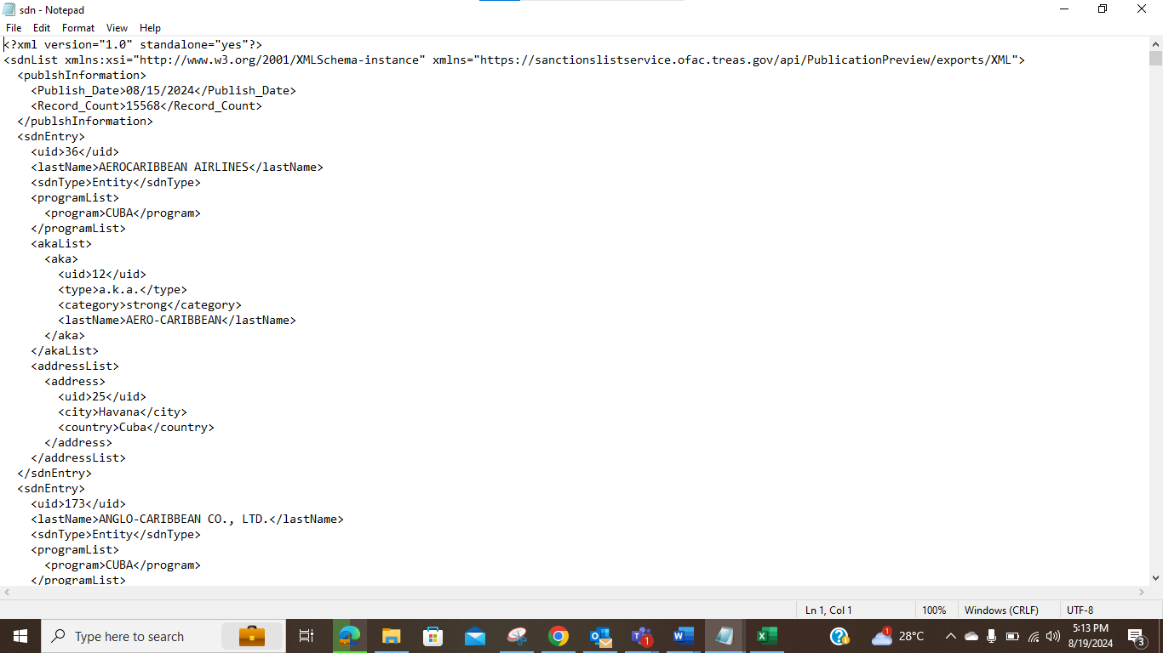

EU
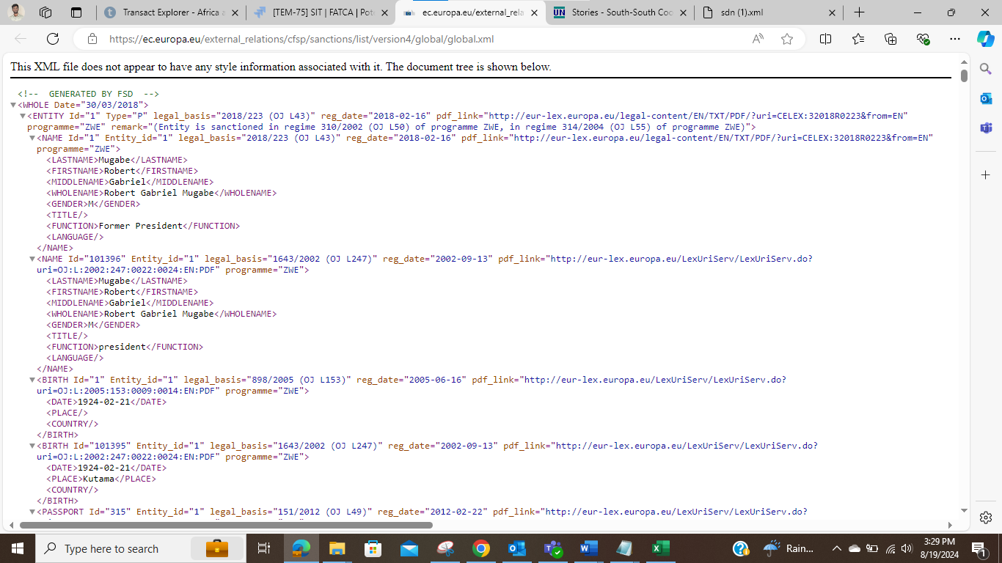

UN

