



Temenos T24™

Trade Bank of Iraq – KSA

FUNCTIONAL SPECIFICATION DOCUMENT

R21 Treasury - Forex

Document History

Author | Version | Date | Comment
Abdul Samad | 1.0 | 17 Mar 2023 | Initial Draft & Reviewed

Document Sign Off

Name / Position | Signature

FSD Quality – Client Rating on Understand ability.

Table of Content

1
1
Document History 2
Table of Content 3
1. Introduction 4
2. Reference Documentation 4
3. Requirement Overview 4
4. Existing Functionality 5
5. Gaps 6
5.1 WS05-01.01-1 – System Date as Deal Date 6
5.2 WS05-01.01-2 – SOD Yes on SP Deals 7
5.3 WS05-01.02-3 – System Date as Deal Date 7
5.4 WS05-01.02-4 – SOD Yes in FW 8
6 New Functionality 9
7.1.1 Accounting 9
7.1.2 Limits 9
7.1.3 COB Processing 9
7.1.4 Test Cases and Expected Results 9
7.1.5 New Tables 10
Table Properties 10
Table Layout 10
Field Checks 10
7.1.6 Cross Validation Checks 10
7.1.7 Other Processing 10
7.1.8 INSERT Files 10
7.1.9 Subroutines 10
7.1.10 Data Records 11
7.1.11 LOCAL.TABLE 11
7.1.12 LOCAL.REF.TABLE 11
7.1.13 I-DESCRIPTORS 11
7.1.14 STANDARD.SELECTION 12

Introduction

The bank has decided to implement Temenos T24 Core Banking System and will be using the browser version. The functional specification will cover Customization and Configuration changes needed for Model bank implementation on R21 Release
Bank is focused on building a full-service consumer, corporate, investment banking and capital markets franchise. Currently, they are working to expand their products and services across the consumer, corporate, investment banking and global markets. In addition to its corporate financial services, the Bank also provides its individual customers retail services such as credit cards, personal loans, car loans, home loans, competitive interest rates and flexible terms on different categories of personal bank accounts.

Reference Documentation

In today's world, trade services are rapidly growing as exporters and importers seek alternative solutions to finance the exchange of goods and services. The challenge for banks is to provide customer services that meet their precise objectives. Trade Bank of Iraq – Saudi Arabia offers a range of products to facilitate and finance customer needs.
The purpose of this document is to provide the solutions of the Gaps identified during the Business Process Alignment held with Bank TRY team and IT team.

Document Name | Embedded Document | Author, Company
BPR Document |  | Abdul Samad, NDC

Requirement Overview

S No. | Gap Number | Description | Process Name | Gap Type
1 | WS05-01.1-1 | Auto Set of System Date in Deal Date in Forex Spot | Capture Forex Spot | Configuration
2 | WS05-01.1-2 | SOD set as YES in FX Spot Inter Bank Deal & Corporate | Capture Forex Spot | Configuration
3 | WS05-01.2-4 | Auto Set of System Date in Deal Date in Forex Forward | Capture Forex Forward | Configuration
4 | WS05-01.2-5 | SOD set as YES in FX Spot Inter Bank Deal & Corporate | Capture Forex Forward | Configuration

Existing Functionality

Currently T24 support the above-mentioned requirements. Bank has New Core Banking system.

Gaps

5.1 WS05-01.01-1 – System Date as Deal Date

Auto Set of System Date on a Deal Date in Forex Spot, but User can change the date.
New FX Input Version with the name of FOREX,TBI.SPOTDEAL.IB.INP will be created and same will attached to Treasury Menu.
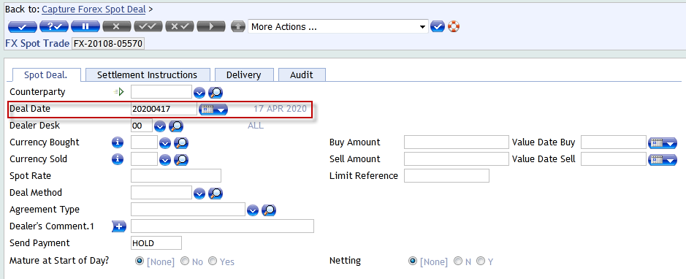

Auto Set of System Date on a Deal Date in Corporate Forex Spot, but User can change the date.
New FX Input Version with the name of FOREX,TBI.SPOTDEAL will be created and same will attached to Treasury Menu.
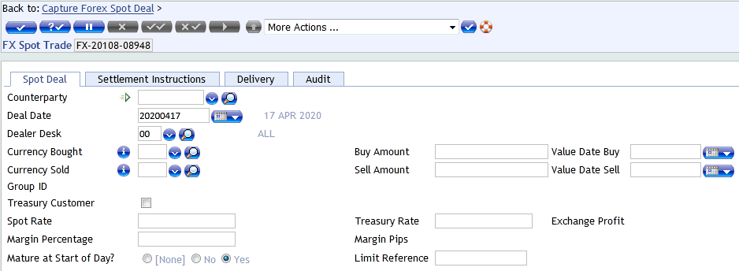

5.2 WS05-01.01-2 – SOD Yes on SP Deals

SOD set as YES in FX Spot Inter Bank Deal & Corporate
On a FOREX,TBI.SPOTDEAL.IB.INP version SOD set as YES on Autom field.
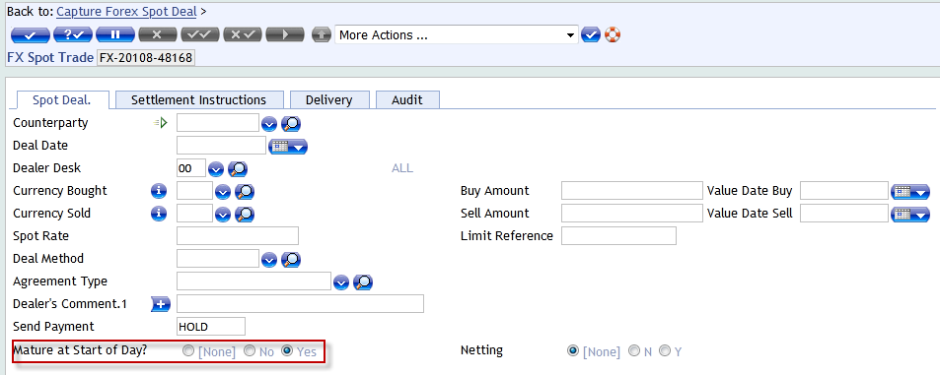
On a FOREX,TBI.SPOTDEAL.INP version SOD set as YES on Autom field. 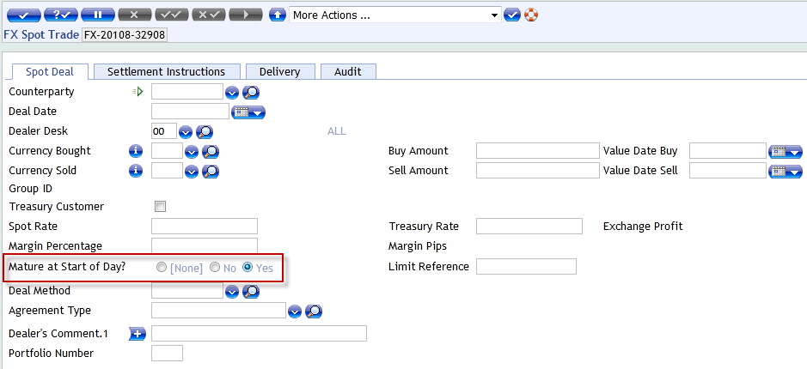

5.3 WS05-01.02-3 – System Date as Deal Date

Auto Set of System Date on a Deal Date in Forex Forward, but User can change the date.
New FX Input Version with the name of FOREX,TBI.FORWARDDEAL.IB.INP will be created and same will attached to Treasury Menu.
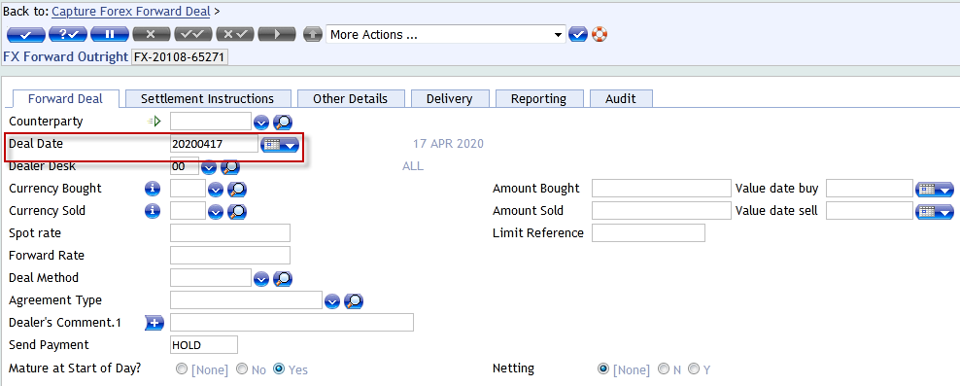

5.4 WS05-01.02-4 – SOD Yes in FW

SOD set as YES in FX FW Inter Bank Deal & Corporate on a Version
New FX Input Version with the name of FOREX,TBI.FORWARDDEAL.IB.INP will be created and same will attached to Treasury Menu.
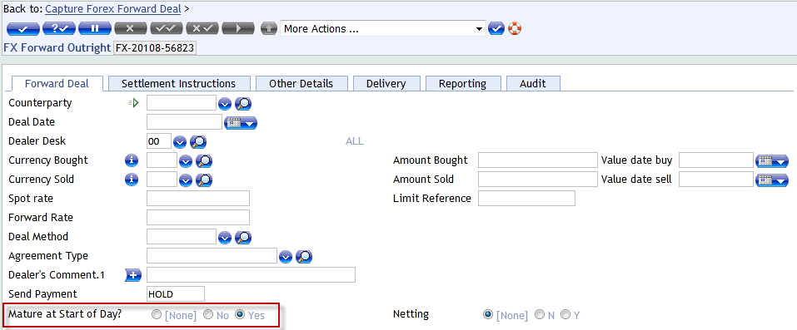

New FX Input Version with the name of FOREX,TBI.FOREX,FORWARDDEAL.INP will be created and same will attached to Treasury Menu.
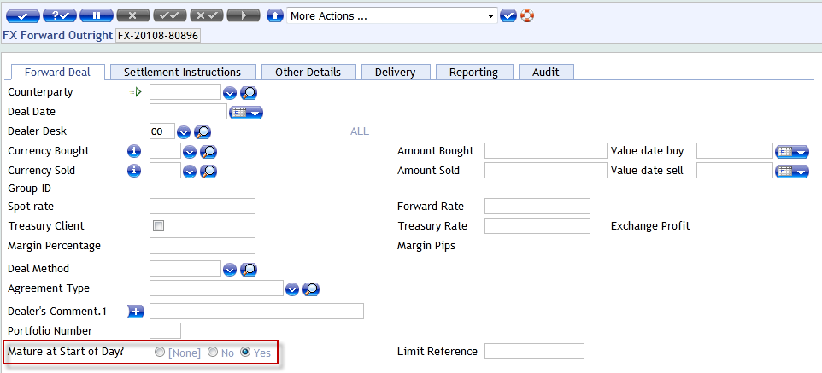

New Functionality
NA

Accounting
Standard T24 contingent entries

Limits
Standard T24 Contingent Entries.

COB Processing
N/A.

Test Cases and Expected Results
Test Case

New Tables
N/A

[Table Name]
[Please refer to the naming conventions guide for naming the template. Please repeat the following set of Table Properties, Layout, Field Checks, Cross validation Checks, Other processing and Insert files for each Table]

Table Properties
No. | Property | Definition
1 | Name
2 | Product
2 | File Type
3 | Classification

Table Layout
No. | Field Name | IN2 & Edit | Description | Width

Field Checks
S.No | Name of the field | Check’s to be done

Cross Validation Checks
N/A

Other Processing
.

INSERT Files
N/A

Subroutines
N/A

Subroutine Name
[Please refer to the Naming convention guide for naming of subroutines. Please provide the following detailed information for creation of Subroutine]
Property | Specification
Type
Attached To
Attached As
Dependency
Description
Arguments – IN
Arguments – OUT
Prelim Conditions
Subroutine Flow
Special Instructions

Data Records
N/A

LOCAL.TABLE
.

Local Reference Name
For other applications the below mentioned set is used.
No. | Field | Definition
1 | @ID
1.1 | Description
1.2 | Short Name
1.3 | Max. Char
1.4 | Min. Char
1.5 | Char Type
1.6 | Vetting Table
1.7 | Application
1.8 | Enri. Field

LOCAL.REF.TABLE
Application | Local Ref | Association

I-DESCRIPTORS
N/A

STANDARD.SELECTION

