0147
\54




Temenos T24™

Trade Bank of Iraq – KSA

FUNCTIONAL SPECIFICATION DOCUMENT

R21 Treasury – Money Market

Document History

Author | Version | Date | Comment
Abdul Samad | 1.0 | 20 Mar 2023 | Initial Draft & Reviewed

Document Sign Off

Name / Position | Signature

FSD Quality – Client Rating on Understand ability

Table of Content

1
1
Document History 2
Table of Content 3
1. Introduction 4
2. Reference Documentation 5
3. Requirement Overview 5
4. Existing Functionality 6
5. Gaps 7
5.1 WS05-01.21-5 – Change in Category 7
5.2 WS05-01.21-6 – SOD set as YES 7
5.3 WS05-01.21-7 – Auto Deal Date 8
5.4 WS05-01.23-8 – SOD set as YES 9
5.5 WS05-01.23-9 – Auto Deal Date 9
5.6 WS05-01.25-10 – Change in Category 10
5.7 WS05-01.25-11 – SOD set as YES 10
5.8 WS05-01.25-12 – Auto Deal Date 11
5.9 WS05-01.27-13 – SOD set as YES 11
5.10 WS05-01.27-14 – Auto Deal Date 12
5.11 WS05-01.34-15 – Deal Start Date 12
5.12 WS05-01.35-16 – Product Code 13
5.13 WS05-01.37-17 – Deal Start Date 13
5.14 WS05-01.38-18 – Product Code 14
6 New Functionality 14
7.1.1 Accounting 15
7.1.2 Limits 15
7.1.3 COB Processing 15
7.1.4 Test Cases and Expected Results 15
7.1.5 New Tables 15
Table Properties 15
Table Layout 15
Field Checks 15
7.1.6 Cross Validation Checks 16
7.1.7 Other Processing 16
7.1.8 INSERT Files 16
7.1.9 Subroutines 16
7.1.10 Data Records 16
7.1.11 LOCAL.TABLE 16
7.1.12 LOCAL.REF.TABLE 17
7.1.13 I-DESCRIPTORS 17
7.1.14 STANDARD.SELECTION 17

Introduction

The bank has decided to implement Temenos T24 Core Banking System and will be using the browser version. The functional specification will cover Customization and Configuration changes needed for Model bank implementation on R20 Release
Bank is focused on building a full-service consumer, corporate, investment banking and capital markets franchise. Currently, they are working to expand their products and services across the consumer, corporate, investment banking and global markets. In addition to its corporate financial services, the Bank also provides its individual customers retail services such as credit cards, personal loans, car loans, home loans, competitive interest rates and flexible terms on different categories of personal bank accounts.

Reference Documentation

In today's world, trade services are rapidly growing as exporters and importers seek alternative solutions to finance the exchange of goods and services. The challenge for banks is to provide customer services that meet their precise objectives. Trade Bank of Iraq – Saudi Arabia offers a range of products to facilitate and finance customer needs.
The purpose of this document is to provide the solutions of the Gaps identified during the Business Process Alignment held with Bank TRY team and IT team.

Document Name | Embedded Document | Author, Company
BPR Document |  | Abdul Samad, NDC

Requirement Overview

S No. | Gap Number | Description |  | Process Name | Gap Type
1 | WS05-01.21-5 |  | MM Borrowing Category Required  21032 -BORROWING WITH HEAD OFFICE  21033 -BORROWING FORIGN BRANCHES  21034 -BORROWING FORIGN BANKS  21035- BORROWING LOCAL BANKS  21036 -BORROWING CORPORATE CUSTOMER | Call/Notice Contracts Borrowing | Configuration
2 | WS05-01.21-6 |  | SOD set as YES in MM Call Borrowing Version | Call/Notice Contracts Borrowing | Configuration
3 | WS05-01.21-7 |  | Auto set of system Date in Deal Date | Call/Notice Contracts Borrowing | Configuration
4 | WS05-01.23-8 |  | SOD set as YES in MM Borrowing Version | Fixed Maturity Contracts Borrowing | Configuration
5 | WS05-01.23-9 |  | Auto set of system Date in Deal Date | Fixed Maturity Contracts Borrowing | Configuration
6 | WS05-01.25-10 |  | Placement Category Required  21076 -PLACEMENT WITH HEAD OFFICE  21077 -PLACEMENT FORIGN BRANCHES  21078 -PLACEMENT FORIGN BANKS  21079 -PLACEMENT LOCAL BANKS  21080 -PLACEMENT CORPORATE CUSTOMER | Call/Notice Contracts Lending | Configuration
7 | WS05-01.25-11 |  | SOD set as YES in MM Call Borrowing Version | Call/Notice Contracts Lending | Configuration
8 | WS05-01.25-12 |  | Auto set of system Date in Deal Date | Call/Notice Contracts Lending | Configuration
9 | WS05-01.27-13 |  | SOD set as YES in MM Placement Version | Fixed Maturity Contracts Lending | Configuration
10 | WS05-01.27-14 |  | Auto set of system Date in Deal Date | Fixed Maturity Contracts Lending | Configuration
11 | WS05-01.34-15 |  | Search criteria like Deal Date & Maturity Date, Total Interest and Profit Required -Placement | List of Fixed Term Placements | Configuration
12 | WS05-01.35-16 |  | In Enquiry, Product Code, Interest Amount, Total Interest and Profit are required -Placement | MM Fixed Placement Maturing in next 5 days | Configuration
13 | WS05-01.37-17 |  | Search criteria like Deal Date & Maturity Date, Total Interest and Profit Required -Borrowing | List of Fixed Term Takings | Configuration
14 | WS05-01.38-18 |  | In Enquiry, Product Code, Interest Amount, Total Interest and Profit are required -Borrowing | MM Fixed Takings Maturing in next 5 days | Configuration

Existing Functionality

Currently T24 support the above-mentioned requirements.

Gaps

5.1 WS05-01.21-5 – Change in Category

Borrowing Category can be changed by rename of the following
21032 BORROWING WITH HEAD OFFICE
21033 BORROWING FORIGN BRANCHES
21034 BORROWING FORIGN BANKS
21035 BORROWING LOCAL BANKS
21036 BORROWING CORPORATE CUSTOMER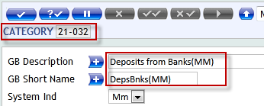
New MM Input Version with the name of MM.MONEY.MARKET,TBI.TKGCALL.INP will be created and same will attached to Treasury Menu.

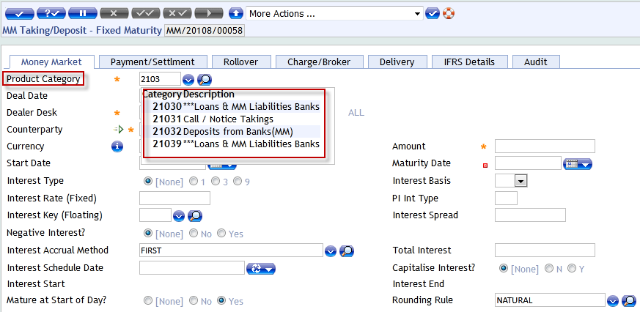

5.2 WS05-01.21-6 – SOD set as YES

Set the SOD field of MM into the version MM.MONEY.MARKET,TBI.TKGCALL.INP
and same will attached to Treasury Menu.

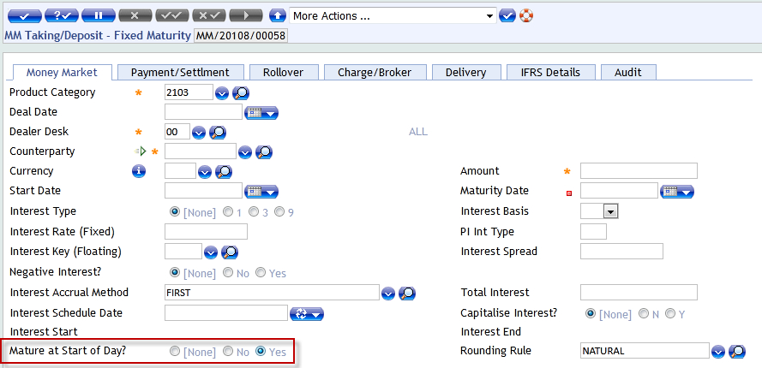

5.3 WS05-01.21-7 – Auto Deal Date

Set Autom the Deal Date field of MM into the version MM.MONEY.MARKET,
TBI.TKGCALL.INP and same will attached to Treasury Menu.
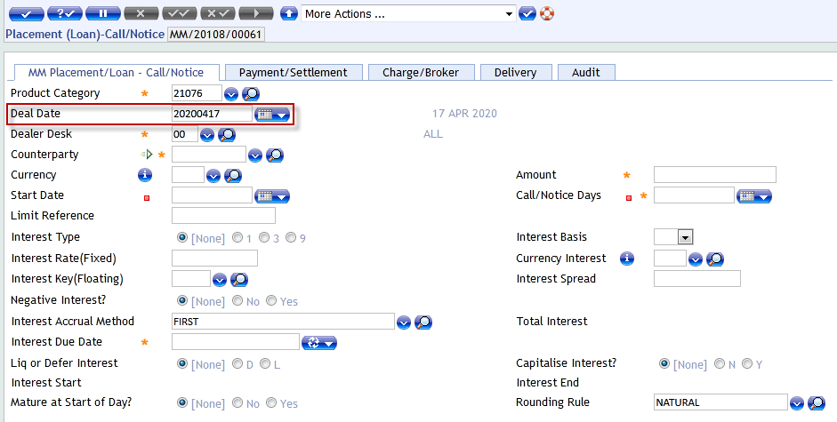

5.4 WS05-01.23-8 – SOD set as YES

Set the SOD field of MM into the version MM.MONEY.MARKET,TBI.TAKING.INP
and same will attached to Treasury Menu.

5.5 WS05-01.23-9 – Auto Deal Date

Set Autom the Deal Date field of MM into the version MM.MONEY.MARKET,
TBI.TAKING.INP and same will attached to Treasury Menu.

5.6 WS05-01.25-10 – Change in Category

Placement Category can be changed by rename of the following
21076 PLACEMENT WITH HEAD OFFICE
21077 PLACEMENT FORIGN BRANCHES
21078 PLACEMENT FORIGN BANKS
21079 PLACEMENT LOCAL BANKS
21080 PLACEMENT CORPORATE CUSTOMER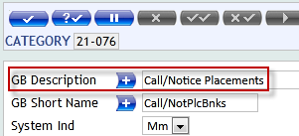
New MM Input Version with the name of MM.MONEY.MARKET,TBI.PLACE.CALL.INP will be created and same will attached to Treasury Menu.
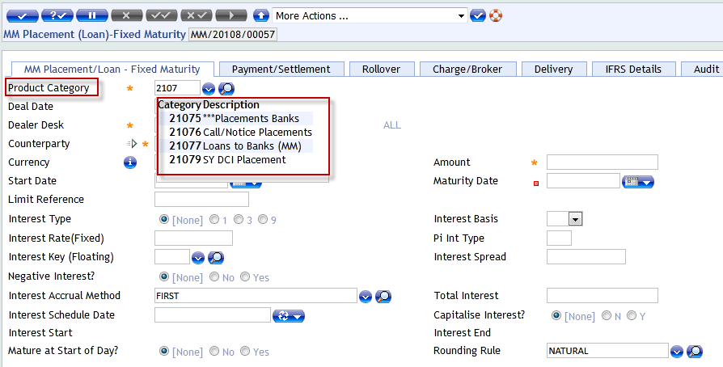

5.7 WS05-01.25-11 – SOD set as YES

Set the SOD field of MM into the version MM.MONEY.MARKET,TBI.PLACE.CALL.INP
and same will attached to Treasury Menu.

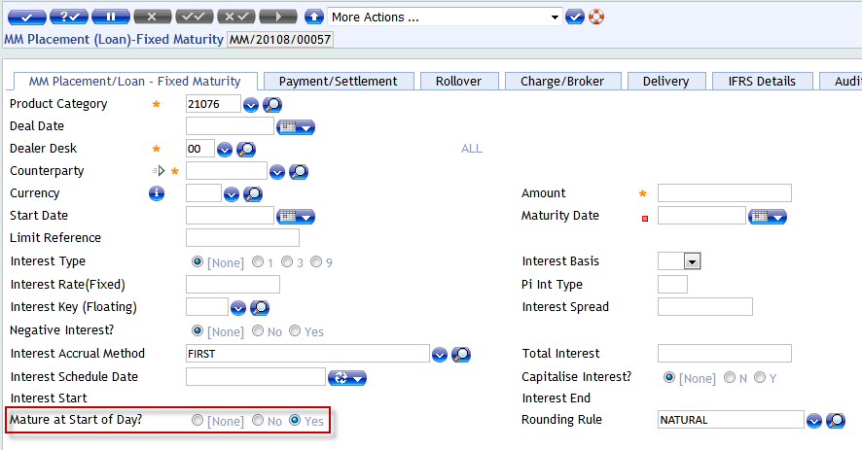

5.8 WS05-01.25-12 – Auto Deal Date

Set Autom the Deal Date field of MM into the version MM.MONEY.MARKET,
TBI.PLACE.CALL.INP and same will attached to Treasury Menu.
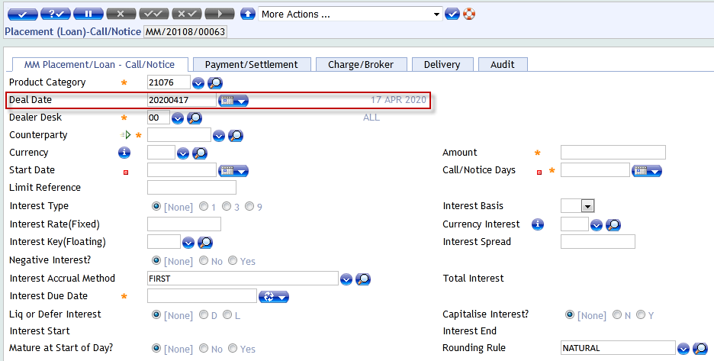

5.9 WS05-01.27-13 – SOD set as YES

Set the SOD field of MM into the version MM.MONEY.MARKET,TBI.PLACE.INP
and same will attached to Treasury Menu.

5.10 WS05-01.27-14 – Auto Deal Date

Set Autom the Deal Date field of MM into the version MM.MONEY.MARKET,TBI.
PLACE.INP and same will attached to Treasury Menu.

5.11 WS05-01.34-15 – Deal Start Date

New Enquire will be develop with the name of TBI.MM.LIV.PL.FIXED.LIST and search criteria like Deal Date & Value Date will be add and in enquiry Product Category.
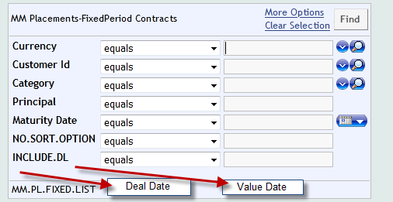

5.12 WS05-01.35-16 – Product Code

New Enquire will be develop with the name of TBI.MM.LIV.PL.FIXED.MAT.DEALS and in enquiry Total Placement Amount, Interest Amount, Product Category & Total Interest Amount Required on Placement Deals.
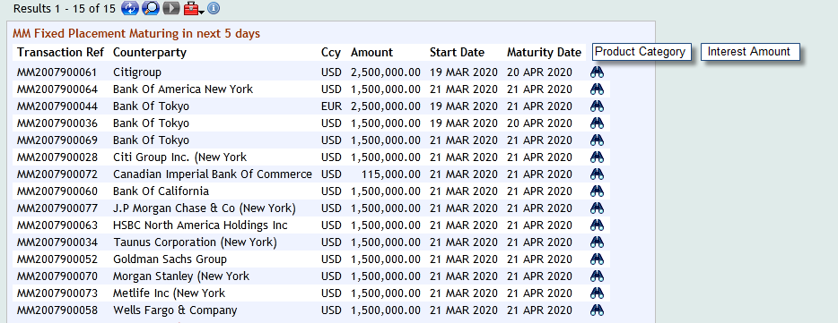

5.13 WS05-01.37-17 – Deal Start Date

New Enquire will be develop with the name of TBI.MM.LIV.TK.FIXED.LIST and search criteria like Deal Date & Value Date will be add and in enquiry Product Category, Interest Amount, Required on Placement Deals.
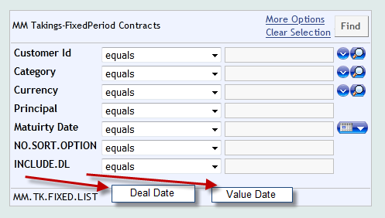
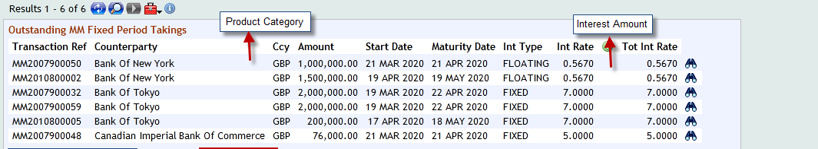

5.14 WS05-01.38-18 – Product Code

New Enquire will be develop with the name of TBI.MM.LIV.TK.MAT.DEALS and in enquiry Total Placement Amount, Interest Amount, Product Category & Total Interest Amount Required on Placement Deals.

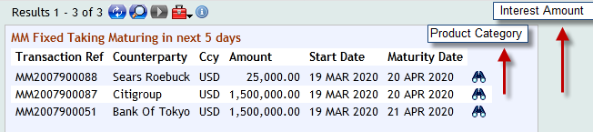

New Functionality
NA

Accounting
Standard T24 contingent entries

Limits
Standard T24 Contingent Entries.

COB Processing
N/A.

Test Cases and Expected Results
Test Case

New Tables
N/A

[Table Name]
[Please refer to the naming conventions guide for naming the template. Please repeat the following set of Table Properties, Layout, Field Checks, Cross validation Checks, Other processing and Insert files for each Table]

Table Properties
No. | Property | Definition
1 | Name
2 | Product
2 | File Type
3 | Classification

Table Layout
No. | Field Name | IN2 & Edit | Description | Width

Field Checks
S.No | Name of the field | Check’s to be done

Cross Validation Checks
N/A

Other Processing
.

INSERT Files
N/A

Subroutines
N/A

Subroutine Name
[Please refer to the Naming convention guide for naming of subroutines. Please provide the following detailed information for creation of Subroutine]
Property | Specification
Type
Attached To
Attached As
Dependency
Description
Arguments – IN
Arguments – OUT
Prelim Conditions
Subroutine Flow
Special Instructions

Data Records
N/A

LOCAL.TABLE
.

Local Reference Name
For other applications the below mentioned set is used.
No. | Field | Definition
1 | @ID
1.1 | Description
1.2 | Short Name
1.3 | Max. Char
1.4 | Min. Char
1.5 | Char Type
1.6 | Vetting Table
1.7 | Application
1.8 | Enri. Field

LOCAL.REF.TABLE
Application | Local Ref | Association

I-DESCRIPTORS
N/A

STANDARD.SELECTION

