Document History
Retail Banking
Functional Specification Document of
Teller

Version | Date | Author | Comments / Change Description
1.0 | 11-Jan-2022 | Salman Arif

Document Sign Off
Date | Name | Company / Position | Signature

FSD Quality – Client Rating on Understandability

Table of Contents
1. Background 4
1.1 Introduction 4
1.2 Glossary 4
2. Requirement Overview 4
2.1 Reference Documentation 5
3. Existing functionality 5
4. Existing Workflow in T24 5
Create New Till 6
5. Proposed Solution Description 11
5.1 WS02-TT-10.01, WS02-TT-13.01, WS02-TT-16.01 11
5.1.1 Gap Description 11
5.1.2 Existing Functionality 11
5.1.3 Proposed solution 12
5.1.4 Sub Routine Information 16
5.2 WS02-TT-11.1, WS02-TT-12.1, WS02-TT-14.1 17
5.2.1 Gap Description 17
5.2.2 Existing Functionality 17
5.2.3 Proposed Solution 17
5.2.4 Sub Routine Information 18

Background
This document has been prepared by NDC in response to Gaps identified by NBP during Business Process Review (BPR), to develop certain functionality in T24.
By signing this document or otherwise approving or accepting it, NBP indicates its acceptance and approval for NDC to proceed with the work involved in designing and developing such proposed functionalities.

Introduction
National Bank of Pakistan is the leading bank with a high network of a branch in all the cites on Pakistan along with the offshore branches around the world.

Glossary

Abbreviations | Description
T24 | Core Banking System
LOV | List of values
BPR | Business Process Review
FSD | Functional Specification Document

Requirement Overview
Following gaps are addressed in this document.
S.No | Requirement Reference | Requirement Title | Summary Description | Gap Type
1 | WS02-TT-10.01 | Cash deposit Local | Required auto populate information of Depositor in TELLER,NBPSA.LCY.CASHIN version | Customization
2 | WS02-TT-11.1 | Cash deposit Local | Required auto populate information of Depositor in TELLER,NBPSA.LCY.CASHCHQ version. | Configuration
3 | WS02-TT-12.1 | Cash withdrawal Local (Without Cheque) | Required auto populate information of withdrawer in TELLER,NBPSA.LCY.CASHWDL versions | Configuration
4 | WS02-TT-13.1 | Cash Deposit Local - Foreign | Required auto populate information of withdrawer in TELLER,NBPSA.LCY.CASHIN.FCY.ACCT version. | Configuration
5 | WS02-TT-14.1 | Cash withdrawal Local- Foreign | Required auto populate information of withdrawer in TELLER,LCY.CASHCHQ.FCY.ACCT . | Configuration
6 | WS02-TT-16.1 | Cash deposit Foreign | Required auto populate information of depositor in TELLER,NBPSA.FCY.CASHCHQ version. | Configuration
7 | WS02-TT-17.1 | Cash withdrawal Foreign | Required auto populate information of withdrawer in TELLER,NBPSA.FCY.CASHCHQ version. | Configuration

Reference Documentation
This document contains the solution to the requirements pointed out in the Business Requirement Document-BRD and Business Process Review Sheet-BPR sheet.

Document Name | Embedded Document | Author, Company
BPR Document

Existing functionality
Currently, a bank doesn’t have such fields in their version; they do manual work.

Existing Workflow in T24
The Teller module in T24 is used to maintain the physical Cash into the system. The module covers the process as discussed below,
- TILL Creation,
- Cash Deposit and Withdrawal,
- Cash Withdrawal (Without Cheque)
- Cash Deposit foreign
- Cash withdrawal Foreign
- Change Denomination
- Account to Account Transfer
- LCY Till transfer
- Till to Vault
- Vault to Till transfer,

The general processes are discussed below:

Create New Till
In T24, whenever the physical cash transaction has been involved, new Till ID is needed for the Teller. The Till ID will be the four-digit unique Till numbers which will be assigned to a Teller.
The system will automatically maintain an Account for the Teller, which will include the four unique Till numbers with the cash category Account. The common set of fields and their use throughout the New Till Creation process enlisted below,
Till Status: Defines the status of the teller position whether the Till is Open or Closed.

Teller: ID of the User that has been assigned to the Till.

Update Stock: Field to indicate if Denomination units inputted in TELLER.ID during till closure treat this as final stock with Teller.
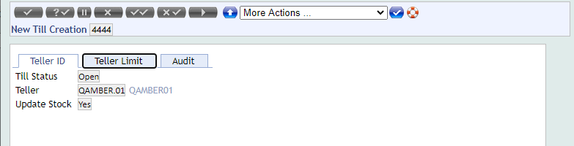

Cash Deposit Local:
This option can be used for the Deposit of Local Currency Cash to the Specific Customer Account.
Below is the sample Screenshot.
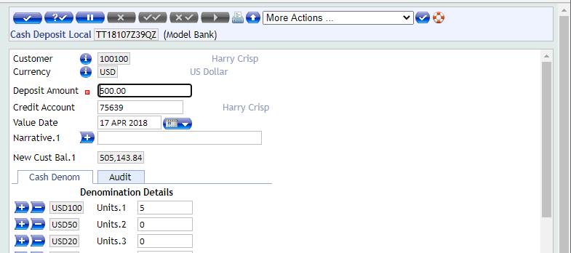

Cash Withdrawal Local:
This option can be used for the Withdrawal of Local Currency Cash from the Specific Customer Account. Cheque No. is a must for the withdrawal through this option.
Some Common Field used in this option are as bellows,
Withdrawal Amount: Specifies the amount to be debited.
Debit Account: Identifies the Account being debited in respect of the withdrawal transaction.
Cheque No.: Specifies the cheque number used for withdrawal.
Below is the sample Screenshot.
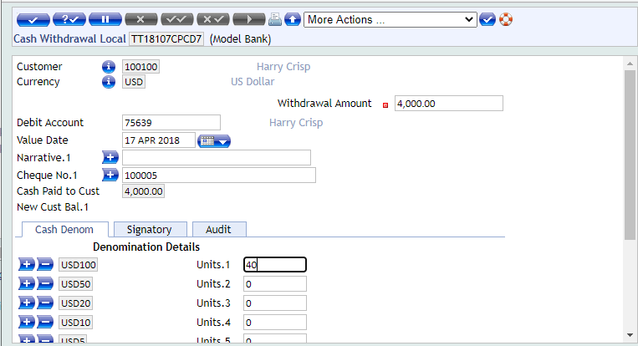
Cash Withdrawal (Without Cheque)
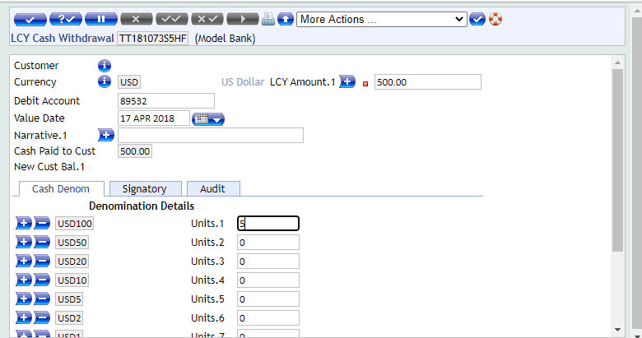
Cash Deposit Foreign
This version can be used to deposit Cash in a foreign currency account
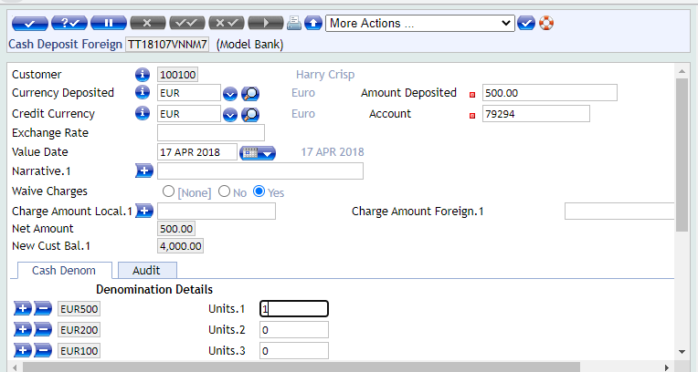

Cash Withdrawal Foreign
This version can be used to withdrawal Cash from foreign currency account
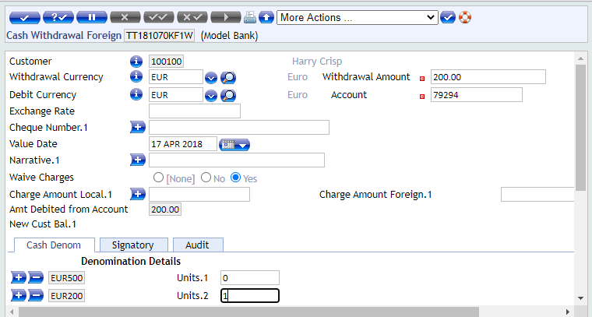

Change Denomination
This version can be used to change the denomination
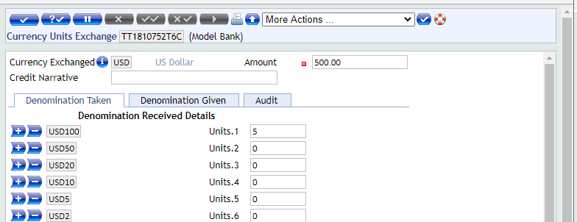
Account to Account, Transfer:
This option can be used to Transfer amount between two Accounts; it can be of the same customer or between different customers.
Below is the sample Screenshot.
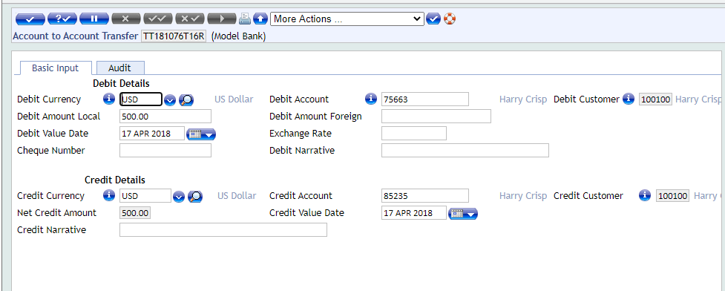
LCY Till Transfer:
“LCY Till Transfer” screen can be used when the Physical Cash is transferring between the Branch Tellers or when one Teller is facing the physical cash Shortage and ask some cash from the other Teller. Currently, all “From Teller” & “To Teller” fields are editable, and the user can input as per requirement, as shown below,
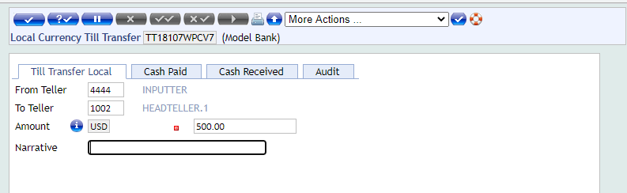

Till to Vault:
At the day end, the Teller will transfer all the physical Cash into the Vault as per the Bank policy. User will use the below screen to transfer the Cash from his Till to the Vault Account. Be noted that the Till and Vault accounts are the Cash category Internal accounts with a unique ID.
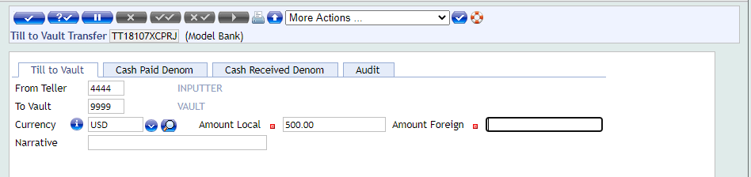
Vault to Till:
At the start of the day, normally the Cash is distributed among the Tellers to start the branch operations. This Cash is taken from the Vault and transfer into the Tills of the Tellers.
Below is the screen, which is used for transferring the Cash from the Vault to Till,
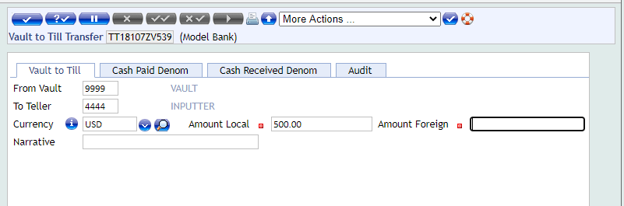

Financial Entries as per T24 Flow:

The Possible entries that can be raise on different activities done by the Teller are discus below,
Cash Deposit:-
Dr Till Account
Cr Customer Account

Cash Withdrawal:-
Dr Customer Account
Cr Till Account

Till to Vault Transfer:-
Dr Vault Account
Cr Till Account

Vault to Till Transfer:-
Dr Till Account
Cr Vault Account

Proposed Solution Description

WS02-TT-10.01, WS02-TT-13.01, WS02-TT-16.01

Gap Description
When user will input Depositor Legal ID No in “NBPSA.ID.REF.NO” Field if that legal id is belong to existing customer then fetch detail from system and auto populate the below fields otherwise make it blank for inputting.
- Depositor Legal ID Type
  - Depositor Legal ID No
  - Depositor Name
  - Despositor ID Expiry Date
  - Mobile Number

Existing Functionality
In T24 there are no such fields available for the user where he can capture the information of that person who is depositing Cash & withdrawing. Proposed Solution

Proposed solution
- Below is the list of the existing version names.

- Need to create the new validation routine and build the logic where user will input Depositor Legal ID No in “NBPSA.ID.REF.NO” Field if that legal id is belong to existing customer then fetch detail from system and auto populate the below fields otherwise make it blank for

Sr.no | Existing Versions
1 | TELLER,NBPSA.LCY.CASHIN
2 | TELLER,NBPSA.LCY.CASHIN.FCY.ACCT
3 | TELLER,NBPSA.FCY.CASHIN

Sub Routine Information

N/A

WS02-TT-11.1, WS02-TT-12.1, WS02-TT-14.1

Gap Description
Bank wants to auto populates the cash withdrawer person information in the following fields . When user will input withdrawer Legal ID No in “NBPSA.ID.REF.NO” Field if that legal id is belong to existing customer then fetch detail from system and auto populate the below fields otherwise make it blank for inputting.
• Withdrawer Legal ID Type
• Withdrawer Legal ID No
• Withdrawer Name
• Withdrawer ID Expiry Date

Existing Functionality
In T24 there are no such fields available for the user where he can capture the information of that person who is depositing Cash & withdrawing.

Proposed Solution

- Be Below is the list of the existing version and New versions names.

- Need to create the copy of the existing version with the name of New version which is defined in below table.

Sr.no | Existing Versions
1 | TELLER,NPBSA.LCY.CASHWDL
2 | TELLER,NBPSA.LCY.CASHCHQ
3 | TELLER,NBPSA.LCY.CASHCHQ.FCY.ACCT

- Below is the list of the existing version names.

- Need to create the new validation routine and build the logic where user will input Depositor Legal ID No in “NBPSA.ID.REF.NO” Field if that legal id is belong to existing customer then fetch detail from system and auto populate the below fields otherwise make it blank for

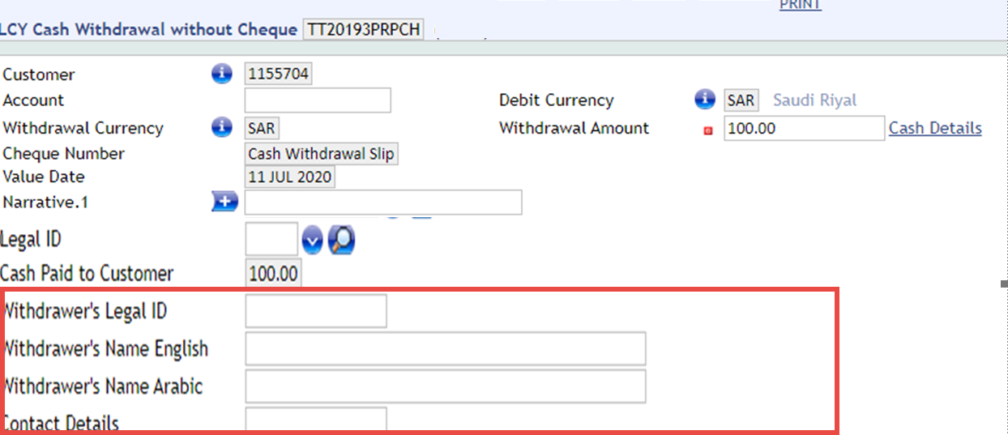

Sub Routine Information

N/A

