Functional Specification Document

Focal Point Ref : AA Account -WS02_TBI_AR_FSD_v1.0
Client Name: Trade Bank of Iraq

Document History
Author | Version | Date | Description
Muhammad Kashif | 1.0 | ^{23th} December 2021

Comments:
The purpose of this document is to provide the solutions of the Gaps identified during the Business
Process Alignment held with Bank team and IT team.

Table of Contents

1. Contractual Information 5
2. Acronyms 6
3. Background 7
3.1 Introduction 7
3.2 Reference Documents 8
3.3 Related and Dependent Enhancements 8
4. Proposed Functional Solution Description 8
4.1 Requirements or Gap Description 8
4.1.1 Requirement WS02-AR-01.01 Open Current Account 8
4.1.2 Requirement WS02-AR-01.02 Open Current Account 9
4.1.3 Requirement WS02-AR-01.03 Open Current Account 10
4.1.4 Requirement WS02-AR-01.04 Open Current Account 10
4.1.5 Requirement WS02-AR-01.05 Open Current Account 11
4.1.6 Requirement WS02-AR-07.01 Account Dormancy 12
4.1.7 Requirement WS02-AR-01.06 Open Current Account 13
4.1.8 Requirement WS02-AR-08.01 Account Enquiry 13
4.1.9 Requirement WS02-AR-06.01 Generate Account Statement 13
4.1.10 Requirement WS02-AR-06.02 Generate Account Statement 14
4.1.11 Requirement WS02-AR-06.03 Generate Account Statement 15
4.1.12 Requirement WS02-AR-06.04 Generate Account Statement 17
5. Use Cases 18
5.1 Use Case 18
5.2 Use Case 18
5.3 Use Case 18
5.4 Use Case 18
5.5 Use Case 18
5.6 Use Case 18
6. Assumptions 19
7. Exclusions (Specific Functionality that is not covered by this Development) 19
8. Proposed Product Solution 19
8.1 Requirement Classification 19
8.2 Existing Functionality 20
8.2.1 Topic 1 Existing Feature 1 20
8.3 Proposed New Product Functionality 25
8.3.1 Topic 1 New Product WS02-AR-01.01 Open Current Account 25
8.3.2 Topic 1 New Product WS02-AR-01.02 Open Current Account 31
8.3.3 Topic 1 New Product WS02-AR-01.03 Open Current Account 34
8.3.4 Topic 1 New Product WS02-AR-01.04 Open Current Account 36
8.3.5 Topic 1 New Product WS02-AR-01.05 Open Current Account 38
8.3.6 Topic 1 New Product WS02-AR-07.01 Account Dormancy 40
8.3.7 Topic 1 New Product WS02-AR-01.06 Open Current Account 41
8.3.8 Topic 1 New Product WS02-AR-08.01 Account Enquiry 43
8.3.9 Topic 1 New Product WS02-AR-06.01 Generate Account Statement 44
8.3.10 Topic 1 New Product WS02-AR-06.02 Generate Account Statement 45
8.3.11 Topic 1 New Product WS02-AR-06.03 Generate Account Statement 48
8.3.12 Topic 1 New Product WS02-AR-06.04 Generate Account Statement 50
8.4 New and Amended tables 58
8.4.1 Table name 58
8.4.2 Customer Data Protection (CDP): 58
8.5 Business Events 58
8.6 Integration Points 59
8.7 Configuration – Screens and Menu 59
8.7.1 Config Screen 1 59
8.7.2 Mock up Screens 59
8.8 Configuration – Other Data 59
8.8.1 Config Item 1 59
8.9 Model Configuration 59
8.10 APIs to be released 59
8.10.1 API 1 59
9. Functionality Point Matrix 61

Contractual Information
<< Standard contractual text statement>>
This Functional Specification Document (“FSD”) has been prepared by Temenos Headquarters SA (together with its affiliates, “Temenos”) in response to either an identified contractual gap in the course of an implementation, or a Change Request (“CR”) or Request For Services (“RFS”) from Temenos’ Client (as named below), in each case to develop certain added functionality in the Software.
By signing this FSD or otherwise approving or accepting this FSD in writing, Client indicates its acceptance and approval for Temenos to proceed with the work involved in designing and developing such proposed functional change to the Software and (if applicable) the quotation for such work either set out herein or otherwise agreed between the Client and Temenos.
The terms of the relevant Agreement between Temenos and Client in relation to the Software (together with the CR or RFS as applicable) shall govern this FSD and the services provided in connection herewith. Terms used but not otherwise defined herein shall have the meaning set out in the Software Agreement.
Please note that the relevant Developments will only be incorporated into the latest available Software. In case one or more Developments need to be incorporated into the Client release, an approval from Design Authority Review Board is mandatory. Any modifications to the FSD may impact the quotation (if any) and/or delivery release date and are therefore subject to mutual written agreement between Temenos and Client.
Development Reference: EN: TBI_AR_FSD_v1.0

Development Description: AA Account

Client Name(s) : Trade Bank of Iraq

Client Reference: Trade Bank of Iraq - WS02_AA_AR_TBIKSA_BPR_Gap Analysis v1.0
Opportunity Reference:

Request Reference:

Signed for and on behalf of the Client: <<Should also be signed off by a Temenos internal owner for internal SI>>
Name:
Signature:

Date:
Position:

<<Estimation section here should be removed for non-chargeable developments>>
Quotation:
N/A
 | Sub Total | Total
Design |  | T&M
Functional Specification | T&M
Development |  | 0
Technical Specification | B
Coding | C
Testing | D
Documentation | E
Delivery Management |  | F
TOTAL MAN DAYS |  | 0

Release Commitment: << To be completed for client SI>>
Monthly Release for delivering this development, provided sign-off is received before the expiry date of this release commitment | Release yyyymm

The above release date is the month of the expected release in which the new functionality will be made available. This is dependent upon signature or acceptance of this FSD by the ‘Expiry date of Release Commitment” noted below.

Date of Issue of this Release Commitment |  |  | Date of Expiry of this Release Commitment

Acronyms
Acronym | Description
BPR | Business Process Review
FSD | Functional Specification Document
AA | Arrangement Architecture
AR | AA Retail Accounts

Background

Introduction
Trade Bank of Iraq opens its first external Branch at Riyadh – Kingdom of Saudi Arabia, Abraj Al Tawuniya – Al-Olya District – King Fahad Road and it is also the first Iraqi Trade Finance Bank at Kingdom of Saudi Arabia. The Branch seeks to expand business relations between both Financial & Banking sectors thus supporting investment between the two countries.

Requirement Reference | Requirement Title | Summary Description
WS02-AR-01.01 | Open Current Account | Current Corporate Account Currency, SAR, EUR, USD, IQD, GBP, JPY & CNY.
WS02-AR-01.02 | Open Current Account | Current Individual & Staff Account Currency, SAR, USD & IQD.
WS02-AR-01.03 | Open Current Account | Account length will be 10 as per model bank.
WS02-AR-01.04 | Open Current Account | Iban is required and bank will share the document.
WS02-AR-01.05 | Open Current Account | Mode of Operation bank is required as "Others".
WS02-AR-07.01 | Account Dormancy | Dormancy Status, Dormant (2Y), Unclaimed (5Y) & Abandoned (10Y).
WS02-AR-01.06 | Open Current Account | If new account is opened and no debit and credit transaction happened in this account then after 90 days it will be closed automatically. Regulatory requirement.
WS02-AR-08.01 | Account Enquiry | Bank is required report those new account where no debit and credit after 90 days close automatically and report will be generated before 10 days means (80 days) past.
WS02-AR-06.01 | Generate Account Statement | No AA Account Statement condition will be use.
WS02-AR-06.02 | Generate Account Statement | Bank will share the online (Adhoc) Account statement format.
WS02-AR-06.03 | Generate Account Statement | Bank will share the periodic statement format.
WS02-AR-06.04 | Generate Account Statement | Basis on customer email id, every month on 2nd day account statement will be generated and it will be sent on customer email automatically.

Reference Documents
Trade Bank of Iraq - WS02_AA_AR_TBIKSA_BPR_Gap Analysis v1.0

Related and Dependent Enhancements
N/A

Proposed Functional Solution Description

Requirements or Gap Description

Requirement WS02-AR-01.01 Open Current Account
Current Corporate Account Currency, SAR, EUR, USD, IQD, GBP, JPY & CNY.
Corporate Current Account will be opened in multiple currencies as mentioned above. New product will be designed by copying the existing NBPKSA product for Trade Bank of Iraq.

Workflows
End user will have to input Customer ID and Currency for Corporate Current Account opening. Below is the screen shot of account opening screen.
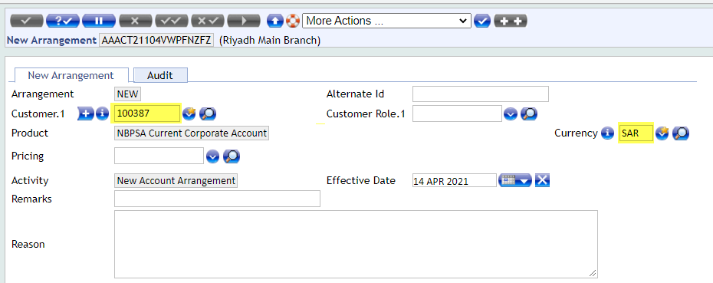

Requirement WS02-AR-01.02 Open Current Account
Current Individual & Staff Account Currency, SAR, USD & IQD.
Individual Current Account will be opened in multiple currencies as mentioned above. New product will be designed by copying the existing NBPKSA product for Trade Bank of Iraq.

Workflows
End user will have to input Customer ID and Currency for Individual & Staff Current Account opening. Below is the screen shot of account opening screen.
Individual Current Account:

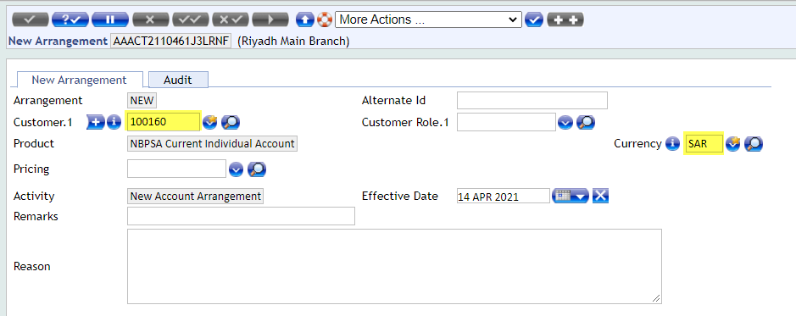
Staff Current Account:
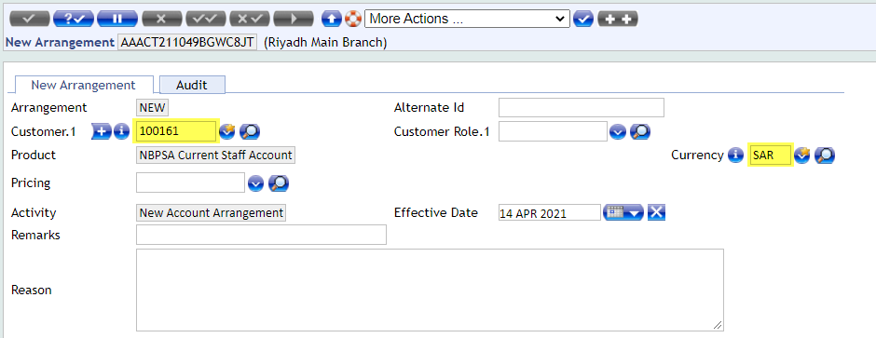

Requirement WS02-AR-01.03 Open Current Account
Account length will be 10 as per model bank.
At the time of current account opening, system will generate account number automatically as per the defined length setup.

Workflows
At the time of current account opening, upon validate system will generate account number automatically as per the setup. Below is the screen shot of account number.
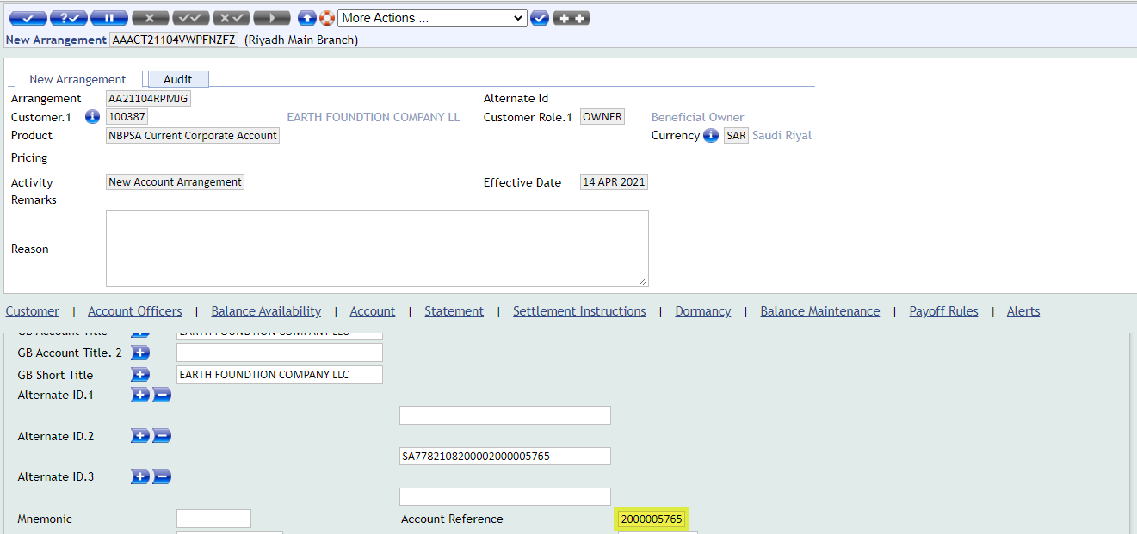

Requirement WS02-AR-01.04 Open Current Account
Iban is required and bank will share the document.
At the time of current account opening, system will generate IBAN number automatically as per the defined setup.

Workflows
At the time of current account opening, upon second validate system will generate IBAN number automatically as per the setup. Below is the screen shot of IBAN number.
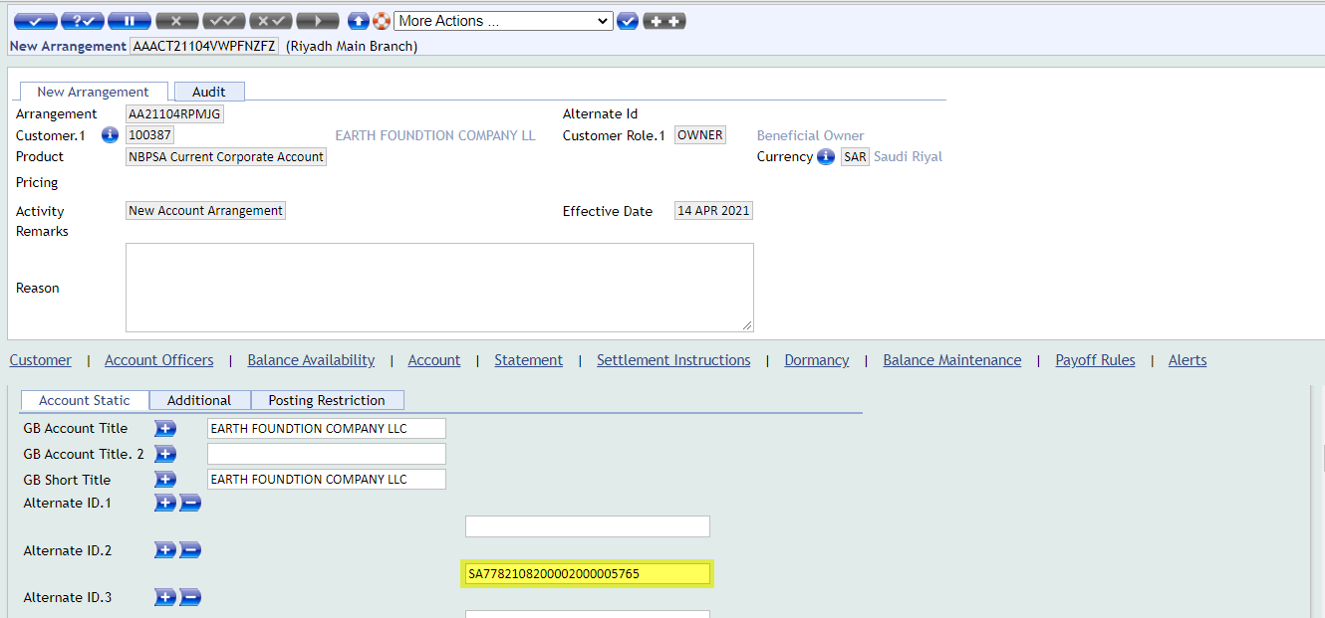

Requirement WS02-AR-01.05 Open Current Account
Mode of Operation bank is required as "Others".
Current account opening screen in account tab, in Mode of Operation dropdown field “Others” option will be added.

Workflows
“Other” option will be added in Mode of Operation dropdown field.
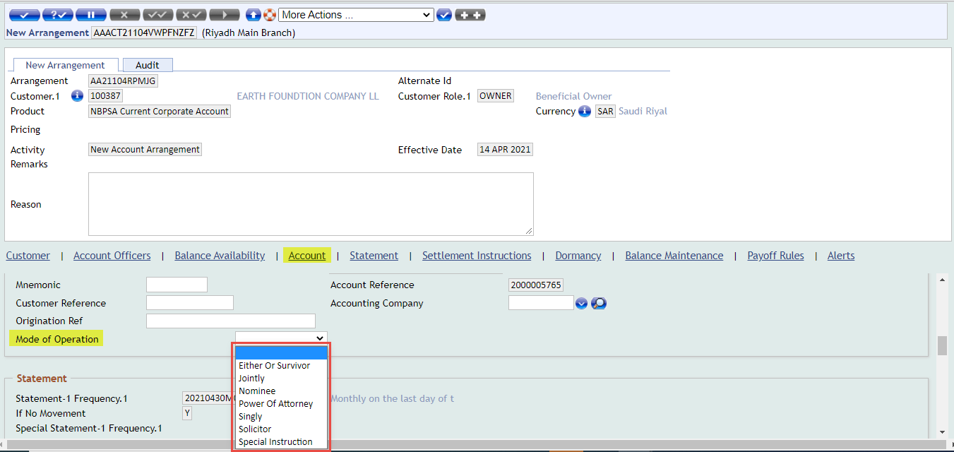

Requirement WS02-AR-07.01 Account Dormancy
Dormancy Status, Dormant (2Y), Unclaimed (5Y) & Abandoned (10Y).
On current account opening screen, dormancy statuses will be set as mentioned above on account product.

Workflows
Three statuses will be set on account product and frozen status will be removed from the account product.
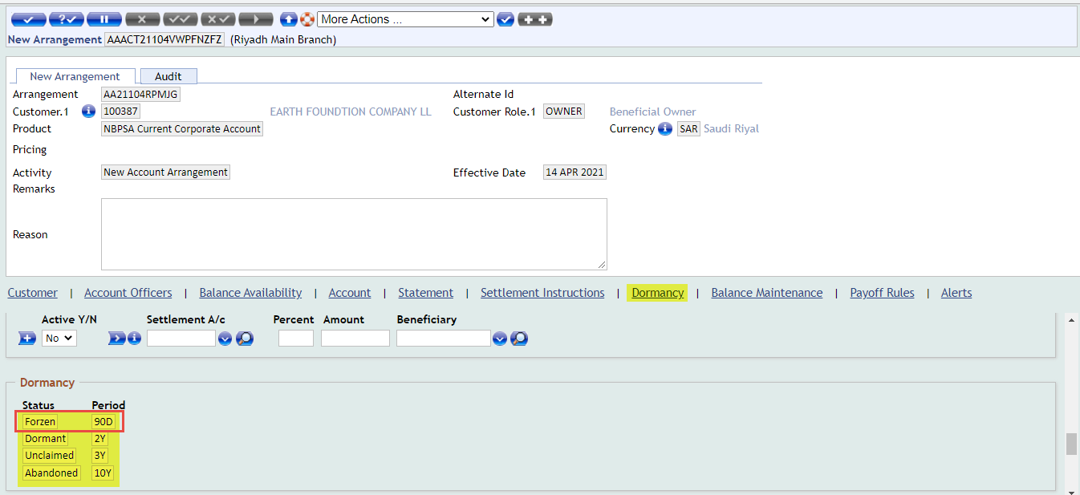

Requirement WS02-AR-01.06 Open Current Account
If new account is opened and no debit and credit transaction happened in this account, then after 90 days it will be closed automatically. Regulatory requirement.
For automatic account closure, new parameter screen will be created and closing days define in this parameter. When new account will be closed automatically then it will check first no debit and credit happen in the account.

Workflows
At present no screen available.

Requirement WS02-AR-08.01 Account Enquiry
Bank is required report those new account where no debit and credit after 90 days close automatically and report will be generated before 10 days means (80 days) past.
New enquiry will be created to display only those new accounts records which past 80 days and there is no debit and credit happen. It will also check the arrangement status equal to “Auth” mean account is authorized status.

Workflows
At present no screen available.

Requirement WS02-AR-06.01 Generate Account Statement
No AA Account Statement condition will be use.
Initially in BPR session we had discussed this statement condition will be removed from the account product but as per this Gap (4.1.12 Requirement WS02-AR-06.04 Generate Account Statement), this statement condition will not be removed from the account product.

Workflows
Account statement will be updated as per the bank required.
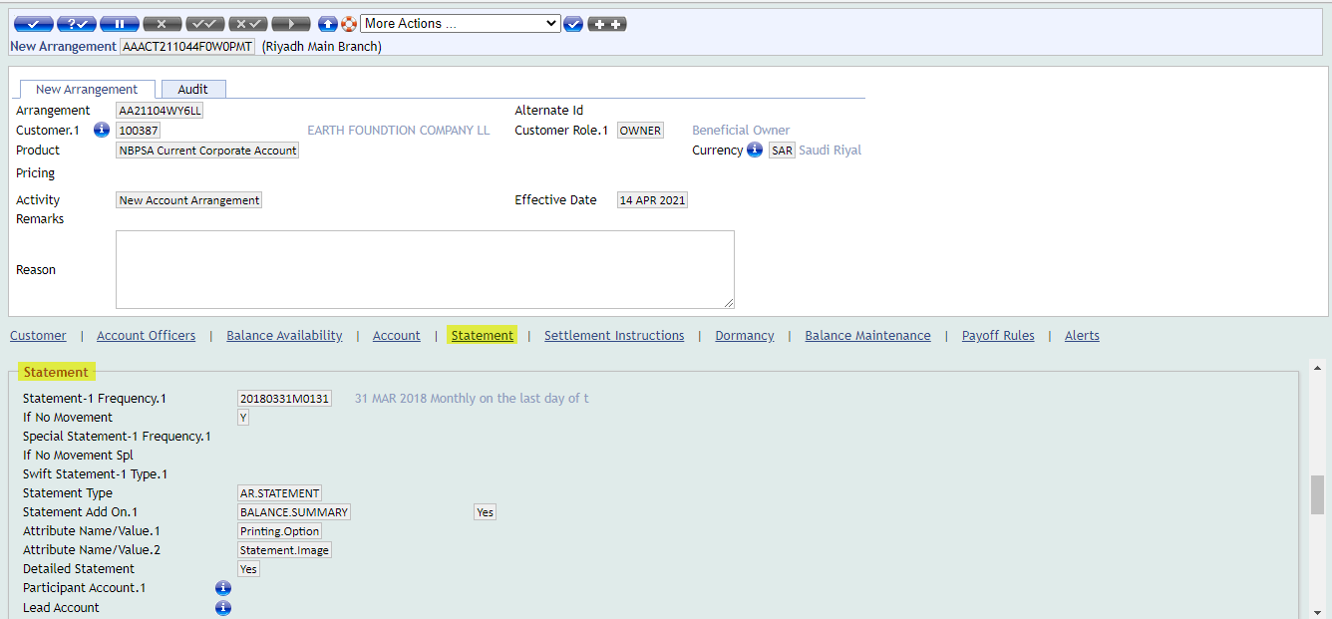

Requirement WS02-AR-06.02 Generate Account Statement
Bank will share the online (Adhoc) Account statement format.
As per the Saudi Sama regulation, account statement is designed already and bank can give the same to their customers.
Note: Once updated statement format will be received from the Bank, then this gap will be updated accordingly.

Workflows
This format will be used for adhoc account statement printing for customers.
English Account Statement:

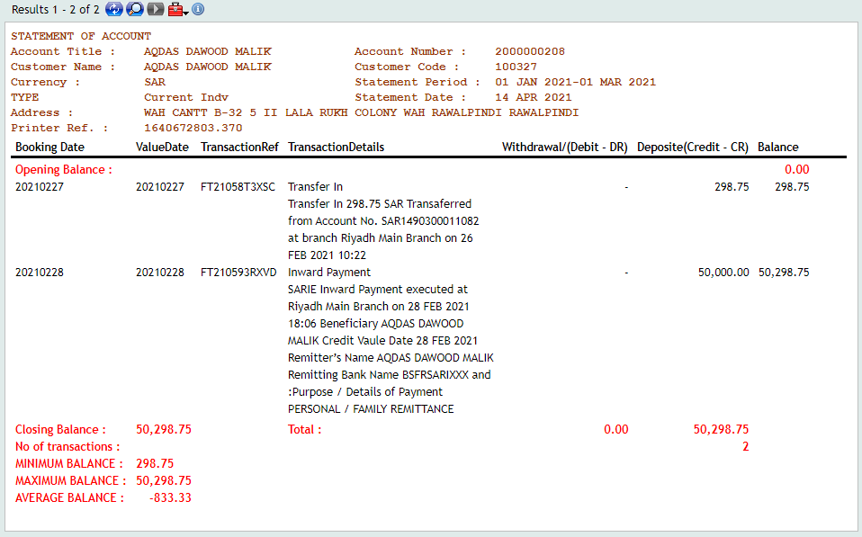
Arabic Account Statement:
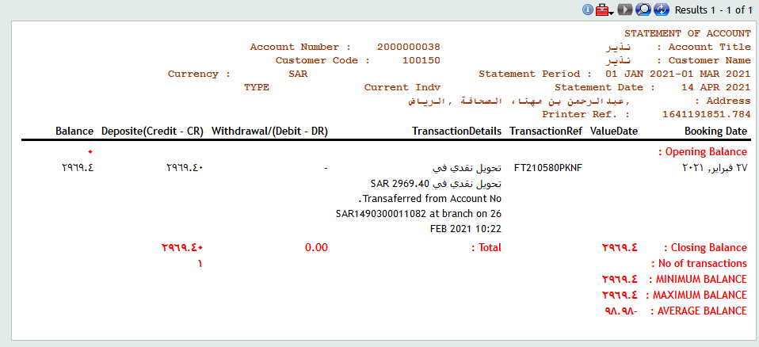

Requirement WS02-AR-06.03 Generate Account Statement
Bank will share the periodic statement format.
As per the Saudi Sama regulation, account statement is designed already and bank can give the same account statement to their customers. Currently same account statement will be used for adhoc and periodic account statement print.
Note: Once updated statement format will be received from the Bank, then this gap will be updated accordingly.

Workflows
Same format will be used for periodic account statement printing for customers.
English Account Statement:

Arabic Account Statement:

Requirement WS02-AR-06.04 Generate Account Statement
Basis on customer email id, every month on 2nd day account statement will be generated and it will be sent on customer email automatically.
Generate Account statement in the bulk mode as text file and convert into PDF, Send to customer via email. Once the email is sent, the PDF should be sent to backup folder & deleted from the main folder.

Workflows
At present no screen available.

Use Cases

Use Case
Variations | Expected Results
Open Current Corporate Account Currency, SAR, EUR, USD, IQD, GBP, JPY & CNY. | System should allow to open corporate current account in these currencies, SAR, EUR, USD, IQD, GBP, JPY & CNY.

Use Case
Variations | Expected Results
Open Current Individual & Staff Account Currency, SAR, USD & IQD. | System should allow to open corporate current account in these currencies, SAR, USD & IQD.

Use Case
Variations | Expected Results
Open account number in T24 system. | Open Account number and check length should be “10” of digit.

Use Case
Variations | Expected Results
To check IBAN is generating. | At the time of account opening IBAN should be generated.

Use Case
Variations | Expected Results
Check the Dormancy status of account | Basis on the dormancy days, system should be applied dormancy as per the defined statuses in the T24 system.

Use Case
Variations | Expected Results
To check the account statement generation. | System Should be generated account statement in the T24 system.

Assumptions
1 - User has internet connection
2 - User has Browser & Valid URL
3 - User has Environment (T24) Access
4 - Bank provide SMTP credentials

Exclusions (Specific Functionality that is not covered by this Development)
- In the document the name of components are refer the other bank, just for understanding the current process.

Proposed Product Solution

Requirement Classification
Gap Reference | Description | Summary | Type of Gap
WS02-AR-01.01 | Open Current Account | Current Corporate Account Currency, SAR, EUR, USD, IQD, GBP, JPY & CNY. | Configuration
WS02-AR-01.02 | Open Current Account | Current Individual & Staff Account Currency, SAR, USD & IQD. | Configuration
WS02-AR-01.03 | Open Current Account | Account length will be 10 as per model bank. | Configuration
WS02-AR-01.04 | Open Current Account | Iban is required and bank will share the document. | Configuration
WS02-AR-01.05 | Open Current Account | Mode of Operation bank is required as "Others". | Configuration
WS02-AR-07.01 | Account Dormancy | Dormancy Status, Dormant (2Y), Unclaimed (5Y) & Abandoned (10Y). | Configuration
WS02-AR-01.06 | Open Current Account | If new account is opened and no debit and credit transaction happened in this account then after 90 days it will be closed automatically. Regulatory requirement. | Customization
WS02-AR-08.01 | Account Enquiry | Bank is required report those new account where no debit and credit after 90 days close automatically and report will be generated before 10 days means (80 days) past. | Customization
WS02-AR-06.01 | Generate Account Statement | No AA Account Statement condition will be use. | Configuration
WS02-AR-06.02 | Generate Account Statement | Bank will share the online (Adhoc) Account statement format. | Customization
WS02-AR-06.03 | Generate Account Statement | Bank will share the periodic statement format. | Customization
WS02-AR-06.04 | Generate Account Statement | Basis on customer email id, every month on 2nd day account statement will be generated and it will be sent on customer email automatically. | Customization

Existing Functionality

Topic 1 Existing Feature 1
Existing functionalities with screen shot is define below:
AA Account Opening:
Click on Account Catalog option to view the account products.
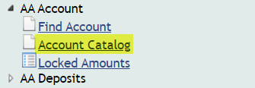
Below are the current account products.
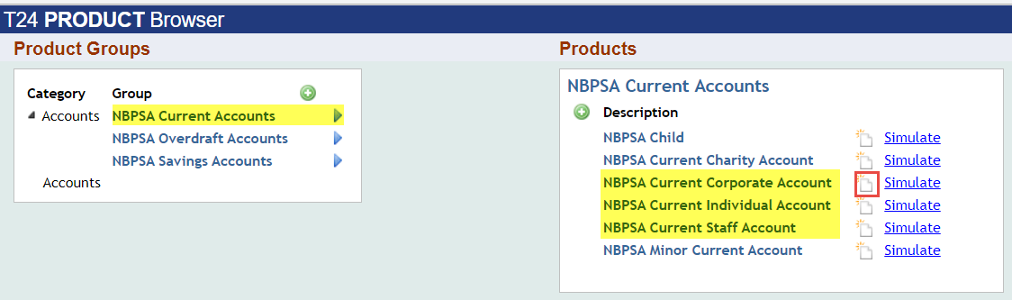
After new deal input customer id and currency and then validate record.

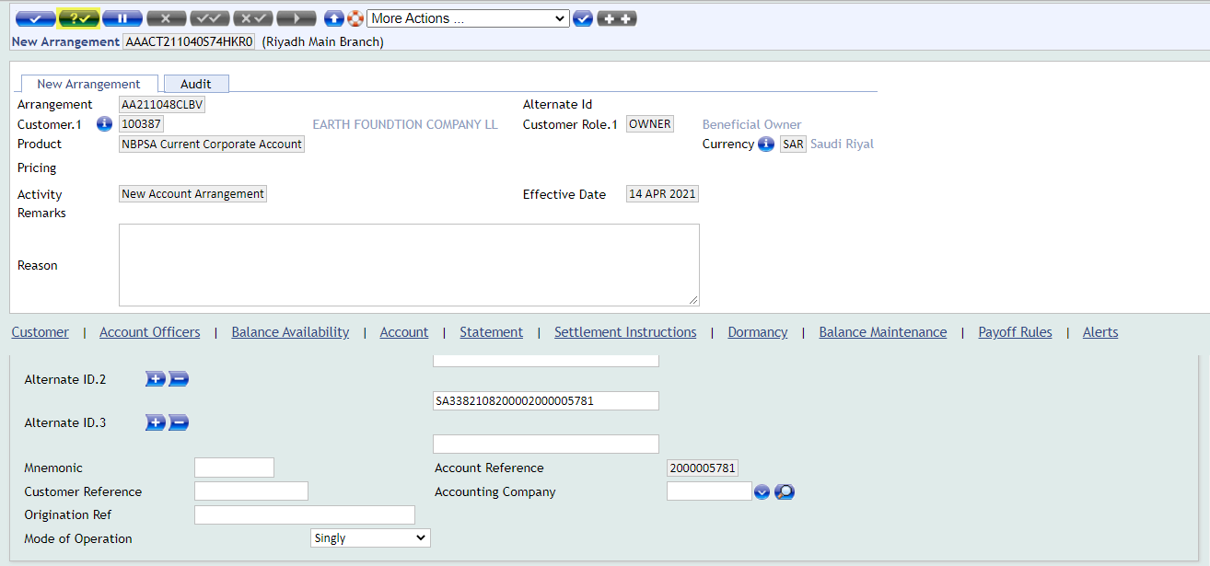
After commit above record, below message will come and user has to select option Received or Not Received to and then commit the record.
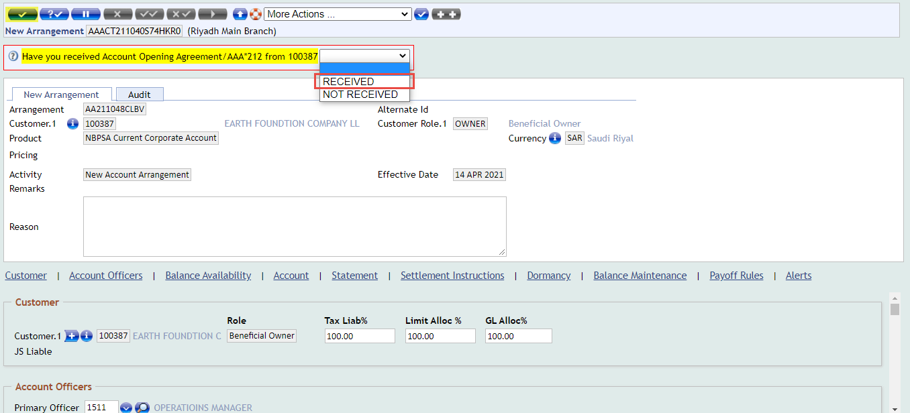
Below record successfully commit.
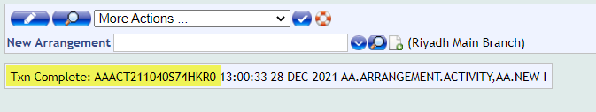
Click on Find Account option to see the unauthorize enquiry.
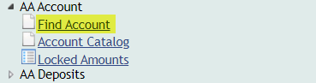
Click on Find option to see the unauthorize account records.

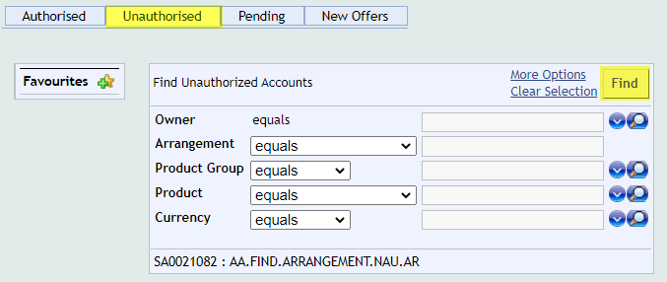
Click on binocular for further process.
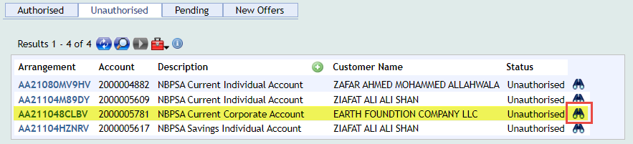
Click on tick sign after selecting option.
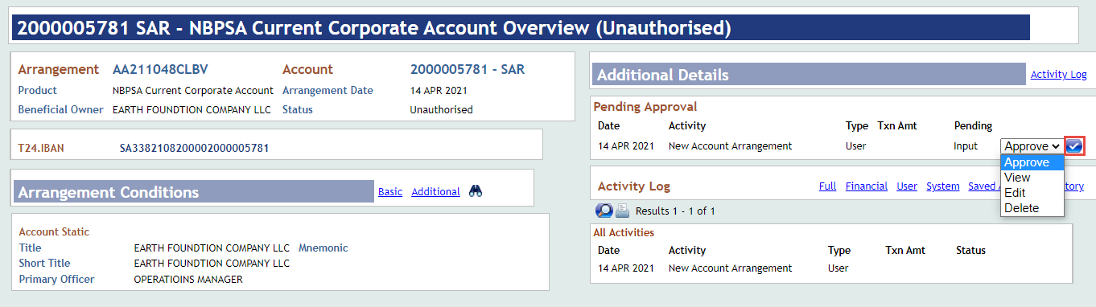
View the account details before authorization.
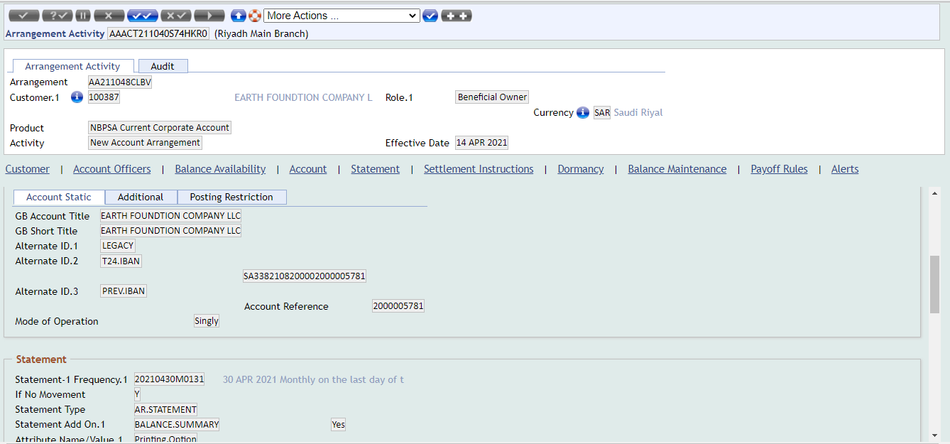
And see audit tab to see override message, record status of account and then authorize.
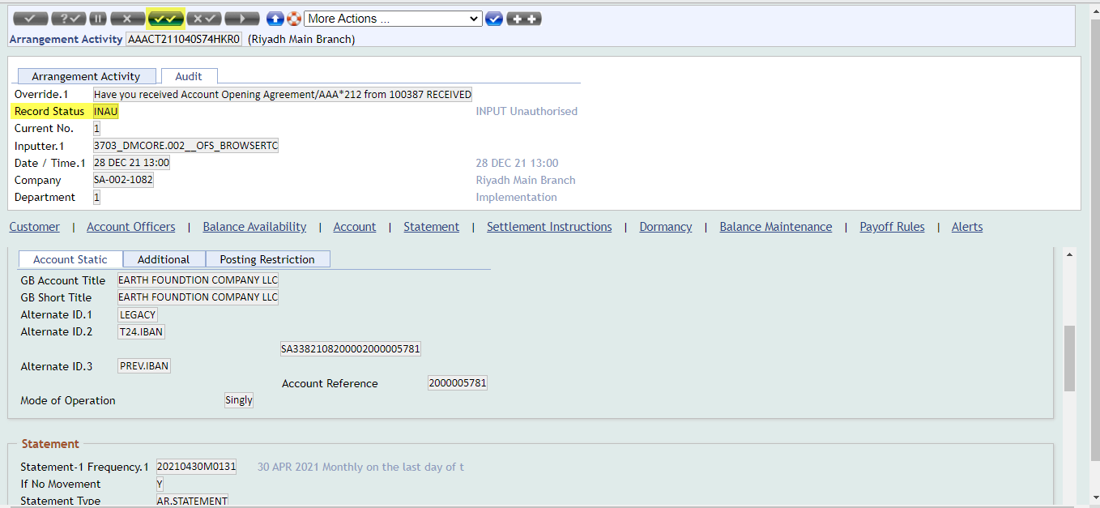
Account record successfully authorized.
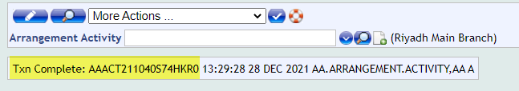

After the authorization of account user can see the details of account or any amendment is required then use below option.
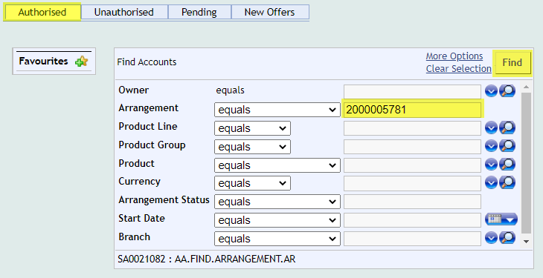
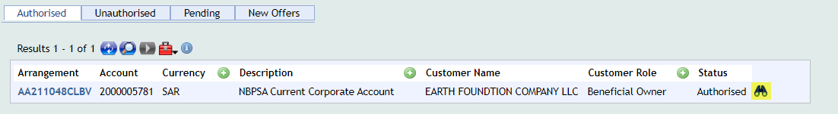
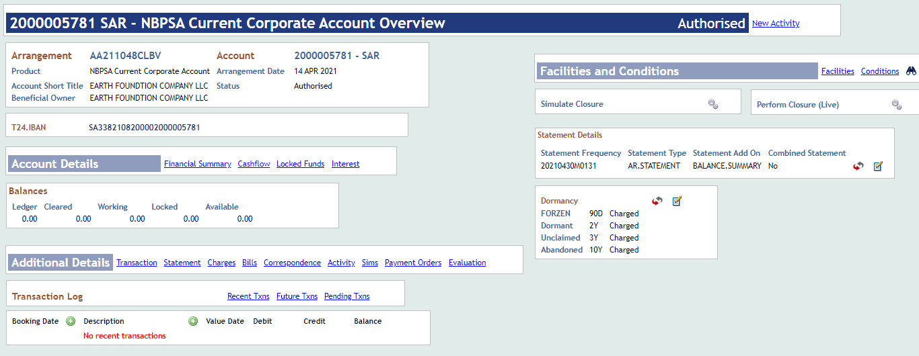

Proposed New Product Functionality

Topic 1 New Product WS02-AR-01.01 Open Current Account

Summary/ Description
Current Corporate Account Currency, SAR, EUR, USD, IQD, GBP, JPY & CNY.
Corporate Current Account will be opened in multiple currencies as mentioned above. New product will be designed by copying the existing NBPKSA product for Trade Bank of Iraq.

Existing Functionality
As per the existing functionality, user can open corporate current account in only below currencies SAR, USD & EUR.
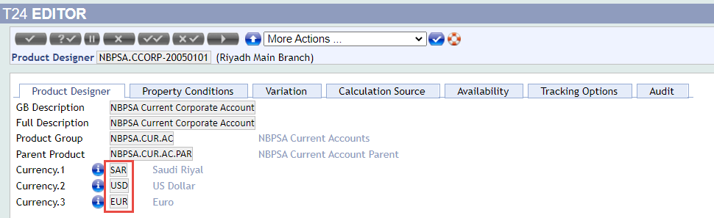
Input Customer ID and Currency in below account opening screen.
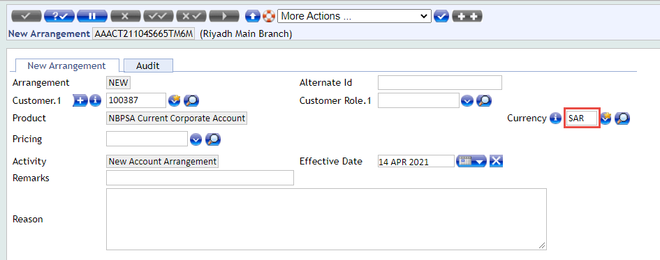

Proposed Functionality
For corporate current account product, new product conditions will be created against the below Property by coping exiting production conditions likes as:

- Product Conditions:
AA.PRD.DES.ACCOUNTING: TBISA.CUR.ACCOUNTING.PAR
AA.PRD.DES.ACCOUNT: TBISA.CUR.CUTOMER.PAR
AA.PRD.DES.OFFICERS: TBISA.CUR.OFFICERS.PAR
AA.PRD.DES.ACTIVITY.MESSAGING: TBISA.CUR.MESSAGING.PAR
AA.PRD.DES.ACTIVITY.PRESENTATION: TBISA.CUR.PRESENTATION
AA.PRD.DES.CLOSURE: TBISA.CUR.CLOSURE.PAR
AA.PRD.DES.BALANCE.MAINTENANCE: TBISA.CUR.BAL.MNT.PAR
AA.PRD.DES.ACTIVITY.MAPPING: TBISA.CUR.ACT.MAPPING.PAR
AA.PRD.DES.PAYOFF: TBISA.CUR.PAYOFF.PAR
AA.PRD.DES.DORMANCY: TBISA.CUR.DORMANCY.PAR
AA.PRD.DES.STATEMENT: TBISA.CUR.STMT.PAR
AA.PRD.DES.BALANCE.AVAILABILITY: TBISA.CUR.BAL.AVL.PAR
AA.PRD.DES.SETTLEMENT: TBISA.CUR.SETTLEMENT.PAR
AA.PRD.DES.ALERTS: TBISA.CUR.ALERTS.PAR
AA.PRD.DES.ACTIVITY.API: TBISA.ACT.API.PAR

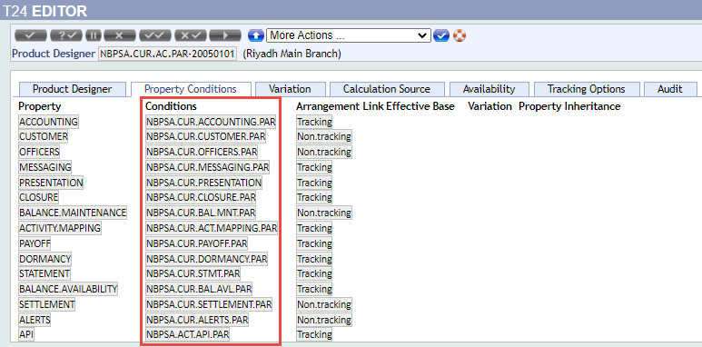

- Product Group:
After creation of all production conditions then product group will be created of Current Account by copying existing product
AA.PRODUCT.GROUP: TBISA.CUR.AC
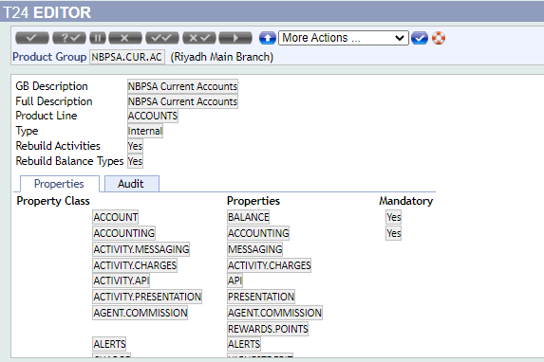
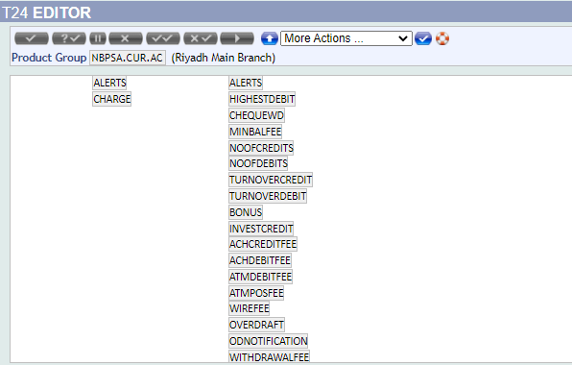
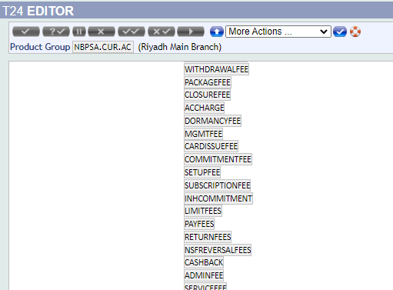
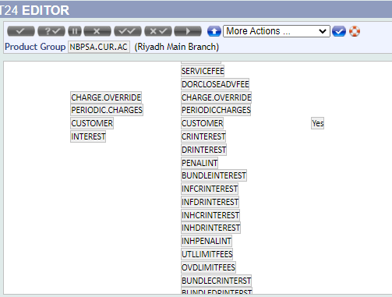
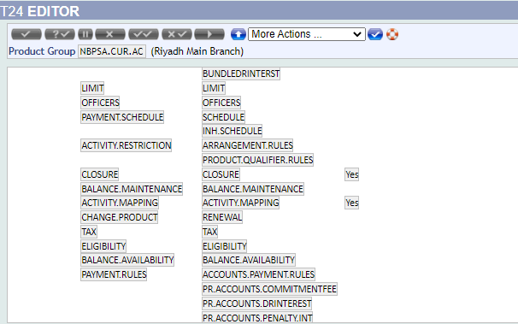
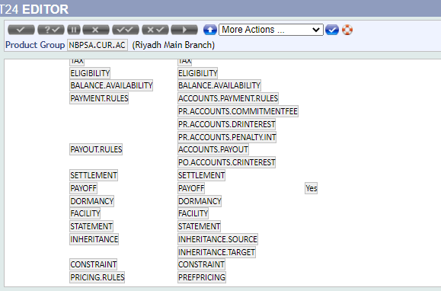
3. Product Designer of Parent:
Current parent will be created by copying existing product and new currencies will add as SAR, EUR, USD, IQD, GBP, JPY & CNY.
AA.PRODUCT.DESIGNER: TBISA.CUR.AC.PAR-20050101
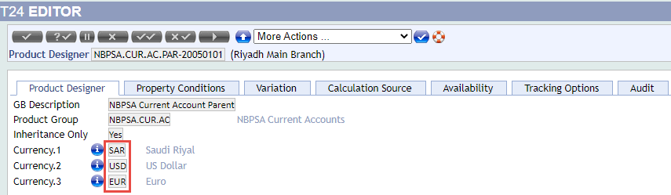
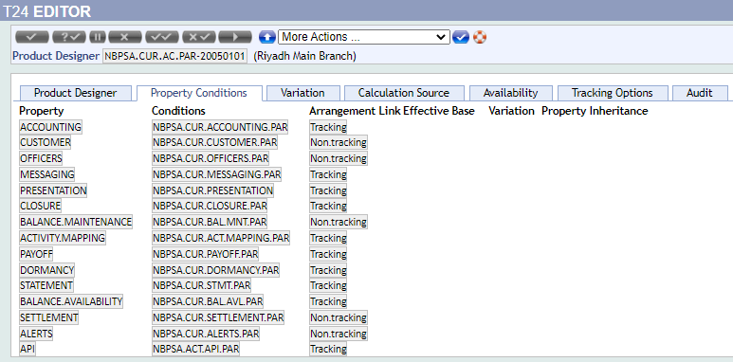
4. Product Designer of Child:
Corporate Current Account child will be created by copying existing product and new currencies will be added as SAR, EUR, USD, IQD, GBP, JPY & CNY.
AA.PRODUCT.DESIGNER: TBISA.CCORP-20050101
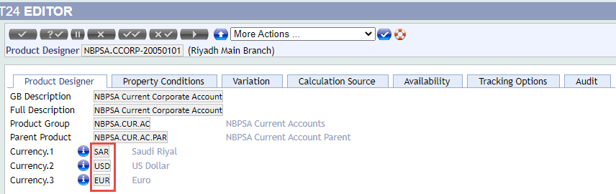
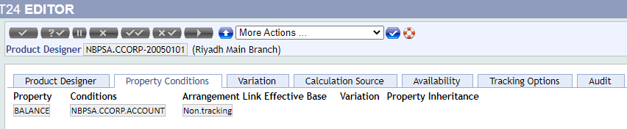

Topic 1 New Product WS02-AR-01.02 Open Current Account

Summary/ Description
Current Individual & Staff Account Currency, SAR, USD & IQD.
Individual Current Account will be opened in multiple currencies as mentioned above. New product will be designed by copying the existing NBPKSA product for Trade Bank of Iraq.

Existing Functionality
Existing product of Individual Current Account, input customer id of individual customer in account opening screen.
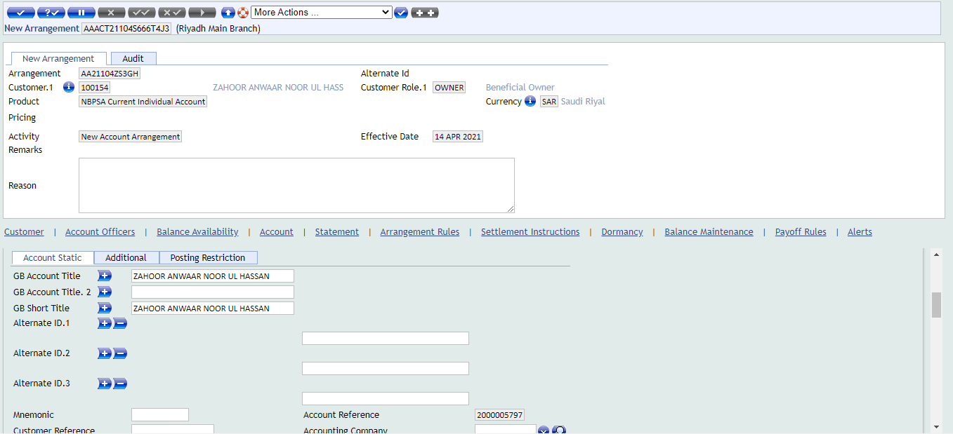
Existing product of Staff Current Account, input customer id of staff customer in account opening screen.
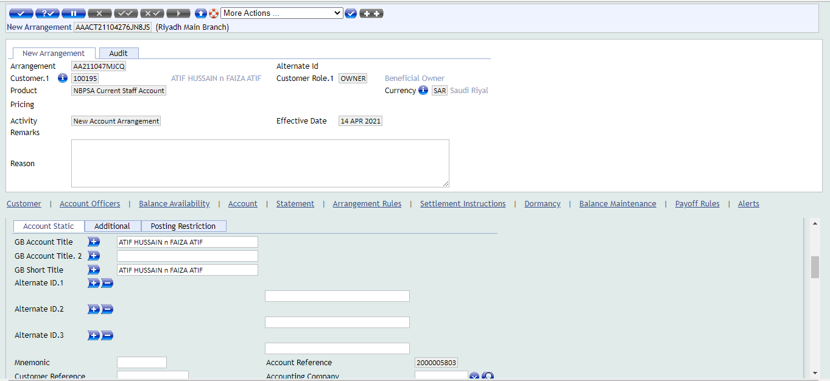

Proposed Functionality
Under the above product group and parent product, New Individual & Staff product will be created by copying existing product.
Product Designer of Child:
Individual & Staff Current Account child will be created by copying existing product and new currencies will be updated as SAR, USD & IQD.
AA.PRODUCT.DESIGNER: TBISA.CIA-20050101 (Individual Current Account).
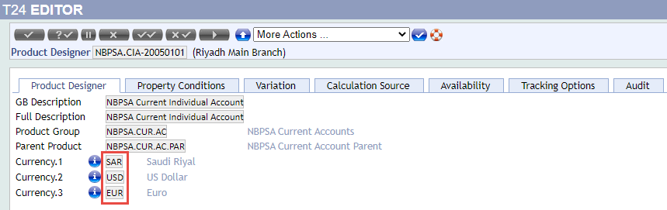
Below condition will be updated with the name of TBI.
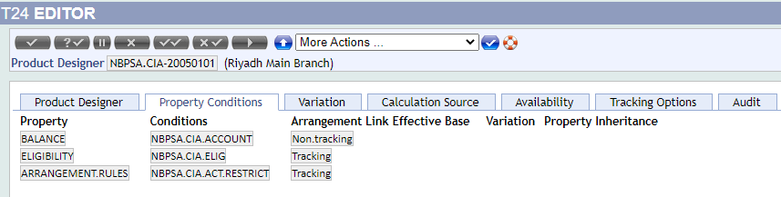
AA.PRODUCT.DESIGNER: TBISA.CSA-20050101 (Staff Current Account).
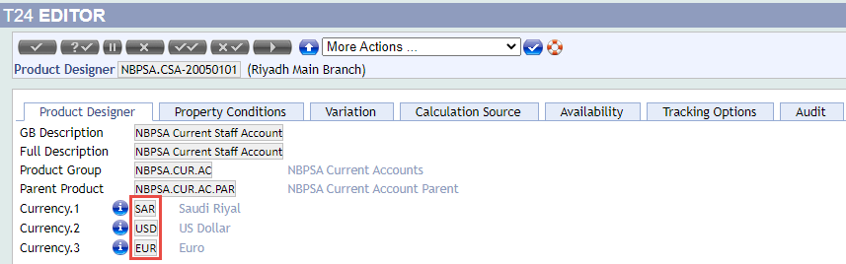
Below condition will be updated with the name of TBI.
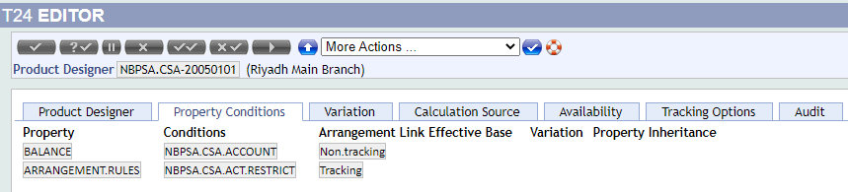

Topic 1 New Product WS02-AR-01.03 Open Current Account

Summary/ Description
Account length will be 10 as per model bank.
At the time of current account opening, system will generate account number automatically as per the defined length setup.

Existing Functionality
At the time of account opening, system is generating account number automatically as per the predefined setup in T24.
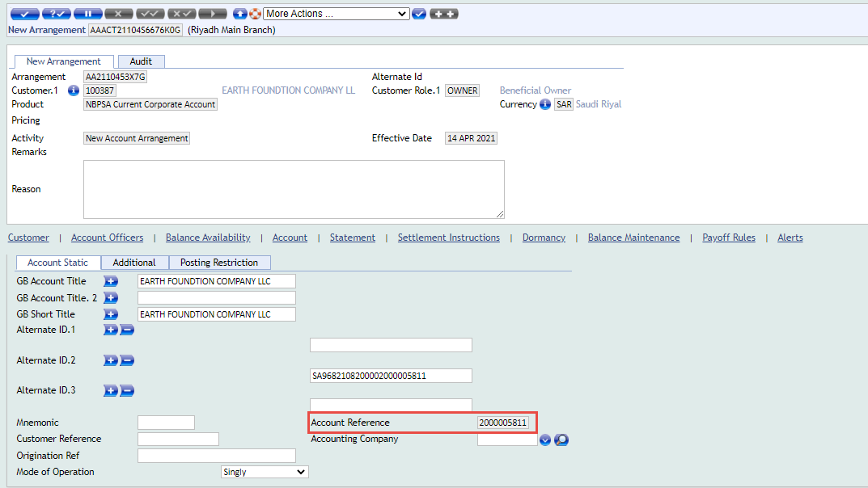

Proposed Functionality
System will generate account number automatically as per the below define INETCO.PARAMETER setup of T24 and same setup of 10-digit account number generation will be used for Trade Bank of Iraq.
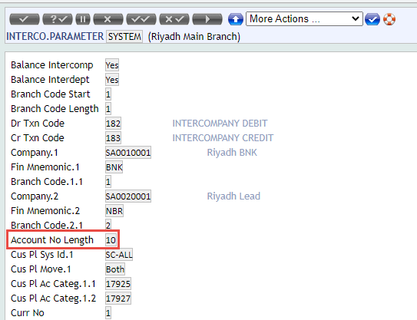
After new product design of current account, account number will be generated as below mentioned screen shot.

Topic 1 New Product WS02-AR-01.04 Open Current Account

Summary/ Description
Iban is required and bank will share the document.
At the time of current account opening, system will generate IBAN number automatically as per the defined setup.

Existing Functionality
As per the existing functionality, IBAN number is generating at the time of account opening.
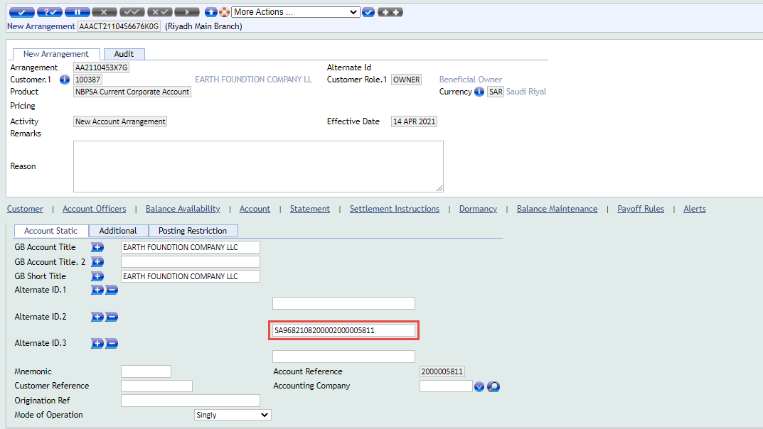

Proposed Functionality
Bank will share the IBAN generation document. After the setup of IBAN, upon creation of current account IBAN number will be generated automatically as per the define setup.
Below two parameter records will be set to generate the IBAN number:
IN.IBAN.STRUCTURE
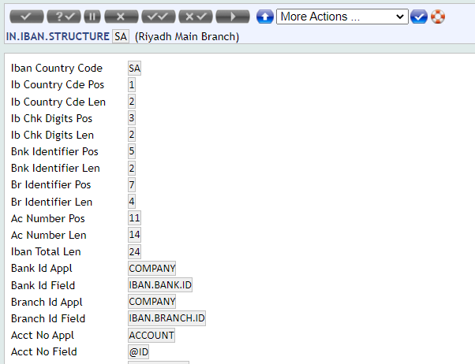

AA.PRD.DES.ACCOUNT:
In account product condition Generate Iban field will set as “Yes” for IBAN generation. And below three new account products Generate Iban field will be set as “Yes”.

1. TBISA.CCORP.ACCOUNT—20050101
2. TBISA.CIA.ACCOUNT—20050101
3.TBISA.CSA.ACCOUNT--20050101

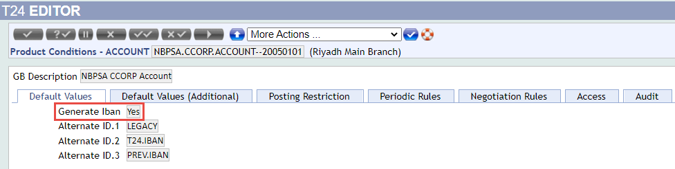

Topic 1 New Product WS02-AR-01.05 Open Current Account

Summary/ Description
Mode of Operation bank is required as "Others".
Current account opening screen in account tab, in Mode of Operation dropdown field “Others” option will be added.

Existing Functionality
As per the existing functionality, in the account opening account screen Mode of Operation field below options are appearing in dropdown.
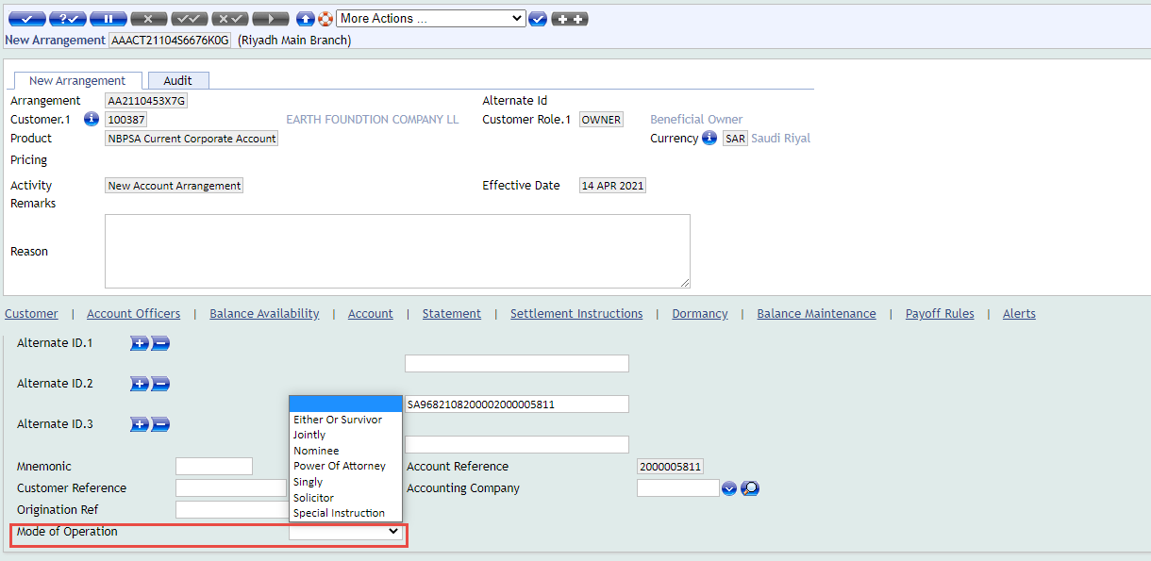

Proposed Functionality
In LOCAL.TABLE @ID (NBPSA.AC.OPR.INST) of AA.PRD.DES.ACCOUNT, below highlighted Vetting Table and Remark field new value will be added as “Others”.
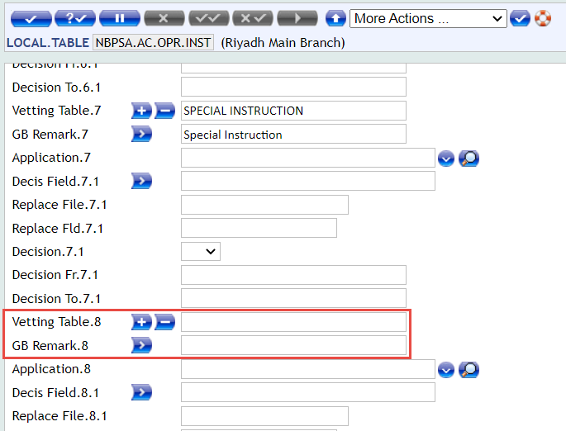
After adding “Others” value in above local table, and then it will be appeared in the below dropdown Mode of Operation (NBPSA.AC.OPR.IN) field of Current Account.

Topic 1 New Product WS02-AR-07.01 Account Dormancy

Summary/ Description
Dormancy Status, Dormant (2Y), Unclaimed (5Y) & Abandoned (10Y).
On current account opening screen, dormancy statuses will be set as mentioned above on account product.

Existing Functionality
At present, dormancy is set on account opening as Frozen 90Days, Dormant 2Years, Unclaimed 3Years and Abandoned 10Years.
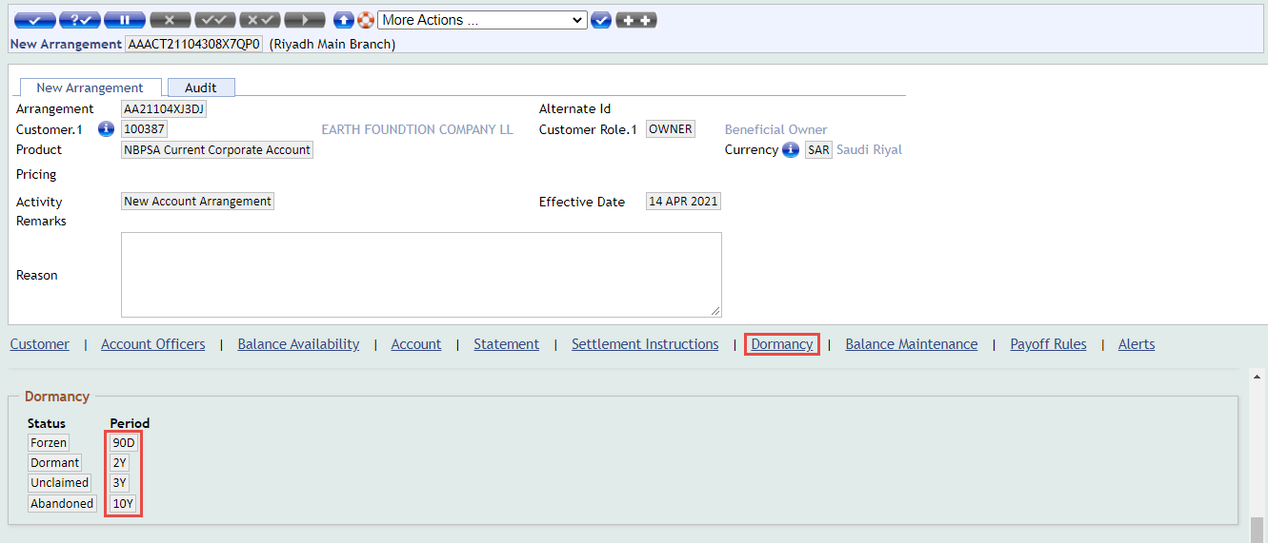

Proposed Functionality
Dormancy condition will be updated as per the bank requirement, and new dormancy condition will be created in AA.PRD.DES.DORMANCY by coping below existing dormancy product condition of current account.
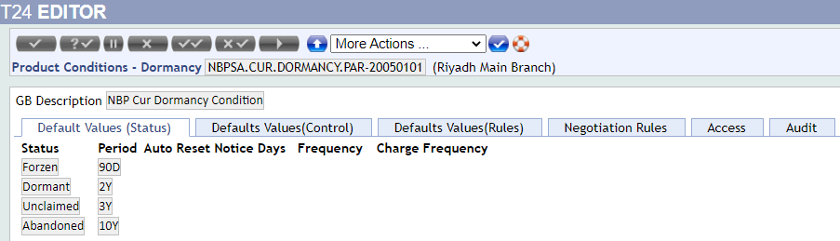
And new dormancy condition will be updated as:
- Dormant 2Y
- Unclaimed 5Y
- Abandoned 10Y

Topic 1 New Product WS02-AR-01.06 Open Current Account

Summary/ Description
If new account is opened and no debit and credit transaction happened in this account, then after 90 days it will be closed automatically. Regulatory requirement.
For automatic account closure, new parameter screen will be created and closing days define in this parameter. When new account will be closed automatically then it will check first no debit and credit happen in the account.

Existing Functionality
At present no screen available.

Proposed Functionality
New parameter table will be created where number of days will define to check if new current account is opened in AA and no Debit and Credit transaction happen in 90 days then after this account will be closed automatically.
Local Parameter Name: TBI.H.ACCT.CLS.DAYS
Field Name | Description | Remarks
@ID | Rec id “SYSTEM” | SYSTEM
ACCT.CLS.DAYS | Account Closure Days | 90 DAYS
When new current account will be opened in AA, then it will write in below parameter.
Local Live Template Name: TBI.L.ACCT.DR.CR.DAYS
Field Name | Description | Remarks
@ID | Rec id “Account Number” | Account Number
OPENIG.DATE | Opening Date | Opening Date of Account
REMAINING.DAYS | Remaining Days | Remaining Days
CO.CODE | Branch Name | Branch Name
Once new AA current account will open in T24 system then it will write in this local live template (TBI.L.ACCT.DR.CR.DAYS) as @ID of Account. If no debit credit transaction happen in this account then system will check first in account application field of DATE.LAST.DR.CUST & DATE.LAST.CR.CUST if Date is found within 90 days then account will not be closed, if last debit and last credit date not found then after 90 Days current account will be closed automatically basis on the OPENING.DATE of Current Account in account application minus (-) today system date and read from Dates table of T24 system. Below activity will be triggered at the time of account closing.
ACCOUNTS-CLOSE-ARRANGEMENT

Subroutine Information
Following table contains the basic information of the subroutine.
Post routine attached on new account activity:
Property | Specification
Name | TBI.L.ACCT.DR.CR.DAYS
Type | Subroutine
Attached To | ACCOUNTS-NEW-ARRANGEMENT
Attached As | POST ROUTINE
Dependency | N/A
Description | This post routine will be attached activity on ACCOUNTS-NEW-ARRANGEMENT of Account API product condition. When new current account is opened in AA then this routine will write @ID of Account, Opening Date, Remaining Days and Co Code in Local Live Template.
Arguments – IN
Arguments – OUT
Prelim Condition | N/A
Subroutine Flow
Special Instructions | N/A
Service Routine attach on COB:
Property | Specification
Name | TBI.NEW.ACCT.DR.CR.CLS
Type | Subroutine
Attached To | Batch Routine and attach on COB
Attached As | Service Routine
Dependency | N/A
Description | This service routine will check those new AA Current Account records where no debit credit transaction happen 90 days in this account then it will close automatically after 90 days.  In this live template TBI.L.ACCT.DR.CR.DAYS Remaining Days will update on COB (Account Opening Date – Today System Current Date) @ID of Account record.
Arguments – IN
Arguments – OUT
Prelim Condition | N/A
Subroutine Flow
Special Instructions | N/A

Topic 1 New Product WS02-AR-08.01 Account Enquiry

Summary/ Description
Bank is required report those new account where no debit and credit after 90 days close automatically and report will be generated before 10 days means (80 days) past.
New enquiry will be created to display only those new accounts records which past 80 days and there is no debit and credit happen. It will also check the arrangement status equal to “Auth” mean account is authorized status.

Existing Functionality
At present no screen available.

Proposed Functionality
New enquiry will be designed with the name ENQ TBI.E.ACCT.CLS.REM.DAYS, in this enquiry data will be fetched from this live template (TBI.L.ACCT.DR.CR.DAYS).
Below is the column of enquire:
Label: Account Closure Remaining Days
@ID: Account Number
OPENING.DATE: Date of Account Opening
REMAINING.DAYS: Remaining Days Left
CO.CODE: Branch Name

Topic 1 New Product WS02-AR-06.01 Generate Account Statement

Summary/ Description
No AA Account Statement condition will be use.
Initially in BPR session we had discussed this statement condition will be removed from the account product but as per this Gap (4.1.12 Requirement WS02-AR-06.04 Generate Account Statement), this statement condition will not be removed from the account product.

Existing Functionality
At present, below account statement frequency is set on AA account product.

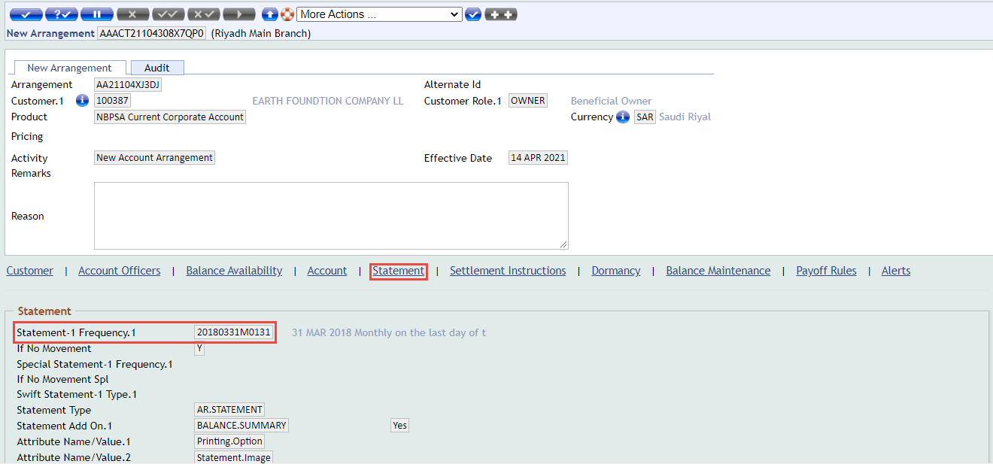

Proposed Functionality
New Statement product condition will be created for current account product and frequency will be set every month on 2nd day by copying existing statement condition. As per this Gap (4.1.12 Requirement WS02-AR-06.04 Generate Account Statement), this condition will be used.
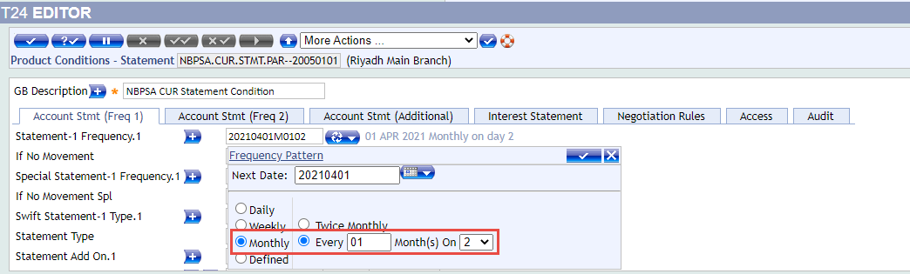

Topic 1 New Product WS02-AR-06.02 Generate Account Statement

Summary/ Description
Bank will share the online (Adhoc) Account statement format.
As per the Saudi Sama regulation, account statement is designed already and bank can give the same to their customers.

Existing Functionality
Currently Account Statement is generating as per the Saudi Sama regulation for adhoc. Below is the screen shot of English and Arabic account statement.
Arabic Account Statement:

Proposed Functionality
As per the Saudi Sama regulation, account statement is designed already and bank can give the same to their customers. Below is the process to generate the Adhoc account statement.
Account Statement Enquiry Name: ENQ E.NOFILE.STMT.NEW
As highlighted below fields, input Account ID, Start Date, End Date and then click on Find option to view the account statement and print.
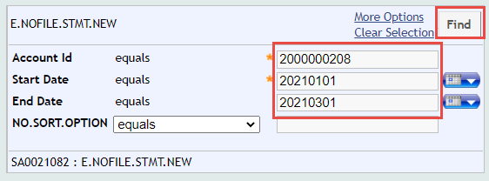
Account Statement:
Note: Once updated account statement format will be received from the bank then this gap will be updated accordingly.

Topic 1 New Product WS02-AR-06.03 Generate Account Statement

Summary/ Description
Bank will share the periodic statement format.
As per the Saudi Sama regulation, account statement is designed already and bank can give the same to their customers. Currently same account statement will be used for adhoc and periodic account statement print.

Existing Functionality
Currently same Account Statement is generating as per the Saudi Sama regulation for adhoc and periodic. Below is the screen shot of English and Arabic account statement.
Arabic Account Statement:

Proposed Functionality
As per the Saudi Sama regulation, account statement is designed already and bank can give the same to their customers. Below is the same process to generate the account statement Adhoc and Periodic.
Account Statement Enquiry Name: ENQ E.NOFILE.STMT.NEW
As highlighted below fields, input Account ID, Start Date, End Date and then click on Find option to view the account statement and print.
Account Statement:
Note: Once updated account statement format will be received from the bank, then this gap will be updated accordingly.

Topic 1 New Product WS02-AR-06.04 Generate Account Statement

Summary/ Description
Basis on customer email id, every month on 2nd day account statement will be generated and it will be sent on customer email automatically.
Generate Account statement in the bulk mode as text file and convert into PDF, Send to customer via email. Once the email is sent, the PDF should be sent to backup folder & deleted from the main folder.

Existing Functionality
At present no screen available.

Proposed Functionality
Account statement will be generated in the bulk mode as text file and convert into PDF, Send to customer via email. Once the email is sent, the PDF should be sent to backup folder & deleted from the main folder.

Below is the process diagram:
Below is the high-level process to generate account statement and send statement on email.
- Define the Parameter setup
  - Spooling category
  - Last Statement Generated Date
  - Next Statement Generation Date
  - Posting Restrictions
- Run the Account Statement Generation service
  - Service generate Account Statement into &HOLD& folder
- Next Batch to move the files
  - Service move all Account statements from &HOLD& to AC.STMT folder
- Next Batch the PDF generation service
  - Service generate PDF for all account statements and stored in AC.STMT folder
- Run the Service to Send email with attachment
  - Email Id will pick form customer application
  - Email Subject as per Parameter
  - Email Body as per Parameter
  - PDF as attachment
  - Maintain the Logs & Backup

Parameter Setup:

Generic Parameter,
TBI.H.GEN.STMT.PARAM
Field Name | Description | Remarks
@ID | Rec id “SYSTEM” | SYSTEM
TEXT.FILE.PATH | Define the Account statement txt file Path
PDF.FILE.PATH | Define the PDF path
BACKUP.PATH | Define the Backup Path | PDF & txt
Account Statement Generation Parameter:
TBI.H.ACCT.STMT.PARM
Field Name | Description | Remarks
@ID | Rec id Account ID | Account ID
ARRANGEMENT.ID | Arrangement ID
CUSTOMER ID | Customer ID
CATEGORY | Category
POSTING.RESTRIC | Posting Restriction
ACCT.STMT.FREQ | Statement Frequency
LAST.STMT.DATE | Last Generated | Last Statement Generated
NEXT.STMT.DATE | Next Generated | Next Statement Gen Date
GEN.STMT.FLG | Flag for Statement | Possible values (Y/N)
The above table update based on the Authorization of Arrangement

Statement Spooling Parameter
TBI.H.STMT.SPOOL.PARAMS
Field Name | Description | Remarks
@ID | Rec id “STMT.SPOOL.CATEG”
DESCRIPTION | Description
XX.CATEGORY | Define the Category ID to include in the Spool Printing | Multivalued Field
STATUS | - Active  - Inactive

Email Generic Parameter
TBI.H.EMAIL.MAPPING
Field Name | Description | Remarks
@ID | Rec id “ACCT.STATMENT”
DESCRIPTION | Description
XX.MESSAGE.TEXT | Message Text for Email Body | Multivalued Field
SUBJECT | Define the Email Subject
STATUS | - Active  - Inactive

Email Parameter
TBI.H.EMAIL.PARAM
Field Name | Description | Remarks
@ID | “EMAIL”
USER.NAME
SENDER.NAME
SMTP.HOST
SMTP.PORT

Email Logs
TBI.L.EMAIL.LOGS
Field Name | Description | Remarks
@ID | System Generated | Unique Reference
REQUEST.DATE | Request Gen Date
MESSAGE.TEXT | Message Text for Email Body
SUBJECT | Email Subject
STATUS | - New  - Sent  - Failed
MESSAGE.RESPONSE
REQUEST.OUT.DATE
REQUEST.OUT.TIME
MAIL.TO
ATTACHMENT.FILE.NAME

- REPORT.CONTROL > ACCOUNT.STATEMENT
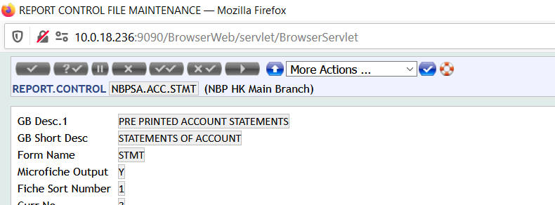

- DE.FORM.TYPE > STMT
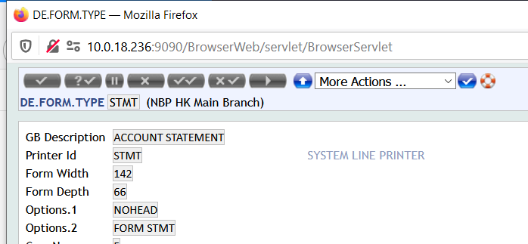

- PRINTER.ID > STMT
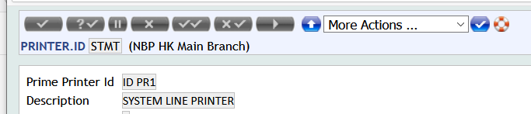
TSA Service Setup:
Below services name will be updated as per bank naming convention and below are the sample screen shots of other bank for reference only.

Generate Statement
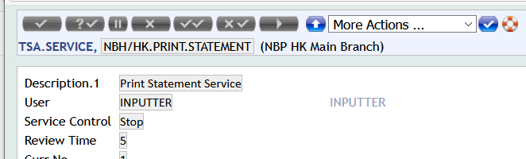

- Start the below mentioned service for the generation of Account Statements.
- Get the list of account from
  - TBI.H.STMT.SPOOL.PARAMS
  - TBI.H.GEN.STMT.PARAM
- This service should always be executed with 1 Server and 1 Agent.
- Account Statements will be generate in &HOLD& Folder.
- PDF.CONV job will convert all the files into pdf and transfer from UD/STMT.PDF to UD/STMT.PDF.backup folder

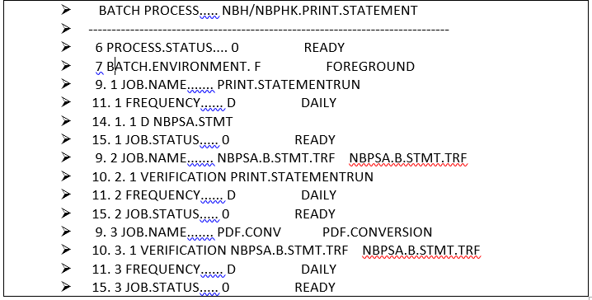

Generate PDF

- Start Files are converted to PDF Format and placed under UD/STMT.PDF Folder with Account Number and T24 Todays Date
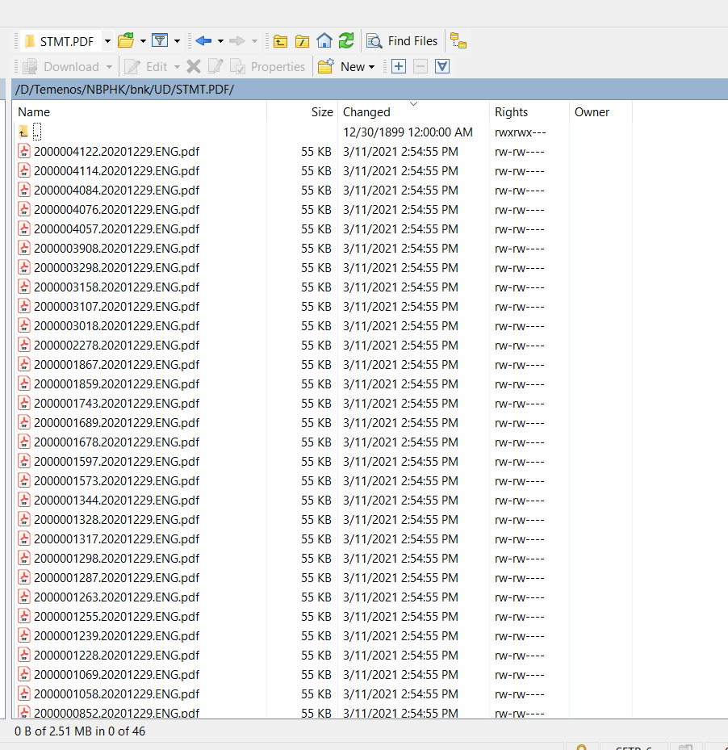
- Original Statement Files are then transferred to UD/STMT.PDF.backup Folder

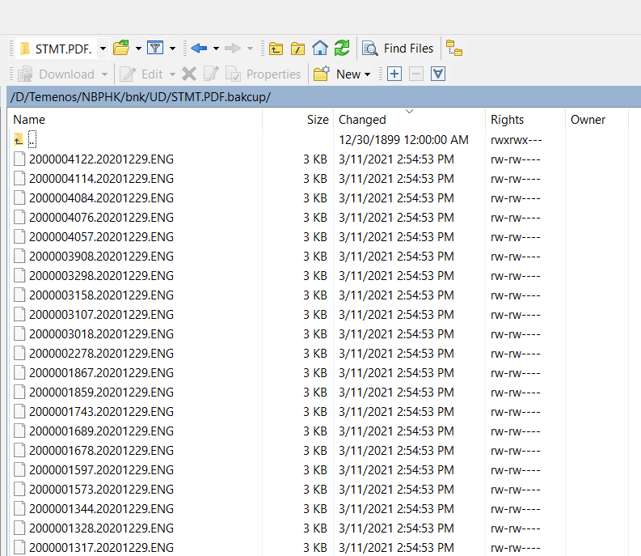

Sending Emails Service:
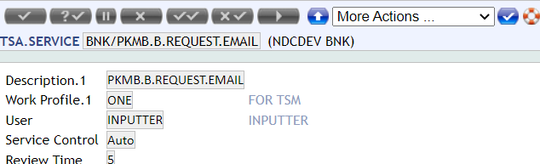

- The above service send the email with attachment
- Email ID will pick from Customer
- Maintain the logs

Subroutine Information
Following table contains the basic information of the subroutine.
Property | Specification
Name | TBI.ACCT.STMT.GEN.PARAM  TBISA.PRINT.STATEMENT
Type | Subroutine
Attached To | ACCOUNTS-NEW-ARRANGEMENT  TSA & BATCH
Attached As | Post Routine  Service Routine and attach on COB
Dependency | N/A
Description | - This account statement generation table (TBI.H.ACCT.STMT.PARM) will be updated based on the Authorization of Arrangement.  - Run the Account Statement Generation service  - Service generate Account Statement into &HOLD& folder  - Next Batch to move the files  - Service move all Account statements from &HOLD& to AC.STMT folder  - Next Batch the PDF generation service  - Service generate PDF for all account statements and stored in AC.STMT folder  - Run the Service to Send email with attachment  - Email Id will pick form customer application
Arguments – IN
Arguments – OUT
Prelim Condition | N/A
Subroutine Flow
Special Instructions | N/A

New and Amended tables
N/A

Table name
N/A
ID Name | Type | Length | Description

Customer Data Protection (CDP):
N/A
Field Name | Table Name | Purpose | Attributes | Accessibility | ERASE.OPTION - Is field mandatory? (Yes/No)
Note: The clients who have CZ (Customer Data Protection) module installed can recognize the impact of these changes.

Business Events
N/A

Integration Points
N/A

Configuration – Screens and Menu
N/A

Config Screen 1

Mock up Screens

Configuration – Other Data
N/A

Config Item 1

Model Configuration
N/A

APIs to be released
N/A

API 1

API Details
N/A
https://confluence.temenos.com/display/IRFS/4.+REST+Style+Guide >>
Method | POST
URI  (includes api version , domain & Resource names) | Expected URI – Ex. /v1.0.0/party/customers/
T24 Artefact name | <Model Bank Artefact Name>
Functionality Description | <Description for the API to be added in the developer portal. This gives the functional description of the API>
Operation | <unique operation id> like getCustomerDetails
Domain | holdings|order|meta|party|product|reference  <should be one of the existing domains>
API Group names | Format : <domain>-<resource>-<subresource>-service  Ex. holdings-accounts-service, holdings-customers-service, party-customers-messages-service

New/Modified artefact details
<<This section will be filled with the required new enquiry/version details in case the API is not based on an existing Model Bank artefact. All the required field names and its functions should be mentioned in the section.
In case of slight modifications to the existing artefacts, then the existing artefact name and the required additional details for modification should be specified>>

Input fields
<To be filled in whenever the API gets an input from the consumer of the API>
Application Field Name | Display Type  (ALPHANUMERIC, AMOUNT, DATE, TIMESTAMP, BOOLEAN) | Label Name ( Vocabulary)  <to be filled in Enquiry/Version> | Additional Details | Description
The field name in T24 model bank artefact. | The data type of the field | The field name to be used in the API <as per REST API and IRIS vocabulary standards> | Details regarding whether mandatory input or optional input. Other details about the field if any. | The functional description to be added in the API documentation. The description should be functional and not in T24 language.

Output fields
<To be filled in whenever the API returns enquiry or version details. Mostly in case of GET APIs>
Application Field Name | Display Type  (ALPHANUMERIC, AMOUNT, DATE, TIMESTAMP, BOOLEAN) | Label Name ( Vocabulary)  <to be filled in Enquiry/Version> | Additional Details | Description
The field name in T24 model bank artefact. | The data type of the field | The field name to be used in the API <as per REST API and IRIS vocabulary standards> | Details regarding Other details about the field if any. | The functional description to be added in the API documentation. The description should be functional and not in T24 language.

Dependant and Related APIs
<<This section includes references to FSDs, other documents and any information about APIs that are related/dependant on this enhancement. For example, a vetting table that is used in the Version for which an API is built.
This also includes information about APIs that this API is dependent on>>
API Documentation Guidelines produced by Knowledge Team is embedded herewith for reference and adoption.

L3 API Hook requirements
<<This section relates to any features to be exposed from within the L1 product level to enable L3 customisation of the core functionality for the new feature or enhancement. This section should detail the need for any L3 APIs/hooks and use cases that are envisaged at the L3 level. This could be based on the usage of any existing L1 jBC methods that will be needed by Java Implementation clients, who will no longer be able to make use of any L1 jBC methods directly>>

Functionality Point Matrix
N/A

<< Functionality Matrix is the traceability till FSD and Test Cases starting from BRD. Mention the Section ID and the Description of the Requirement under BRD column, Section ID and the Description of the Functionality under FSD column and the mapping Test cases under Test Cases column with relevant test case ID>> ( mandatory for all client specific developments)
BRD | FSD | Test Cases

<<Note: In case any of above sections are not updated, because they are not relevant to the enhancement, they can be removed from the final version of the FS document sent to the client (only if the below pre-requisites are met. Care to be ensured that the sections are not missed for the enhancement and are in-line with the requirements agreed with the Client.
Pre-requisites:
• Frozen BRD
• Reviewed and baselined FS>>

