Functional Specification Document

Focal Point Ref : LETTER.OF.CREDIT -WS04_TBI_LC_FSD_v1.1
Client Name: Trade Bank of Iraq

Document History
Author | Version | Date | Description
Taiyyab Azim | 1.0 | ^{23th} December 2021
Taiyyab Azim | 1.1 | 26th January 2021

Comments:
The purpose of this document is to provide the solutions of the Gaps identified during the Business
Process Alignment held with Bank team and IT team.

Table of Contents
1. Contractual Information 5
2. Acronyms 6
3. Background 7
3.1 Introduction 7
3.2 Reference Documents 10
3.3 Related and Dependent Enhancements 10
4. Proposed Functional Solution Description 10
4.1 Requirements or Gap Description 10
4.1.1 Requirement WS04-01-01.01 Margin A/C for Import L/C Issuance 10
4.1.2 Requirement WS04-01-01.02 Internal LCs 11
4.1.3 Requirement WS04-01-01.02 Separate Report For Internal LCs 15
4.1.4 Requirement WS04-01-01.04 Local Fields Import/Export LC 17
4.1.5 Requirement WS04-01-01.05 Local Fields For Import/Export Docs 18
4.1.6 Requirement WS04-01-01.06 Local Fields For Import/Export Docs Payment 20
4.1.7 Requirement WS04-01-01.07 Swift Messages and Advices Enquiry 22
4.1.8 Requirement WS04-01-01.08 Waive Charges Option to Be Removed 26
4.1.9 Requirement WS04-01-01.09 H.S Code Field in Enquiry 28
4.1.10 Requirement WS04-01-01.10 Margin Functionality for Reimbursement Processing 28
4.1.11 Requirement WS04-01-01.11 Fields To Be Mapped In LC Charge Details Enquiry 30
4.1.12 Requirement WS04-01-01.12 LC Expiry Date Field Required On Export LC Drawings Document Capture Step 33
4.1.13 Requirement WS04-01-01.13 Tracer feature for Export LC Docs 34
5. Use Cases 42
5.1 Use Case 42
5.2 Use Case 42
5.3 Use Case 42
5.4 Use Case 42
5.5 Use Case 42
5.6 Use Case 43
5.7 Use Case 43
5.8 Use Case 43
5.9 Use Case 43
5.10 Use Case 44
5.11 Use Case 44
5.12 Use Case 44
5.13 Use Case 44
6. Assumptions 45
7. Exclusions (Specific Functionality that is not covered by this Development) 45
8. Proposed Product Solution 45
8.1 Requirement Classification 45
8.2 Existing Functionality 46
8.2.1 Topic 1 Existing Feature 1 46
8.3 Proposed New Product Functionality 47
8.3.1 Topic 1 WS04-01-01.01 Margin A/C for Import L/C Issuance 47
8.3.2 Topic 1 New Product WS02-AR-01.02 Open Current Account 48
8.3.3 Topic 1 New Product WS02-AR-01.03 Open Current Account 52
8.3.4 Topic 1 New Product WS04-01-01.04 Local Fields Import/Export LC 54
8.3.5 Topic 1 WS04-01-01.05 Local Fields For Import/Export Docs 56
8.3.6 Topic 1 WS04-01-01.06 Local Fields for Import/Export Docs Payment 58
8.3.7 Topic 1 WS04-01-01.07 Swift Messages and Advices Enquiry 61
8.3.8 Topic 1 WS04-01-01.08 Waive Charges Option to Be Removed 65
8.3.1 Topic 1 WS04-01-01.09 H.S Code Field in Enquiry 66
8.3.1 Topic 1 WS04-01-01.10 Margin Functionality for Reimbursement Processing 67
8.3.2 Topic 1 WS04-01-01.11 Fields to Be Mapped In LC Charge Details Enquiry 69
8.3.3 Topic 1 LC Expiry Date Field Required On Export LC Drawings Document Capture Step 72
8.3.4 Topic 1 WS04-01-01.13 Tracer feature for Export LC Docs 75
8.4 Accounting 83
8.5 Limits 83
8.6 COB Processing 83
8.7 Test Cases and Expected Results 83
8.8 New Tables 83
8.8.1 [Table Name] 83
8.8.2 Table Properties 83
8.8.3 Table Layout 83
8.8.4 Field Checks 84
8.9 Cross Validation Checks 84
8.10 Other Processing 84
8.11 INSERT Files 84
8.12 Subroutines 84
8.12.1 Subroutine Name 84
8.13 Data Records 85
8.14 LOCAL.TABLE 85
8.14.1 Local Reference Name 85
8.15 LOCAL.REF.TABLE 85
8.16 I-DESCRIPTORS 85
8.17 STANDARD.SELECTION 85
8.17.1 API 1 85
9. Functionality Point Matrix 87

Contractual Information
<< Standard contractual text statement>>
This Functional Specification Document (“FSD”) has been prepared by Temenos Headquarters SA (together with its affiliates, “Temenos”) in response to either an identified contractual gap in the course of an implementation, or a Change Request (“CR”) or Request For Services (“RFS”) from Temenos’ Client (as named below), in each case to develop certain added functionality in the Software.
By signing this FSD or otherwise approving or accepting this FSD in writing, Client indicates its acceptance and approval for Temenos to proceed with the work involved in designing and developing such proposed functional change to the Software and (if applicable) the quotation for such work either set out herein or otherwise agreed between the Client and Temenos.
The terms of the relevant Agreement between Temenos and Client in relation to the Software (together with the CR or RFS as applicable) shall govern this FSD and the services provided in connection herewith. Terms used but not otherwise defined herein shall have the meaning set out in the Software Agreement.
Please note that the relevant Developments will only be incorporated into the latest available Software. In case one or more Developments need to be incorporated into the Client release, an approval from Design Authority Review Board is mandatory. Any modifications to the FSD may impact the quotation (if any) and/or delivery release date and are therefore subject to mutual written agreement between Temenos and Client.
Development Reference: EN: TBI_LC_FSD_v1.0

Development Description: LETTER OF CREDIT

Client Name(s) : Trade Bank of Iraq

Client Reference: Trade Bank of Iraq - WS04_LC_TBIKSA_BPR_Gap Analysis v1.0
Opportunity Reference:

Request Reference:

Signed for and on behalf of the Client: <<Should also be signed off by a Temenos internal owner for internal SI>>
Name:
Signature:

Date:
Position:

<<Estimation section here should be removed for non-chargeable developments>>
Quotation:
N/A
 | Sub Total | Total
Design |  | T&M
Functional Specification | T&M
Development |  | 0
Technical Specification | B
Coding | C
Testing | D
Documentation | E
Delivery Management |  | F
TOTAL MAN DAYS |  | 0

Release Commitment: << To be completed for client SI>>
Monthly Release for delivering this development, provided sign-off is received before the expiry date of this release commitment | Release yyyymm

The above release date is the month of the expected release in which the new functionality will be made available. This is dependent upon signature or acceptance of this FSD by the ‘Expiry date of Release Commitment” noted below.

Date of Issue of this Release Commitment |  |  | Date of Expiry of this Release Commitment

Acronyms
Acronym | Description
BPR | Business Process Review
FSD | Functional Specification Document
LC | Letter Of Credit
DR | Drawings

Background

Introduction
Trade Bank of Iraq opens its first external Branch at Riyadh – Kingdom of Saudi Arabia, Abraj Al Tawuniya – Al-Olya District – King Fahad Road and it is also the first Iraqi Trade Finance Bank at Kingdom of Saudi Arabia. The Branch seeks to expand business relations between both Financial & Banking sectors thus supporting investment between the two countries.

Requirement Reference | Requirement Title | Summary Description
WS04-01-01.01 | Import LC Issuance | Under Import And Export LC Outstanding Reports Field To Be Added:  H.S. Code/Goods Code
WS04-01-01.02 | Import LC  Export LC | Reimbursement Processing:  Margin Functionality To Be Added In Reimbursement Processing Screens  Separate New Report Required For Reimbursement:  Field To Be Added:  Available With  Margin Currency  Margin Amount
WS04-01-01.03 | Import LC Issuance | Under LC Charge Details Report Fields To Be Added:  CHRG.STATUS  DATE.RECEIVED
WS04-01-01.04 | Import LC Issuance  Export LC Issuance | Local Field to be Added:  Under Export LC Issuance Screens Local Fields To Be Added:  Applicant Country Field Required  H.S Code (Text Field)  Under Import LC Issuance Screens Local Fields To Be Added:  Beneficiary Country (Text Field)  Principal Country (Text Field)  H.S Code (Text Field)  Under Amendment Versions The Above Mentioned Fields To Also Be Incorporated Subsequently For Both Impo rt And Export.
WS04-01-01.05 | Import LC Drawings  Export LC Drawings  Inward Collection  Outward Collection | Under Import/Export Document Capture As Well As Inward And Outward Collection:  Local Fields to be added:  VESSEL NAME (Text Field)  CARRIER COMPANY Field (Text Field)  AGENT (Text Field)  MANUFACTURER (Text Field)  Port Of Origin (Text Field)  Port Of Destination (Text Field)
WS04-01-01.06 | Import and Export  Drawings/Payment | Under Import/Export Payment As Well As Inward And Outward Collection Payment Step:  Local Fields to be added:  VESSEL NAME (Text Field)  CARRIER COMPANY Field (Text Field)  AGENT (Text Field)  MANUFACTURER (Text Field)  Port Of Origin (Text Field)  Port Of Destination (Text Field)
WS04-01-01.07 | Import LC & Drawings  Export LC & Drawings  Inward Collection  Outward Collection | Enquiry For All Swift/Advices Messages for both;  Inward And Outward For Particular Transactions.
WS04-01-01.08 | Import LC  Export LC  Inward Collection  Outward Collection | In Charges Tab "Charge Status Field" Only Charge Status 2: Collected And Charge Status 3: Charges Claimed To Show  And Charge Status 15: Waived To Be Removed From The Drop Down Field.
WS04-01-01.09 | Import LC Outstanding Report  Export LC Outstanding Report | Under Import And Export LC Outstanding Reports Field To Be Added:  H.S. Code/Goods Code
WS04-01-01.10 | Reimbursement Processing | Reimbursement Processing:  Margin Functionality To Be Added In Reimbursement Processing Screens  Separate New Report Required For Reimbursement:  Field To Be Added:  Available With  Margin Currency  Margin Amount
WS04-01-01.11 | LC Charge Details Report  LC Commission Calculator Report | Under LC Charge Details Report Fields To Be Added:  CHRG.STATUS  DATE.RECEIVED
WS04-01-01.12 | Export LC Drawings (Document Capture Stage) | Under Export Lodgement schedule;  Expiry Date Field to be added

Reference Documents
Trade Bank of Iraq – TBI LC BPR Reference Sheet V1.1.xlsx

Related and Dependent Enhancements
LC makes use of:
- CUSTOMER
- ACCOUNT

Core Dependencies:
- Delivery
- Accounting
- Limits

LC also uses other Static tables

Proposed Functional Solution Description

Requirements or Gap Description

Requirement WS04-01-01.01 Margin A/C for Import L/C Issuance

Currently in Import LC Issuance step we have the option to collect cash margin. Cash margin is collected by debiting the account from which the margin is to be taken and then T24 credits the margin amount in an internal pool accounts categorized as the “Margin on LCs” account.
This account can we set up currency wise according to the different types of currencies present in the currency table as per the bank requirement. New margin accounts will be opened by copying the existing NBPKSA margin A/C types for Trade Bank of Iraq.

Workflows
End user will have to input the cash margin details in the import LC issuance step and currency in which the margin is to be taken. Below is the screen shot of cash margin collection screen in Import LC issuance.
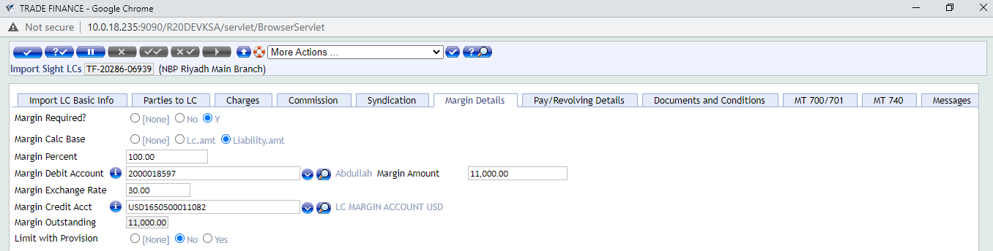

Requirement WS04-01-01.02 Internal LCs
Currently in NBP-KSA we have the functionality of Foreign LCs and Local LCs bifurcation. Foreign LCs for foreign currency LC transactions and Local LCs for LC transactions in SAR currency. If swift message is not required to be sent in an Internal LC transaction then in the “Messages” tab in field “SEND.MESSAGE” select the option “No” in the drop-down field in order for the swift message not to be sent/transmitted.
The illustration of this activity is shown in the screen shots below for reference. Also, there is a separate report available in the NBP-KSA environment as well for Local LCs. This functionality will be designed by copying the existing NBPKSA product for Trade Bank of Iraq.

Workflows
End user will have to select “No” in “SEND.MESSAGE” drop-down field which is present in the “Messages” tab of the Import LC issuance transaction in order for the swift message not to be generated. Below is the screen shot of import LC issuance screens.
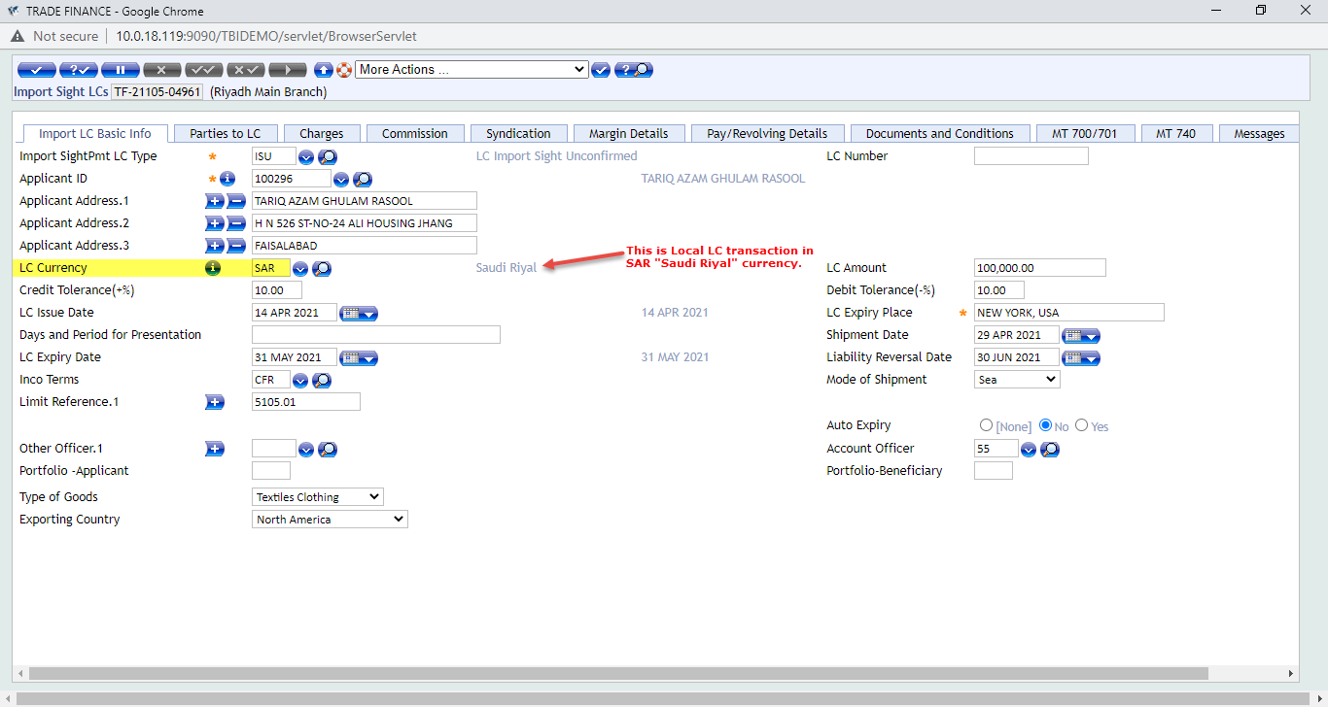
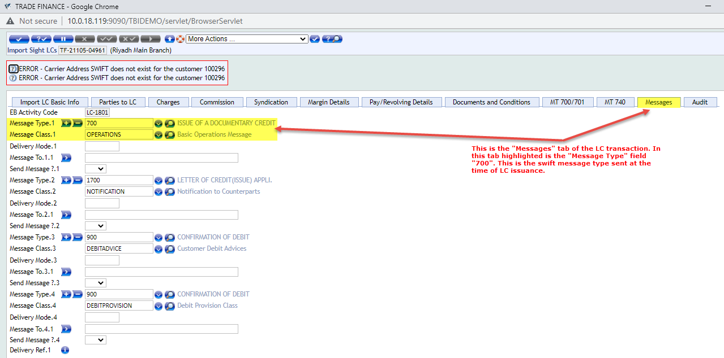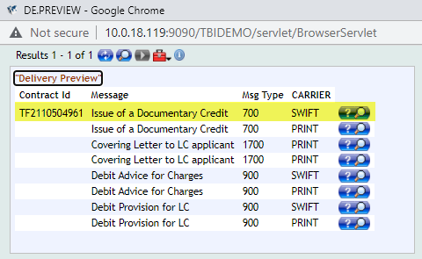
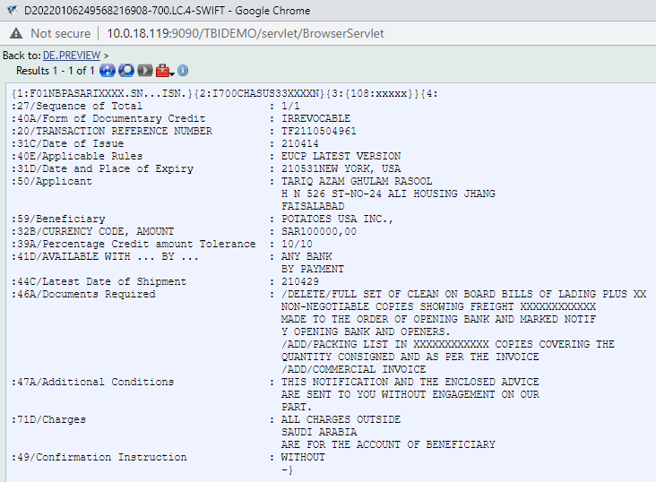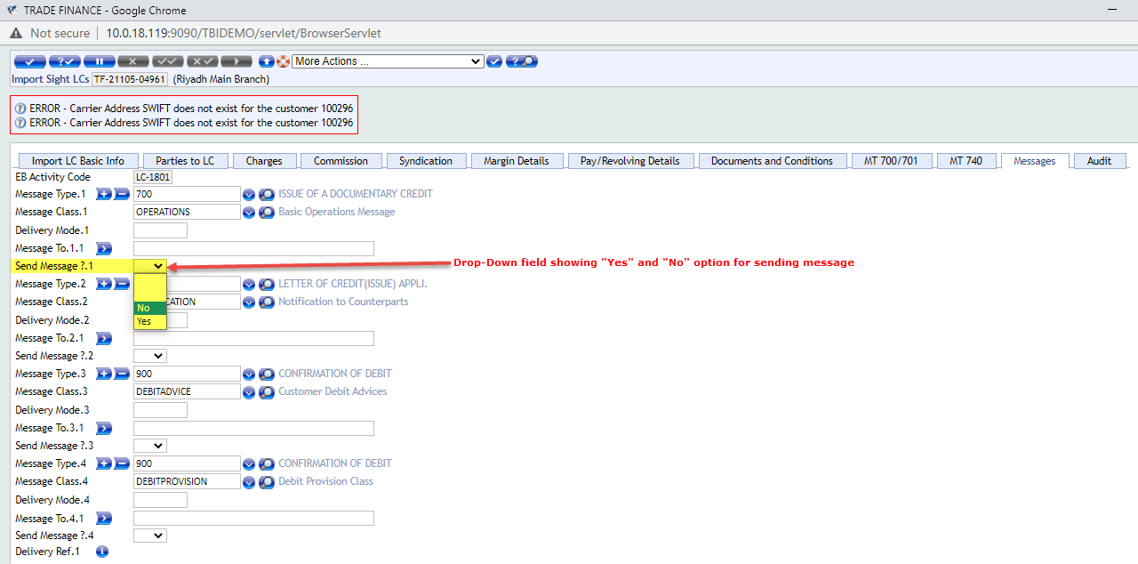
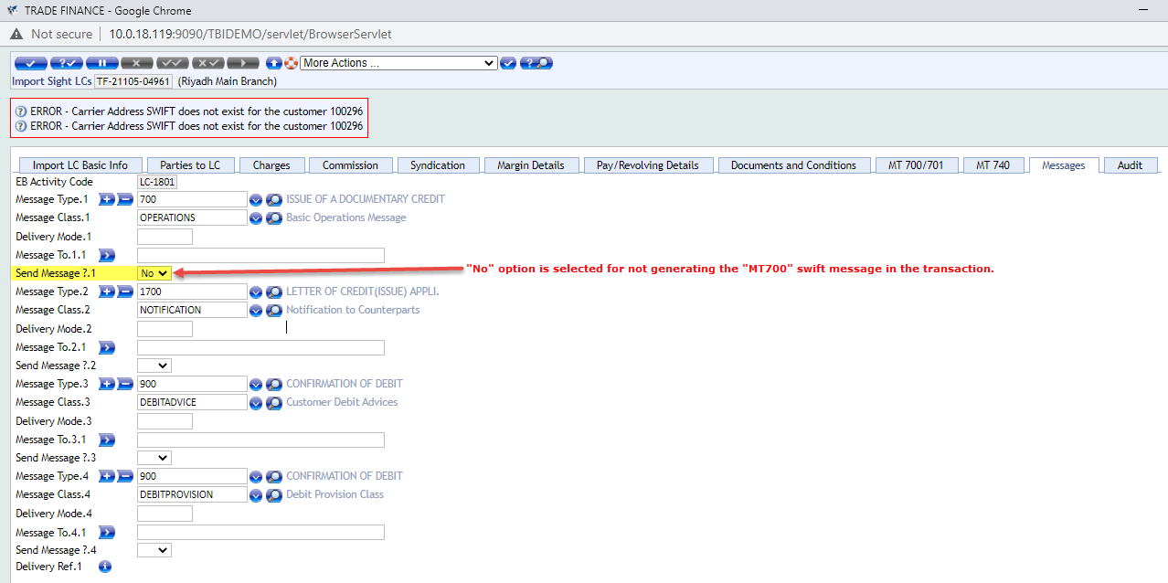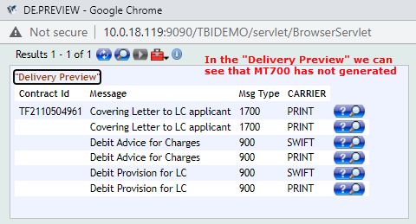

Requirement WS04-01-01.03 Separate Report For Internal LCs
Currently in NBP-KSA environment there is a separate report available for Local LCs. These reports in T24 terminology are called enquiries.

Workflows
Currently the local LC report is available in the “Trade Finance Menu” in NBP-KSA. Below is the screen shot of the enquiry.
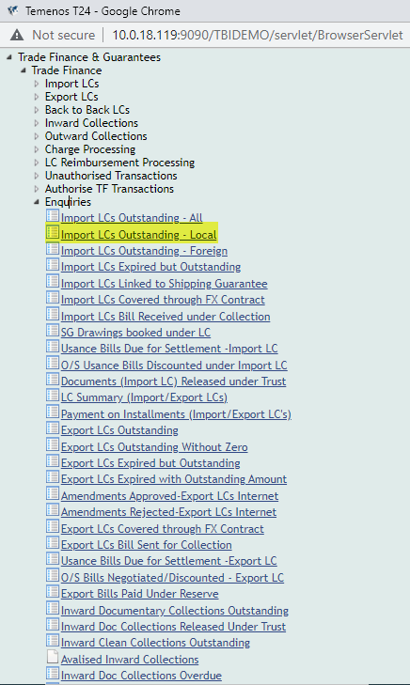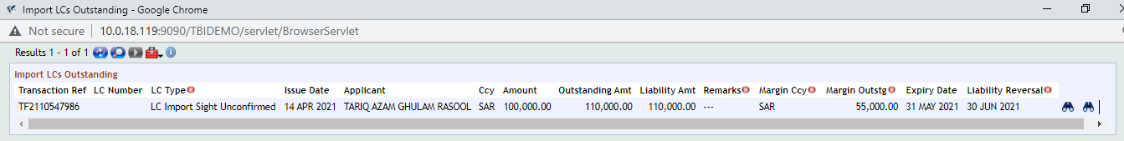

Requirement WS04-01-01.04 Local Fields Import/Export LC
There is a requirement of local fields for “Beneficiary Country” “Applicant Country”, “Principal Country”, “Country of Origin” and H.S. Code at Import and Export LC Issuance transaction steps. The local fields can be incorporated accordingly and will be made available for the end user on the Import/Export Basic Info screen tab which is the first screen for both transaction types. The purpose of these fields as per the requirement is that it is supposed to be used for reporting purpose as well as for sanction screening purpose as well.

Workflows
The illustration of these fields is made below for reference.
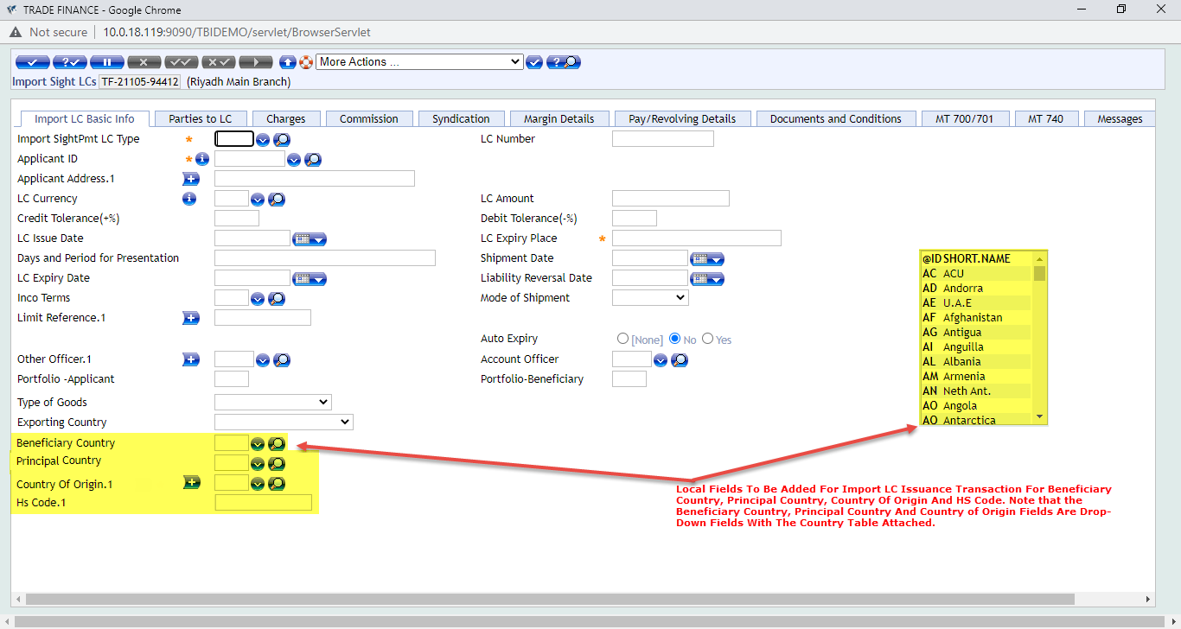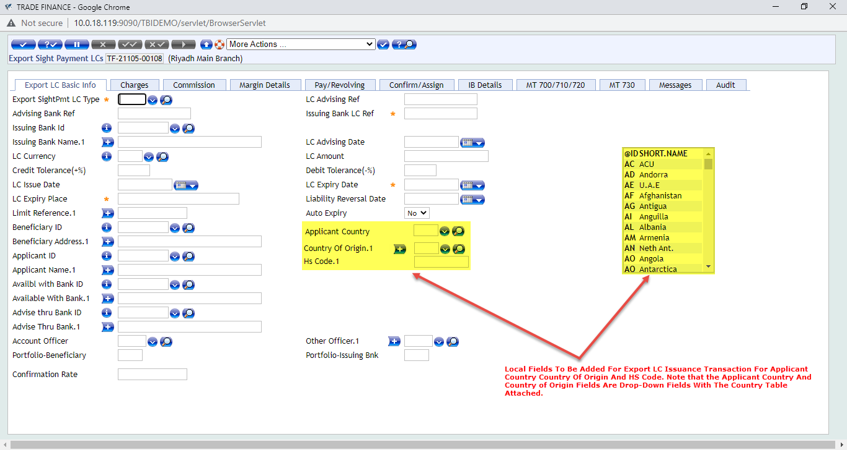

Requirement WS04-01-01.05 Local Fields For Import/Export Docs
Bank requires local fields for shipping documents presented under LC as well as under Collections for both Imports and Exports. The purpose of these fields as per the requirement is for sanction screening so parties to the selected fields can be captured in the transaction and if any of these parties is part of the sanction lit than they can be identified and transaction can be handled accordingly in order to avoid regulatory or global penalties with regards to the international sanctions compliance.
The screen shots of the transaction screens with these fields is attached below for reference.

Workflows
The screen shots with the added fields are attached below for reference.
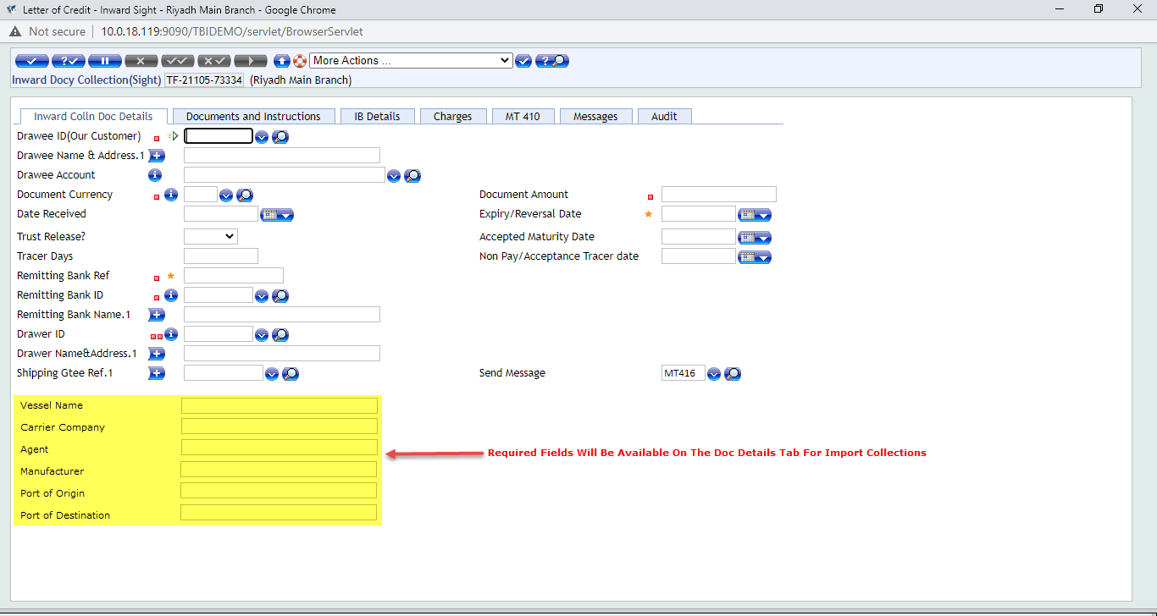
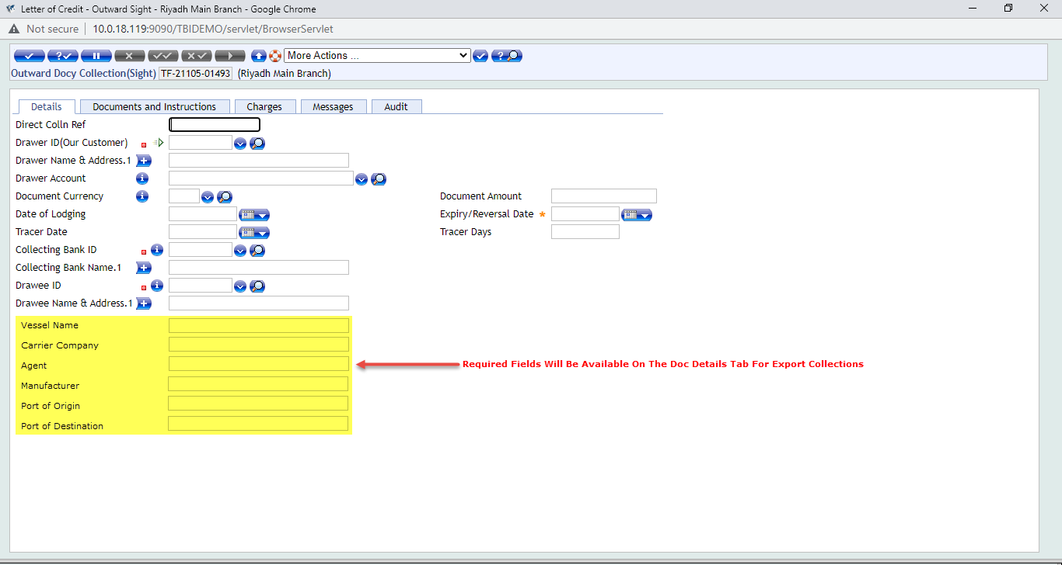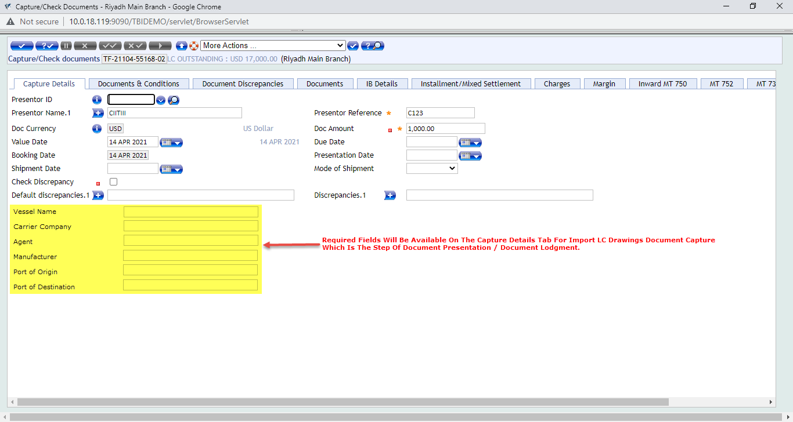
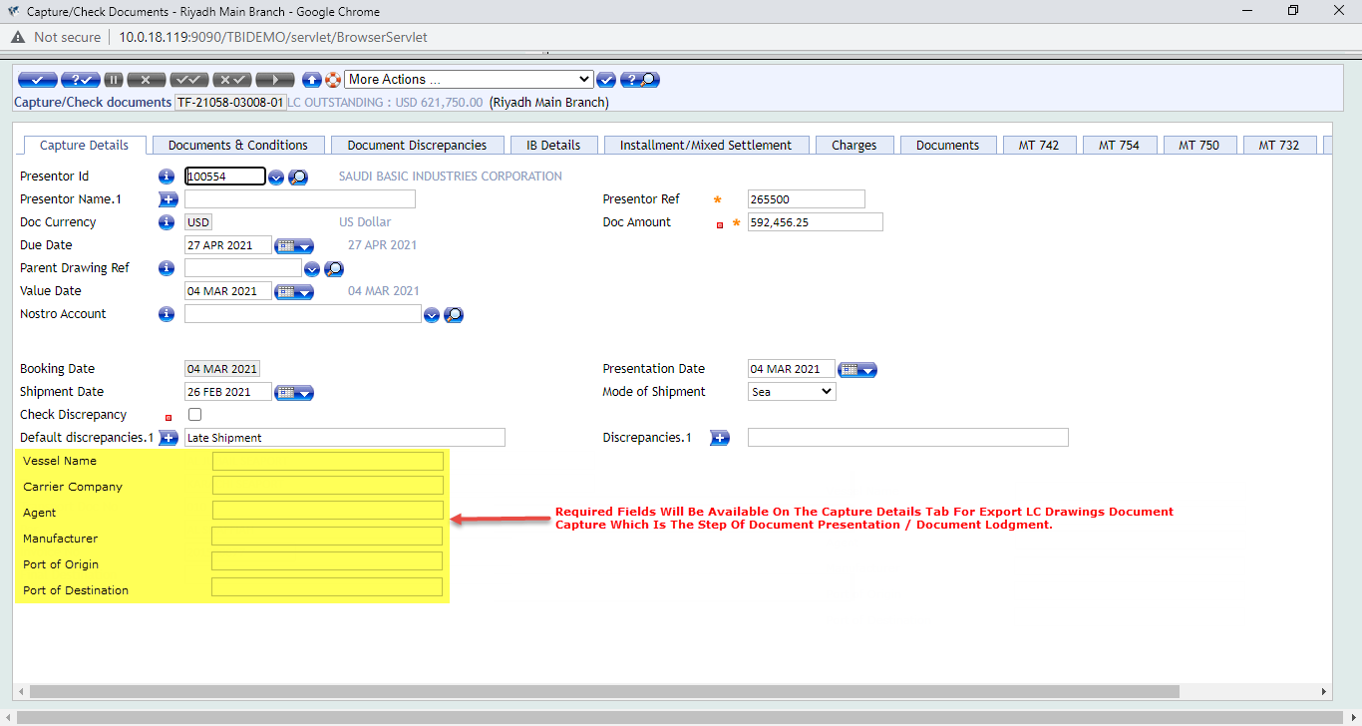

Requirement WS04-01-01.06 Local Fields For Import/Export Docs Payment
Bank requires local fields for payment step under LC as well as under Collections for both Imports and Exports. The purpose of these fields as per the requirement is for sanction screening so parties to the selected fields can be captured in the transaction and if any of these parties is part of the sanction lit than they can be identified and transaction can be handled accordingly in order to avoid regulatory or global penalties with regards to the international sanctions compliance.
The screen shots of the transaction screens with these fields is attached below for reference.

Workflows
The screen shots with the added fields are attached below for reference.
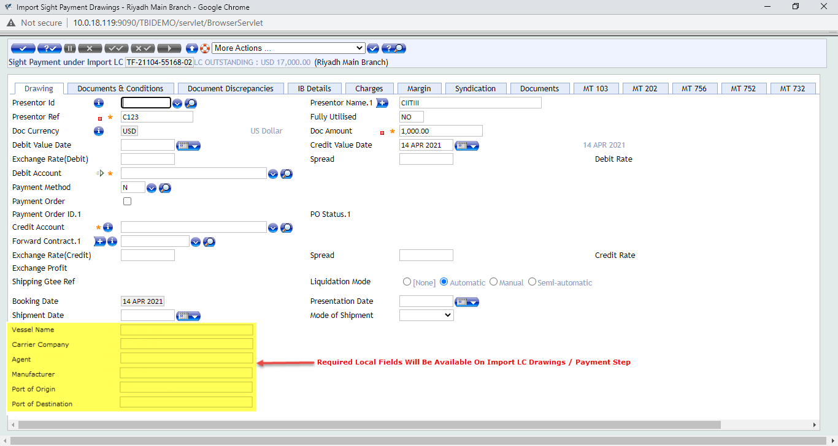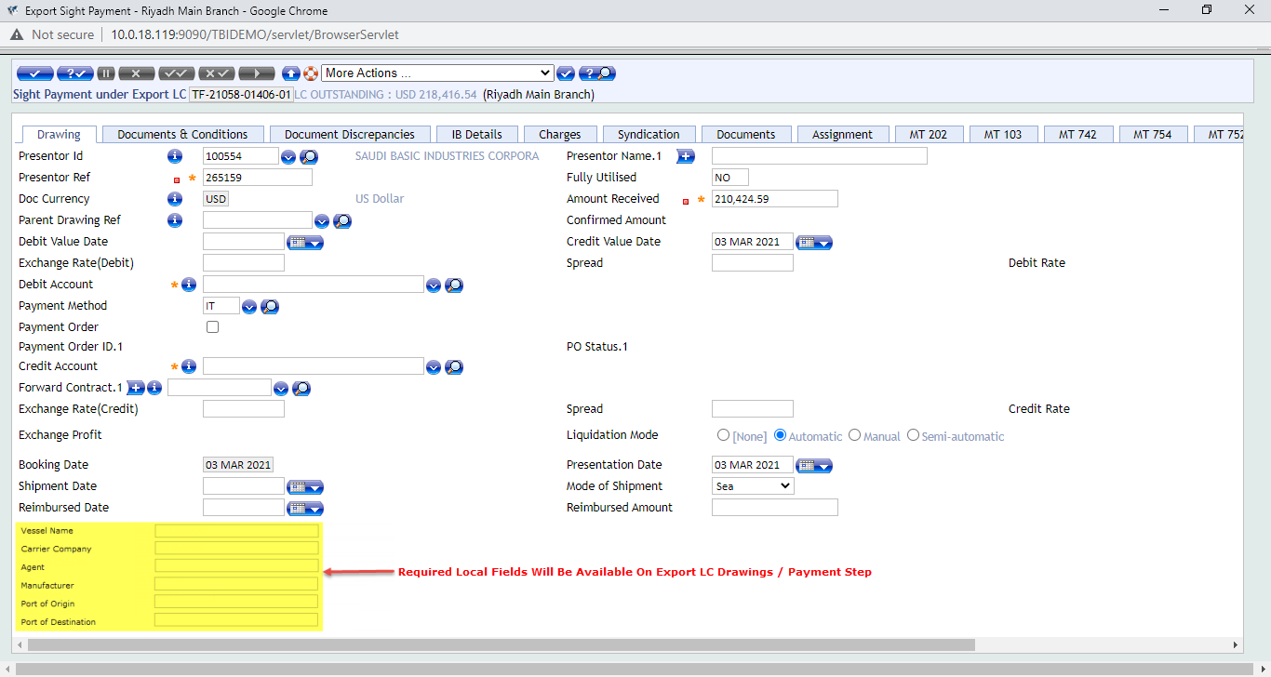
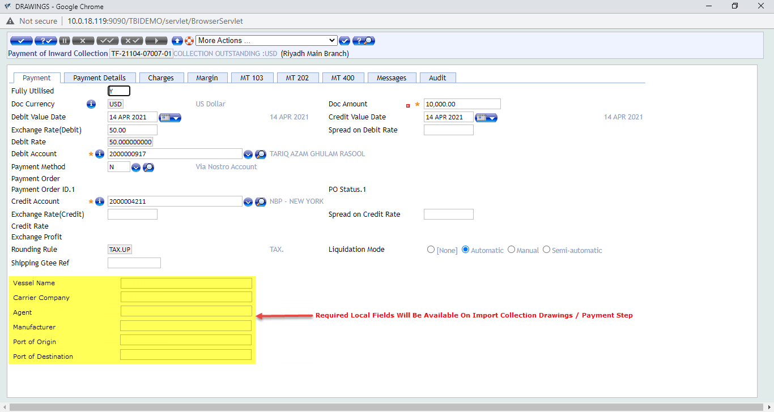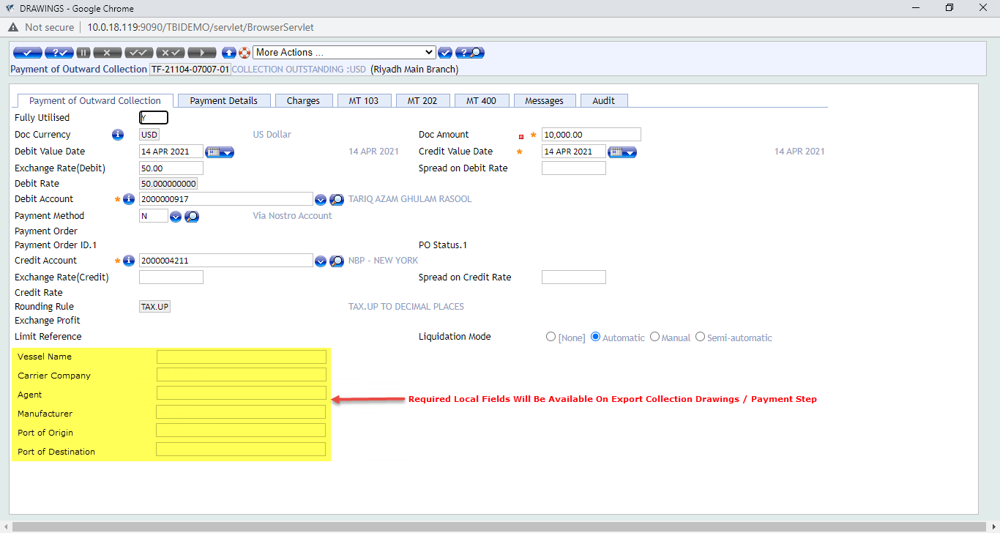

Requirement WS04-01-01.07 Swift Messages and Advices Enquiry
There is a requirement for enquiry for transaction-wise swift message both inward and outward as well as advices to be generated through T24. The requirement is that the end user inputs the transaction reference number and all messages and advices related to that transaction reference will be displayed.

Workflows
At present in we have separate inquiries for inward and outward messages/advices. These enquiries are part of the delivery module in T24. The delivery module to extract advices and swift messages at transaction level. After the transaction is authorized these messages and advices can be viewed as well. For outward messages the repository in T24 is by the “DE.O.HEADER” and for viewing inward messages we have the repository by the name of “DE.I.HEADER”.
INCOMING MESSAGE HEADERS: DE.I.HEADER
OVERVIEW OF OUTGOING MESSAGE HEADERS: DE.O.HEADER
Inward Messages / Advices Enquiry Name: %DE.I.HEADER
Outward Messages / Advices Enquiry Name: %DE.O.HEADER
Screen shots of the process are available for your reference:
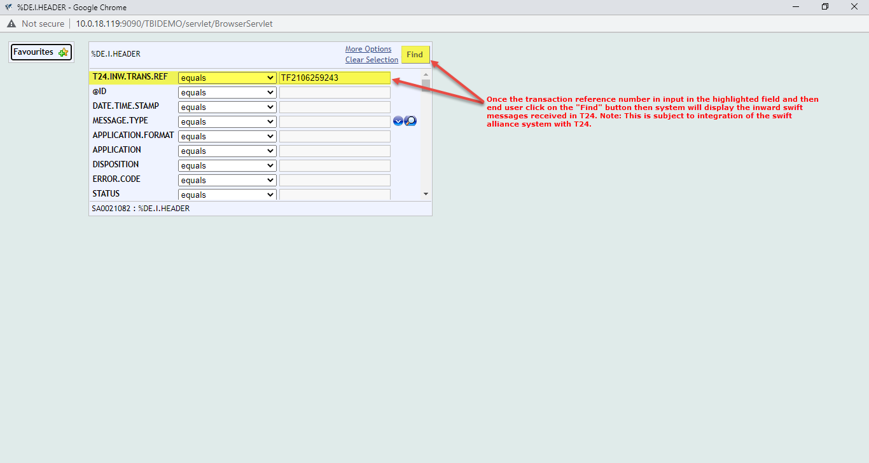
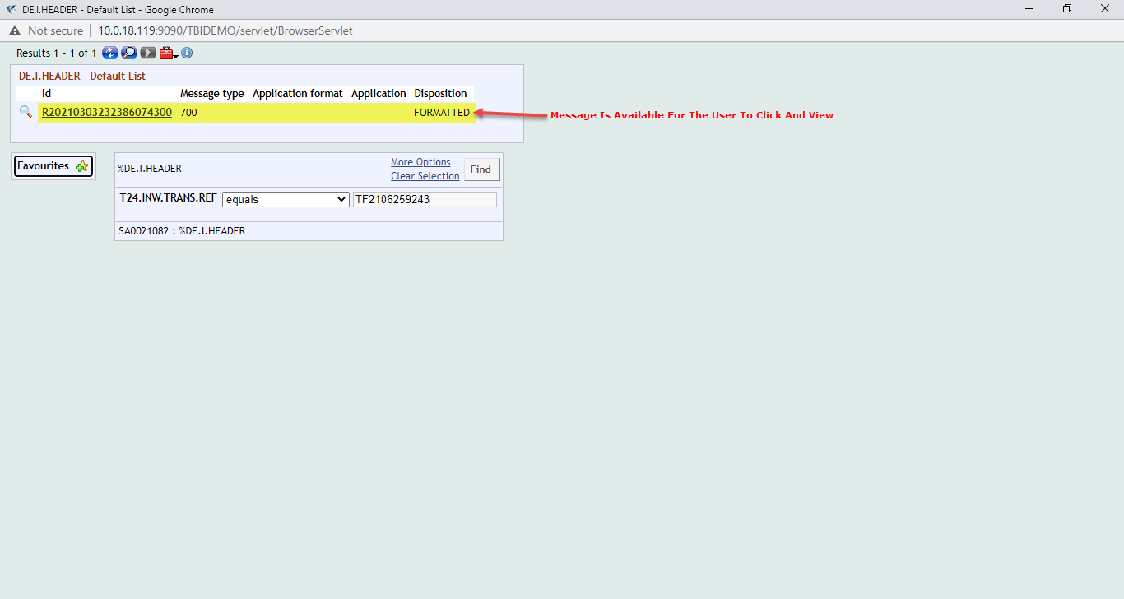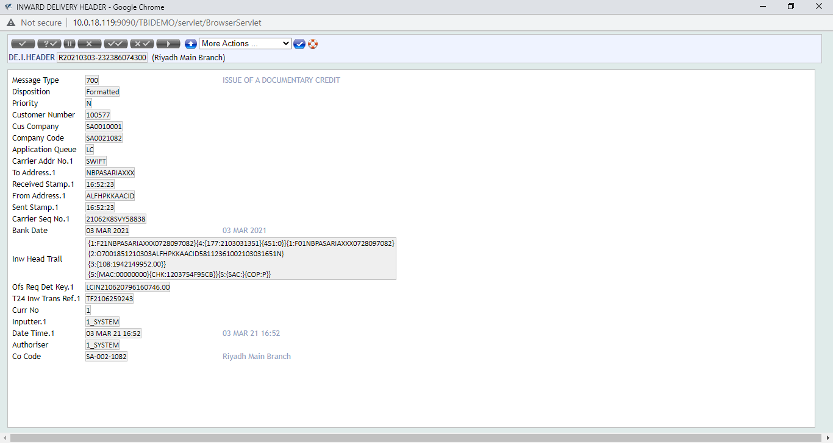
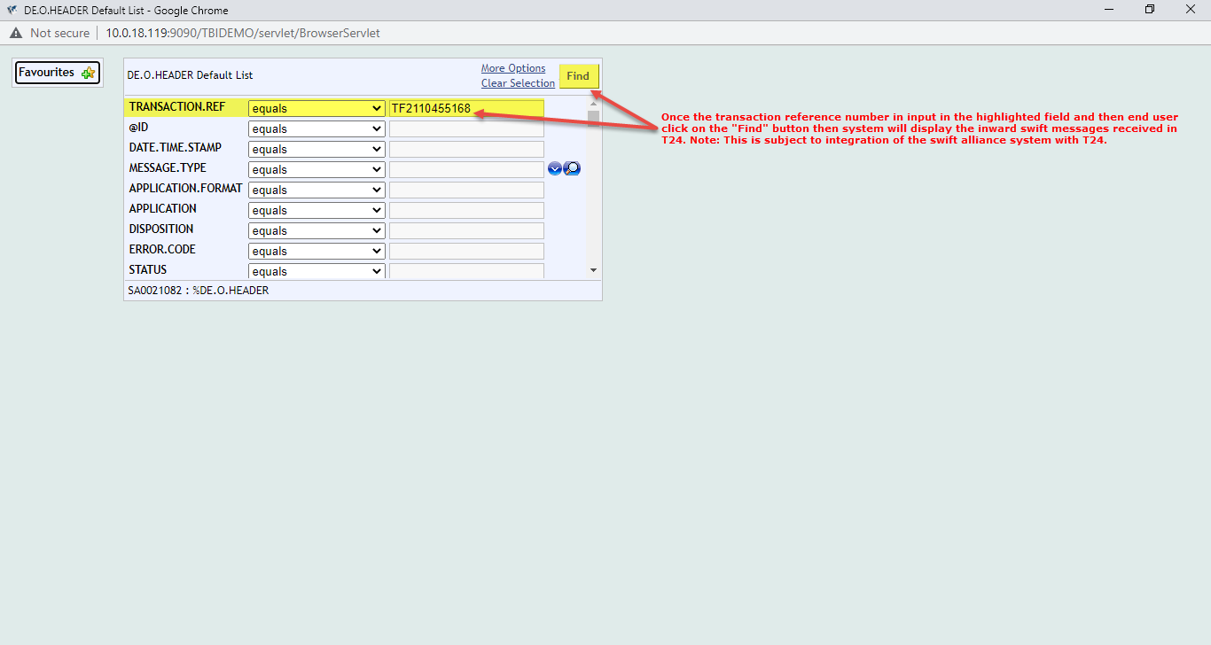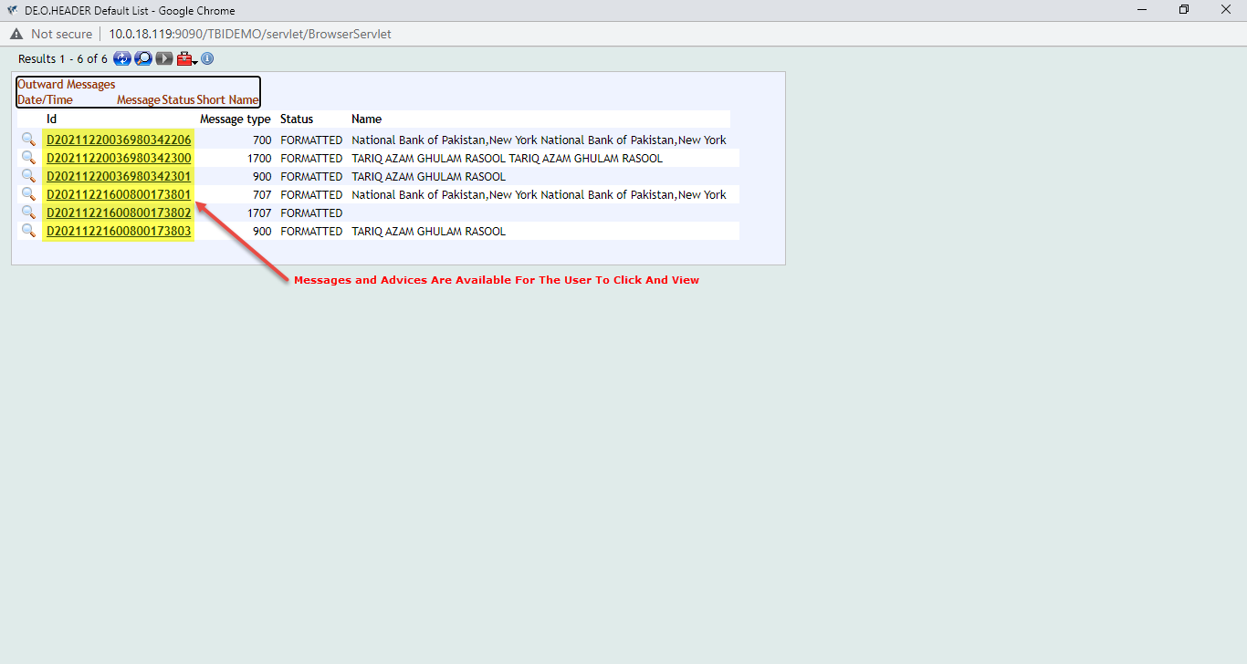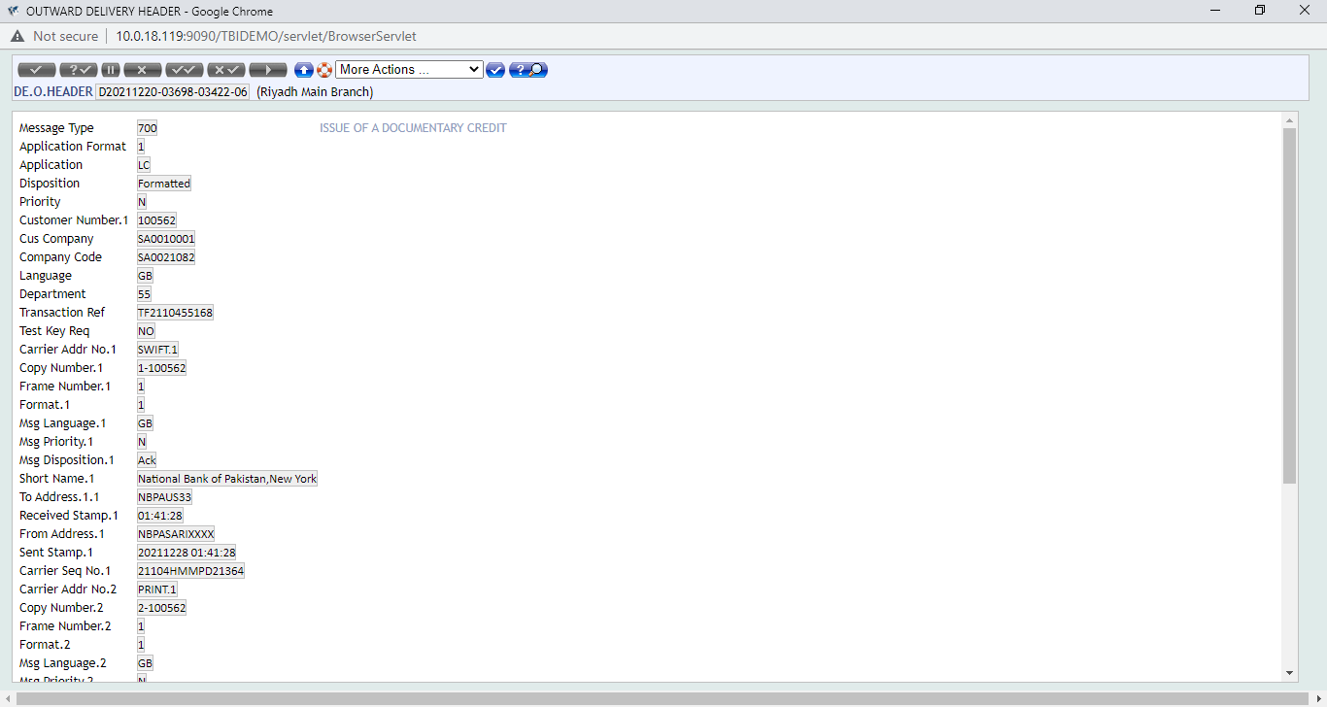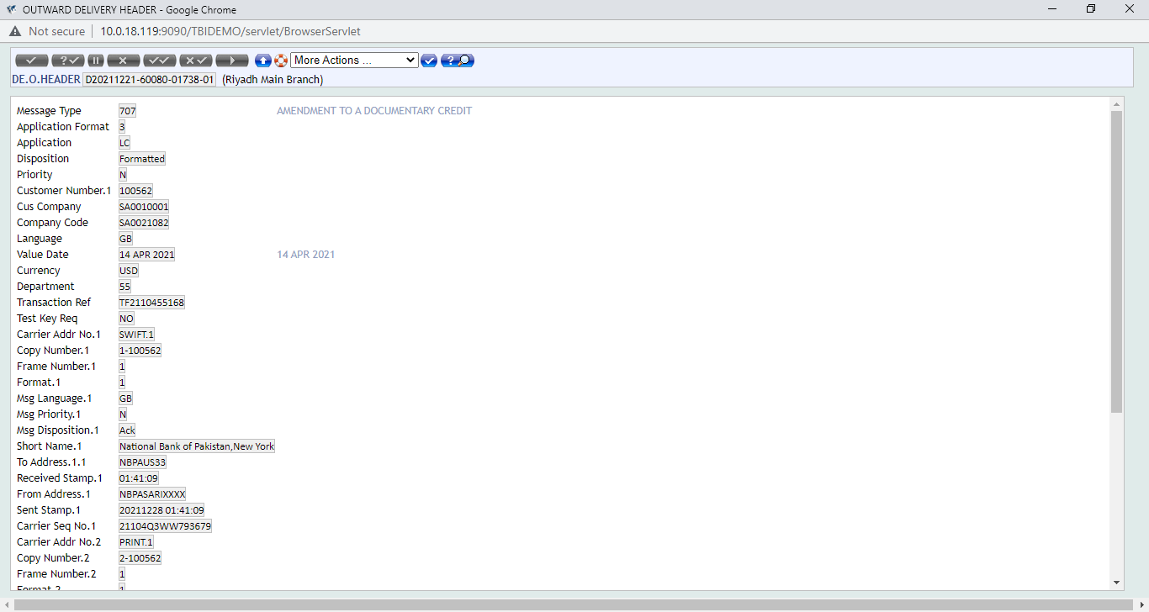

Requirement WS04-01-01.08 Waive Charges Option to Be Removed
Bank requires that for all LC and DRAWINGS related transaction steps and for all maintenance and miscellaneous steps where charges tab is available. The “CHARGE.STATUS” field should not be having the option of charge status “15” for “Waived” charges.
We can achieve this by setting the “WAIVE.CHARGES” field as “No” and then making the same configurational setup at version level where the field “WAIVE.CHARGES” can be marked as an “AUTOM” Field and well as a “NOINPUT” field with field value set and fixed as “NO”.
VERSION: All versions applicable to charges

Workflows
The screen shots of the transaction level setup is attached below for reference.
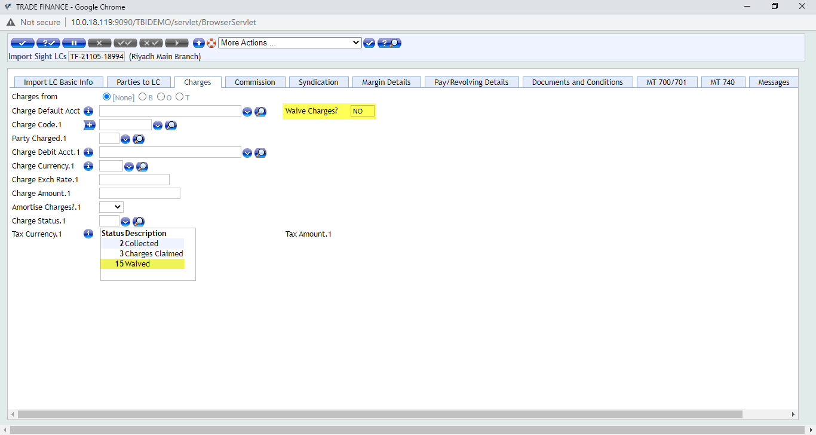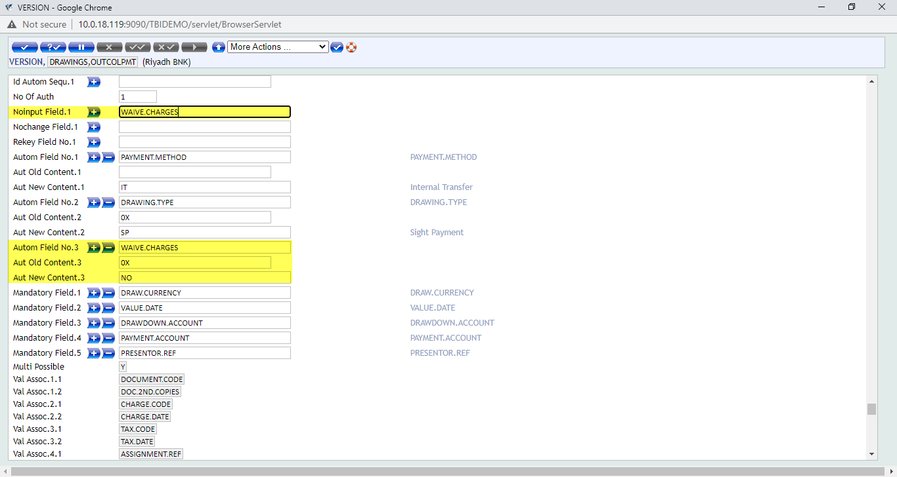

Requirement WS04-01-01.09 H.S Code Field in Enquiry
There is a requirement that the H.S. Code field is required in the Import/Export LC Outstanding report. This can be handled through the enquiry setup. The local field of the H.S. Code can be mapped in the relevant enquiry and it will display once the enquiry is generated.
ENQUIRY NAME 1: TF.IMPLCOS
ENQUIRY NAME 2: NBPKSA.TF.EXPLCOS
ENQUIRY NAME 3: NBPKSA.TF.LIVE.LOCAL.OUT
ENQUIRY NAME 4: NBPKSA.TF.EXPLCOS

Workflows
Screen shots of the enquiry with the H.S Code field attached below for reference. Please note that this is simulated version of a proposed solution and this is it supposed to appear on the T24 screen.
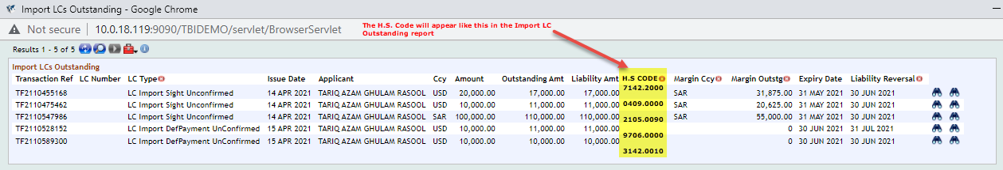

Requirement WS04-01-01.10 Margin Functionality for Reimbursement Processing
There is a requirement for margin functionality in “LC Reimbursement Processing”. As per the business requirement stated by TBI that margin is required to be taken for in certain conditions with regards to confirmation of LCs and if there is no RMA with the counter-party bank then TBI taken 100 percent cash margin in order to cover the risk of non-payment.
T24 supports Letter of Credit - Reimbursement process in the LC cycle. Normally, the nominated bank (Claiming Bank) to whom the Beneficiary presents the documents, would not hold a direct account relationship in the LC currency with the Issuing bank.
For the above reason the Issuing bank would assign a Reimbursement bank with whom he has an account relationship. The Reimbursing bank would normally be in the country of LC currency. The Claiming bank could claim the LC amount from the Reimbursing bank through a reimbursement claim by MT742.
The Issuing bank would have already provided a reimbursement authority through swift MT740 to the Reimbursing bank which would specify their authorisation to debit Issuing bank's account with Reimbursing bank for a specific amount under a specified Documentary Credit Number. This authority would be stored under the records by the Reimbursement bank.
Once the Claiming bank claims the LC amount through MT742, the Reimbursing bank matches the claim with the reimbursement authority it holds, if the conditions of authority are satisfied, it debits the account of Issuing bank with it and honours the claim of claiming bank.
End user can Input Reimbursement Authority received or amend and modify the same. In the same way he can Register or Pay a reimbursement claim and also modify the same.
T24 supports recording of Reimbursement authorization received from the Issuing bank by swift MT740. It consists of details such as Documentary credit number, Currency, Amount, Available by and the party responsible for charges. Model bank also supports to modify the Reimbursement authority.
In order to record and modify the Reimbursement authorization, the user needs to initiate the transaction from the "Trade Finance Officer" Home Page. Click the "Home" icon on the Left Bottom Corner of this Home Page and a new tabbed window will be available on the right side from where the user needs to choose the following option, Transaction>Reimbursement Processing>Input authority.
Click on the New Task icon to input new authority. The user has to input mandatory details and other details of Reimbursement Authority based on MT 740 received. After inputting the details, the user has to validate transaction and preview delivery messages related to this transaction.
On satisfying with input, the user has to commit the transaction to make it available to Trade Finance Supervisor for verification and Authorization.
If supervisor suggests any changes/correction due to error in data input, the user has to recall the transaction from this enquiry and do necessary changes.

Workflows
Screen shots are attached below for reference. Please note that this is simulated version of a proposed solution and this is it supposed to appear on the T24 screen.
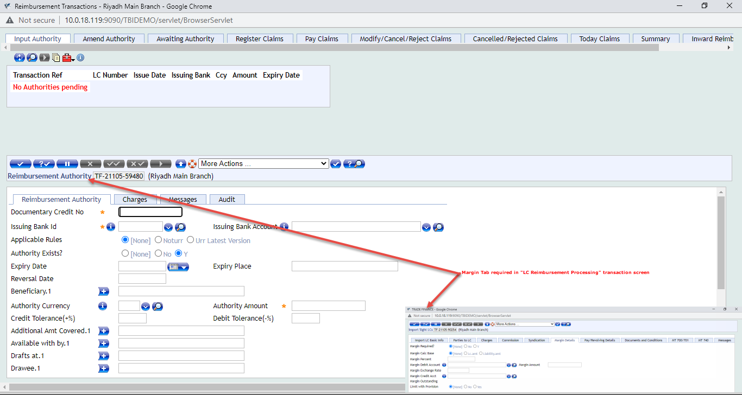

Requirement WS04-01-01.11 Fields To Be Mapped In LC Charge Details Enquiry
The LC Charge Details report is available in T24 as per core functionality. This report gives the details of the flat and percentage based charges that are part of a particular LC or DRAWINGS applications related transaction. This includes all Import and Export LC as well Collection transaction steps where charges are deducted or amortized as part of the transaction.
Bank Requires Under LC Charge Details Report Fields To Be Added:
CHRG.STATUS
DATE.RECEIVED

Workflows
The “View Charge Details” enquiry is part of the core functionality which shows the charges deducted or claimed for a particular transaction. The status field in the enquiry shows the activity performed against a particular charge as part of a transaction. For example, if charge is collected up-front from the customer at transaction level with “Charge.Status” as 2 meaning “Collected”. Then the enquiry will show in the status field as “Collected”. If payment is done through Drawings module for the LC transaction and charges are deducted. Then status field will show “Deducted from Payment”. If charges are claimed using charge status “3” then the report will show in status field “Charges Claimed”. Screen shots are attached below for reference. Please note that this is simulated version of a proposed solution and this is it supposed to appear on the T24 screen.
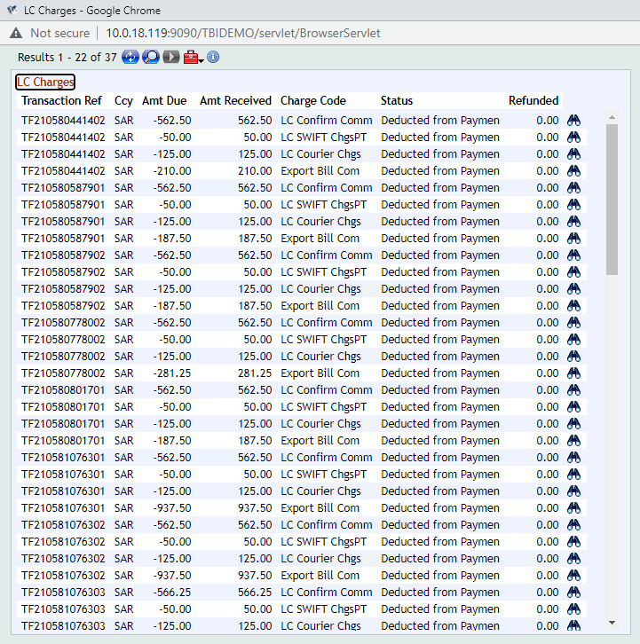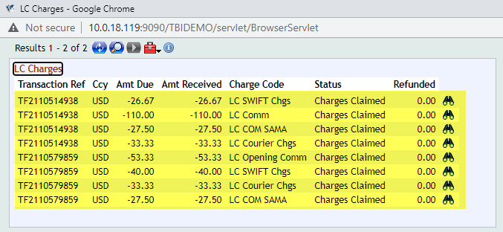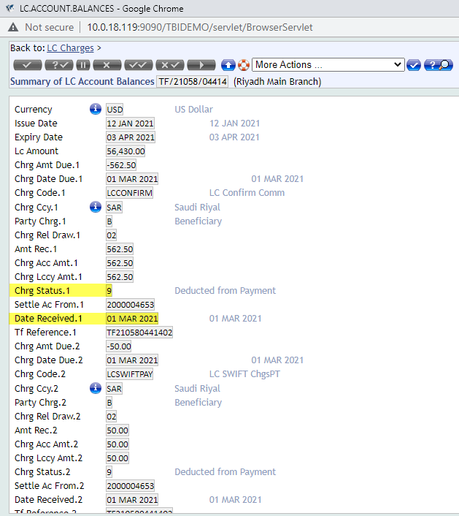

Requirement WS04-01-01.12 LC Expiry Date Field Required On Export LC Drawings Document Capture Step
The export LC drawings record by core functionality is generated in the “Document Capture” (DC) step of the transaction after the advising of the export LC has been executed in the system. This step is done under the DRAWINGS module. The export covering schedule includes the details of the shipping documents that are being sent to the applicant bank along with the instructions of handling these documents which are in line with the LC terms as well as the international governing rules for LCs which is the UCP 600.
Under Export Lodgement schedule; Expiry Date Field to be added.

Workflows
Screen shots are attached below for reference. Please note that this is simulated version of a proposed solution and this is it supposed to appear on the T24 screen.
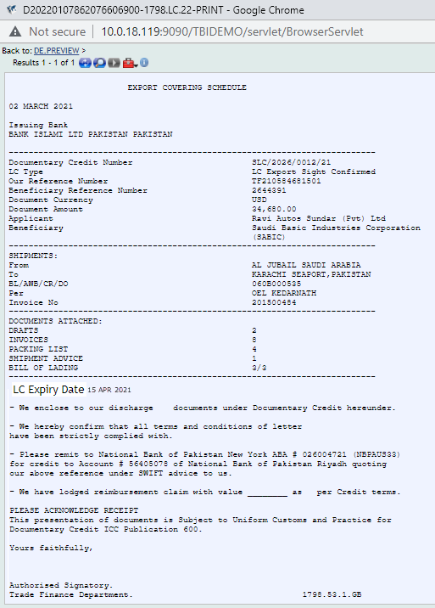
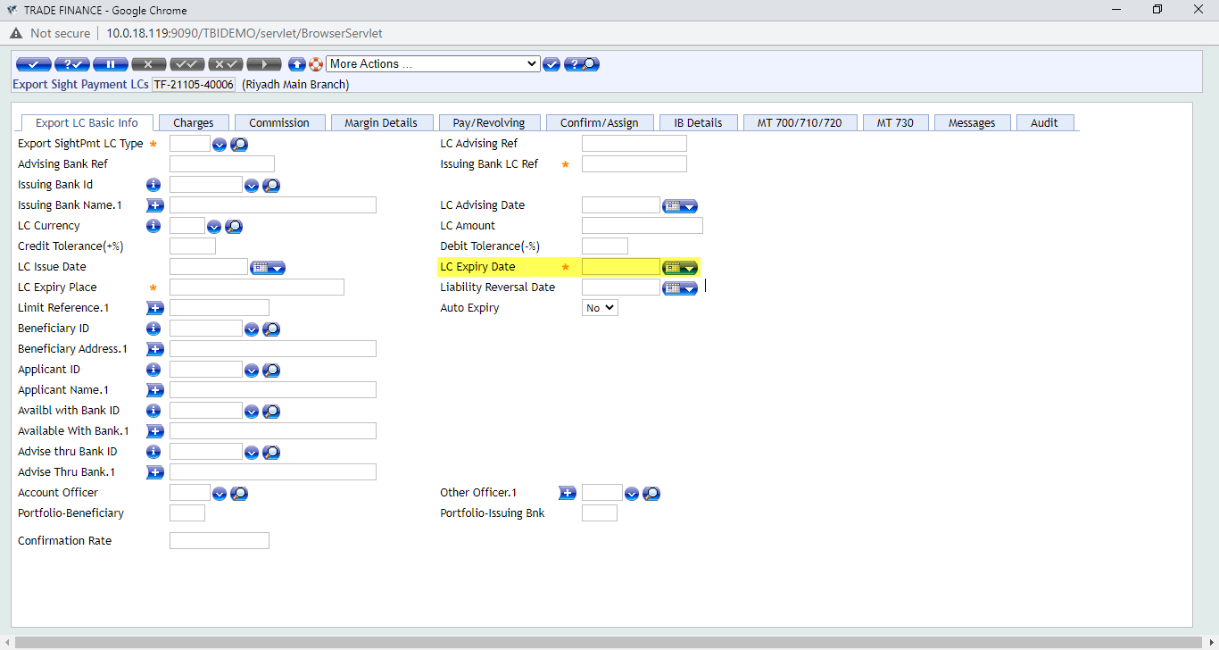

Requirement WS04-01-01.13 Tracer feature for Export LC Docs
T24 supports sending of Tracers for an unpaid Outward Collection online and if necessary set the frequency for auto generation of tracers. In order to do Tracer for Inward collection, the user needs to initiate the transaction from the "Trade Finance Officer" Home Page. Click the "Transaction" icon on the Left Bottom Corner of this Home Page and a new window will be opened where the user needs to select values from the dropdown for the following fields.
After selecting the values in dropdown and entering the transaction reference in the field "Instrument Ref", the user has to validate and commit the transaction. On committing the transaction, new screen will be opened to input Tracer details. The user has to input mandatory values and the other details. After inputting the details, the user has to validate transaction and preview delivery messages related to this transaction. Once satisfied with the delivery preview and details, the user needs to commit the transaction to make the transaction available to "Trade Finance Supervisor" to authorize the transaction.
Sample screen shot of Tracer for outward collection is shown below.
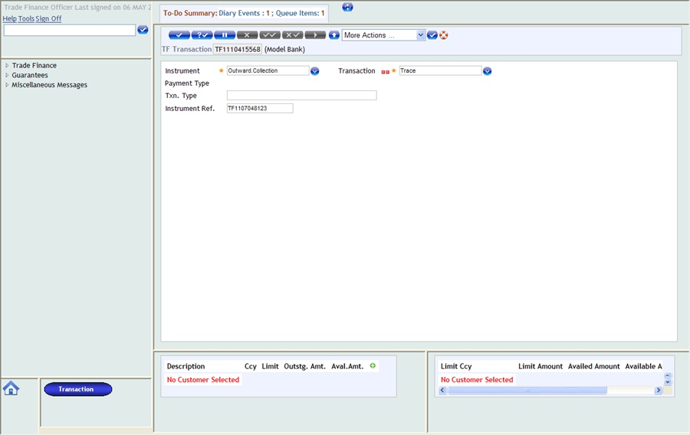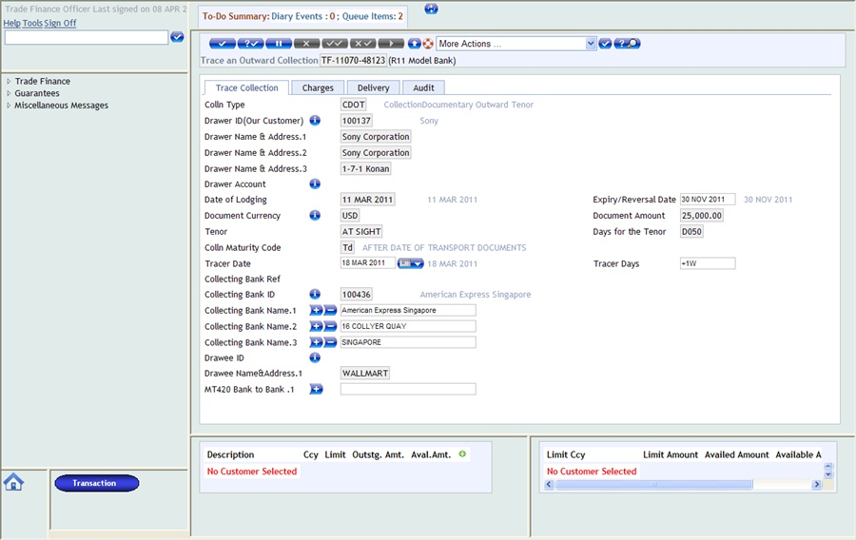
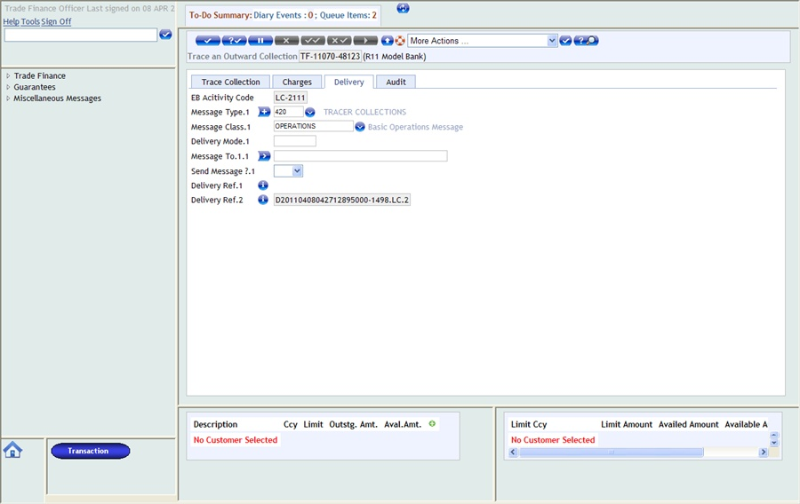

Workflows
Tracing operations are available in both the LETTER.OF.CREDIT and DRAWINGS applications. By inputting an appropriate date greater than the Bank date, the automatic generation of Tracers during the Close of Business operation is enabled. The fields are TRACER.DATE in LC and TRACE.DATE in the DRAWINGS application. As soon as a tracer is generated the next date for tracer generation is automatically decided by the EB.FREE.PARAMETERS or COUNTRY file input. At any time during the life cycle, changing the status to "STOP" in EB.FREE.MESSAGE can stop the scheduled tracer.
Alternately, removing the Tracer Date in the application can stop any scheduled tracer.
EB.FREE.PARAMETERS has a Company code as the Id. Setting up of this becomes mandatory if Tracers are to be scheduled. A set of Model routines are also released. This application is used for tracer mechanism which takes place by triggering a tracer routine. The tracer routine uses any valid EB.ACTIVITY.
The TRACE.DATE field is applicable only to documentary collections and indicate the date the collection should be chased. Accepts Standard date format. Holds the Scheduled date on which a Tracer message has to be sent. If the date is some future date, then an EB.FREE.MESSAGE record is produced on authorization of the DRAWING which holds the Tracer message and relevant details of the particular transaction with the scheduled date on which it has to be sent. If the date is TODAY then the Tracer message is sent during End of Day.
Validation Rules:
Mandatory when Draw Type is 'CO'
Will get cycled only if EB.FREE.PARAMETERS is set up.
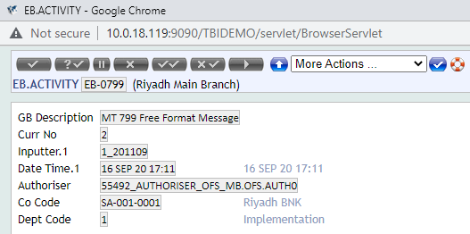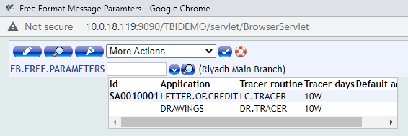
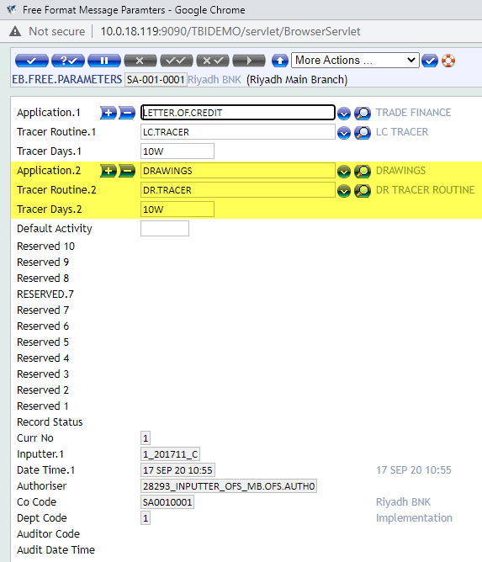
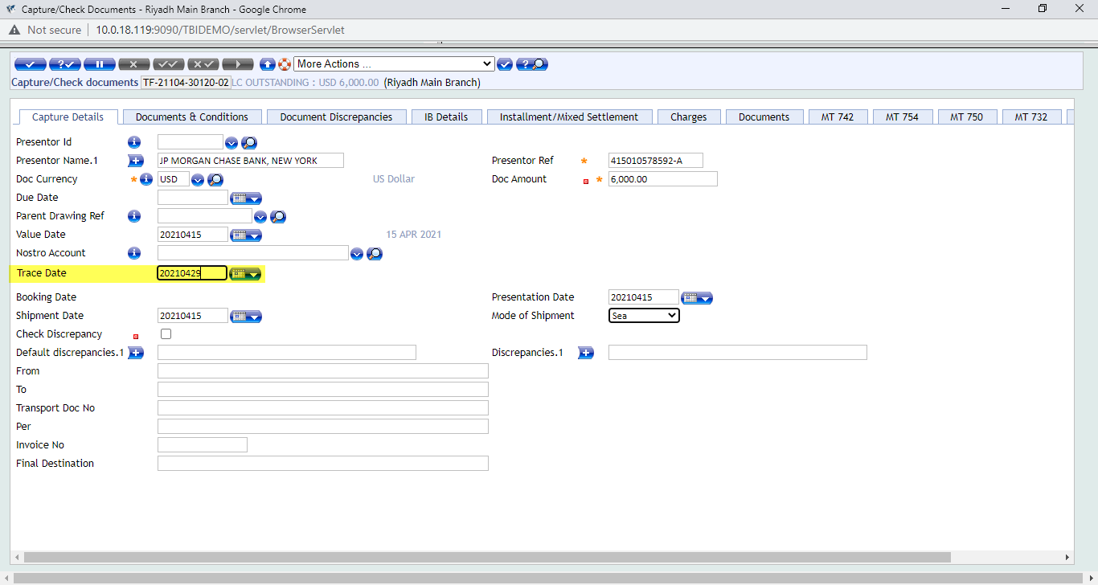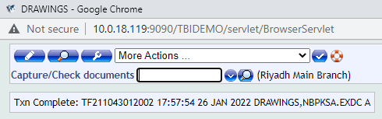
Once the DRAWINGS record is authorized user is to go to the EB.FREE.MESSAGE table to setup the tracer functionality for the particular transaction. The “DRAWINGS” record will be automatically appearing in the drop-down field of the table.
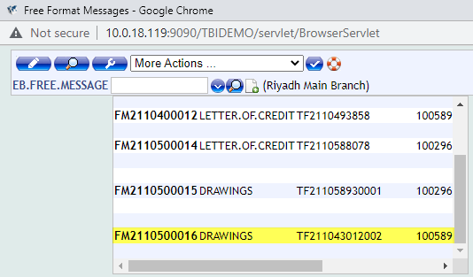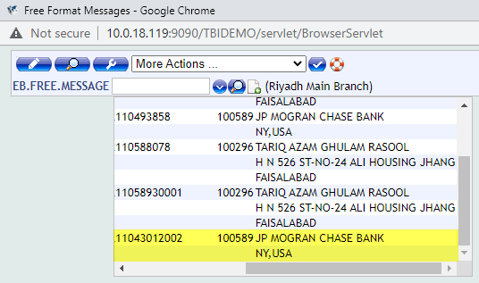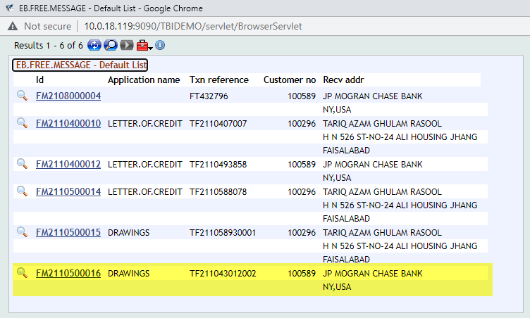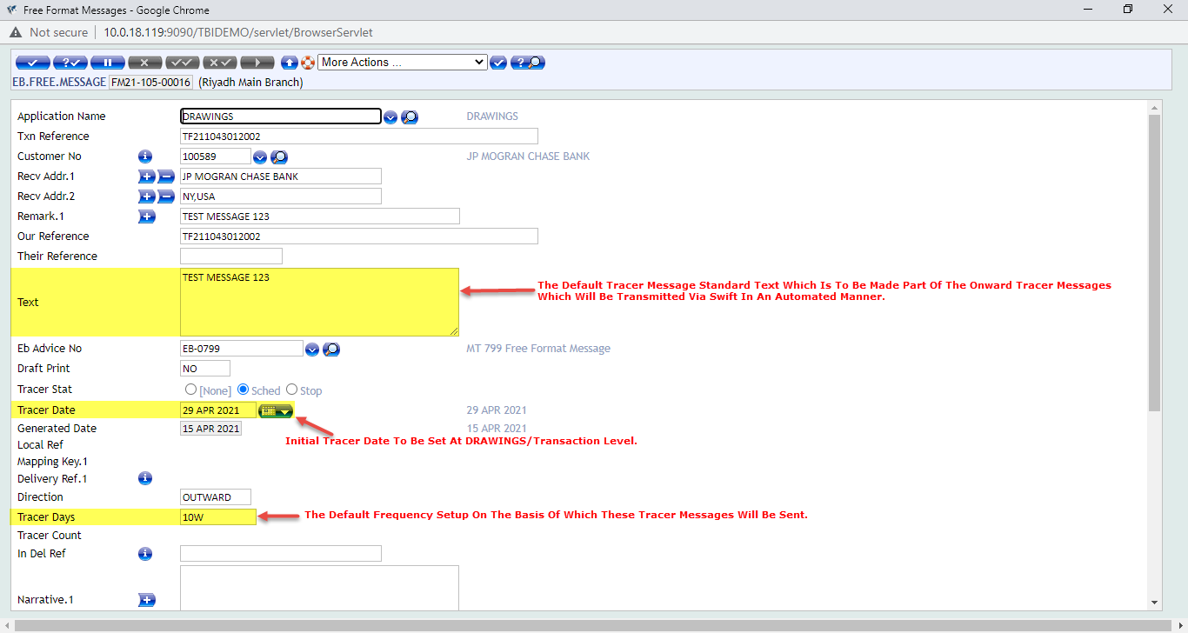

Use Cases

Use Case
Variations | Expected Results
Margin A/C for Import L/C Issuance | The margin are not customer-wise but are categorized transaction type wise for example there only two category of margin accounts which are available that is Margin on LCs and Margin on Guarantees and these margin accounts are pool accounts which are setup currency wise for different currencies. The margin break-down can be seen transaction wise in the LC outstanding and guarantees issued outstanding reports.

Use Case
Variations | Expected Results
Internal LCs | Separate LC Types By The Name Of Local LCs Are Ready Available In The System.

Use Case
Variations | Expected Results
Separate Report For Internal LCs | Separate Local LCs Outstanding Report Already Available In The System.

Use Case
Variations | Expected Results
Local Fields Import/Export LC | Under Import and Export LC as well as the amendment steps field local fields to be added to the transaction screen for “Country of Origin” and “H.S. Code”. This is required for information purpose as well as for sanction screening.

Use Case
Variations | Expected Results
Local Fields For Import/Export Docs | Under Import/Export Document Capture As Well As Inward And Outward Collection:  Local Fields to be added:  VESSEL NAME (Text Field)  CARRIER COMPANY Field (Text Field)  AGENT (Text Field)  MANUFACTURER (Text Field)  Port Of Origin (Text Field)  Port Of Destination (Text Field)

Use Case
Variations | Expected Results
Local Fields For Import/Export Docs Payment | Under Import/Export Payment As Well As Inward And Outward Collection Payment Step:  Local Fields to be added:  VESSEL NAME (Text Field)  CARRIER COMPANY Field (Text Field)  AGENT (Text Field)  MANUFACTURER (Text Field)  Port Of Origin (Text Field)  Port Of Destination (Text Field)

Use Case
Variations | Expected Results
Swift Messages and Advices Enquiry | Enquiry For All Swift/Advices Messages for both;  Inward And Outward For Particular Transactions.

Use Case
Variations | Expected Results
Waive Charges Option To Be Removed | Version level setup using Waive.Charges field by setting it to “Autom” and “No-Input”.

Use Case
Variations | Expected Results
H.S Code Field in Enquiry | Under Import And Export LC Outstanding Reports Field To Be Added:  H.S. Code/Goods Code

Use Case
Variations | Expected Results
Margin Functionality for Reimbursement Processing | Reimbursement Processing:  Margin Functionality To Be Added In Reimbursement Processing Screens  Separate New Report Required For Reimbursment:  Field To Be Added:  Available With  Margin Currency  Margin Amount

Use Case
Variations | Expected Results
Fields To Be Mapped In LC Charge Details Enquiry | Under LC Charge Details Report Fields To Be Added:  CHRG.STATUS  DATE.RECEIVED

Use Case
Variations | Expected Results
LC Expiry Date Field Required On Export LC Drawings Document Capture Step | Under Export Lodgement schedule;  Expiry Date Field to be added

Use Case
Variations | Expected Results
Tracer Messages Functionality For Export LC Document Presentation | Configurational Setup Can Be Made Using The Field TRACE.DATE at DRAWINGS level. As well as parameterization through EB.FREE.PARAMETER table and transaction level tracer setup through EB.FREE.MESSAGE table.

Assumptions
1 - User has internet connection
2 - User has Browser & Valid URL
3 - User has Environment (T24) Access
4 - Bank provide SMTP credentials

Exclusions (Specific Functionality that is not covered by this Development)
- In the document the name of components are refer the other bank, just for understanding the current process.

Proposed Product Solution

Requirement Classification
Gap Reference | Description | Summary | Type of Gap
WS04-01-01.01 | Margin A/C for Import L/C Issuance | Currency-Wise Pool A/C For Cash Margin Against Import LCs | Configuration
WS04-01-01.02 | Internal LCs | The option of local LCs already available in the system | Configuration
WS04-01-01.03 | Separate Report For Internal LCs | Separate enquiry also available in system for Outstanding Local LCs | Configuration
WS04-01-01.04 | Local Fields Import/Export LC | LTs to be created and then placed in the application LETTER.OF.CREDIT LRT. Then the same is to be added at the version level as well. | Configuration
WS04-01-01.05 | Local Fields For Import/Export Docs | LTs to be created and then placed in the application LETTER.OF.CREDIT LRT. Then the same is to be added at the version level as well. | Configuration
WS04-01-01.06 | Local Fields For Import/Export Docs Payment | LTs to be created and then placed in the application LETTER.OF.CREDIT LRT. Then the same is to be added at the version level as well. | Configuration
WS04-01-01.07 | Swift Messages and Advices Enquiry | A separate enquiry to be made keeping in mind the DE.O.HEADER and the DE.I.HEADER. Create a combination of the two. | Configuration
WS04-01-01.08 | Waive Charges Option To Be Removed | Using Autom and Noinput setting for the field WAIVE.CHARGES at version level. This restriction can be made possible. | Configuration
WS04-01-01.09 | H.S Code Field in Enquiry | First LT to be crated and then placed in the LC LRT. Then the same to be set at version level. After that the field can be mapped in the enquiry. | Configuration
WS04-01-01.10 | Margin Functionality for Reimbursement Processing | Cash Margin Associate Version Present In Import LC Issuance Main Version To Be Added In The Reimburse Authority Main Version As Well. | Configuration
WS04-01-01.11 | Fields To Be Mapped In LC Charge Details Enquiry | Fields from the table LC.ACCOUNT.BALANCES to be mapped in the LC Charge Details Enquiry. | Configuration
WS04-01-01.12 | LC Expiry Date Field Required On Export LC Drawings Document Capture Step | EXPIRY.DATE field from the LC application to be mapped in the delivery message and the respective EB.ADVICES code. | Configuration
WS04-01-01.13 | Tracer Messages Functionality For Export LC Document Presentation | Configurational Setup Can Be Made Using The Field TRACE.DATE at DRAWINGS level. As well as parameterization through EB.FREE.PARAMETER table and transaction level tracer setup through EB.FREE.MESSAGE table. | Configuration

Existing Functionality

Topic 1 Existing Feature 1
Existing functionalities with screen shot is define below:

The existing functionality screen shots as well as the proposed solution with appropriate solution based screen shots as applicable to the specific issues are stated below for your reference.

Proposed New Product Functionality

Topic 1 WS04-01-01.01 Margin A/C for Import L/C Issuance

Summary/ Description
Currently in Import LC Issuance step we have the option to collect cash margin. Cash margin is collected by debiting the account from which the margin is to be taken and then T24 credits the margin amount in an internal pool accounts categorized as the “Margin on LCs” account.
This account can we set up currency wise according to the different types of currencies present in the currency table as per the bank requirement. New margin accounts will be opened by copying the existing NBPKSA margin A/C types for Trade Bank of Iraq.

Existing Functionality
End user will have to input the cash margin details in the import LC issuance step and currency in which the margin is to be taken. Below is the screen shot of cash margin collection screen in Import LC issuance.

The above screen tab in the “Letter of Credit” transaction is named “Margin Details” and is present for the purpose of margin recovery for the client in case if the transaction involves “Provision/Margin” as per the terms of the transaction and the facility. The exchange rate field is not input-able since the exchange rates are auto generated through the system.

Proposed Functionality
Same as above.

Topic 1 New Product WS02-AR-01.02 Open Current Account

Summary/ Description
Currently in NBP-KSA we have the functionality of Foreign LCs and Local LCs bifurcation. Foreign LCs for foreign currency LC transactions and Local LCs for LC transactions in SAR currency. If swift message is not required to be sent in an Internal LC transaction then in the “Messages” tab in field “SEND.MESSAGE” select the option “No” in the drop-down field in order for the swift message not to be sent/transmitted.

Existing Functionality
The illustration of this activity is shown in the screen shots below for reference. Also, there is a separate report available in the NBP-KSA environment as well for Local LCs. This functionality will be designed by copying the existing NBPKSA product for Trade Bank of Iraq.
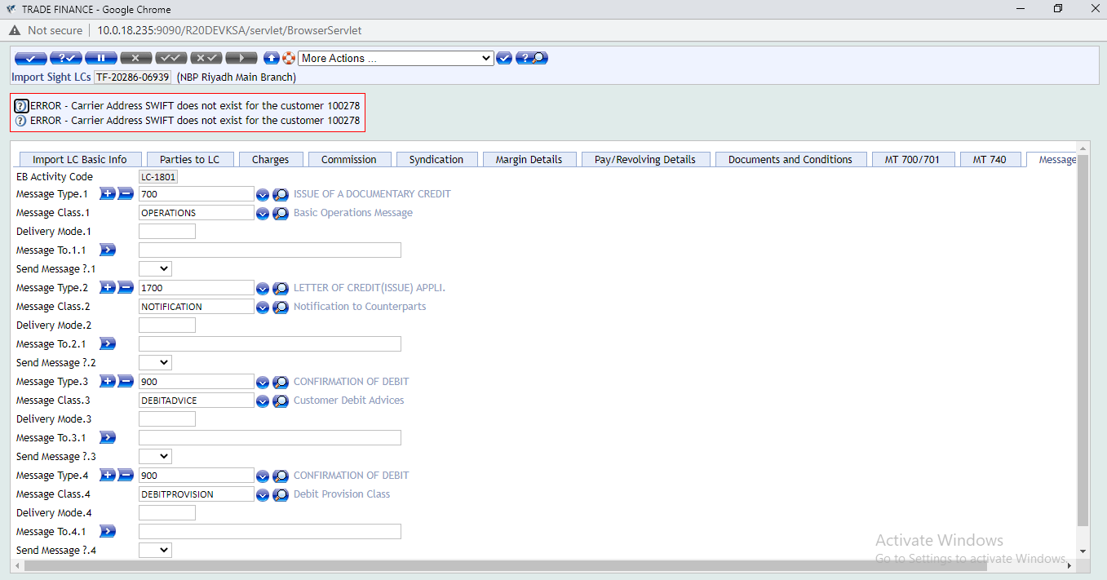

The above screen shows the “Messages” tab in which different types of advices and swift messages will be generated through the system such as debit/credit advices, swift message advices etc.

Proposed Functionality
End user will have to select “No” in “SEND.MESSAGE” drop-down field which is present in the “Messages” tab of the Import LC issuance transaction in order for the swift message not to be generated. Below is the screen shot of import LC issuance screens.

Topic 1 New Product WS02-AR-01.03 Open Current Account

Summary/ Description
Currently in NBP-KSA environment there is a separate report available for Local LCs. These reports in T24 terminology are called enquiries.

Existing Functionality
Currently the local LC report is available in the “Trade Finance Menu” in NBP-KSA. Below is the screen shot of the enquiry.

Proposed Functionality

Topic 1 New Product WS04-01-01.04 Local Fields Import/Export LC

Summary/ Description
There is a requirement of local fields for “Country of Origin” and H.S. Code at Import and Export LC Issuance transaction steps. The local fields can be incorporated accordingly and will be made available for the end user on the Import/Export Basic Info screen tab which is the first screen for both transaction types. The purpose of these fields as per the requirement is that it is supposed to be used for reporting purpose as well as for sanction screening purpose as well.

Existing Functionality
The illustration of these fields is made below for reference.
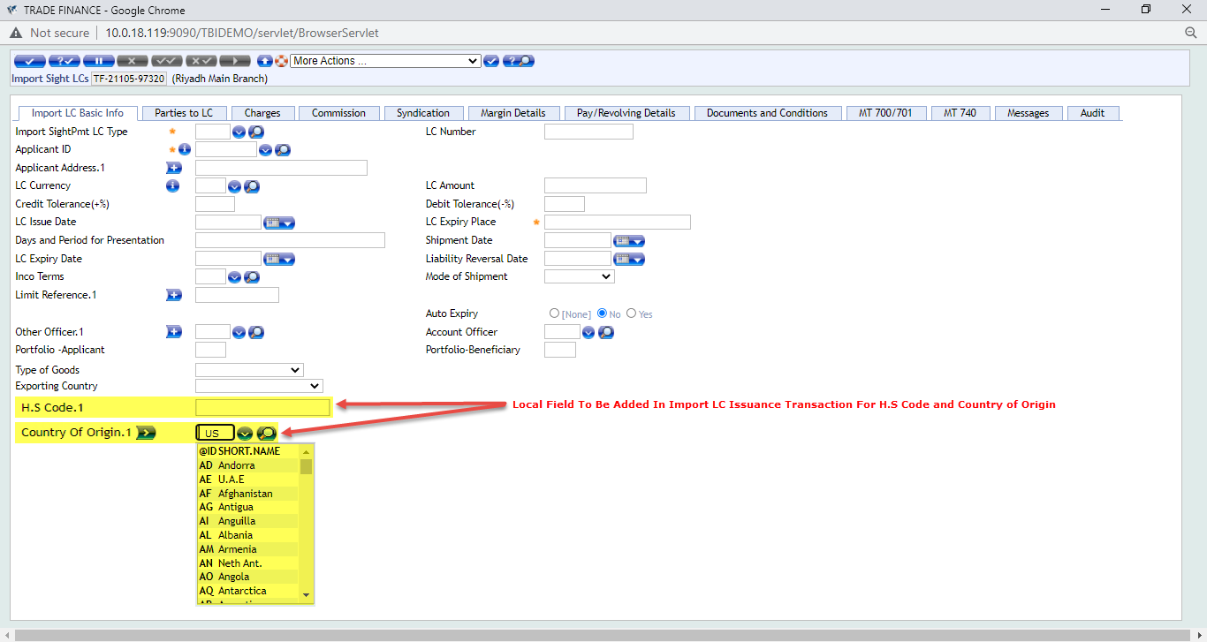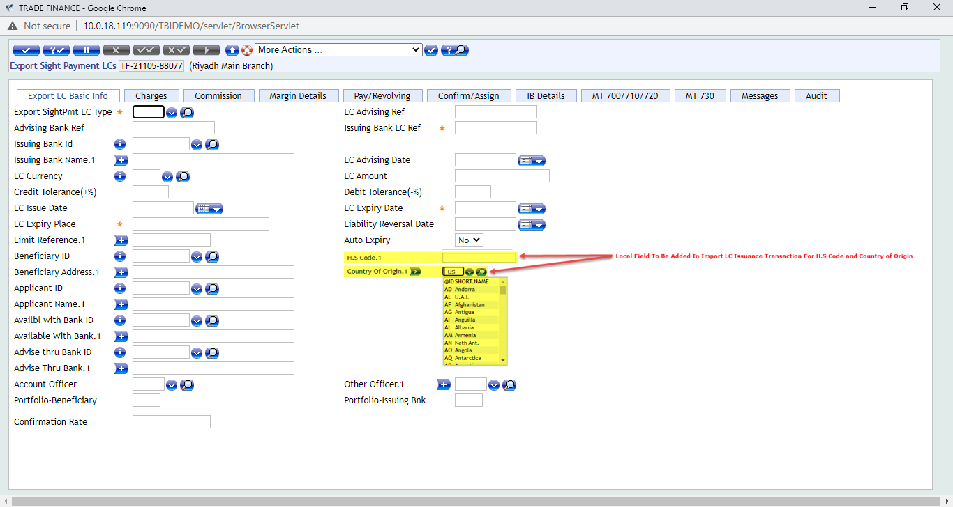

Proposed Functionality

There is a requirement of local fields for “Country of Origin” and H.S. Code at Import and Export LC Issuance transaction steps. The local fields can be incorporated accordingly and will be made available for the end user on the Import/Export Basic Info screen tab which is the first screen for both transaction types. The purpose of these fields as per the requirement is that it is supposed to be used for reporting purpose as well as for sanction screening purpose as well. The illustration of these fields is made below for reference:

Topic 1 WS04-01-01.05 Local Fields For Import/Export Docs

Summary/ Description
Bank requires local fields for shipping documents presented under LC as well as under Collections for both Imports and Exports. The purpose of these fields as per the requirement is for sanction screening so parties to the selected fields can be captured in the transaction and if any of these parties is part of the sanction lit than they can be identified and transaction can be handled accordingly in order to avoid regulatory or global penalties with regards to the international sanctions compliance.
The screen shots of the transaction screens with these fields is attached below for reference.

Existing Functionality

The screen shots with the added fields are attached below for reference.

Topic 1 WS04-01-01.06 Local Fields for Import/Export Docs Payment

Summary/ Description
Bank requires local fields for payment step under LC as well as under Collections for both Imports and Exports. The purpose of these fields as per the requirement is for sanction screening so parties to the selected fields can be captured in the transaction and if any of these parties is part of the sanction lit than they can be identified and transaction can be handled accordingly in order to avoid regulatory or global penalties with regards to the international sanctions compliance.
The screen shots of the transaction screens with these fields is attached below for reference.

Existing Functionality
The screen shots with the added fields are attached below for reference.

Proposed Functionality

Topic 1 WS04-01-01.07 Swift Messages and Advices Enquiry

Summary/ Description
There is a requirement for enquiry for transaction-wise swift message both inward and outward as well as advices to be generated through T24. The requirement is that the end user inputs the transaction reference number and all messages and advices related to that transaction reference will be displayed.

Existing Functionality

Proposed Functionality
At present in we have separate inquiries for inward and outward messages/advices. These enquiries are part of the delivery module in T24. The delivery module to extract advices and swift messages at transaction level. After the transaction is authorized these messages and advices can be viewed as well. For outward messages the repository in T24 is by the “DE.O.HEADER” and for viewing inward messages we have the repository by the name of “DE.I.HEADER”.
INCOMING MESSAGE HEADERS: DE.I.HEADER
OVERVIEW OF OUTGOING MESSAGE HEADERS: DE.O.HEADER
Inward Messages / Advices Enquiry Name: %DE.I.HEADER
Outward Messages / Advices Enquiry Name: %DE.O.HEADER

Topic 1 WS04-01-01.08 Waive Charges Option to Be Removed

Summary/ Description
Bank requires that for all LC and DRAWINGS related transaction steps and for all maintenance and miscellaneous steps where charges tab is available. The “CHARGE.STATUS” field should not be having the option of charge status “15” for “Waived” charges.

Existing Functionality

Proposed Functionality
We can achieve this by setting the “WAIVE.CHARGES” field as “No” and then making the same configurational setup at version level where the field “WAIVE.CHARGES” can be marked as an “AUTOM” Field and well as a “NOINPUT” field with field value set and fixed as “NO”.

Topic 1 WS04-01-01.09 H.S Code Field in Enquiry

Summary/ Description
There is a requirement that the H.S. Code field is required in the Import/Export LC Outstanding report. This can be handled through the enquiry setup. The local field of the H.S. Code can be mapped in the relevant enquiry and it will display once the enquiry is generated.
ENQUIRY NAME 1: TF.IMPLCOS
ENQUIRY NAME 2: NBPKSA.TF.EXPLCOS
ENQUIRY NAME 3: NBPKSA.TF.LIVE.LOCAL.OUT
ENQUIRY NAME 4: NBPKSA.TF.EXPLCOS

Existing Functionality
At present, below is the screen shot of the enquiry.

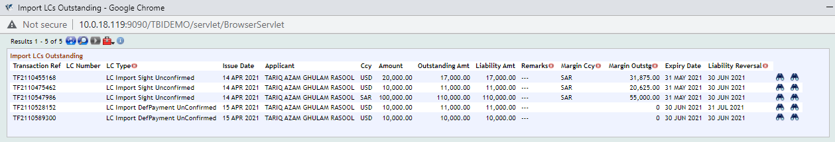

Proposed Functionality
Screen shots of the enquiry with the H.S Code field attached below for reference. Please note that this is simulated version of a proposed solution and this is it supposed to appear on the T24 screen.

Topic 1 WS04-01-01.10 Margin Functionality for Reimbursement Processing

Summary/ Description
There is a requirement for margin functionality in “LC Reimbursement Processing”. As per the business requirement stated by TBI that margin is required to be taken for in certain conditions with regards to confirmation of LCs and if there is no RMA with the counter-party bank then TBI taken 100 percent cash margin in order to cover the risk of non-payment.

Existing Functionality
T24 supports Letter of Credit - Reimbursement process in the LC cycle. Normally, the nominated bank (Claiming Bank) to whom the Beneficiary presents the documents, would not hold a direct account relationship in the LC currency with the Issuing bank.
For the above reason the Issuing bank would assign a Reimbursement bank with whom he has an account relationship. The Reimbursing bank would normally be in the country of LC currency. The Claiming bank could claim the LC amount from the Reimbursing bank through a reimbursement claim by MT742.
The Issuing bank would have already provided a reimbursement authority through swift MT740 to the Reimbursing bank which would specify their authorisation to debit Issuing bank's account with Reimbursing bank for a specific amount under a specified Documentary Credit Number. This authority would be stored under the records by the Reimbursement bank.
Once the Claiming bank claims the LC amount through MT742, the Reimbursing bank matches the claim with the reimbursement authority it holds, if the conditions of authority are satisfied, it debits the account of Issuing bank with it and honours the claim of claiming bank.
End user can Input Reimbursement Authority received or amend and modify the same. In the same way he can Register or Pay a reimbursement claim and also modify the same.
T24 supports recording of Reimbursement authorization received from the Issuing bank by swift MT740. It consists of details such as Documentary credit number, Currency, Amount, Available by and the party responsible for charges. Model bank also supports to modify the Reimbursement authority.
In order to record and modify the Reimbursement authorization, the user needs to initiate the transaction from the "Trade Finance Officer" Home Page. Click the "Home" icon on the Left Bottom Corner of this Home Page and a new tabbed window will be available on the right side from where the user needs to choose the following option, Transaction>Reimbursement Processing>Input authority.
Click on the New Task icon to input new authority. The user has to input mandatory details and other details of Reimbursement Authority based on MT 740 received. After inputting the details, the user has to validate transaction and preview delivery messages related to this transaction.
On satisfying with input, the user has to commit the transaction to make it available to Trade Finance Supervisor for verification and Authorization.
If supervisor suggests any changes/correction due to error in data input, the user has to recall the transaction from this enquiry and do necessary changes.

Proposed Functionality
The margin tab will be added to the reimbursement processing screen.

Topic 1 WS04-01-01.11 Fields to Be Mapped In LC Charge Details Enquiry

Summary/ Description
The LC Charge Details report is available in T24 as per core functionality. This report gives the details of the flat and percentage based charges that are part of a particular LC or DRAWINGS applications related transaction. This includes all Import and Export LC as well Collection transaction steps where charges are deducted or amortized as part of the transaction.

Existing Functionality
The “View Charge Details” enquiry is part of the core functionality which shows the charges deducted or claimed for a particular transaction. The status field in the enquiry shows the activity performed against a particular charge as part of a transaction. For example, if charge is collected up-front from the customer at transaction level with “Charge.Status” as 2 meaning “Collected”. Then the enquiry will show in the status field as “Collected”. If payment is done through Drawings module for the LC transaction and charges are deducted. Then status field will show “Deducted from Payment”. If charges are claimed using charge status “3” then the report will show in status field “Charges Claimed”. Below is the screen shot of the existing enquiry for reference.

Proposed Functionality
Bank Requires Under LC Charge Details Report Fields To Be Added:
CHRG.STATUS
DATE.RECEIVED

Topic 1 LC Expiry Date Field Required On Export LC Drawings Document Capture Step

Summary/ Description
The export LC drawings record by core functionality is generated in the “Document Capture” (DC) step of the transaction after the advising of the export LC has been executed in the system. This step is done under the DRAWINGS module. The export covering schedule includes the details of the shipping documents that are being sent to the applicant bank along with the instructions of handling these documents which are in line with the LC terms as well as the international governing rules for LCs which is the UCP 600.

Existing Functionality
Below is the screen shot of the existing export LC document covering schedule being generated through the system.
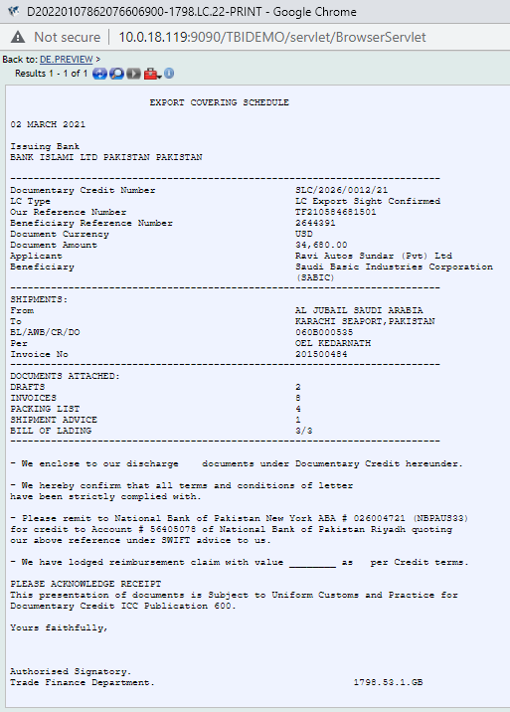

Proposed Functionality
Under Export Lodgement schedule; Expiry Date Field to be added.

Topic 1 WS04-01-01.13 Tracer feature for Export LC Docs

Summary/ Description
Configurational Setup Can Be Made Using The Field TRACE.DATE at DRAWINGS level. As well as parameterization through EB.FREE.PARAMETER table and transaction level tracer setup through EB.FREE.MESSAGE table.

Existing Functionality
T24 supports sending of Tracers for an unpaid Outward Collection online and if necessary set the frequency for auto generation of tracers. In order to do Tracer for Inward collection, the user needs to initiate the transaction from the "Trade Finance Officer" Home Page. Click the "Transaction" icon on the Left Bottom Corner of this Home Page and a new window will be opened where the user needs to select values from the dropdown for the following fields.
After selecting the values in dropdown and entering the transaction reference in the field "Instrument Ref", the user has to validate and commit the transaction. On committing the transaction, new screen will be opened to input Tracer details. The user has to input mandatory values and the other details. After inputting the details, the user has to validate transaction and preview delivery messages related to this transaction. Once satisfied with the delivery preview and details, the user needs to commit the transaction to make the transaction available to "Trade Finance Supervisor" to authorize the transaction.
Sample screen shot of Tracer for outward collection is shown below.

Proposed Functionality
Tracing operations are available in both the LETTER.OF.CREDIT and DRAWINGS applications. By inputting an appropriate date greater than the Bank date, the automatic generation of Tracers during the Close of Business operation is enabled. The fields are TRACER.DATE in LC and TRACE.DATE in the DRAWINGS application. As soon as a tracer is generated the next date for tracer generation is automatically decided by the EB.FREE.PARAMETERS or COUNTRY file input. At any time during the life cycle, changing the status to "STOP" in EB.FREE.MESSAGE can stop the scheduled tracer.
Alternately, removing the Tracer Date in the application can stop any scheduled tracer.
EB.FREE.PARAMETERS has a Company code as the Id. Setting up of this becomes mandatory if Tracers are to be scheduled. A set of Model routines are also released. This application is used for tracer mechanism which takes place by triggering a tracer routine. The tracer routine uses any valid EB.ACTIVITY.
The TRACE.DATE field is applicable only to documentary collections and indicate the date the collection should be chased. Accepts Standard date format. Holds the Scheduled date on which a Tracer message has to be sent. If the date is some future date, then an EB.FREE.MESSAGE record is produced on authorization of the DRAWING which holds the Tracer message and relevant details of the particular transaction with the scheduled date on which it has to be sent. If the date is TODAY then the Tracer message is sent during End of Day.
Validation Rules:
Mandatory when Draw Type is 'CO'
Will get cycled only if EB.FREE.PARAMETERS is set up.
Once the DRAWINGS record is authorized user is to go to the EB.FREE.MESSAGE table to setup the tracer functionality for the particular transaction. The “DRAWINGS” record will be automatically appearing in the drop-down field of the table.

Accounting
Standard T24 contingent entries

Limits
Standard T24 Contingent Entries.

COB Processing
N/A

Test Cases and Expected Results
Test Case

New Tables
N/A

[Table Name]
[Please refer to the naming conventions guide for naming the template. Please repeat the following set of Table Properties, Layout, Field Checks, Cross validation Checks, Other processing and Insert files for each Table]

Table Properties
No. | Property | Definition
1 | Name
2 | Product
2 | File Type
3 | Classification

Table Layout
No. | Field Name | IN2 & Edit | Description | Width

Field Checks
S.No | Name of the field | Check’s to be done

Cross Validation Checks
N/A

Other Processing
N/A

INSERT Files
N/A

Subroutines
N/A

Subroutine Name
[Please refer to the Naming convention guide for naming of subroutines. Please provide the following detailed information for creation of Subroutine]
Property | Specification
Type
Attached To
Attached As
Dependency
Description
Arguments – IN
Arguments – OUT
Prelim Conditions
Subroutine Flow
Special Instructions

Data Records
N/A

LOCAL.TABLE

Local Reference Name
For other applications the below mentioned set is used.
No. | Field | Definition
1 | @ID
1.1 | Description
1.2 | Short Name
1.3 | Max. Char
1.4 | Min. Char
1.5 | Char Type
1.6 | Vetting Table
1.7 | Application
1.8 | Enri. Field

LOCAL.REF.TABLE
Application | Local Ref | Association

I-DESCRIPTORS
N/A

STANDARD.SELECTION

API 1

API Details
N/A
https://confluence.temenos.com/display/IRFS/4.+REST+Style+Guide >>
Method | POST
URI  (includes api version , domain & Resource names) | Expected URI – Ex. /v1.0.0/party/customers/
T24 Artefact name | <Model Bank Artefact Name>
Functionality Description | <Description for the API to be added in the developer portal. This gives the functional description of the API>
Operation | <unique operation id> like getCustomerDetails
Domain | holdings|order|meta|party|product|reference  <should be one of the existing domains>
API Group names | Format : <domain>-<resource>-<subresource>-service  Ex. holdings-accounts-service, holdings-customers-service, party-customers-messages-service

New/Modified artefact details
<<This section will be filled with the required new enquiry/version details in case the API is not based on an existing Model Bank artefact. All the required field names and its functions should be mentioned in the section.
In case of slight modifications to the existing artefacts, then the existing artefact name and the required additional details for modification should be specified>>

Input fields
<To be filled in whenever the API gets an input from the consumer of the API>
Application Field Name | Display Type  (ALPHANUMERIC, AMOUNT, DATE, TIMESTAMP, BOOLEAN) | Label Name ( Vocabulary)  <to be filled in Enquiry/Version> | Additional Details | Description
The field name in T24 model bank artefact. | The data type of the field | The field name to be used in the API <as per REST API and IRIS vocabulary standards> | Details regarding whether mandatory input or optional input. Other details about the field if any. | The functional description to be added in the API documentation. The description should be functional and not in T24 language.

Output fields
<To be filled in whenever the API returns enquiry or version details. Mostly in case of GET APIs>
Application Field Name | Display Type  (ALPHANUMERIC, AMOUNT, DATE, TIMESTAMP, BOOLEAN) | Label Name ( Vocabulary)  <to be filled in Enquiry/Version> | Additional Details | Description
The field name in T24 model bank artefact. | The data type of the field | The field name to be used in the API <as per REST API and IRIS vocabulary standards> | Details regarding Other details about the field if any. | The functional description to be added in the API documentation. The description should be functional and not in T24 language.

Dependant and Related APIs
<<This section includes references to FSDs, other documents and any information about APIs that are related/dependant on this enhancement. For example, a vetting table that is used in the Version for which an API is built.
This also includes information about APIs that this API is dependent on>>
API Documentation Guidelines produced by Knowledge Team is embedded herewith for reference and adoption.

L3 API Hook requirements
<<This section relates to any features to be exposed from within the L1 product level to enable L3 customisation of the core functionality for the new feature or enhancement. This section should detail the need for any L3 APIs/hooks and use cases that are envisaged at the L3 level. This could be based on the usage of any existing L1 jBC methods that will be needed by Java Implementation clients, who will no longer be able to make use of any L1 jBC methods directly>>

Functionality Point Matrix
N/A

<< Functionality Matrix is the traceability till FSD and Test Cases starting from BRD. Mention the Section ID and the Description of the Requirement under BRD column, Section ID and the Description of the Functionality under FSD column and the mapping Test cases under Test Cases column with relevant test case ID>> ( mandatory for all client specific developments)
BRD | FSD | Test Cases

<<Note: In case any of above sections are not updated, because they are not relevant to the enhancement, they can be removed from the final version of the FS document sent to the client (only if the below pre-requisites are met. Care to be ensured that the sections are not missed for the enhancement and are in-line with the requirements agreed with the Client.
Pre-requisites:
• Frozen BRD
• Reviewed and baselined FS>>

