Functional Specification Document

Focal Point Ref : MISCELLENEOUS.DEALS -WS04_TBI_MD_FSD_v1.0
Client Name: Trade Bank of Iraq

Document History
Author | Version | Date | Description
Taiyyab Azim | 1.0 | ^{23th} December 2021
Taiyyab Azim | 1.1 | 26th January 2021

Comments:
The purpose of this document is to provide the solutions of the Gaps identified during the Business
Process Alignment held with Bank team and IT team.

Table of Contents
1. Contractual Information 5
2. Acronyms 6
3. Background 7
3.1 Introduction 7
3.2 Reference Documents 8
3.3 Related and Dependent Enhancements 9
4. Proposed Functional Solution Description 9
4.1 Requirements or Gap Description 9
4.1.1 Requirement WS04-MD-01 TO 07.01 New Product “Warranty Guarantee” 9
4.1.2 Requirement WS04-MD-01 TO 07.02 Local Fields Required In Guarantee Issuance Versions 12
4.1.3 Requirement WS04-MD-18 TO 21.01 Local Fields Required In Guarantee Received Versions 14
4.1.4 Requirement WS04-MD-18 TO 21.02 Local Fields Required In Guarantee Received and Guarantee Claim Register Versions 15
4.1.5 Requirement WS04-MD-18 TO 21.03 Issued Guarantee Amount and Expiry Date Should Not Exceed Counter-Guarantee Amount and Expiry 17
4.1.6 Requirement WS04-MD-32.01 Fields Required In Enquiry 21
4.1.7 Requirement WS04-MD-33.01 Fields Required In Enquiry 23
4.1.8 Requirement WS04-MD-12.01 Associate Version Required In Main Version of Pay/Reject Claim under Guarantee 25
4.1.9 Requirement WS04-MD-18 TO 21.04 MT799 Associate Version Required In Main Version of Guarantee Received 26
4.1.10 Requirement WS04-MD-18 TO 21.05 Claimed Charges Processing Under Guarantee Received 28
5. Use Cases 37
5.1 Use Case 37
5.2 Use Case 37
5.3 Use Case 37
5.4 Use Case 37
5.5 Use Case 38
5.6 Use Case 38
5.7 Use Case 38
5.8 Use Case 38
5.9 Use Case 38
5.10 Use Case 38
6. Assumptions 39
7. Exclusions (Specific Functionality that is not covered by this Development) 39
8. Proposed Product Solution 39
8.1 Requirement Classification 39
8.2 Existing Functionality 40
8.2.1 Topic 1 Existing Feature 1 40
8.3 Proposed New Product Functionality 40
8.3.1 Topic 1 WS04-MD-01 TO 07.01 New Product “Warranty Guarantee” 40
8.3.2 Topic 1 WS04-MD-01 TO 07.02 Local Fields Required In Guarantee Issuance Versions 43
8.3.3 Topic 1 New Product WS02-AR-01.03 Open Current Account 45
8.3.4 Topic 1 WS04-MD-18 TO 21.02 Local Fields Required In Guarantee Received and Guarantee Claim Register Versions 47
8.3.5 Topic 1 WS04-MD-18 TO 21.03 Issued Guarantee Amount and Expiry Date Should Not Exceed Counter-Guarantee Amount and Expiry 49
8.3.6 Topic 1 WS04-MD-32.01 Fields Required In Enquiry 53
8.3.7 Topic 1 WS04-MD-33.01 Fields Required In Enquiry 56
8.3.8 Topic 1 WS04-MD-12.01 Associate Version Required In Main Version of Pay/Reject Claim under Guarantee 59
8.3.1 Topic 1 WS04-MD-18 TO 21.04 MT799 Associate Version Required In Main Version of Guarantee Received 61
8.3.1 Topic 1 WS04-MD-18 TO 21.05 Claimed Charges Processing Under Guarantee Received 64
8.4 Accounting 72
8.5 Limits 72
8.6 COB Processing 72
8.7 Test Cases and Expected Results 72
8.8 New Tables 72
8.8.1 [Table Name] 72
8.8.2 Table Properties 72
8.8.3 Table Layout 73
8.8.4 Field Checks 73
8.9 Cross Validation Checks 73
8.10 Other Processing 73
8.11 INSERT Files 73
8.12 Subroutines 73
8.12.1 Subroutine Name 73
8.13 Data Records 74
8.14 LOCAL.TABLE 74
8.14.1 Local Reference Name 74
8.15 LOCAL.REF.TABLE 74
8.16 I-DESCRIPTORS 74
8.17 STANDARD.SELECTION 75
8.17.1 API 1 75
9. Functionality Point Matrix 77

Contractual Information
<< Standard contractual text statement>>
This Functional Specification Document (“FSD”) has been prepared by Temenos Headquarters SA (together with its affiliates, “Temenos”) in response to either an identified contractual gap in the course of an implementation, or a Change Request (“CR”) or Request For Services (“RFS”) from Temenos’ Client (as named below), in each case to develop certain added functionality in the Software.
By signing this FSD or otherwise approving or accepting this FSD in writing, Client indicates its acceptance and approval for Temenos to proceed with the work involved in designing and developing such proposed functional change to the Software and (if applicable) the quotation for such work either set out herein or otherwise agreed between the Client and Temenos.
The terms of the relevant Agreement between Temenos and Client in relation to the Software (together with the CR or RFS as applicable) shall govern this FSD and the services provided in connection herewith. Terms used but not otherwise defined herein shall have the meaning set out in the Software Agreement.
Please note that the relevant Developments will only be incorporated into the latest available Software. In case one or more Developments need to be incorporated into the Client release, an approval from Design Authority Review Board is mandatory. Any modifications to the FSD may impact the quotation (if any) and/or delivery release date and are therefore subject to mutual written agreement between Temenos and Client.
Development Reference: EN: TBI_MD_FSD_v1.0

Development Description: MISCELLENEOUS DEALS

Client Name(s): Trade Bank of Iraq

Client Reference: Trade Bank of Iraq - WS04_MD_TBIKSA_BPR_Gap Analysis v1.0
Opportunity Reference:

Request Reference:

Signed for and on behalf of the Client: <<Should also be signed off by a Temenos internal owner for internal SI>>
Name:
Signature:

Date:
Position:

<<Estimation section here should be removed for non-chargeable developments>>
Quotation:
N/A
 | Sub Total | Total
Design
Functional Specification
Development
Technical Specification
Coding
Testing
Documentation
Delivery Management
TOTAL MAN DAYS

Release Commitment: << To be completed for client SI>>
Monthly Release for delivering this development, provided sign-off is received before the expiry date of this release commitment | Release yyyymm

The above release date is the month of the expected release in which the new functionality will be made available. This is dependent upon signature or acceptance of this FSD by the ‘Expiry date of Release Commitment” noted below.

Date of Issue of this Release Commitment |  |  | Date of Expiry of this Release Commitment

Acronyms
Acronym | Description
BPR | Business Process Review
FSD | Functional Specification Document
MD | Miscellaneous Deals
MD.DEAL | Miscellaneous Deal

Background

Introduction
Trade Bank of Iraq opens its first external Branch at Riyadh – Kingdom of Saudi Arabia, Abraj Al Tawuniya – Al-Olya District – King Fahad Road and it is also the first Iraqi Trade Finance Bank at Kingdom of Saudi Arabia. The Branch seeks to expand business relations between both Financial & Banking sectors thus supporting investment between the two countries.

Requirement Reference | Requirement Title | Summary Description
WS04-MD-01 TO 07.01 | New Product to be added  *Warranty Guarantee | Bank has a business requirement that they need another guarantee type to be incorporated in the system by the name of “Warranty Guarantee”.
WS04-MD-01 TO 07.02 | Field to be added in GTEE Issuance version;  *Beneficiary Country (Free Text Field)  *Counter-Guarantee Reference (Enquiry to reflect all GTEE Received)  The same Fields To Be Reflect In The Report - GTEE Outstanding | The beneficiary country “free text local field” is required for the purpose of sanctions screening and reporting. This field is required in all versions/screens of “Guarantee Issued” transactions.
WS04-MD-18 TO 21.01 | Local Field to be Added on GTEE Received  *Type of GTEE (Free Text Field)  *Issuer's Country Field (Free Text Field) | The beneficiary country “Free Text Local Field” is required for the purpose of sanctions screening and reporting. This field is required in all versions/screens of “Guarantee Received” transactions.
WS04-MD-18 TO 21.02 | Field to be added in GTEE Received/Claim Register version;  *Beneficiary Name To Be Changed To Applicant.  *Applicant Country (Free Text Field) | In the “Guarantee Received” as well as the “Claim Register Under Guarantee Received” transaction screen “Free Text Local Field” is required for the purpose of sanctions screening and reporting. The “BENEF.CUST.1” and “BEN.ADDRESS” field screen name to be changed from “Beneficiary” to “Applicant”.  Also, another local field for “Applicant Country” to be also added where we can add the drop-down from the “Country” table.
WS04-MD-18 TO 21.02 | Error Message Required In Guarantee Issued Against Guarantee Received | Guarantee Issued Should Give Error Message When Expiry Date And Amount Are Exceeding The Counter Received Guarantee Expiry Date And Amount. This functionality is not readily available in the system and will be customized.
WS04-MD-32.01 | Local field required in Guarantee Issued Outstanding Report | In Guarantee Issued And Received Outstanding Report The Below Mentioned Field Need To Be Incorporated:  *CHARGE.DATE  *CHARGE.CURR  *CHARGE.CODE  *CHARGE.AMOUNT
WS04-MD-33.01 | Local field required in Guarantee Received Outstanding Report | In Guarantee Issued And Received Outstanding Report The Below Mentioned Field Need To Be Incorporated:  *CHARGE.DATE  *CHARGE.CURR  *CHARGE.CODE  *CHARGE.AMOUNT
WS04-MD-12.01 | Associate Version Required In Pay/Reject Claim under Guarantee | At Invocation Claim Version;  Add version Of MT-799
WS04-MD-18 TO 21.03 | Associate Version Required In Guarantee Received | Under GTEE Received Issuance Version:  MT799 Associate Versions to be added on main version/screen.
WS04-MD-18 TO 21.02 | Claimed Charges Processing And Settlement | Under Guarantee Received Charges:  Accounting Entry For Claimed Charges  Debit Suspense  And Credit P/L  *Then Settle The Entry After Funds Are Received In Nostro Account Nostro A/C Debit  And Suspense Account Credit.  (Settlement will be done manually by user by Fund Transfer)

Reference Documents
Trade Bank of Iraq – TBI MD BPR Reference Sheet V1.1.xlsx

Related and Dependent Enhancements
MD makes use of:
- CUSTOMER
- ACCOUNT

Core Dependencies:
- Delivery
- Accounting
- Limits

MD also uses other Static tables

Proposed Functional Solution Description

Requirements or Gap Description

Requirement WS04-MD-01 TO 07.01 New Product “Warranty Guarantee”
There is a requirement for a new guarantee type to be added in the list of guarantee products i.e. “Warranty Guarantee”. A new transaction version/screen will be created by the name of “Warranty Guarantee”. The new guarantee will be placed in the guarantees menu for the user to process the transaction like other guarantees that are part of the menu.

Workflows
End user will access the system and open the guarantees menu to process the transaction. After accessing the transaction screen through the menu user can process the transaction.
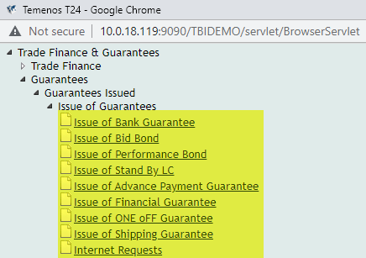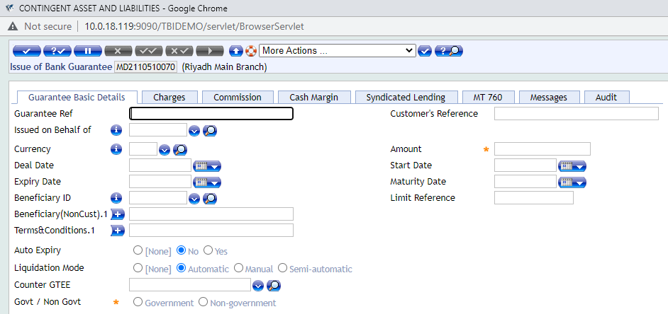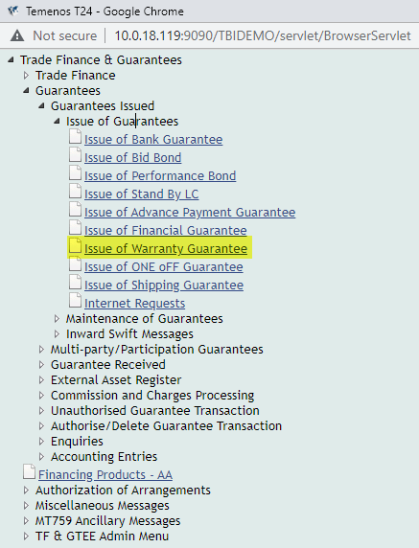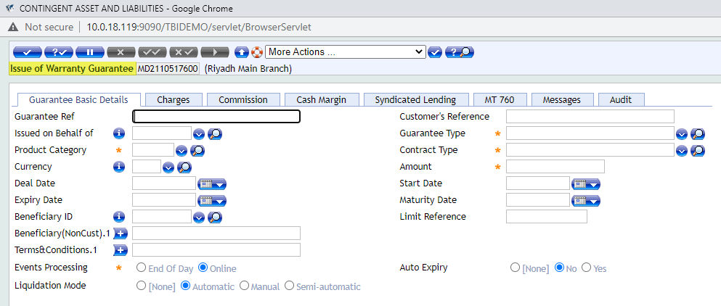
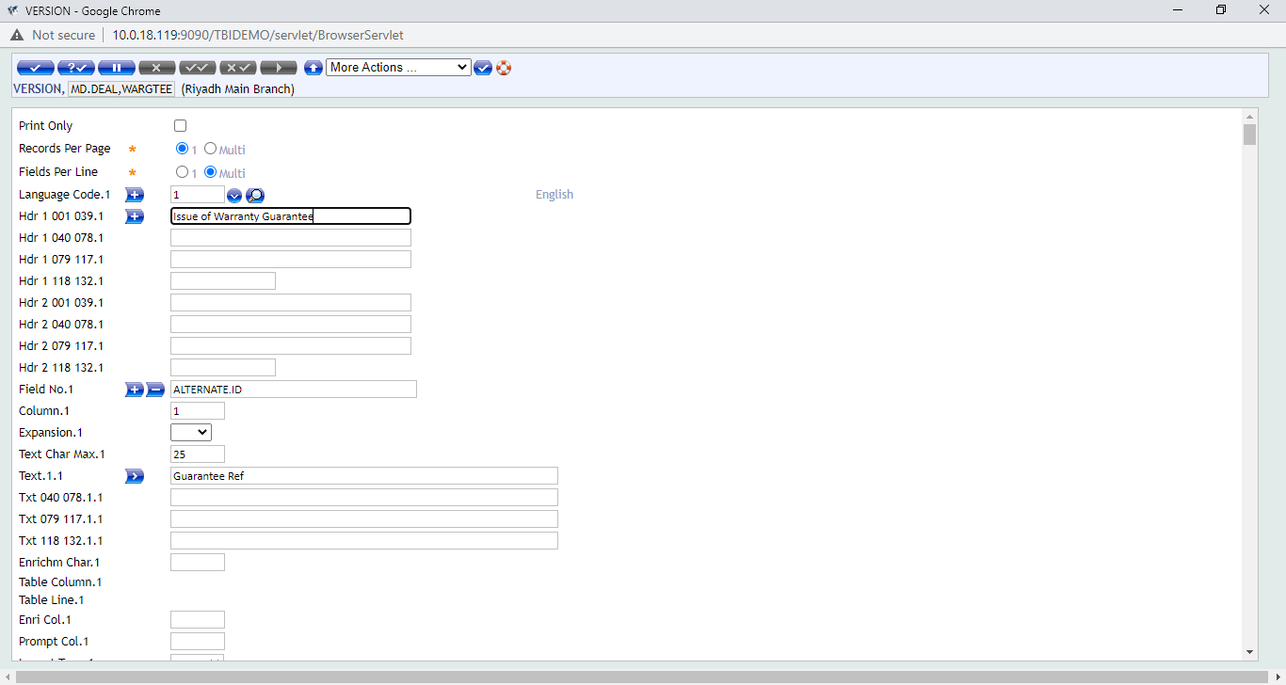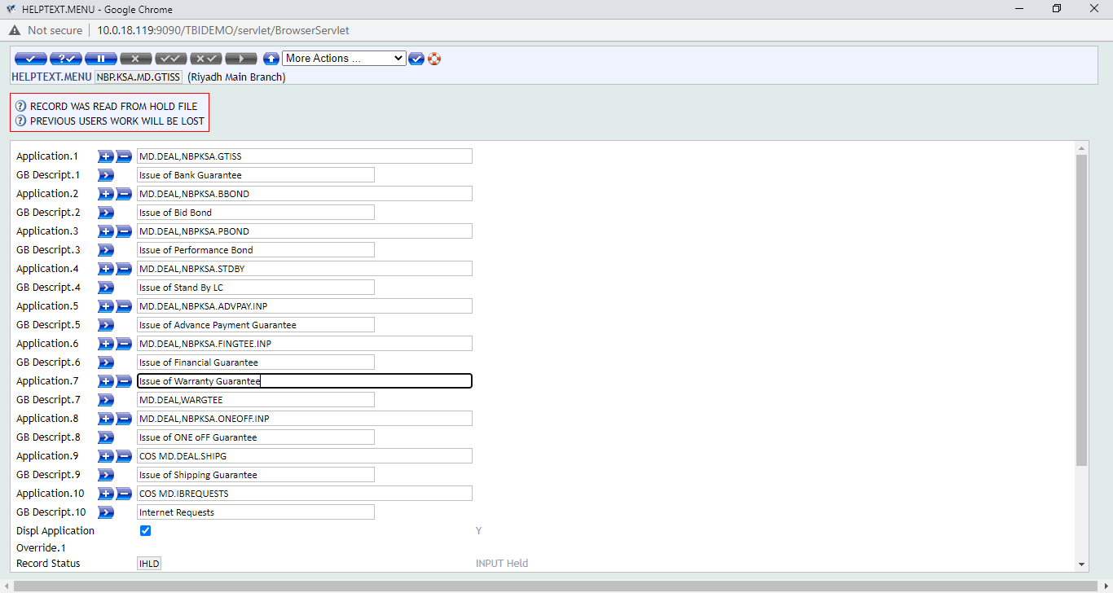

Requirement WS04-MD-01 TO 07.02 Local Fields Required In Guarantee Issuance Versions
There is a requirement for “free text local fields” to be made available at the guarantee issuance step. These fields include the “Beneficiary Country” fields to which we can add the country table and make it a drop-down field. Also, counter guarantee reference field is also required in the guarantee issuance screen which is already available in the NBP-KSA environment. The same fields to be reflect in the Guarantee Issued Outstanding Report.

Workflows
In the guarantees menu when end user click on the guarantee issuance option and select the type of guarantee which is to be processed. The transaction processing screen will open and in the screen are the fields available for the user to input the relevant data pertaining to the transaction. The local fields will be made available on the main screen tab “Guarantee Basic Details”. The same fields to be reflect in the Guarantee Issued Outstanding Report.
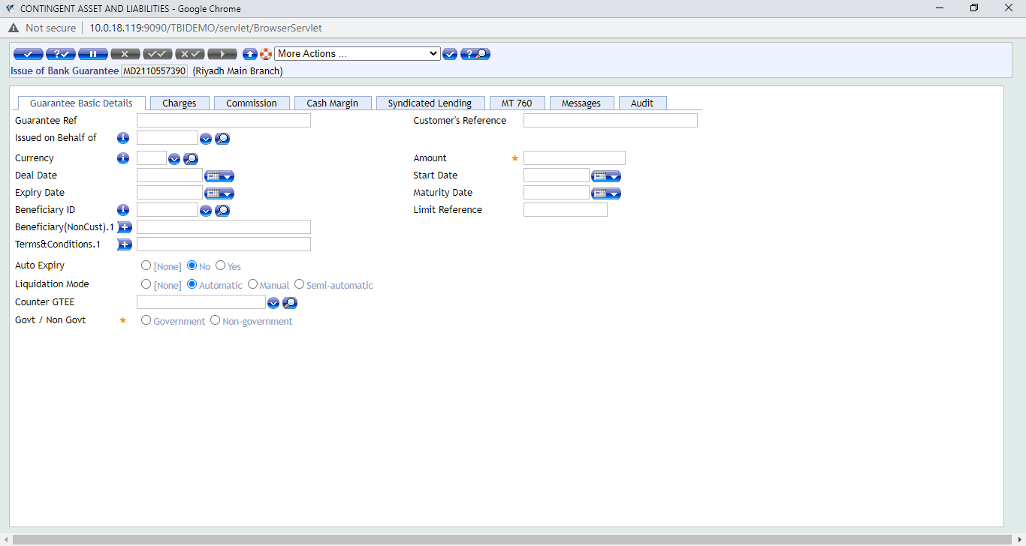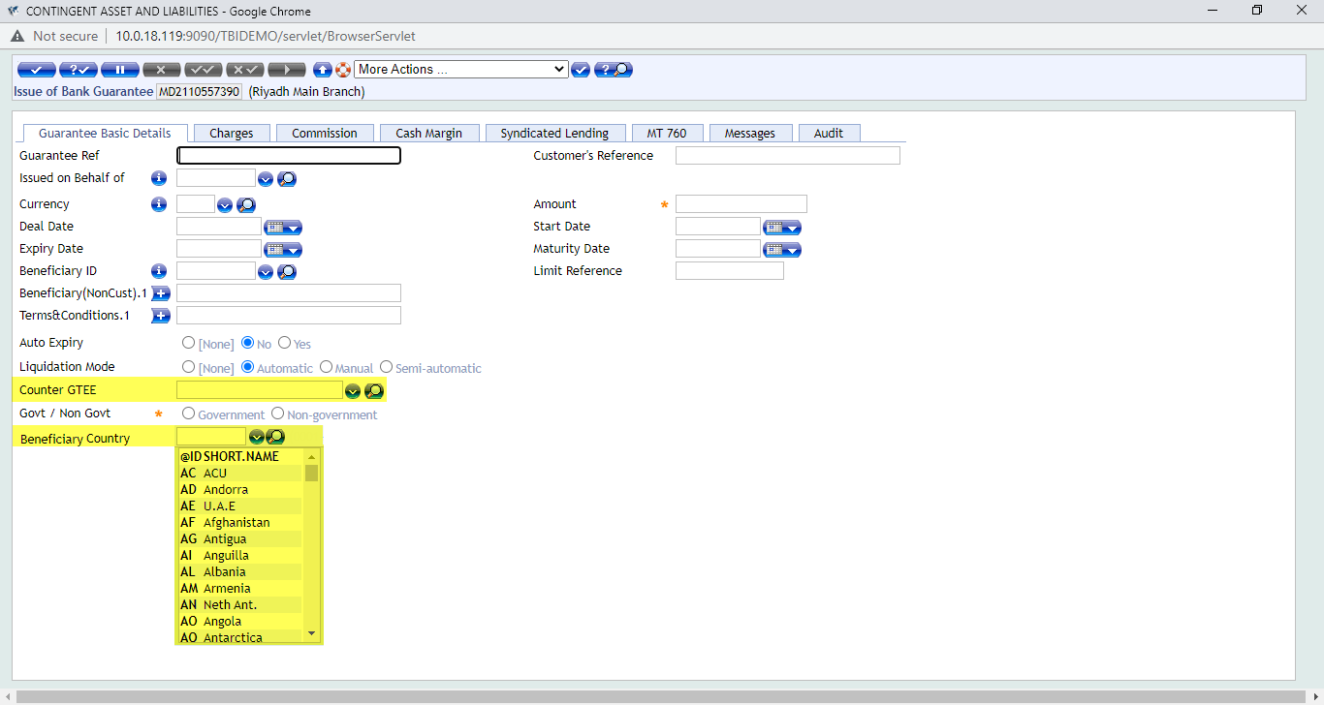

Requirement WS04-MD-18 TO 21.01 Local Fields Required In Guarantee Received Versions

There is a requirement for “free text local fields” to be made available at the guarantee issuance step. These fields include the “Type Of Gtee” which could be free text field as well as “Issuer’s Country” fields to which we can add the country table and make it a drop-down field. The same fields to be reflect in the Guarantee Received Outstanding Report.

Workflows
In the guarantees menu when end user click on the guarantee received option and select the guarantee received transaction. The transaction processing screen will open and in the screen are the fields available for the user to input the relevant data pertaining to the transaction. The local fields will be made available on the main screen tab “Guarantee Basic Info”.

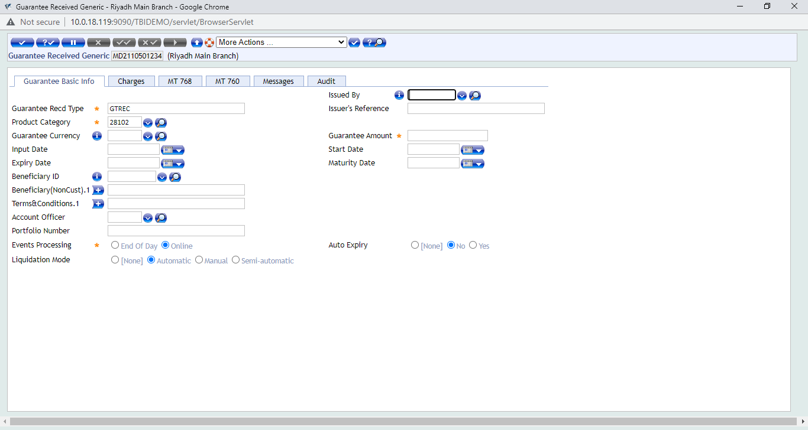
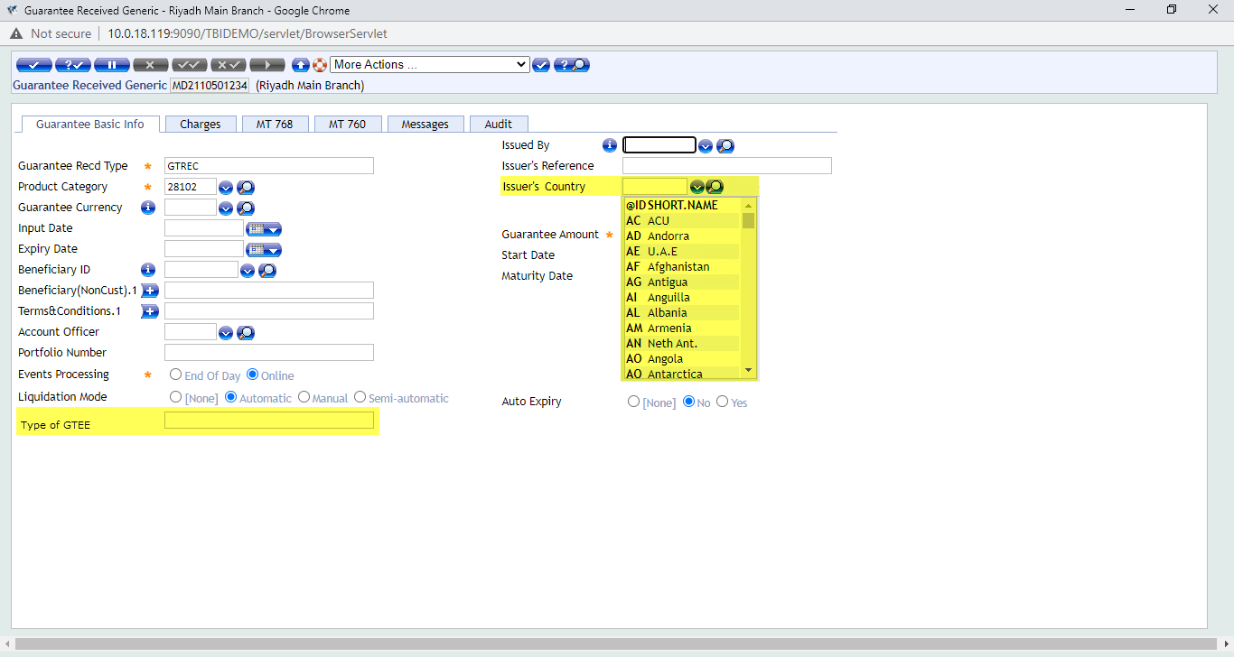

Requirement WS04-MD-18 TO 21.02 Local Fields Required In Guarantee Received and Guarantee Claim Register Versions
There is a requirement for “free text local fields” to be made available at the guarantee received step and also the guarantee received claim register step. These fields include the “Applicant Name” which would be a free text field as well as “Applicant Country” fields to which we can add the country table and make it a drop-down field.

Workflows
In the guarantees menu when end user click on the guarantee received option and select the guarantee received transaction. The transaction processing screen will open and in the screen are the fields available for the user to input the relevant data pertaining to the transaction. The local fields will be made available on the main screen tab “Guarantee Basic Info”. In the claim register under guarantee screen these fields will reflect in the “Initiate Claim” tab.
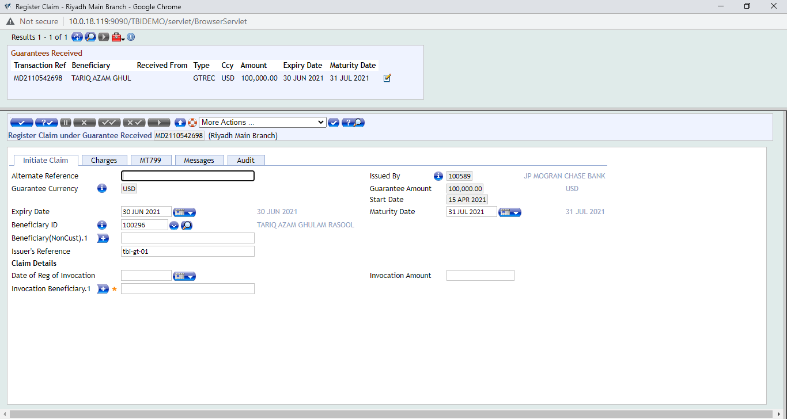
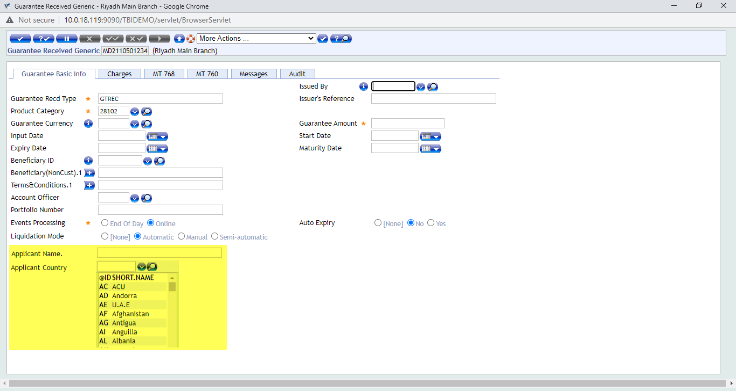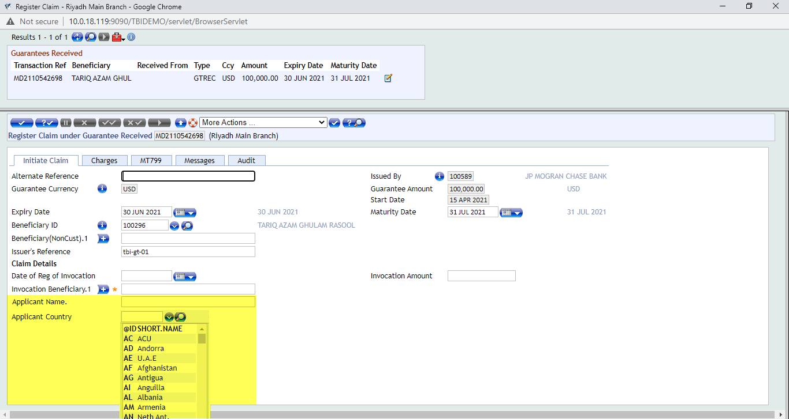

Requirement WS04-MD-18 TO 21.03 Issued Guarantee Amount and Expiry Date Should Not Exceed Counter-Guarantee Amount and Expiry
There is a requirement from the client to place an error message check for the transaction scenario when a guarantee is being issued against a counter-guarantee which has been processed in the system through the “Guarantee Received” functionality.
Once inward guarantee is received it is to be processed in the system and then another guarantee is to be issued against the received guarantee. The error message check is to be placed at the transaction level so that once user input the transaction details like the amount and expiry date in the respective fields. If the amount or expiry date or both values entered by the user exceed the amount and expiry date of the guarantee received record tagged with the transaction then system should give an error message.
The screen shots of the transaction screens with these fields is attached below for reference.
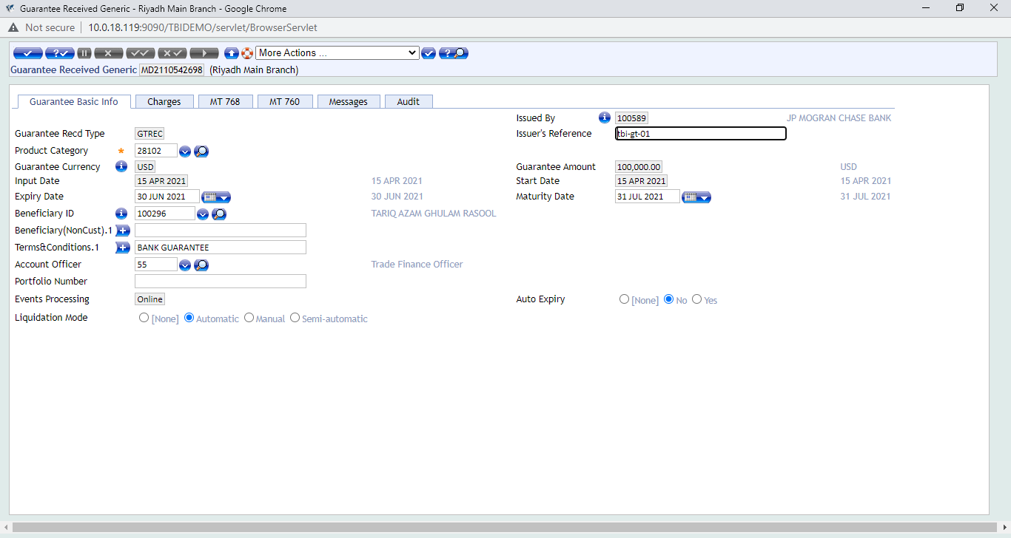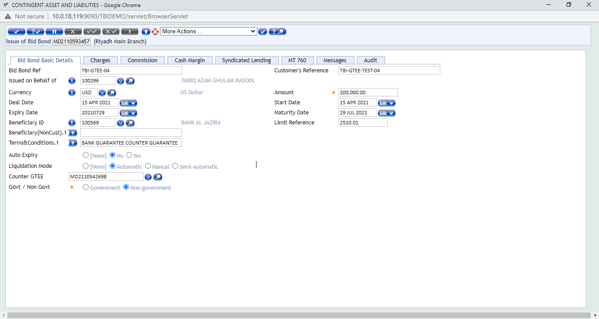
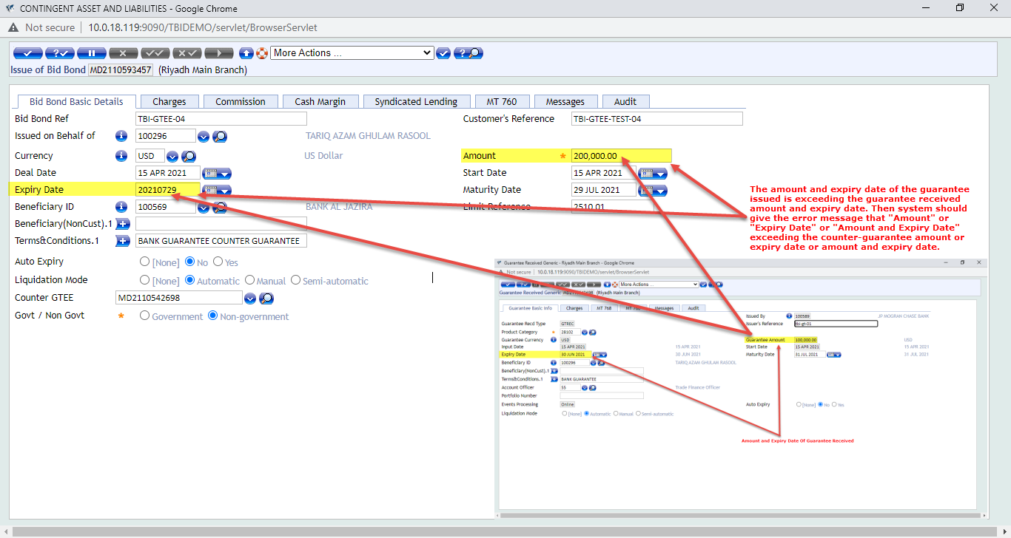

Workflows
Once inward guarantee is received it is to be processed in the system and then another guarantee is to be issued against the received guarantee. The error message check is to be placed at the transaction level so that once user input the transaction details like the amount and expiry date in the respective fields. If the amount or expiry date or both values entered by the user exceed the amount and expiry date of the guarantee received record tagged with the transaction then system should give an error message.

Field Names:
- Guarantee Amount: PRINCIPAL.AMOUNT
- Expiry Date: ADVICE.EXPIRY.DATE

Version Names For Guarantee Received:

- Guarantee Received Generic: MD.DEAL,GTREC
- Guarantee Received Covering Facility: MD.DEAL,GTREC
- Amendment to Guarantee Received: MD.DEAL,GTRECAMD

Versions Names For Guarantee Issued:

- Issue of Bank Guarantee: MD.DEAL,NBPKSA.GTISS
- Issue of Bid Bond: MD.DEAL,NBPKSA.BBOND
- Issue of Performance Bond: MD.DEAL,NBPKSA.PBOND
- Issue of Stand By Import LCs: MD.DEAL,NBPKSA.STDBY
- Issue of Advance Payment GTEE: MD.DEAL,NBPKSA.ADVPAY.INP
- Issue of Financial Guarantee: MD.DEAL,NBPKSA.FINGTEE.INP
- Issue of One OFF GTEE: MD.DEAL,NBPKSA.ONEOFF.INP
- Issue Shipping Guarantee under LC: MD.DEAL,SHIPGLC
- Issue Shipping Guarantee under Import Collection Document: MD.DEAL,SHIPGCOLL

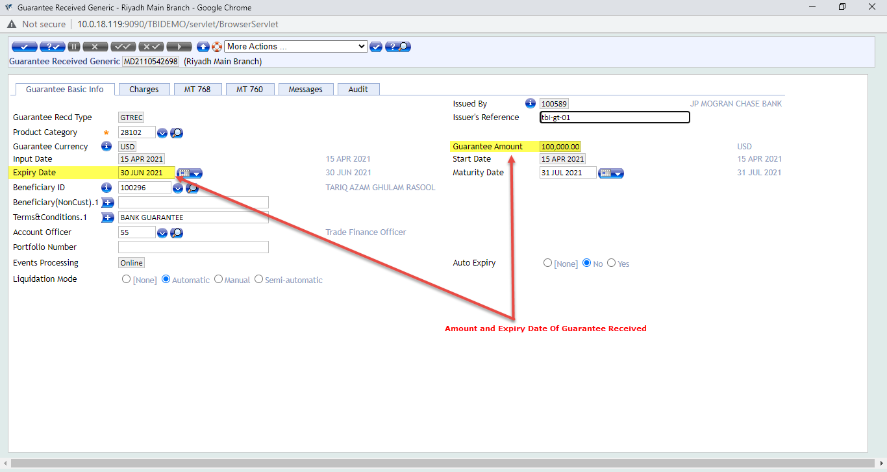

Requirement WS04-MD-32.01 Fields Required In Enquiry
There is a requirement for fields to be mapped from MD.BALANCES table in the Guarantee Issued Outstanding Report. The Guarantee Issued Outstanding Report is a core enquiry. It displays the status of all the issued guarantee that are currently live in the system and have not expiry/settled/closed. The fields which are required to be mapped in this enquiry are to be extracted from MD.BALANCES table and the names of these fields are stated below:

CHARGE.DATE
CHARGE.CURR
CHARGE.CODE
CHARGE.AMOUNT

Workflows
The screen shots of the enquiry with these fields is attached below for reference.
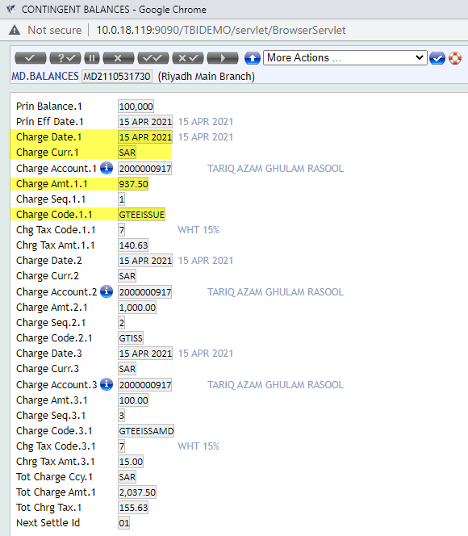
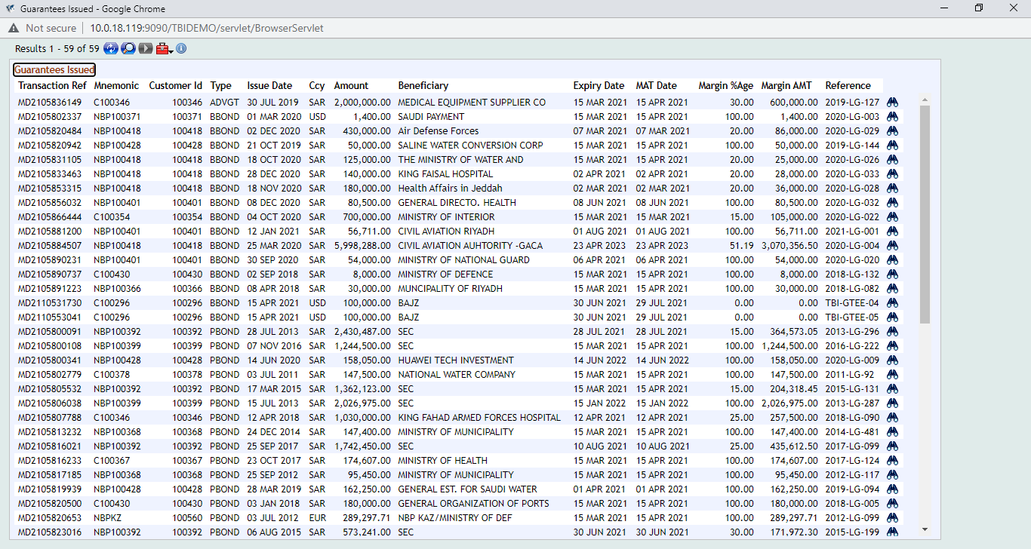
Transaction Ref | Mnemonic | Customer Id | Type | Issue Date | Ccy | Amount | Beneficiary | Expiry Date | MAT Date | Margin %Age | Margin AMT | Reference | Charge Date | Charge Ccy | Charge Amt | Charge Code
MD2110531730 | C100296 | 100296 | BBOND | 15-Apr-21 | USD | 100,000.00 | BAJZ | 30-Jun-21 | 29-Jul-21 | 0 | 0 | TBI-GTEE-04 | 15-Apr-2021 | SAR | 937.50 | GTEEISS

Requirement WS04-MD-33.01 Fields Required In Enquiry
There is a requirement for fields to be mapped from MD.BALANCES table in the Guarantee Received Outstanding Report. The fields to be mapped from MD.BALANCES are stated below:
CHARGE.DATE
CHARGE.CURR
CHARGE.CODE
CHARGE.AMOUNT

Workflows
The screen shots of the enquiry with these fields is attached below for reference.
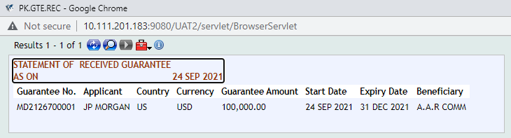

Transaction Ref | Mnemonic | Customer Id | Type | Issue Date | Ccy | Amount | Beneficiary | Expiry Date | MAT Date | Margin %Age | Margin AMT | Reference | Charge Date | Charge Ccy | Charge Amt | Charge Code
MD2110531730 | C100296 | 100296 | BBOND | 15-Apr-21 | USD | 100,000.00 | BAJZ | 30-Jun-21 | 29-Jul-21 | 0 | 0 | TBI-GTEE-04 | 15-Apr-2021 | SAR | 937.50 | GTEEISS

Requirement WS04-MD-12.01 Associate Version Required In Main Version of Pay/Reject Claim under Guarantee

There is a requirement for MT-799 swift message option to be added to the guarantee claim payment payment/rejection step. This can be achieved by adding the associate version of the MT-799 swift message to the main version of Guarantee Pay/Reject Claim version. The version names are stated below for your reference:

Main Version Name: MD.DEAL,GTINVEXE and MD.DEAL,GTINVCAN
Associate Version: MD.DEAL,IN.MT799

Workflows
At Invocation Claim Version; add version Of MT-799. The screen shots of the transaction level setup is attached below for reference.
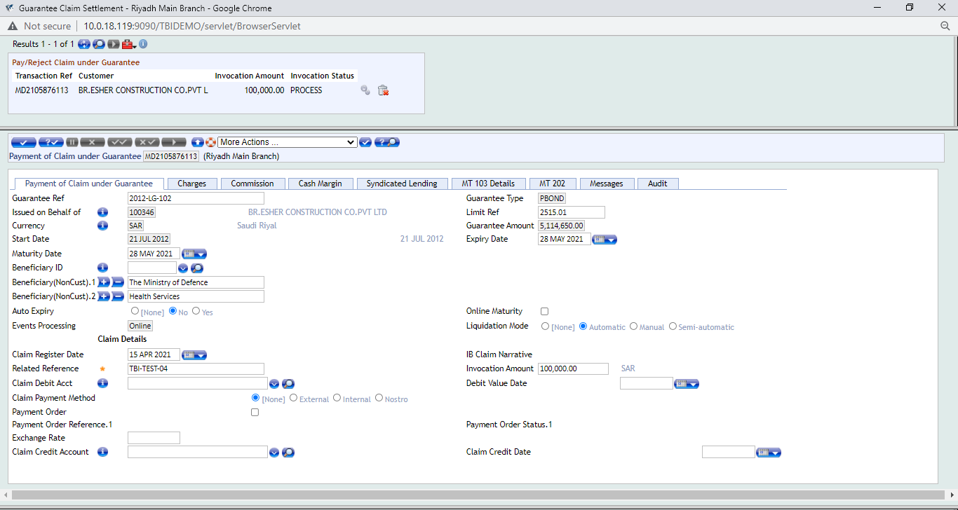
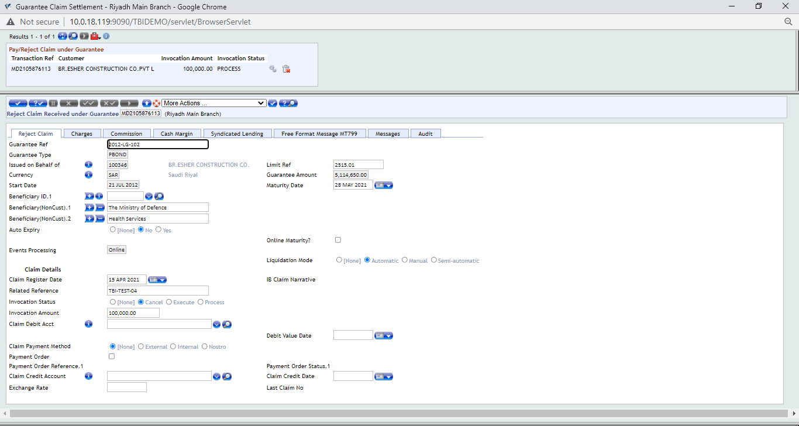
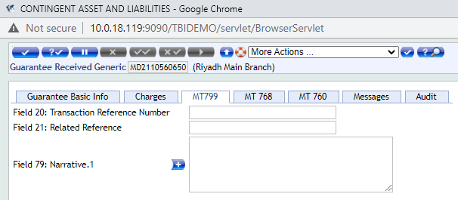

Requirement WS04-MD-18 TO 21.04 MT799 Associate Version Required In Main Version of Guarantee Received
There is a requirement for MT-799 swift message option to be added to the guarantee received transaction step. This can be achieved by adding the associate version of the MT-799 swift message to the main version of Guarantee Pay/Reject Claim version. The version names are stated below for your reference:

Main Version Name: MD.DEAL,GTREC, MD.DEAL,GTFAC AND MD.DEAL,GTREC
Associate Version: MD.DEAL,IN.MT799

Workflows
Under GTEE Received Issuance Version; MT799 Associated Versions to be added on version. The screen shots of the transaction level setup is attached below for reference.
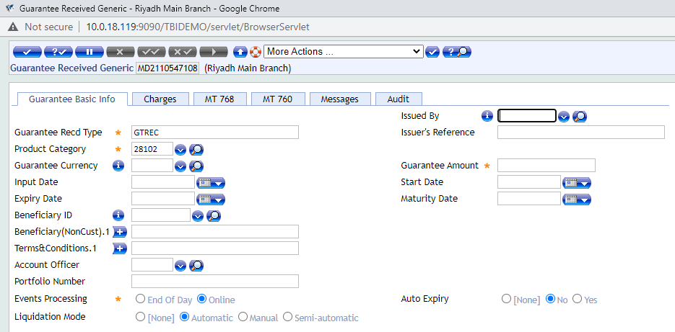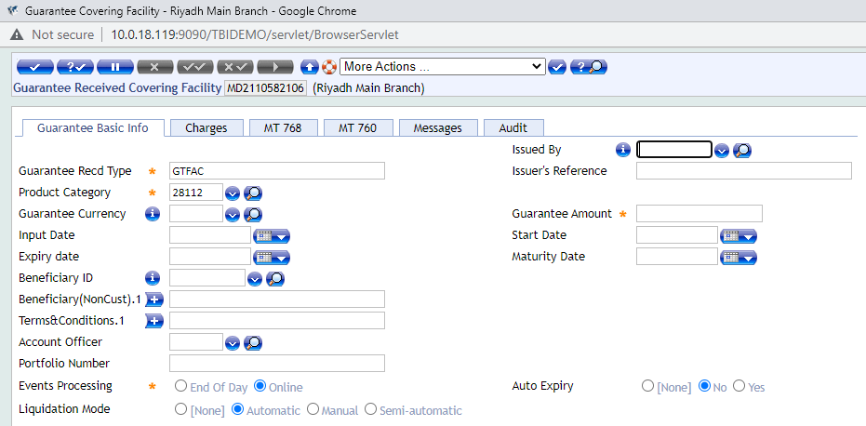
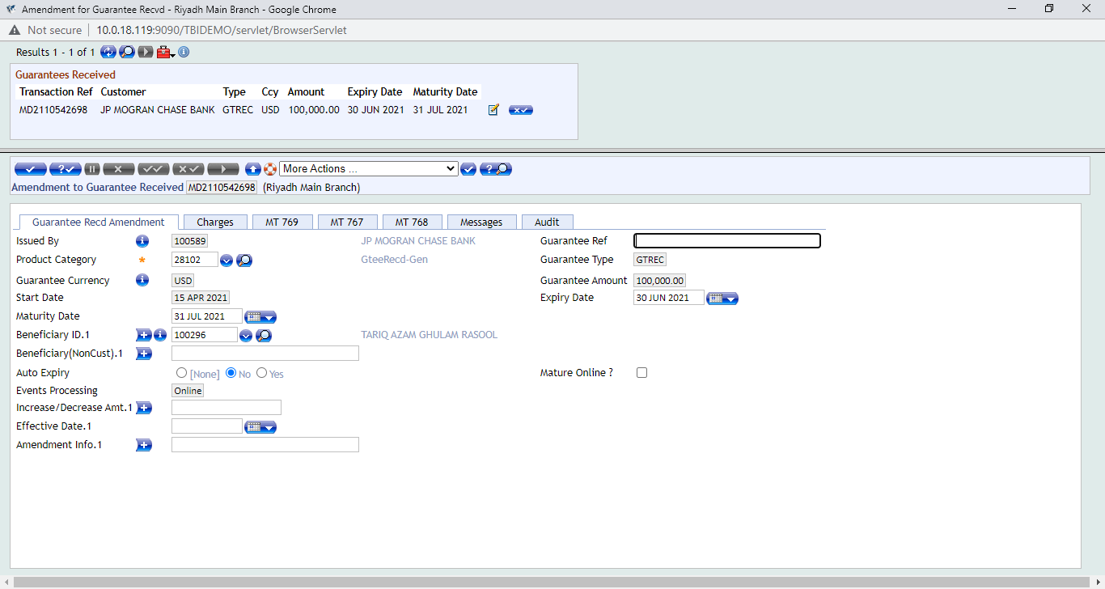

Requirement WS04-MD-18 TO 21.05 Claimed Charges Processing Under Guarantee Received

There is a requirement for catering to the claimed charges processing for guarantees received. In case where customer A/C is not to be debited against charges that are pertaining to the transaction. The process of the claim charges treatment is stated below:

Under Guarantee Received Charges:

Accounting Entry for Claimed Charges
Debit Suspense
And Credit P/L

Then Settle the Entry After Funds Are Received In Nostro Account Nostro A/C Debit
And Suspense Account Credit.
(Settlement will be done manually by user by Fund Transfer)

Workflows
The charges tab is available in the guarantee received transaction screen/version. End user can manually enter the suspense A/C number which is to be debited against the charge in the transaction.
The screen shots are attached below for reference. Please note that this is simulated version of a proposed solution and this is it supposed to appear on the T24 screen.
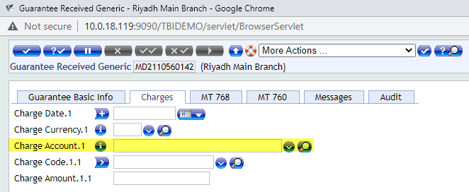
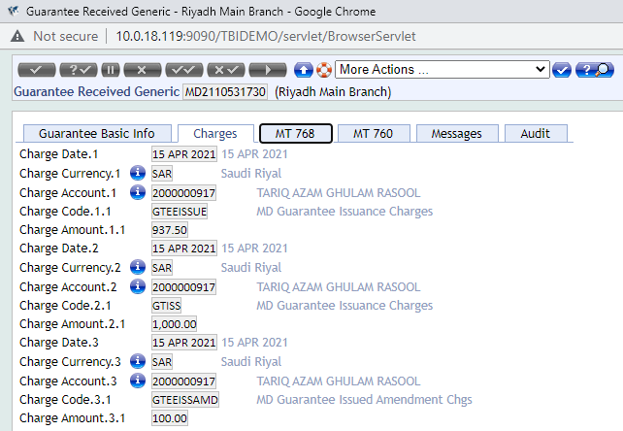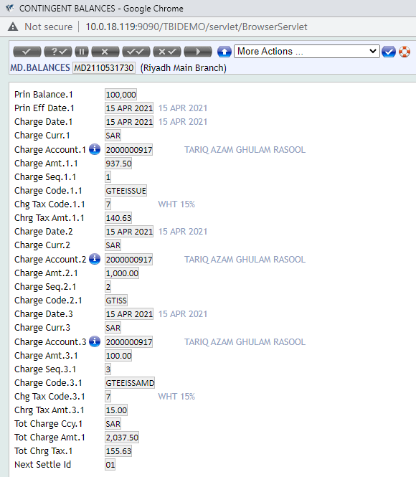
The transaction level process for commission claim / commission amortization. The screen shot illustration of this process is presented below for reference.
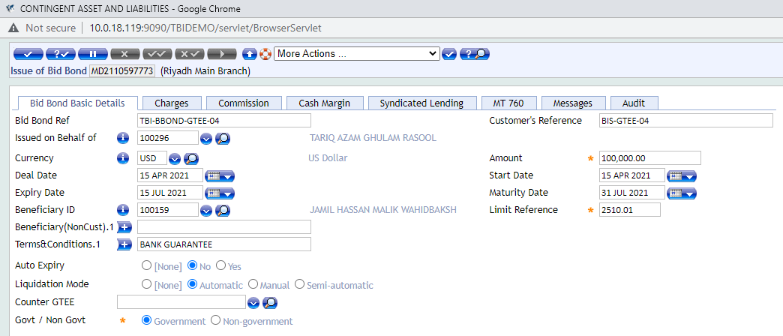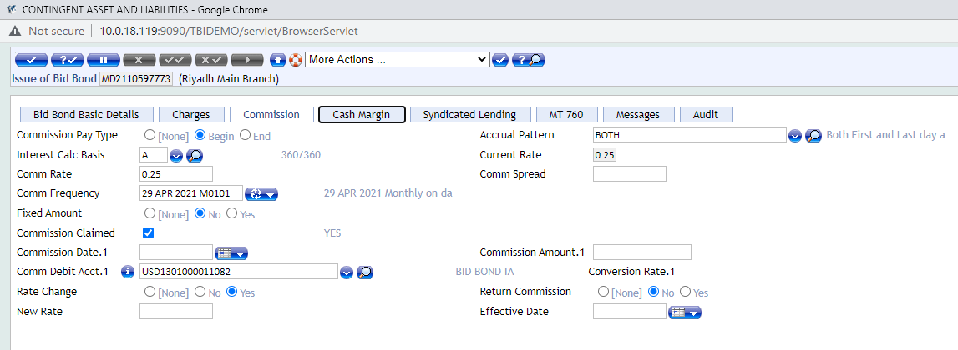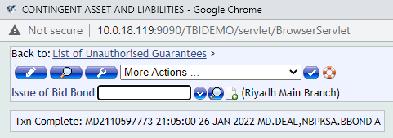
After the guarantee transaction is authorized then claim settlement process is to commence. The screen shot illustration of that process is also attached below for reference.
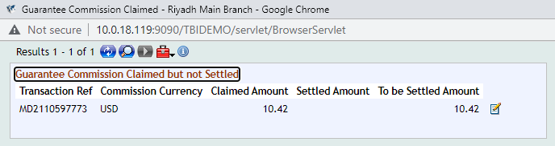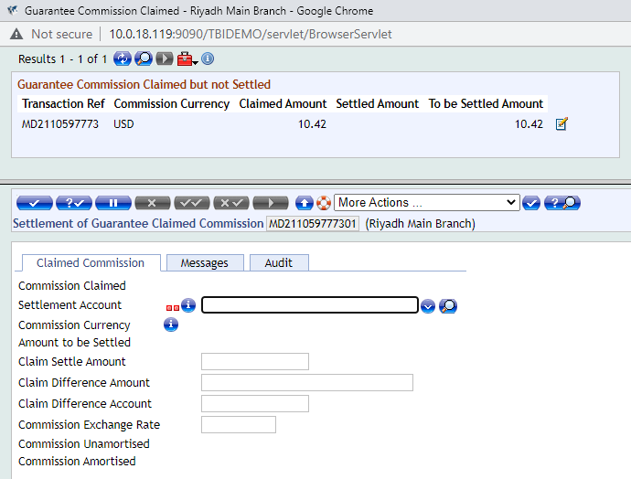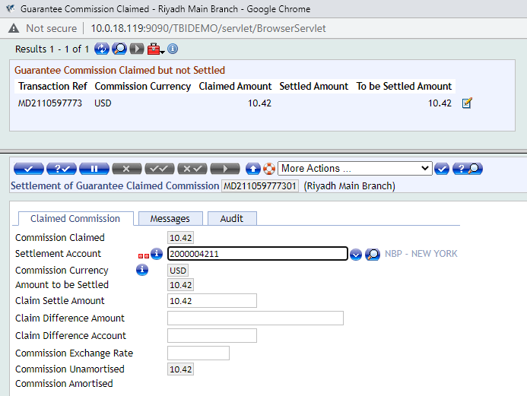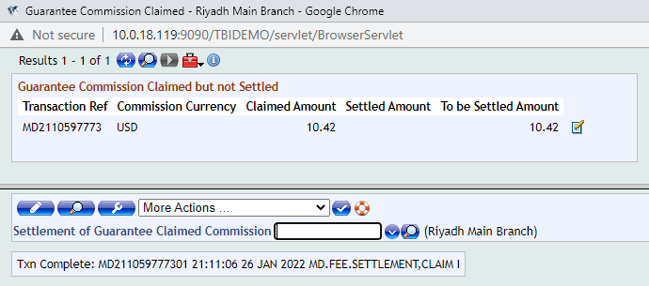

The core functionality for Amortisation/Accrual of Charges in MD.DEAL is stated below for reference.
The charges so defined in MD.DEAL can also be either amortised or accrued over a period of time. These charges, whether to be accrued or amortised, and the period over which these are to be accrued or amortised, etc., are defined in FT.COMMISSION.TYPE.
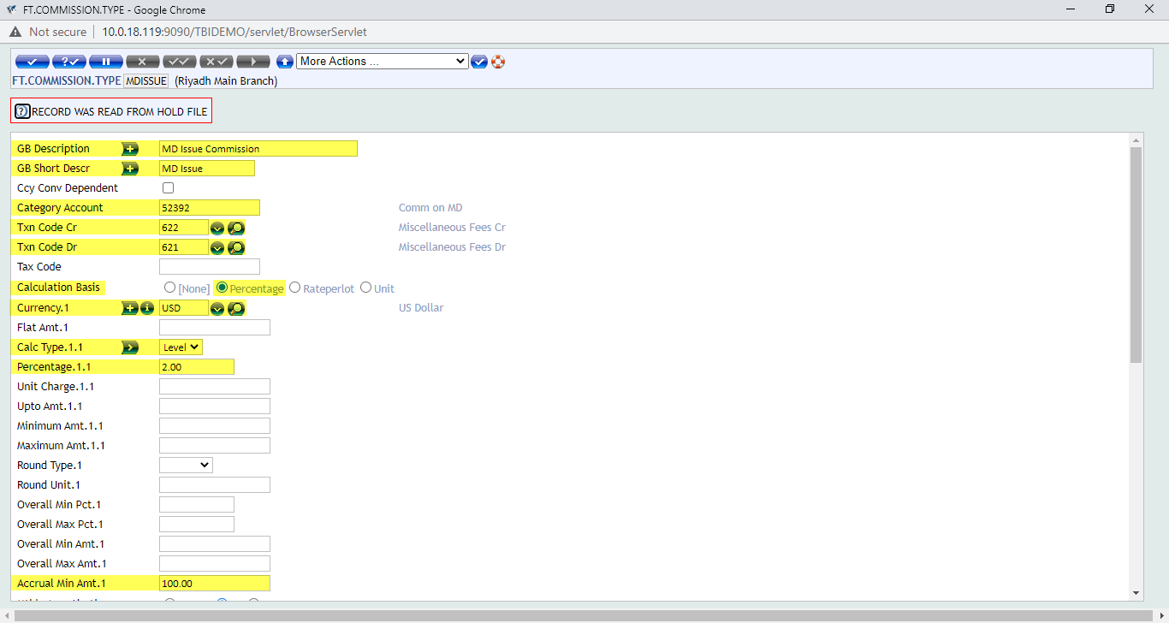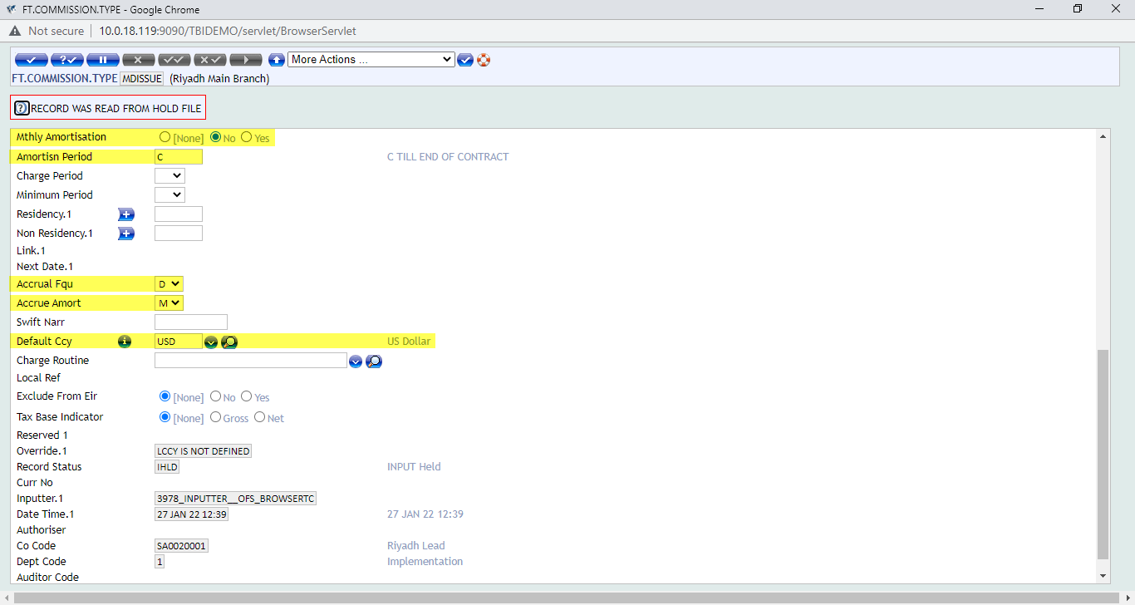
FT.COMMISSION.TYPE
If no values are defined in the above fields then the accrual of charge will not take place and P&L will be credited directly on the charge date.
When a charge where amortise or accrue is defined is attached to an MD contract, on authorisation the system creates a record in the EB.ACCRUAL application where all the details required by the core system to carry out the accrual process are updated. Further, Ids of all the EB.ACCRUAL records created for a contract are updated in a concat file called EB.ACCRUAL.CONCAT.
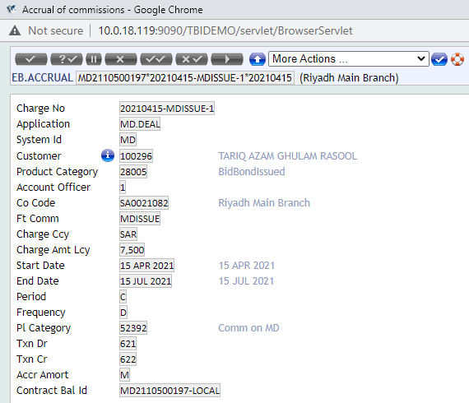
EB.ACCRUAL
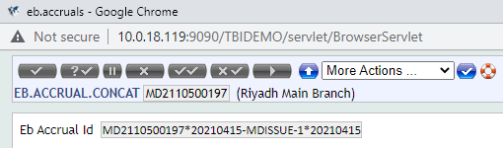
EB.ACCRUAL.CONCAT

The valid values that are accepted in the AMORTISN.PERIOD field in FT.COMMISSION.TYPE (FTC) that are defaulted in the field PERIOD in the EB.ACCRUAL record are "C" (Model Bank period), "R" (period between schedules), nM (number of months) and nA (number of years). The start date and end date of the amortisation or accrual depends on the value input in this field as detailed below:
It is to be noted that the enquiry for accrued/amortized charges against MD.DEAL can be based on the EB.ACCRUAL table. The fields which will be appearing in this enquiry are stated below in table form for reference. The report heads are at the top and their respective T24 field names are listed below.
Transaction Reference No: Field Name | Transaction Amount | Transaction Date | Accrued Charge Currency | Accrued Charge Amount | Accrual Amount For Amortized Charge | Event Reference
CONTRACT.BAL.ID | PRIN.BALANCE | START.DATE | CHARGE.CCY | CHARGE.AMT.LCY | ACCR.AMORT | PRODUCT.CATEGORY

Use Cases

Use Case
Variations | Expected Results
New Product “Warranty Guarantee” | After creating the new version of the “Warranty Guarantee” and doing the approprite setting at version level. The version will be placed in the “Guarantees Issued” HM in order for the transaction to be made available in the Guarantee Menu for the end user.

Use Case
Variations | Expected Results
Local Fields Required In Guarantee Issuance Versions | LT to be created for the local fields respectively. These LTs are to be then placed appropriately at the application level LRT for MD.Deal. Then once this is done then the LTs are to be added at the version level.

Use Case
Variations | Expected Results
Local Fields Required In Guarantee Received Versions | LT to be created for the local fields respectively. These LTs are to be then placed appropriately at the application level LRT for MD.Deal. Then once this is done then the LTs are to be added at the version level.

Use Case
Variations | Expected Results
Local Fields Required In Guarantee Received and Guarantee Claim Register Versions | LT to be created for the local fields respectively. These LTs are to be then placed appropriately at the application level LRT for MD.Deal. Then once this is done then the LTs are to be added at the version level.

Use Case
Variations | Expected Results
Issued Guarantee Amount and Expiry Date Should Not Exceed Counter-Guarantee Amount and Expiry | Error message check to be placed at transaction level. This can be achieved through customization.

Use Case
Variations | Expected Results
Fields Required In Enquiry | Respective fields to be mapped accordingly in the Guarantees Issued Outstanding Report

Use Case
Variations | Expected Results
Fields Required In Enquiry | Respective fields to be mapped accordingly in the Guarantees Received Outstanding Report

Use Case
Variations | Expected Results
Associate Version Required In Main Version of Pay/Reject Claim under Guarantee | MT799 swift message associate version to be added to the main version.

Use Case
Variations | Expected Results
Requirement MT799 Associate Version Required In Main Version of Guarantee Received | MT799 swift message associate version to be added to the main version.

Use Case
Variations | Expected Results
Claimed Charges Processing Under Guarantee Received | Manual Process Using Suspense Account And MD.BALANCES to track the status of the charges. These charges are also to be settled manually as well through FT (Funds Transfer).

Assumptions
1 - User has internet connection
2 - User has Browser & Valid URL
3 - User has Environment (T24) Access
4 - Bank provide SMTP credentials

Exclusions (Specific Functionality that is not covered by this Development)
- In the document the name of components are refer the other bank, just for understanding the current process.

Proposed Product Solution

Requirement Classification
Gap Reference | Description | Summary | Type of Gap
WS04-MD-01 TO 07.01 | New Product “Warranty Guarantee” | New Version To Be Created For The New Transaction Type And Placed In HM | Configuration
WS04-MD-01 TO 07.02 | Local Fields Required In Guarantee Issuance Versions | LT LRT Setup To Be Made At Version Level | Configuration
WS04-MD-18 TO 21.01 | Local Fields Required In Guarantee Received Versions | LT LRT Setup To Be Made At Version Level | Configuration
WS04-MD-18 TO 21.02 | Local Fields Required In Guarantee Received and Guarantee Claim Register Versions | LT LRT Setup To Be Made At Version Level | Configuration
WS04-MD-18 TO 21.03 | Issued Guarantee Amount and Expiry Date Should Not Exceed Counter-Guarantee Amount and Expiry | Validation check error message to generate at transaction level | Customization
WS04-MD-32.01 | Fields Required In Enquiry | Guarantees Issued Outstanding Report Field Mapping Required With MD.BALANCES table | Configuration
WS04-MD-33.01 | Fields Required In Enquiry | Guarantees Issued Outstanding Report Field Mapping Required With MD.BALANCES table | Configuration
WS04-MD-12.01 | Associate Version Required In Main Version of Pay/Reject Claim under Guarantee | MT799 Swift Message Option Required At Transaction Level | Configuration
WS04-MD-18 TO 21.04 | Requirement MT799 Associate Version Required In Main Version of Guarantee Received | MT799 Swift Message Option Required At Transaction Level | Configuration
WS04-MD-18 TO 21.05 | Claimed Charges Processing Under Guarantee Received | Claimed Charge Processing | Configuration

Existing Functionality

Topic 1 Existing Feature 1
Existing functionalities with screen shot is define below:

The existing functionality screen shots as well as the proposed solution with appropriate solution based screen shots as applicable to the specific issues are stated below for your reference.

Proposed New Product Functionality

Topic 1 WS04-MD-01 TO 07.01 New Product “Warranty Guarantee”

Summary/ Description
There is a requirement for a new guarantee type to be added in the list of guarantee products i.e. “Warranty Guarantee”. A new transaction version/screen will be created by the name of “Warranty Guarantee”. The new guarantee will be placed in the guarantees menu for the user to process the transaction like other guarantees that are part of the menu.

Existing Functionality
In the NBP-KSA environment we do not have a particular “Warranty Guarantee” type of guarantee in the different types of guarantee which are available in the “Guarantees Issued” sub-menu of the main guarantees menu. Please find attached below are the screen shots of the existing functionality:

Proposed Functionality
In order to incorporate the “Warranty Guarantee” in the guarantees menu. A new guarantee issuance version by the name of “Warranty Guarantee” has to be created in the system and also that all the development which have to be made have to also be incorporated in this version. Also, then this version has to be inserted in the “HM” HELPTEXT.MENU.

Topic 1 WS04-MD-01 TO 07.02 Local Fields Required In Guarantee Issuance Versions

Summary/ Description
There is a requirement for “free text local fields” to be made available at the guarantee issuance step. These fields include the “Beneficiary Country” fields to which we can add the country table and make it a drop-down field. Also, counter guarantee reference field is also required in the guarantee issuance screen which is already available in the NBP-KSA environment. The same fields to be reflect in the Guarantee Issued Outstanding Report.

Existing Functionality
Currently in NBP-KSA environment the field “Counter Guarantee Reference” is available at transaction level. This fields shows the “Guarantee Received” records in the form of drop-down field. The “Beneficiary Country” though, is currently not available in the system. Screen shots of the existing functionality in the system are attached below for your reference.

Proposed Functionality
In the guarantees menu when end user click on the guarantee issuance option and select the type of guarantee which is to be processed. The transaction processing screen will open and in the screen are the fields available for the user to input the relevant data pertaining to the transaction. The local fields will be made available on the main screen tab “Guarantee Basic Details”. The same fields to be reflect in the Guarantee Issued Outstanding Report.
In the system “LT” record for “Beneficiary Country” field has to be created and then it has to be attached in the MD.DEAL “LRT”. The screen shot of the simulated/projected result are attached below for your reference. After that these records are also to be attached version level as well so that they can appear on the transaction screen. The projected /simulated version of the transaction after the above activity has been performed is attached below for your reference.

Topic 1 New Product WS02-AR-01.03 Open Current Account

Summary/ Description
There is a requirement for “free text local fields” to be made available at the guarantee issuance step. These fields include the “Type Of Gtee” which could be free text field as well as “Issuer’s Country” fields to which we can add the country table and make it a drop-down field. The same fields to be reflect in the Guarantee Received Outstanding Report.

Existing Functionality
Currently in the NBP-KSA do not have the above stated fields available in the “Guarantee Received” menu. The screen shot of the existing transaction screen is attached below for reference:

Proposed Functionality
In the guarantees menu when end user click on the guarantee received option and select the guarantee received transaction. The transaction processing screen will open and in the screen are the fields available for the user to input the relevant data pertaining to the transaction. The local fields will be made available on the main screen tab “Guarantee Basic Info”.
This can be incorporated and made part of the transaction screen by creating “LT” LOCAL.TABLE records for “Type Of Gtee” field and “Issuer’s Country” field. After creating these LT records in the system they have to be attached in the “LRT” of “MD.DEAL”. After that these records are also to be attached version level as well so that they can appear on the transaction screen. The projected /simulated version of the transaction after the above activity has been performed is attached below for your reference.

Topic 1 WS04-MD-18 TO 21.02 Local Fields Required In Guarantee Received and Guarantee Claim Register Versions

Summary/ Description
There is a requirement for “free text local fields” to be made available at the guarantee received step and also the guarantee received claim register step. These fields include the “Applicant Name” which would be a free text field as well as “Applicant Country” fields to which we can add the country table and make it a drop-down field.

Existing Functionality
Currently in the “Guarantee Received” as well as the “Guarantee Received Claim Register” version there are no such fields available to capture the required information. The illustration of the current transaction screen is attached below for reference.

Proposed Functionality
In the guarantees menu when end user click on the guarantee received option and select the guarantee received transaction. The transaction processing screen will open and in the screen are the fields available for the user to input the relevant data pertaining to the transaction. The local fields will be made available on the main screen tab “Guarantee Basic Info”. In the claim register under guarantee screen these fields will reflect in the “Initiate Claim” tab.
This can be incorporated and made part of the transaction screen by creating “LT” LOCAL.TABLE records for “Applicant Name” field and “Applicant Country” field. After creating these LT records in the system they have to be attached in the “LRT” of “MD.DEAL”. After that these records are also to be attached version level as well so that they can appear on the transaction screen. The projected /simulated version of the transaction after the above activity has been performed is attached below for your reference.

Topic 1 WS04-MD-18 TO 21.03 Issued Guarantee Amount and Expiry Date Should Not Exceed Counter-Guarantee Amount and Expiry

Summary/ Description
There is a requirement from the client to place an error message check for the transaction scenario when a guarantee is being issued against a counter-guarantee which has been processed in the system through the “Guarantee Received” functionality.

Existing Functionality
Currently in the “Guarantee Issued” version there are no such functionality available to check this kind of transaction scenario. The current illustration of the existing guarantee issuance step in the form of screen shots is attached below for reference:

Proposed Functionality
Once inward guarantee is received it is to be processed in the system and then another guarantee is to be issued against the received guarantee. The error message check is to be placed at the transaction level so that once user input the transaction details like the amount and expiry date in the respective fields. If the amount or expiry date or both values entered by the user exceed the amount and expiry date of the guarantee received record tagged with the transaction then system should give an error message. The illustration of the suggested below in form of screen shots for reference.

Once inward guarantee is received it is to be processed in the system and then another guarantee is to be issued against the received guarantee. The error message check is to be placed at the transaction level so that once user input the transaction details like the amount and expiry date in the respective fields. If the amount or expiry date or both values entered by the user exceed the amount and expiry date of the guarantee received record tagged with the transaction then system should give an error message.

Field Names:
- Guarantee Amount: PRINCIPAL.AMOUNT
- Expiry Date: ADVICE.EXPIRY.DATE

Version Names For Guarantee Received:

- Guarantee Received Generic: MD.DEAL,GTREC
- Guarantee Received Covering Facility: MD.DEAL,GTREC
- Amendment to Guarantee Received: MD.DEAL,GTRECAMD

Versions Names For Guarantee Issued:

- Issue of Bank Guarantee: MD.DEAL,NBPKSA.GTISS
- Issue of Bid Bond: MD.DEAL,NBPKSA.BBOND
- Issue of Performance Bond: MD.DEAL,NBPKSA.PBOND
- Issue of Stand By Import LCs: MD.DEAL,NBPKSA.STDBY
- Issue of Advance Payment GTEE: MD.DEAL,NBPKSA.ADVPAY.INP
- Issue of Financial Guarantee: MD.DEAL,NBPKSA.FINGTEE.INP
- Issue of One OFF GTEE: MD.DEAL,NBPKSA.ONEOFF.INP
- Issue Shipping Guarantee under LC: MD.DEAL,SHIPGLC
- Issue Shipping Guarantee under Import Collection Document: MD.DEAL,SHIPGCOLL

Topic 1 WS04-MD-32.01 Fields Required In Enquiry

Summary/ Description
There is a requirement for fields to be mapped from MD.BALANCES table in the Guarantee Issued Outstanding Report. The Guarantee Issued Outstanding Report is a core enquiry. It displays the status of all the issued guarantee that are currently live in the system and have not expiry/settled/closed. The fields which are required to be mapped in this enquiry are to be extracted from MD.BALANCES table and the names of these fields are stated below:
CHARGE.DATE
CHARGE.CURR
CHARGE.CODE
CHARGE.AMOUNT
The Guarantee Issued: The screen shots of the transaction screens with these fields is attached below for reference.

Existing Functionality
The screen shots of the existing report is attached below for reference.

Proposed Functionality
The Guarantees Issued Outstanding Enquiry/Report is a part of core functionality. Through this enquiry the user can get the company-wise all live records of guarantees issued from the system that are either settled or closed or reversed or expired. The proposed solution to the issue is to map the above stated fields from MD.BALANCES table into the Guarantees Issued Outstanding Report.
Transaction Ref | Mnemonic | Customer Id | Type | Issue Date | Ccy | Amount | Beneficiary | Expiry Date | MAT Date | Margin %Age | Margin AMT | Reference | Charge Date | Charge Ccy | Charge Amt | Charge Code
MD2110531730 | C100296 | 100296 | BBOND | 15-Apr-21 | USD | 100,000.00 | BAJZ | 30-Jun-21 | 29-Jul-21 | 0 | 0 | TBI-GTEE-04 | 15-Apr-2021 | SAR | 937.50 | GTEEISS

Topic 1 WS04-MD-33.01 Fields Required In Enquiry

Summary/ Description
There is a requirement for fields to be mapped from MD.BALANCES table in the Guarantee Received Outstanding Report. The Guarantee Received Outstanding Report is a core enquiry. It displays the status of all the received guarantees that are currently live in the system and have not expiry/reversed/settled/closed. The fields which are required to be mapped in this enquiry are to be extracted from MD.BALANCES table and the names of these fields are stated below:
CHARGE.DATE
CHARGE.CURR
CHARGE.CODE
CHARGE.AMOUNT

Existing Functionality
The screen shots of the existing enquiry/report is attached below for reference.

Proposed Functionality
The Guarantees Received Outstanding Enquiry/Report is a part of core functionality. Through this enquiry the user can get the company-wise all live records of guarantees received from the system that are either settled or closed or reversed or expired. The proposed solution to the issue is to map the above stated fields from MD.BALANCES table into the Guarantees Received Outstanding Report.

Transaction Ref | Mnemonic | Customer Id | Type | Issue Date | Ccy | Amount | Beneficiary | Expiry Date | MAT Date | Margin %Age | Margin AMT | Reference | Charge Date | Charge Ccy | Charge Amt | Charge Code
MD2110531730 | C100296 | 100296 | BBOND | 15-Apr-21 | USD | 100,000.00 | BAJZ | 30-Jun-21 | 29-Jul-21 | 0 | 0 | TBI-GTEE-04 | 15-Apr-2021 | SAR | 937.50 | GTEEISS

Topic 1 WS04-MD-12.01 Associate Version Required In Main Version of Pay/Reject Claim under Guarantee

Summary/ Description
There is a requirement for MT-799 swift message option to be added to the guarantee claim payment payment/rejection step. This can be achieved by adding the associate version of the MT-799 swift message to the main version of Guarantee Pay/Reject Claim version. The version names are stated below for your reference:
Main Version Name: MD.DEAL,GTINVEXE and MD.DEAL,GTINVCAN
Associate Version: MD.DEAL,IN.MT799

Existing Functionality
In the existing functionality, in both Claim Payment and Claim Reject versions of guarantees issued the option of MT-799 swift message is not part of the transaction. The screen shots of the existing tranaction screen shots are attached below for reference.

Proposed Functionality
At Invocation Claim Version; Add version Of MT-799. The details of the versions are stated above. The screen shot of the associate version which is to be attached with the main version in present below for reference.

Topic 1 WS04-MD-18 TO 21.04 MT799 Associate Version Required In Main Version of Guarantee Received

Summary/ Description
There is a requirement for MT-799 swift message option to be added to the guarantee received transaction step. This can be achieved by adding the associate version of the MT-799 swift message to the main version of Guarantee Pay/Reject Claim version. The version names are stated below for your reference:

Main Version Name: MD.DEAL,GTREC, MD.DEAL,GTFAC AND MD.DEAL,GTREC
Associate Version: MD.DEAL,IN.MT799

Existing Functionality
At present, the transaction screen shots are attached below where it can be clearly that the option of sending MT-799 swift message is not available at transaction level.

Proposed Functionality
At Guarantee Received Version; Add version Of MT-799. The details of the versions are stated above. The screen shot of the associate version which is to be attached with the main version in present below for reference.

Topic 1 WS04-MD-18 TO 21.05 Claimed Charges Processing Under Guarantee Received

Summary/ Description
There is a requirement for catering to the claimed charges processing for guarantees received. In case where customer A/C is not to be debited against charges that are pertaining to the transaction. The process of the claim charges treatment is stated below:

Under Guarantee Received Charges:

Accounting Entry for Claimed Charges
Debit Suspense
And Credit P/L

Then Settle the Entry After Funds Are Received In Nostro Account Nostro A/C Debit
And Suspense Account Credit.
(Settlement will be done manually by user by Fund Transfer)

Existing Functionality
There is no process in place in T24 to handle the Claim Charge Processing in an automated manner and also no screen shots are available.

Proposed Functionality
The charges tab is available in the guarantee received transaction screen/version. End user can manually enter the suspense A/C number which is to be debited against the charge in the transaction.
The screen shots are attached below for reference. Please note that this is simulated version of a proposed solution and this is it supposed to appear on the T24 screen.

The transaction level process for commission claim / commission amortization. The screen shot illustration of this process is presented below for reference.
After the guarantee transaction is authorized then claim settlement process is to commence. The screen shot illustration of that process is also attached below for reference.

The core functionality for Amortisation/Accrual of Charges in MD.DEAL is stated below for reference.
The charges so defined in MD.DEAL can also be either amortised or accrued over a period of time. These charges, whether to be accrued or amortised, and the period over which these are to be accrued or amortised, etc., are defined in FT.COMMISSION.TYPE.
FT.COMMISSION.TYPE
If no values are defined in the above fields then the accrual of charge will not take place and P&L will be credited directly on the charge date.
When a charge where amortise or accrue is defined is attached to an MD contract, on authorisation the system creates a record in the EB.ACCRUAL application where all the details required by the core system to carry out the accrual process are updated. Further, Ids of all the EB.ACCRUAL records created for a contract are updated in a concat file called EB.ACCRUAL.CONCAT.
EB.ACCRUAL
EB.ACCRUAL.CONCAT

The valid values that are accepted in the AMORTISN.PERIOD field in FT.COMMISSION.TYPE (FTC) that are defaulted in the field PERIOD in the EB.ACCRUAL record are "C" (Model Bank period), "R" (period between schedules), nM (number of months) and nA (number of years). The start date and end date of the amortisation or accrual depends on the value input in this field as detailed below:
It is to be noted that the enquiry for accrued/amortized charges against MD.DEAL can be based on the EB.ACCRUAL table. The fields which will be appearing in this enquiry are stated below in table form for reference. The report heads are at the top and their respective T24 field names are listed below.
Transaction Reference No: Field Name | Transaction Amount | Transaction Date | Accrued Charge Currency | Accrued Charge Amount | Accrual Amount For Amortized Charge | Event Reference
CONTRACT.BAL.ID | PRIN.BALANCE | START.DATE | CHARGE.CCY | CHARGE.AMT.LCY | ACCR.AMORT | PRODUCT.CATEGORY

Accounting
Standard T24 contingent entries

Limits
Standard T24 Contingent Entries.

COB Processing
N/A

Test Cases and Expected Results
Test Case

New Tables
N/A

[Table Name]
[Please refer to the naming conventions guide for naming the template. Please repeat the following set of Table Properties, Layout, Field Checks, Cross validation Checks, Other processing and Insert files for each Table]

Table Properties
No. | Property | Definition
1 | Name
2 | Product
2 | File Type
3 | Classification

Table Layout
No. | Field Name | IN2 & Edit | Description | Width

Field Checks
S.No | Name of the field | Check’s to be done

Cross Validation Checks
N/A

Other Processing
N/A

INSERT Files
N/A

Subroutines
N/A

Subroutine Name
[Please refer to the Naming convention guide for naming of subroutines. Please provide the following detailed information for creation of Subroutine]
Property | Specification
Type
Attached To
Attached As
Dependency
Description
Arguments – IN
Arguments – OUT
Prelim Conditions
Subroutine Flow
Special Instructions

Data Records
N/A

LOCAL.TABLE

Local Reference Name
For other applications the below mentioned set is used.
No. | Field | Definition
1 | @ID
1.1 | Description
1.2 | Short Name
1.3 | Max. Char
1.4 | Min. Char
1.5 | Char Type
1.6 | Vetting Table
1.7 | Application
1.8 | Enri. Field

LOCAL.REF.TABLE
Application | Local Ref | Association

I-DESCRIPTORS
N/A

STANDARD.SELECTION

API 1

API Details
N/A
https://confluence.temenos.com/display/IRFS/4.+REST+Style+Guide >>
Method | POST
URI  (includes api version , domain & Resource names) | Expected URI – Ex. /v1.0.0/party/customers/
T24 Artefact name | <Model Bank Artefact Name>
Functionality Description | <Description for the API to be added in the developer portal. This gives the functional description of the API>
Operation | <unique operation id> like getCustomerDetails
Domain | holdings|order|meta|party|product|reference  <should be one of the existing domains>
API Group names | Format : <domain>-<resource>-<subresource>-service  Ex. holdings-accounts-service, holdings-customers-service, party-customers-messages-service

New/Modified artefact details
<<This section will be filled with the required new enquiry/version details in case the API is not based on an existing Model Bank artefact. All the required field names and its functions should be mentioned in the section.
In case of slight modifications to the existing artefacts, then the existing artefact name and the required additional details for modification should be specified>>

Input fields
<To be filled in whenever the API gets an input from the consumer of the API>
Application Field Name | Display Type  (ALPHANUMERIC, AMOUNT, DATE, TIMESTAMP, BOOLEAN) | Label Name ( Vocabulary)  <to be filled in Enquiry/Version> | Additional Details | Description
The field name in T24 model bank artefact. | The data type of the field | The field name to be used in the API <as per REST API and IRIS vocabulary standards> | Details regarding whether mandatory input or optional input. Other details about the field if any. | The functional description to be added in the API documentation. The description should be functional and not in T24 language.

Output fields
<To be filled in whenever the API returns enquiry or version details. Mostly in case of GET APIs>
Application Field Name | Display Type  (ALPHANUMERIC, AMOUNT, DATE, TIMESTAMP, BOOLEAN) | Label Name ( Vocabulary)  <to be filled in Enquiry/Version> | Additional Details | Description
The field name in T24 model bank artefact. | The data type of the field | The field name to be used in the API <as per REST API and IRIS vocabulary standards> | Details regarding Other details about the field if any. | The functional description to be added in the API documentation. The description should be functional and not in T24 language.

Dependant and Related APIs
<<This section includes references to FSDs, other documents and any information about APIs that are related/dependant on this enhancement. For example, a vetting table that is used in the Version for which an API is built.
This also includes information about APIs that this API is dependent on>>
API Documentation Guidelines produced by Knowledge Team is embedded herewith for reference and adoption.

L3 API Hook requirements
<<This section relates to any features to be exposed from within the L1 product level to enable L3 customisation of the core functionality for the new feature or enhancement. This section should detail the need for any L3 APIs/hooks and use cases that are envisaged at the L3 level. This could be based on the usage of any existing L1 jBC methods that will be needed by Java Implementation clients, who will no longer be able to make use of any L1 jBC methods directly>>

Functionality Point Matrix
N/A

<< Functionality Matrix is the traceability till FSD and Test Cases starting from BRD. Mention the Section ID and the Description of the Requirement under BRD column, Section ID and the Description of the Functionality under FSD column and the mapping Test cases under Test Cases column with relevant test case ID>> ( mandatory for all client specific developments)
BRD | FSD | Test Cases

<<Note: In case any of above sections are not updated, because they are not relevant to the enhancement, they can be removed from the final version of the FS document sent to the client (only if the below pre-requisites are met. Care to be ensured that the sections are not missed for the enhancement and are in-line with the requirements agreed with the Client.
Pre-requisites:
• Frozen BRD
• Reviewed and baselined FS>>

