Team:   
Venkatesh Duvvuri ([VED14@pitt.edu](mailto:VED14@pitt.edu))

Haifa Alnasser([HIA11@pitt.edu](mailto:HIA11@pitt.edu" \t "_blank))

Gopi Tata([GKT3@pitt.edu](mailto:GKT3@pitt.edu))

1. House Votes Manual Model (House Votes Manual.xdsl
2. Overall classification accuracy = 0.967816

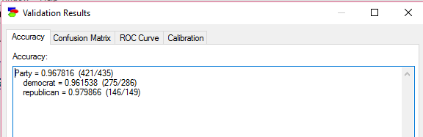

1. Sensitivity and specificity for each of the two parties
   1. 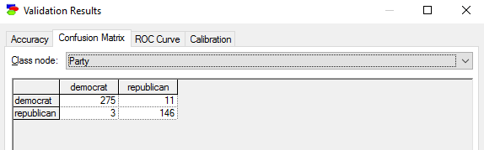The Confusion Matrix is
2. Sensitivity of Democrat = 275/ (275 + 3) = 275/278 = 0.9892
3. Specificity of Democrat = 146/ (146 + 11) = 146/157 = 0.9299
4. Sensitivity of Republican = 146/ (146 + 11) = 146/157 = 0.9299
5. Specificity of Republican = 275/ (275 + 3) = 275/286 = 0.9892
6. Positive and negative predictive value for each of the two parties
   1. Positive Predictive value of Democrat = 275/(275 + 11) =

275/286 = 0.9615

* 1. Negative Predictive Value of Democrat = 146/(146+3) =

146/149 = 0.9798

* 1. Positive Predictive value of Republican = 146/(146+3) =

146/149 = 0.9798

* 1. Negative Predictive value of Republican = 275/(275 + 11) =

275/286 = 0.9615

1. Calibration curve for a selected bin count or window size
   1. Bin count = 10
   2. For Democrat Party

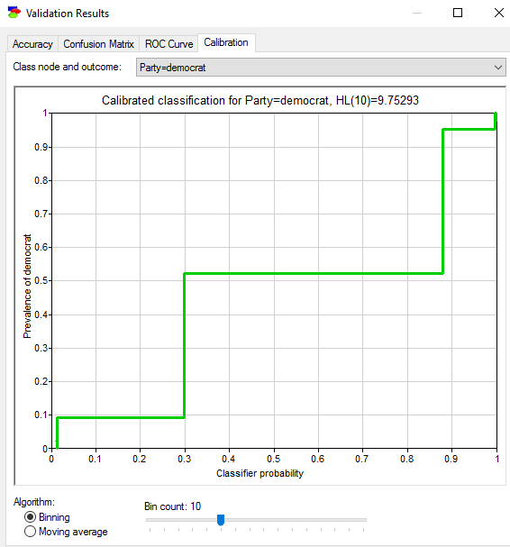

* 1. For Republic Party:

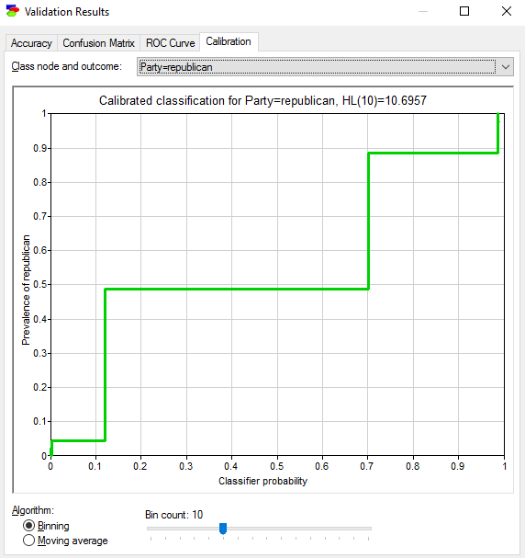

1. House Votes naïve Model: (House Votes Naive.xdsl)
2. Overall classification accuracy = 0.995402

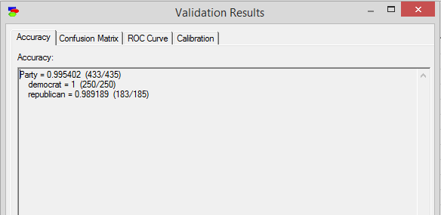

1. Sensitivity and specificity for each of the two parties
   1. 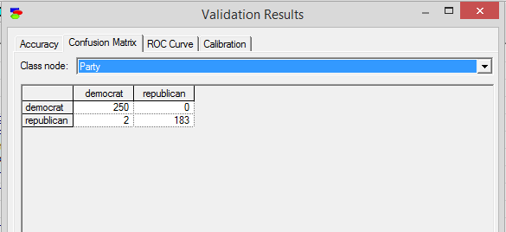Confusion Matrix is
2. Sensitivity of Democrat = 250/ (250 + 2) = 250/252 = 0.9920
3. Specificity of Democrat = 183/ (183 + 0) = 183/183 = 1
4. Sensitivity of Republican = 183/ (183 + 0) = 183/183 = 1
5. Specificity of Republican = 250/ (250 + 2) = 250/252 = 0.9920
6. Positive and negative predictive value for each of the two parties
   1. Positive Predictive value of Democrat = 250/(250 + 0) =

250/250 = 1

* 1. Negative Predictive Value of Democrat = 183/(183+2) =

183/185 = 0.9891

* 1. Positive Predictive value of Republican = 183/(183+2) =

183/185 = 0.9891

* 1. Negative Predictive value of Republican = = 250/(250 + 0) =

250/250 = 1

1. Calibration curve for a selected bin count or window size
   1. Bin count = 10
   2. For Democrat Party

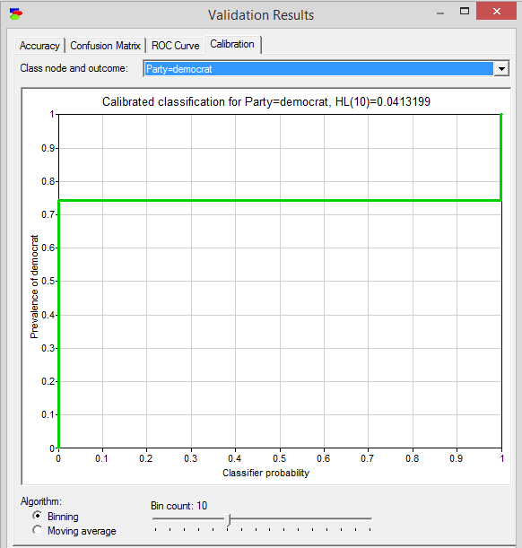

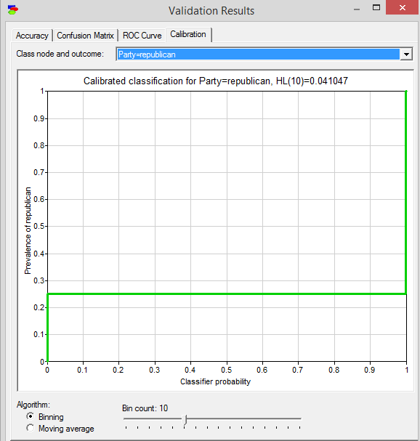

C. For Republic Party:

1. House Votes PC Model (House Votes PC.xdsl)  
     
   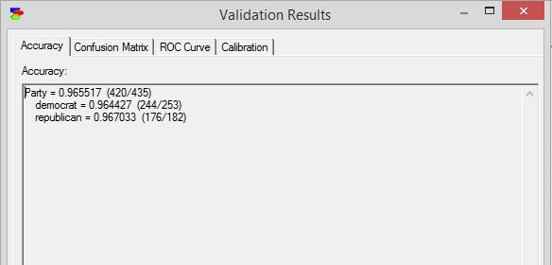
2. Overall classification accuracy = 0.965517
3. Sensitivity and Specificity for each of the two parties
   1. Confusion Matrix is

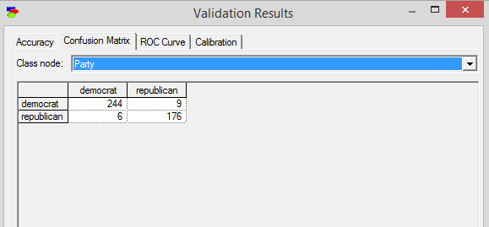

1. Sensitivity of Democrat = 244/ (244 + 6) = 244/250 = 0.9760
2. Specificity of Democrat = 176/ (176 + 9) = 176/185 = 0.9513
3. Sensitivity of Republican = 176/ (176 + 9) = 176/185 = 0.9513
4. Specificity of Republican = 244/ (244 + 6) = 244/250 = 0.9760
5. Positive and negative predictive value for each of the two parties
   1. Positive Predictive value of Democrat = 244/(244 + 9) =

244/253 = 0.9644

* 1. Negative Predictive Value of Democrat = 176/(176+6) =

176/182 = 0.9670

* 1. Positive Predictive value of Republican = 176/(176+6) =

176/182 = 0.9670

* 1. Negative Predictive value of Republican 244/(244 + 9) =

244/253 = 0.9644

1. Calibration curve for a selected bin count or window size
   1. Bin count = 10
   2. For Democrat Party

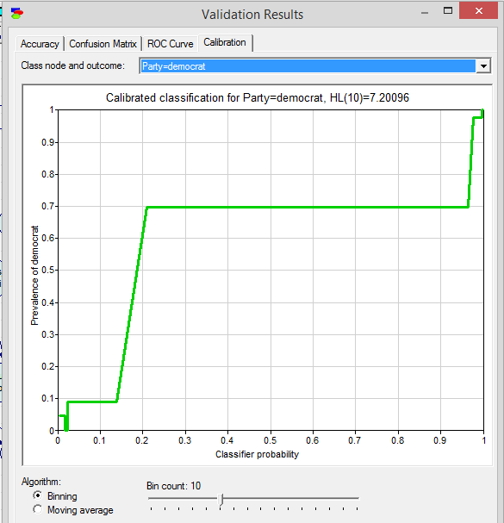

C. For Republic Party:

