**Assignment 6: Probabilistic Approaches**

**Team:**

Venkatesh Duvvuri ([VED14@pitt.edu](mailto:VED14@pitt.edu))

Haifa Alnasser([HIA11@pitt.edu](mailto:HIA11@pitt.edu))

Gopi Tata ([GKT3@pitt.edu](mailto:GKT3@pitt.edu))

Summary:

We have gathered the data from internet (as mentioned at the end the various links) of the consumption of Chocolates, alcohol, meat, coffee and tea per capita of various countries that the author has chosen for studying the relationship between the chocolates and Nobel laureates.

First we processed the relationship between the Chocolate consumption per capita of the selected countries and could see there is a correlation between these variables and which is close to what the author has found. We observed a positive strong correlation with a correlation coefficient of 0.7287.

Later on processed the other data to see if there is any correlation between Nobel Laureates and consumption of other food namely coffee, tea, alcohol or meat. Similarly there is to some extent strong positive correlation has been observed between coffee consumption and Nobel laureates with a correlation coefficient of 0.5888 and a lesser positive relationship between (correlation coefficient of 0.2898) meat consumption and Nobel laureates.

The reason for strong correlation between Nobel laureates and consumption of Chocolate or coffee we believe that due to the common brain stimulant, called caffeine. In other words coffee consumption and Chocolate consumption observed to be giving a common effect of increased Nobel laureates.

Also we observed that there is a weak negative correlation between alcohol consumption and Nobel Laureates (correlation coefficient of -0.0725) and negligible correlation between tea consumption and Nobel laureates (correlation coefficient of 0.0026).

Causal Chain:

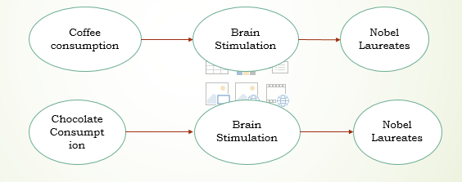

Common Effect:

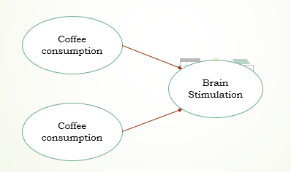

Explain Away Effect:

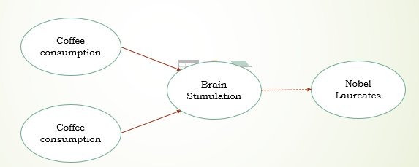

**Data for chocolate, alcohol, coffee, meat, tea and Nobel prizes in 23 countries:**  
Reading the file:

Nobel <- read.csv("nobel_fourvar.csv", header = TRUE)

Data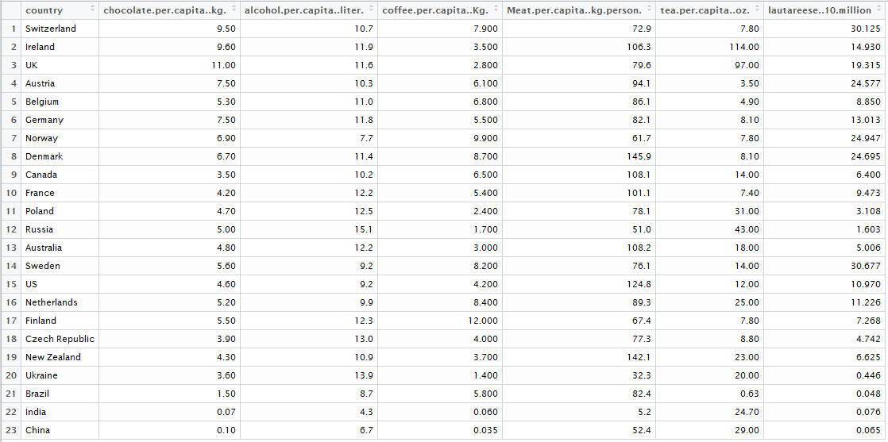: View(Nobel)

1. Analysis Replication : Correlation between **chocolate** consumption and Nobel laureates

> nobel_prize = Nobel$lautareese..10.million

> chocolatepercapita = Nobel$chocolate.per.capita..kg.

> chocolatepercapita

[1] 9.50 9.60 11.00 7.50 5.30 7.50 6.90 6.70 3.50 4.20 4.70 5.00 4.80

[14] 5.60 4.60 5.20 5.50 3.90 4.30 3.60 1.50 0.07 0.10

> Chocolatecorrelation= cor(chocolatepercapita, nobel_prize)

> Chocolatecorrelation

[1] 0.7287111

> plot(chocolatepercapita, nobel_prize)

> abline(lm(nobel_prize ~ chocolatepercapita))

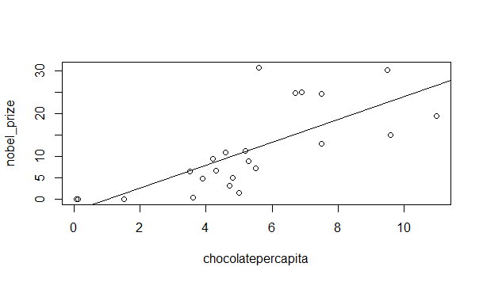

1. Correlation between **alcohol** consumption and Nobel laureates

> alcoholpercapita = Nobel$alcohol.per.capita..liter.

> alcoholpercapita

[1] 10.7 11.9 11.6 10.3 11.0 11.8 7.7 11.4 10.2 12.2 12.5 15.1 12.2 9.2 9.2 9.9

[17] 12.3 13.0 10.9 13.9 8.7 4.3 6.7

> alcoholcorrelation= cor(alcoholpercapita, nobel_prize)

> alcoholcorrelation

[1] -0.07253954

> plot(alcoholpercapita, nobel_prize)

> abline(lm(nobel_prize ~ alcoholpercapita))

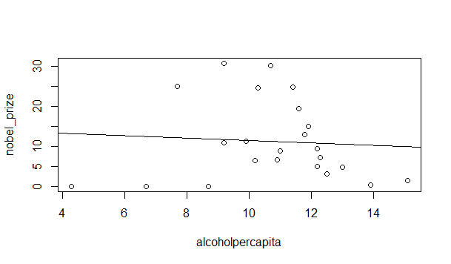

1. Correlation between **coffee** consumption and Nobel laureates

> coffeepercapita = Nobel$coffee.per.capita..Kg.

> coffeepercapita

[1] 7.900 3.500 2.800 6.100 6.800 5.500 9.900 8.700 6.500 5.400 2.400

[12] 1.700 3.000 8.200 4.200 8.400 12.000 4.000 3.700 1.400 5.800 0.060

[23] 0.035

> coffeecorrelation= cor(coffeepercapita, nobel_prize)

> coffeecorrelation

[1] 0.588828

> plot(coffeepercapita, nobel_prize)

> abline(lm(nobel_prize ~ coffeepercapita))

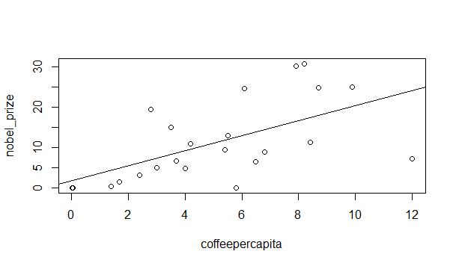

1. Correlation between **meat** consumption and Nobel laureates

> meatpercapita = Nobel$Meat.per.capita..kg.person.

> meatpercapita

[1] 72.9 106.3 79.6 94.1 86.1 82.1 61.7 145.9 108.1 101.1 78.1 51.0 108.2

[14] 76.1 124.8 89.3 67.4 77.3 142.1 32.3 82.4 5.2 52.4

> meatcorrelation= cor(meatpercapita, nobel_prize)

> meatcorrelation

[1] 0.2898139

> plot(meatpercapita, nobel_prize)

> abline(lm(nobel_prize ~ meatpercapita))

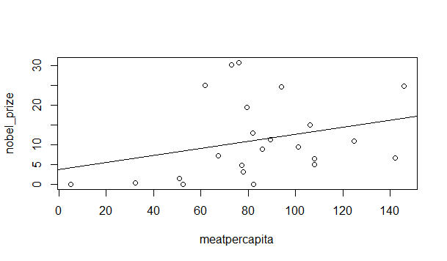

1. Correlation between **tea** consumption and Nobel laureates

> teapercapita = Nobel$tea.per.capita..oz.

> teapercapita

[1] 7.80 114.00 97.00 3.50 4.90 8.10 7.80 8.10 14.00 7.40 31.00

[12] 43.00 18.00 14.00 12.00 25.00 7.80 8.80 23.00 20.00 0.63 24.70

[23] 29.00

> teacorrelation= cor(teapercapita, nobel_prize)

> teacorrelation

[1] 0.002627898

> plot(teapercapita, nobel_prize)

> abline(lm(nobel_prize ~ teapercapita))

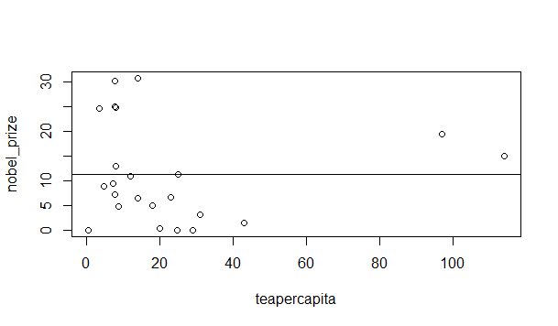

**References:**

<http://www.icco.org/about-us/international-cocoa-agreements/cat_view/30-related-documents/45-statistics-other-statistics.html>

<http://en.wikipedia.org/wiki/List_of_countries_by_Nobel_laureates_per_capita>

<http://www.ico.org/documents/cy2014-15/icc-115-7e-study-china.pdf>

http://www.icco.org/about-us/international-cocoa-agreements/cat_view/30-related-documents/45-statistics-other-statistics.html

http://en.wikipedia.org/wiki/List_of_countries_by_Nobel_laureates_per_capita

<http://www.ico.org/documents/cy2014-15/icc-115-7e-study-china.pdf>

List of countries by **alcohol** consumption per capita  
<https://en.wikipedia.org/wiki/List_of_countries_by_alcohol_consumption_per_capita>

## Amount of chocolate consumed per person in 2011, by country (in kilograms)

<http://www.statista.com/statistics/262981/amount-of-chocolate-consumed-per-person-by-country/>

List of countries by **coffee** consumption per capita  
<https://www.google.com/fusiontables/DataSource?docid=1C-fn6nSe21acP0xJIO1T1x0wohqfMYCQyJjbqdk#rows:id=1>

List of countries by **tea** consumption per capita  
<https://en.wikipedia.org/wiki/List_of_countries_by_tea_consumption_per_capita>

List of countries by **meat** consumption per capita  
https://en.wikipedia.org/wiki/List_of_countries_by_meat_consumption