**Node in a Linked List:**

A node in a linked list basically has two parts.   
-one part holds the data of the node.  
-other part holds the address of the next node.

A node class written in c++

*class node   
{  
 public:  
  int data;  
  node *next;  
};*

We will discuss node in detail. Just have a look at the code for now.

After looking at the code you might be wondering how does a node looks like.

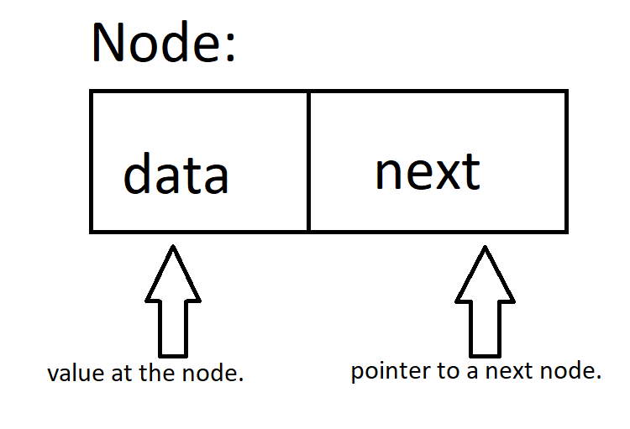Diagrammatical representation of a node.

Now you know what a node is.   
But what is a pointer to a next node??! Why do we need it??!

In a linked list all nodes are attached to the previous nodes(or next nodes) via a link. This link is where the beauty of pointers lies.

When a node is created we also create a pointer for that node. Thus the value of the pointer is the address of the node we just created.Instead of dealing with the data and the next pointer seperately , the pointer can be used to deal with the whole node without much hassle.

