WEEK2_C_15
Compiler Design Lab

Name: Venkatesh Gaur
Reg No. : 220905089
Section : C
Roll No. : 15
Title : PRELIMINARY SCANNING APPLICATIONS
Date: 11 – Jan – 2025

Q1) Write a ‘C’ program that takes a file as input and replaces blank spaces and tabs by single space and writes the output to a file
Code

#include <stdio.h>
#include <stdlib.h>

int main() {
FILE *fa, *fb;

fa = fopen("input.c", "r");
if (fa == NULL) {
printf("Cannot open input file\n");
exit(0);
}

fb = fopen("output.c", "w");
if (fb == NULL) {
printf("Cannot open output file\n");
fclose(fa);
exit(0);
}

int ca;
int str_lit = 0;
int char_lit = 0;

ca = getc(fa);
while (ca != EOF) {
if (ca == '"' && !char_lit) {
putc(ca, fb);
ca = getc(fa);
str_lit = !str_lit;
continue;
}

if (ca == '\'' && !str_lit) {
putc(ca, fb);
ca = getc(fa);
char_lit = !char_lit;
continue;
}

if (str_lit || char_lit) {
putc(ca, fb);
ca = getc(fa);
} else {
if (ca == ' ' || ca == '\t') {
putc(' ', fb);
do {
ca = getc(fa);
} while (ca == ' ' || ca == '\t');
} else {
putc(ca, fb);
ca = getc(fa);
}
}
}

printf("The output file output.c has content replacing blank spaces and tabs with a single space from input file input.c\n");

fclose(fa);
fclose(fb);

return 0;
}

Output:

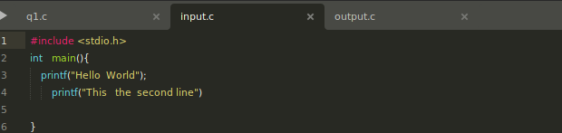
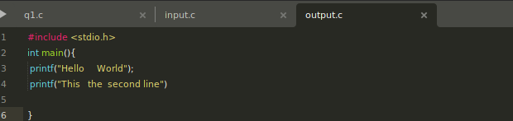
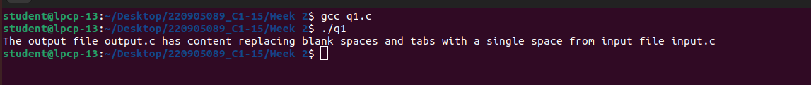

Q2) To discard preprocessor directives from the given input ‘C’ file

Code
#include <stdio.h>
#include <stdlib.h>
#include <string.h>

int main() {
FILE *fa, *fb;

fa = fopen("input2.c", "r");
if (fa == NULL) {
printf("File cannot be opened\n");
exit(0);
}

fb = fopen("output2.c", "w");
if (fb == NULL) {
printf("File cannot be opened\n");
fclose(fa);
exit(0);
}

char line[100];

while (fgets(line, sizeof(line), fa)) {
if (line[0] == '#') {
continue;
} else {
fputs(line, fb);
}
}

fclose(fa);
fclose(fb);

printf("The output file has content with preprocessor directives removed.\n");

return 0;
}

Output

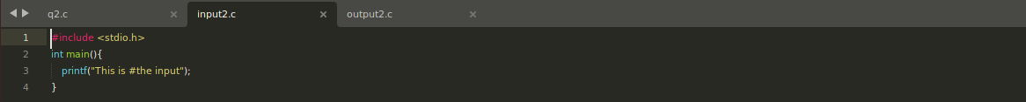

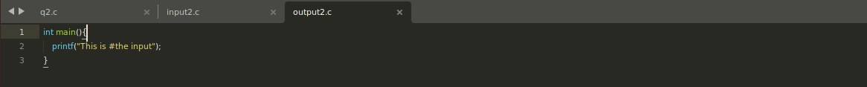
Q3) Write a C program that takes C program as input, recognizes all the keywords and prints them in upper case.

Code
#include <stdio.h>
#include <stdlib.h>
#include <string.h>
#include <ctype.h>

#define MAX_KEYWORDS 20
#define MAX_LINE_LENGTH 100

char *keywords[MAX_KEYWORDS] = {
"int", "char", "float", "continue", "break", "do", "while",
"for", "if", "else", "return", "sizeof", "printf", "scanf",
"struct", "main", "void", "include", "return", "define"
};

int is_keyword(const char *word) {
for (int i = 0; i < MAX_KEYWORDS; i++) {
if (strcmp(word, keywords[i]) == 0) {
return 1;
}
}
return 0;
}

void to_uppercase(char *word) {
for (int i = 0; word[i]; i++) {
word[i] = toupper(word[i]);
}
}

int main() {
FILE *fa, *fb;

fa = fopen("input3.c", "r");
if (fa == NULL) {
printf("File cannot be opened\n");
exit(0);
}

fb = fopen("output3.c", "w");
if (fb == NULL) {
printf("File cannot be opened\n");
fclose(fa);
exit(0);
}

char line[MAX_LINE_LENGTH];

while (fgets(line, sizeof(line), fa)) {
char word[MAX_LINE_LENGTH];
int word_index = 0;

for (int i = 0; line[i] != '\0'; i++) {
if (isalpha(line[i]) || isdigit(line[i])) {
word[word_index++] = line[i];
} else {
if (word_index > 0) {
word[word_index] = '\0';
if (is_keyword(word)) {
to_uppercase(word);
}
fputs(word, fb);
word_index = 0;
}
fputc(line[i], fb);
}
}
}

fclose(fa);
fclose(fb);

printf("The C program has been processed and saved with keywords in uppercase.\n");

return 0;
}
Output:
