WEEK6_C_15
Compiler Design Lab
Name: Venkatesh Gaur
Reg No. : 220905089
Section : C
Roll No. : 15
Title : Recursive Descent Parser For Simple Grammars
Date: 5 – Feb – 2025

Q1) Write a recursive descent parser for the following simple grammars.
1. S→a | > | ( T )
T→T, S|S

Code
#include <stdio.h>
#include <stdlib.h>
#include <stdbool.h>
#include <ctype.h>

const char *input;
char currentChar;
int position = 0;

bool parseS();
bool parseT();

void advance() {
currentChar = input[position++];
}

bool isEnd() {
return currentChar == '$';
}

bool parseS() {
if (isEnd()) return false;

if (currentChar == 'a') {
advance();
return true;
} else if (currentChar == '>') {
advance();
return true;
} else if (currentChar == '(') {
advance();
if (parseT()) {
if (currentChar == ')') {
advance();
return true;
}
}
}
return false;
}

bool parseT() {
if (parseS()) {
if (currentChar == ',') {
advance();
return parseT();
}
return true;
}
return false;
}

int main() {
char *exampleInput = (char *)malloc(100 * sizeof(char));
printf("Enter the input string: ");
scanf("%s", exampleInput);
input = exampleInput;

position = 0;
advance();

if (parseS() && isEnd()) {
printf("Input is valid according to the grammar.\n");
} else {
printf("Input is NOT valid according to the grammar.\n");
}

return 0;
}

Output
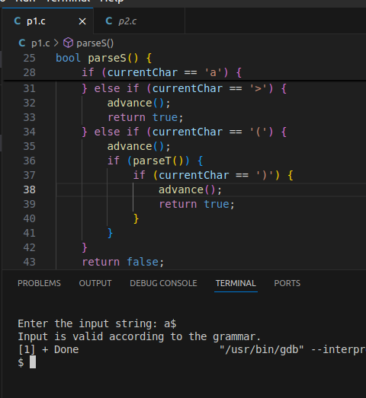
Q2) Write a recursive descent parser for the following simple grammars.
S→UVW
U →(S) | aSb | d
V → aV | 𝜖
W → cW | 𝜖

#include <stdio.h>
#include <stdlib.h>
#include <stdbool.h>

const char *input;
char currentChar;
int position = 0;

bool parseS();
bool parseU();
bool parseV();
bool parseW();

void advance() {
currentChar = input[position++];
}

bool isEnd() {
return currentChar == '$';
}

bool parseS() {
return parseU() && parseV() && parseW();
}

bool parseU() {
if (isEnd()) return false;

if (currentChar == '(') {
advance();
if (parseS()) {
if (currentChar == ')') {
advance();
return true;
}
}
} else if (currentChar == 'a') {
advance();
if (parseS()) {
if (currentChar == 'b') {
advance();
return true;
}
}
} else if (currentChar == 'd') {
advance();
return true;
}
return false;
}

bool parseV() {
if (currentChar == 'a') {
advance();
return parseV();
}
return true;
}

bool parseW() {
if (currentChar == 'c') {
advance();
return parseW();
}
return true;
}

int main() {
char *exampleInput = (char *)malloc(100 * sizeof(char));
printf("Enter the input string: ");
scanf("%s", exampleInput);
input = exampleInput;

position = 0;
advance();
if (parseS() && isEnd()) {
printf("Input is valid according to the grammar.\n");
} else {
printf("Input is NOT valid according to the grammar.\n");
}
return 0;
}

Output 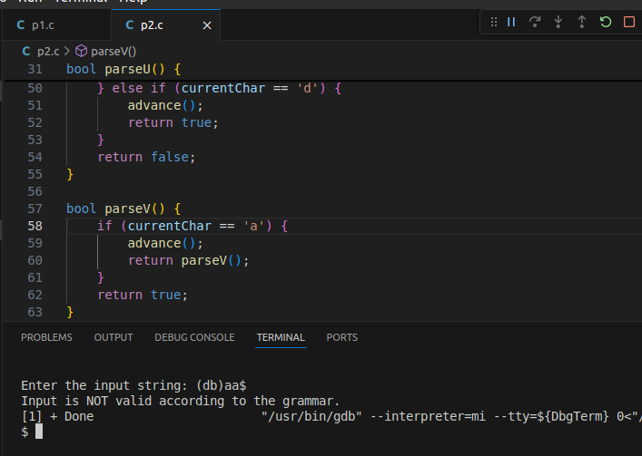
Q3) Write a recursive descent parser for the following simple grammars.

S→aAcBe
A→Ab|b
B→d
Code
#include <stdio.h>
#include <stdlib.h>
#include <stdbool.h>

const char *input;
char currentChar;
int position = 0;

void advance();
bool isEnd();
bool parseS();
bool parseA();
bool parseB();

void advance() {
currentChar = input[position++];
}

bool isEnd() {
return currentChar == '$';
}

bool parseS() {
if (currentChar == 'a') {
advance();
if (parseA()) {
if (parseB()) {
if (currentChar == 'e') {
advance();
return true;
}
}
}
}
return false;
}

bool parseA() {
if (currentChar == 'b') {
advance();
return true;
} else if (currentChar == 'A') {
advance();
if (parseA()) {
if (currentChar == 'b') {
advance();
return true;
}
}
}
return false;
}

bool parseB() {
if (currentChar == 'd') {
advance();
return true;
}
return false;
}

int main() {
char *exampleInput = (char *)malloc(100 * sizeof(char));
printf("Enter the input string: ");
scanf("%s", exampleInput);
input = exampleInput;

position = 0;
advance();

if (parseS() && isEnd()) {
printf("Input is valid according to the grammar.\n");
} else {
printf("Input is NOT valid according to the grammar.\n");
}

return 0;
}
Output
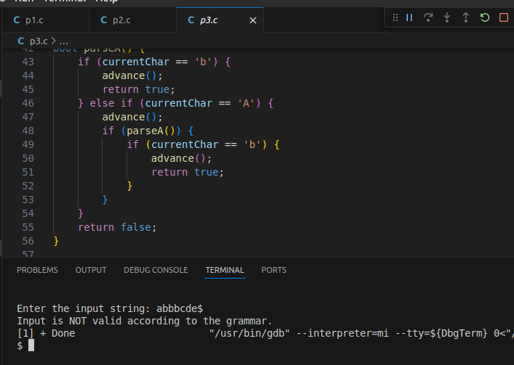

Q4) Write a recursive descent parser for the following simple grammars.
S →(L) | a
L → L,S | S
Code
#include <stdio.h>
#include <stdlib.h>
#include <stdbool.h>

const char *input;
char currentChar;
int position = 0;

void advance();
bool isEnd();
bool parseS();
bool parseL();

void advance() {
currentChar = input[position++];
}

bool isEnd() {
return currentChar == '$';
}

bool parseS() {
if (currentChar == '(') {
advance();
if (parseL()) {
if (currentChar == ')') {
advance();
return true;
}
}
} else if (currentChar == 'a') {
advance();
return true;
}
return false;
}

bool parseL() {
if (parseS()) {
if (currentChar == ',') {
advance();
return parseL();
}
return true;
}
return false;
}

int main() {
char *exampleInput = (char *)malloc(100 * sizeof(char));
printf("Enter the input string: ");
scanf("%s", exampleInput);
input = exampleInput;

position = 0;
advance();

if (parseS() && isEnd()) {
printf("Input is valid according to the grammar.\n");
} else {
printf("Input is NOT valid according to the grammar.\n");
}

return 0;
}
Output
