WEEK1_C_2
Compiler Design

Name: Venkatesh Gaur
Reg No. : 220905089
Section : C
Roll No. : 15
Title : BASIC FILE HANDLING OPERATIONS
Date: 4 – Jan – 2025

Example
Q) Program to copy contents of source file to destination file

Code
#include <stdio.h>
#include <stdlib.h>

int main()

{
FILE *ftpr1 ,*ftpr2;
char filename[100],c;
printf("Enter the filename to open for reading\n");
scanf("%s",filename);
ftpr1 = fopen(filename,"r");

if(ftpr1 == NULL)
{
printf("Cannot open file to open for reading \n");
exit(0);
}

printf("Enter the filename to open for writing: \n");
scanf("%s", filename);
ftpr2 = fopen(filename,"w+");
c = fgetc(ftpr1);
while(c!=EOF)
{
fputc(c,ftpr2);
c = fgetc(ftpr1);
}
printf("\nContents copied to %s", filename);
fclose(ftpr1);
fclose(ftpr2);
return 0;
}
Output
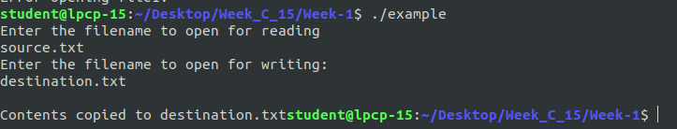

Q1 : To count the number of lines and characters in a file.

Code

#include <stdio.h>
#include <stdlib.h>
int main()
{
FILE *fptr1;
char filename[100], c;
int numc = 0; // Variable to count the number of characters in the file
int numl = 0; // Variable to count the number of lines in the file

printf("Enter the filename to open for reading: \n");
scanf("%s", filename); // Read the filename from the user
// Open the file for reading ("r" mode)

fptr1 = fopen(filename, "r");
if (fptr1 == NULL) {
printf("Can15 ptnot open file %s \n", filename);
exit(0); }

c = fgetc(fptr1); // Read the first character from the file

while (c != EOF) // Continue reading until the end of the file (EOF)
{
if (c == '\n') // If the character is a newline (end of a line)
numl++; // Increment the line counter
else
numc++; // Otherwise, it's a character, so increment the character counter

// Read the next character
c = fgetc(fptr1);
}

// Since the last line may not end with a newline, add 1 to the line count
numl++;
printf("Number of characters: %d \n", numc);
printf("Number of lines: %d \n", numl);

// Close the file after reading
fclose(fptr1); 12 pt

return 0;
}
Output
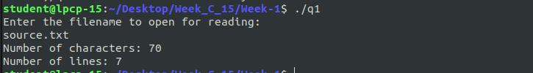

Q2)To reverse the file contents and store in another file. Also display the size of file using file handling
function.

Code

#include <stdio.h>
#include <stdlib.h> // For exit()

int main() {
FILE *fptr1, *fptr2;
char filename[100];
long fileSize;
int c;

//Enter the filename of the source file
printf("Enter the filename to open for reading: \n");
scanf("%s", filename);

// Open the source file for reading
fptr1 = fopen(filename, "r");
if (fptr1 == NULL) {
printf("Cannot open file %s \n", filename);
exit(0);
}

// Get the file size
fseek(fptr1, 0, SEEK_END); // Move the file pointer to the end of the file
fileSize = ftell(fptr1); // Get the current file pointer position (file size)
fseek(fptr1, 0, SEEK_SET); // Move the file pointer back to the beginning of the file

printf("\nContents of the original file (%s):\n", filename);
fseek(fptr1, 0, SEEK_SET);
while ((c = fgetc(fptr1)) != EOF) {
putchar(c);
}
printf("\nEnter the filename to open for writing: \n");
scanf("%s", filename);

// Open the destination file for writing
fptr2 = fopen(filename, "w");
if (fptr2 == NULL) {
printf("Cannot open file %s \n", filename);
fclose(fptr1);
exit(0);
}

// Reverse the contents of the file
for (long i = fileSize - 1; i >= 0; i--) {
fseek(fptr1, i, SEEK_SET); // Move file pointer to the i-th byte
c = fgetc(fptr1); // Read the character at this position
fputc(c, fptr2); // Write the character to the destination file
}

fclose(fptr2);
printf("Contents reversed and copied to %s\n", filename);
fptr2 = fopen(filename, "r");

printf("\nContents of the reversed file (%s):\n", filename);
while ((c = fgetc(fptr2)) != EOF) {
putchar(c);
}

fclose(fptr1);
fclose(fptr2);

return 0;
}

Output
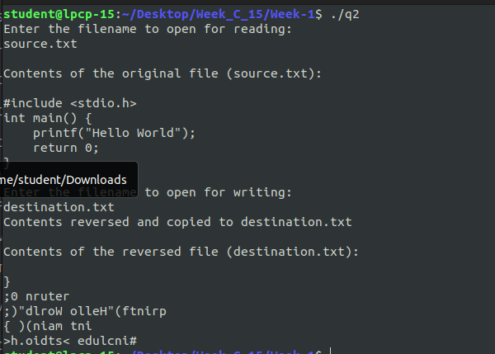

Q3: That merges lines alternatively from 2 files and stores it in a resultant file.
Code:
#include <stdlib.h>
#include <stdio.h>

int main() {
FILE *fp1, *fp2, *fp3;
char filename[100];
char c1, c2;

printf("Enter file1: ");
scanf("%99s", filename); // Safe input
fp1 = fopen(filename, "r");
if (fp1 == NULL) {
printf("Error opening file1.\n");
return 1;
}

printf("Enter file2: ");
scanf("%99s", filename); // Safe input
fp2 = fopen(filename, "r");
if (fp2 == NULL) {
printf("Error opening file2.\n");
return 1;
}

printf("Enter file3: ");
scanf("%99s", filename); // Safe input
fp3 = fopen(filename, "w+");
if (fp3 == NULL) {
printf("Error opening file3.\n");
return 1;
}

// Read characters from both files and alternate writing to fp3
c1 = fgetc(fp1);
c2 = fgetc(fp2);

while (c1 != EOF && c2 != EOF) {
// Write characters from file1
while (c1 != '\n' && c1 != EOF) {
fputc(c1, fp3);
c1 = fgetc(fp1); // Update c1 after writing
}

// Write characters from file2
while (c2 != '\n' && c2 != EOF) {
fputc(c2, fp3);
c2 = fgetc(fp2); // Update c2 after writing
}

if (c1 == '\n') {
c1 = fgetc(fp1);
}
if (c2 == '\n') {
c2 = fgetc(fp2);
}

fputc('\n', fp3);
}

while (c1 != EOF) {
// Write characters from file1
while (c1 != '\n' && c1 != EOF) {
fputc(c1, fp3);
c1 = fgetc(fp1); // Update c1 after writing
}

if (c1 == '\n') {
c1 = fgetc(fp1);
}

fputc('\n', fp3);
}

while (c2 != EOF) {

// Write characters from file2
while (c2 != '\n' && c2 != EOF) {
fputc(c2, fp3);
c2 = fgetc(fp2); // Update c2 after writing
}

if (c2 == '\n') {
c2 = fgetc(fp2);
}

fputc('\n', fp3);
}

fclose(fp1);
fclose(fp2);
fclose(fp3);

printf("\nResult written to file3\n");
return 0;
}

Output

