WEEK5_C_15
Compiler Design Lab
Name: Venkatesh Gaur
Reg No. : 220905089
Section : C
Roll No. : 15
Title : Introduction To Flex
Date: 12 – Feb – 2025

Q1) Count the number of vowels and consonants in the given input.
Code
%{
#include <stdio.h>
int vowels = 0;
int consonants = 0;
%}

%%
[aeiouAEIOU] { vowels++; }
[a-zA-Z] { consonants++; }
%%

int main() {
printf("Enter text (Ctrl+D to end input):\n");
yylex();
printf("Number of vowels: %d\n", vowels);
printf("Number of consonants: %d\n", consonants);
}

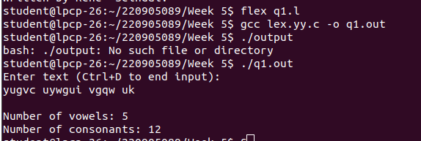
int yywrap() {
return 1;
}
Output

Q2)
Count the number of words, characters, blanks and lines in a given text.
Code
%{
#include <stdio.h>
int words = 0;
int chars = 0;
int blanks = 0;
int lines = 0;
%}

%%
\n { lines++; }
[ \t] { blanks++; }
[a-zA-Z]+ { words++; chars += yyleng; }
. { chars++; }
%%

int main() {
printf("Enter text (Ctrl+D to end input):\n");
yylex();
printf("Lines: %d\n", lines);
printf("Words: %d\n", words);
printf("Characters: %d\n", chars);
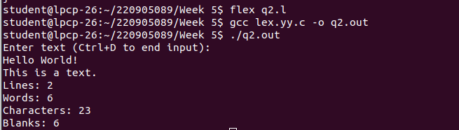
printf("Blanks: %d\n", blanks);
return 0;
}

int yywrap() {
return 1;
}
Output

Q3)
Find the number of positive integer, negative integer, positive floating positive number and negative floating point number
Code
%{
#include <stdio.h>
int pos_int = 0;
int neg_int = 0;
int pos_float = 0;
int neg_float = 0;
%}

%%
[0-9]+ { pos_int++; }
-[0-9]+ { neg_int++; }
[0-9]+\.[0-9]+ { pos_float++; }
-[0-9]+\.[0-9]+ { neg_float++; }
. { /* Ignore other characters */ }
%%

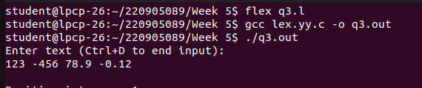
int main() {
printf("Enter text (Ctrl+D to end input):\n");
yylex();
printf("Positive integers: %d\n", pos_int);
printf("Negative integers: %d\n", neg_int);
printf("Positive floating-point numbers: %d\n", pos_float);
printf("Negative floating-point numbers: %d\n", neg_float);
return 0;
}
int yywrap() {
return 1;
}
Output

Q4) Given a input C file, replace all scanf with READ and printf with WRITE statements also find the number of scanf and printf in the file.
Code
%{
#include <stdio.h>
int scanf_count = 0;
int printf_count = 0;
%}

%%
scanf { printf("READ"); scanf_count++; }
printf { printf("WRITE"); printf_count++; }
. { printf("%c",yytext[0]); }
%%
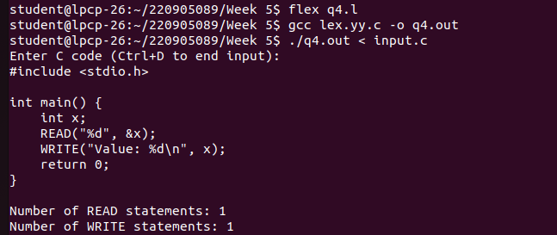
int main() {
printf("Enter C code (Ctrl+D to end input):\n");
yylex();
printf("\nNumber of READ statements: %d\n", scanf_count);
printf("Number of WRITE statements: %d\n", printf_count);
return 0;
}
int yywrap() {
return 1;
}
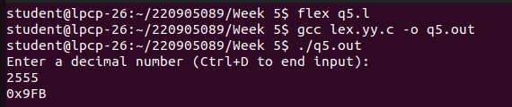
Output

Q5)
Write a program yhat changes a number from decimal to hexadecimal notation.
Code
%{
#include <stdio.h>
%}

%%
[0-9]+ { printf("0x%X\n", atoi(yytext)); }
. { putchar(yytext[0]); }
%%

int main() {
printf("Enter a decimal number (Ctrl+D to end input):\n");
yylex();
return 0;
}
int yywrap() {
return 1;
}
Output

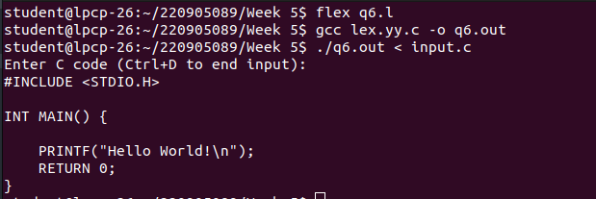

Q6)
Convert uppercase characters to lowercase characters of C file excluding the characters present in the comment.
Code
%{
#include <stdio.h>
%}

%%
\"[^\"]*\"|\'[^\']*\'|\/\/[^\n]*|\/\*[^*]*\*+([^/*][^*]*\*+)*\/ { ECHO; }
[a-z] { putchar(yytext[0] - 'a' + 'A'); }
[A-Z] { putchar(yytext[0] - 'A' + 'a'); }
. { putchar(yytext[0]); }
%%

int main() {
printf("Enter C code (Ctrl+D to end input):\n");
yylex();
return 0;
}
int yywrap() {
return 1;
}
Output

