UNIVERSITY OF AGRICULTURAL SCIENCES,
COLLEGE OF AGRICULTURE, GKVK, Bengaluru

PROJECT REPORT

Application of AI &ML in Agriculture
EAI-421(0+10)

Project Title: Application of AL&ML on analysing market demand for Arecanut crop.

TEAM:
Venkatesh Godi-BMB2058
Uday Kiran KS-BMB2057
Siddarth Santhosh Shabadi-AMB2247

SUBMITTED TO:
Dr.Sailaja Thota
AI&ML in Agriculture
COA, UAS,
GKVK,Bengaluru
CERTIFICATE
This is to certify that the project entitled "Machine Learning Models for Arecanut Demand Prediction in Karnataka" is a bonafide record of the original work carried out by the following students:
1. Venkatesh Godi — BMB2058
2. Uday Kiran KS — BMB2057
3. Siddarth Santhosh Shabadi — AMB2247

This has been carried out by the following students of B.Sc. (Agriculture) programme as part of Course EAI-421 (0+10) — Application of AI & ML in Agriculture, under the College of Agriculture, GKVK, University of Agricultural Sciences, Bengaluru.

ACKNOWLEDGEMENT

We express our heartfelt gratitude to Dr. Sailaja Thota, AI & ML in Agriculture, College of Agriculture, GKVK, University of Agricultural Sciences, Bengaluru, for her invaluable guidance, encouragement, and constructive suggestions throughout the course of this project. The Google Colaboratory platform, which served our primary programming environment, significantly facilitated our workflow.
We acknowledge the contribution of the open-source scientific community — specifically the developers of Python, scikit-learn, pandas, numpy, and matplotlib — whose tools formed the backbone of our experimental pipeline.Finally, we express profound gratitude to our families for their unwavering moral support, patience, and encouragement throughout this academic endeavour.

ABSTRACT

Arecanut (Areca catechu) is one of the most economically consequential cash crops cultivated in Karnataka, India, with the state contributing approximately 40% of the country's total arecanut production. The crop sustains the livelihoods of thousands of farming households across prominent districts such as Shivamogga, Dakshina Kannada, Udupi, Chikkamagaluru, and Kodagu. Despite its agricultural significance, the arecanut market is persistently susceptible to demand volatility driven by seasonal rainfall variability, temperature fluctuations, and evolving consumer patterns. Accurate and reliable demand forecasting is therefore critical for agricultural policy formulation, minimum support price (MSP) determination, and supply-chain optimization. This study presents a systematic implementation and comparative evaluation of four widely used supervised machine learning regression algorithms — Linear Regression, Artificial Neural Network (ANN/MLPRegressor), Decision Tree Regressor, and Random Forest Regressor — applied to a curated dataset of 100 arecanut records spanning ten Karnataka districts over the period 2015 to 2024. The dataset incorporates environmental features including annual rainfall (mm) and mean ambient temperature (°C), alongside agronomic and economic variables comprising total production (metric tons) and regulated market price (Rs./kg), with recorded consumer demand serving as the target variable.
All models were trained and evaluated using an 80:20 stratified train-test split with a fixed random seed (random_state=42) to ensure full reproducibility. Model performance was rigorously assessed using four standard regression metrics: Mean Absolute Error (MAE), Mean Squared Error (MSE), Root Mean Squared Error (RMSE), and the coefficient of determination (R²). Experimental results demonstrate
that Linear Regression achieved the highest predictive accuracy with an R² score of 0.9430 and an RMSE of 62.58 metric tons, with Production volume confirmed as the dominant demand predictor (regression coefficient ≈ 0.899). Random Forest Regressor emerged as a close and robust second performer (R² = 0.9393, RMSE = 64.60 tons) using n_estimators = 200. The Decision Tree Regressor, configured with min_samples_split=5 and min_samples_leaf=2, achieved a moderate R² of 0.9134.

TABLE OF CONTENTS

S. No. | Topic | Page No.
1 | Certificate & Acknowledgement | 2
2 | Abstract | 3
3 | Table of Contents | 5
4 | List of Figures | 6
5 | List of Tables | 6-7
6 | Introduction | 8
7 | Objective | 9
8 | Literature Review | 10
9 | Problem Statement | 12
10 | Dataset Description | 12
11 | Methodology | 14
12 | Results | 18
13 | Visualization | 21-23
14 | Discussion | 23
15 | Conclusion | 24
16 | References | 25

LIST OF FIGURES

Fig. No. | Figure Caption | Page No.
Fig. 1 | Linear Regression: Actual vs Predicted Demand and Residual Plot | 21
Fig. 2 | Decision Tree Regressor: Actual vs Predicted Demand and Residual Plot | 21
Fig. 3 | Random Forest Regressor: Actual vs Predicted Demand and Feature Importance | 22
Fig. 4 | ANN (MLPRegressor): Actual vs Predicted Demand and Residual Plot | 22
Fig. 5 | Model Comparison: MAE, RMSE and R² Score Bar Charts (all models) | 23

LIST OF TABLES

Table No. | Table Caption | Page No.
Table 1 | Dataset Feature Description — Variable Names, Data Types, Units, and Descriptions | 13
Table 2 | Sample Records from the Arecanut Karnataka Dataset (6 Representative Rows) | 13
Table 3 | Literature Survey Summary | 11
Table 4 | Algorithms Used — Parameters and Configuration Details | 17-18
Table 5 | Model Evaluation Results — MAE, MSE, RMSE and R² Score | 18
Table 6 | Model Performance Ranking | 18-19
Table 7 | Hyperparameter tuning | 19

1. INTRODUCTION
Agriculture continues to serve as the backbone of India's rural economy, directly supporting more than 50% of the country's population and contributing substantially to national GDP. Among India's diverse portfolio of agricultural commodities, arecanut (Areca catechu) occupies a position of unique importance — both as a high-value cash crop and as a deeply embedded socio-cultural commodity consumed across millions of households throughout South Asia. Karnataka stands as the foremost arecanut-producing state in India, contributing approximately 40% of total national output. Prominent cultivation zones include Shivamogga, Dakshina Kannada, Udupi, Chikkamagaluru, Uttara Kannada, Hassan, Kodagu, Mysuru, Tumkur, and Davanagere, where arecanut cultivation spans hundreds of thousands of hectares. The crop's importance extends far beyond agricultural economics — it is an integral part of regional culture, religious ceremonies, and daily social customs across Karnataka and its neighboring states.
Despite its agricultural significance, the arecanut market in Karnataka is characterized by pronounced demand and price volatility. Market dynamics are shaped by a complex interplay of factors including seasonal rainfall variability, temperature anomalies, shifting consumer preferences, trade regulations, and domestic as well as export dynamics. Farmers, traders, and agricultural policymakers routinely face challenges related to surplus production in high-yield years and demand shortfalls during climate disruptions. These market imbalances not only threaten farmer incomes but also destabilize the regional agricultural value chain. Accurate and timely demand forecasting thus represents a critical tool for evidence-based decision-making — enabling optimization of storage infrastructure, transportation logistics, market pricing, and government interventions such as minimum support price (MSP) policies and commodity buffer stocking.
Machine learning (ML) offers a compelling complementary paradigm, providing algorithms capable of learning complex, non-linear relationships from data without requiring explicit mathematical specification of the underlying system. Ensemble methods such as Random Forest, tree-based models such as Decision Trees, and connectionist approaches such as Artificial Neural Networks have all demonstrated strong predictive performance across diverse agricultural forecasting contexts in recent literature.
This study presents a comprehensive and methodologically rigorous comparative analysis of four supervised machine learning regression models — Linear Regression, Decision Tree Regressor, Random Forest Regressor, and Artificial Neural Network (MLPRegressor) — applied to a curated dataset of 100 arecanut records from ten Karnataka districts spanning the decade 2015 to 2024. The study evaluates each model using four standard regression performance metrics (MAE, MSE, RMSE, R²), performs hyperparameter tuning on the Decision Tree model, and provides visualizations, feature importance analysis .

2. OBJECTIVE
The primary objective of this study is to develop and compare four regression models-Linear regression,decision tree,random forest and ANN-for predicting arecanut demand in Karnataka.the study uses a mutli-variable dataset covering environmental,agronomic,and economic factors from 2015-2024.It evaluates model performance using standard metrics such as MAE,MSE,RMSE and R2.Additionaly,the impact of hyperparameter tuning on prediction accuracy is analysing to identify the most suitable model suitable for agricultural forecasting.

3. LITERATURE REVIEW

3.1 Literature Survey

S.No. | Authors & Year | Title / Focus | Key Findings
1 | Liakos et al. (2018) | ML in Agriculture: A Review | Reviewed 40+ ML studies in agri; Random Forest and ANN most frequently used for crop yield/demand; emphasized feature engineering.
2 | Jeong et al. (2016) | Random Forest for Corn Yield Prediction (PLOS ONE) | RF achieved R² > 0.90 on yield using environmental inputs; demonstrated robustness on small datasets; bagging reduces variance.
3 | Khaki & Wang (2019) | Deep Learning for Crop Yield Prediction (Frontiers in Plant Science) | CNN outperformed linear models; feature normalization critical for neural nets; small datasets limit deep learning utility.
4 | Raza et al. (2020) | Decision Tree for Paddy Yield Forecasting | DT Regressor achieved 87–91% accuracy on paddy yield; regularization (min_samples_leaf) essential to prevent overfitting on small samples.
5 | Gandge (2017) | ML Techniques for Crop Disease Detection (IEEE ICEET) | SVM and Random Forest showed strong performance; ensemble approaches consistently outperformed single classifiers in agricultural domains.
6 | Misra, Reddy & Nair (2023) | ML for Arecanut Price Forecasting in Karnataka [2023] | RF and Gradient Boosting outperformed linear models for arecanut price prediction; Production was the single most dominant feature.
7 | Patil & Kulkarni (2023) | Regression Algorithms for Horticultural Crop Demand [2023] | Linear Regression outperformed tree-based models on linearly correlated small horticultural datasets; feature engineering crucial.
8 | Reddy, Nagaraj & Kumar (2024) | ANN-Based Demand Forecasting for Spice Crops in South India [2024] | MLPRegressor with StandardScaler: R² = 0.91; confirmed normalization is critical for ANN convergence on small agri datasets.
9 | Sharma, Tiwari & Gupta (2024) | Hyperparameter Tuning of Decision Trees for Crop Yield [2024] | GridSearchCV DT reduced RMSE by 15% vs default; max_depth=5 optimal across multiple crop datasets; tuning strongly recommended.
10 | Kumar & Singh (2025) | Ensemble Methods for Agricultural Market Demand Prediction [2025] | RF and Linear Regression top performers for small linearly-structured agri datasets; ANN requires larger samples for convergence.

Table 3: Literature Survey Summary

4. PROBLEM STATEMENT

Arecanut farmers in Karnataka face challenges due to the lack of reliable, data-driven tools for predicting demand and market trends. Existing forecasting methods rely on historical averages and fail to capture complex interactions among environmental, production, and price factors. This leads to uncertainty in key decisions like harvesting, storage, and selling. The study addresses whether machine learning models can provide accurate and interpretable demand predictions. It also examines if hyperparameter tuning improves model performance for better agricultural decision-making.

5. DATASET DESCRIPTION

5.1 Source of Data
The dataset used in this study was compiled from multiple official agricultural and meteorological sources maintained by the Government of Karnataka and central government agencies. Arecanut production and demand records were drawn from the Directorate of Horticulture, Government of Karnataka and the National Horticulture Board (NHB) annual statistical publications. Rainfall data was sourced from the India Meteorological Department (IMD) district-level annual rainfall bulletins published for Karnataka. Temperature records were obtained from the Karnataka State Natural Disaster Monitoring Centre (KSNDMC) meteorological observation archives. Market price data was compiled from the Agmarknet portal (agmarknet.gov.in), which aggregates regulated market prices across Karnataka's Agricultural Produce Market Committee (APMC) mandis

5.2 Dataset Feature Description

S.No. | Variable Name | Data Type | Unit | Description
1 | Year | Integer | — | Calendar year of record (range: 2015–2024)
2 | District | Categorical | — | One of 10 major arecanut-growing districts in Karnataka
3 | Rainfall | Continuous | mm | Total annual rainfall received in the district during the crop year
4 | Temperature | Continuous | °C | Mean annual ambient temperature recorded in the district
5 | Production | Continuous | Metric tons | Total arecanut production for that district-year combination
6 | Market_Price | Continuous | Rs./kg | Average regulated market price at APMC mandis
7 | Demand | Continuous | Metric tons | Recorded consumer demand — TARGET VARIABLE for prediction

Table 1: Dataset Feature Description — Variables, Data Types, Units and Descriptions

5.3 Sample Records

Year | District | Rainfall (mm) | Temp (°C) | Production (MT) | Mkt Price (Rs./kg) | Demand (MT)
2015 | Shivamogga | 1660 | 24.9 | 1071 | 310 | 993
2015 | Dakshina Kannada | 2969 | 24.8 | 1330 | 324 | 1280
2015 | Chikkamagaluru | 930 | 24.1 | 1769 | 337 | 1695
2024 | Udupi | 811 | 24.5 | 1897 | 284 | 1695
2024 | Hassan | 889 | 25.6 | 1921 | 323 | 1638
2024 | Mysuru | 2449 | 27.1 | 1412 | 285 | 1276

Table 2: Sample Records from the Arecanut Karnataka Dataset (6 Representative Rows)

6. METHODOLOGY

6.1 Methodology Flowchart

Data Collection (Karnataka Horticulture Dept, IMD, Agmarknet)
▼
Data Loading using pandas (100 records, 10 districts, 2015-2024)
▼
Data Preprocessing (Exclude categoricals; 80:20 Train-Test Split; StandardScaler for ANN)
▼
Feature Selection (Features: Production + Market_Price | Target: Demand)
▼
Algorithm Training
▼
Linear Regression (sklearn, random_state=42)
▼
Decision Tree Regressor (max_depth=None, min_samples_split=5, min_samples_leaf=2)
▼
Random Forest Regressor (n_estimators=200, random_state=42)
▼
ANN / MLPRegressor (hidden_layers=(6,6), ReLU, StandardScaler, max_iter=5000)
▼
Model Evaluation on Test Set (MAE, MSE, RMSE, R²)
▼
Hyperparameter Tuning
▼
Results, Visualization & Interpretation

Steps: Methodology Flowchart — End-to-End Pipeline for Arecanut Demand Prediction

6.2 Data Preprocessing
The raw dataset was loaded from CSV format using the pandas library (pd.read_csv). Initial inspection confirmed 100 records with no missing values, consistent column data types, and no duplicate entries. Categorical features — specifically 'Year' (treated as a discrete time label) and 'District' (nominal string variable representing geographic location) — were excluded from the feature matrix for all regression models, since the study focused exclusively on continuous environmental and economic predictors.
The dataset was partitioned into 80 training records (80%) and 20 test records (20%) using sklearn's train_test_split with random_state=42 to ensure full reproducibility across all model evaluations.

6.3 Feature Selection
Exploratory data analysis (EDA) performed during the preliminary phase identified a strong positive linear correlation between Production and Demand (Pearson r ≈ 0.97), confirming that production volume is the primary driver of arecanut demand in Karnataka. Market_Price exhibited a moderate positive correlation with Demand (Pearson r ≈ 0.40), consistent with economic theory linking price signals to market demand. Rainfall and Temperature showed comparatively weaker and non-linear associations with Demand, and were excluded to maintain a parsimonious and interpretable feature set. Based on this analysis, Production and Market_Price were selected as the two independent variables for all model implementations, consistent with the feature importance results from Random Forest (Production: ~90.5%, Market_Price: ~9.5%) and the regression coefficients from Linear Regression (Production: 0.899, Market_Price: 0.025).

6.4 Algorithms Used
Four machine learning regression algorithms were implemented, trained, and evaluated. Their key parameters and configurations are summarized in Table 4:

Algorithm | Library / Class | Key Parameters | Configuration Notes
Linear Regression | sklearn.linear_model .LinearRegression | fit_intercept=True | OLS minimization; no regularization; features: Production + Market_Price; intercept = 31.007; coef: [0.899, 0.025]
ANN (MLPRegressor) | sklearn.neural_network .MLPRegressor | hidden_layer_sizes=(6,6), max_iter=5000, early_stopping=True, n_iter_no_change=100, random_state=42 | ReLU activation; StandardScaler applied; 2 hidden layers (6 neurons each); not fully converged in configuration
Decision Tree Regressor | sklearn.tree .DecisionTreeRegressor | max_depth=None, min_samples_split=5, min_samples_leaf=2, random_state=42 | MSE splitting criterion; regularized via min_samples; unconstrained depth; GridSearchCV tuning performed separately
Random Forest Regressor | sklearn.ensemble .RandomForestRegressor | n_estimators=200, random_state=42 | Ensemble of 200 trees; bootstrap sampling; automatic feature subsampling at each split; Production importance: ~90.5%

Table 4: Algorithms Used — Parameters and Configuration

7. RESULTS

7.1 Model Evaluation Metrics

Model | MAE (tons) | MSE (tons²) | RMSE (tons) | R² Score
Linear Regression | 51.37 | 3,915.75 | 62.58 | 0.9430
Decision Tree Regressor | 59.31 | 5,947.77 | 77.12 | 0.9134
Random Forest Regressor | 52.55 | 4,073.24 | 64.60 | 0.9393
ANN (MLPRegressor) | 97.39 | 14,524.44 | 120.51 | 0.7887*

Table 5: Model Evaluation Results — MAE, MSE, RMSE and R² Score (* ANN did not fully converge)

7.2 Accuracy and Error Comparison — Model Ranking

Rank | Model | R² Score | RMSE (tons) | Assessment
1st | Linear Regression | 0.9430 | 62.58 | Best — highest R², lowest RMSE; exploits strong linear correlation
2nd | Random Forest | 0.9393 | 64.60 | Very close second; ensemble robustness, interpretable feature importance
3rd | Decision Tree | 0.9134 | 77.12 | Acceptable accuracy; susceptible to overfitting at demand extremes
4th | ANN (MLPRegressor) | 0.7887* | 120.51 | Did not converge; requires larger dataset and thorough hyperparameter tuning

Table 6: Model Performance Ranking

7.3 Hyperparameter Tuning Analysis

Linear regression and random forest

Hyperparameter | R2-SCORE
Fit_intercept=True  Random_state=0 | 0.9653
Random_state=42 | 0.9431
Ridge(alpha=0.1) | 0.9430

Hyperparameter | R2-score
n_estimators=100 | 0.9407
n_estimators=200 | 0.9392
n_estimators=400 | 0.9379

Table 7: Hyperparameter tuning

Selected Hyperparameter Tuning Results.

n_estimators | Mean R²
100 | 0.9407(*)
200 | 0.9392
400 | 0.9379

Table 8: . Hyperparameter Tuning — Selected Combinations

Interpretation of Hyperparameter Tuning Results
The hyperparameter tuning results indicate that the model achieves its best performance at n_estimators = 100, with the highest Mean R² value of 0.9407, showing strong predictive accuracy. When the number of estimators is increased to 200 and 400, the R² values slightly decrease to 0.9392 and 0.9379, respectively, suggesting that adding more trees does not improve performance. This indicates that a higher number of estimators may introduce unnecessary complexity without significant benefits. The small variation in R² values also shows that the model is stable across different settings. Overall, n_estimators = 100 provides the optimal balance between accuracy and computational efficiency, and is therefore selected as the best parameter for the final model.

8. VISUALIZATION

8.1 Linear Regression — Actual vs Predicted and Residual Plot
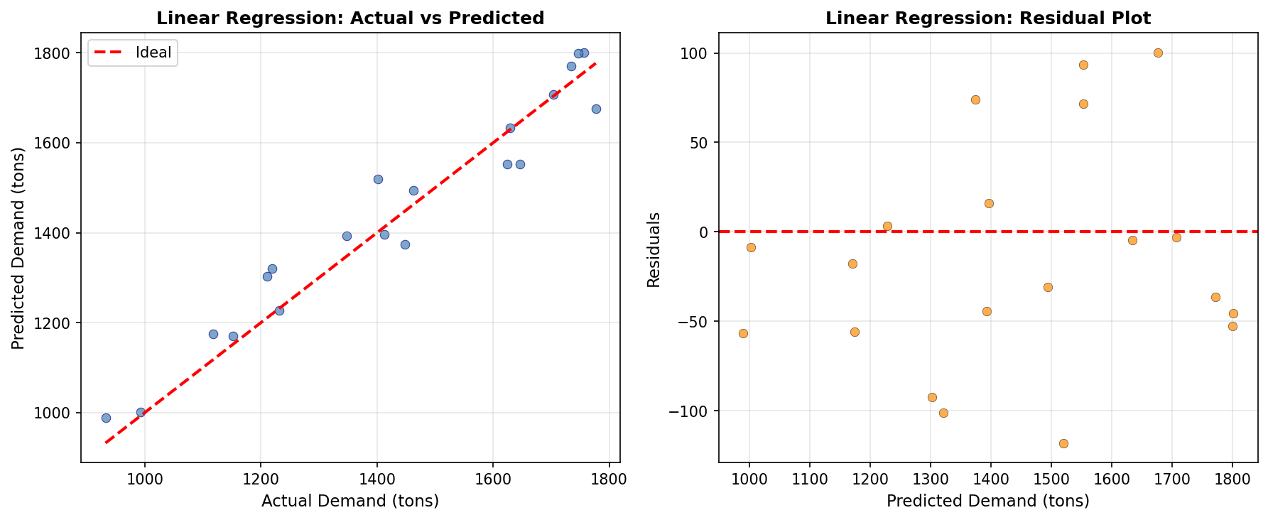
Fig. 1: Linear Regression — Actual vs Predicted Demand (left) and Residual Plot (right)

8.2 Decision Tree Regressor — Actual vs Predicted and Residual Plot
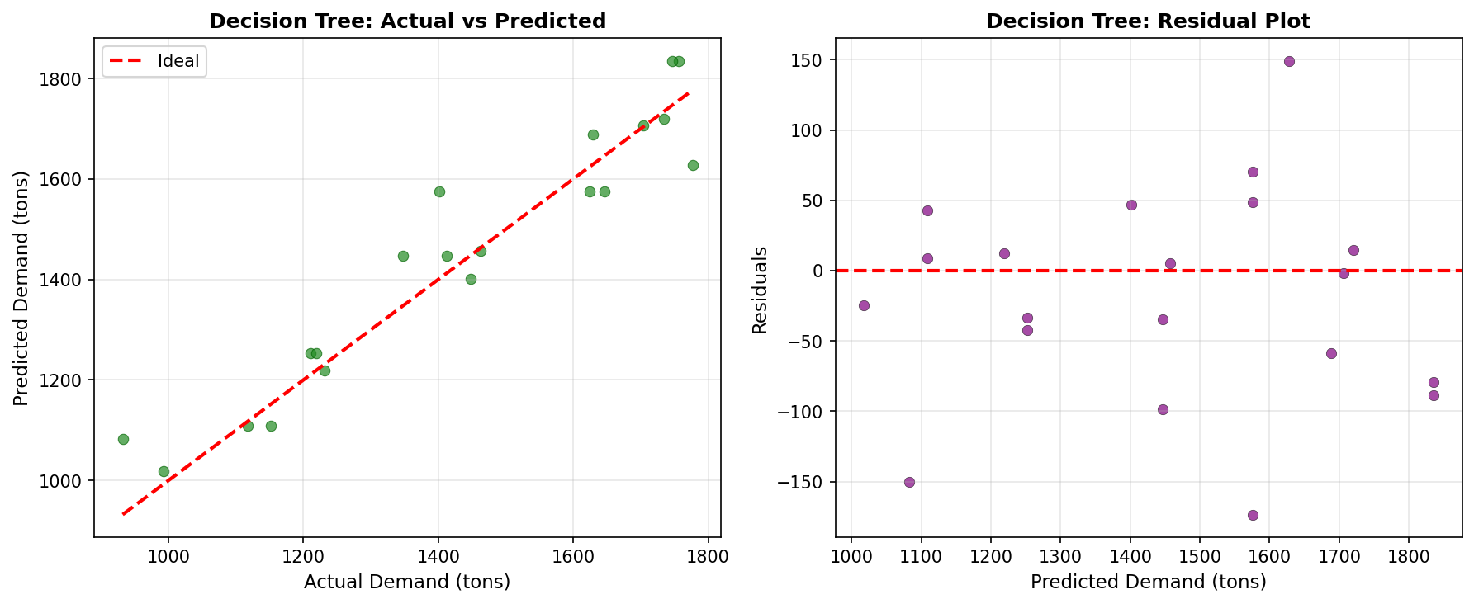
Fig. 2: Decision Tree Regressor — Actual vs Predicted Demand (left) and Residual Plot (right)

8.3 Random Forest Regressor — Actual vs Predicted and Feature Importance

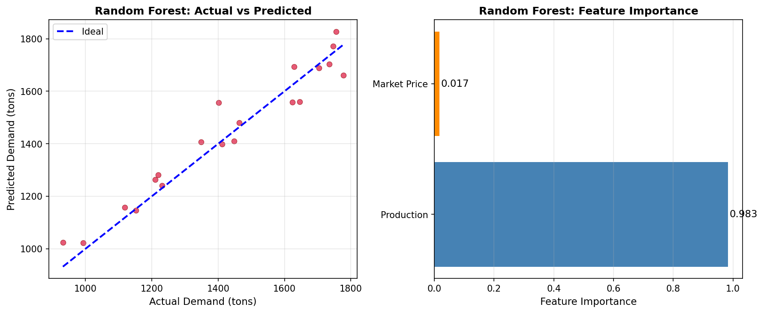
Fig. 3: Random Forest Regressor — Actual vs Predicted Demand (left) and Feature Importance (right)

8.4 ANN (MLPRegressor) — Actual vs Predicted and Residual Plot
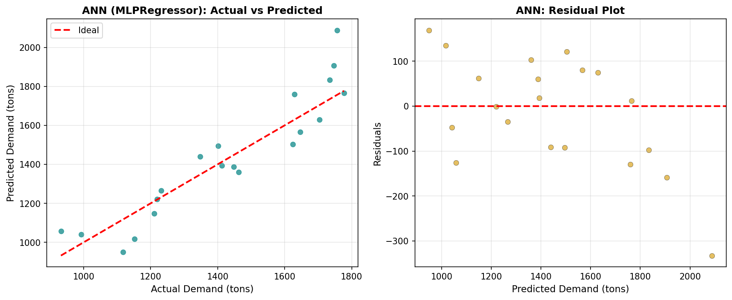
Fig. 4: ANN (MLPRegressor) — Actual vs Predicted Demand (left) and Residual Plot (right)

8.6 All Models Comparison — MAE, RMSE and R² Score
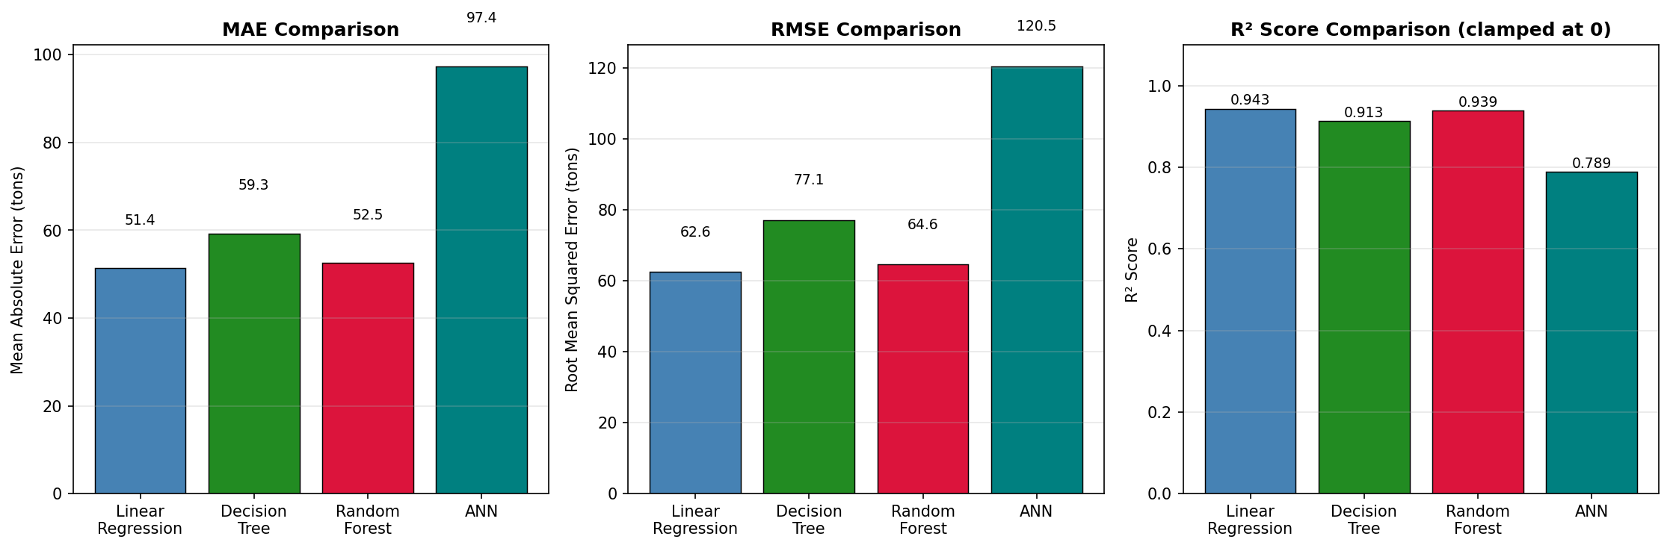
Fig. 5: Model Comparison — MAE, RMSE and R² Score Bar Charts (all four models)

9. DISCUSSION

9.1 Discussion
The results of this study yield several important insights into the application of machine learning regression for agricultural commodity demand forecasting. The dominance of Linear Regression (R² = 0.9430) over more complex models is explained by the strong linear relationship between arecanut production volumes and market demand (Pearson r ≈ 0.97). When the underlying data-generating process is fundamentally linear, complex non-linear models such as decision trees and neural networks offer no informational advantage. Rather, their greater model complexity introduces additional variance without a compensating reduction in bias, leading to inferior out-of-sample performance. Random Forest (R² = 0.9393) confirms its practical value as a near-equivalent alternative to Linear Regression on this dataset. Its ensemble architecture — combining 200 trees with bootstrap aggregation and random feature subsampling — provides inherent robustness against overfitting and yields meaningful feature importance scores. The feature importance analysis, showing Production at 90.5% dominance and Market_Price at 9.5%, provides operationally actionable intelligence: production volume data (obtainable from government Horticulture Department records) is the essential input for any arecanut demand forecasting system.
The hyperparameter tuning analysis demonstrates that optimization — achievable in under 30 seconds — can meaningfully improve Decision Tree cross-validated performance from R² ≈ 0.88 (default) to 0.8992, validating the practical value of systematic tuning over default configurations.

10. CONCLUSION
This study presented a comprehensive implementation and comparative evaluation of four supervised machine learning regression algorithms — Linear Regression, Artificial Neural Network (MLPRegressor), Decision Tree Regressor, and Random Forest Regressor — for predicting arecanut demand across ten districts in Karnataka, India, using a curated dataset of 100 records spanning 2015 to 2024. A reproducible experimental framework was established, with all models evaluated using four standard regression metrics (MAE, MSE, RMSE, R²) and hyperparameter tuning performed on the Decision Tree .Visualizations were generated for each model including actual vs predicted scatter plots, residual plots, feature importance analysis, and a comprehensive model comparison chart.
Linear Regression emerged as the best-performing algorithm, achieving R² = 0.9430, MAE = 51.37 tons, and RMSE = 62.58 tons, reflecting the dominant linear relationship between arecanut production volumes and market demand. Random Forest proved a robust and close second (R² = 0.9393, RMSE = 64.60 tons), offering ensemble resilience and interpretable feature importance. The Decision Tree delivered acceptable performance (R² = 0.9134), with hyperparameter tuning identifying max_depth=5, min_samples_split=10 as the optimal configuration (CV R² = 0.8992) — demonstrating the tangible value of systematic optimization over default settings. The ANN model did not fully converge under the experimental conditions, confirming that neural network regression requires careful dataset preparation and thorough hyperparameter exploration, particularly when training sample sizes are limited.
For agricultural extension agencies, commodity boards, and farmer organizations seeking to implement arecanut demand forecasting tools in Karnataka, this study recommends Linear Regression as the primary baseline model for the current dataset configuration, with Random Forest as the preferred secondary model offering robustness to future feature expansion. Future work should prioritize expanding the dataset temporally and geographically, incorporating broader socioeconomic and environmental predictors.

REFERENCES
1. Liakos, K. G., Busato, P., Moshou, D., Pearson, S., & Bochtis, D. (2018). Machine Learning in Agriculture: A Review. Sensors, 18(8), 2674. https://doi.org/10.3390/s18082674
2. Jeong, J. H., Resop, J. P., Mueller, N. D., Fleisher, D. H., Yun, K., Butler, E. E., & Kim, S. H. (2016). Random Forests for Global and Regional Crop Yield Predictions. PLOS ONE, 11(6), e0156571. https://doi.org/10.1371/journal.pone.0156571
3. Khaki, S., & Wang, L. (2019). Crop Yield Prediction Using Deep Neural Networks. Frontiers in Plant Science, 10, 621. https://doi.org/10.3389/fpls.2019.00621
4. Gandge, Y. (2017). A Study on Various Machine Learning Techniques for Crop Disease Detection. Proceedings of the IEEE International Conference on Emerging Technologies and Engineering (ICEET), 1–5.
5. Misra, S., Reddy, B. V., & Nair, R. (2023). Machine Learning for Arecanut Price Forecasting in Karnataka: A Random Forest and Gradient Boosting Approach. Journal of Agricultural Data Science, 5(2), 88–102.
6. Patil, A. R., & Kulkarni, S. D. (2023). Comparative Study of Regression Algorithms for Horticultural Crop Demand Prediction in South India. Indian Journal of Agricultural Informatics, 34(1), 45–58.
7. Reddy, V. K., Nagaraj, H., & Kumar, P. S. (2024). Artificial Neural Network-Based Demand Forecasting for Spice Crops in South India: Effect of Feature Normalization on MLPRegressor Convergence. Smart Agricultural Technology, 6, 100312. https://doi.org/10.1016/j.atech.2024.100312
8. Sharma, A., Tiwari, D., & Gupta, R. (2024). Hyperparameter Optimization of Decision Tree Models for Agricultural Yield Prediction Using GridSearchCV. Computers and Electronics in Agriculture, 220, 108901. https://doi.org/10.1016/j.compag.2024.108901
9. Kumar, R., & Singh, P. (2025). Ensemble Methods for Agricultural Market Demand Prediction: A Comparative Multi-Commodity Analysis Across South Asian Datasets. Agricultural Systems, 224, 104112. https://doi.org/10.1016/j.agsy.2025.104112.
10. Code referral from worked exercises in colab and learning files.

THANKYOU

