VEHICLE PARKING PERMIT REGISTRATION SYSTEM
AS-IS and TO-BE Workflow Diagrams

1. AS-IS Workflow — Current Manual Process
This represents a typical manual process. Adjust it if your college currently follows a different procedure.
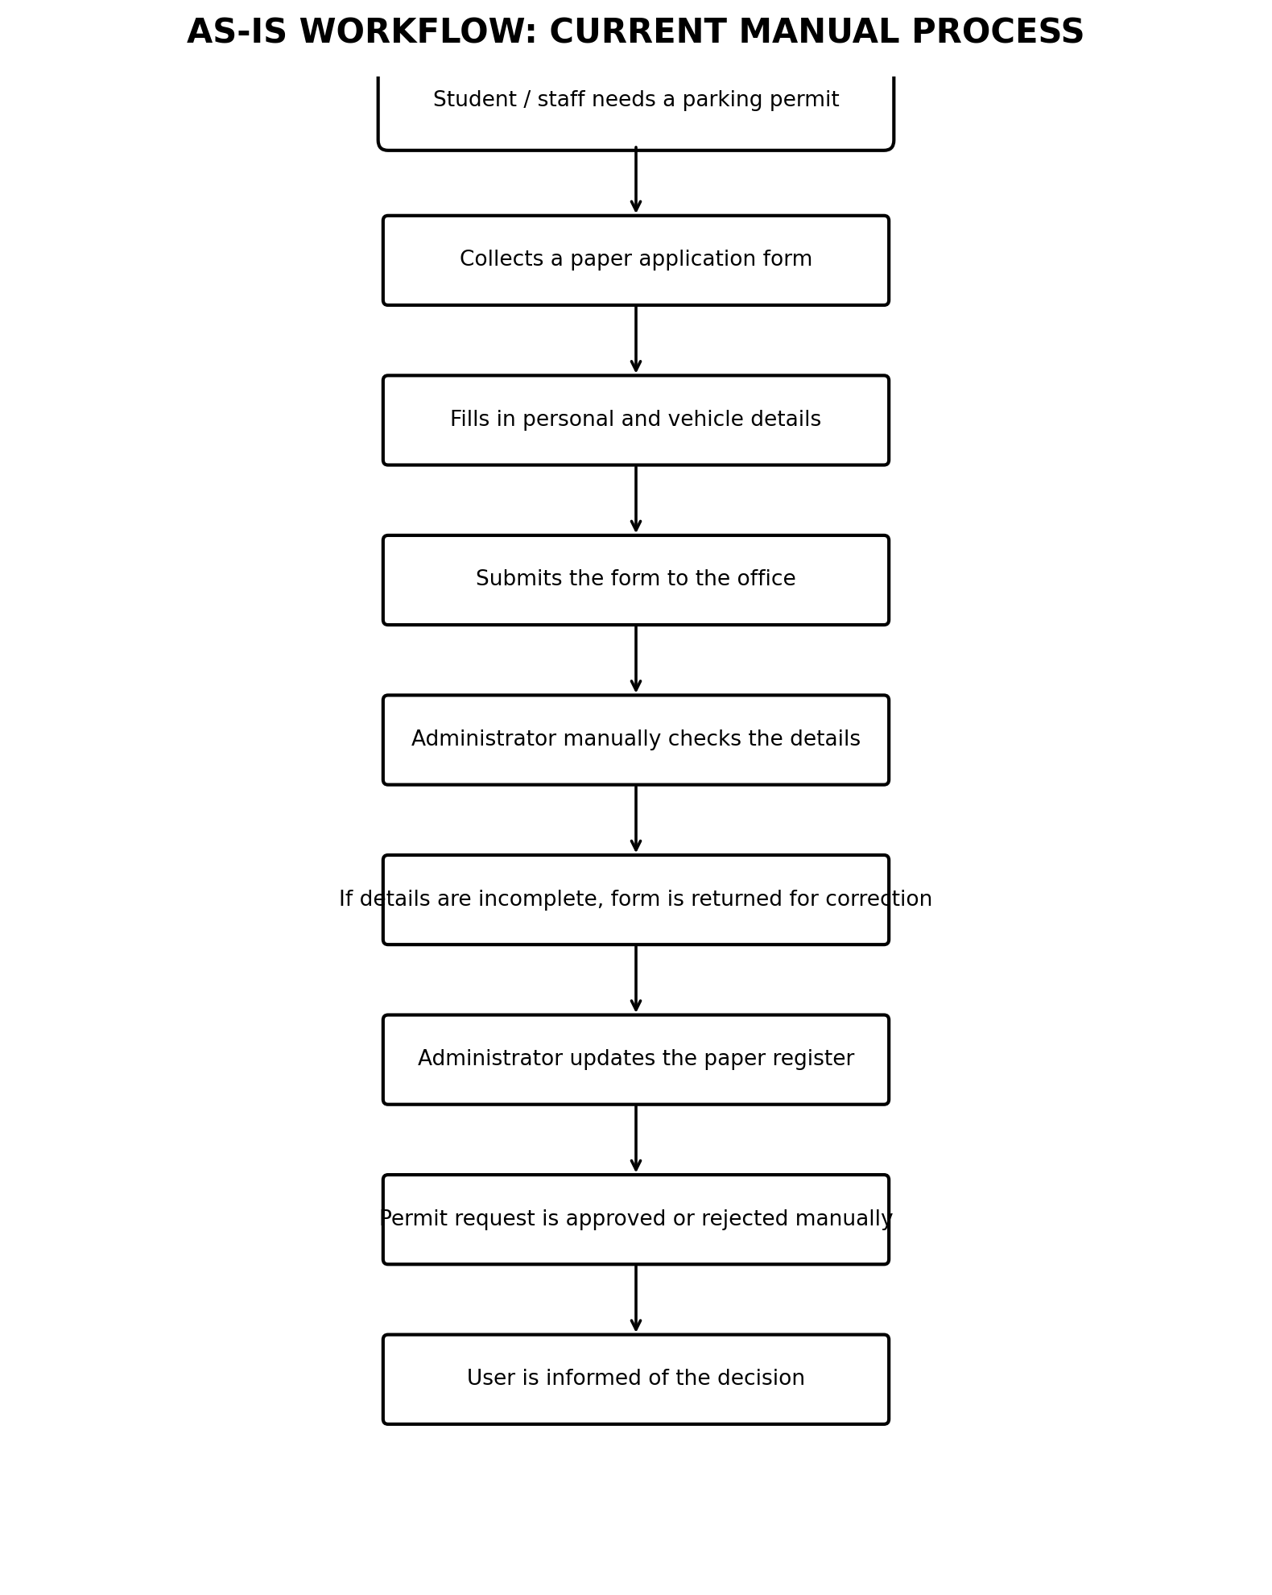

2. TO-BE Workflow — Proposed Web-Based System
This represents the planned process for your application. Keep only features you intend to implement.
