**SOCIAL NETWORK ANAYSIS USING HTML&CSS&JAVASCRIPT**

**A PROJECT REPORT**

***Submitted by***

**Name of Student: VENKATESH KOPPULA**

**Registration No: 12408104**

**Roll No: 33**

**Section: K24EU**

***in partial fulfillment for the award of the degree***

***of***

**BACHELOR OF COMPUTER SCIENCE and ENGINEERING**



**Lovely Professional University, Punjab**

**CSE326 – Internet Programming Laboratory**

**DECEMBER 2024**

**TABLE OF CONTENTS**

|  |  |  |
| --- | --- | --- |
| **S NO.** | **TOPIC** | **PAGE NO.** |
| **1** | **Project Description** | **2** |
| **2** | **Project Objectives** | **2** |
| **3** | **Expected Outcome of Project** | **3** |
| **4** | **[Firstpage].html** | **4** |
| **5** | **[Secondpage].html** | **5** |
| **6** | **[thirdpage].html** | **6** |
| **7** | **[fouthpage].html** | **7,8** |
| **8** | **Output Screenshots** | **9** |
| **9** | **Github Repo Link** | **10** |
| **10** | **References** | **10,11** |

**Project Description:**

The **Car Parking System** is a web-based project designed to simulate the layout and basic management of a parking lot. This project is built using core web development technologies, including **HTML**, **CSS**, and **JavaScript**, and serves as an introductory step into developing interactive and responsive web applications. Below is a comprehensive description of the project:

#### Purpose and Scope

The primary purpose of this project is to provide a simple user interface where users can view and interact with parking slots. Users can select and reserve available slots, which is essential for demonstrating the use of web technologies in creating dynamic and interactive content. This project can be extended into a more advanced parking management system with additional features.

**Project Objectives:**

The **Car Parking System** project has been designed with clear, targeted objectives to ensure that its development serves both educational and practical purposes. Below are the primary objectives of this project:

#### 1. **Develop a Functional Prototype**

* **Create an interactive and responsive web-based parking layout** that simulates the allocation of parking slots.
* **Provide users with the ability to select and reserve parking slots** through a simple click interaction, giving visual feedback for selected and reserved states.

#### 2. **Improve Frontend Development Skills**

* **Reinforce HTML skills** by structuring a user interface with semantic tags for better accessibility and search engine optimization.
* **Enhance CSS knowledge** by creating responsive designs with CSS Grid and Flexbox, ensuring the application adapts to different screen sizes and devices.
* **Develop proficiency in JavaScript** by implementing event handling, DOM manipulation, and basic user interactions.

#### 3. **Implement a User-Friendly Interface**

* **Design an intuitive UI** that users can easily navigate and understand without extensive instructions.
* **Incorporate visual cues** such as color changes and hover effects to indicate slot availability, selection, or reservation status.

**Expected Outcome of Project:**

The **Expected Outcome** of this Car Parking System project is a simple yet functional web-based application that simulates the layout and management of a parking lot. Below is what you can expect from this project upon completion:

**1. User Interface:**

* **Responsive Design**: A visually appealing and responsive layout that adapts to different screen sizes, ensuring a good user experience on both desktop and mobile devices.
* **Interactive Parking Slots**: A grid layout displaying available parking slots, with hover effects and click interactions.

**2. Core Functionalities:**

* **Slot Selection**: Users can click on a parking slot to select or deselect it. This interaction will highlight the selected slot, providing a visual cue that it's reserved or chosen.
* **Status Indicators**: Parking slots can change color based on their state (e.g., available, selected, or reserved).
* **User Feedback**: Alerts or notifications when a slot is selected to confirm the user action.

**3. Technical Structure:**

* **Modular Code**: A clean separation of HTML for structure, CSS for styling, and JavaScript for interaction, following best practices for code readability and maintainability.
* **Scalable Layout**: The grid structure is adaptable, allowing easy expansion for more slots or additional features like rows or sections.

<!DOCTYPE html>

<html lang="en">

<head>

    <meta charset="UTF-8">

    <meta http-equiv="X-UA-Compatible" content="IE=edge">

    <meta name="viewport" content="width=device-width, initial-scale=1.0">

    <title>Creative Car Parking System</title>

    <style>

        body {

            font-family: Arial, sans-serif;

            background-color: #f4f4f9;

            margin: 0;

            padding: 0;

        }

        header {

            width: 2100px;

            height: 800px;

            background-image: url(car\ parking.jfif);

            background-size: 100% 100%;

            background-repeat: no-repeat;

            background-position: center;

            border: 1px solid #000;

            text-align: center;

        }

        .container {

            width: 80%;

            margin: auto;

            overflow: hidden;

            color: #000;

        }

        nav {

            display: flex;

            justify-content: space-between;

            padding: 1em;

        }

        nav a {

            text-decoration: none;

            color: white;

            padding: 1em;

            background-color: #555;

            border-radius: 5px;

        }

        nav a:hover {

            background-color: #444;

        }

        .hero {

            background-image: url('parking-hero.jpg');

            background-size: cover;

            background-position: center;

            color: white;

            padding: 5em 0;

            text-align: center;

        }

        .hero h1 {

            font-size: 3em;

        }

        .features {

            display: flex;

            justify-content: space-around;

            margin: 2em 0;

        }

        .features div {

            background-color: #fff;

            padding: 2em;

            width: 30%;

            box-shadow: 0 4px 8px rgba(0, 0, 0, 0.1);

            text-align: center;

        }

        .features div:hover {

            transform: scale(1.05);

            transition: 0.3s ease;

        }

        .parking-grid {

            display: grid;

            grid-template-columns: repeat(4, 1fr);

            gap: 1em;

            margin: 2em 0;

        }

        .parking-slot {

            background-color: #fff;

            border: 2px solid #ddd;

            padding: 2em;

            text-align: center;

            box-shadow: 0 2px 5px rgba(0, 0, 0, 0.2);

        }

        .search-box {

            display: flex;

            justify-content: center;

            margin-top: 20px;

        }

        .search-box input[type="text"] {

            padding: 0.5em;

            width: 300px;

            border: 1px solid #ddd;

            border-radius: 5px;

        }

        .search-box button {

            padding: 0.5em;

            border: none;

            background-color: #555;

            color: white;

            cursor: pointer;

            border-radius: 5px;

            margin-left: 10px;

        }

        .search-box button:hover {

            background-color: #444;

        }

        footer {

            background-color: #333;

            color: white;

            text-align: center;

            padding: 1em 0;

        }

    </style>

</head>

<body>

    <header>

        <div class="container">

            <h1>Parking of cars</h1>

            <nav>

                <a href="#">Home</a>

                <a href="#">Services</a>

                <a href="#">Booking</a>

                <a href="#">Contact</a>

            </nav>

            <!-- Search box -->

            <div class="search-box">

                <input type="text" placeholder="Search for parking...">

                <button type="submit">Search</button>

            </div>

        </div>

    </header>

    <section class="hero">

        <div class="container">

            <h1>Welcome to Our Parking System</h1>

            <p>Smart, Secure, and Hassle-Free Parking Experience</p>

        </div>

    </section>

    <section class="features">

        <div>

            <h2>Fast Booking</h2>

            <p>Book your parking slot in seconds with our easy-to-use platform.</p>

        </div>

        <div>

            <h2>Real-Time Updates</h2>

            <p>Get real-time notifications on available parking spots.</p>

        </div>

        <div>

            <h2>Secure Parking</h2>

            <p>Your vehicle is safe in our state-of-the-art parking lots.</p>

        </div>

    </section>

    <section class="parking-grid container">

        <div class="parking-slot">

            <h3>Slot 1</h3>

            <p>Status: Available</p>

        </div>

        <div class="parking-slot">

            <h3>Slot 2</h3>

            <p>Status: Booked</p>

        </div>

        <div class="parking-slot">

            <h3>Slot 3</h3>

            <p>Status: Available</p>

        </div>

        <div class="parking-slot">

            <h3>Slot 4</h3>

            <p>Status: Available</p>

        </div>

        <div class="parking-slot">

            <h3>Slot 5</h3>

            <p>Status: Available</p>

        </div>

    </section>

    <footer>

        <p>&copy; 2024 Parking of cars. All rights reserved.</p>

    </footer>

</body>

</html>

**Output Screenshots:**

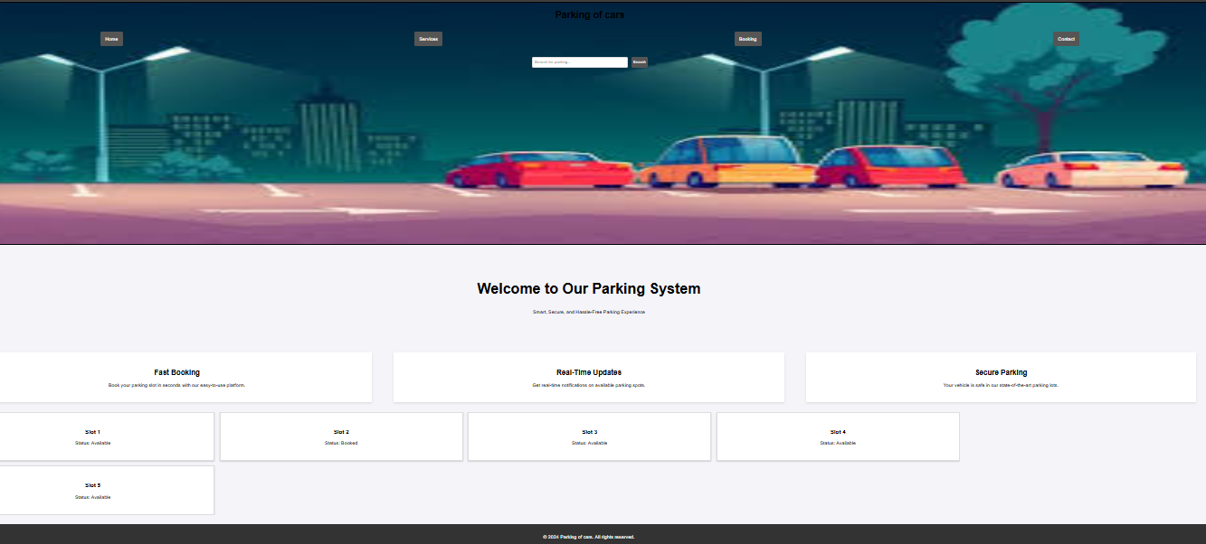

**Github Repo Link:**

**https://github.com/venkateshkoppula**

### References:

### 1. HTML, CSS, and JavaScript Fundamentals

* **MDN Web Docs (Mozilla Developer Network)**:
  + [HTML Documentation](https://developer.mozilla.org/en-US/docs/Web/HTML)
  + [CSS Documentation](https://developer.mozilla.org/en-US/docs/Web/CSS)
  + [JavaScript Documentation](https://developer.mozilla.org/en-US/docs/Web/JavaScript)
* **W3Schools**:
  + Comprehensive tutorials for learning HTML, CSS, and JavaScript.

**2. Responsive Design and Layout Techniques**

* **CSS Grid Layout**:
  + A Complete Guide to Grid by CSS-Tricks, explaining how to use CSS Grid to create complex and responsive layouts.
* **Flexbox Layout**:
  + A Complete Guide to Flexbox by CSS-Tricks, for flexible layout designs.
* **Responsive Design**:
  + Responsive Web Design Basics by Google Developers for designing web pages that adapt to different screen sizes.

**3. JavaScript Event Handling and DOM Manipulation**

* **MDN Web Docs**:
  + [JavaScript Events](https://developer.mozilla.org/en-US/docs/Learn/JavaScript/Building_blocks/Events) for understanding how to handle user interactions.
  + [DOM Manipulation](https://developer.mozilla.org/en-US/docs/Web/API/Document_Object_Model/Introduction) for dynamically interacting with web page content.
* **JavaScript.info**:
  + JavaScript Event Delegation for efficient handling of events on multiple elements.

**4. Web Development Best Practices**

* **Clean Code Principles**:
  + Clean Code for Frontend Developers for writing readable and maintainable code.
* **Organizing Code**:
  + Best Practices for Frontend Development from the Front-End Handbook for organizing code files and project structure.

**5. Project Inspiration and Advanced Features**

* **GitHub Repositories**:
  + Explore [GitHub](https://github.com/) for open-source projects related to parking systems and frontend development projects. Use keywords like "parking system," "web projects," or "interactive web apps."
* **CodePen**:
  + Browse [CodePen](https://codepen.io/) for examples of interactive components and grid layouts that can inspire enhancements to the project