**Introduction:**The project focuses on organizing and analyzing pharmacy claims data using a relational database approach. The raw data was normalized from its original format into 3NF (Third Normal Form) to eliminate redundancies and ensure that the data is well-structured for efficient querying. The project involved creating a star schema with fact and dimension tables to facilitate easy data retrieval for business analysis. Key operations included designing primary and foreign keys for data integrity and implementing SQL queries to provide insights into prescription trends, member demographics, and insurance payments.

**Part -1:**

**Table converted to INF:** Initially violated the First Normal Form (1NF) due to repeating groups of attributes fill dates, copay amounts, and insurance payments. To address this, I flattened the repeating groups into individual rows, every contained atomic data and unique values for fill dates, copays, and insurance payments.

**Fact table 1:fact_drug.csv**

Moving to Second Normal Form (2NF) To resolve this, I split the original table into two ensuring that all non-key attributes were fully dependent on the entire PK.

Finally, to achieve 3NF and eliminate transitive dependencies, I further decomposed **into** 2 tables. So by all means we have 4 dim and 1 fact

**Dim table 1:dim_member.csv:**

**Dim table 2: dim_drug_ndc.csv**

**Dimension table 3: dim_drug_form_code.csv**

**Dim table 4: dim_brand_generic.csv**



**Copay: This is an additive fact, as it can be summed across various dimensions**

**InsurancePaid: This is also an additive fact. can be summed across dimensions to calculate total insurance coverage.**



**Grain of the fact table: The grain of the fact_drug table refers to an individual prescription fill event, where each row captures the specific details of a prescription filled by a member, including the copay amount, insurance payment, and the date of the transaction.**

**Part -2:**

Database Setup and Updates

* Database Creation:  
  Imported the provided 3NF-structured CSV files into a new database, final_project, to establish a star schema for analysis.
* All 5 files converted from 5 excel to csv and imported csv files to my sql



|  |  |  |  |
| --- | --- | --- | --- |
| **Foreign Key (FK)** | **Action on DELETE** | **Action on UPDATE** | **Justification** |
| fact_drug.member_id | SET NULL | CASCADE | **DELETE**: Keeps historical data intact by setting member_id to NULL if a member is deleted. **UPDATE**: Ensures updates cascade to maintain consistency. |
| fact_drug.drug_ndc | SET NULL | CASCADE | **DELETE**: Nullifies references to deleted drugs but retains transactions. **UPDATE**: Cascades updates for accurate referencing. |
| fact_drug.drug_form_code | SET NULL | CASCADE | **DELETE**: Preserves historical data by setting drug_form_code to NULL if a drug form is deleted. **UPDATE**: Cascades updates for consistency. |
| fact_drug.drug_brand_generic_code | SET NULL | CASCADE | **DELETE**: Nullifies references to deleted brand-generic codes to retain transaction integrity. **UPDATE**: Cascades updates to avoid data issues. |

Conversion and Formatting

* Date Fields: Converted fill_date and member_birth_date to MySQL DATE type for efficient queries and proper handling of date operations.
* Column Adjustments: Modified data types (e.g., VARCHAR(100)) to meet MySQL requirements for primary keys and foreign key constraints.

This approach aligns with best practices for ensuring data integrity and optimizing database design for analytical queries.

Part -3:

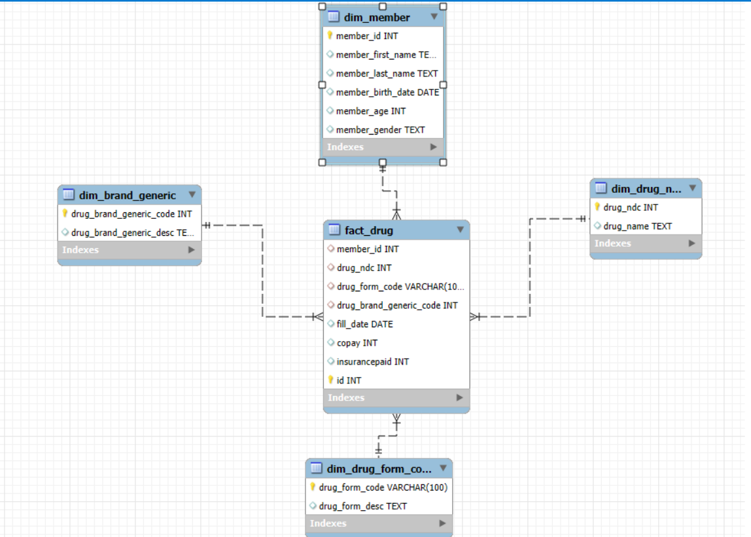

Part 4 :

Query -1: Prescriptions Grouped by Drug Name

A total of 5 prescriptions were filled for the drug Ambien.

Query 2:

* There is 1 unique member over the age of 65.
* They filled a total of 6 prescriptions.

Query -3:

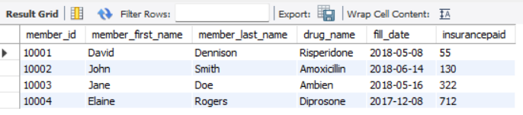

The

* Upon reviewing the latest prescription records, I found that the drug dispensed to member ID 10003 on their most recent fill date was **Ambien.**
* Insurance payment for this medication amounted to **322**.

**Conclusion:**  
The database setup and normalization process resulted in a well-organized schema that allows for efficient querying and reporting. By applying normalization techniques, we ensured that the data is stored without redundancy and with integrity. The queries provided useful insights into prescription trends, member demographics, and insurance payments, which will aid in future decision-making and reporting for pharmacy claims management. The overall setup aligns with best practices for data warehousing and SQL, making the data both accessible and actionable for analysis.

**References:**

* **Ben-Gan, I. (2020). *SQL Server 2019: The complete guide to database normalization* [Blog post].** [**https://www.sqlservercentral.com/articles/sql-server-2019-the-complete-guide-to-database-normalization**](https://www.sqlservercentral.com/articles/sql-server-2019-the-complete-guide-to-database-normalization)

