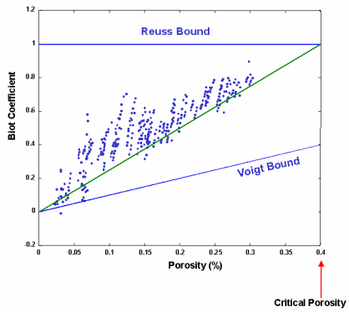

Figure 1.1 Cross plot of core data from Han, et al. (1986), plotted in the “Biot plane”.

Physically realizable rocks are bounded by the Reuss bound, which represents the softest

possible rock, and the Voigt bound, which represents the hardest possible rock. In the Biot

plane, the Reuss bound is simply Biot = 1.0, while the Voigt bound is Biot = rock porosity.

Nur’s modified Voigt bound (green line) represents a reasonable lower limit.

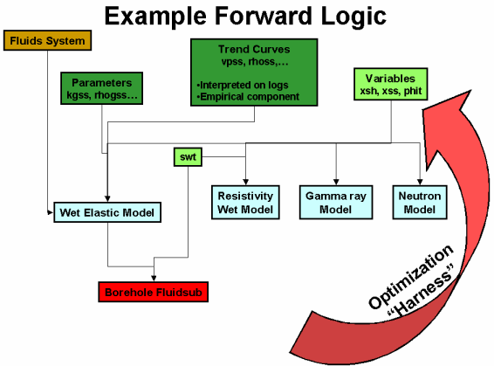

Figure 1.2 Generalized forward logic used in Converge.

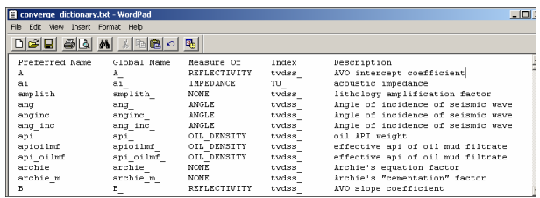

Figure 2.1 The Converge dictionary.

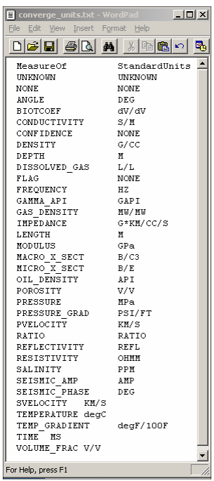

Figure 2.2 The Converge unit Measure-Of definition table.

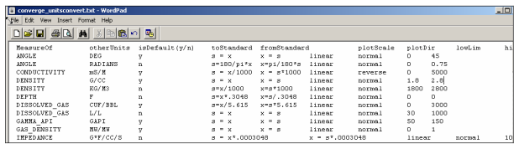

Figure 2.3 The Converge unit conversion table.

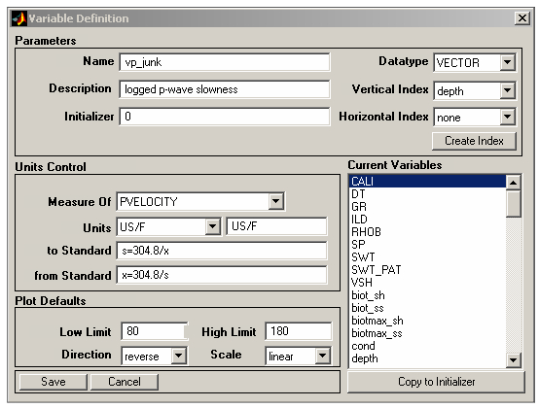

Figure 2.4 The Converge variable definition dialog window.

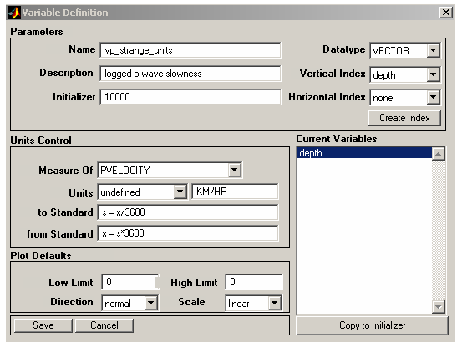

Figure 2.5 Initializing Vp to 10000 km/hr.

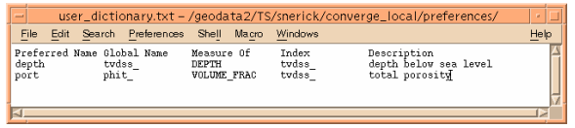

Figure 2.6 Example Converge user dictionary.

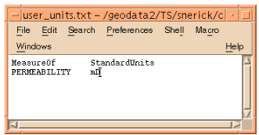

Figure 2.7 Specifying user standard units.

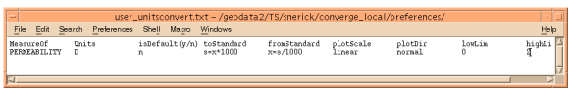

Figure 2.8 User specified unit conversion.

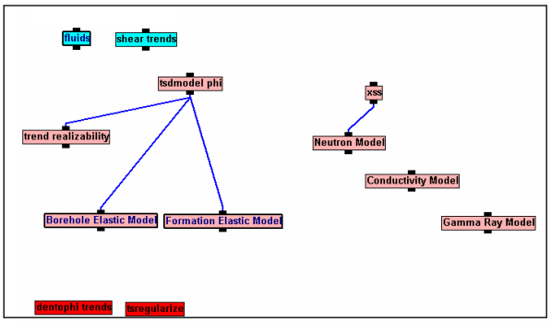

Figure 2.9 The Converge canvas.

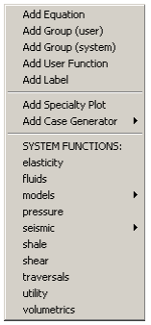

Figure 2.10 The Canvas popup menu.

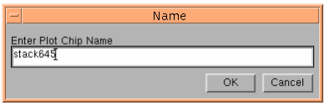

Figure 2.11 Specifying a chip name for the Canvas.

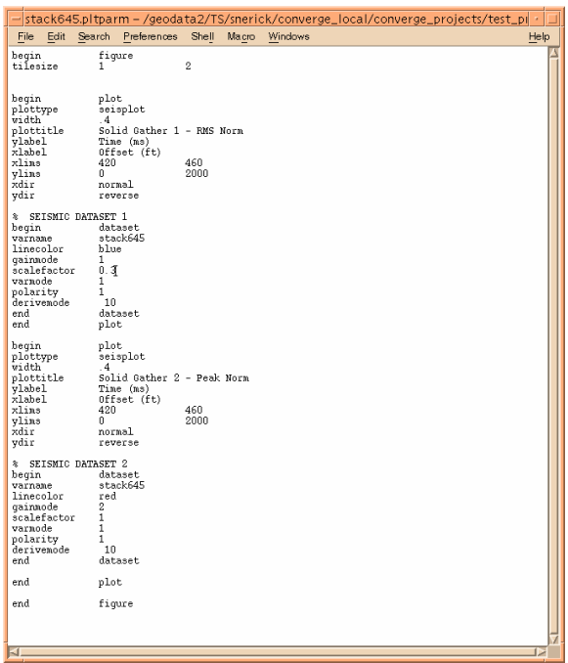

Figure 2.12 The parameter file for a speciality plot of two datasets.

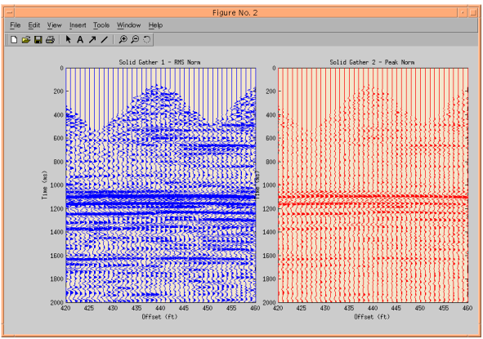

Figure 2.13 The resulting speciality plot.

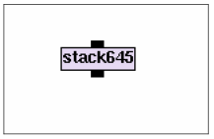

Figure 2.14 Example speciality plot chip.

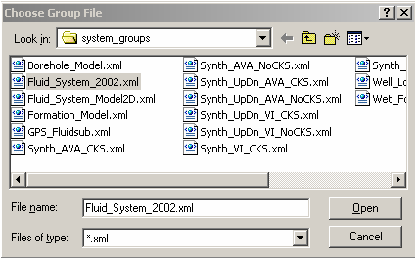

Figure 2.15 Selecting a group XML chip.

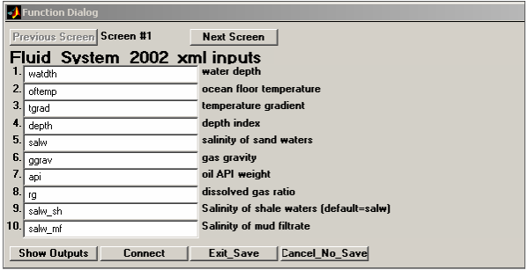

Figure 2.16 Specifying input parameters for the group chip.

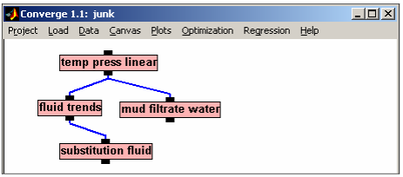

Figure 2.17 After expanding the group fluid system chip.

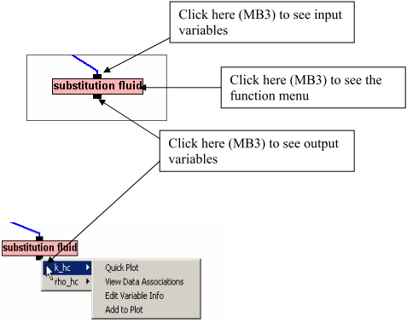

Figure 2.18 Selecting options from Canvas popup menus.

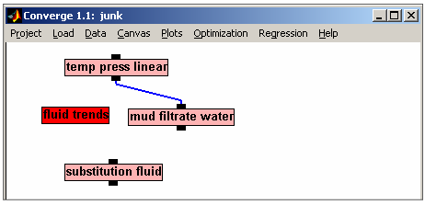

Figure 2.19 After disconnecting the fluid trends chip.

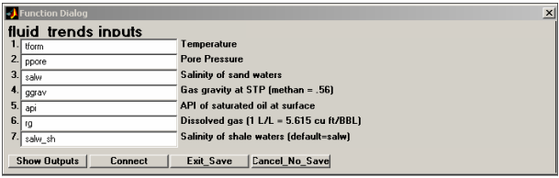

Figure 2.20 Editing input parameters for the fluid trends chip.

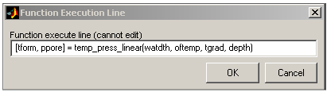

Figure 2.21 The function line view of the temp_press_linear chip.

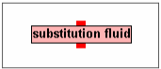

Figure 2.22 A chip after hiding both input and output wires.

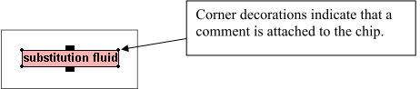

Figure 2.23 A chip with saved comments.

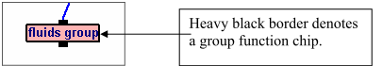

Figure 2.24 A group chip has a heavy border.

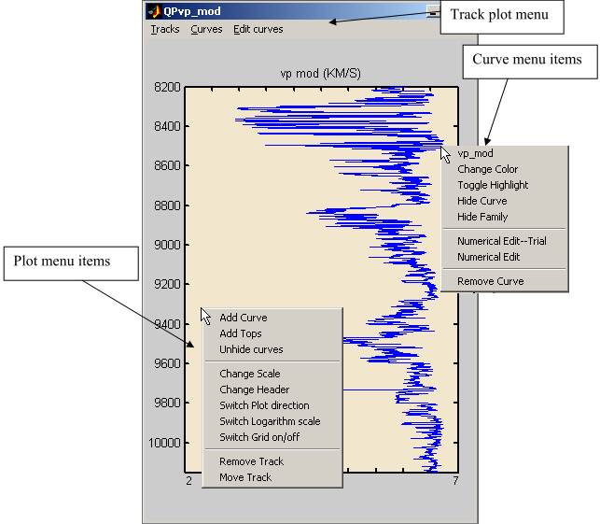

Figure 2.25 The quick plot popup menu.

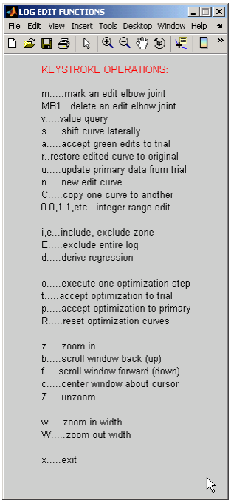

Figure 2.26 The graphical log edit menu.

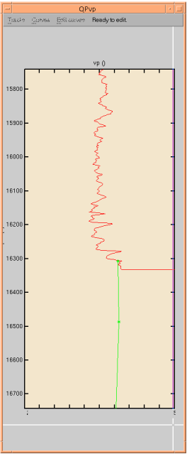

Figure 2.27 Re-drawing a log to edit bad values.

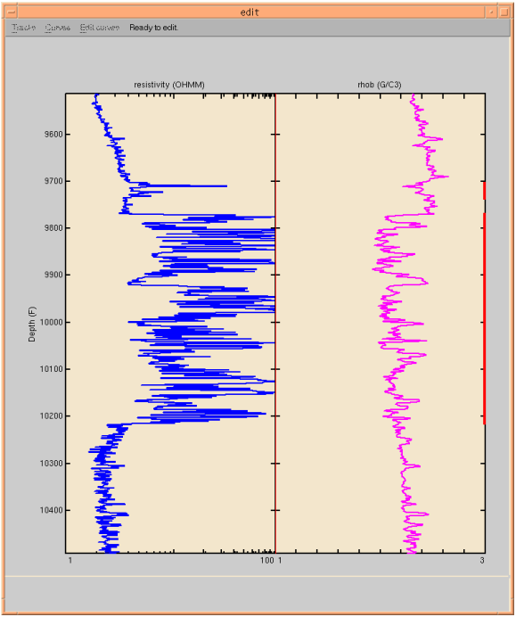

Figure 2.28 Include zones in edit mode are highlighted on the right track edge.

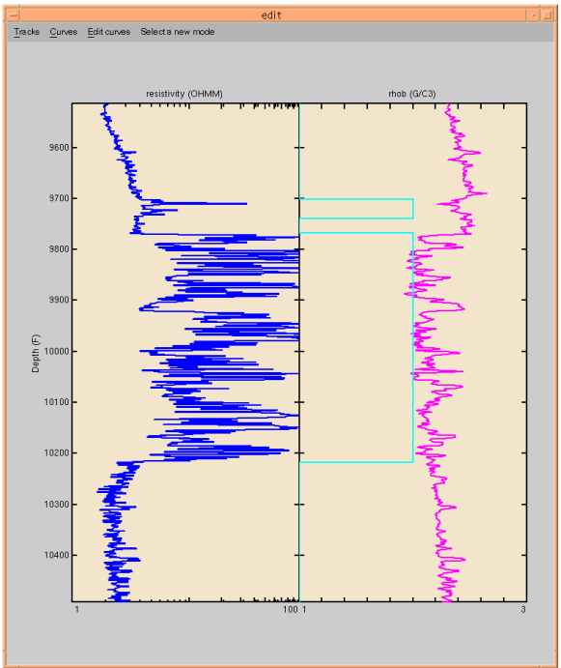

Figure 2.29 Edit results after using the flag curve.

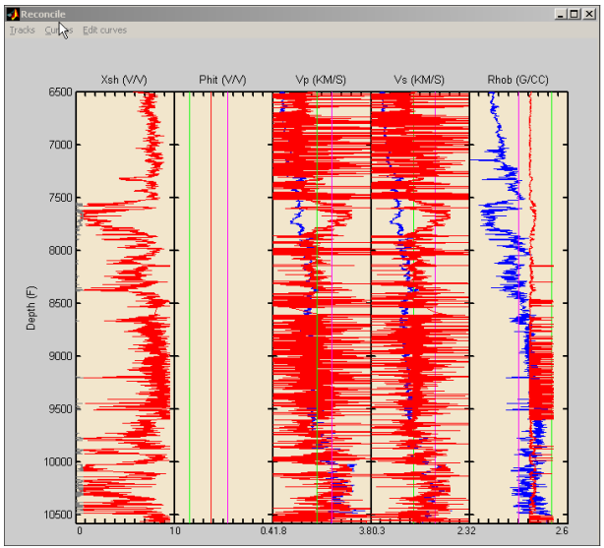

Figure 3.10 Plots for reconciliation of TSD model. They aren’t looking so good yet, mainly

because of lack of constraints on physical parameters.