**Name**: Venkatesh Rongala

**Module-8: Terraform Assignment - 1**

**Task-1**

* Create an EC2 service in the default subnet in the ohio region

**Solution:**

* First create one EC2 instance for terraform installation

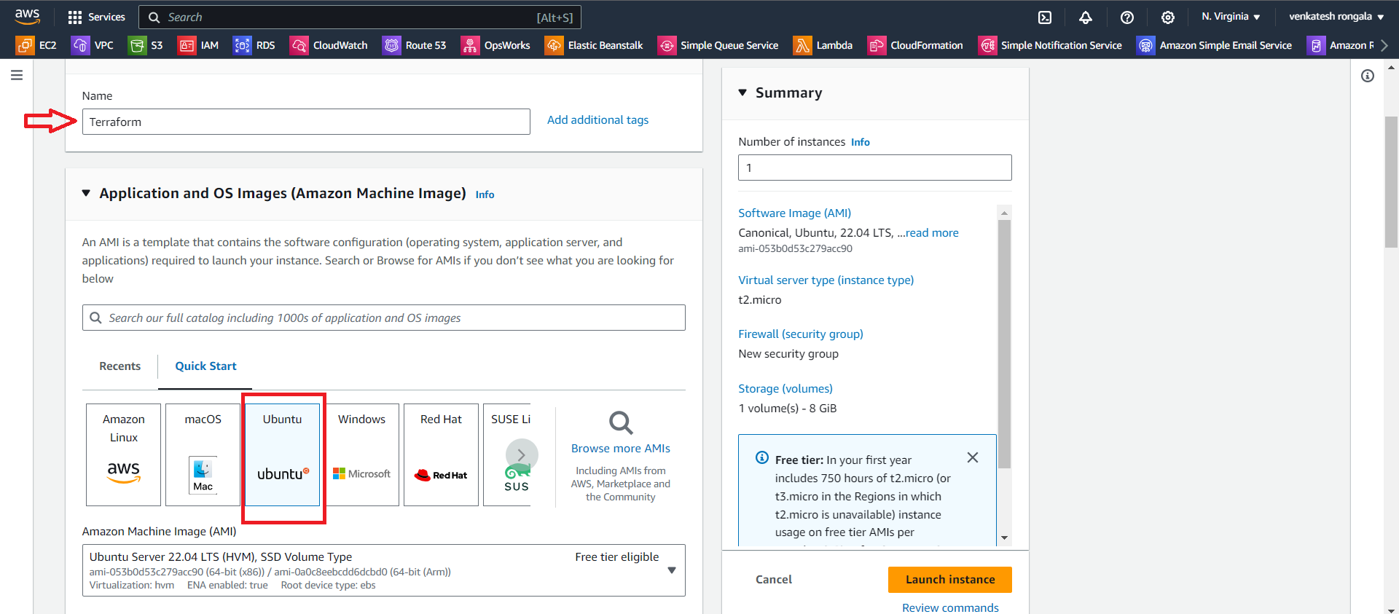

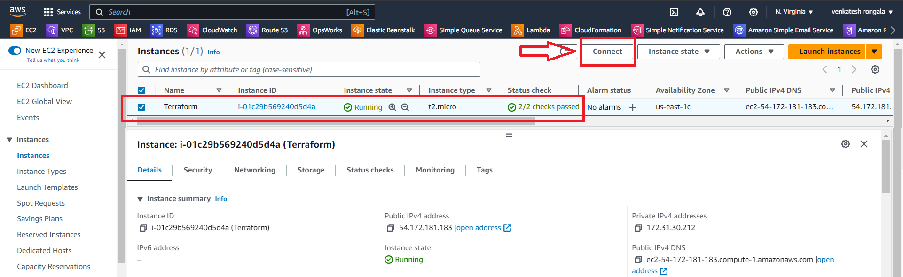

* Next connect to the instance & install “terraform”

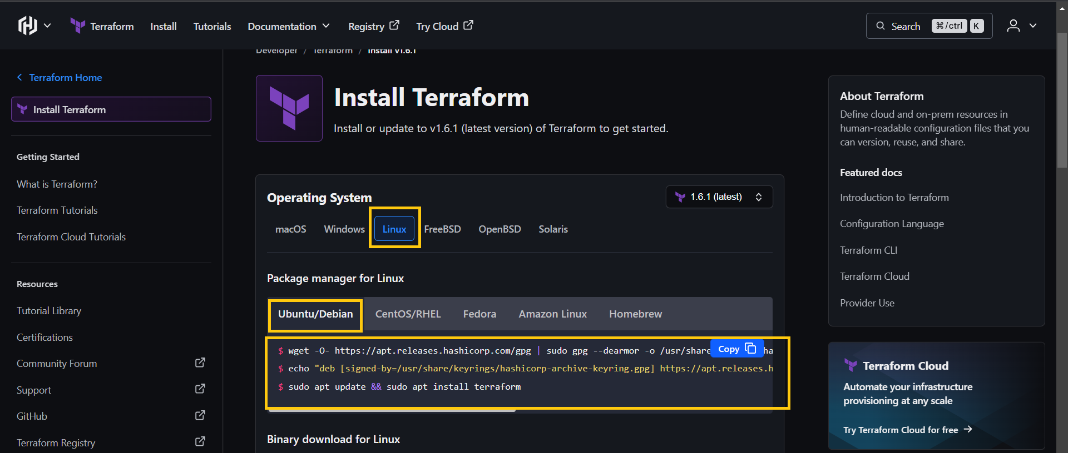

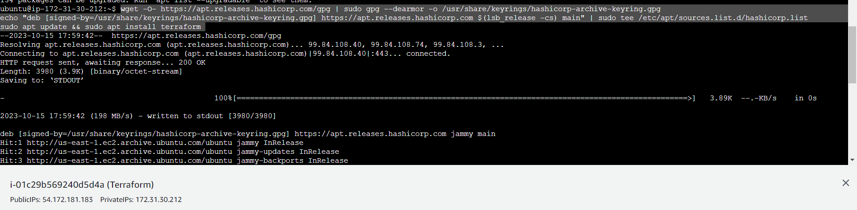

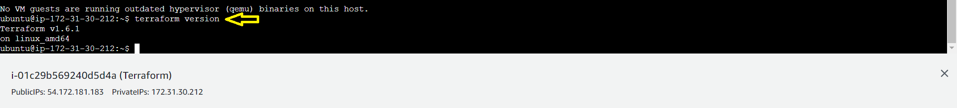

* Next install “aws cli”

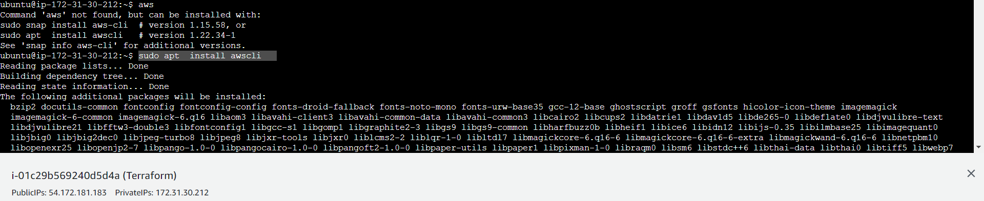

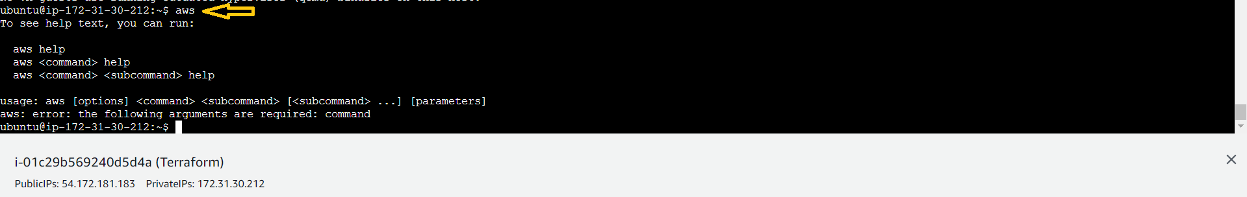

* Next create an IAM user & Generate “Access key & Secret key”

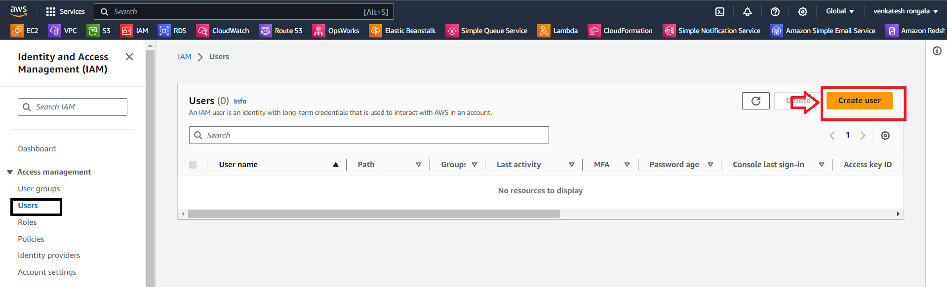

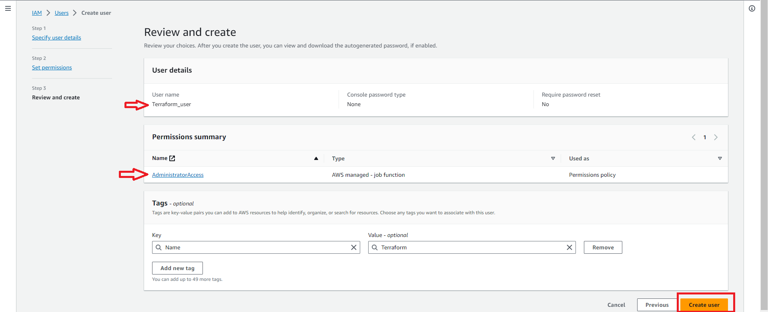

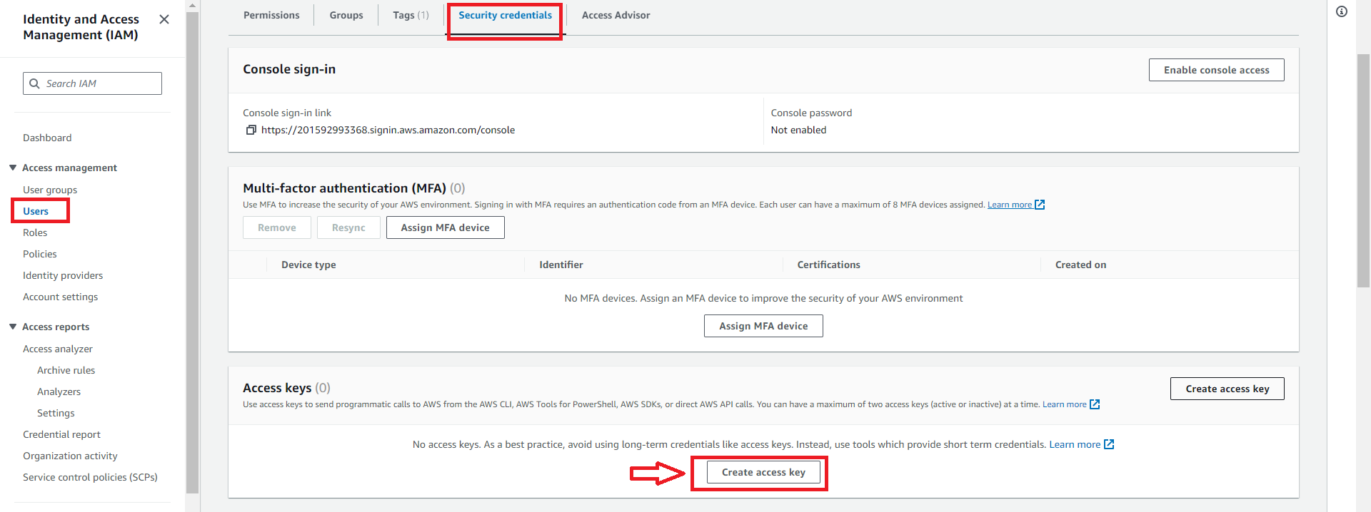

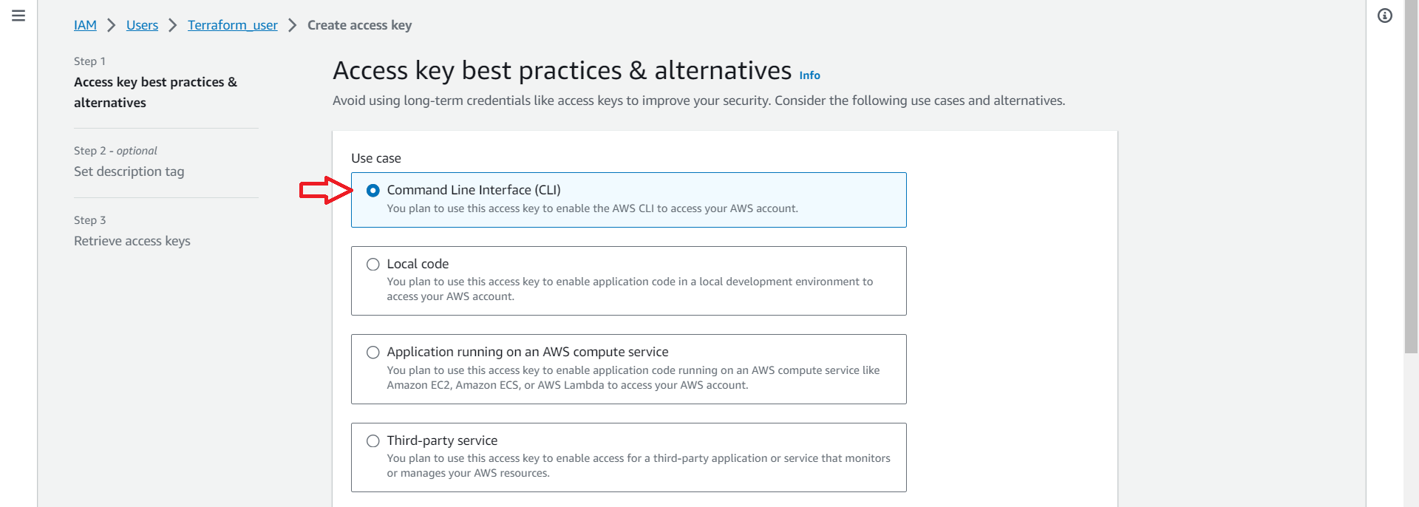

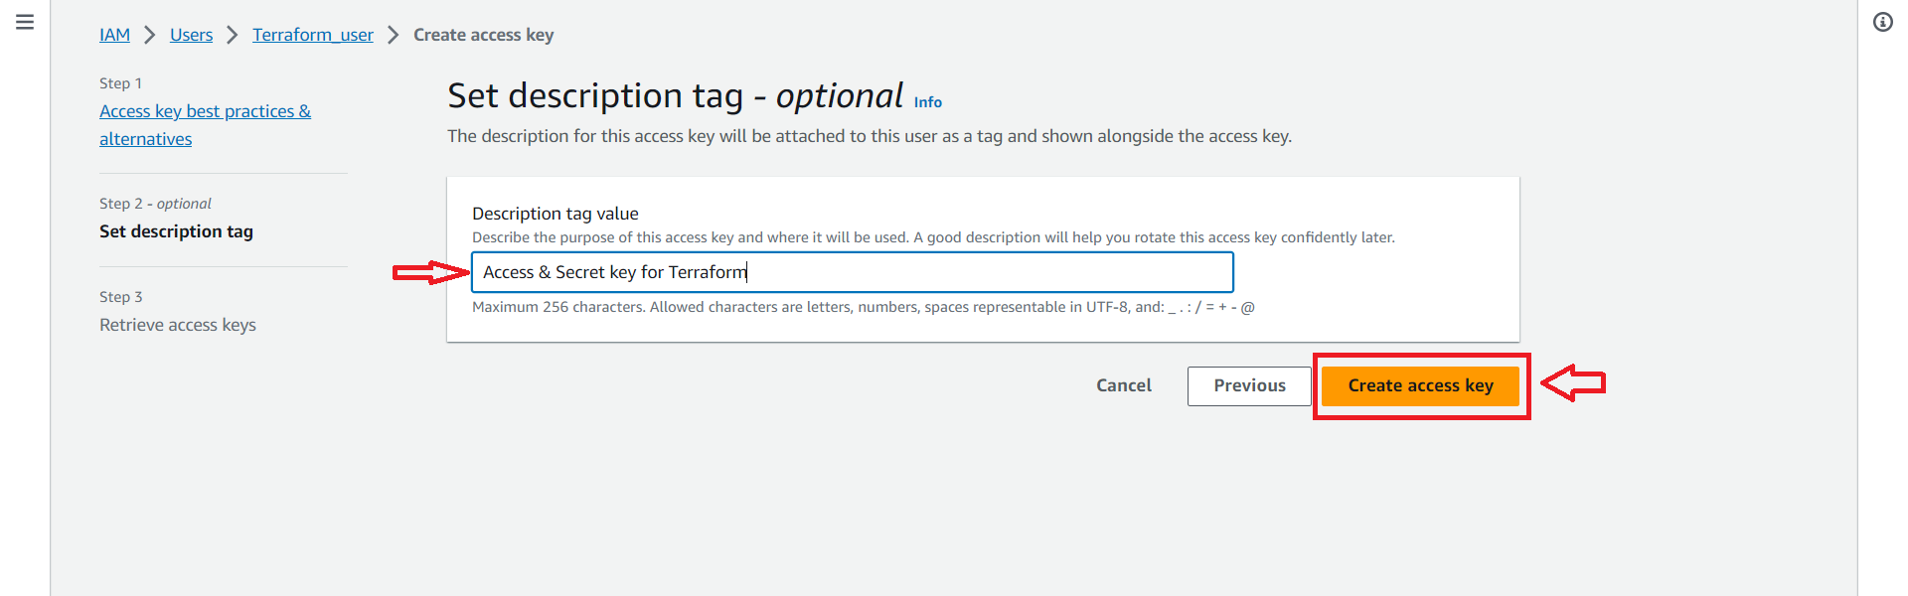

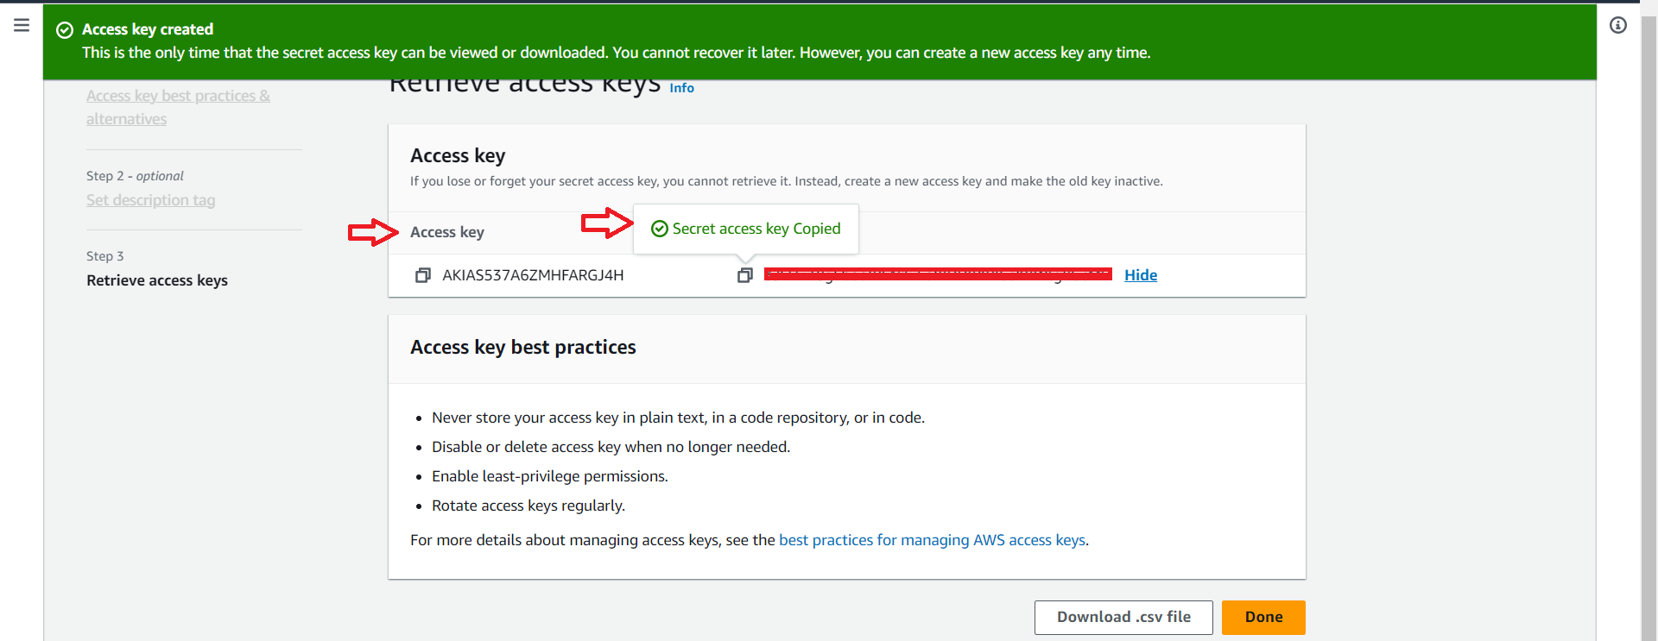

* Next “export” the keys



* Next create a “Directory” & inside create a “main.tf” file

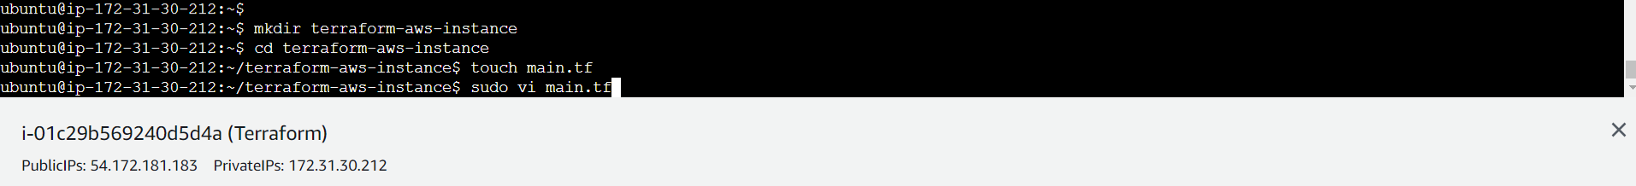

* Now Initialize the terraform, with the command “terraform init”

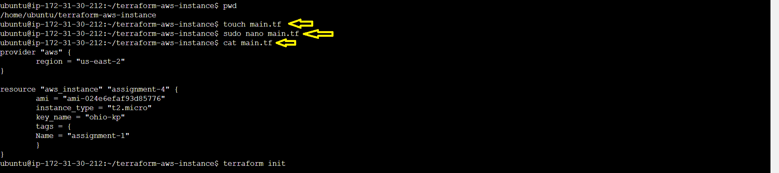

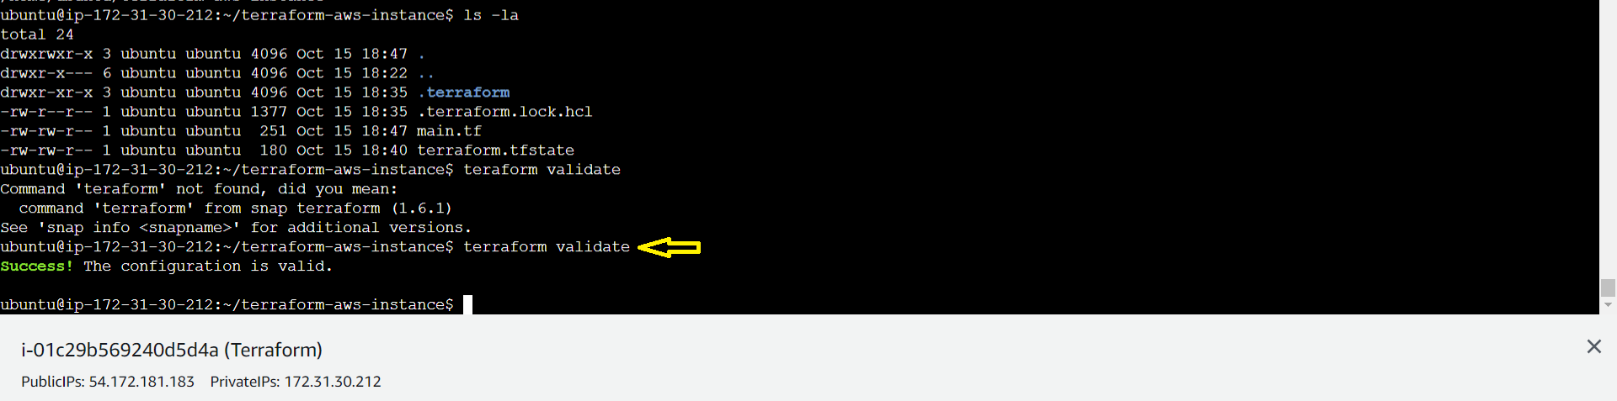

* Before “terraform Apply” command, Go to AWS & check in “Ohio” region

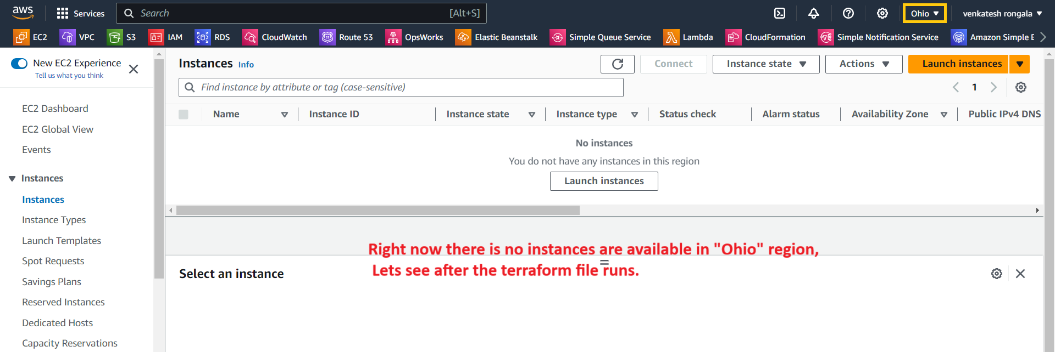

* Now use “terraform plan” command

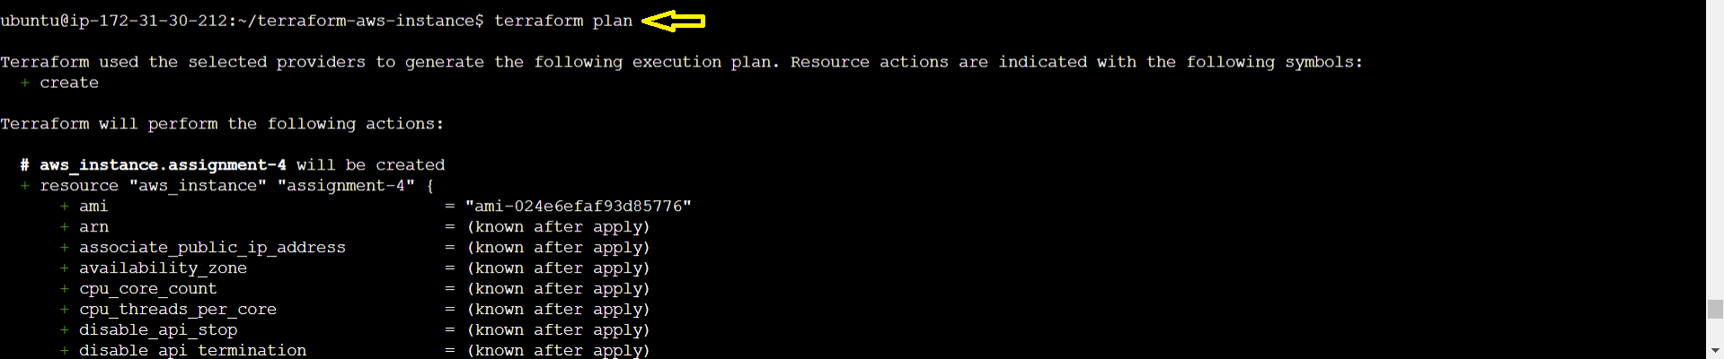

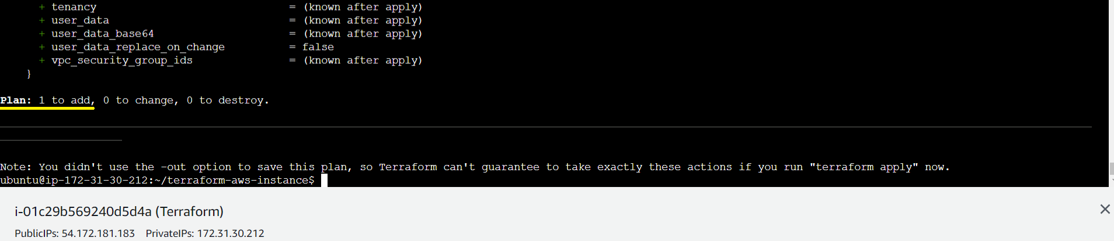

* Now Run the “Terraform apply” command

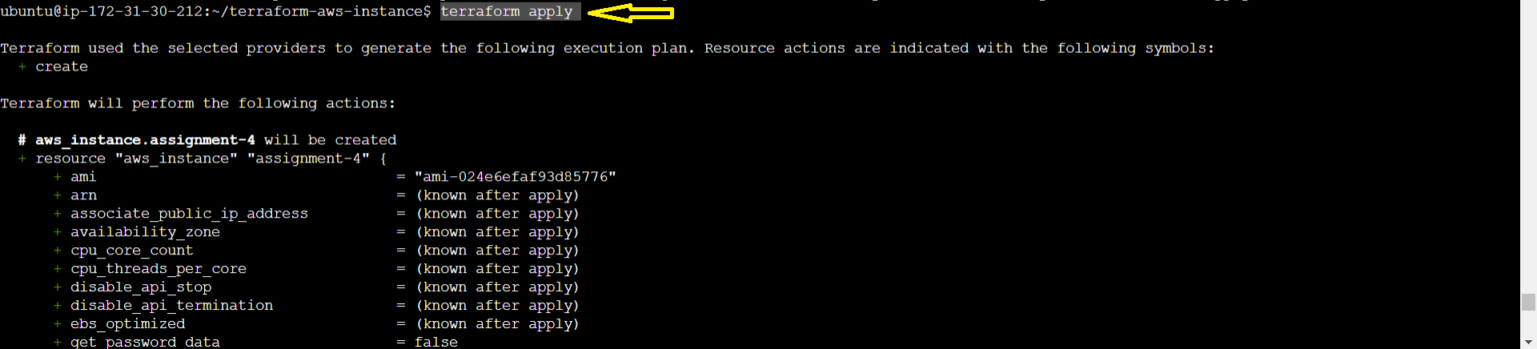

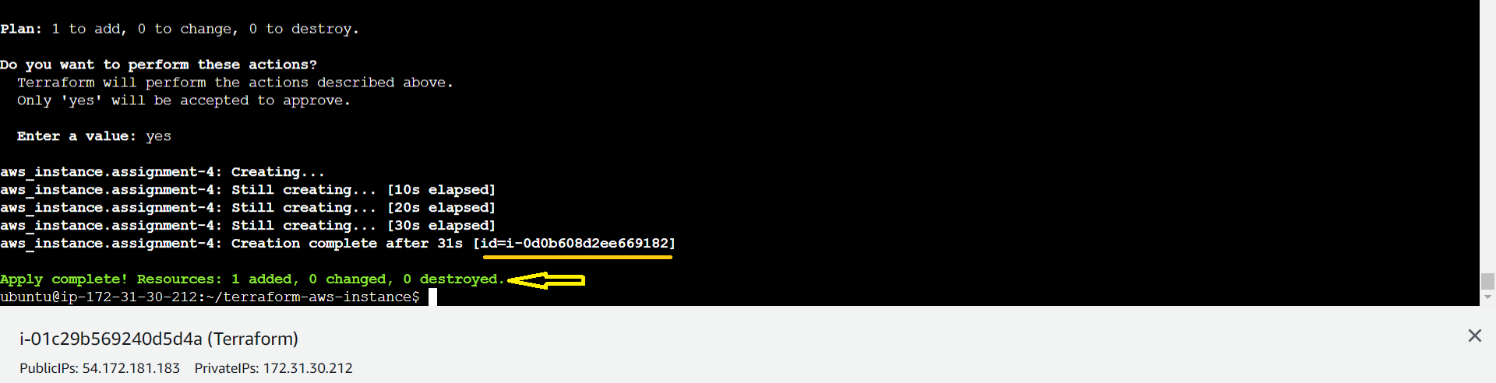

* Now go to AWS 🡪 “Ohio” Region & check the EC2 instance.

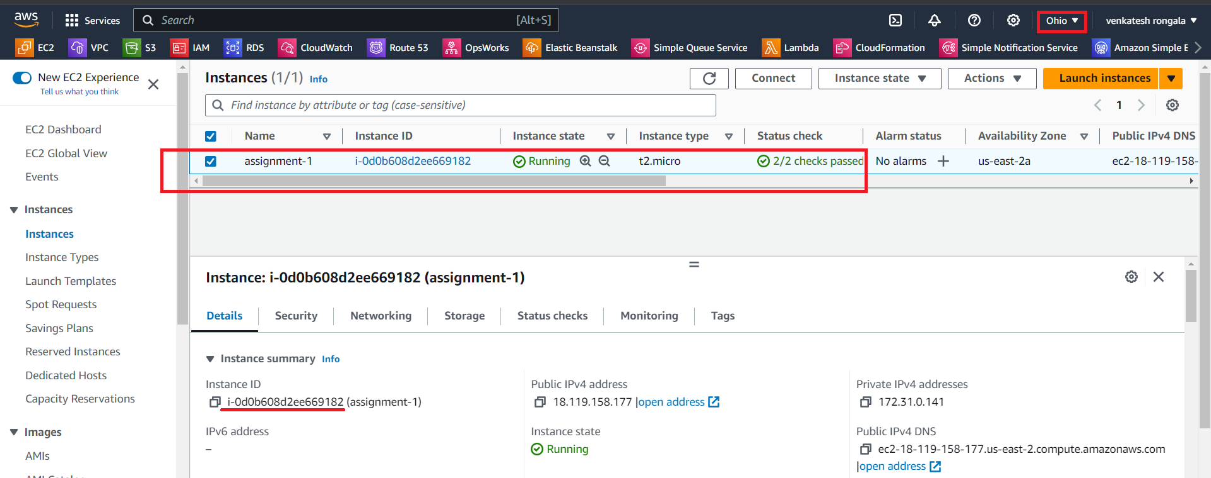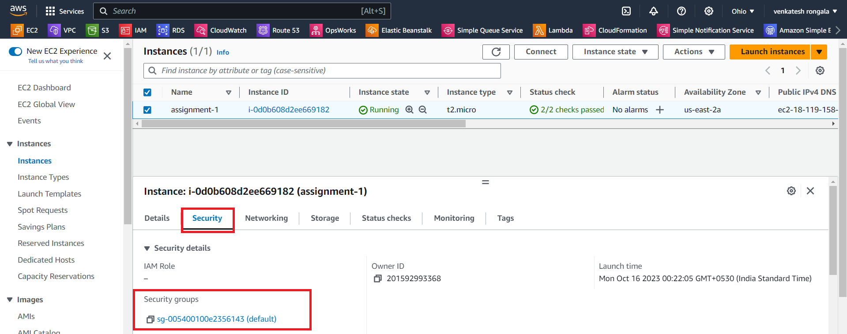

*********** Task Completed ***********