**Name**: Venkatesh Rongala

**Module-8: Terraform Assignment - 2**

**Task-2**

* Destroy the previous deployment
* Create a new EC2 instance with an Elastic IP

**Solution:**

* First Destroy the previous deployment using the command “terraform destroy”

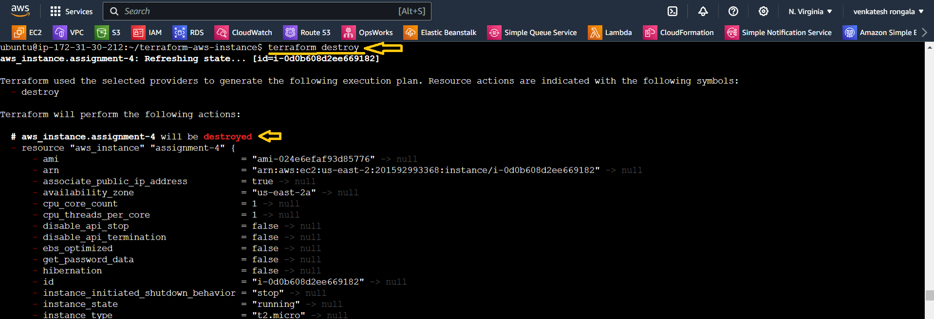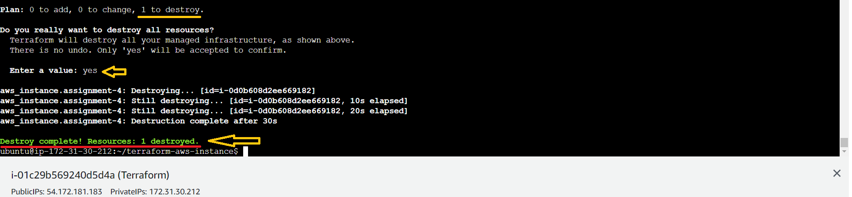

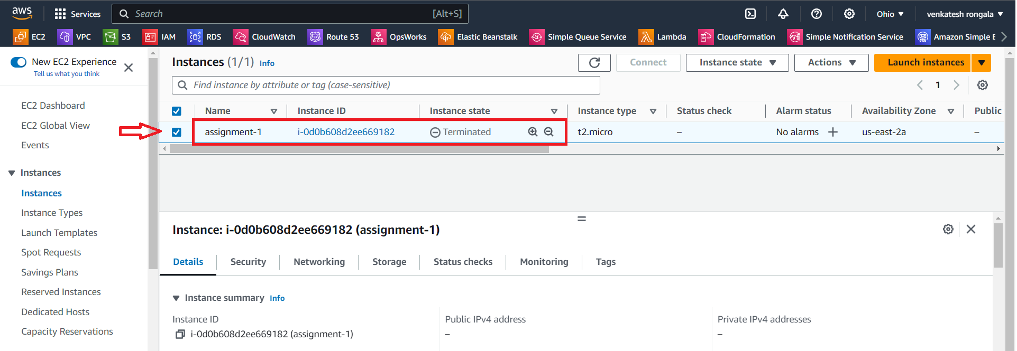

* Create a new EC2 instance with an Elastic IP,
* **main.tf**
* **provider "aws" {**

**region = "us-east-2"**

**}**

**resource "aws_instance" "assignment-2" {**

**ami = "ami-024e6efaf93d85776"**

**instance_type = "t2.micro"**

**key_name = "ohio-kp"**

**tags = {**

**Name = "assignment-2"**

**}**

**}**

**resource "aws_eip" "eip" {**

**vpc = true**

**}**

**resource "aws_eip_association" "eip_assoc" {**

**instance_id = aws_instance.assignment-2.id**

**allocation_id = aws_eip.eip.id**

**}**

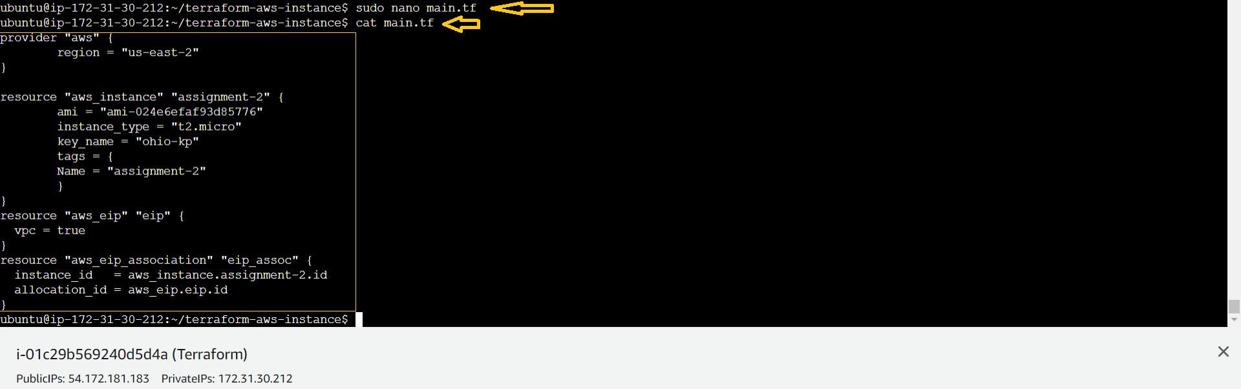

* Next Run the “terraform plan” commands

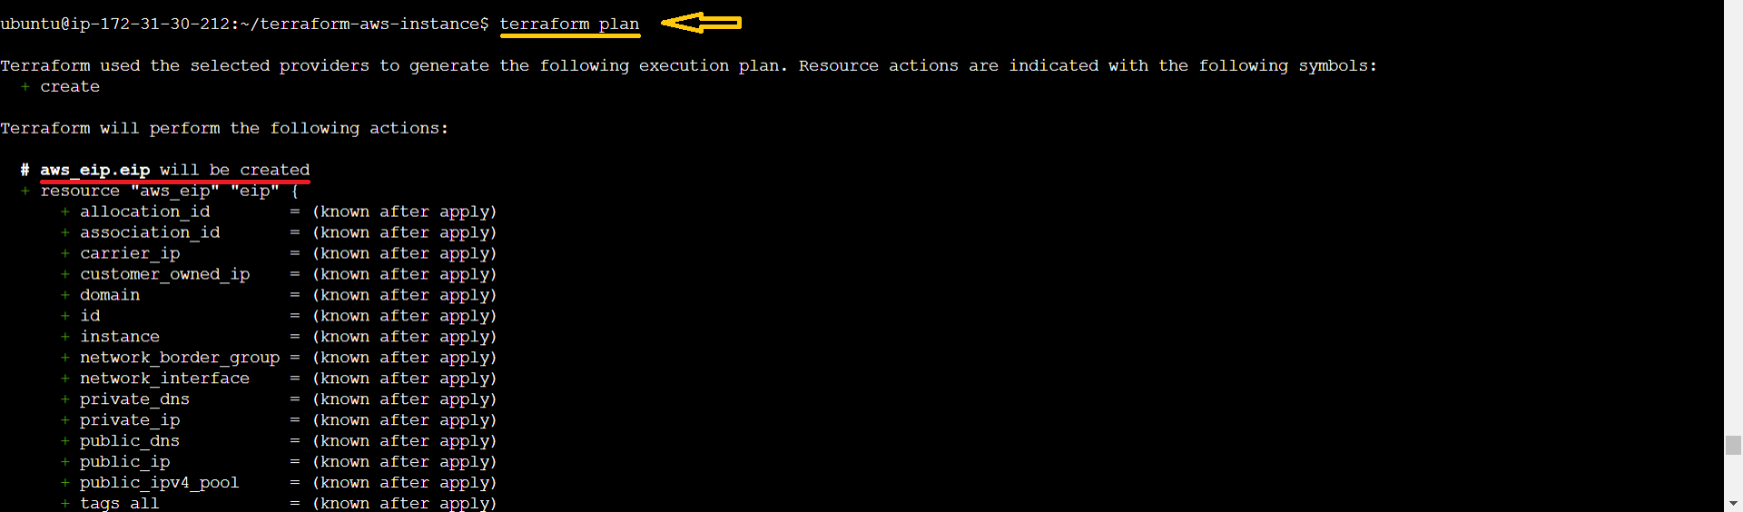

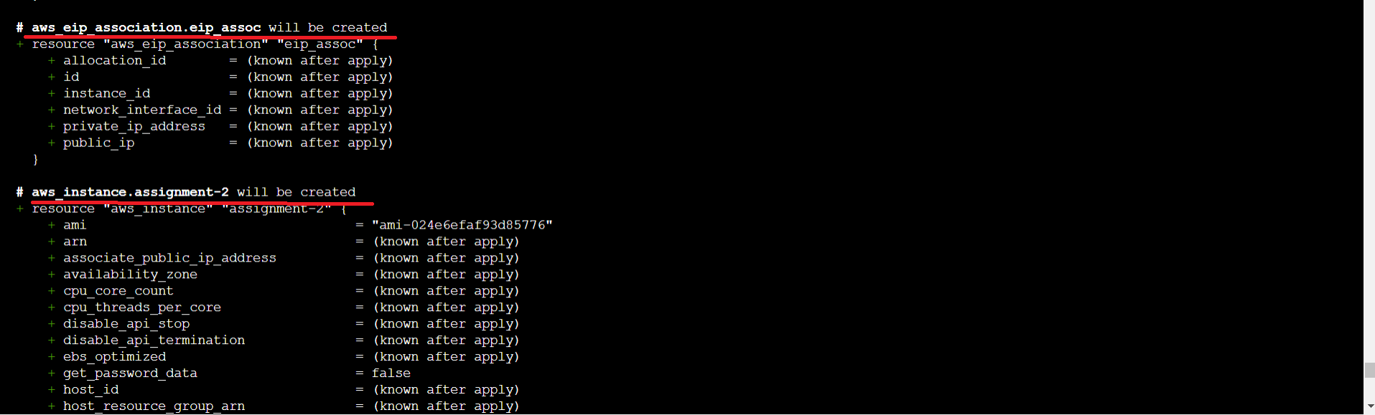

* Next Run the “terraform apply” commands

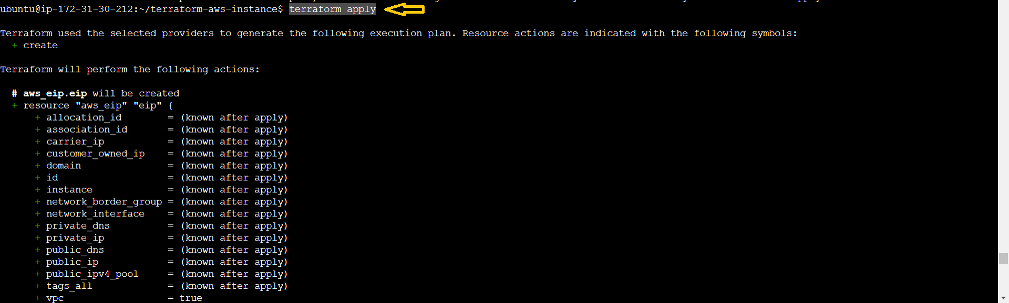

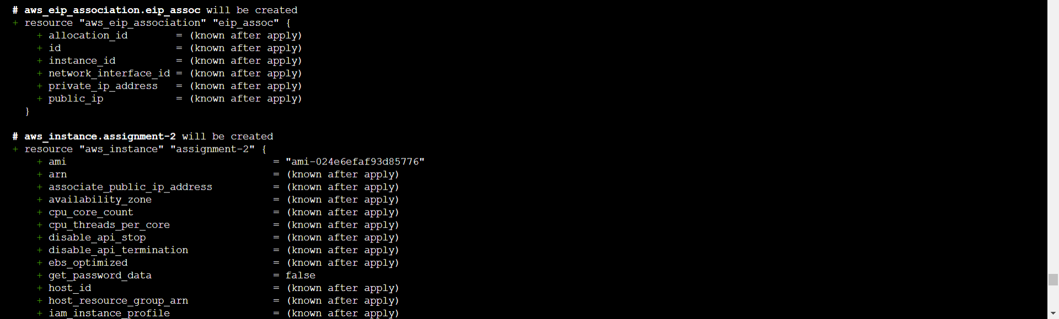



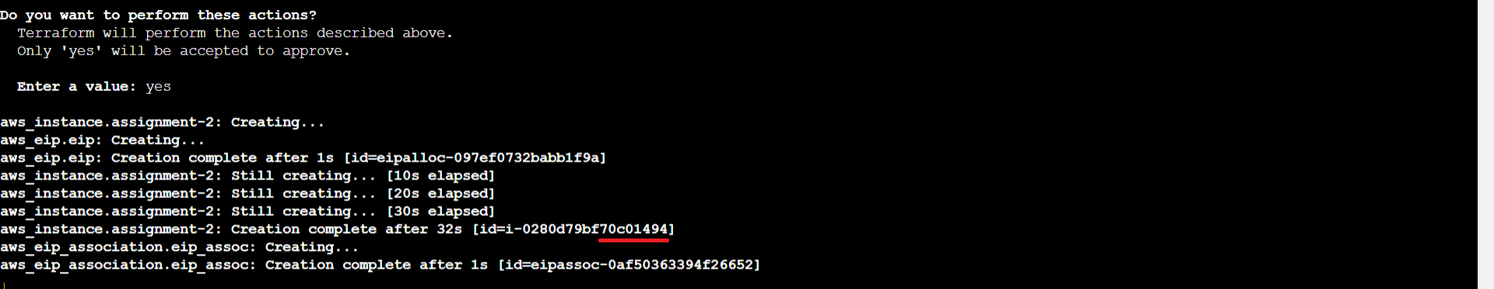

* Now go to AWS 🡪 “Ohio” Region & check the “assignment-2 instance”.

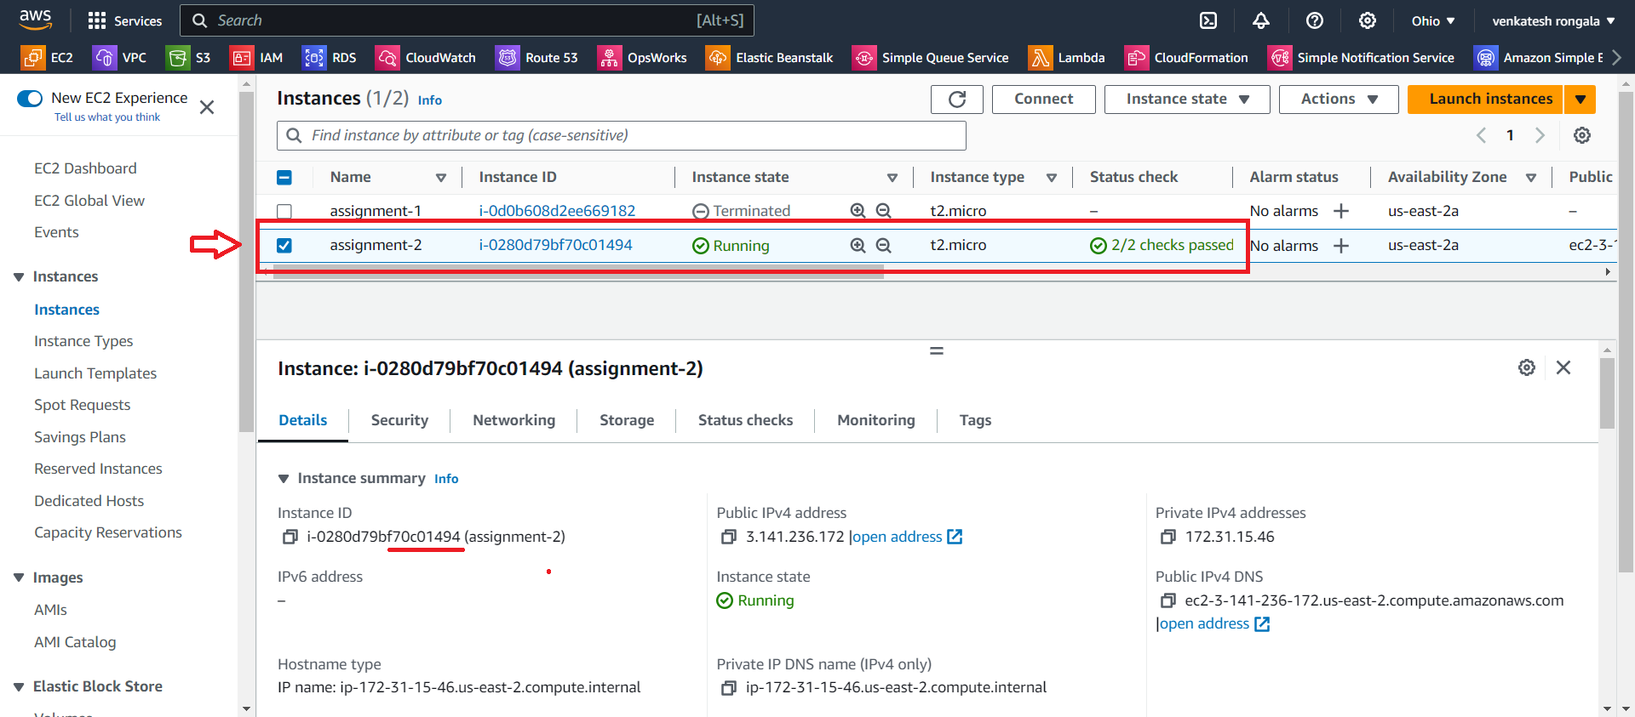

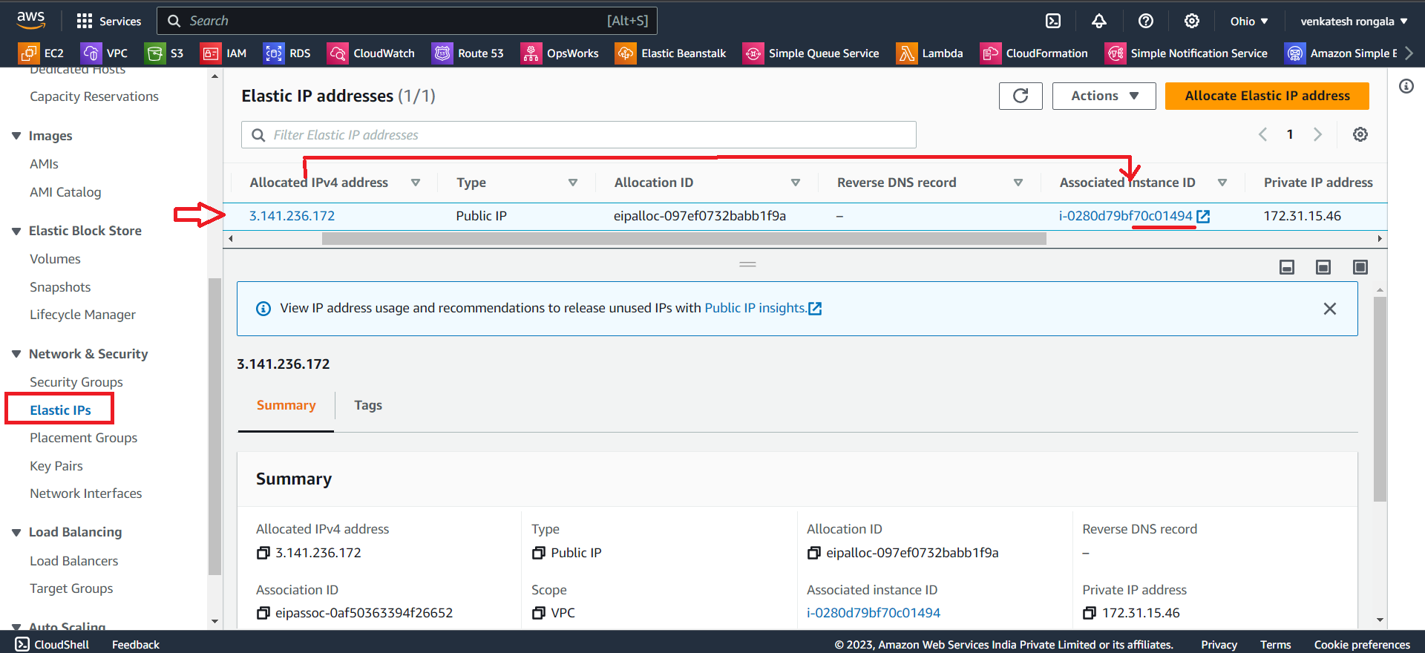

*********** Task Completed ***********