**Name**: Venkatesh Rongala

**Module-8: Terraform Assignment - 3**

**Task-3**

* Destroy the previous deployment
* Create 2 EC2 instances in Ohio and N.Virginia respectively
* Rename Ohio’s instance to ‘hello-Ohio’ and Virginia’s instance to ‘hello-Virginia’

**Solution:**

* First Destroy the previous deployment using the command “terraform destroy”

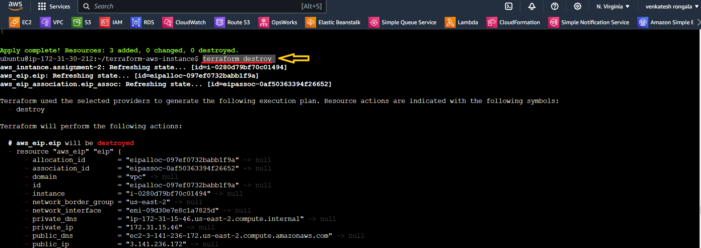

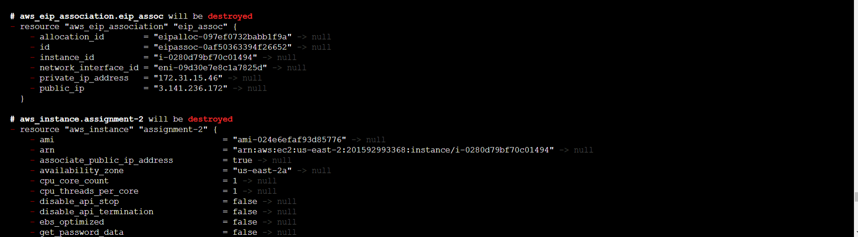

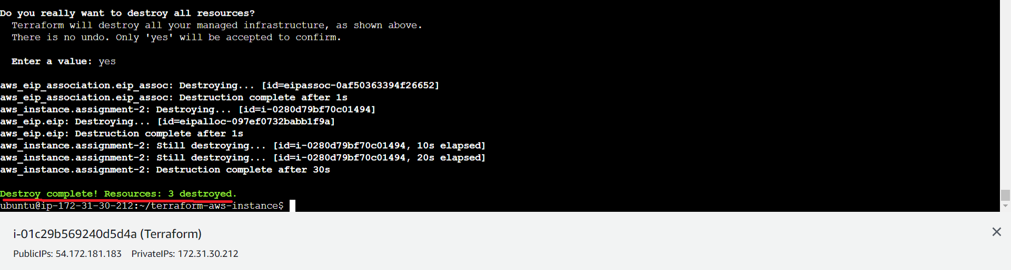

* Create2 EC2 instances in Ohio and N.Virginia respectively &
* Rename Ohio’s instance to ‘hello-Ohio’ and Virginia’s instance to ‘hello-Virginia’
* **main.tf**
* **provider "aws" {**

**alias = "NV"**

**region = "us-east-1"**

**}**

**provider "aws" {**

**alias = "Ohio"**

**region = "us-east-2"**

**}**

**resource "aws_instance" "assignment-3-1" {**

**provider = aws.NV**

**ami = "ami-053b0d53c279acc90"**

**instance_type = "t2.micro"**

**key_name = "ubuntu-KP"**

**tags = {**

**Name = "hello-virginia"**

**}**

**}**

**resource "aws_instance" "assignment-3-2" {**

**provider = aws.Ohio**

**ami = "ami-024e6efaf93d85776"**

**instance_type = "t2.micro"**

**key_name = "ohio-kp"**

**tags = {**

**Name = "hello-ohio"**

**}**

**}**

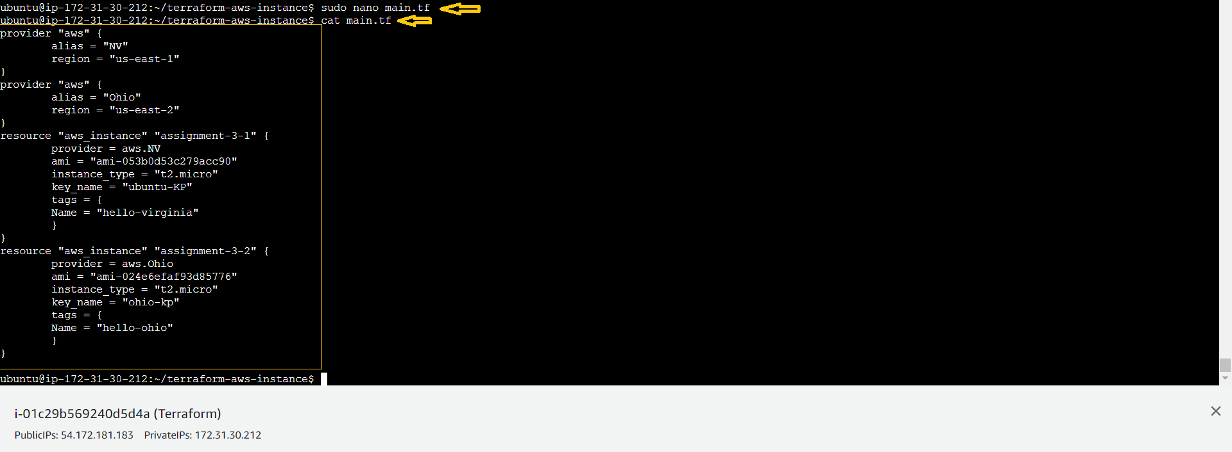

* Next Run the “terraform plan” commands

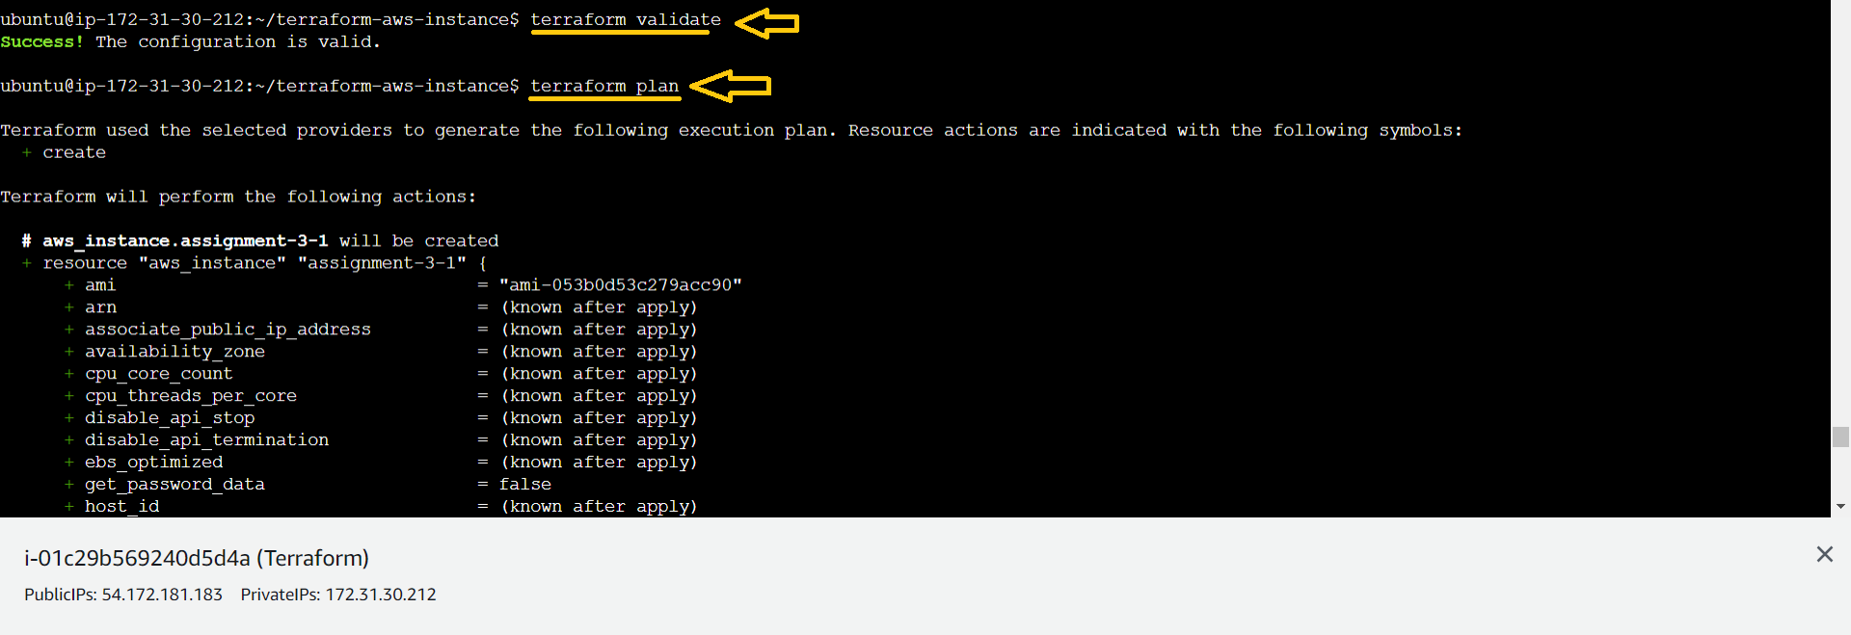

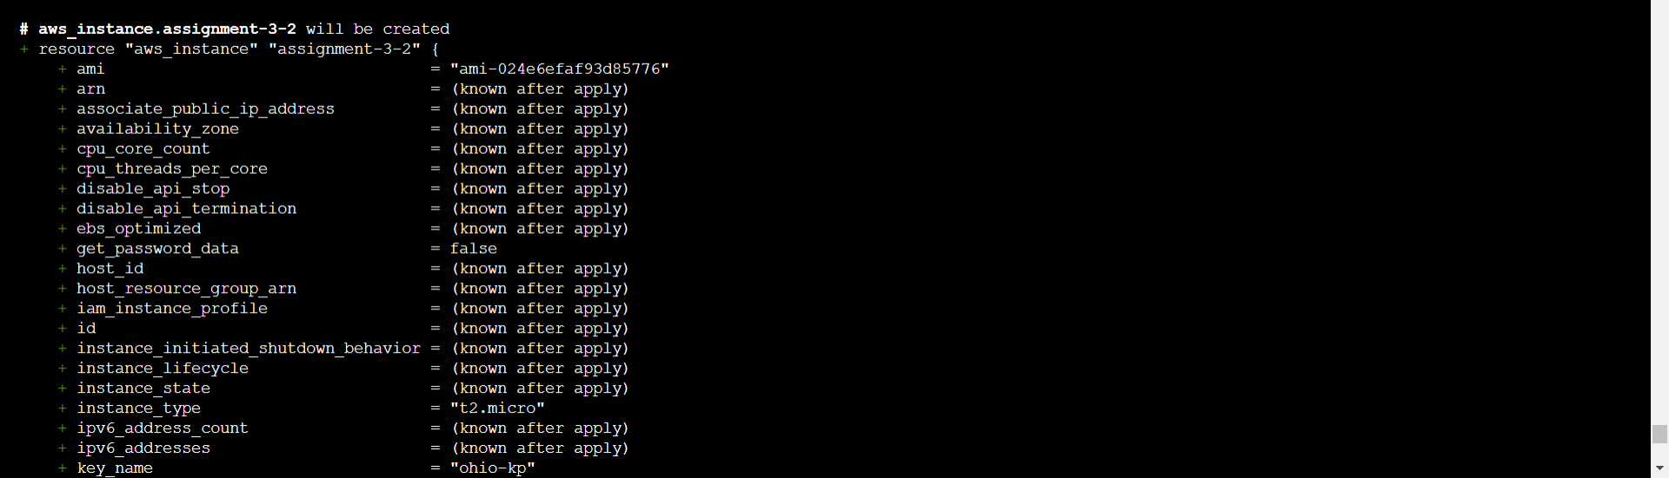

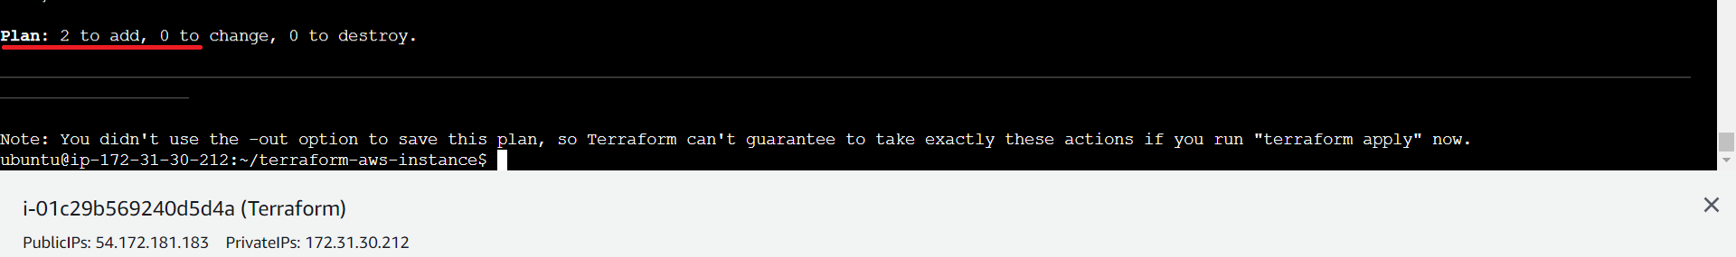

* Next Run the “terraform apply” commands

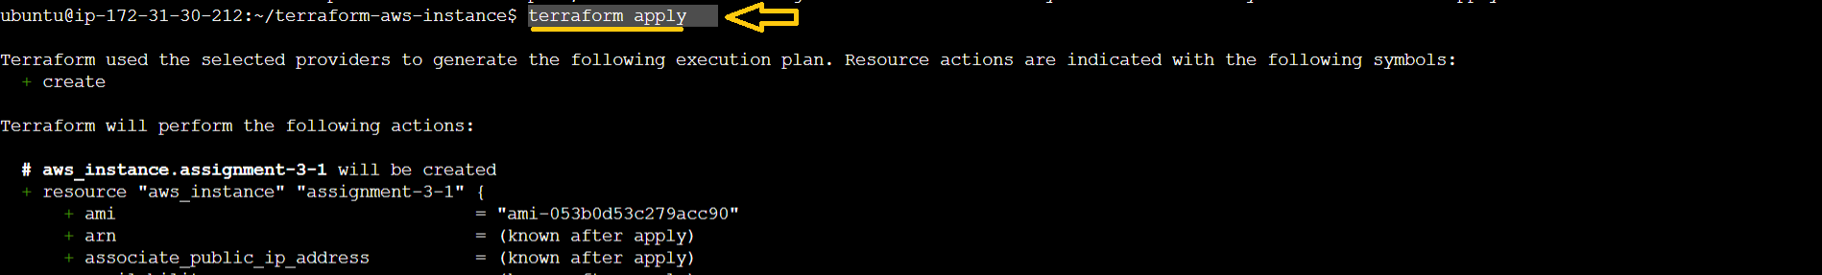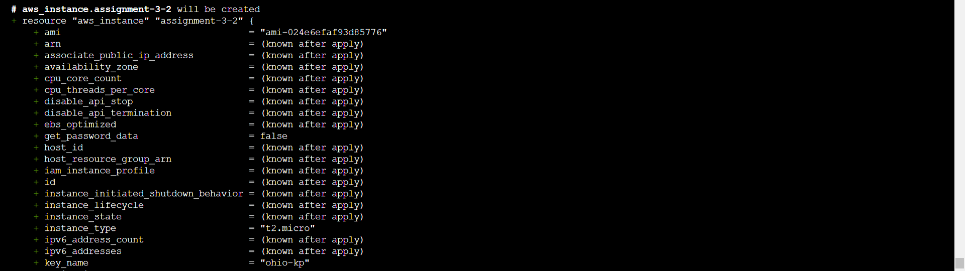

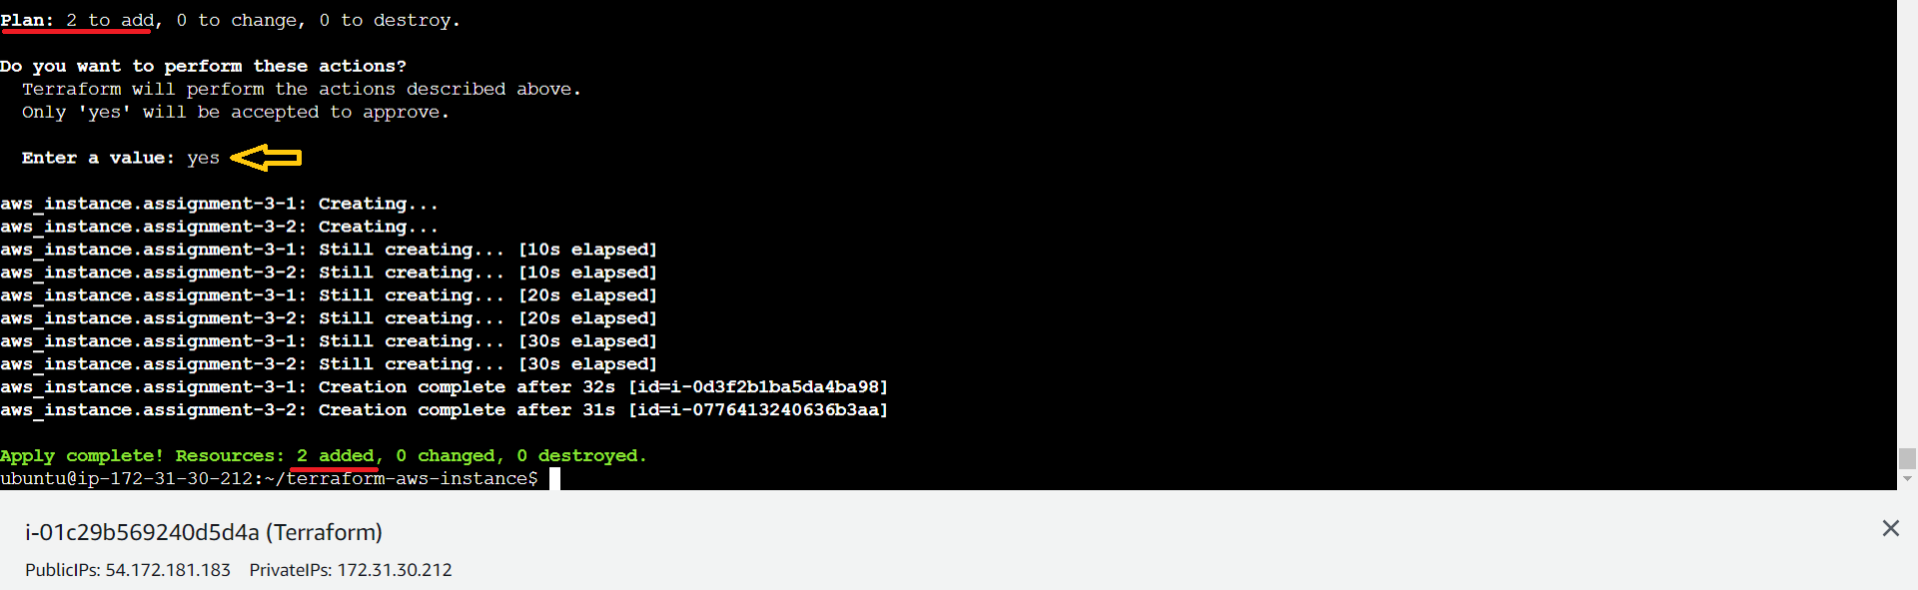

* Now go to AWS 🡪 “Ohio” Region to see ‘hello-Ohio’ instance and
* “N.Virginia” Region to see ‘hello-Virginia’ instance.

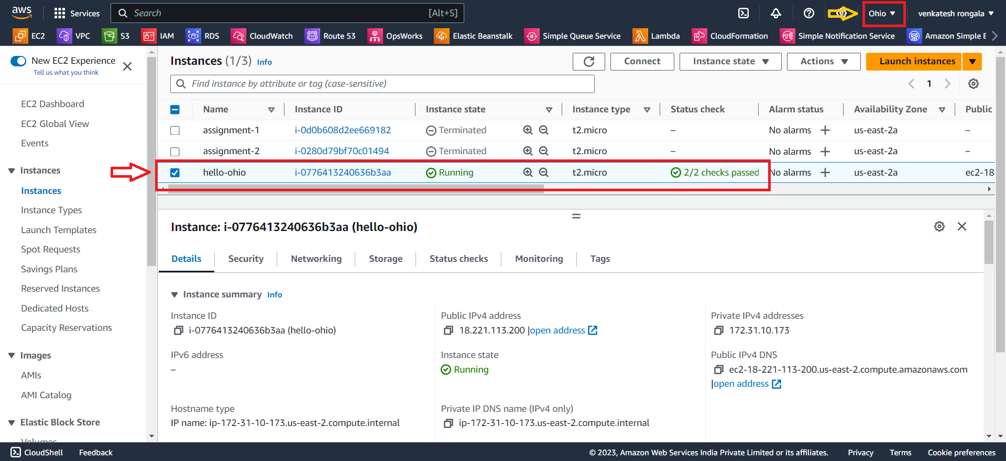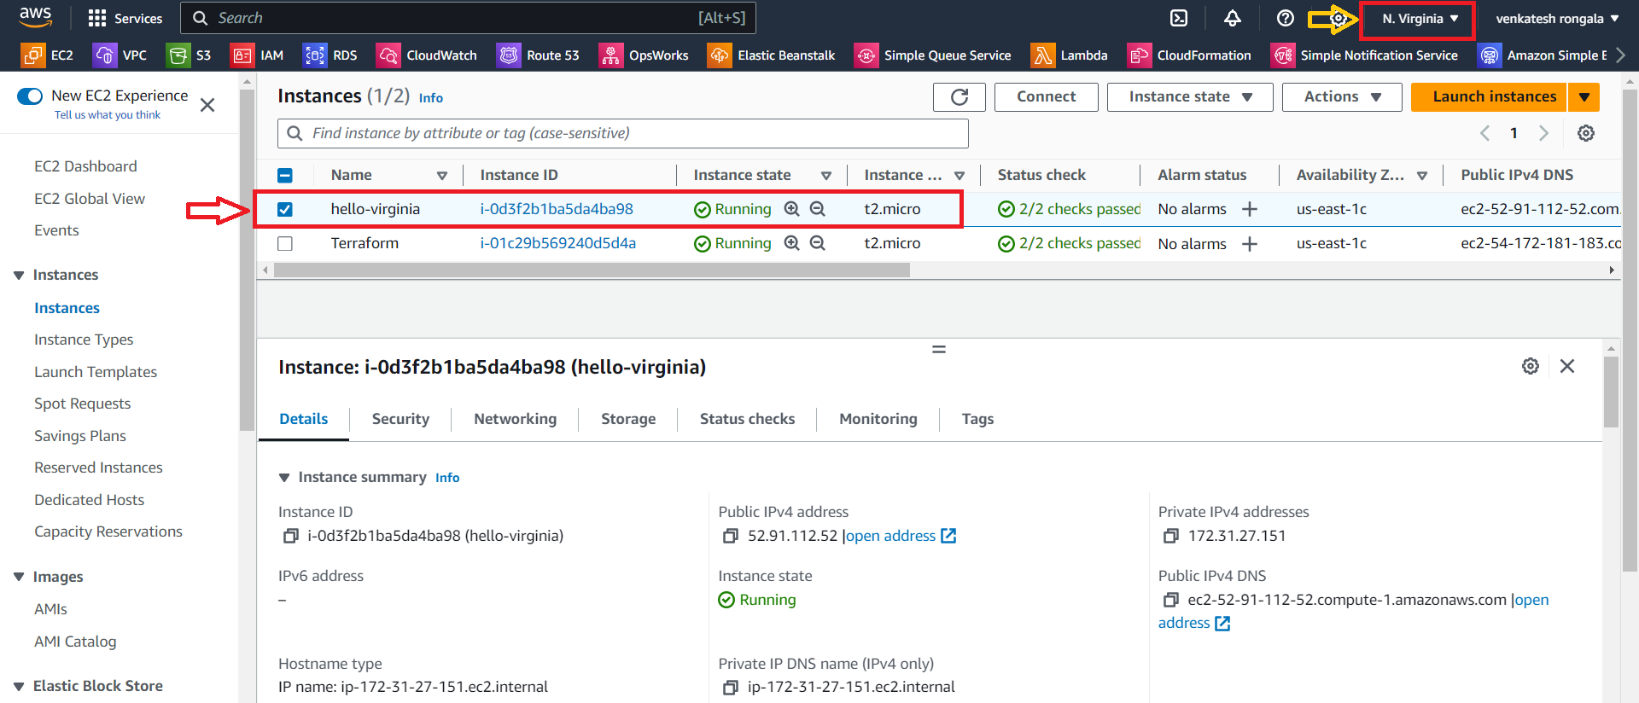

*********** Task Completed ***********