**Name**: Venkatesh Rongala

**Module-8: Terraform Assignment - 4**

**Task-4**

* Destroy the previous deployments
* Create a VPC with the required components using Terraform
* Deploy an EC2 instance inside the VPC

**Solution:**

* First Destroy the previous deployment using the command “terraform destroy”

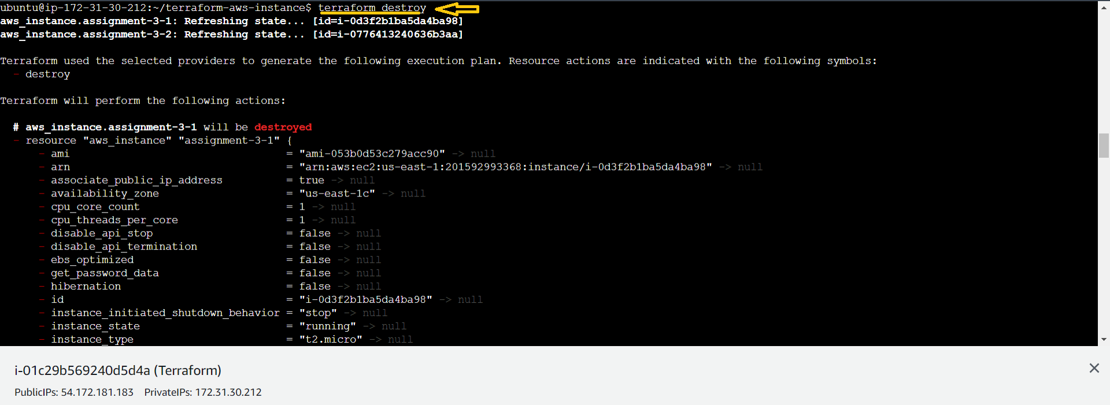

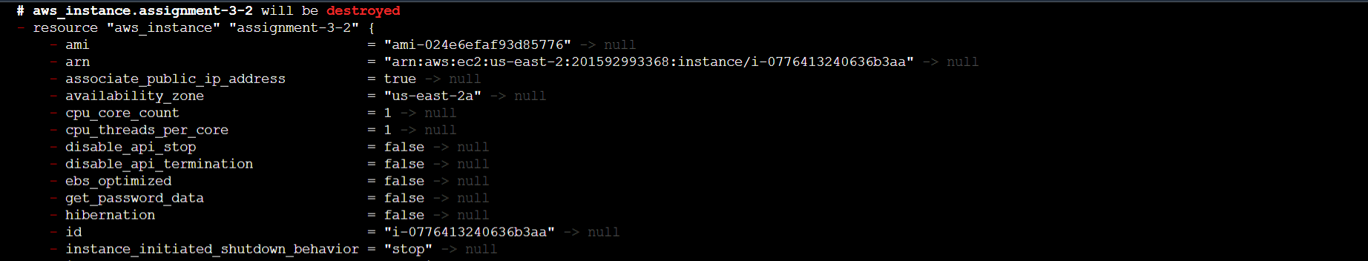

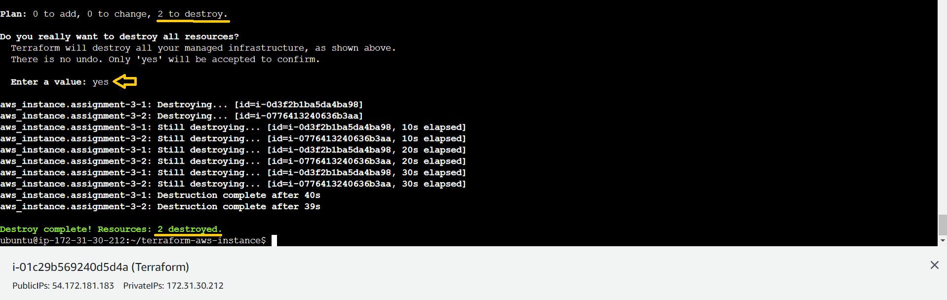

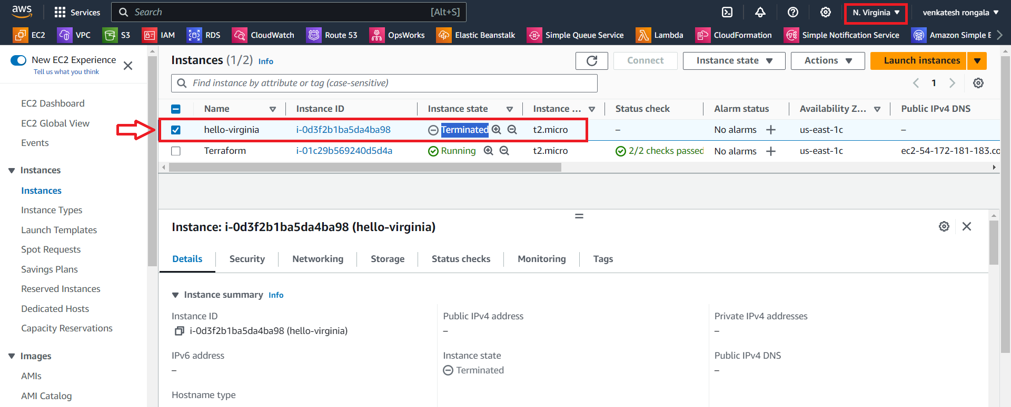

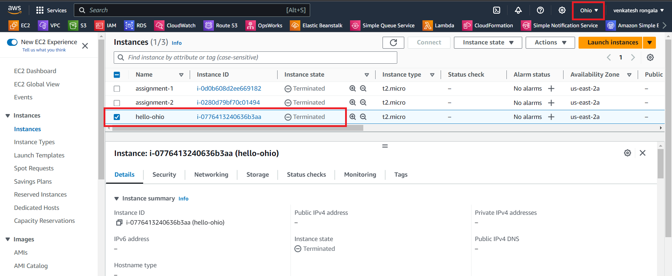

* Now create a VPC with the required components using Terraform
* Deploy an EC2 instance inside the VPC
* **main.tf**
* **provider "aws" {**

**region = "us-east-2"**

**}**

**resource "aws_instance" "assignment-4" {**

**ami = "ami-024e6efaf93d85776"**

**instance_type = "t2.micro"**

**subnet_id = aws_subnet.assignment-4-subnet.id**

**key_name = "ohio-kp"**

**tags = {**

**Name = "assignment-4"**

**}**

**}**

**resource "aws_vpc" "assignment-4-vpc" {**

**cidr_block = "10.10.0.0/16"**

**tags = {**

**Name = "assignment-4-vpc"**

**}**

**}**

**resource "aws_subnet" "assignment-4-subnet" {**

**vpc_id = aws_vpc.assignment-4-vpc.id**

**cidr_block = "10.10.1.0/18"**

**availability_zone = "us-east-2a"**

**tags = {**

**Name = "assignment-4-subnet"**

**}**

**}**

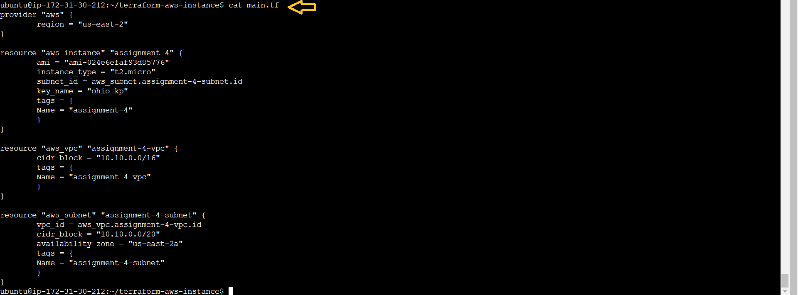

* Next Run the “terraform plan” commands

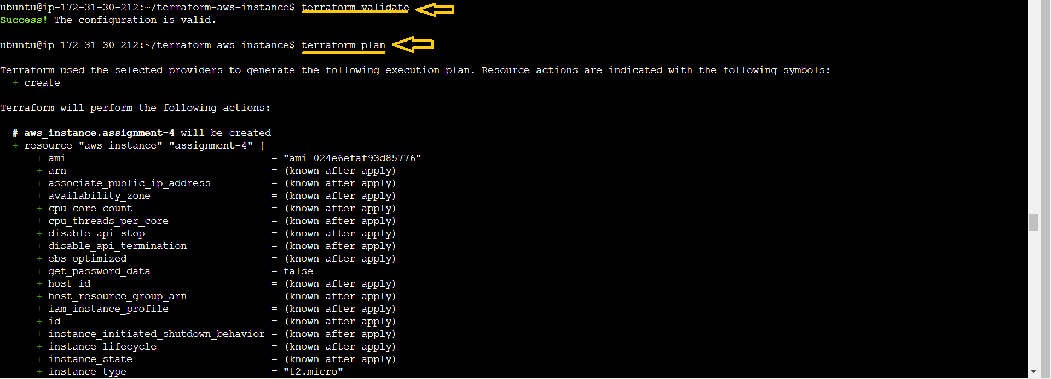

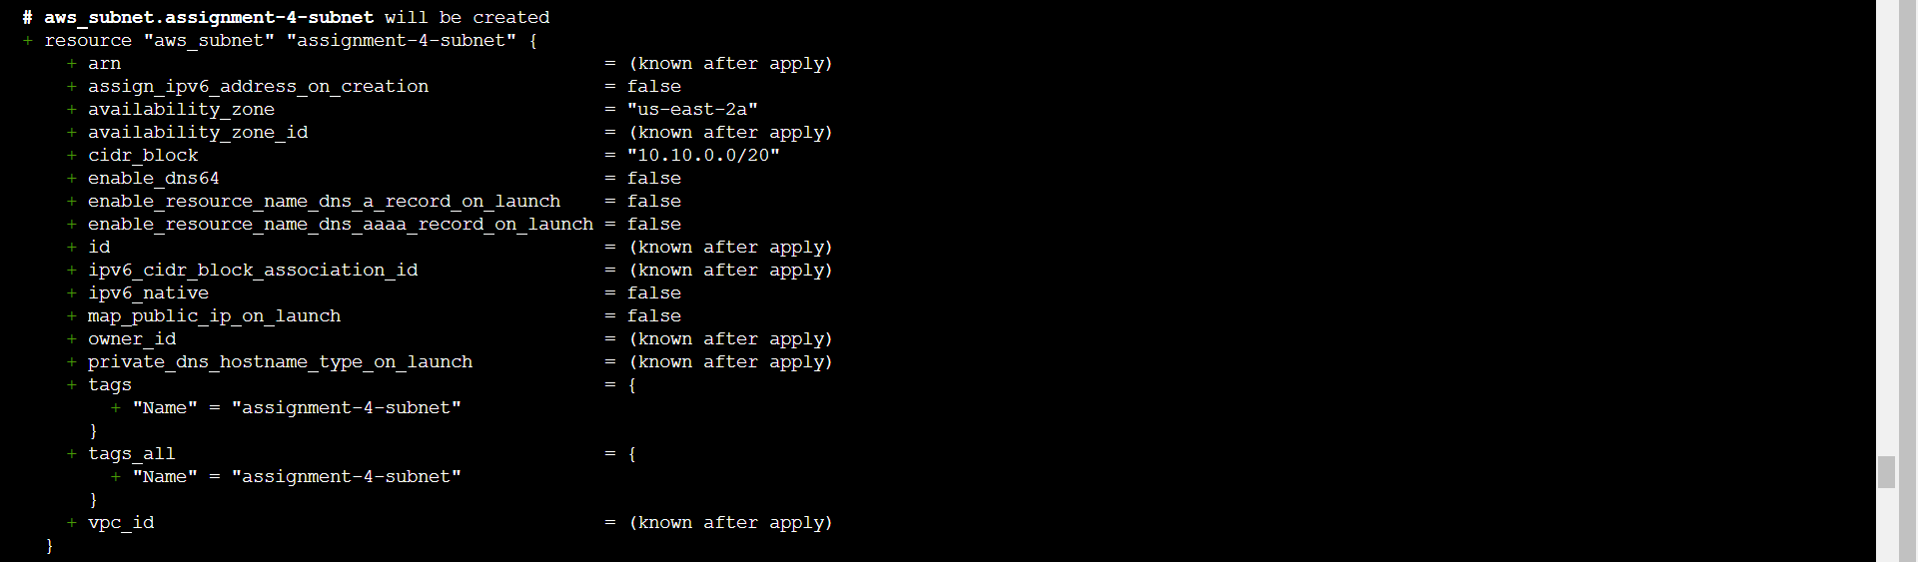

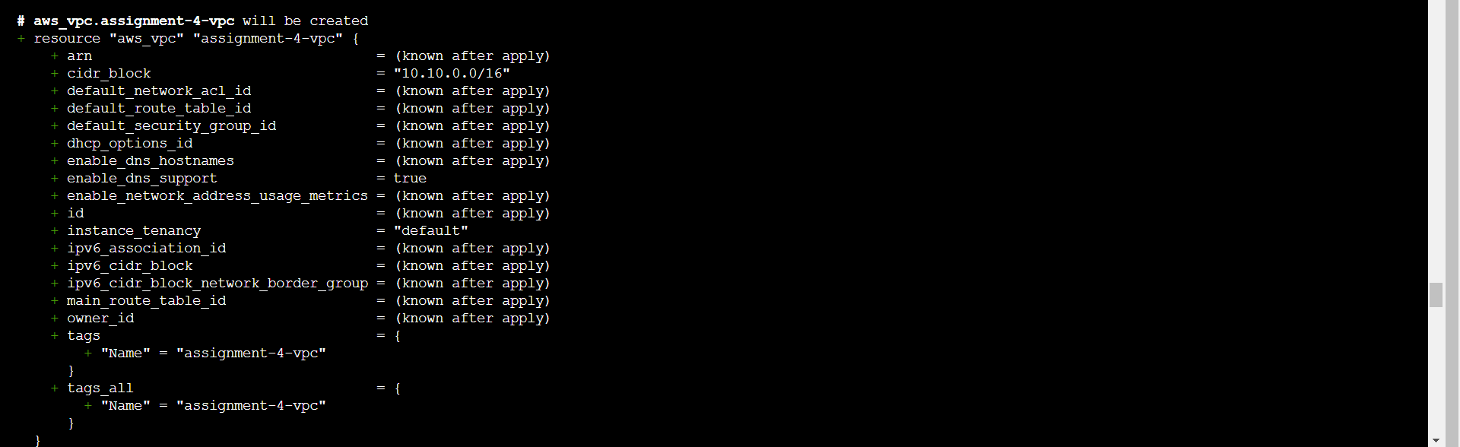



* Next Run the “terraform apply” commands

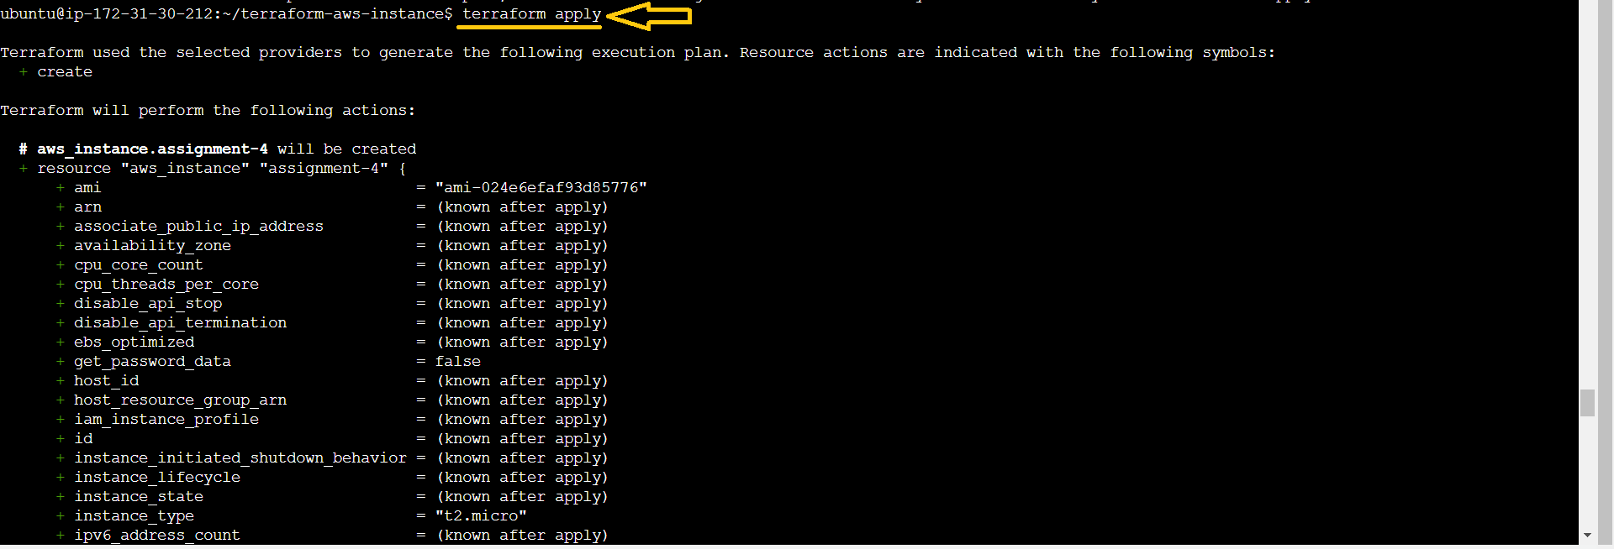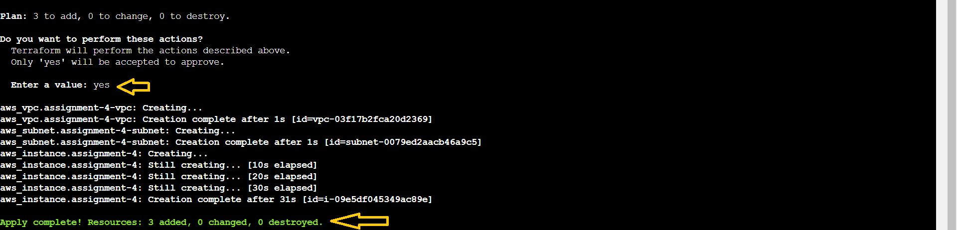

* Now go to AWS 🡪 “Ohio” Region & check the “assignment-4”

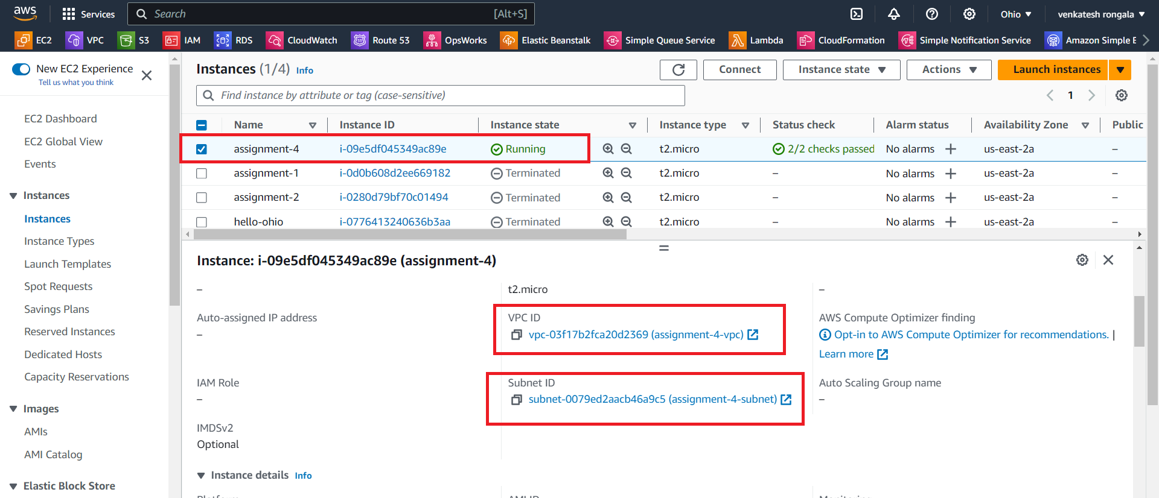

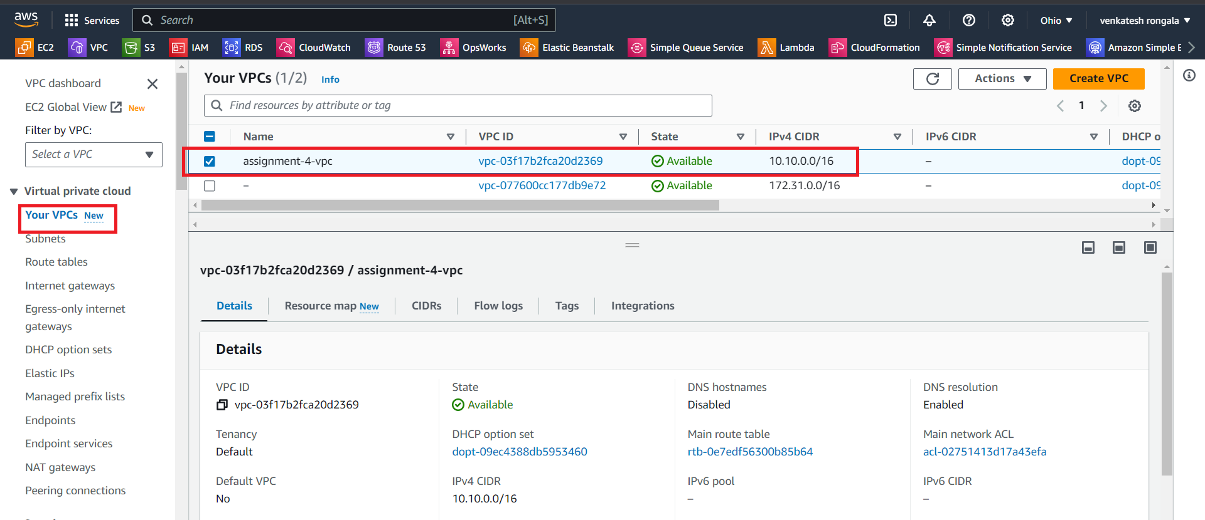

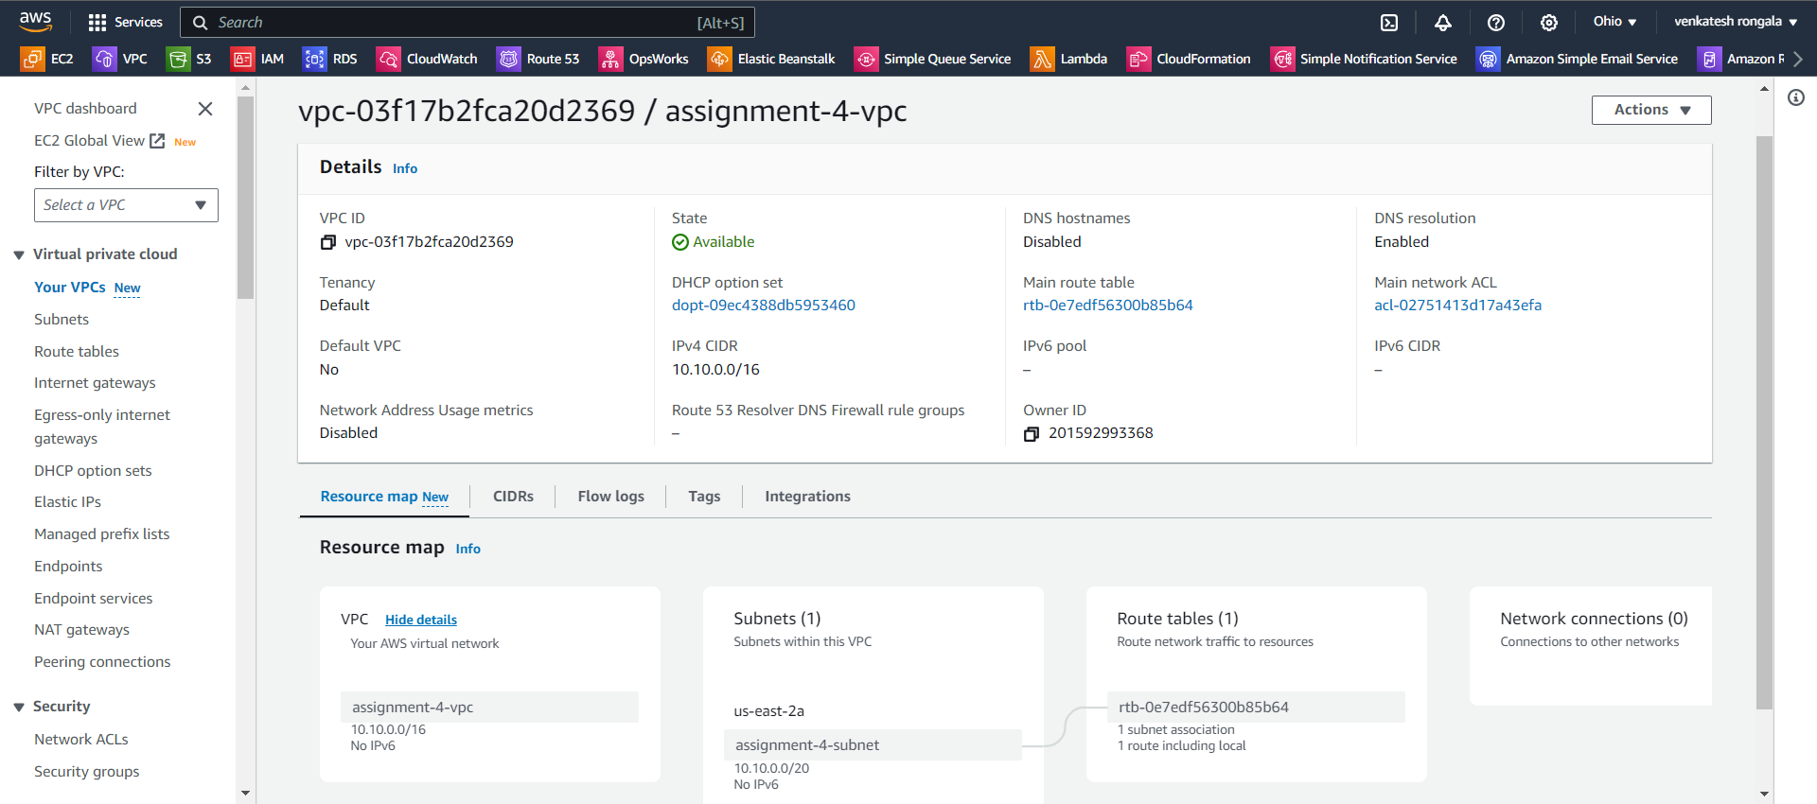

*********** Task Completed ***********