**Name**: Venkatesh Rongala

**Module-8: Terraform Assignment - 5**

**Task-5**

* Destroy the previous deployment
* Create a script to install apache2
* Run this script on a newly created EC2 instance
* Print the IP address of the instance in a file on the local, once deployed

**Solution:**

* First Destroy the previous deployment using the command “terraform destroy”

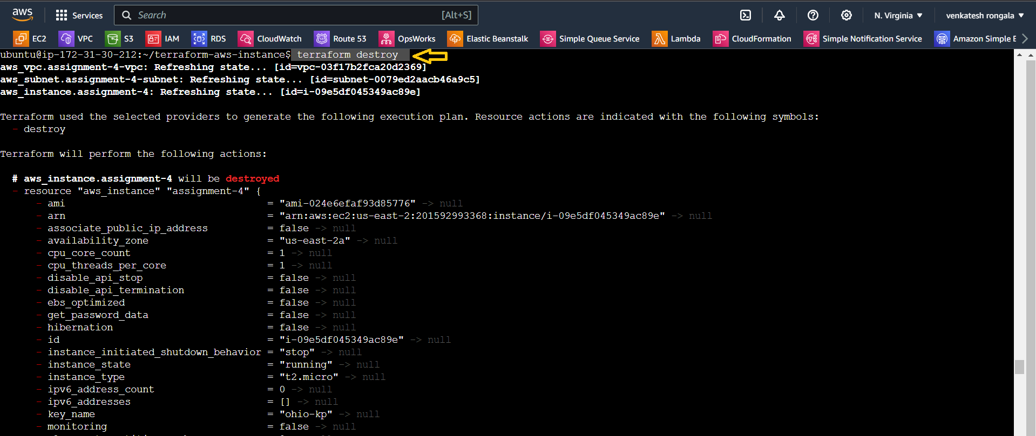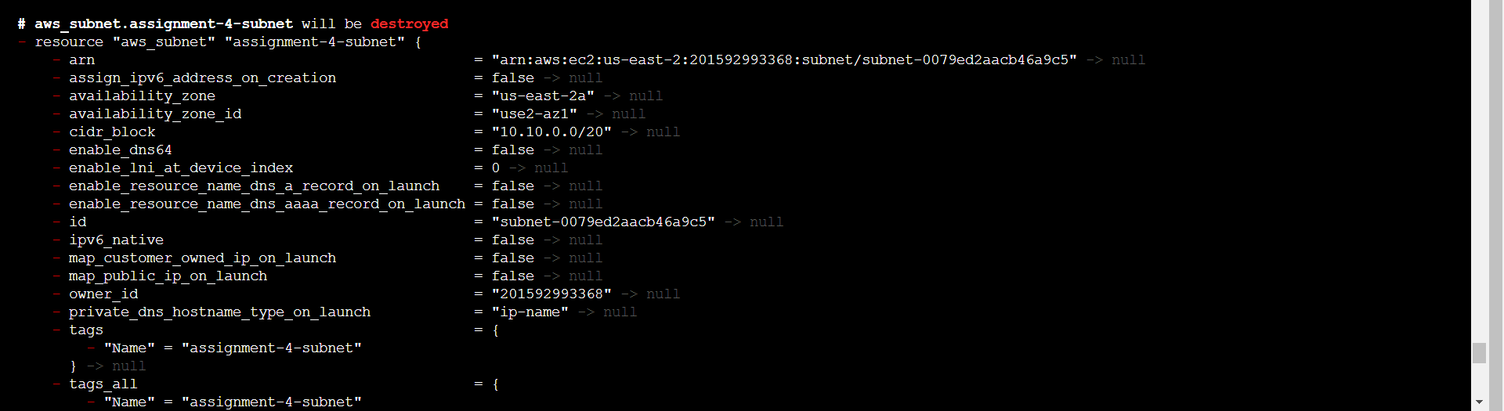

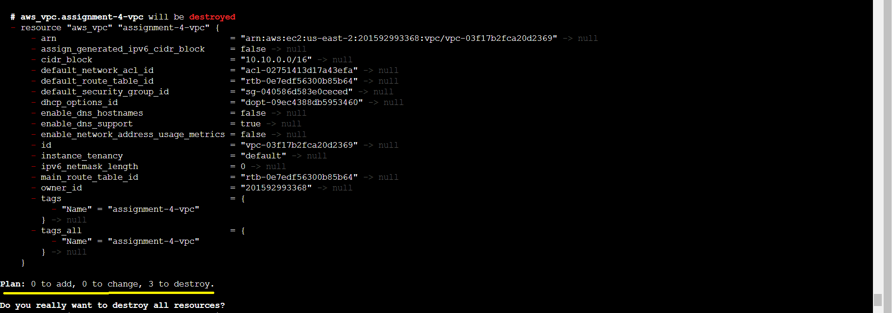

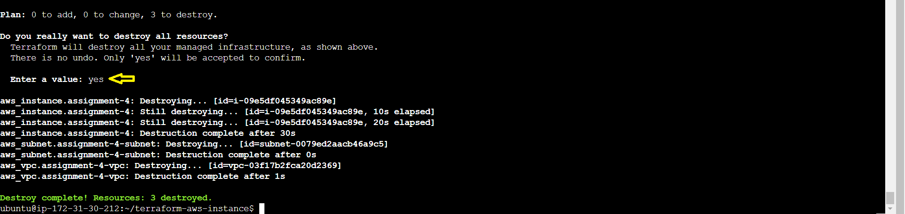

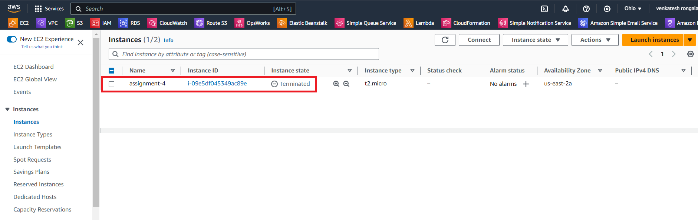

* Now create a script to install apache2 i.e., “install-apache2.sh”
* Run this script on a newly created EC2 instance
* Print the IP address of the instance in a file on the local, once deployed

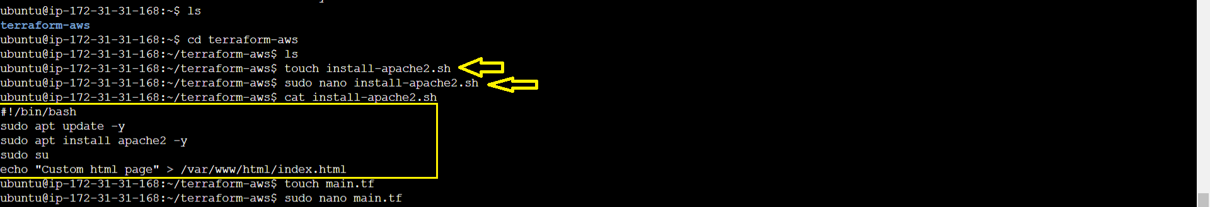

* In “main.tf”

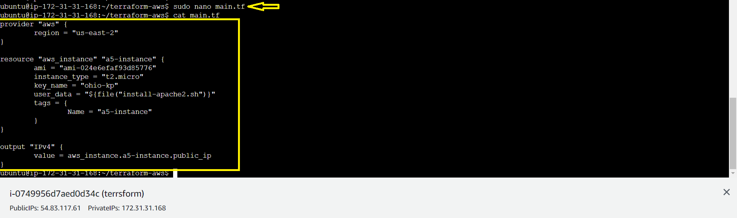

* Now Initialize the terraform, with the command “terraform init”

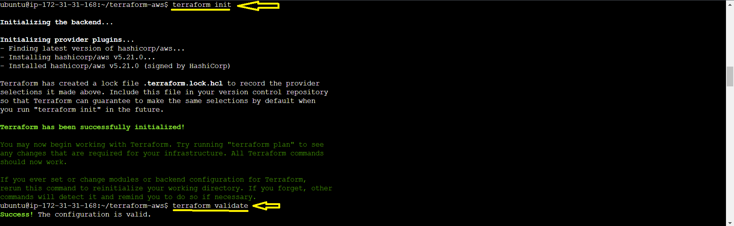

* Now Run the “Terraform plan” command

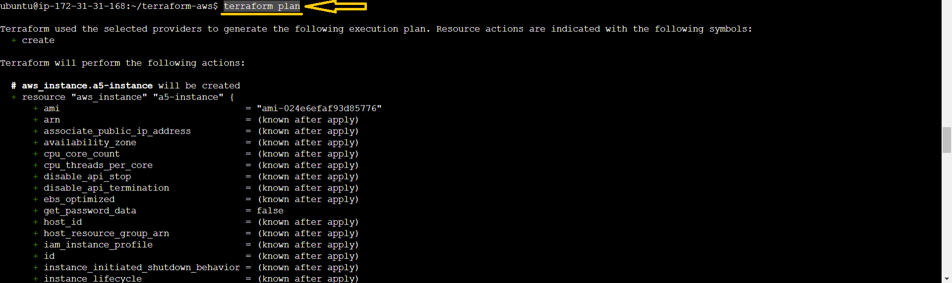

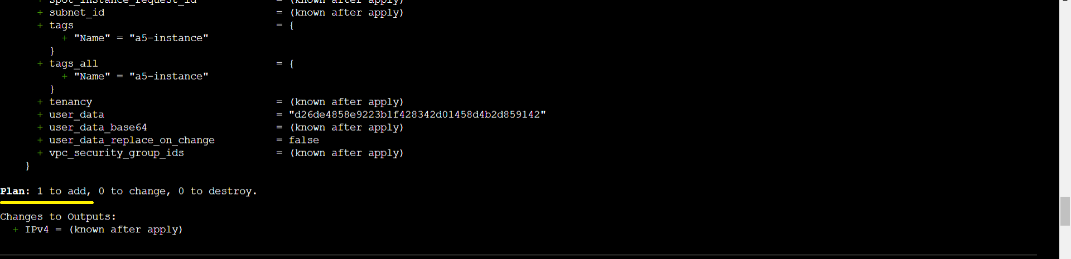

* Now Run the “Terraform apply” command

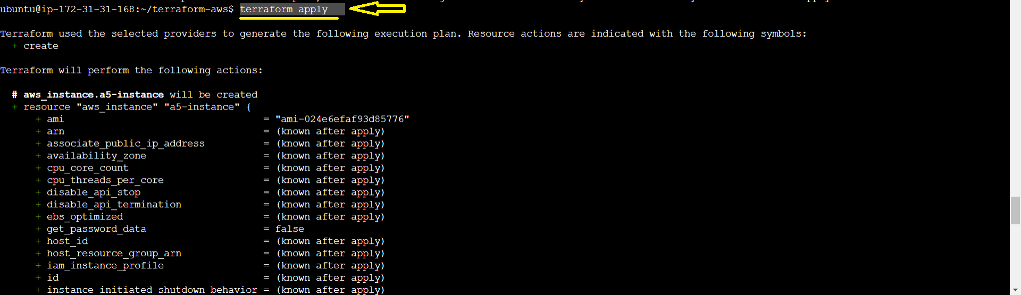

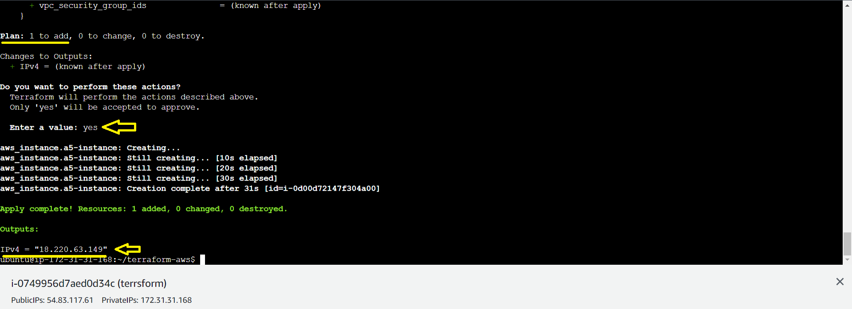

* Now go to AWS 🡪 “Ohio” Region & check the instance i.e.,“a5-instance”

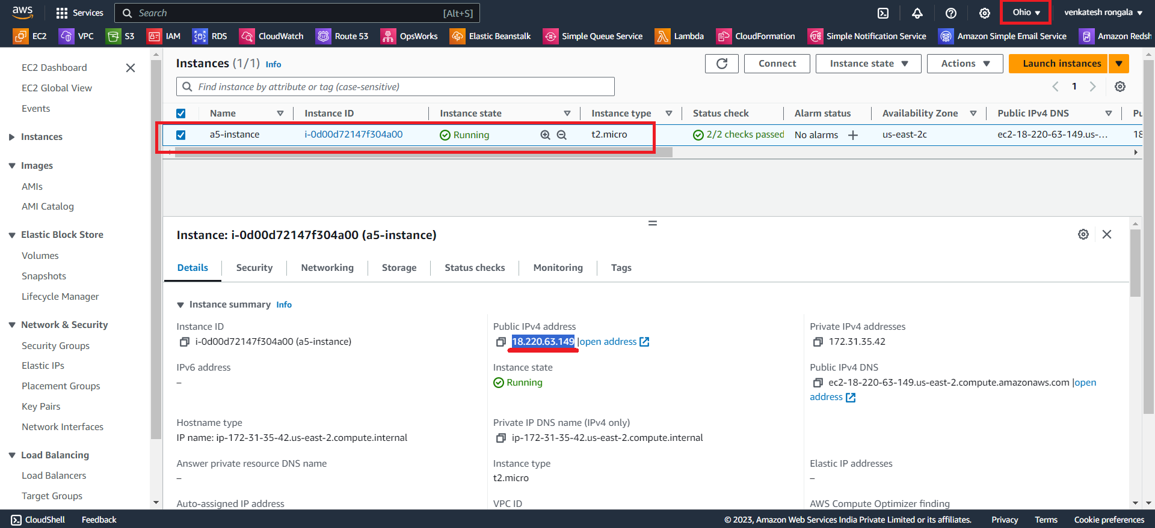

* Now we can check the Custom page of “Apache2” through the “public-IP” of the instance.

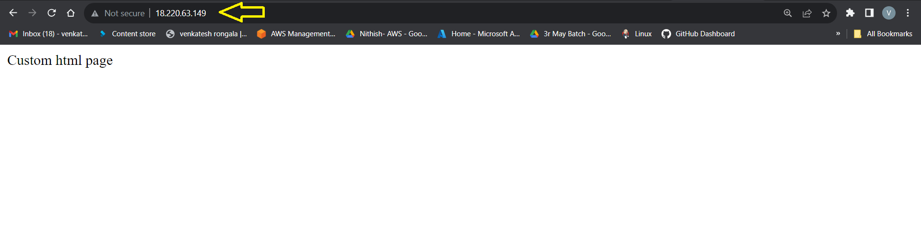

*********** Task Completed ***********