Python Object Oriented Programming

Python is a multi-paradigm programming language. It supports different programming approaches.

One of the popular approaches to solve a programming problem is by creating objects. This is known as Object-Oriented Programming (OOP).

An object has two characteristics:

* attributes
* behavior

Let's take an example:

A parrot is an object, as it has the following properties:

* name, age, color as attributes
* singing, dancing as behavior

The concept of OOP in Python focuses on creating reusable code. This concept is also known as DRY (Don't Repeat Yourself).

# Concepts of OOPS:

1. Class
2. Object
3. Inheritance
4. Encapsulation
5. Polymorphism

Class

A class is a blueprint for the object.

We can think of class as a sketch of a parrot with labels. It contains all the details about the name, colors, size etc. Based on these descriptions, we can study about the parrot. Here, a parrot is an object.

The example for class of parrot can be:

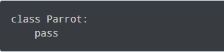

Here, we use the class keyword to define an empty class Parrot. From class, we construct instances. An instance is a specific object created from a particular class.

## Object

An object (instance) is an instantiation of a class. When class is defined, only the description for the object is defined. Therefore, no memory or storage is allocated.



### **Creating Class and Object in Python:**

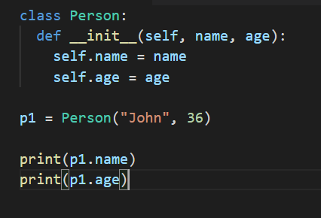

## Methods

Methods are functions defined inside the body of a class. They are used to define the behaviors of an object.

## Inheritance

Inheritance is a way of creating a new class for using details of an existing class without modifying it. The newly formed class is a derived class (or child class). Similarly, the existing class is a base class (or parent class).

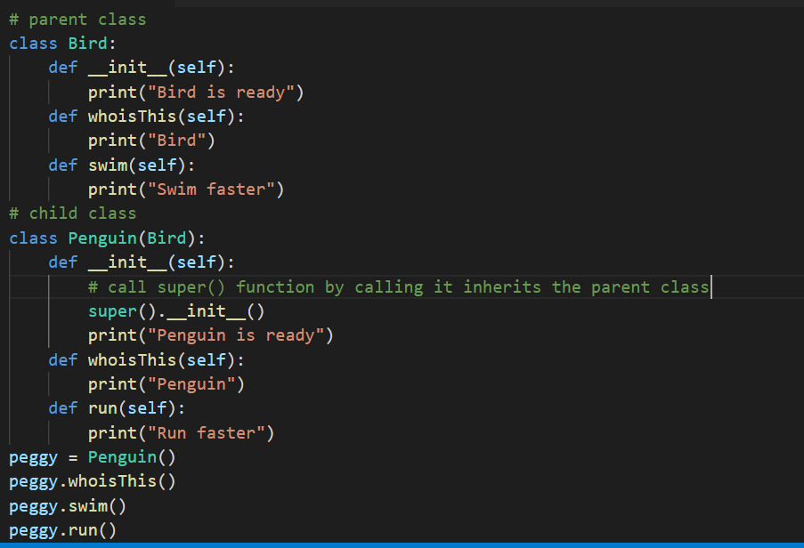

## Encapsulation

Using OOP in Python, we can restrict access to methods and variables. This prevents data from direct modification which is called encapsulation. In Python, we denote private attributes using underscore as the prefix i.e single _ or double __.

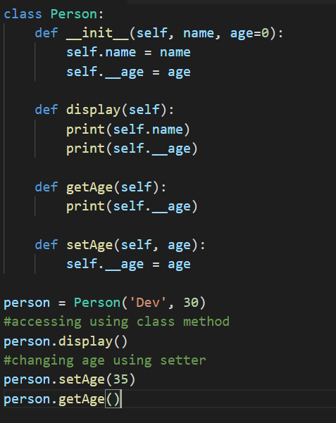

## Polymorphism

Polymorphism is an ability (in OOP) to use a common interface for multiple forms (data types).

Suppose, we need to color a shape, there are multiple shape options (rectangle, square, circle). However, we could use the same method to color any shape. This concept is called Polymorphism.

