What are Comprehensions?

Comprehensions in Python provide us with a short and concise way to construct new sequences (such as lists, set, dictionary etc.) using sequences which have been already defined. Python supports the following 3 types of comprehensions:

* List Comprehensions
* Dictionary Comprehensions
* Set Comprehensions

# List Comprehensions:

List Comprehensions provide an elegant way to create new lists. The following is the basic structure of a list comprehension:

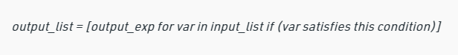

**Note that list comprehension may or may not contain an if condition. List comprehensions can contain multiple for (nested list comprehensions).**

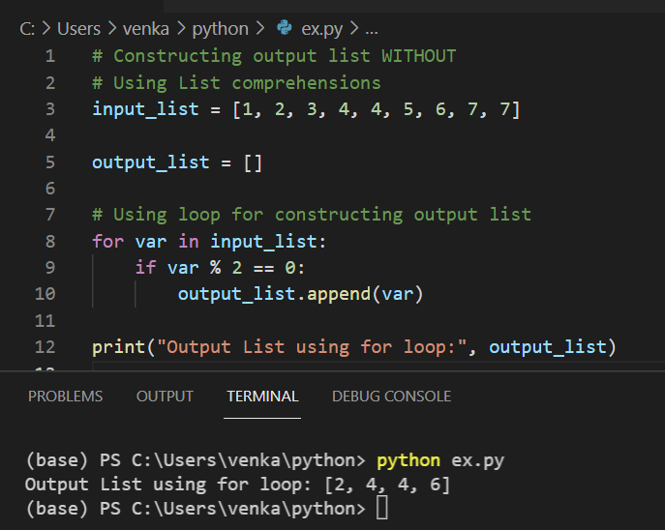

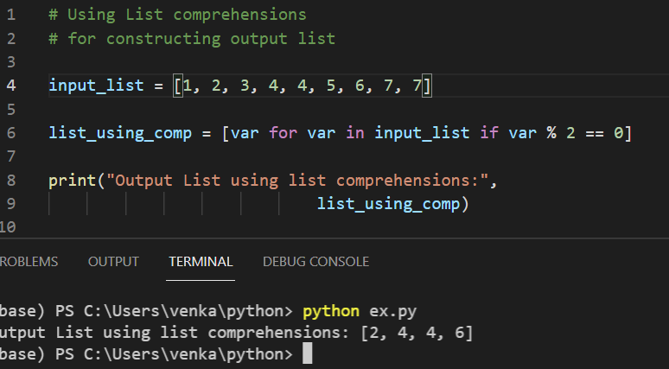

# Dictionary Comprehensions:

Extending the idea of list comprehensions, we can also create a dictionary using dictionary comprehensions. The basic structure of a dictionary comprehension looks like below.

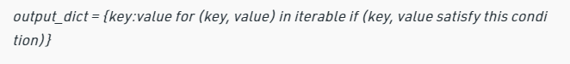

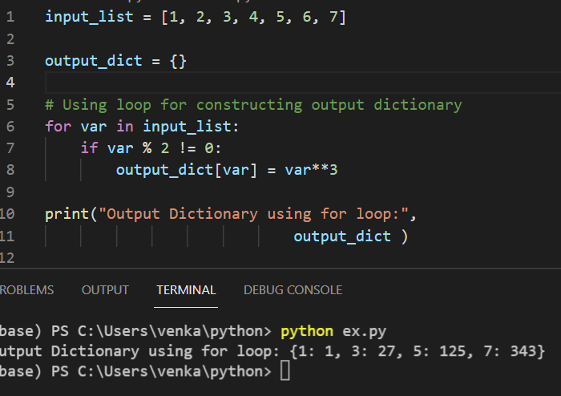

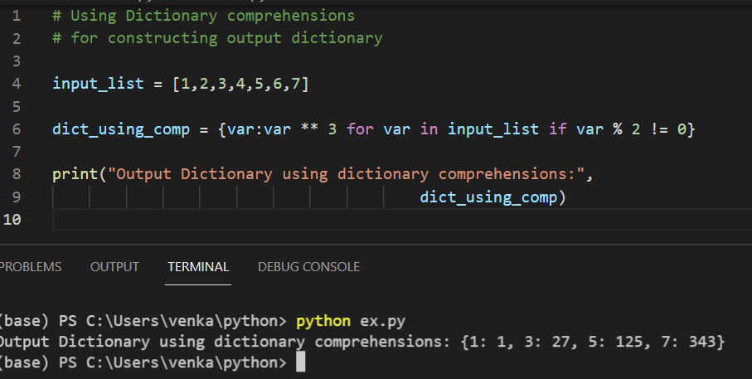

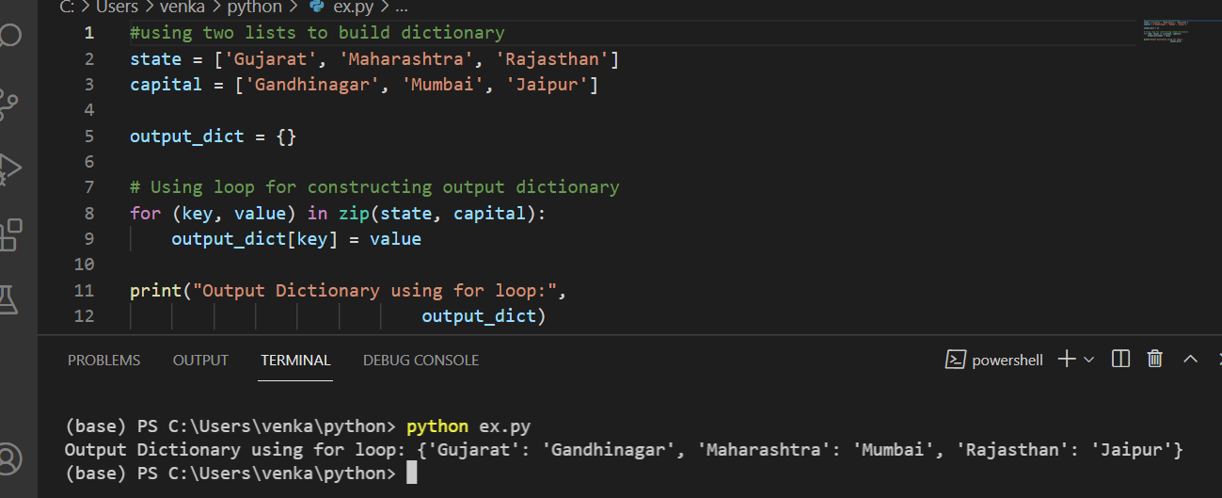

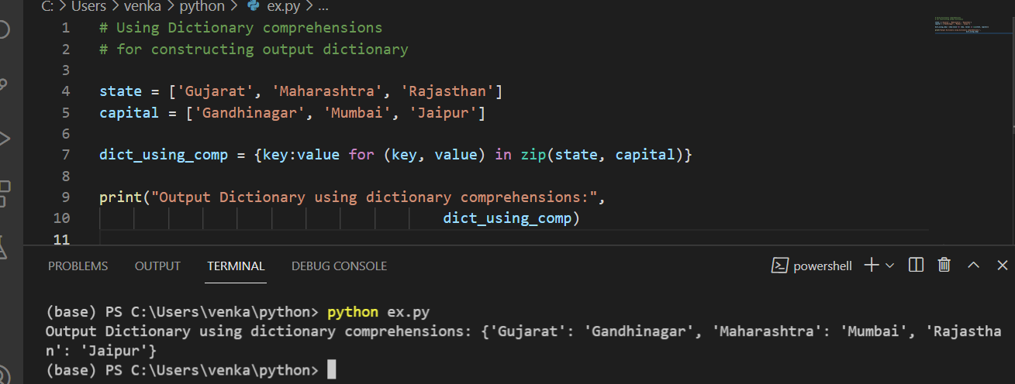

# Set Comprehensions:

Set comprehensions are pretty similar to list comprehensions. The only difference between them is that set comprehensions use curly brackets { }. Let’s look at the following example to understand set comprehensions.

