## **Python Statement**

Instructions that a Python interpreter can execute are called statements. For example, a = 1 is an assignment statement. if statement, for statement, while statement, etc. are other kinds of statements which will be discussed later.

### **Multi-line statement**

In Python, the end of a statement is marked by a newline character. But we can make a statement extend over multiple lines with the line continuation character (\). For example:

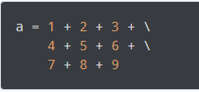

This is an explicit line continuation. In Python, line continuation is implied inside parentheses (), brackets [], and braces {}. For instance, we can implement the above multi-line statement as:

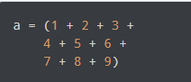

Here, the surrounding parentheses ( ) do the line continuation implicitly. Same is the case with [ ] and { }. For example:

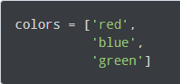

We can also put multiple statements in a single line using semicolons, as follows:



## **Python Indentation**

Most of the programming languages like C, C++, and Java use braces { } to define a block of code. Python, however, uses indentation.

A code block (body of a function, loop, etc.) starts with indentation and ends with the first un-indented line. The amount of indentation is up to you, but it must be consistent throughout that block.

Generally, four whitespaces are used for indentation and are preferred over tabs. Here is an example.

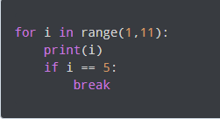

The enforcement of indentation in Python makes the code look neat and clean. This results in Python programs that look similar and consistent.

Indentation can be ignored in line continuation, but it's always a good idea to indent. It makes the code more readable. For example:

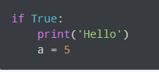

And



both are valid and do the same thing, but the former style is clearer.

Incorrect indentation will result in **Indentation Error**.

## **Python Comments**

Comments are very important while writing a program. They describe what is going on inside a program, so that a person looking at the source code does not have a hard time figuring it out.

You might forget the key details of the program you just wrote in a month's time. So taking the time to explain these concepts in the form of comments is always fruitful.

In Python, we use the hash (**#**) symbol to start writing a comment.

It extends up to the newline character. Comments are for programmers to better understand a program. Python Interpreter ignores comments.

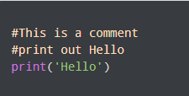

### **Multi-line comments**

We can have comments that extend up to multiple lines. One way is to use the hash(**#**) symbol at the beginning of each line. For example:

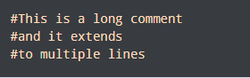

Another way of doing this is to use triple quotes, either ''' or """.

These triple quotes are generally used for multi-line strings. But they can be used as a multi-line comment as well. Unless they are not docstrings, they do not generate any extra code.

