ASSIGNMENT 1
TEAM DETAILS :
B.VENKATESH – 2503A52657 BT-22
J. SRIDHAR - 2503A52648 BT-22
MD.ASAD -2503A52655 BT-22

PRODUCT NAME : Social Media Creator Analytics Dashboard 📊

PROBLEM STATEMENT:
Content creators often upload videos or images without knowing whether their content has strong audience potential. They also spend significant time researching similar YouTube videos, finding relevant keywords, creating titles, and understanding what type of content performs well.

Sponsors and businesses find it difficult to quickly understand a social media creator's audience, engagement, and performance before choosing them for promotions.

SOLUTION: A platform analyzes a social media profile link and provides important creator and audience insights in one simple dashboard.

USER :
- Sponsors & brands
- Marketing agencies
- Content creators
- Businesses
- Influencer managers

⚙️ Expected Features :
- Enter/paste social media profile link
- Identify platform and username
- Followers/subscribers
- Average views, likes & comments
- Engagement rate
- Audience gender distribution
- Audience age groups
- Audience countries
- Category/content type
- Sponsor-focused audience insights
- Simple analytics dashboard

Key Idea :
- “Paste a profile link → Generate data → Understand the creator and their audience.”

DASHBOARD :

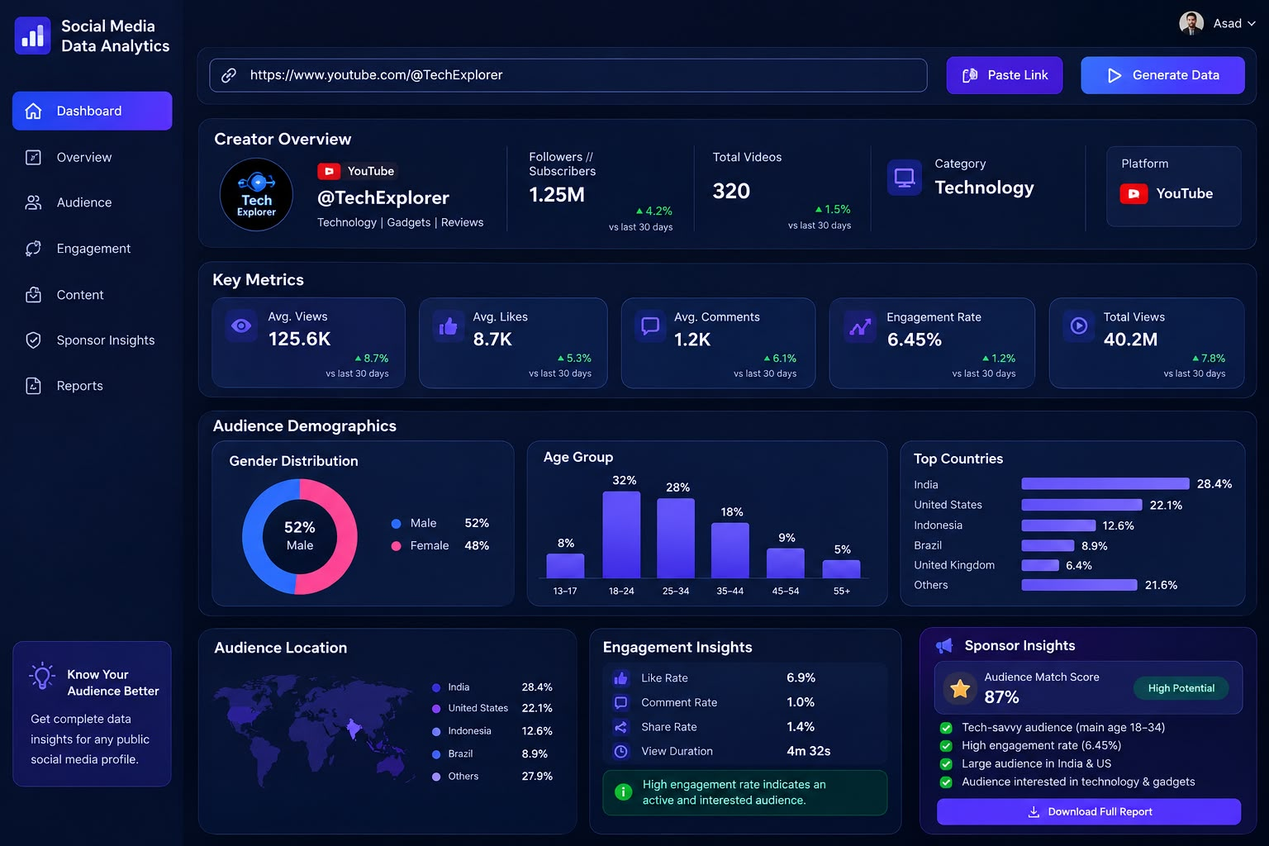

Message It Provides :
“Make smarter sponsorship decisions with data-driven creator insights.”

