**Project Overview:**

This is a project on creating a basic user registration system , a login page to verify the user’s credentials and a basic bulletin board with different user access levels. All this data is stored into the database. This is made as user-friendly as possible with the notifications and error messages. User registration is must before login and user login is must for nay operation on the bulletin board.

A captcha system is added during registration to ensure security.

In the bulletin board, there are three user levels created.

Admin: Can make posts, delete posts and change access level of users

Editor: Can make posts on the board

Viewer: Can view posts on the board

**Software Used:**

1. PHP as the language

2. Apache as server

3. MySQL for database operations

Downloaded xampp which had PHP,Apache and MySQL .

Links for download are available at the end of document.

**Process after downloading:**

1. Htdocs in your xampp is your root.
2. Open xampp control panel and start mysql and apache
3. Create a folder called CH in your htdocs.
4. Paste all the submitted files into that folder.
5. Make a separate folder in htdocs\CH called connections for connection.php

**Database(files for one-time execution):**

1. I have created three files.
2. 1st- databasecreate.php which will create a database .
3. 2nd-databasetable.php which will create the required tables.
4. 3rd- createadmin.php- to create an admin user (the code for password hashing has been written inside as passwords have been hashed for security purposes ).

**During execution of application:**

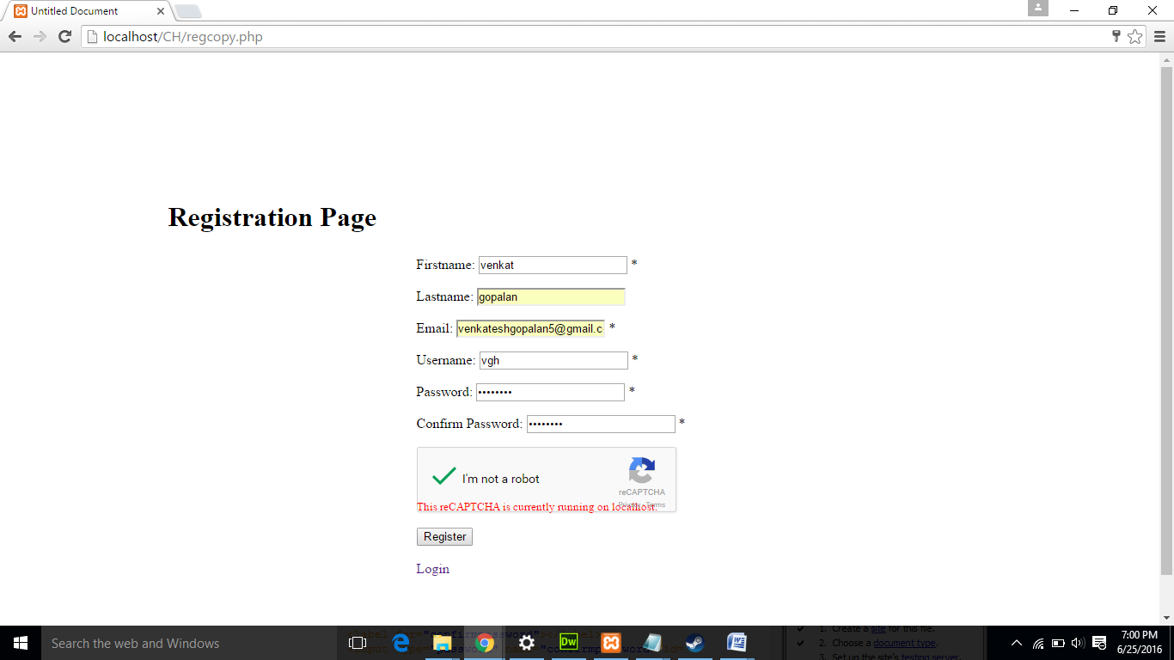

This is the registration page.

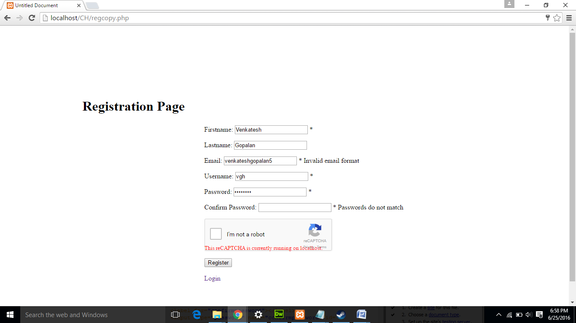

After you register, you will be directed to the login page (login.php).

After you Login,

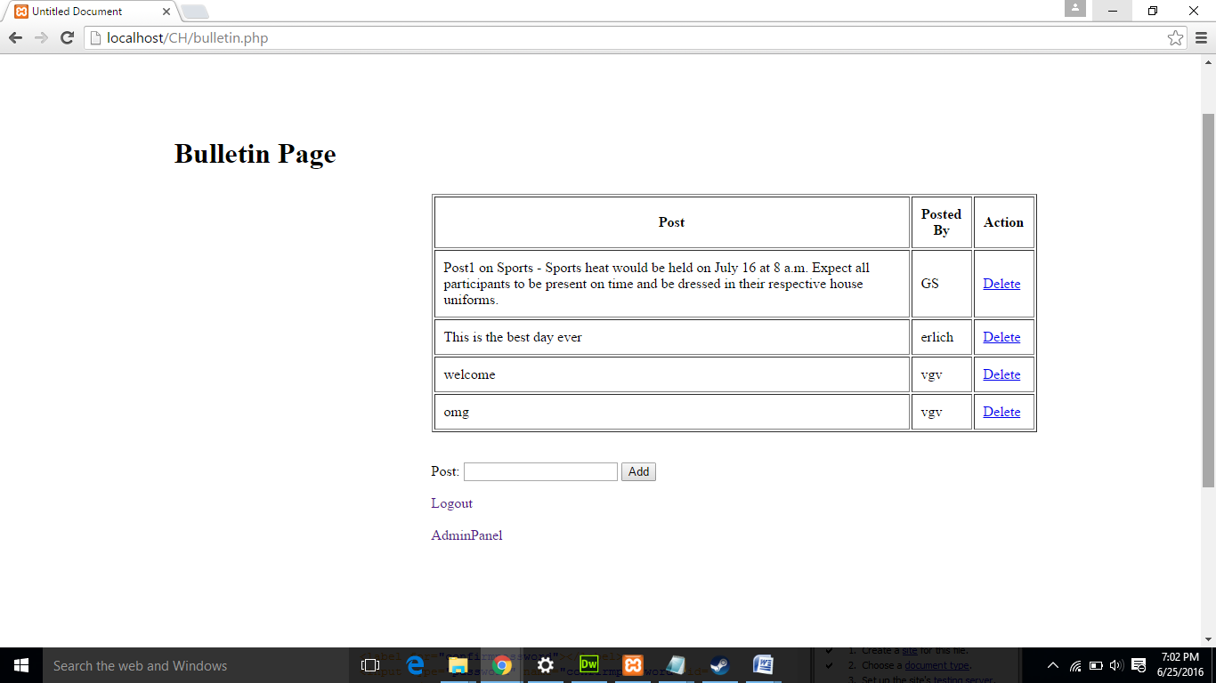

This is how the bulletin board looks for an admin. He can delete posts, make posts and change user access level of non-admins using the ‘Admin panel’ link.

The one below is how the bulletin looks for a Viewer account and he cannot make/ delete posts or change user level of other users. He can only view posts.

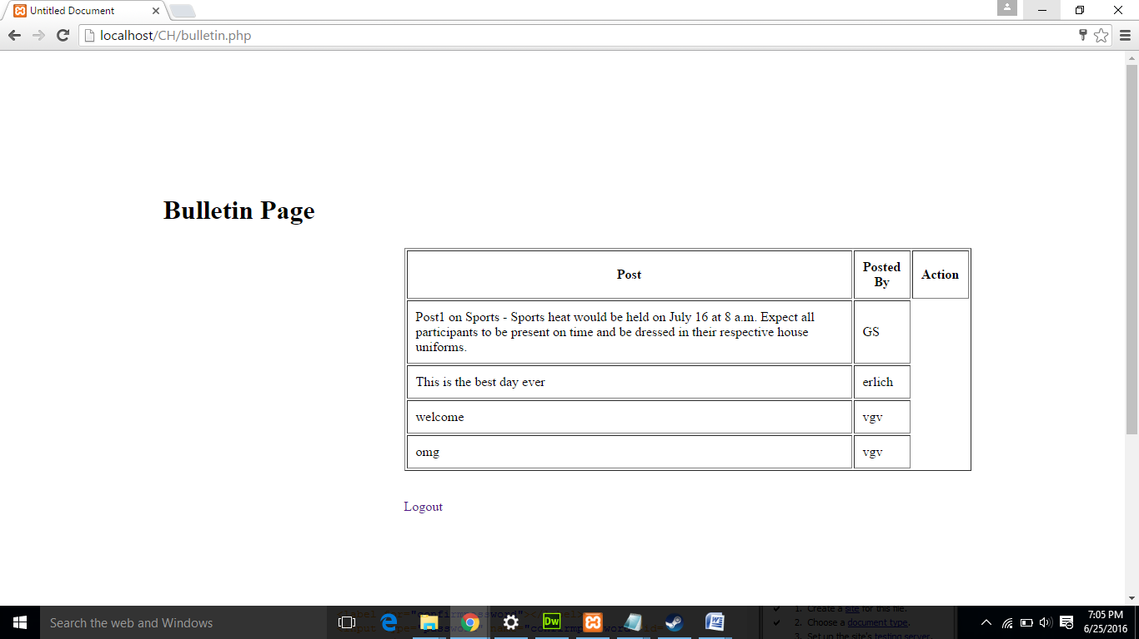

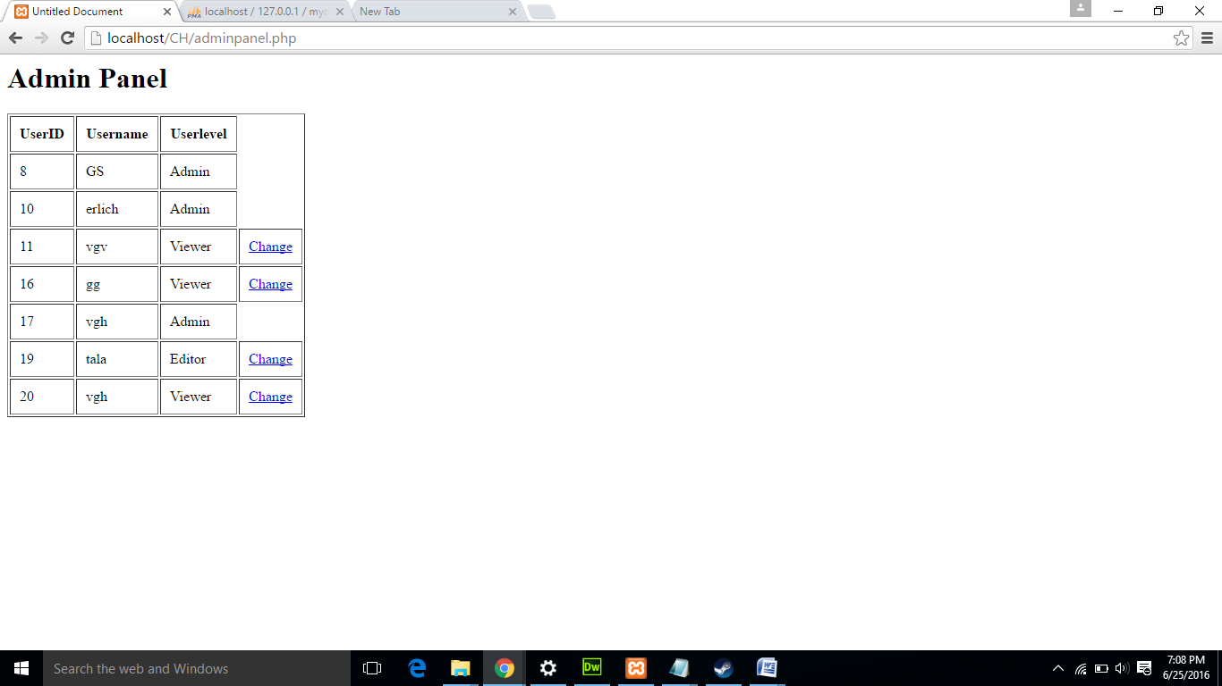

This is the admin panel where admins can change user access levels of non-admins. Editor to Viewer/Admin and Viewer to Editor/Admin are possible changes.

LINKS FOR DOWNLOAD

<https://www.apachefriends.org/download.html>