**Project Overview:**

This is a project on student database management.The user can add, edit and update records into the database. A randomized passcode is generated after adding a record.

Permission to update is given only when passcode is matching with the passcode in the database.

This is made as user-friendly as possible with the error messages.

Have also provided an additional feature and displayed a tabulation of all records of the database and the user can choose to edit any of the records from the tabulation.

**Software Used:**

1. PHP as the language

2. Apache as server

3. MySQL for database operations

4. CodeIgniter as framework

Downloaded xampp which had PHP,Apache and MySQL .

The framework CodeIgniter was downloaded separately.

Links for download are available at the end of document.

**Process after downloading:**

1. Htdocs in your xampp is your root.
2. Open xampp control panedl and start mysql and apache
3. Take the CodeIgniter (name this folder ci_intro)folder and insert into xampp/htdocs
4. Copy the index.php and edit.php to ci_intro/applications/views
5. Copy the studentmodel.php to ci_intro/applications/model
6. Copy the student.php to ci_intro/applications/controllers
7. Go to in ci-intro\application\config\autoload.php

$autoload['libraries'] = array(''); change into $autoload['libraries'] = array('database');

1. Need to specify user=root,db=mydb in ci-intro\application\config\database.php file
2. Index.php is for the basic form and edit.php for editing.
3. Student.php is the controller file, it has all the functions to be executed.

I have used one table ‘stud’ and database mydb for all operations.

**Database and table:**

Create a database.

Be sure to create this table with column names:

1. roll
2. name
3. email
4. physicaladdress
5. dept
6. Passcode

You can access the database by using localhost/phpmyadmin

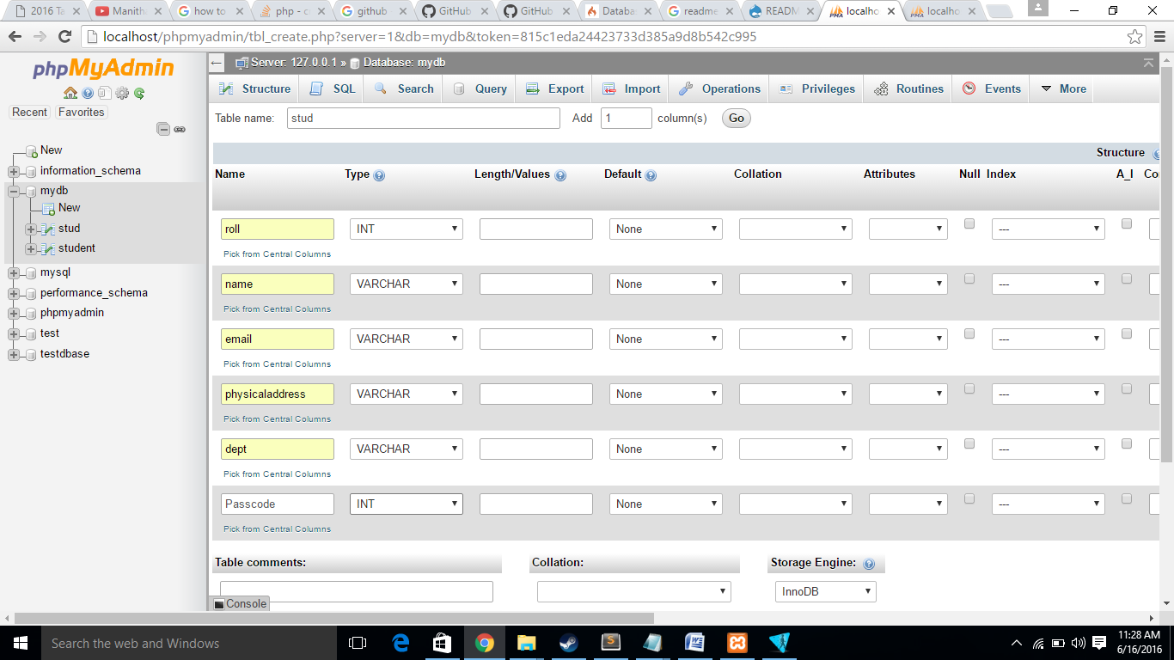

**During execution of application:**

When executing,

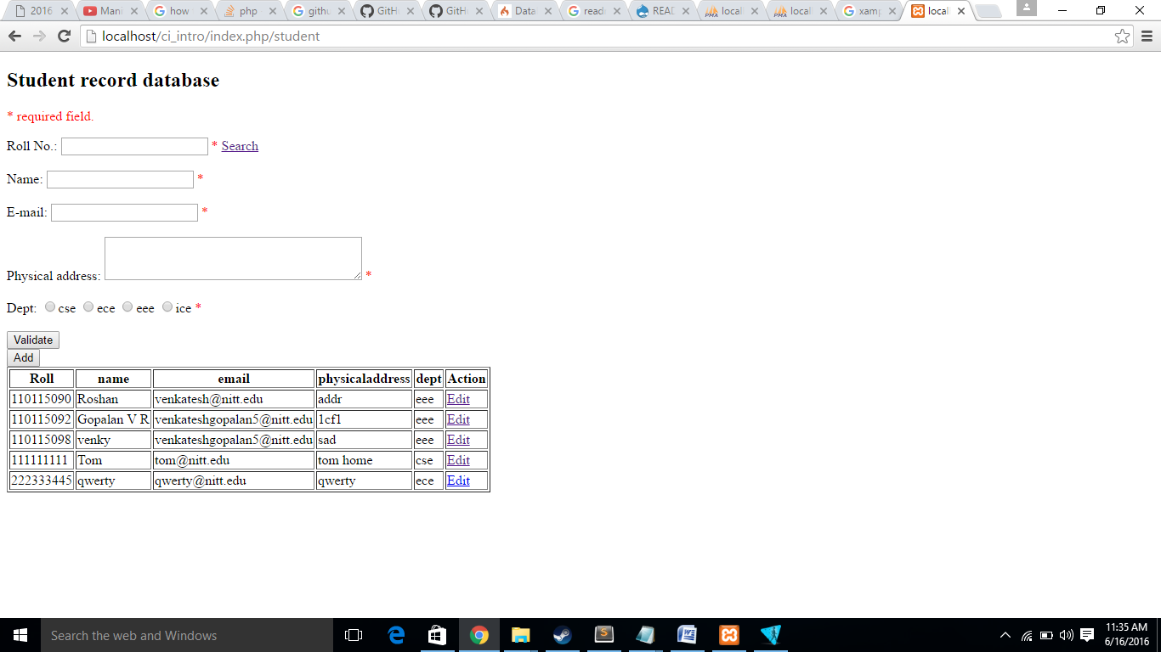

The url must be localhost/ci_intro/index.php/student.

There is a validate button and an add button.

Validate button shows the errors and Add button adds the record into database.

If you enter only roll no. and click search you can view the details of that student.

ALWAYS Validate before clicking add or search.

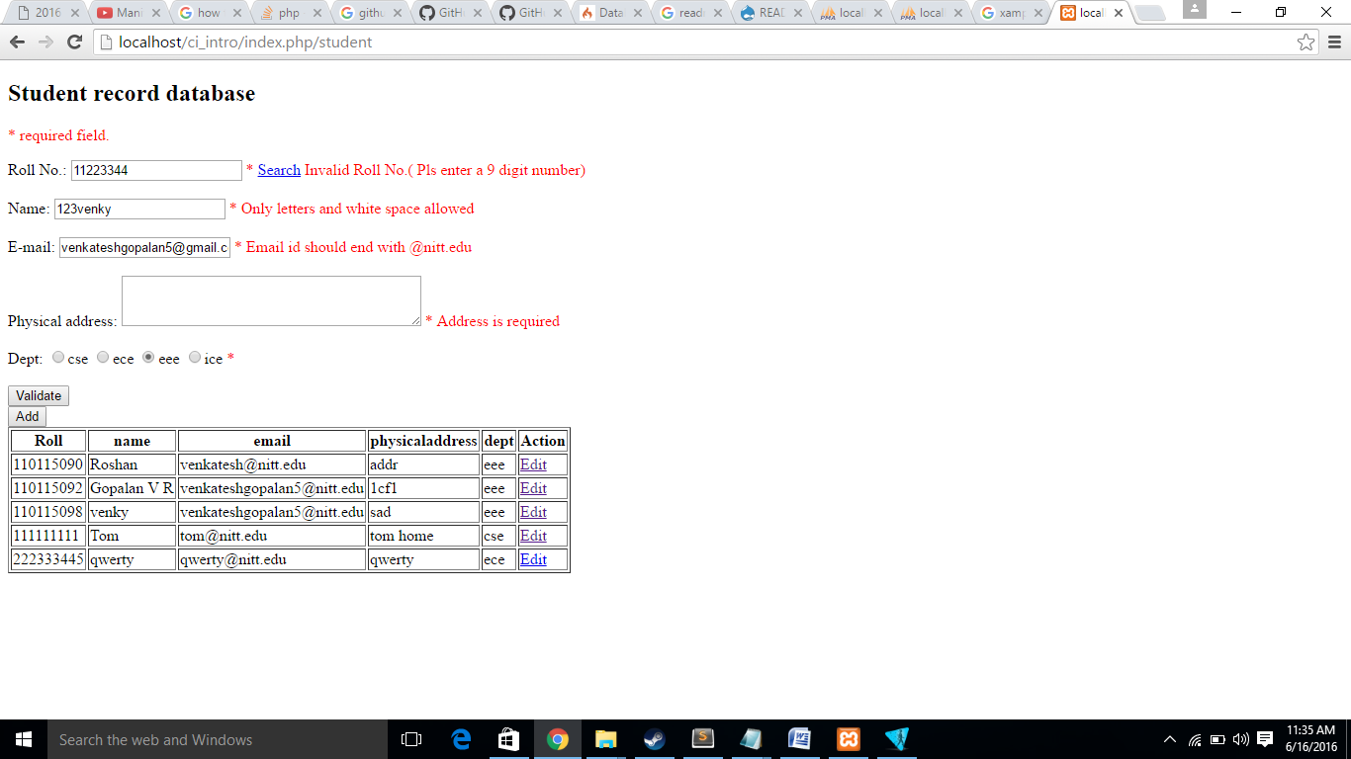

On adding the record, a random passcode is generated and displayed.

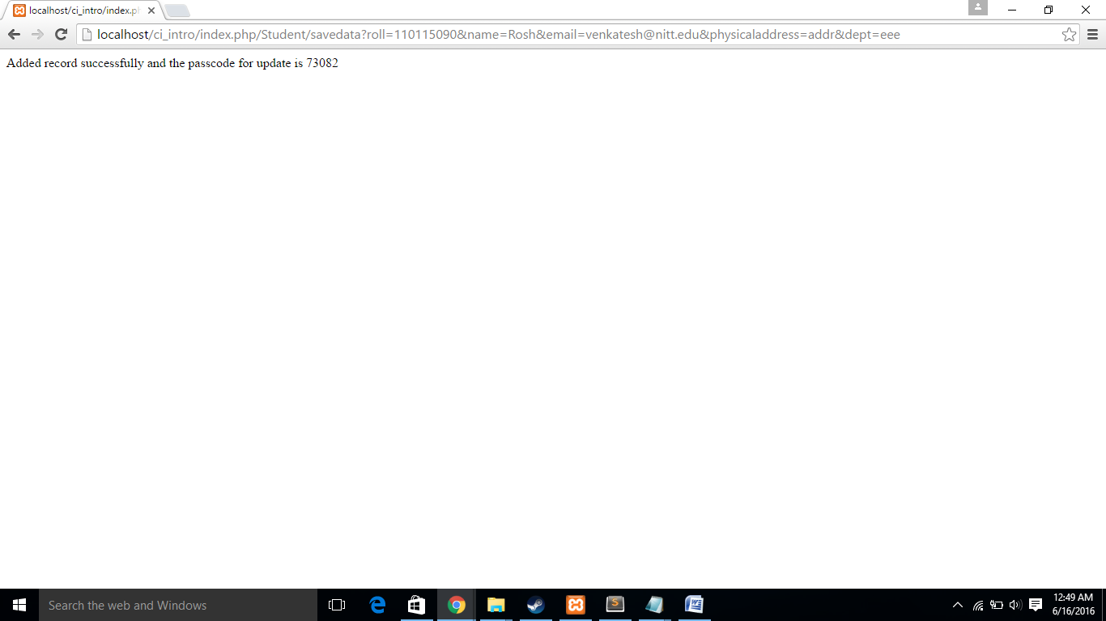

This passcode is saved into the database.

On clicking edit,

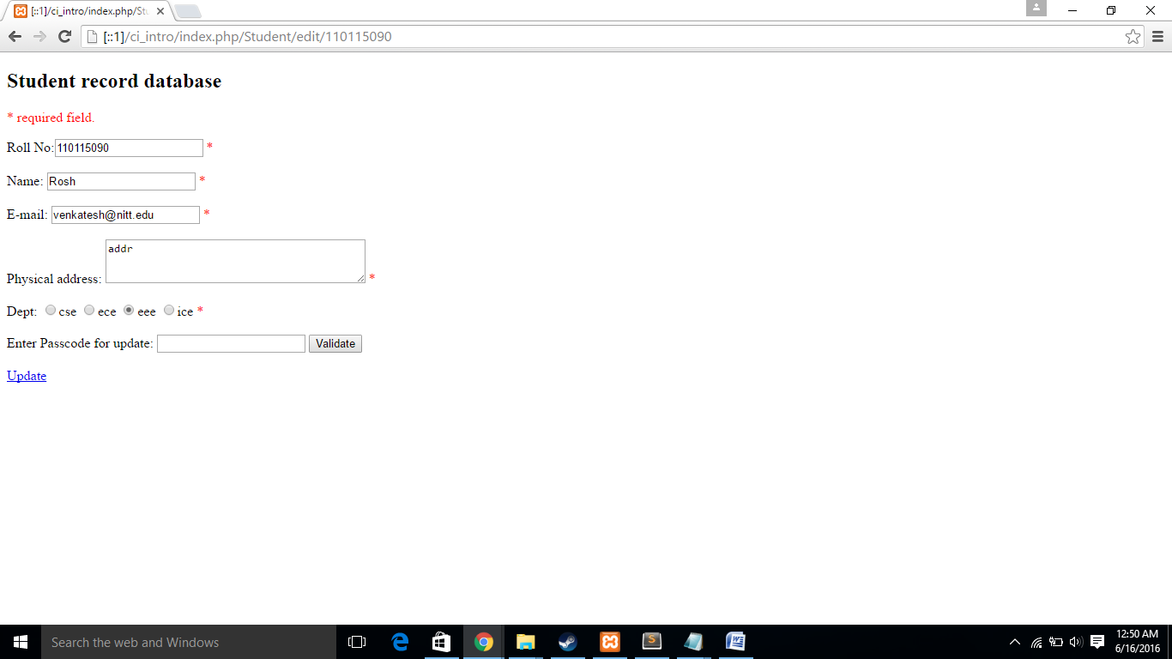

The roll no. is not editable.

After editing the other fields and entering passcode, press validate. It shows you any errors.

After validation, click update.

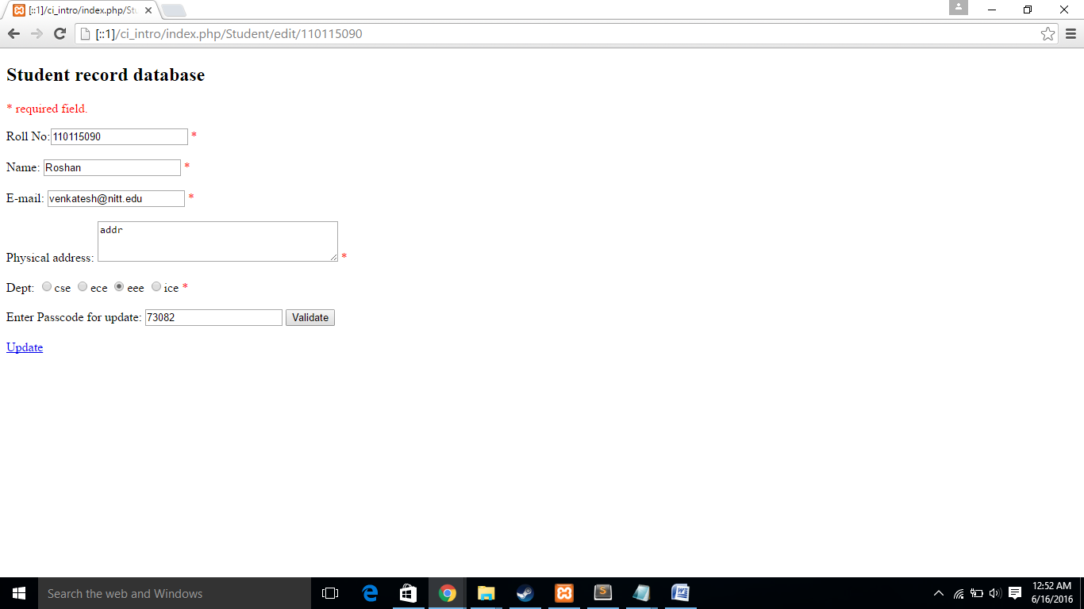

As an illustration, the name is edited and passcode is entered.

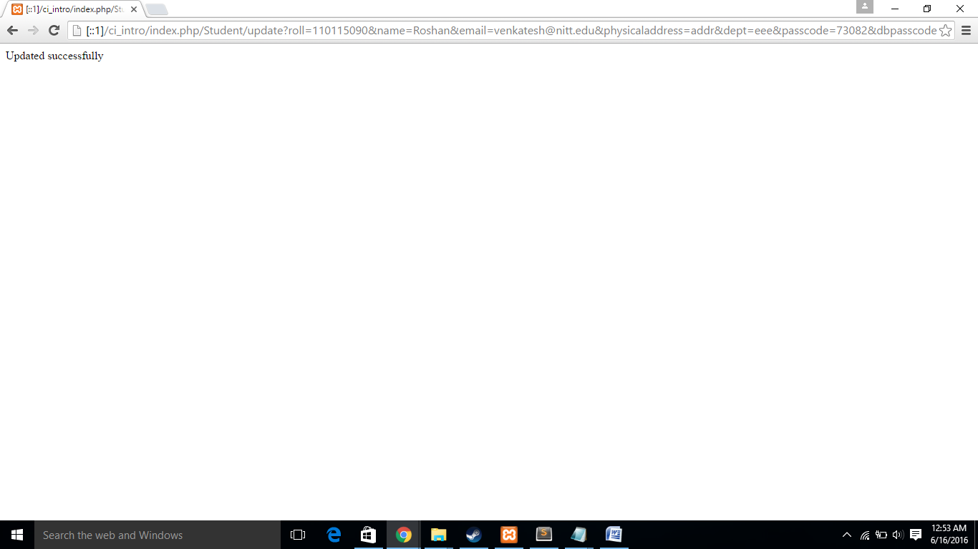

If you enter wrong passcode, You will get an error message and record will not be edited.

The updated record is shown.

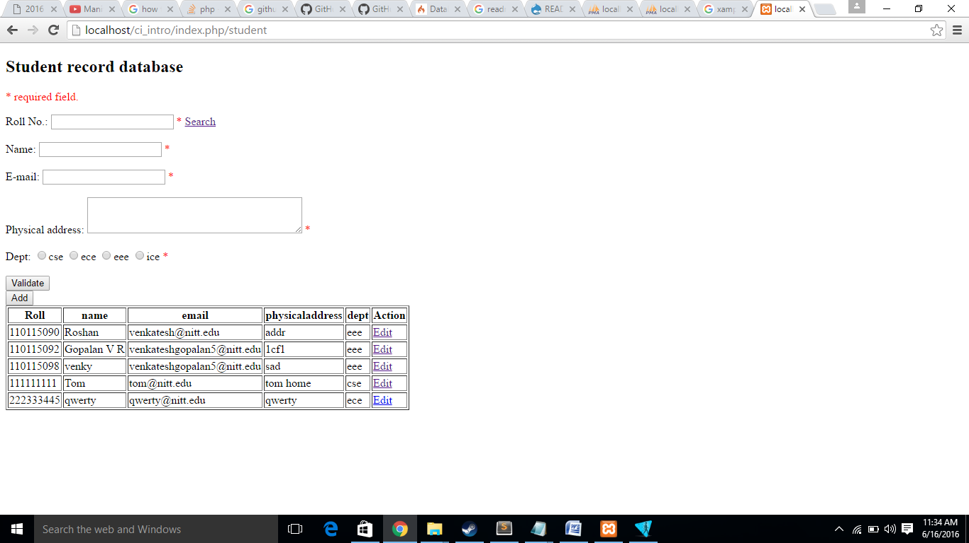

LINKS FOR DOWNLOAD

<https://www.apachefriends.org/download.html>

<https://www.codeigniter.com/download>