## SMAATO TECHNICAL CHALLENGE

1. Developed a REST API “/api/smaato/accept” using Spring boot application to accept the mandatory query id parameter.

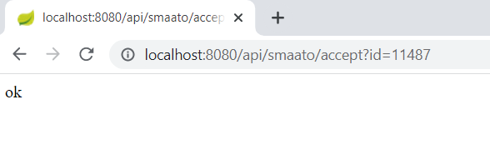

1. If the id parameter is new it will return ok. **Redis Sets** have the desirable property of not allowing repeated members. This will avoid the duplicates.
2. On providing the already existing id the API will return “failed” message.

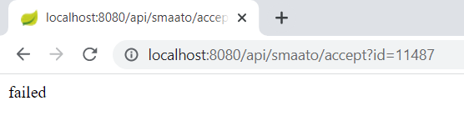

1. Multithreaded tomcat is configured to accept the max thread of 200 counts to accept the 10000 hits per second.
2. To ensure the 10000 hits per second I have used Apache JMeter to test the flow and no errors were observed during DEV Testing.
3. Also the code is configured to accept the optional String parameter to trigger the new endpoint with the latest count of user list.

From the below screenshot 11488 is the current user count which will be appended as part of the HTTP parameter and it will log the HTTP status code in logs for all the unique counts.

HTTP status code is 302 since am redirecting.

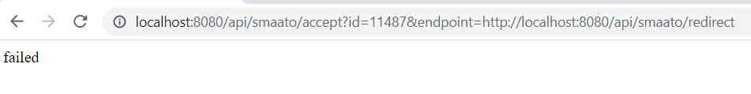





1. Every Minute the application will log the latest user count in logs. Have used the **spring scheduler** to trigger the log for every minute based on the new count.

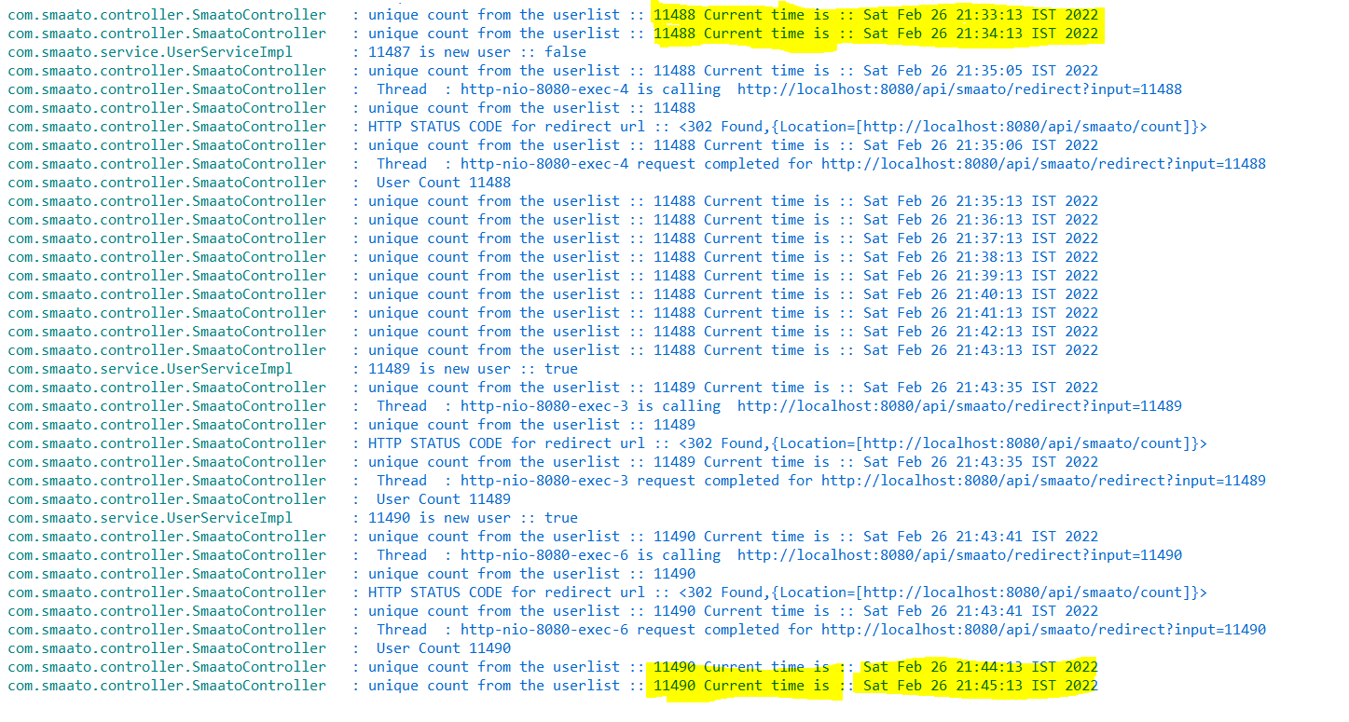

1. **Extension 1:** POST Method created for the “/api/smaato/accept”.

Success:

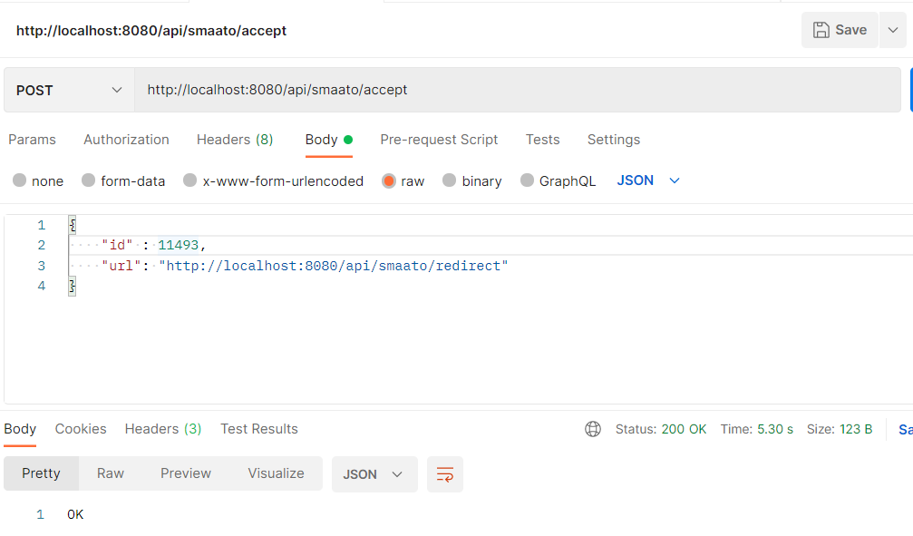

On Duplication:

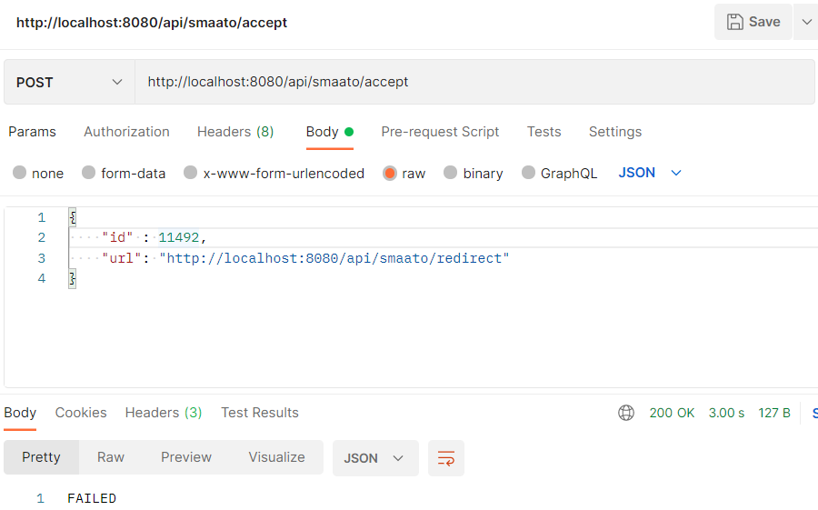

getUsers:

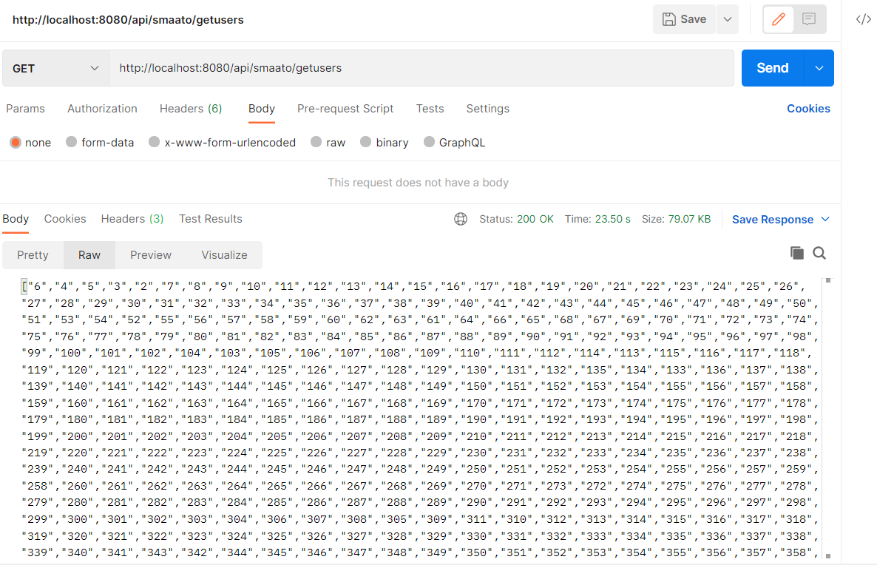

1. **Extension 2:** To ensure the de duplication works on the load balancer have ran the same application in two different tomcat ports with 8080 and 8090.

11490 is a duplicate and hence it fails both on 8080 and 8090. This is achieved using REDIS Set implementation

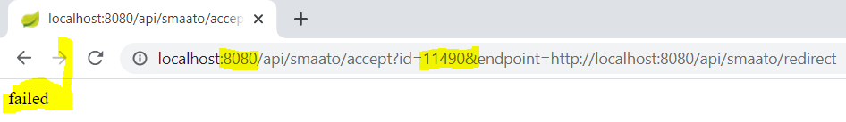

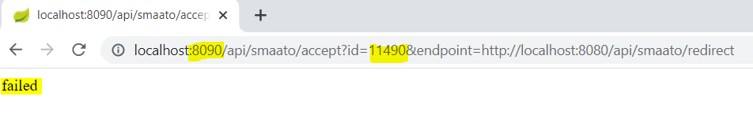

Port 8090 accepts the new id and as a result we get OK.

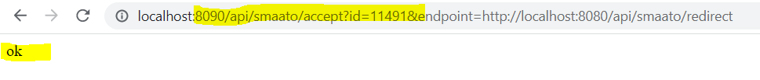

1. **Extension 3:** Log files are moved to streaming service. Have used Elastic Log stash & Kibana (ELK) for streaming and visualization.

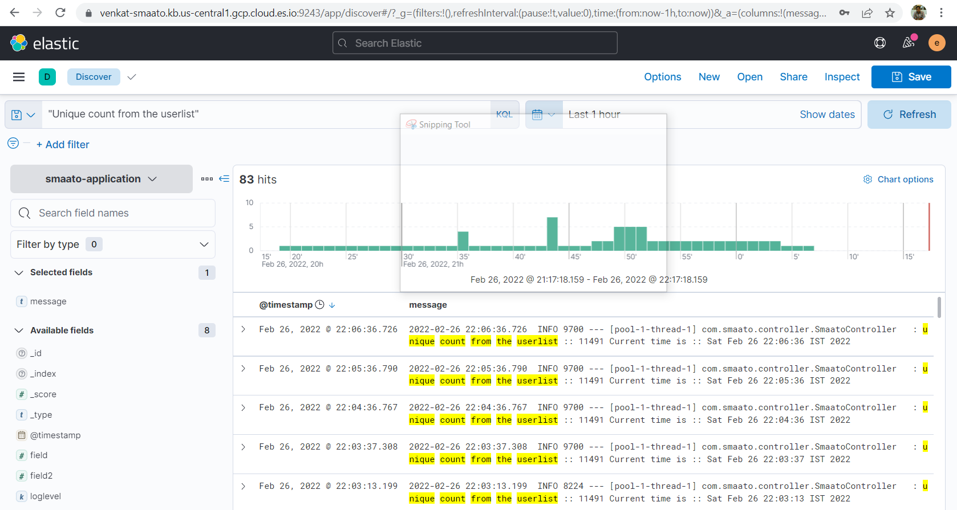

1. Source code and Jar is available in the following GitHub repository.

<https://github.com/venkateshvg1987/SmaatoApp>