Currency Recognition System Using Image Processing

In this paper author is using image processing algorithm called Template Matching to recognized currencies of different countries as local peoples are familiar about their currency and they will be unaware of different currency so by using this application they can upload image and then system will match the pattern of different countries currency with uploaded image and then predict the one with highest matching.

In propose paper author is using currency exchange API to know the rate of that currency as per Indian rupee but this exchange API is not working as they are asking for payment. By paying 1000 dollars we can purchase that API so I am ignoring it and in below screen you can see that payment option

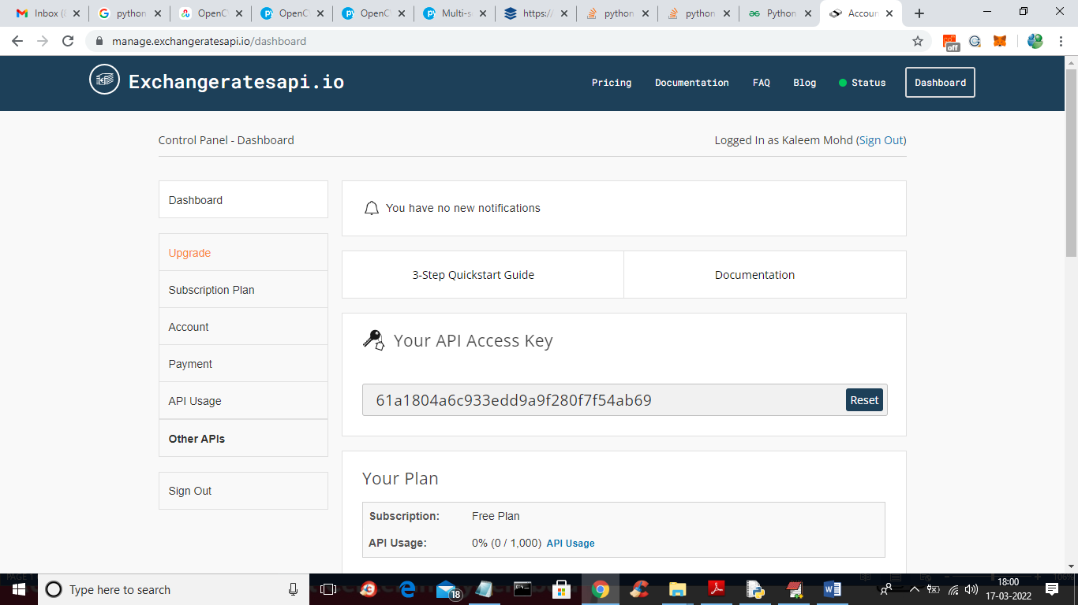

If we use free account then its giving error like below screen

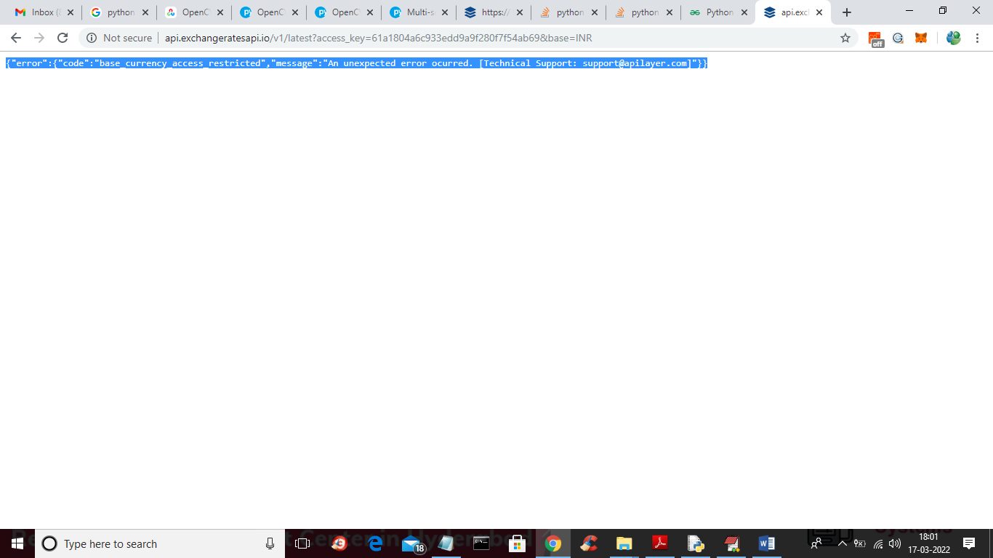

In above screen you can see exchange rate is giving error when trying to access free account.

SCREEN SHOTS

To run project double click on ‘run.bat’ file to get below screen

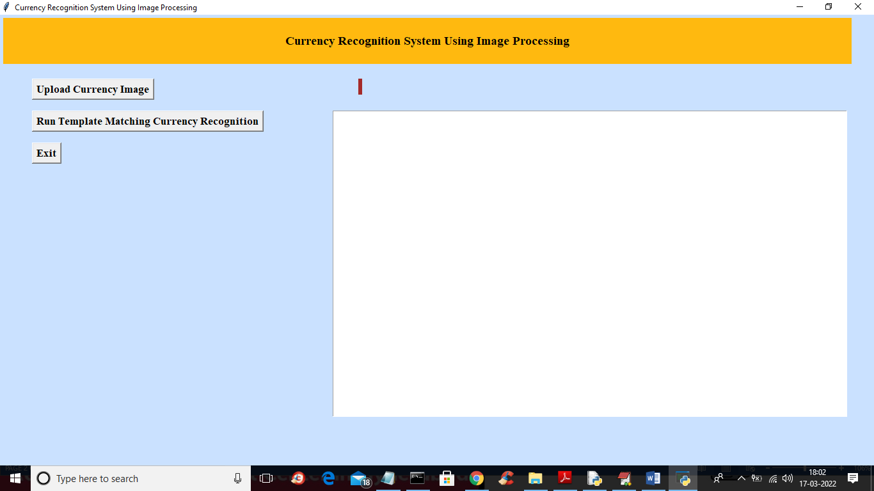

In above screen click on ‘Upload Currency Image’ button to upload currency images like below screen

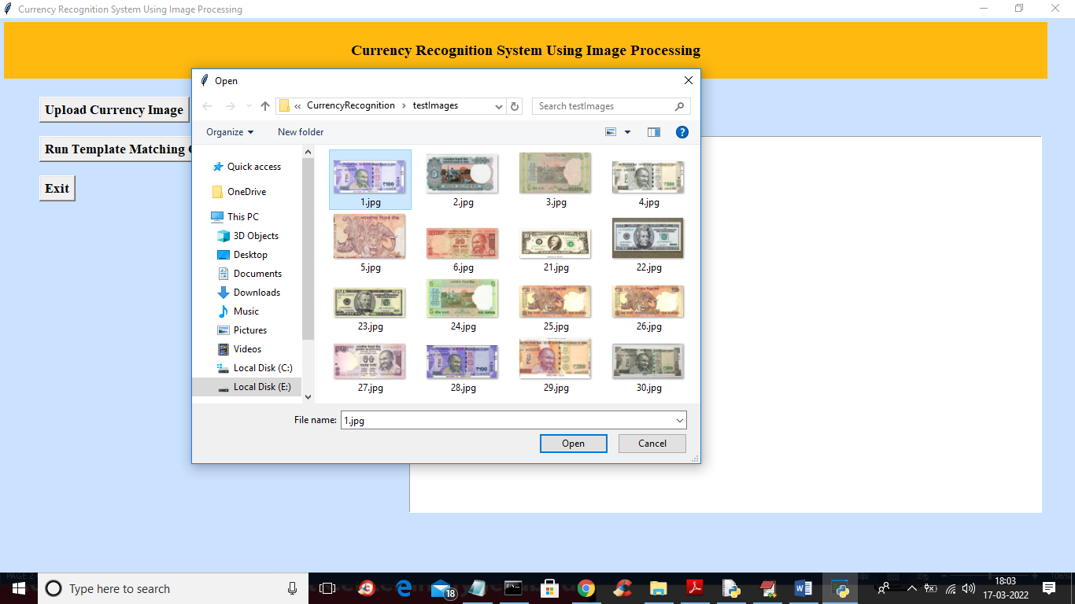

In above screen selecting and uploading ‘1.jpg’ file and then click on ‘Open’ button to load image and then click on ‘Run Template Matching Currency Recognition’ button to get below output

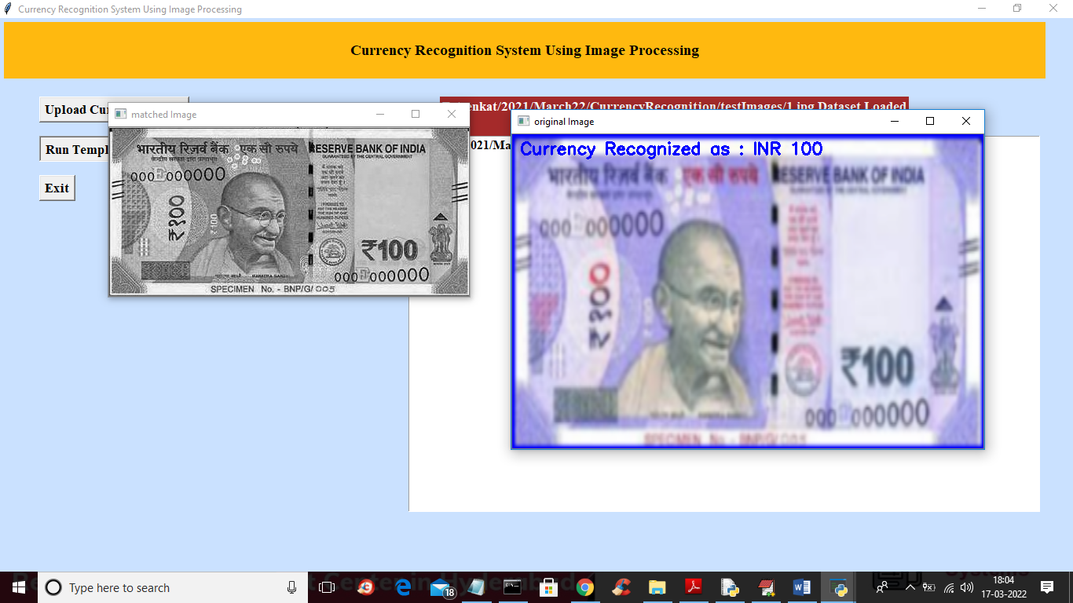

In above screen first image is the training image template and second image is the original image so by applying template matching algorithm we can predict correct currency not and that currency not recognized as INR 100. Similarly you can upload other image and test

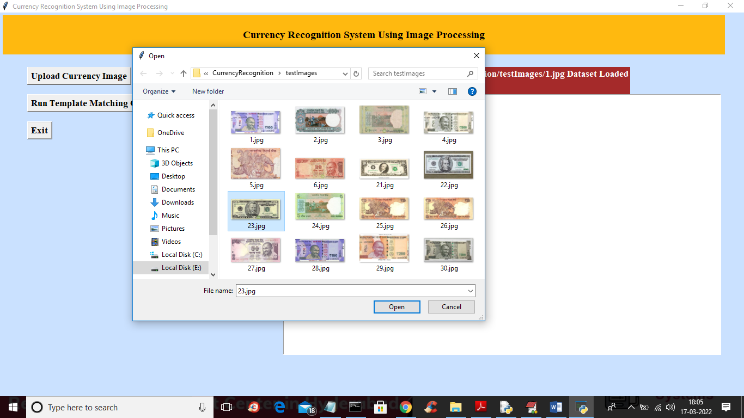

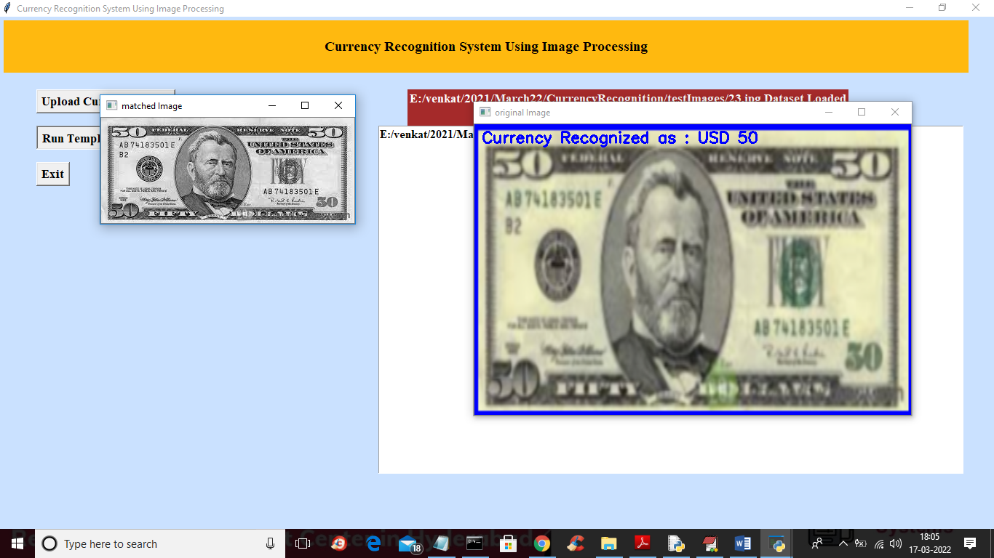

In above screen in blue colour text we can see currency identified as USD 50

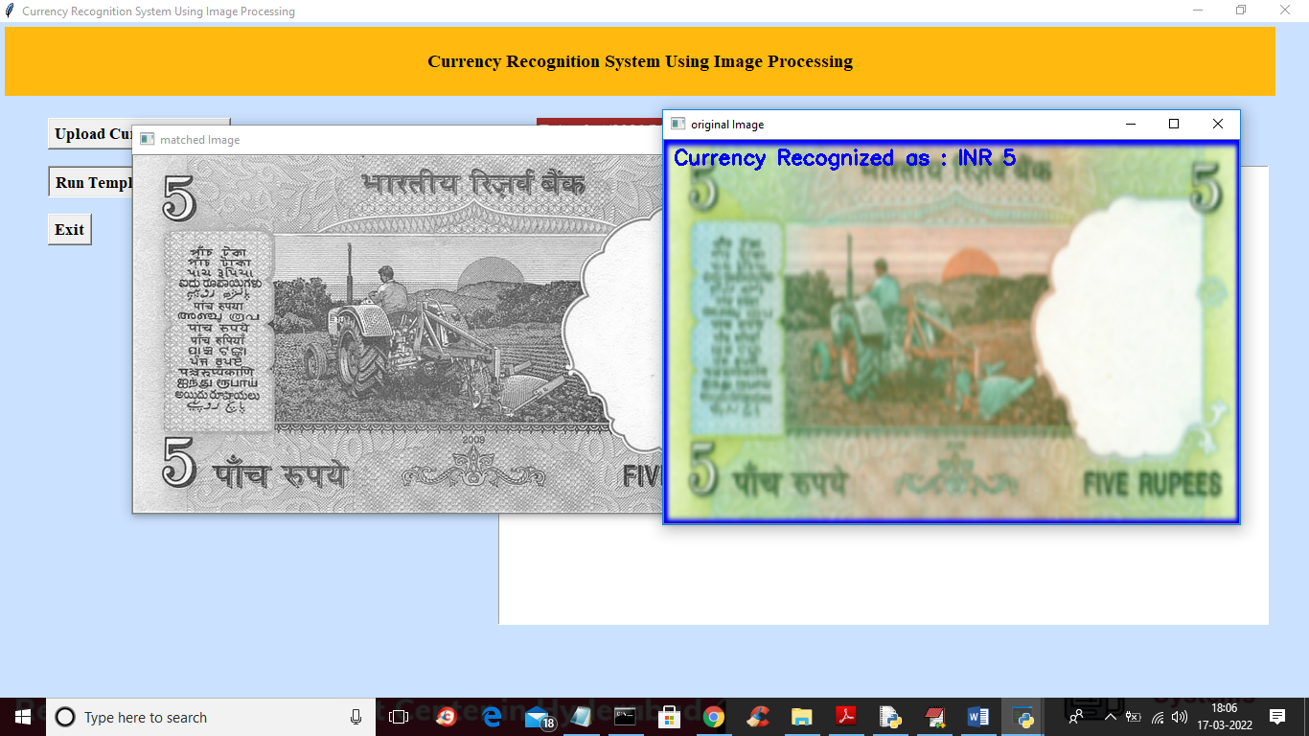

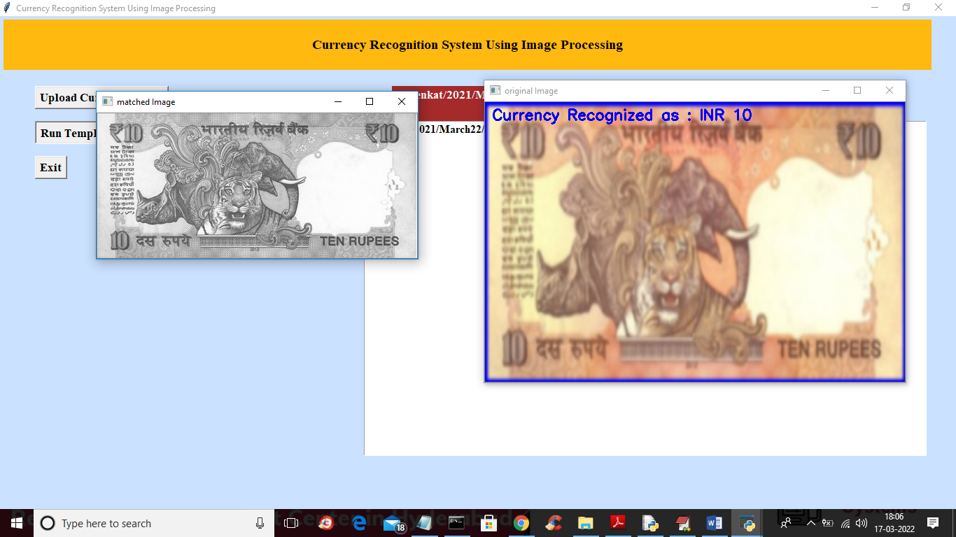

Note: this is computer program not human so it may recognized 7 images out of 10 correctly as no computer algorithms are 100% perfect