Business rules to enquire and booking a vehicle

* Rules to enquire a vehicle

1. Enquire can be allowed only to the customer whose age is greater than or equal to 20.

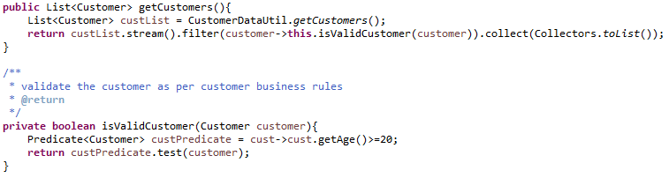

1. Vehicle enquire request must have mandatory fields no.ofwheels, age, country

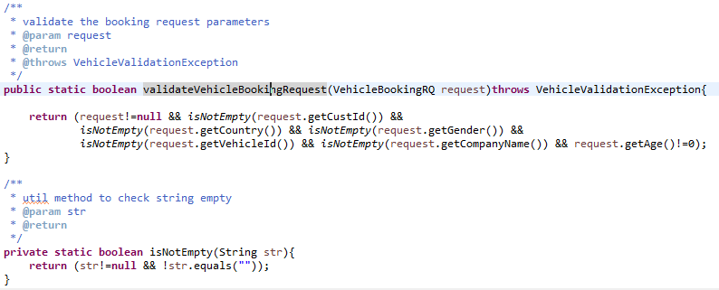

1. Display of vehicles response can be default sorted with total price low-to-high.

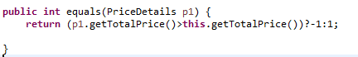



* **Rules to Book a Vehicle**

1. Customer is unique with custId and country combination

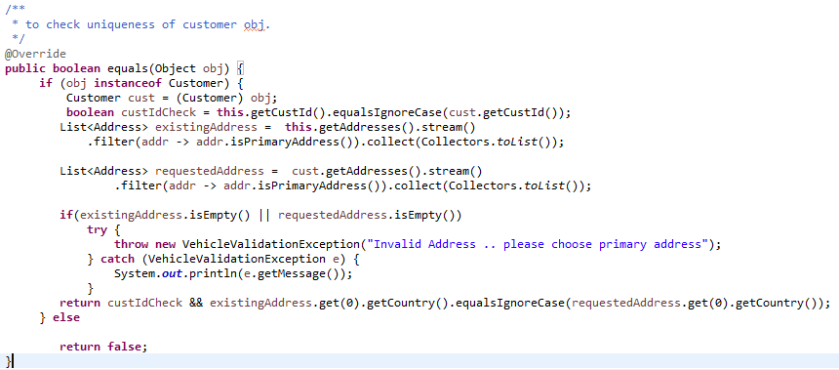

1. Booking can be allowed only to the customer whose age is greater than or equal to 20.
2. One vehicle will be sold to one customer.
3. Vehicle is unique with vehicleId and companyName combination

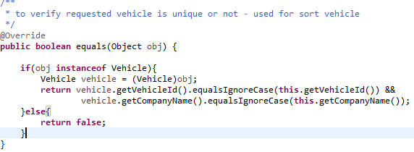

1. Inventory should have atleast 2 vehicles.
2. Once inventory reaches only 2 vehcles with same company. Inventory will be notifies that waiting .