SIMATS ENGINEERING
ASSESSMENT TOOL 3

COURSE NAME: INTERNET PROGRAMMING
COURSE CODE: CSA43

COURSE OUTCOME COVERED
CO-2 : Apply CSS layout and styling techniques to create visually appealing and responsive
web interfaces, and use JavaScript to enable interactive client-side behavior. (L3)
Assessment Tool : Short Answer Test
Weightage: 10%
QUESTIONS: Total Marks: 50
Code of Conduct:
I Venkateswarlu-192411239 (Name / Reg No) certify that this submission is my
original work and that I have adhered to the guidelines specified for this assessment.
I understand that any violation of academic integrity rules will result in disciplinary
action.
Signature of the student: 

Question 1: Responsive Web Design (5 Marks)
Answer:
Responsive Web Design (RWD) is a technique used to create websites that automatically adjust their layout to different screen sizes, such as mobile phones, tablets, and desktops.
Importance:
- Provides a better user experience on all devices.
- Improves readability and navigation.
- Avoids horizontal scrolling.
- Reduces the need to create separate websites for different devices.
Key CSS techniques:
- Flexible layouts using Flexbox and Grid.
- Media queries to apply styles based on screen size.
- Flexible units such as %, rem, and vw.
- Responsive images using max-width: 100%.
- The viewport meta tag.
Example:
<meta name="viewport" content="width=device-width, initial-scale=1.0">

<style>
.container {
display: grid;
grid-template-columns: repeat(3, 1fr);
gap: 10px;
}

.box {
background: lightblue;
padding: 20px;
}

@media (max-width: 768px) {
.container {
grid-template-columns: 1fr;
}
}
</style>

<div class="container">
<div class="box">Home</div>
<div class="box">Courses</div>
<div class="box">Contact</div>
</div>
Improvements: Use readable fonts, accessible colors, touch-friendly buttons, and properly sized images to improve the user experience.
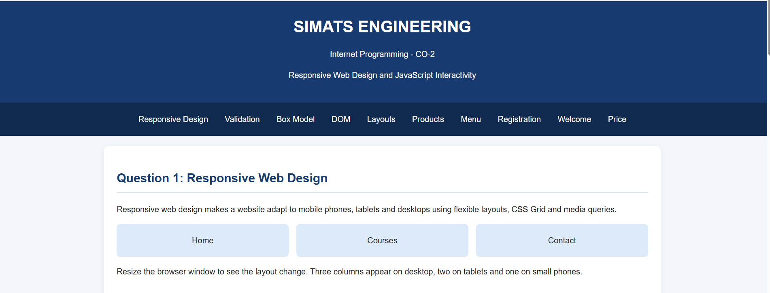
Question 2: Client-Side Validation (5 Marks)
Answer:
Client-side validation checks user input in the browser before submitting a form to the server. It helps prevent empty or incorrectly formatted data from being submitted.
Purpose:
- Detects errors immediately.
- Improves user experience.
- Reduces unnecessary server requests.
- Ensures required fields are completed.
JavaScript event handling uses events such as submit, input, and change to validate user input. Regular expressions (RegEx) are patterns used to check formats such as email addresses and phone numbers.
Example:
<form id="myForm">
<input type="text" id="email" placeholder="Enter email">
<button type="submit">Submit</button>
<p id="message"></p>
</form>

<script>
document.getElementById("myForm").addEventListener("submit", function(event) {
event.preventDefault();

const email = document.getElementById("email").value.trim();
const pattern = /^[^\s@]+@[^\s@]+\.[^\s@]+$/;

if (pattern.test(email)) {
document.getElementById("message").textContent =
"Email is valid.";
} else {
document.getElementById("message").textContent =
"Please enter a valid email.";
}
});
</script>
Improvements: Display clear error messages, validate fields as users type, and use server-side validation as well. Client-side validation alone is not sufficient for security because it can be bypassed.
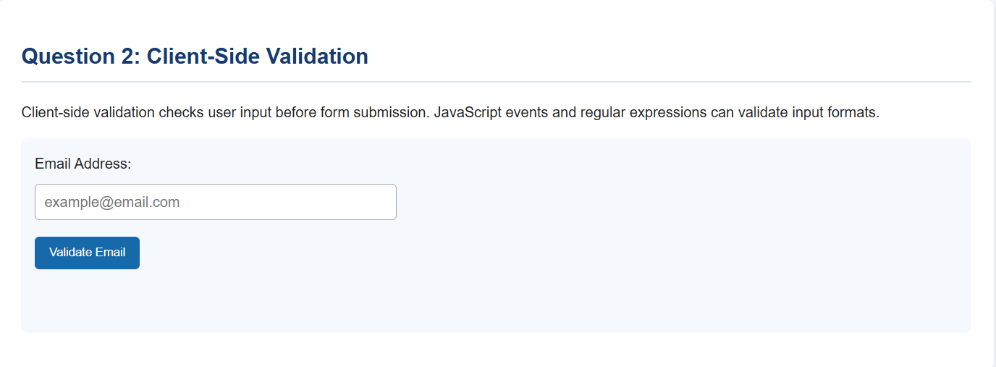
Question 3: CSS Box Model and Positioning (5 Marks)
Answer:
The CSS box model describes how the size of an HTML element is calculated. It contains four components:
- Content: The actual text or image.
- Padding: Space between content and border.
- Border: The boundary surrounding the padding and content.
- Margin: Space outside the border.
CSS positioning techniques:
- static: Default positioning.
- relative: Positions an element relative to its normal position.
- absolute: Positions an element relative to its containing block.
- fixed: Keeps an element fixed relative to the viewport.
- sticky: Makes an element stick during scrolling after reaching a specified position.
Causes of layout breaking:
- Fixed widths that exceed the screen size.
- Excessive margins or padding.
- Incorrect absolute positioning.
- Missing media queries.
- Images wider than their containers.
Example:
<style>
* {
box-sizing: border-box;
}

.container {
width: 100%;
padding: 20px;
background: lightblue;
}

@media (max-width: 600px) {
.container {
padding: 10px;
}
}
</style>

<div class="container">
Responsive container
</div>
Best practices: Use box-sizing: border-box, flexible widths, responsive images, suitable positioning, and media queries to maintain a stable layout.
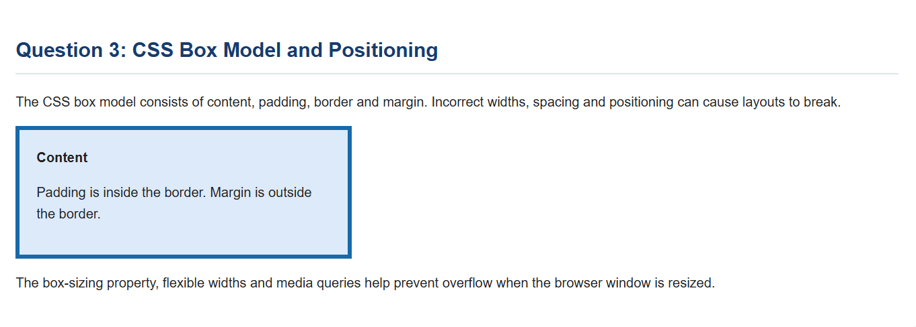
Question 4: DOM Manipulation (5 Marks)
Answer:
The Document Object Model (DOM) is a programming representation of an HTML document as a tree of objects. JavaScript can access and modify these objects to update webpage content dynamically without reloading the entire page.
Uses of DOM manipulation:
- Change text and HTML content.
- Modify CSS styles.
- Add or remove elements.
- Respond to user events.
- Update information dynamically.
Example:
<h2 id="heading">Welcome</h2>
<button id="changeBtn">Change Message</button>

<script>
document.getElementById("changeBtn").addEventListener("click", function() {
document.getElementById("heading").textContent =
"Welcome to Internet Programming!";
});
</script>
When the button is clicked, JavaScript changes the heading without reloading the page.
Improvements: Use textContent for plain text, update only the required elements, avoid unnecessary DOM changes, and provide clear feedback to users.
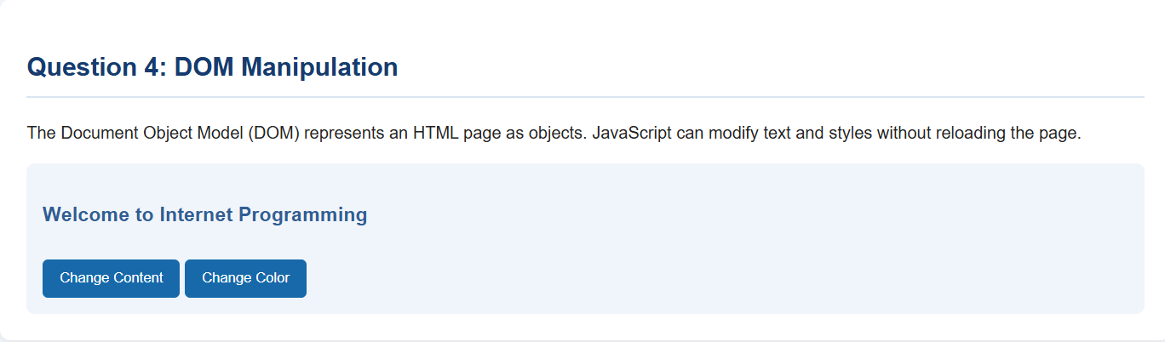
Question 5: Responsive Layout (5 Marks)
Answer:
A responsive college website adapts to desktops, tablets, and mobile phones by using CSS media queries and flexible layouts.
Techniques:
- Use Flexbox or Grid for flexible arrangements.
- Use percentages instead of fixed widths.
- Use media queries for different screen sizes.
- Make images responsive.
- Include the viewport meta tag.
Example:
<meta name="viewport" content="width=device-width, initial-scale=1.0">

<style>
.layout {
display: flex;
gap: 10px;
}

.layout div {
flex: 1;
padding: 20px;
background: lightblue;
}

@media (max-width: 600px) {
.layout {
flex-direction: column;
}
}
</style>

<div class="layout">
<div>Courses</div>
<div>Admissions</div>
<div>Contact</div>
</div>
On larger screens, the sections appear horizontally. On mobile screens, they appear vertically.
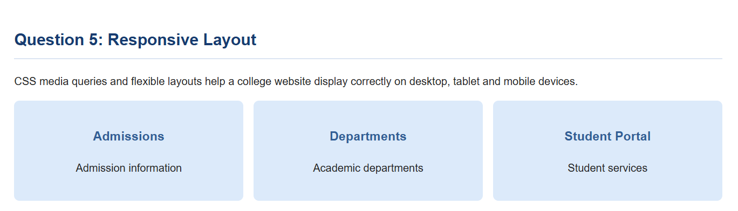
Question 6: CSS Styling for Product Cards (5 Marks)
Answer:
CSS styling improves the appearance of product cards and makes an online shopping website more attractive and user-friendly.
Styling techniques:
- Colors highlight important information.
- Borders separate product cards.
- Shadows create depth.
- Padding provides space inside cards.
- Margins create space between cards.
- Hover effects improve interaction.
Example:
<style>
.card {
background: white;
border: 1px solid #ddd;
border-radius: 10px;
padding: 20px;
margin: 15px;
box-shadow: 0 4px 8px #0002;
transition: transform 0.3s;
}

.card:hover {
transform: translateY(-5px);
}

.price {
color: green;
font-weight: bold;
}
</style>

<div class="card">
<h3>Smartphone</h3>
<p class="price">₹20,000</p>
<button>Add to Cart</button>
</div>
Benefits: Consistent styling improves readability, product visibility, and the overall shopping experience.
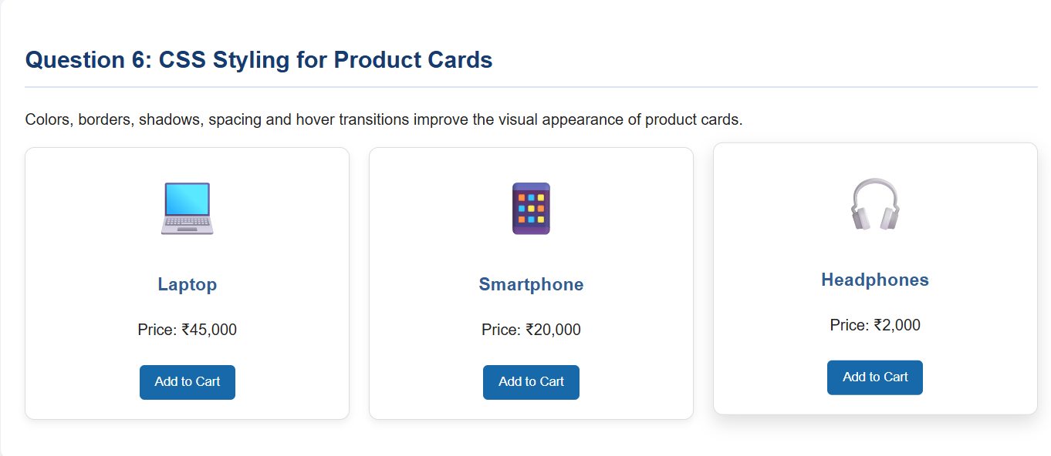
Question 7: Navigation Menu Overlapping Content (5 Marks)
Answer:
A navigation menu may overlap content on smaller screens because of fixed widths, incorrect positioning, or insufficient responsive styling.
Solutions:
- Use Flexbox to align menu items.
- Use media queries to adjust the menu for mobile screens.
- Avoid unnecessary absolute positioning.
- Use a hamburger menu on smaller screens.
- Set appropriate spacing and stacking order with z-index when needed.
Example:
<style>
nav {
display: flex;
justify-content: space-around;
flex-wrap: wrap;
background: navy;
padding: 15px;
}

nav a {
color: white;
text-decoration: none;
padding: 10px;
}

@media (max-width: 600px) {
nav {
flex-direction: column;
align-items: flex-start;
}
}
</style>

<nav>
<a href="#">Home</a>
<a href="#">Courses</a>
<a href="#">About</a>
<a href="#">Contact</a>
</nav>
Result: The navigation links wrap or stack vertically on small screens, reducing overlap and improving usability.
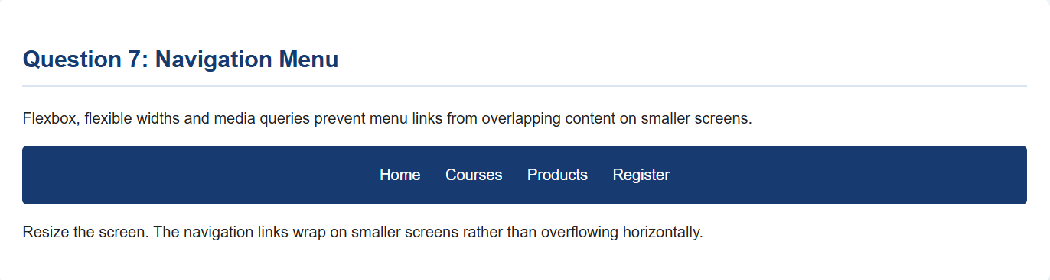
Question 8: JavaScript Form Validation (5 Marks)
Answer:
JavaScript form validation checks whether required fields contain valid information before a form is submitted. It prevents submission when mandatory fields are empty.
Example:
<form id="registerForm">
<input type="text" id="name" placeholder="Enter name">
<button type="submit">Register</button>
<p id="message"></p>
</form>

<script>
document.getElementById("registerForm").addEventListener("submit", function(event) {
event.preventDefault();

const name = document.getElementById("name").value.trim();
const message = document.getElementById("message");

if (name === "") {
message.textContent = "Name is required.";
} else {
message.textContent = "Registration successful!";
}
});
</script>
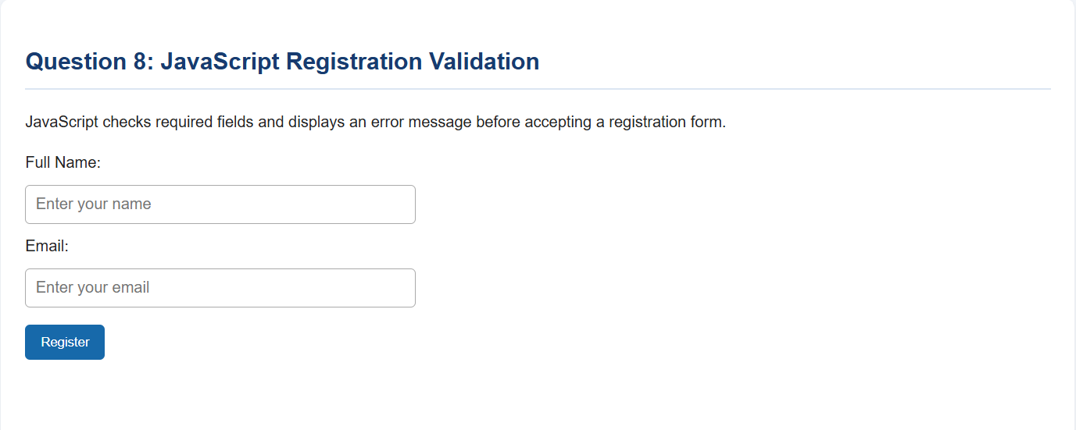
Explanation:
- The submit event detects form submission.
- trim() removes leading and trailing spaces.
- The if condition checks whether the field is empty.
- A message informs the user of the result.
Improvement: Use HTML attributes such as required and perform server-side validation before storing submitted information.
Question 9: Interactive Button (5 Marks)
Answer:
JavaScript makes a webpage interactive by responding to user actions. The click event can display a welcome message when a button is clicked.
Example:
<h2>Online Learning Portal</h2>

<button id="welcomeBtn">Click Here</button>
<p id="message"></p>

<script>
document.getElementById("welcomeBtn").addEventListener("click", function() {
document.getElementById("message").textContent =
"Welcome to our E-Learning Website!";
});
</script>
Explanation:
- HTML creates a button and an empty paragraph.
- JavaScript attaches a click event listener to the button.
- When the user clicks the button, textContent updates the paragraph.
- The welcome message appears without reloading the page.
Benefit: This provides immediate feedback and improves user interaction.
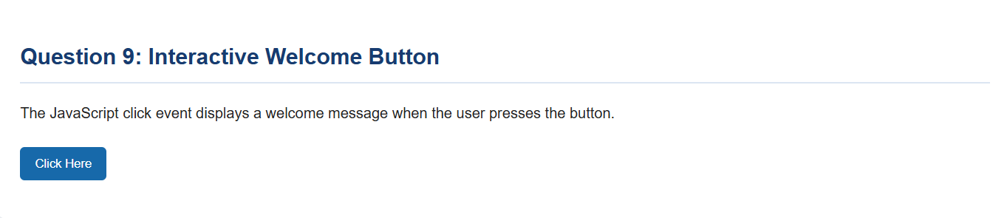
Question 10: Dynamic Content – Updating Product Price (5 Marks)
Answer:
JavaScript can calculate and display the total price dynamically when a customer changes the quantity of a product.
Formula:
\[ \text{Total Price}=\text{Unit Price}\times\text{Quantity} \]
Example:
<h2>Shopping Cart</h2>

<p>Product: Headphones</p>
<p>Price per item: ₹1,000</p>

<label for="quantity">Quantity:</label>
<input type="number" id="quantity" value="1" min="1" max="100">

<p>Total Price: ₹<span id="total">1000</span></p>

<script>
const price = 1000;
const quantity = document.getElementById("quantity");
const total = document.getElementById("total");

function updatePrice() {
let qty = Number(quantity.value);

if (!Number.isInteger(qty) || qty < 1 || qty > 100) {
total.textContent = "Enter quantity from 1 to 100";
return;
}

total.textContent = (price * qty).toLocaleString("en-IN");
}

quantity.addEventListener("input", updatePrice);
</script>
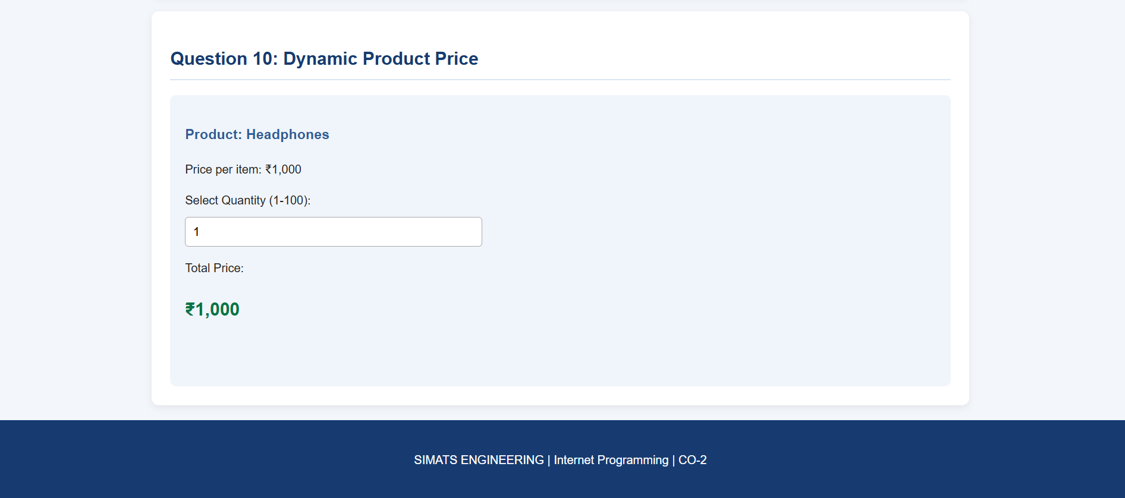
Explanation:
- The unit price is stored in the price variable.
- The input event detects quantity changes.
- JavaScript multiplies the price by the quantity.
- The total price updates immediately without reloading the page.
Improvement: Validate the quantity, format currency properly, and calculate the final payable amount on the server before completing a purchase.

