INTERNET PROGRAMMING LAB
EXPERIMENT – 7
ONLINE BEAUTY PARLOUR APPOINTMENT BOOKING SYSTEM
Name | Venkateswarlu
Register Number | 192411239
Course code | CSA4304

AIM
To create a simple Online Beauty Parlour Appointment Booking System using HTML, CSS, and JavaScript. Users can enter their name, select a service, choose a date and time, and view a booking confirmation.

TOOL REQUIRED
1. Visual Studio Code or any text editor
2. Web browser such as Google Chrome
3. HTML, CSS, and JavaScript

ALGORITHM
1. Start the program.
2. Create an HTML form for customer name, service, date, and time.
3. Use CSS to style the form.
4. Use JavaScript to read the form values.
5. Check that all required fields are completed.
6. Display a confirmation message with the appointment details.
7. Stop the program.

PROGRAM

File 1: index.html
<!DOCTYPE html>
<html lang="en">
<head>
<meta charset="UTF-8">
<meta name="viewport" content="width=device-width, initial-scale=1.0">
<title>Beauty Parlour Appointment</title>
<link rel="stylesheet" href="style.css">
</head>
<body>
<div class="container">
<h1>Glow Beauty Parlour</h1>
<p>Book your beauty appointment</p>
<form id="bookingForm">
<label for="name">Your Name</label>
<input type="text" id="name" required>
<label for="service">Choose Service</label>
<select id="service" required>
<option value="">Select a service</option>
<option>Haircut - ₹300</option>
<option>Facial - ₹700</option>
<option>Manicure - ₹400</option>
<option>Hair Styling - ₹500</option>
</select>
<label for="date">Appointment Date</label>
<input type="date" id="date" required>
<label for="time">Appointment Time</label>
<select id="time" required>
<option value="">Select a time</option>
<option>10:00 AM</option><option>11:00 AM</option>
<option>12:00 PM</option><option>2:00 PM</option>
<option>3:00 PM</option><option>4:00 PM</option>
</select>
<button type="submit">Book Appointment</button>
</form>
<div id="confirmation"></div>
</div>
<script src="script.js"></script>
</body>
</html>

File 2: style.css
body {
font-family: Arial, sans-serif;
background: #fff0f5;
margin: 0;
padding: 20px;
}
.container {
max-width: 520px;
margin: 20px auto;
padding: 25px;
background: white;
border-radius: 10px;
box-shadow: 0 3px 12px #e5cbd5;
}
h1, p { text-align: center; }
h1 { color: #a52a5a; }
form { display: flex; flex-direction: column; gap: 10px; }
label { font-weight: bold; }
input, select, button {
padding: 11px; border: 1px solid #ccc;
border-radius: 5px; font-size: 15px;
}
button { background: #c04475; color: white; border: none; cursor: pointer; }
button:hover { background: #9f2e5c; }
#confirmation { margin-top: 20px; color: #176b3a; font-weight: bold; line-height: 1.6; }
@media (max-width: 600px) {
.container { padding: 15px; }
input, select, button { box-sizing: border-box; width: 100%; }
}

File 3: script.js
document.getElementById("bookingForm").addEventListener("submit", function(event) {
event.preventDefault();
const name = document.getElementById("name").value.trim();
const service = document.getElementById("service").value;
const date = document.getElementById("date").value;
const time = document.getElementById("time").value;
const confirmation = document.getElementById("confirmation");
if (!name || !service || !date || !time) {
confirmation.textContent = "Please fill in all fields.";
return;
}
confirmation.innerHTML =
"Appointment booked successfully!<br>" +
"Name: " + name + "<br>" +
"Service: " + service + "<br>" +
"Date: " + date + "<br>" +
"Time: " + time;
});

OUTPUT
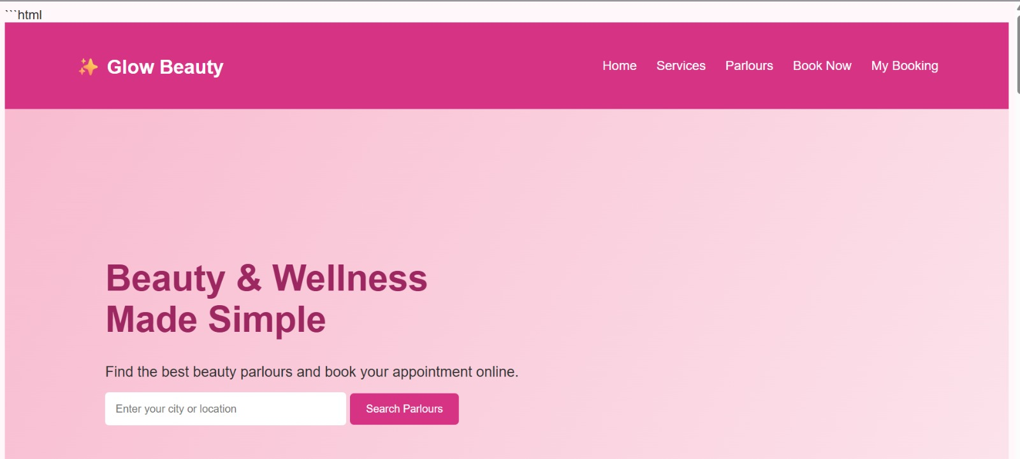

RESULT
Thus, the Online Beauty Parlour Appointment Booking System was created using HTML, CSS, and JavaScript. It displays appointment details as a confirmation. This front-end demo does not store bookings in a database.

